Pharmaceutical Distribution Intelligence Platform
Vision, Architecture & 5-Year Roadmap — Version 1.0
June 2026

1 · Platform Vision
This platform began as an internal ERP reporting solution for a mid-size pharmaceutical distributor and has evolved into a complete Pharmaceutical Distribution Intelligence Platform: a reproducible, PII-safe system that turns raw ERP exports into a reconciled warehouse, decision intelligence, strategic analytics, geographic intelligence, BI exports, and an executive report — from one command.
The vision over five years is to grow from single-firm decision support (v1.0) into a predictive, AI-assisted platform (v2.0) and ultimately an autonomous, multi-tenant SaaS product (v3.0) for the pharmaceutical distribution sector — without re-architecting, because the foundational contracts are stable.

2 · Product Architecture
Ten loosely-coupled layers; each depends only on the contract below it, so the ERP, warehouse, BI tool, or AI models can change independently.
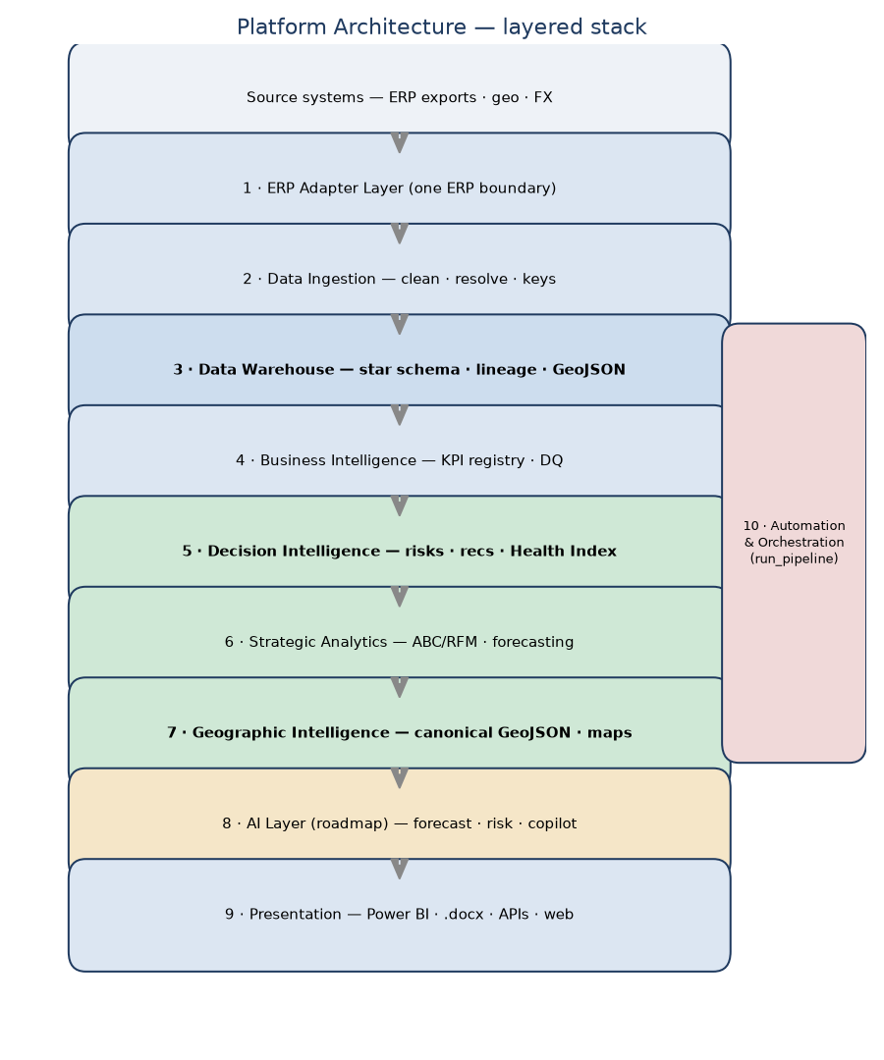
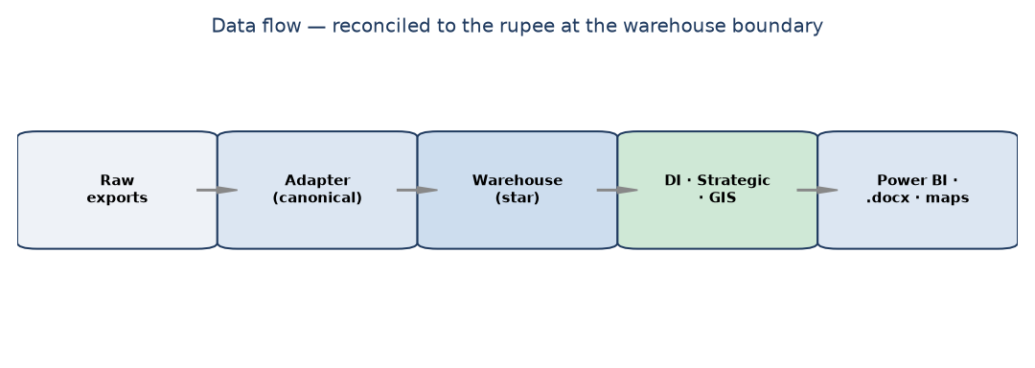
Layer | Responsibility (v1.0)
1 ERP Adapter | MediVision exports → canonical frames (one ERP boundary)
2 Ingestion | clean · reconcile · entity resolution · keys
3 Warehouse | SQLite star schema · lineage/audit/quality · spatial table
4 Business Intelligence | KPI registry · validation · DQ dashboard
5 Decision Intelligence | insights · risks · opportunities · recs · Health Index
6 Strategic Analytics | ABC/RFM · lifecycle · seasonality · forecasting
7 Geographic Intelligence | geocoding · canonical GeoJSON · maps
8 AI Layer (roadmap) | forecasting · risk · pricing · optimisation · copilot
9 Presentation | Power BI exports · .docx reports · (future) APIs/web
10 Automation | one-command pipeline → cron/CI → cloud

3 · Future GIS Roadmap
v1.0 made GeoJSON the canonical spatial format with a warehouse spatial table and reserved GPS/vehicle-route tables. Enhancements add layers and modules, never a redesign.
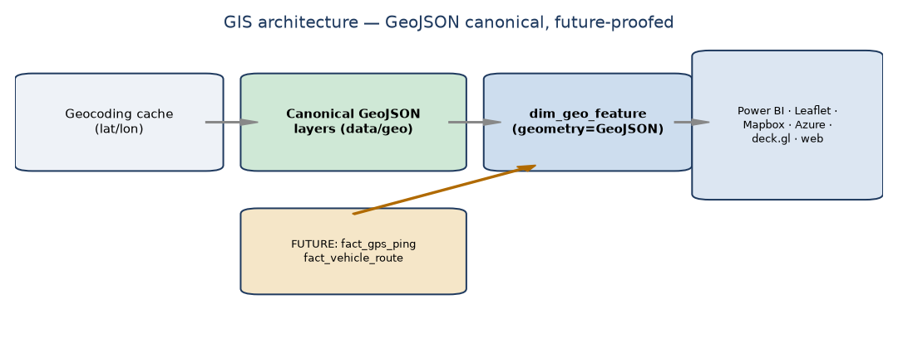
Enhancement | Priority
Official admin boundaries (GADM/OSM/Census) | P1
GPS-enabled delivery tracking | P2
Vehicle routing (actual paths) | P2
Drive-time analysis / isochrones | P2
Territory balancing | P2
Market penetration & white-space maps | P2
Route optimization (VRP) | P3
Warehouse location optimization | P3
Spatial AI (demand surfaces, hot-spots) | P3

4 · AI Roadmap
Each AI module reads the warehouse + KPI registry and writes predictions back as new fact tables — no redesign. Every model ships with confidence, assumptions, quality metrics, and a business explanation.
AI module | Value | Complexity | Priority
Sales forecasting | cash/inventory/capacity planning | Low | P1
Cash-flow forecasting | 30/60/90-day cash visibility | Medium | P1
Customer risk prediction | churn & credit risk → win-back | Medium | P1
Demand forecasting | SKU reorder & scheme planning | High | P2
Inventory optimization | min working capital at service level | High | P2
Purchase recommendation | auto reorder proposals | Medium | P2
Pricing optimization | margin lift on key SKUs | High | P2
Supplier risk prediction | continuity/price-risk flags | Medium | P2
Territory recommendation | route rebalancing & expansion | Medium | P2
NL business assistant | plain-language governed answers | Medium | P2
Route optimization | cut km/fuel/time (with GPS) | High | P3
Executive Copilot | proactive briefings & next actions | High | P3

5 · ERP Expansion
Adding an ERP means one adapter class emitting the canonical contract; the warehouse and everything above are untouched.
ERP | Adapter effort
MediVision ✅ (v1.0) | implemented
Marg | Low
Busy | Low
Tally (XML/ODBC) | Medium
SAP (OData/RFC) | High
Oracle (SQL/REST) | High
Generic CSV | Low (config-only)

6 · SaaS Vision
The same codebase becomes multi-tenant by adding infrastructure and tenancy — not by rewriting the intelligence. The hard parts (canonical model, INR source-of-truth, anonymisation, GeoJSON, configurable analytics) already exist.
Capability | SaaS design
Multi-company | tenant_id + row-level security + per-tenant config
Multi-branch | branch dimension + consolidation views
Multi-warehouse | warehouses already modelled as geo features
Multi-currency | per-tenant base; INR-style reporting layer ✅
Multi-language | i18n string catalogs; localised KPI/insight templates
Role-based security | RBAC + role-based PII masking (anonymiser exists)
Cloud deployment | containers + Postgres + object storage + IaC/CI
REST APIs | /kpis /health-index /forecasts /geojson /reports

7 · Maturity Assessment & Versions
v1.0 is a mature single-firm decision-support platform with a low-risk path to AI and SaaS.
Version | Theme | Introduces
v1.0 (now) | Decision support | Reconciled warehouse, DI + Health Index, strategic + forecasting, canonical GIS, Power BI/.docx, PII-safe, tested
v2.0 | Predictive & deeper | Line-item depth, AI (demand/cash/risk/pricing/inventory), official boundaries, NL assistant, Postgres + first APIs
v3.0 | Autonomous & multi-tenant | Route optimisation (GPS), Executive Copilot, multi-tenant SaaS (RBAC/cloud/i18n), spatial AI

Guiding principle: each version adds layers and tables, never a redesign. This is the Version 1.0 release of a long-term platform — not the end of a project.

