Experiment 02: Design a homepage using HTML with sections like header, navigation menu, main content, and footer.

Learning Objective: Student should be able to design and implement the structure of a website homepage using semantic HTML5 elements header, navigation, main content, section, and footer.

Tools: Notepad, Google Chrome

Theory:
HTML5 introduced a set of semantic elements that provide clear meaning to the structure of a webpage, both for the developer and for the browser. Unlike a generic <div>, a semantic tag like <header> explicitly defines its purpose. Using these elements is a cornerstone of modern web development for several key reasons:
- Accessibility: Screen readers and other assistive technologies use these tags to understand the page layout and help users navigate the content. For example, a user can command a screen reader to jump directly to the <main> content, skipping the navigation.
- SEO (Search Engine Optimization): Search engines like Google give more weight to content placed within semantic tags, helping them better understand your page's structure and importance.
- Maintainability: A semantically structured document is easier for you and your teammates to read and maintain. The code self-documents its layout.
- Key semantic elements for page layout include:
- <header>: Represents the introductory content for the page, often containing the site logo, title, and primary navigation.
- <nav>: Used specifically for major blocks of navigation links.
- <main>: Contains the dominant, unique content of a page. A document must not have more than one <main> element.
- <section>: A thematic grouping of content, typically with its own heading.
- <footer>: Defines the footer for a page, usually containing copyright information, contact details, and related links.

Result and Discussion:
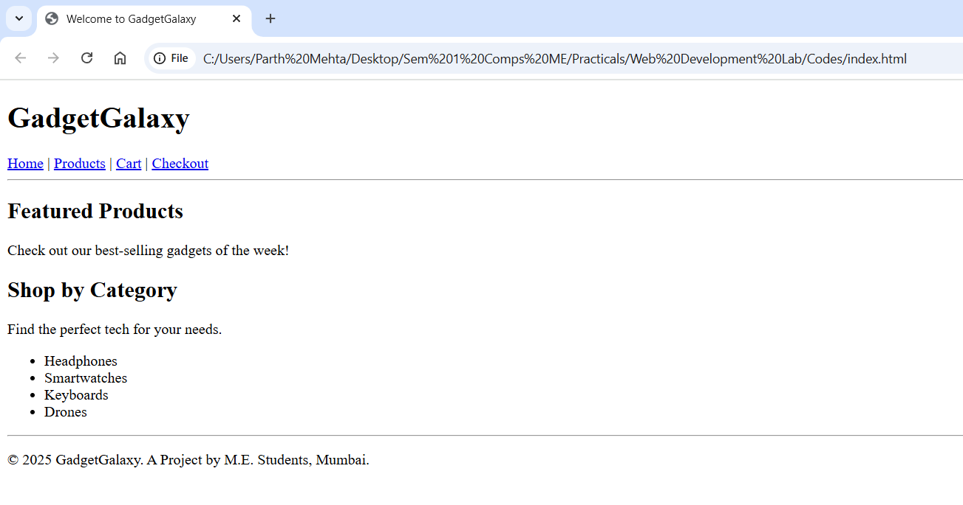
Webpage displaying a various category of products with navigation tabs.
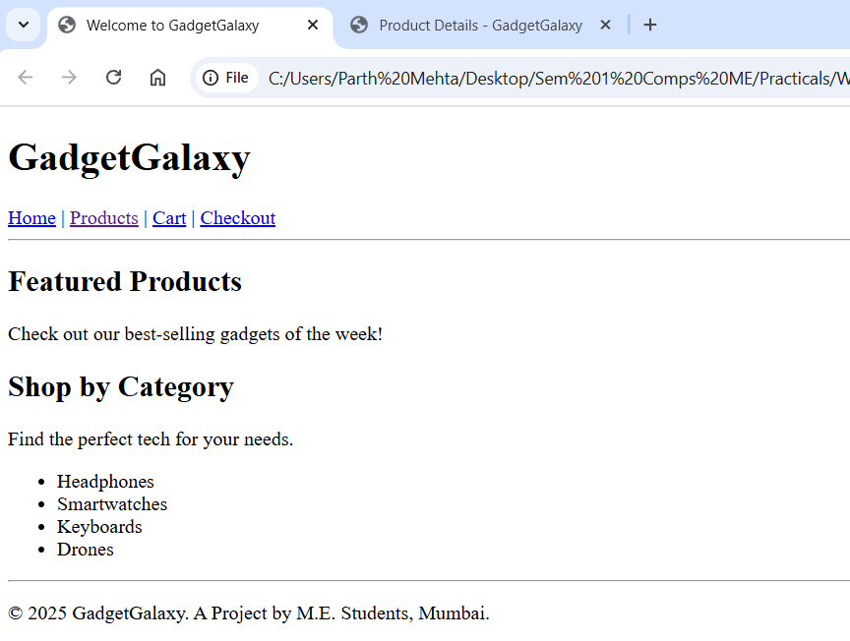
Webpage displaying a various category of products with navigation tabs and product tab clicked.
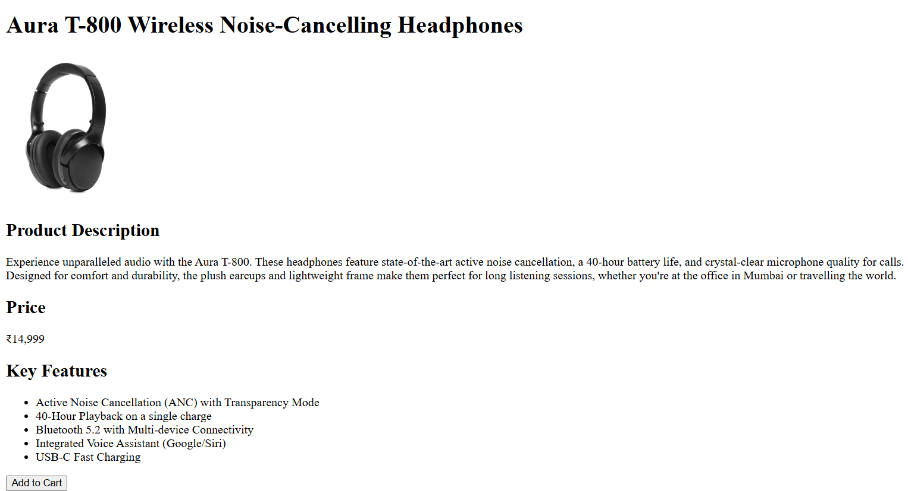
Webpage displaying a product detail with features and pricing.

Learning Outcomes: The student should have the ability to architect a complete webpage layout using HTML5 semantic elements, creating a clear, accessible, and maintainable structure for a complex website.

Course Outcomes: Upon completion of the course students will be able to analyze and apply fundamental client-side web technologies. Also, students will be able to design and develop user interfaces (as this structure is the foundation of UI).

Conclusion:
This experiment successfully demonstrated the power of semantic HTML5 in creating a professional and logical page structure. The “index.html” homepage now serves as a well-defined template for the “GadgetGalaxy” website, providing a solid foundation for the subsequent stages of styling, interactivity, and content integration.

For Faculty Use
Correction Parameters | Formative Assessment [40%] | Timely completion of Practical [40%] | Attendance / Learning Attitude [20%]
Marks Obtained

