Experiment 03: Make a webpage with a table displaying data and use frames to display multiple HTML documents within one window.

Learning Objective: Student should be able to correctly use the table element to structure and display tabular data for a shopping cart page, and to understand and implement the frameset tag to display multiple HTML documents within a single browser window.

Tools: Notepad, Google Chrome

Theory:
This experiment covers two distinct HTML features for structuring content.
1. HTML Tables: The <table> element is designed for one specific purpose: displaying tabular data (data best represented in a grid of rows and columns). In the past, tables were often misused for page layout, but this is now considered a bad practice. Modern layouts are built with CSS (Flexbox, Grid). The key components of a semantic table are:
- <table>: The main container for the entire table.
- <thead>: Groups the header content (column titles).
- <tbody>: Groups the main body content (the data rows).
- <tr>: Defines a table row.
- <th>: Defines a table header cell. It's semantically important and styled as bold by default.
- <td>: Defines a standard table data cell.
2. HTML Frames (<frameset>): Important Note: The <frameset> and <frame> elements are deprecated in HTML5 and should not be used in modern web development. They are included in this experiment for historical and conceptual understanding only.
- Framesets were used to divide a browser window into multiple sections, with each section loading a separate HTML document. This approach is now obsolete due to significant drawbacks:
- Usability Issues: It often "broke" the browser's back button and made bookmarking specific page states impossible.
- SEO Problems: Search engines struggled to index sites built with framesets, as there was no single, cohesive content page.
- Inflexibility: Framesets created rigid, non-responsive layouts.
The modern alternatives are the <iframe> element (for embedding specific, self-contained documents like a Google Map or a YouTube video) and CSS for creating complex page layouts.
Result and Discussion:
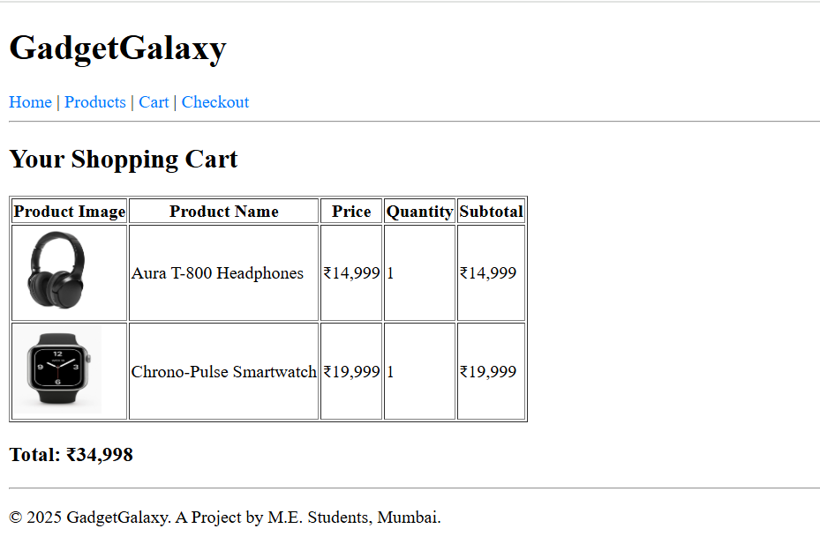
Webpage displaying a total of the added products in the cart.
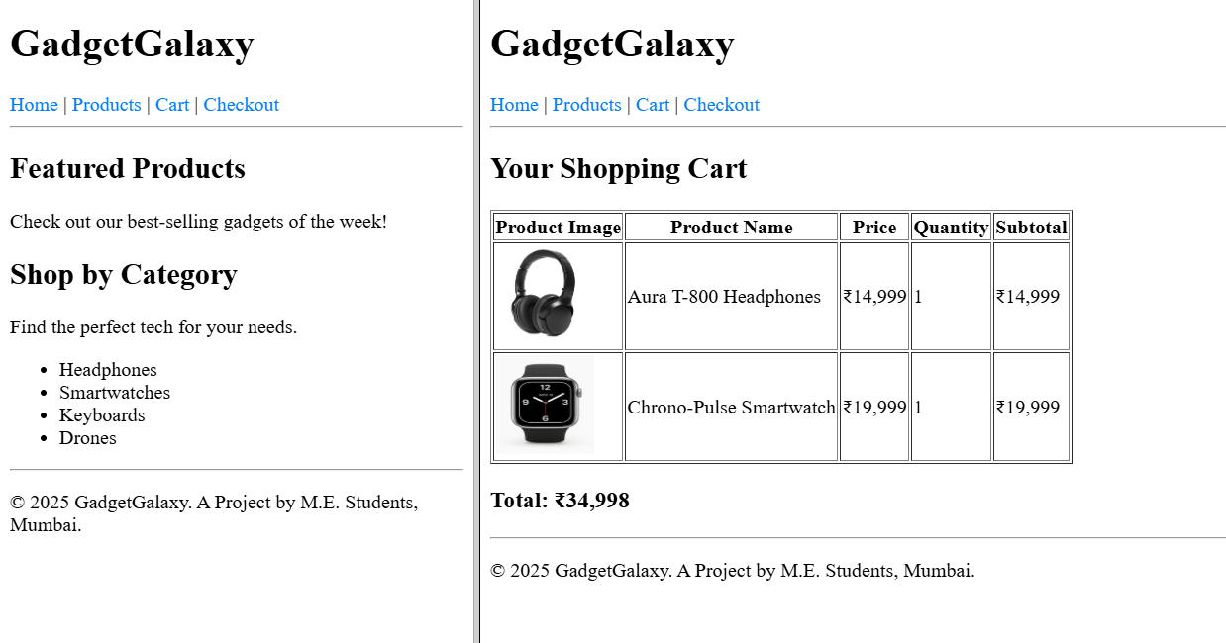
Webpage displaying a two different pages in frames in a single webpage.

Learning Outcomes: The student should have the ability to structure data semantically using HTML tables and understand both the implementation and the significant drawbacks of deprecated HTML framesets.
Course Outcomes: Upon completion of the course students will be able to analyze and apply fundamental client-side web technologies, including both current best practices and legacy concepts.
Conclusion:
This experiment successfully achieved two goals. First, we built a crucial component of our e-commerce site, the cart.html page, demonstrating the correct and modern use of HTML tables for displaying structured data. Second, we explored the deprecated <frameset> element, providing valuable insight into the evolution of web development and a clear understanding of why modern layout techniques are essential.

For Faculty Use
Correction Parameters | Formative Assessment [40%] | Timely completion of Practical [40%] | Attendance / Learning Attitude [20%]
Marks Obtained

