Experiment 04: Create an external CSS file and style your webpage elements (background color, text color, fonts, margins, padding).

Learning Objective: Student should be able to understand the role of CSS in web development by creating an external stylesheet, linking it to the existing HTML files, and applying fundamental CSS properties like background-color, color, font-family, margin, and padding to create a consistent visual theme.

Tools: Notepad, Google Chrome

Theory:
CSS (Cascading Style Sheets) is the language used to control the visual presentation of an HTML document. While HTML defines the structure and content of a page, CSS defines its style and layout. This separation of concerns is a core principle of modern web development.
There are three ways to apply CSS:
- Inline CSS: Using the style attribute directly on an HTML element. (e.g., <p style=“color: blue;”>). Good for quick, single-element styling but bad for maintenance.
- Internal CSS: Placing CSS rules within a <style> tag in the <head> section of an HTML file. Affects only that single page.
- External CSS: Placing all CSS rules in a separate .css file. This file is then linked to multiple HTML pages. This is the best practice because it allows you to change the look of an entire website by editing just one file.
The basic syntax of a CSS rule is: selector { property: value; }
- Selector: Targets the HTML element(s) you want to style (e.g., h1, p, header).
- Property: The visual characteristic you want to change (e.g., font-size, background-color).
- Value: The new setting for that property (e.g., 16px, #333).
The Box Model is a key concept. Every HTML element can be seen as a box with four layers: the content itself, padding (space inside the border), the border, and the margin (space outside the border).

Result and Discussion:
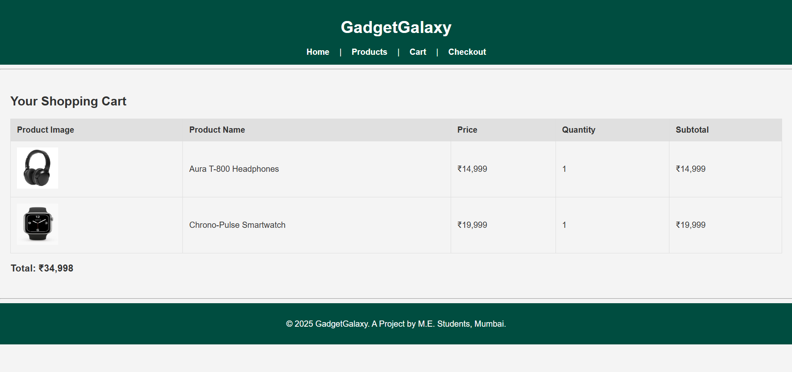
Webpage displaying a total of the added products in the cart with CSS.
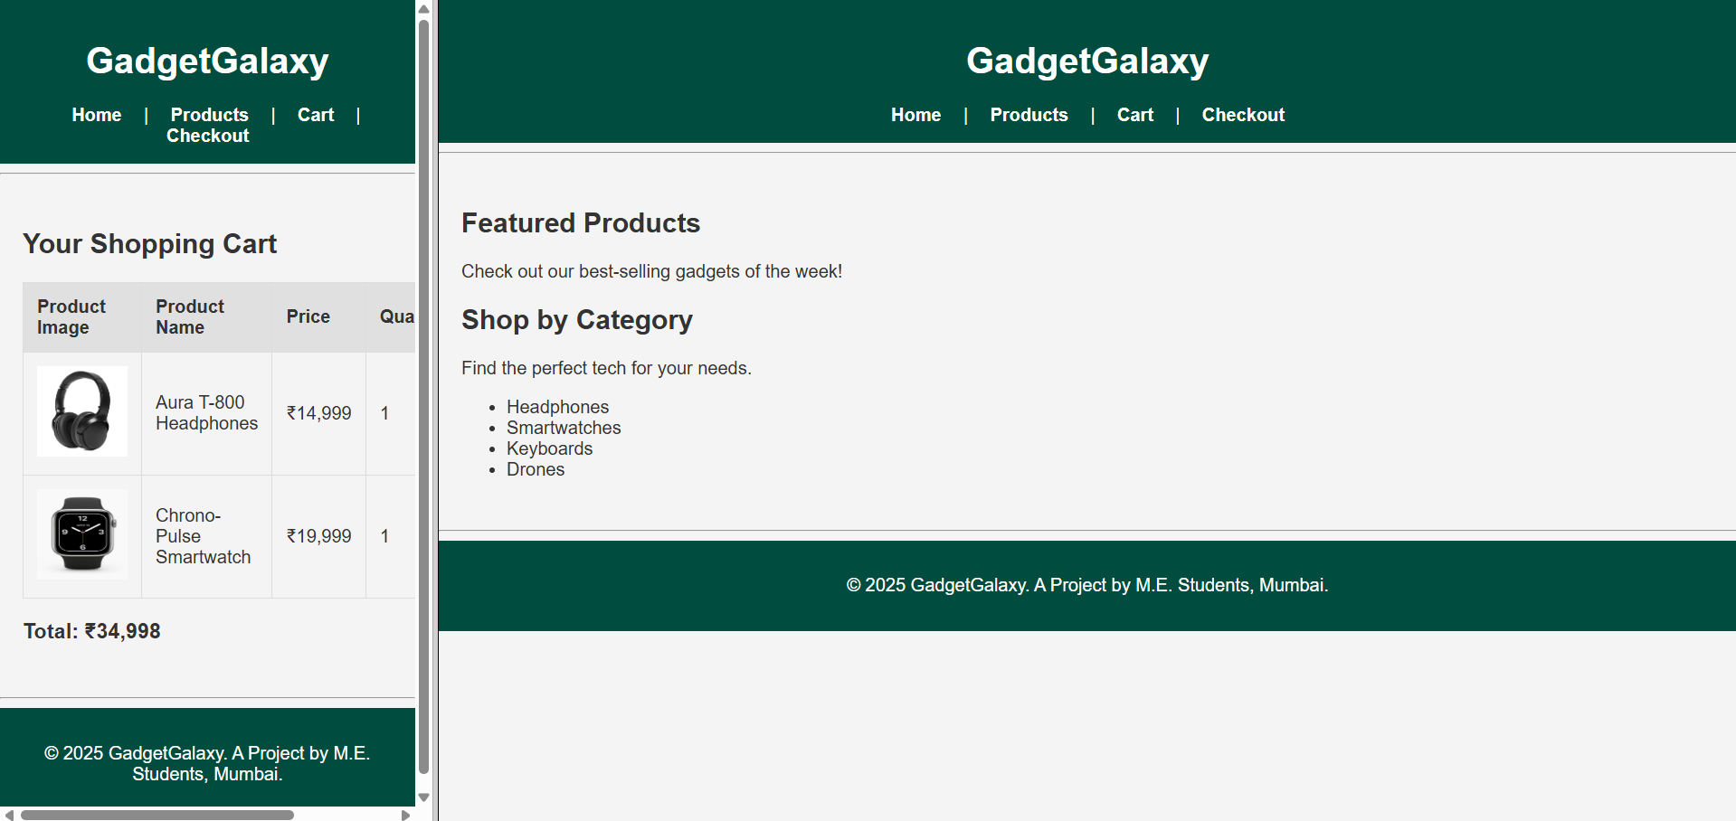
Webpage displaying a two different pages in frames in a single webpage with CSS.

Learning Outcomes: The student should have the ability to create and link an external CSS stylesheet and apply basic CSS properties to control the typography, color, and spacing of webpage elements, thereby separating content structure from its visual presentation.
Course Outcomes: Upon completion of the course students will be able to analyze and apply fundamental client-side web technologies. Also, students will be able to design and develop user interfaces by applying styling rules for a consistent and professional look.
Conclusion:
This experiment successfully demonstrated the fundamental principles of Cascading Style Sheets. By externalizing our styles into a “style.css” file, we have created a maintainable and scalable design foundation for the “GadgetGalaxy” website. The site has been visually transformed from a plain HTML document into the beginnings of a well-designed web application.

For Faculty Use
Correction Parameters | Formative Assessment [40%] | Timely completion of Practical [40%] | Attendance / Learning Attitude [20%]
Marks Obtained

