Experiment 01: Develop a simple webpage using basic HTML tags: headings, paragraphs, line breaks, and lists.

Learning Objective: Student should be able to apply fundamental HTML tags, including headings, paragraphs, images, and lists.

Tools: Notepad, Google Chrome

Theory:
HTML (HyperText Markup Language) is the backbone of the World Wide Web, providing the essential structure for web pages. It uses a system of tags to define elements on a page. When a browser loads an HTML document, it parses these tags to construct a Document Object Model (DOM), which is a tree-like representation of the page's content. This DOM is what other technologies like CSS and JavaScript interact with. For an engineering student, it's crucial to understand that HTML is not just about visual appearance but about semantic meaning. Using the correct tag for the content (e.g., <h1> for the main title, not just for big text) makes the page more accessible, SEO-friendly, and easier to style and script.
- <h1>–<h6>: Hierarchical headings for content organization.
- <p>: A block of paragraph text.
- <img>: An empty tag used to embed images. It requires attributes like src (source URL) and alt (alternative text for accessibility).
- <ul>: An unordered list, typically rendered as bullet points, perfect for listing features or specifications.
- <li>: A list item, which must be a child of a <ul> or <ol> element.

Result and Discussion:
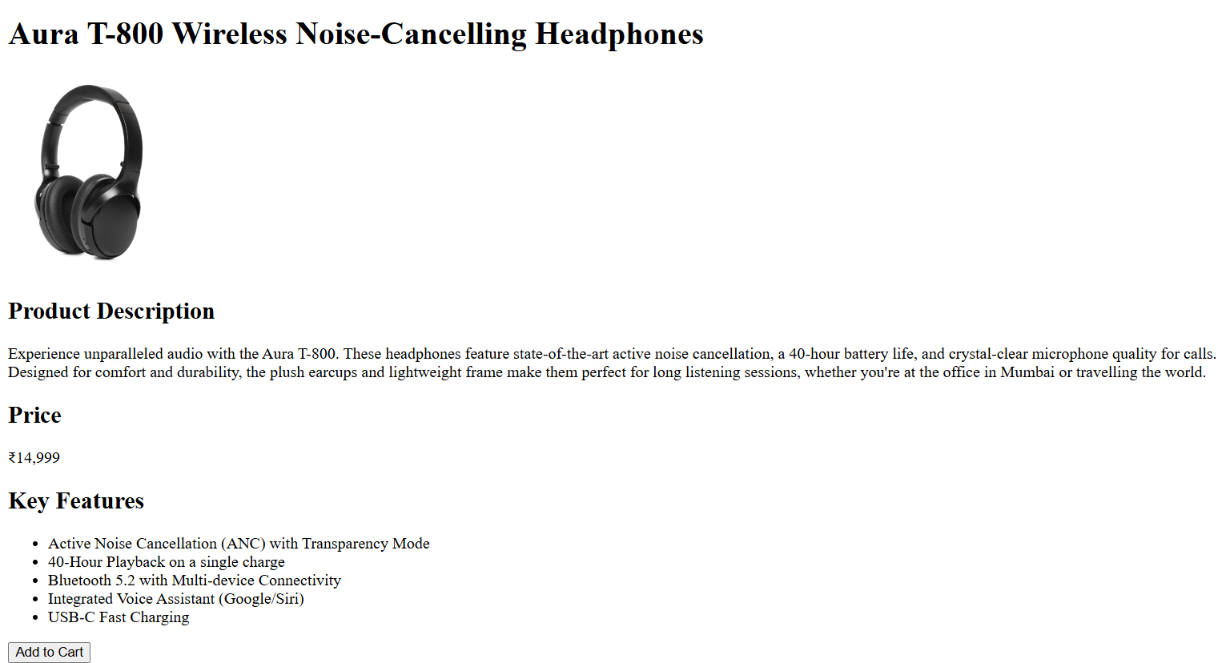
Webpage displaying a product detail with features and pricing.

Learning Outcomes: The student should have the ability to author a well-structured HTML document for a specific purpose (a product page), correctly using tags for headings, paragraphs, images, and lists to represent content semantically.

Course Outcomes: Upon completion of the course students will be able to analyze and apply fundamental client-side web technologies.

Conclusion:
This experiment successfully demonstrated the creation of a foundational HTML document using basic tags. The resulting “product-detail.html” page establishes the semantic structure required for a key component of the “GadgetGalaxy” e-commerce site.

For Faculty Use
Correction Parameters | Formative Assessment [40%] | Timely completion of Practical [40%] | Attendance / Learning Attitude [20%]
Marks Obtained

