Experiment 05: Create a registration or contact form using Bootstrap form components and style it.

Learning Objective: Student should be able to integrate the Bootstrap front-end framework into a project and utilize its pre-built form components and grid system to rapidly create a professional, responsive checkout form.

Tools: Notepad, Google Chrome

Theory:
Bootstrap is a powerful, free, and open-source front-end framework for developing responsive, mobile-first websites. As M.E. students, think of it as a comprehensive library or toolkit for UI development. Instead of writing all the CSS from scratch for common components like buttons, navigation bars, or forms, Bootstrap provides pre-styled, ready-to-use classes.
Key advantages of using Bootstrap:
- Speed: Drastically reduces development time.
- Responsiveness: Its built-in grid system allows you to create layouts that automatically adapt to different screen sizes (desktops, tablets, phones).
- Consistency: Ensures a consistent design language across your entire website.
- Cross-browser Compatibility: Components are tested to work on all modern browsers.
To use Bootstrap, you simply add its CSS and JavaScript files to your HTML, typically via a CDN. A CDN hosts the files on high-speed servers around the world, ensuring fast delivery to your users.
Core Bootstrap Form Classes:
- .form-control: Apply this to <input>, <select>, and <textarea> elements to give them a full-width, styled appearance.
- .form-label: Styles the <label> for proper spacing and font weight.
- mb-3 (Margin Bottom 3): A spacing utility class used on a container <div> to create vertical space between form fields.
- .btn & .btn-primary: Base button style and a modifier class for a primary action button (typically blue).
- .row & .col-md-6: Part of the grid system, used to place form elements side-by-side on medium-sized screens and larger.
Result and Discussion:
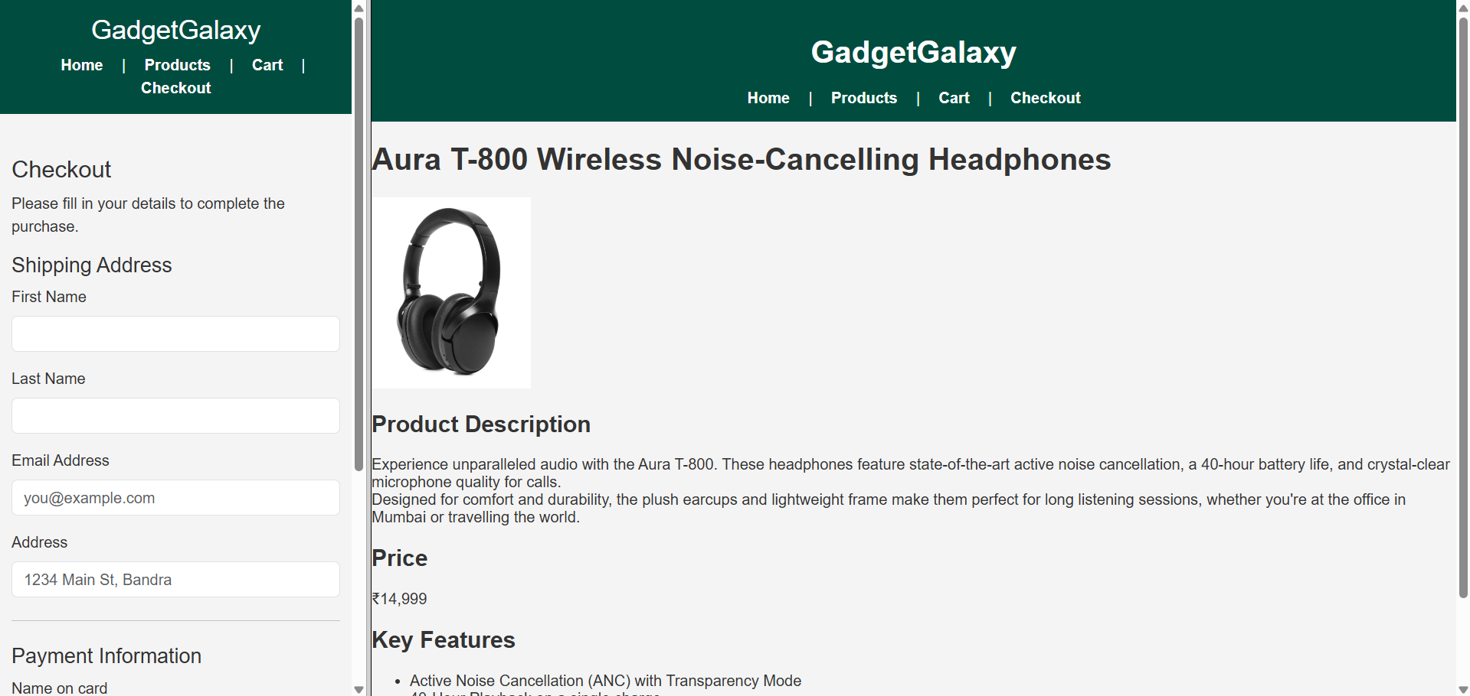
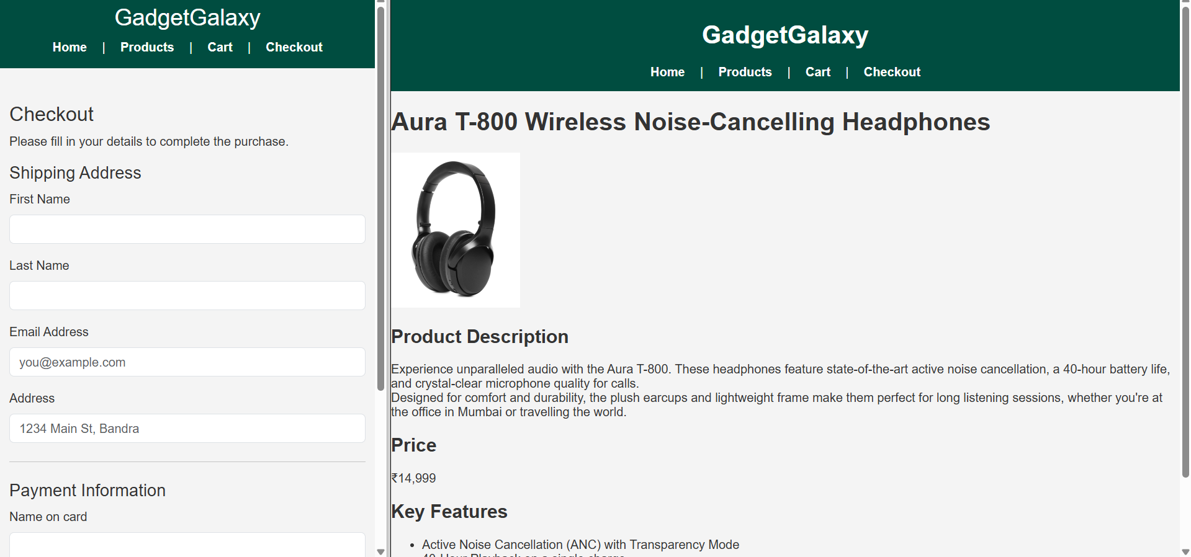
Webpage displaying a two different pages in frames in a single webpage with responsiveness.

Learning Outcomes: The student should have the ability to integrate a third-party CSS framework like Bootstrap into a web project and use its utility classes to rapidly construct a styled and responsive user interface component, such as a complex form.

Course Outcomes: Upon completion of the course students will be able to design and develop modern, responsive user interfaces by leveraging industry-standard frameworks. Also, students will be able to apply client-side technologies to build interactive web components (as this form is a prerequisite for client-side validation).
Conclusion:
This experiment successfully demonstrates the power and efficiency of using a front-end framework like Bootstrap. We have built a complex, responsive checkout form for “GadgetGalaxy” with minimal effort, allowing us to focus on functionality rather than basic styling. This component is now a fully-styled and professional foundation, ready for the addition of client-side validation in the next stage.

For Faculty Use
Correction Parameters | Formative Assessment [40%] | Timely completion of Practical [40%] | Attendance / Learning Attitude [20%]
Marks Obtained

