Experiment 06: Validate a form (e.g., email, password) using JavaScript to ensure proper input before submission.

Learning Objective: Student should be able to implement client-side form validation using JavaScript to ensure that user input meets predefined criteria (e.g., fields are not empty, email format is correct) before the form is submitted.

Tools: Notepad, Google Chrome

Theory:
Client-side validation is the process of checking user input in the web browser before it is sent to the server. This is a fundamental aspect of creating a good user experience and building efficient applications.
Why is it important?
- Immediate Feedback: It provides an instant response to the user if they make a mistake, without the delay of a server round-trip.
- Reduced Server Load: It prevents malformed data from ever reaching the server, saving processing power and bandwidth. This is a critical concept in system design.
- Improved User Experience: It guides the user to fill out the form correctly, reducing frustration.
Core JavaScript Concepts for Form Validation:
- DOM Selection: Accessing HTML elements using methods like document.getElementById().
- Event Handling: Listening for user actions. For forms, the most important event is submit. We use addEventListener() to attach a function that runs when the event occurs.
- event.preventDefault(): A crucial method that stops the browser's default action for an event. For a form's submit event, this prevents the page from reloading, allowing our script to take control.
- Input Values: Retrieving the text entered by a user with the .value property of an input element. The .trim() method is often used to remove any leading or trailing whitespace.
- Conditional Logic: Using if...else statements to check the input values against our validation rules.

Result and Discussion:
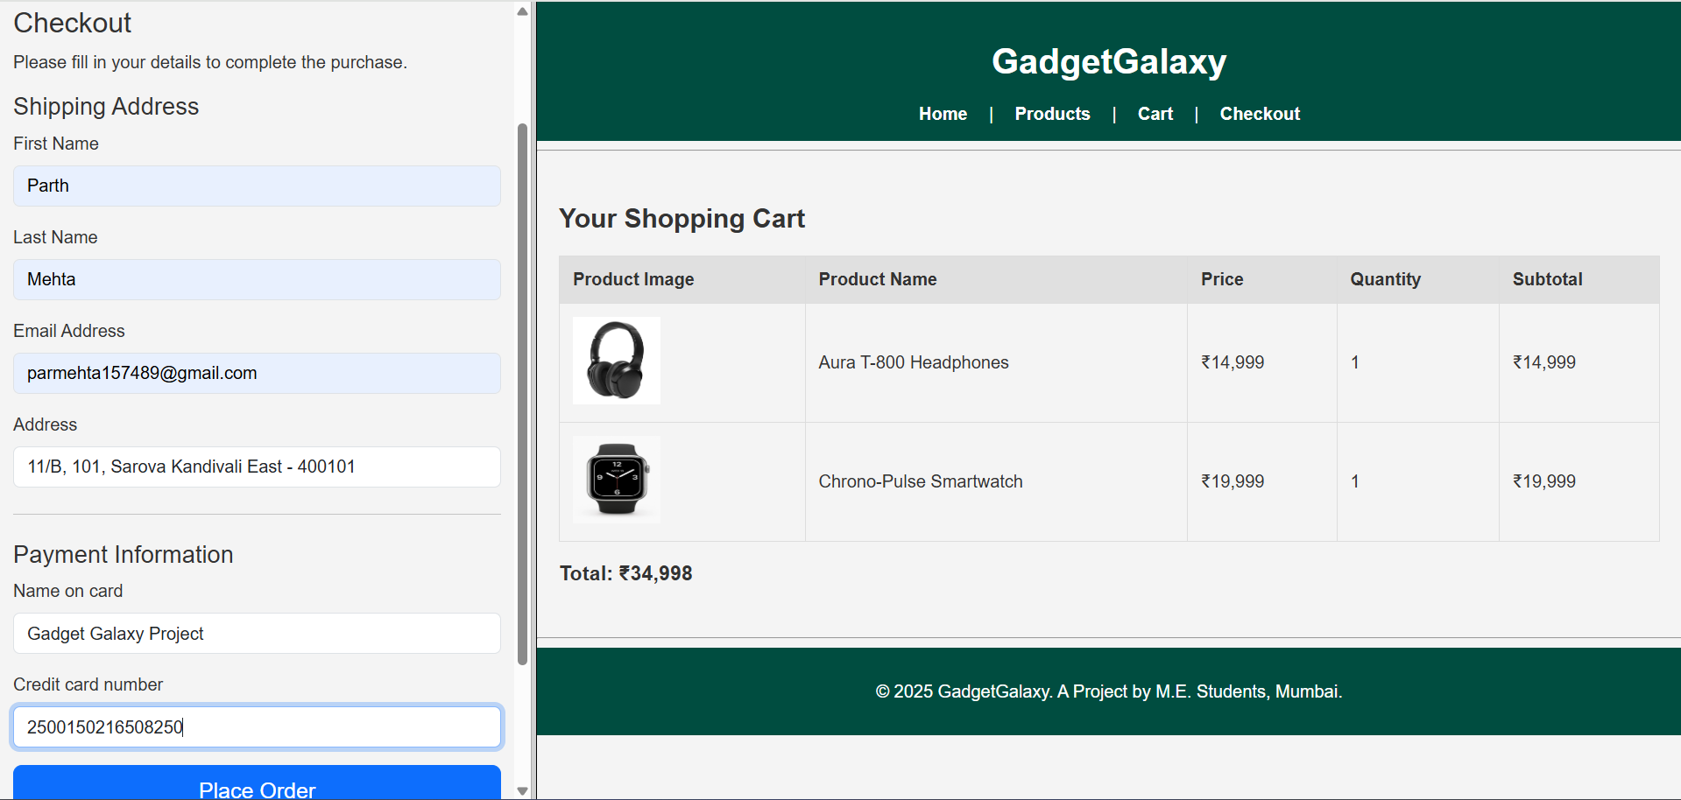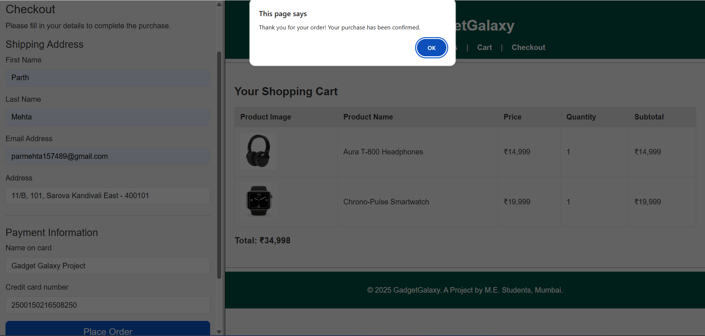Webpage displaying a two different pages in frames in a single webpage with a popup confirming purchase of the order.

Learning Outcomes: The student should have the ability to write JavaScript code to select DOM elements, handle user events like form submission, and implement conditional logic to perform client-side validation, preventing invalid data from being submitted.

Course Outcomes: Upon completion of the course students will be able to apply client-side scripting technologies to create interactive and responsive web applications. Also, students will be able to analyze and implement client-side validation techniques to enhance user experience and data integrity.
Conclusion:
This experiment successfully added a crucial layer of interactivity and intelligence to our web application. By implementing client-side validation, the “GadgetGalaxy” checkout form is now more user-friendly, robust, and efficient. This marks a significant step from creating static pages to building dynamic web applications.

For Faculty Use
Correction Parameters | Formative Assessment [40%] | Timely completion of Practical [40%] | Attendance / Learning Attitude [20%]
Marks Obtained

