Experiment 08: Build a responsive webpage layout using Bootstrap’s grid system that adapts to different screen sizes.

Learning Objective: Student should be able to understand and implement Bootstrap's powerful 12-column grid system (.container, .row, .col-*) to build a “product listing page” that automatically adapts its layout to different screen sizes, from large desktops to mobile phones.

Tools: Notepad, Google Chrome

Theory:
Responsive Web Design (RWD) is the practice of building web pages that look good on all devices (desktops, tablets, and phones). Bootstrap's core feature for achieving this is its grid system.
How the Grid Works:
- 12 Columns: The grid is a 12-column system. You can think of any row on your page as being invisibly divided into 12 equal-width units.
- .container: This is the outermost wrapper. It centers your content and provides horizontal padding.
- .row: This is a horizontal container for your columns. All columns must be immediate children of a .row.
- .col-* Classes: These are the most important part. You use them to define how many of the 12 columns an element should occupy at a specific screen size.
  - col- (for extra small screens, < 576px, the default)
  - col-sm- (for small screens, ≥ 576px)
  - col-md- (for medium screens, ≥ 768px)
  - col-lg- (for large screens, ≥ 992px)
Example: A class col-lg-3 means “this element should take up 3 of the 12 columns on large screens and up.” This would allow you to fit four such elements in one row (3 * 4 = 12).
“Mobile-First” Approach: Bootstrap is “mobile-first,” meaning the styles for the smallest screens (e.g., stacked, full-width columns) are the default. You then add classes for larger screens (e.g., col-md-6) to override this behavior at specific breakpoints.

Result and Discussion:
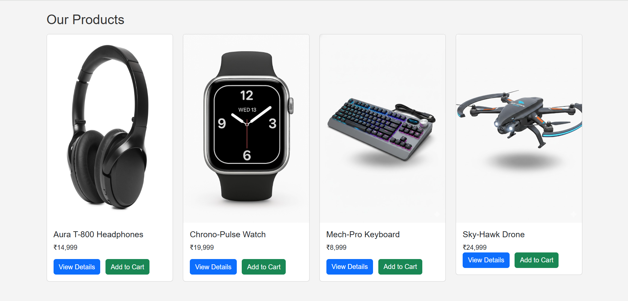
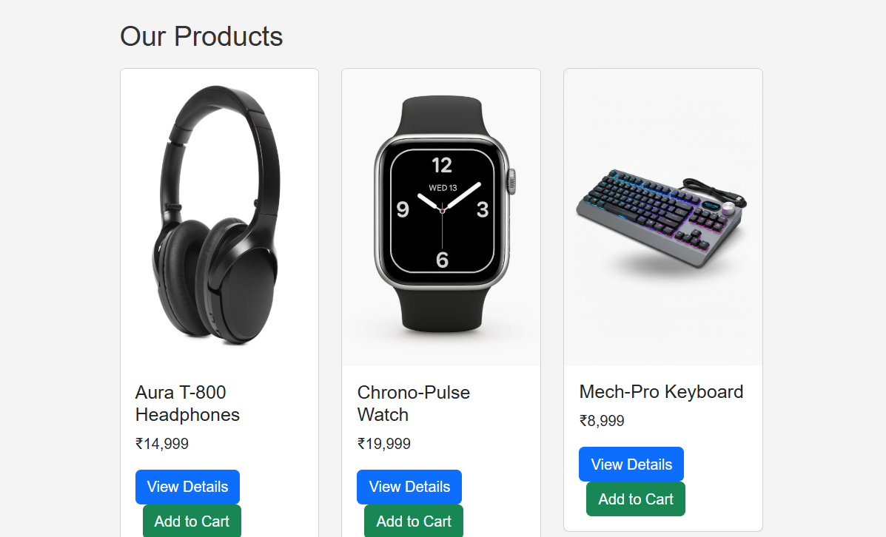
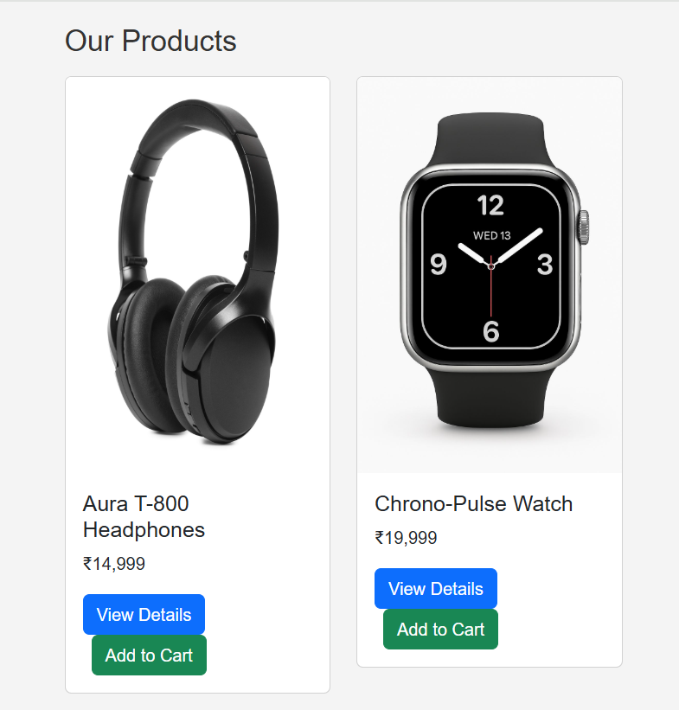
Webpage displaying product details, when reduced size number of display products changes.

Learning Outcomes: The student should have the ability to strategically combine Bootstrap’s grid classes to create a fluid, responsive layout that adapts its structure at different breakpoints, ensuring a good user experience on any device.

Course Outcomes: Upon completion of the course students will be able to design and develop modern, responsive user interfaces that adapt to various screen sizes. Also, students will be able to apply client-side technologies and frameworks to build functional and aesthetically pleasing web applications.
Conclusion:
This experiment successfully demonstrates the core principle of responsive web design. By leveraging Bootstrap’s mobile-first grid system, we have built a product catalog page that is flexible and accessible on all devices. This skill is non-negotiable in modern web development and forms the structural backbone of the entire “GadgetGalaxy” project.

For Faculty Use
Correction Parameters | Formative Assessment [40%] | Timely completion of Practical [40%] | Attendance / Learning Attitude [20%]
Marks Obtained

