Experiment 10: Design and Develop a multi-page, responsive portfolio website / blog showcasing their skills, projects, and contact information.

Learning Objective: Student should be able to synthesize and apply all concepts from the previous nine experiments—including semantic HTML, external CSS, Bootstrap forms and grid, JavaScript validation, and jQuery manipulation—to design, develop, and deploy a complete, multi-page responsive portfolio and blog website for my group.

Tools: Notepad, Google Chrome, Git, GitHub, Command Prompt

Theory:
This capstone experiment represents the integration and deployment phase of a complete web development project. It moves beyond individual skills and focuses on system design, requiring you to act as a full-stack developer (on the client-side).
You will be combining all the separate modules into a single, cohesive application. Key engineering considerations include:
- Modularity: Reusing components, such as a consistent <header> and <footer> across all pages.
- User Journey: Planning the logical flow for a visitor (e.g., a recruiter). A typical journey: Homepage → Projects Page → Contact Page.
- Data Management (Static): The “blog” will be static, meaning each post is its own HTML content, not pulled from a database. Interactivity will be simulated with jQuery.
- Full Lifecycle: This experiment covers the entire development lifecycle:
  - Design: Planning the pages and layout.
  - Development: Writing the code.
  - Testing: Validating forms, checking for broken links, and testing responsiveness.
  - Deployment: Publishing the final site to a live URL.

Result and Discussion:
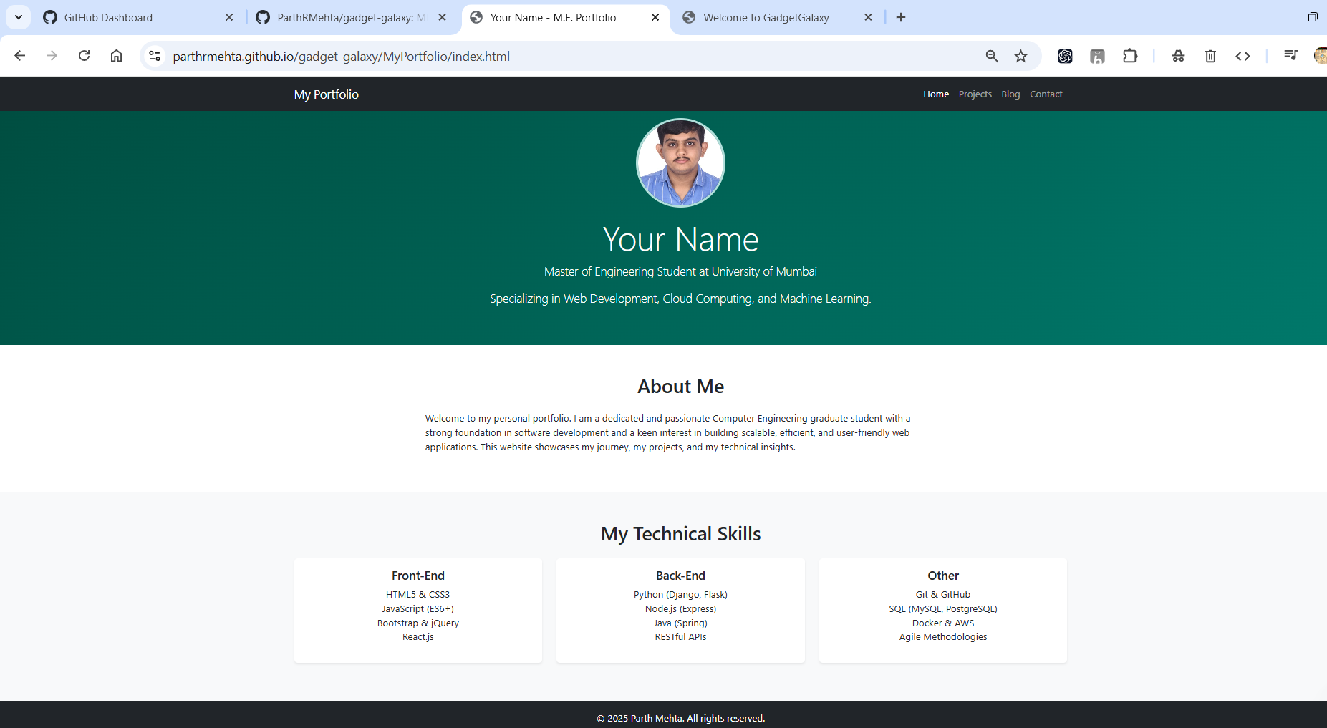
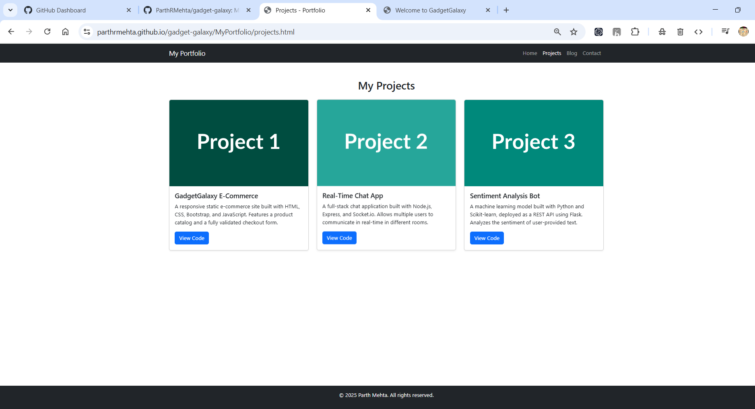
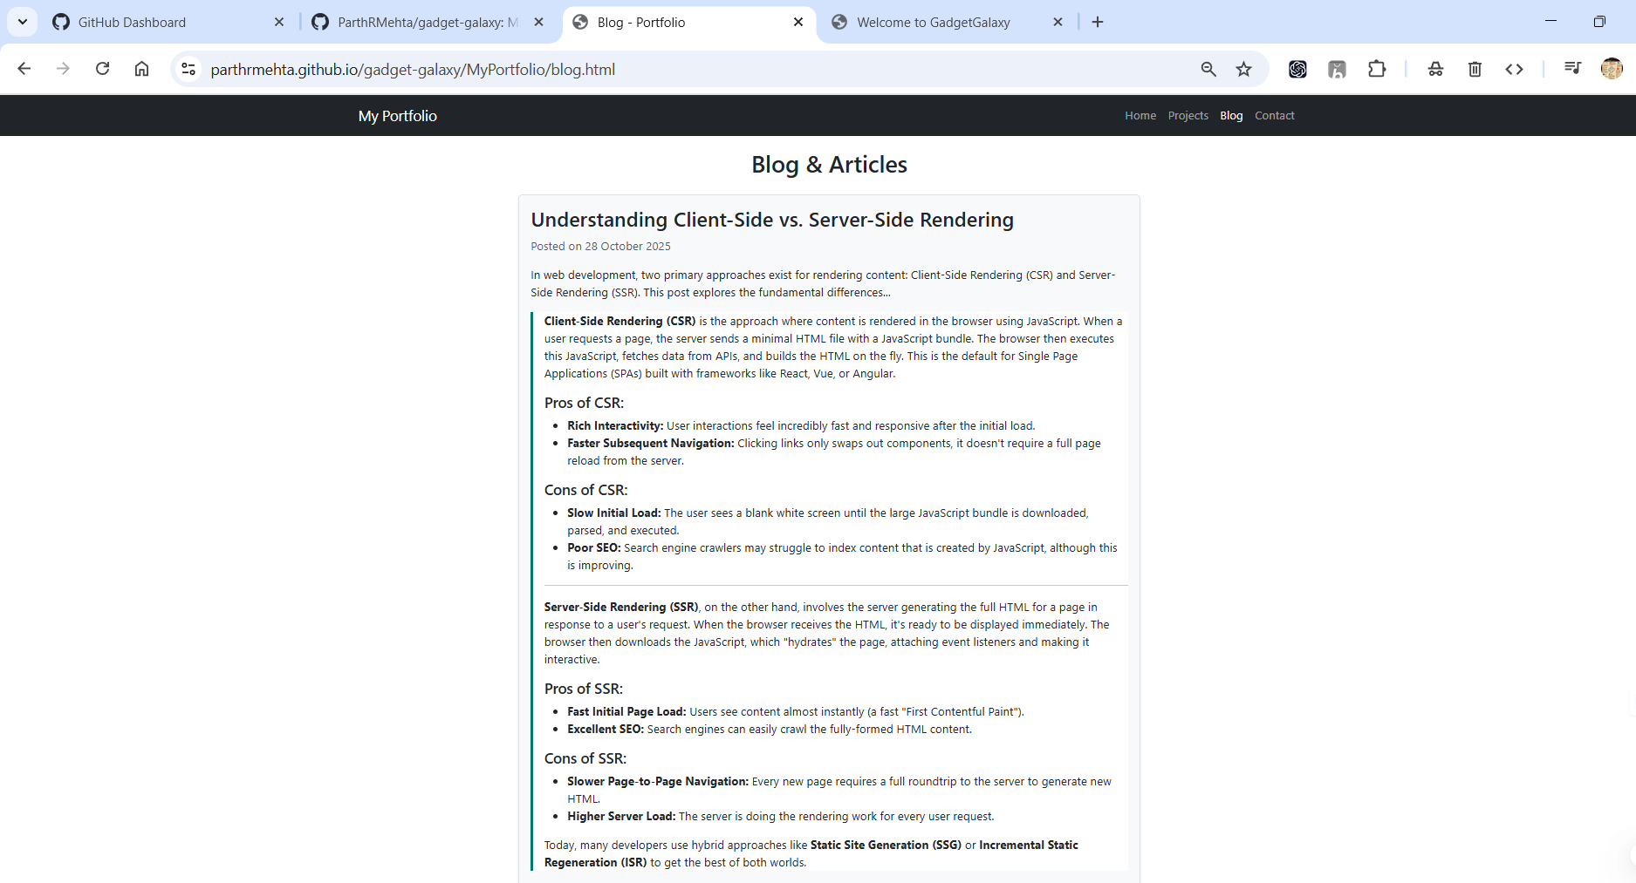
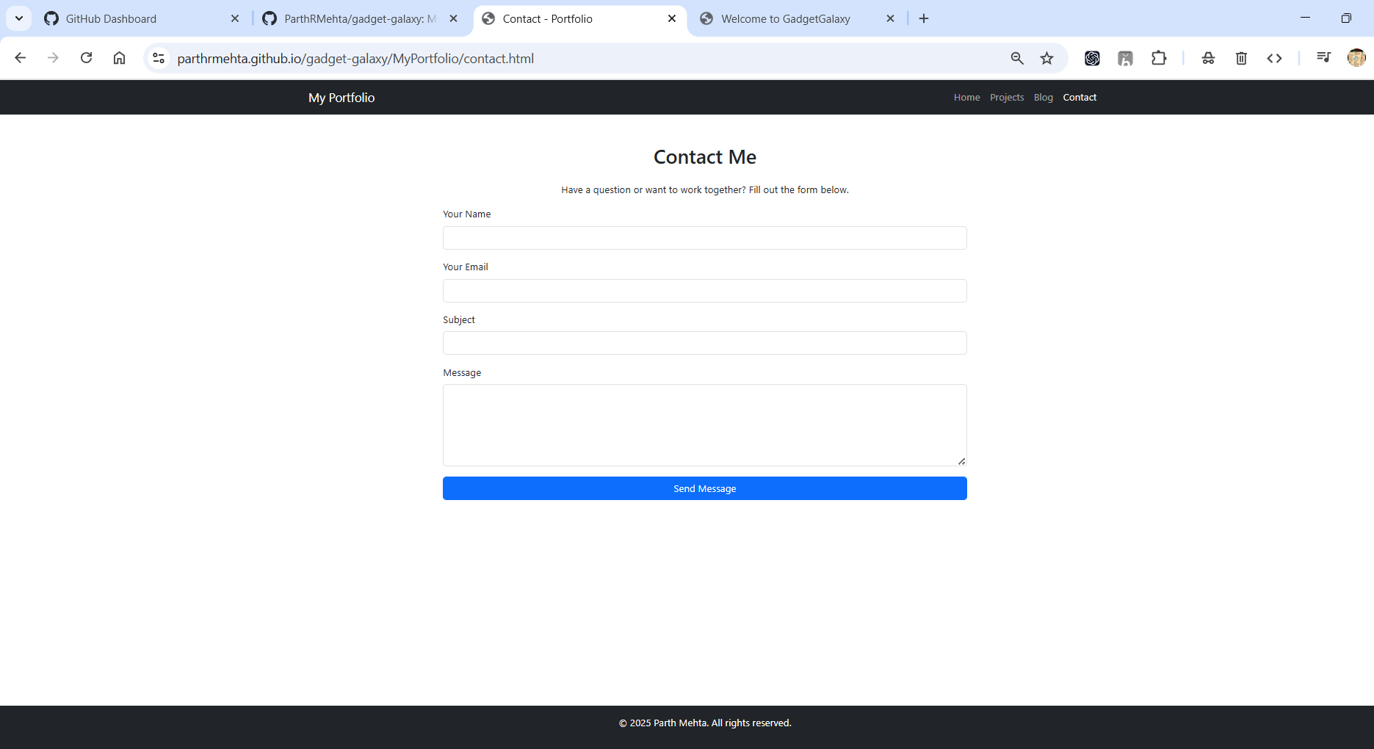
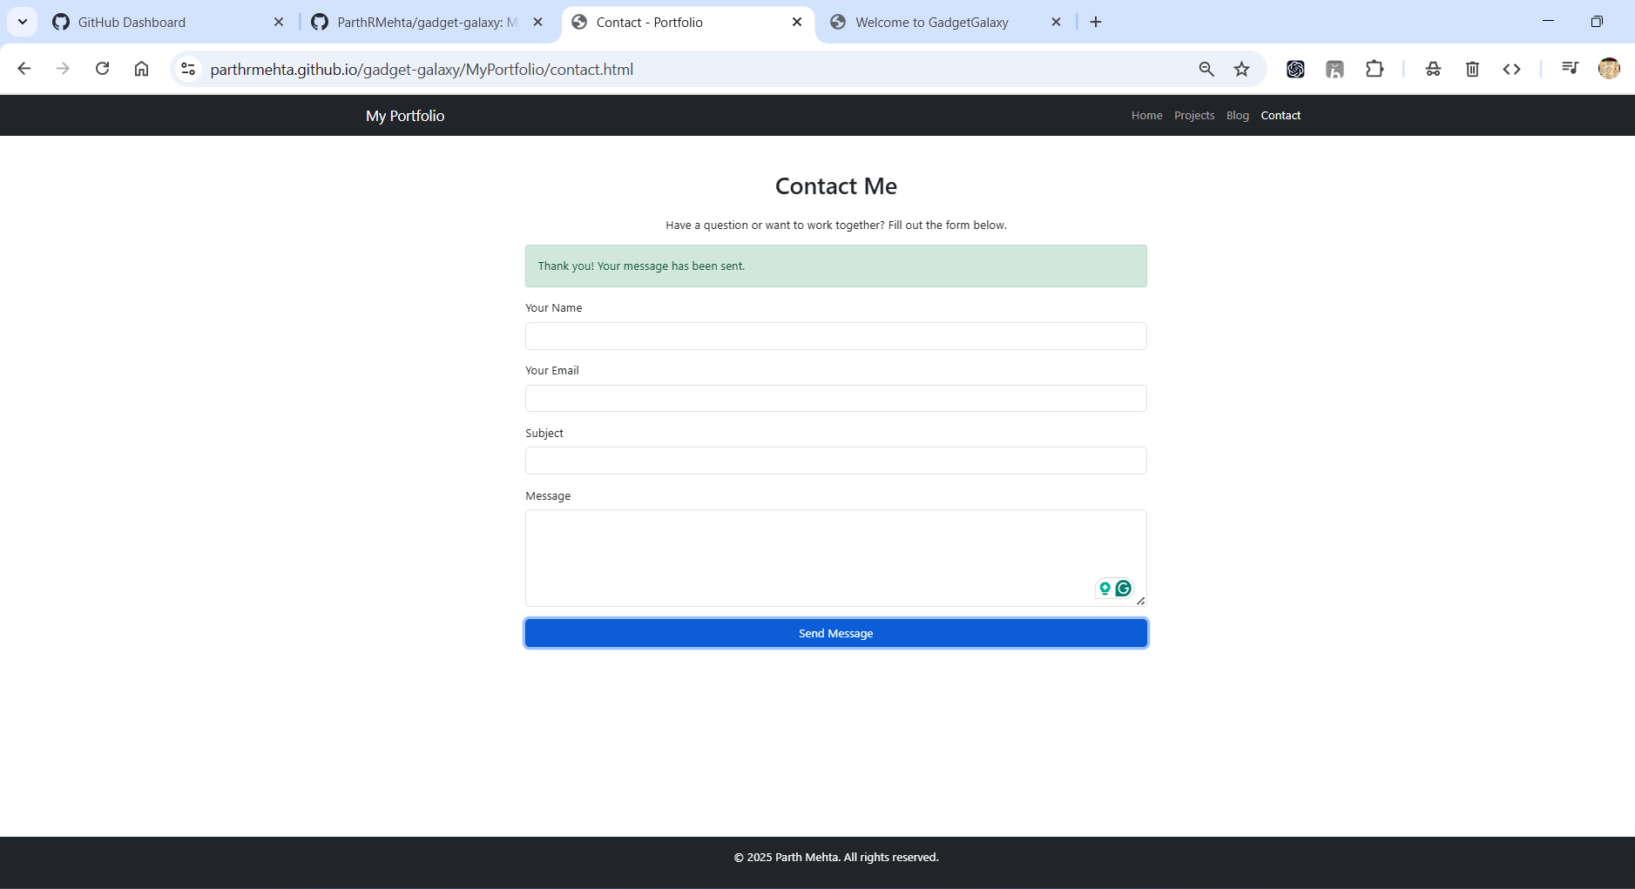
GitHub page displaying MyPortfolio pages.

Learning Outcomes: The student should have the ability to plan, integrate, test, and deploy a complete, multi-page web application, managing the interplay between structure (HTML), style (CSS/Bootstrap), and interactivity (JS/jQuery) in a collaborative group setting.
Course Outcomes: Upon completion of the course students will have successfully synthesized all course concepts to produce a professional, portfolio-worthy, multi-page responsive website, fulfilling the core objective of the course.
Conclusion:
This capstone experiment successfully integrates all the skills from the course into a single, practical, and high-value project. The result is not just a series of exercises but a tangible, live website that can be used professionally to showcase the group’s technical abilities. This demonstrates a complete understanding of the front-end development workflow.

For Faculty Use
Correction Parameters | Formative Assessment [40%] | Timely completion of Practical [40%] | Attendance / Learning Attitude [20%]
Marks Obtained

