Experiment 09: Create a website folder structure, save the project, and publish it using a free hosting service.

Learning Objective: Student should be able to organize the complete “GadgetGalaxy” project into a logical and maintainable folder structure, use Git for version control, and deploy the entire static website to a public URL using GitHub Pages.

Tools: Notepad, Google Chrome, Git, GitHub, Command Prompt

Theory:
This experiment covers the final two stages of any professional development project: organization and deployment.
1. Project Folder Structure: As a project grows from one file to many, a clean folder structure becomes essential. As M.E. students, you can compare this to modular design in software engineering. We separate files based on their type and function. This practice, known as separation of concerns, makes the project:
- Maintainable: You know exactly where to find a file (e.g., all styles are in the CSS folder).
- Scalable: It’s easy to add new pages, scripts, or styles without creating a mess.
- Collaborative: Team members can work on different parts (e.g., one on JS, one on CSS) without conflict.
2. Version Control (Git) & Hosting (GitHub):
- Git is a version control system. It's like a “save” button on steroids. It tracks every change you make to your code, allowing you to revert to previous versions, compare changes, and collaborate with your group without overwriting each other’s work.
- GitHub is a web-based platform that hosts your Git repositories (project folders). It acts as a central cloud backup for your code and provides collaboration tools.
- GitHub Pages is a free service from GitHub that takes the HTML, CSS, and JavaScript files from your repository and hosts them as a live, publicly accessible website. This is perfect for static sites like our “GadgetGalaxy” project.

Result and Discussion:
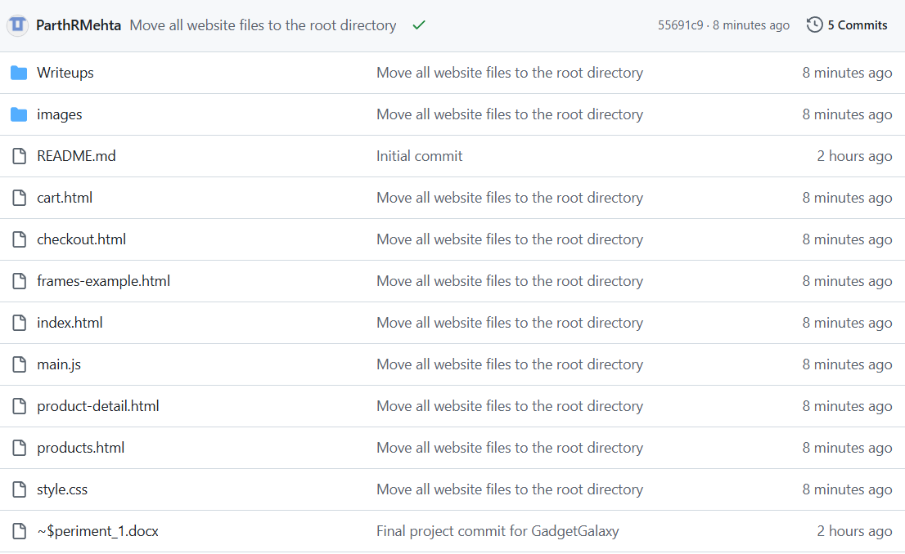
GitHub page displaying files organization structure and live page displaying index.html page.

Learning Outcomes: The student should have the ability to write JavaScript code to select DOM elements, handle user events like form submission, and implement conditional logic to perform client-side validation, preventing invalid data from being submitted.

Course Outcomes: Upon completion of the course students will be able to apply client-side scripting technologies to create interactive and responsive web applications. Also, students will be able to analyze and implement client-side validation techniques to enhance user experience and data integrity.
Conclusion:
This experiment successfully added a crucial layer of interactivity and intelligence to our web application. By implementing client-side validation, the “GadgetGalaxy” checkout form is now more user-friendly, robust, and efficient. This marks a significant step from creating static pages to building dynamic web applications.

For Faculty Use
Correction Parameters | Formative Assessment [40%] | Timely completion of Practical [40%] | Attendance / Learning Attitude [20%]
Marks Obtained

