# Created a Career Guidance Website using HTML,CSS,JS in frontend and Django in backend. 10-6-2021

1. **By the register page, we will add the data in postgresql.**

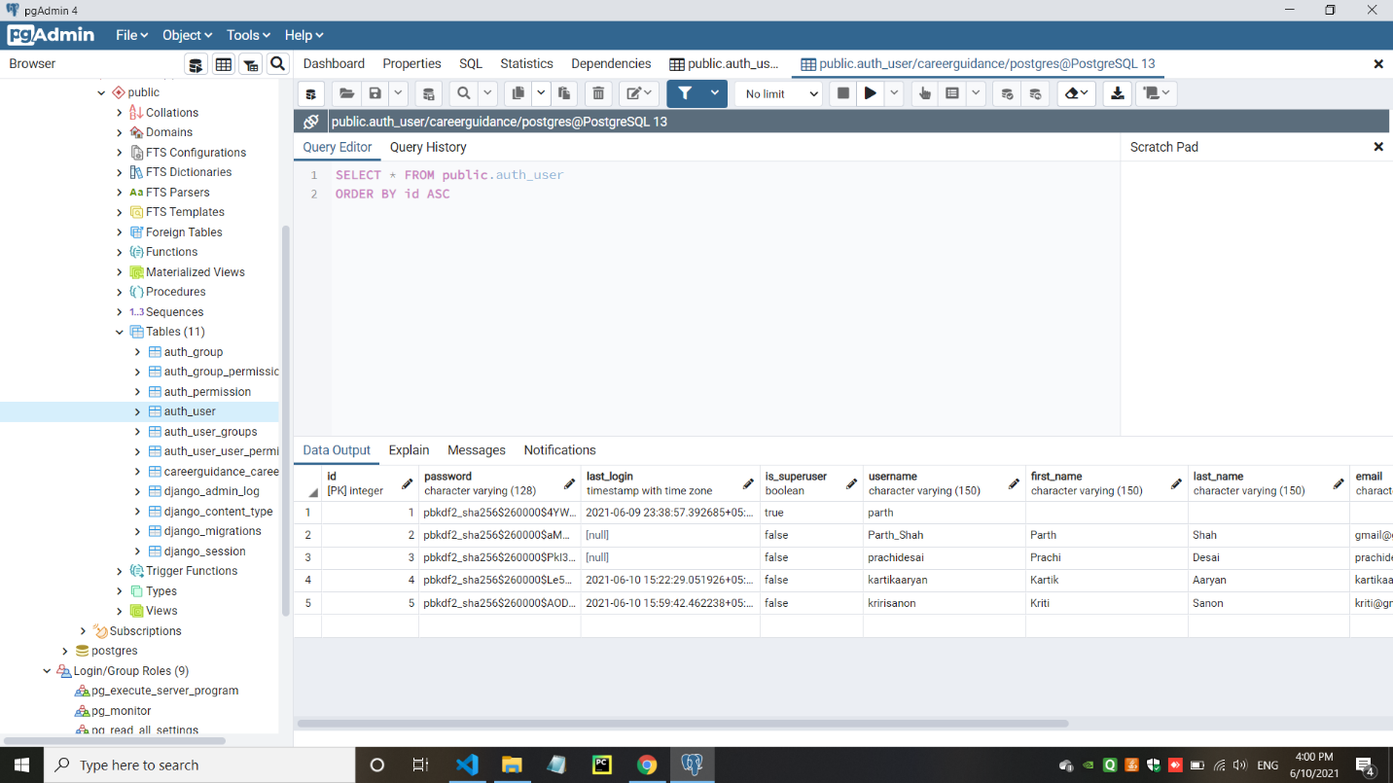

1. **Register page store the data in postgresql as well as in Django admin panel**

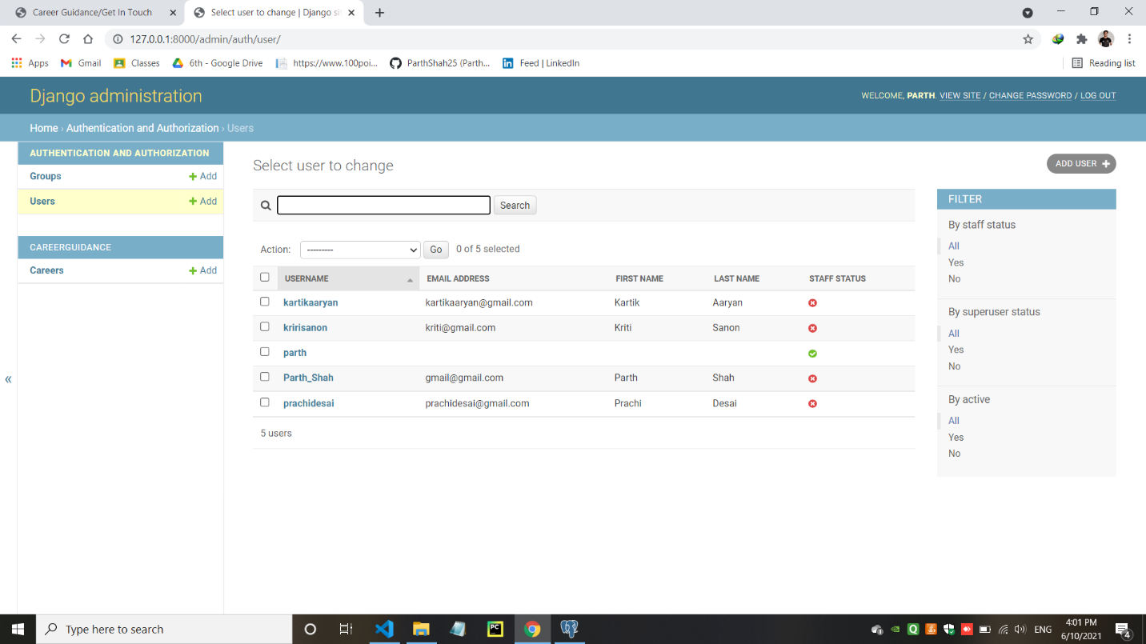

1. **how to add data by the use of CRUD operation in Django admin panel**

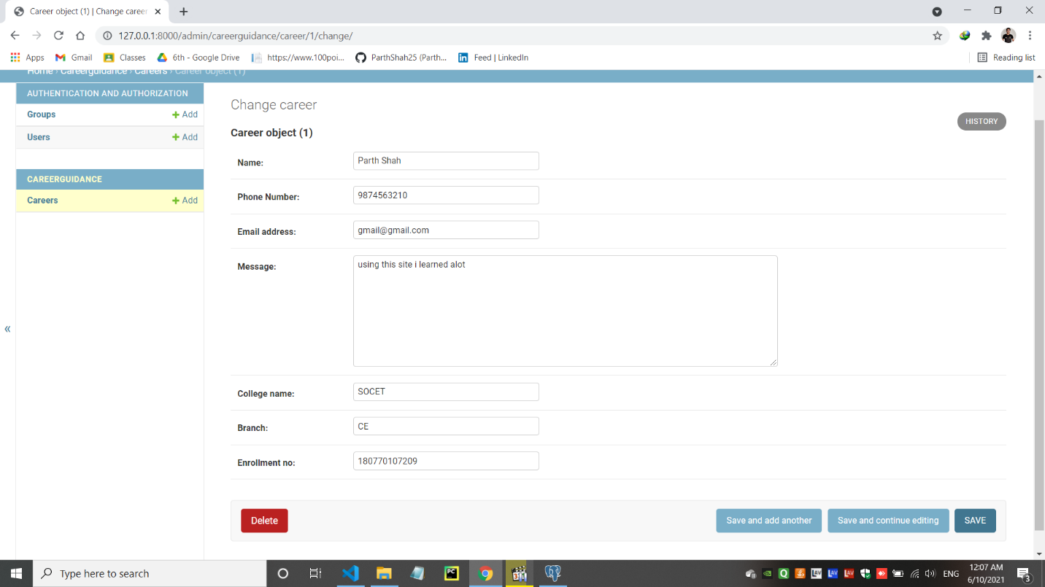

1. **the data that will be add in admin panel**

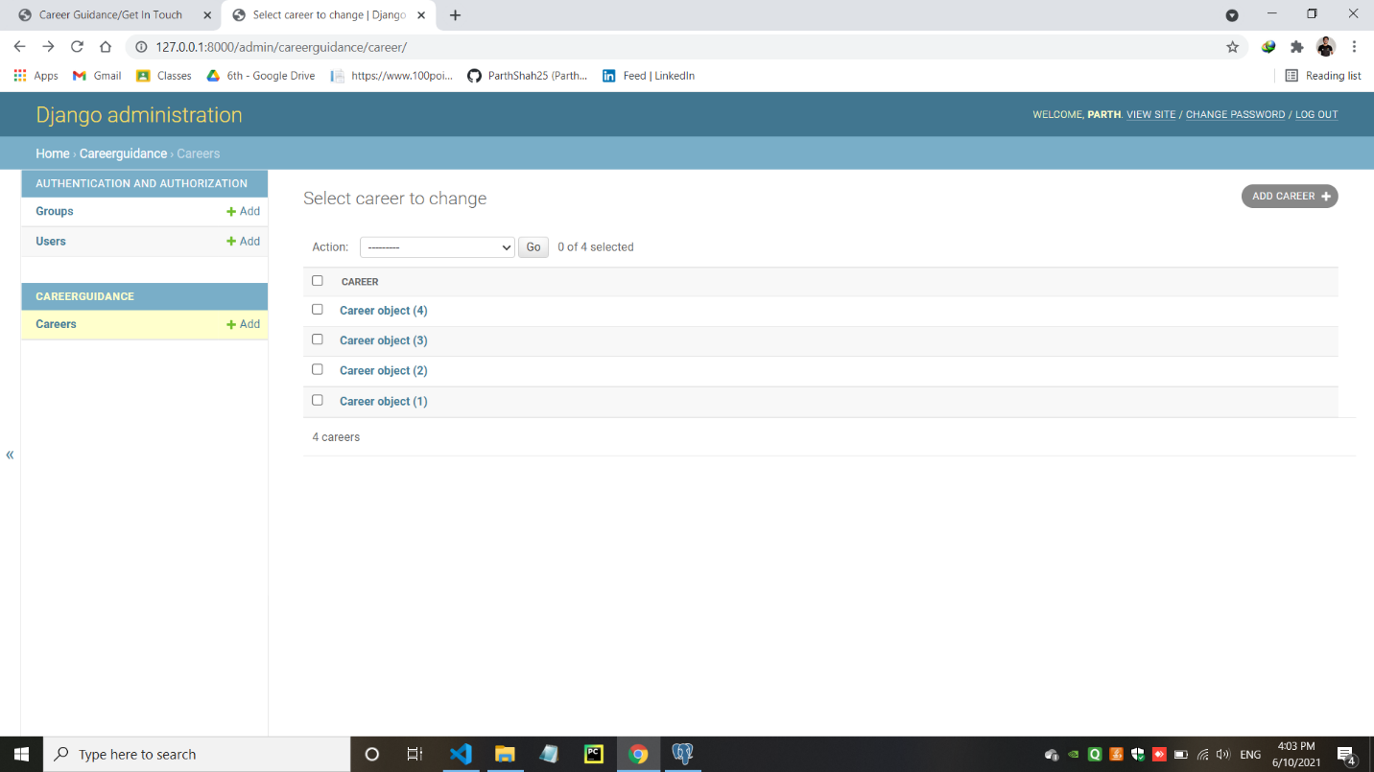

1. **the data that will be add In postgresql by the use of CRUD operation in Django admin panel**

