why not ANN

lets say we are dealing with a image dataset and we are working on RGB colors having size of 1024 x 1024 this means it will have 3 million input features. lets say first hidden layer has 100 input feature this means total no.. of weight parameters will be 3 billion.

Our CPU might not be able to handle them properly or even if they did time taken to train model will be too high, more no. of parameters means overfitting also

CNN – main idea to use filters. Filters are sliding window responsible to detect its features

If the image is grayscale or black and white then the data will range from 0 to 255, where 0 is black

Convultional operation

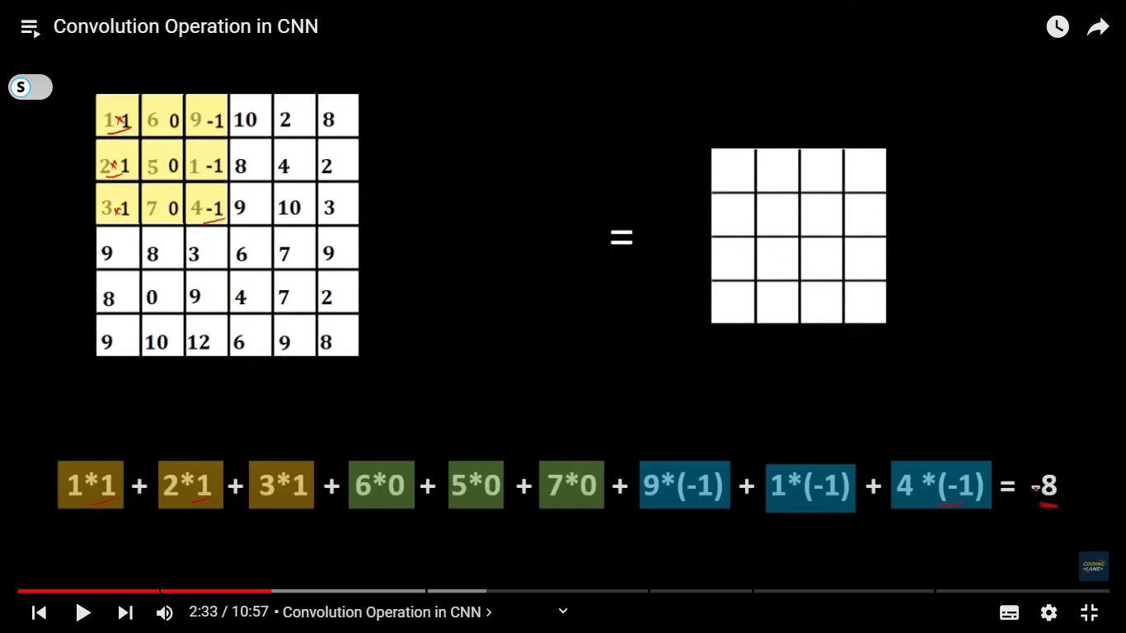

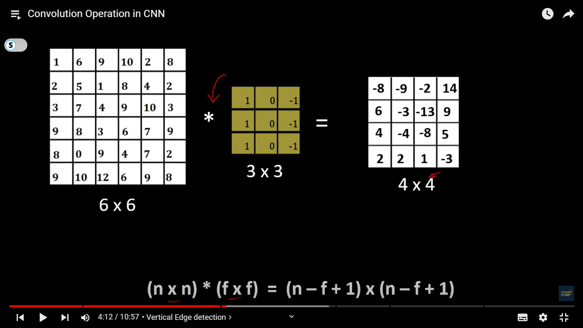

convolution operation is responsible for identifying the edges and the features from the images

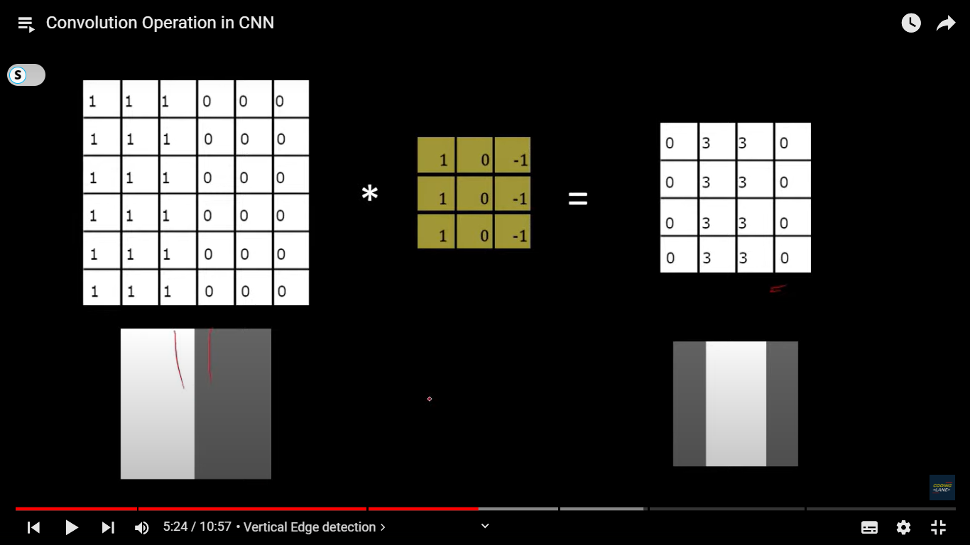



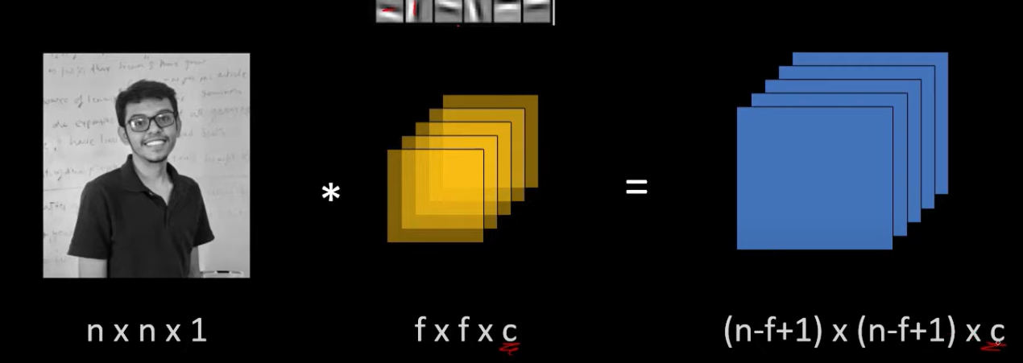



Same

Here it is 1 as its gray scale or else it is 3 – RGB

Padding

when we convolve a 6x6 image with a 3x3 filter we get the output as 4x4 so the size of the final image get reduced by some amount and if we are using many many such layers in a convolutional neural network then it is possible that the final size of the image get reduced so much that we might lose the valuable info  
uneven exposure of pixels.  Ther are some with more exposure to filter while some don’t

we just add layers of zeros so both our problem get solved

There are 2 types of convolution

1. Valid convolutional – no padding
2. Same conovolution – nxn is our image and fxf is feature

Our new input image is

N’ = n + 2p where p Is padding

P = (f-1)/2 f is usually odd if f is even then we need to understand uneven padding



Stride - by how many pixel we move our sliding filter window

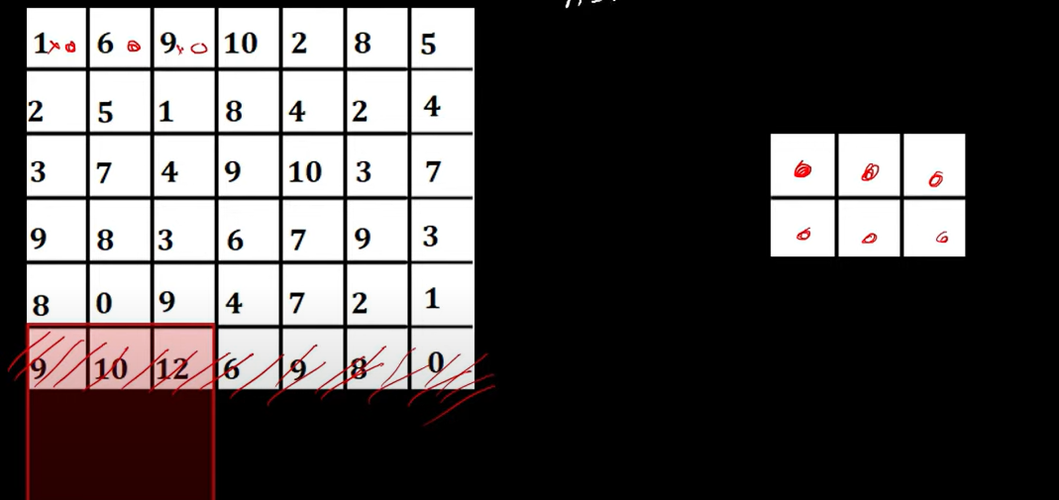

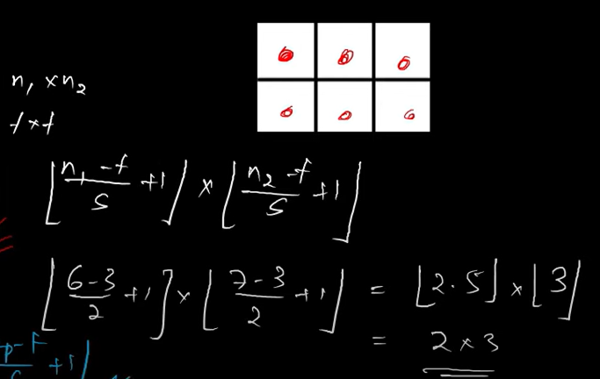

Discard if we don’t have enough pixel values

Final image becomes = floor value of (n-f)/s + 1

Max-pooling -

If fix filter and stride the we go on iterating and then we just take the max value from the feature window and keep moving

Reduce the size of image, reducing computation cost without losing info rather enhancing them

Generally applied after convolutional layer, not always necessary after convolutional layer as It reduces size if we use it too much then it might loose valuable info. So only se when convolutional layer is too big

Avg Pooling – takes the average value

Fully connected layer –

we **flatten** the 2D matrix into a 1D vector and pass it into one or more **fully connected layers**.

Used to classfy features

A dense network of neurons and connection between 2 neurons

Before we pass images to fully connected layer they are flattened using flatten layer

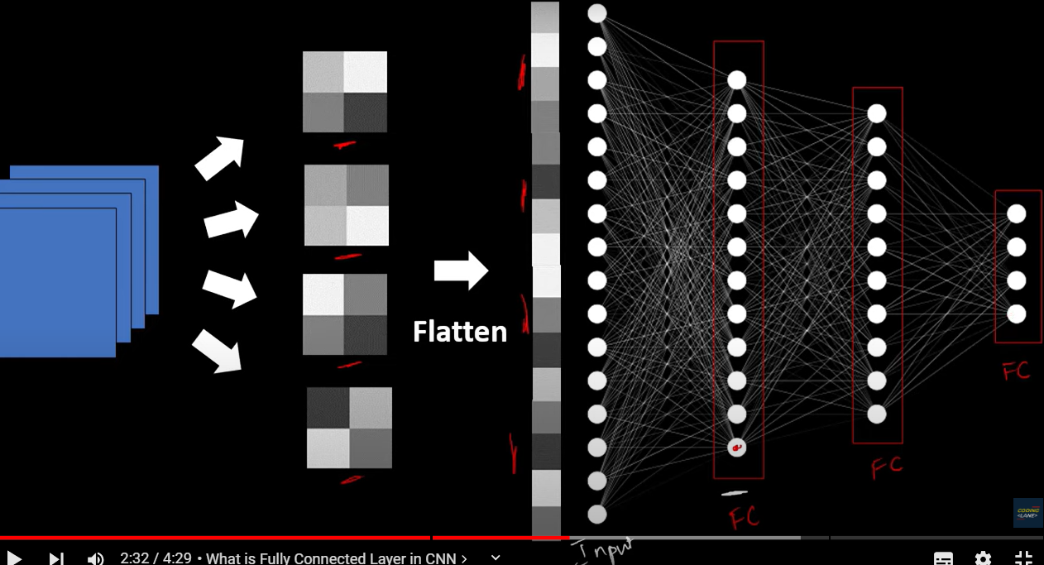

Connection between neurons is also called as weights. And so fully connected layers are also used for learning and associating a feature to classification categeory

Softmax – for calssificatino into many categeory output layer = no. of classifying categeory

Sigmoid – binary classification only 1 output feature

Conlutional layer consist of = applying convolutional operation and giving it to passign to non linear activation function while passing some bias

Traditionaly in cnn – layer of convolution and maxpooling is considered as 1 layre

But before we predict we need to train the model to learn and so then we will calculate cost function based on output of the last fc layer to get amount of error we are getting

For Binary - binary cross entropy function

For mulit-class – categeorical entropy function

Then we back propogate to minimize the cost function eg – SGD, gradient descent

Formula to get size of ouput feature - Output Size=(W−F+2P)/S​+1

**CNN Based Architectures**

1. ***Visual Geometry Group 16***

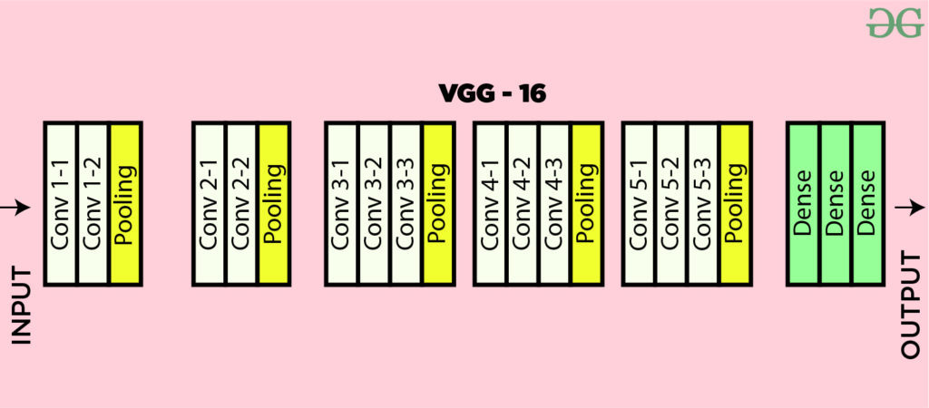

Three fully connected layers with ReLU activation,  outputting probabilities for 1000 classes using softmax activation, predominantly use 3×3 filters

**Limitations Of VGG 16:**

* It is very slow to train
* The size of VGG-16 trained imageNet weights is *528* MB.
* 138 million parameters lead to exploding gradients problem.
* Resnets are introduced to prevent exploding gradients

1. **VGG-19 Architecture**

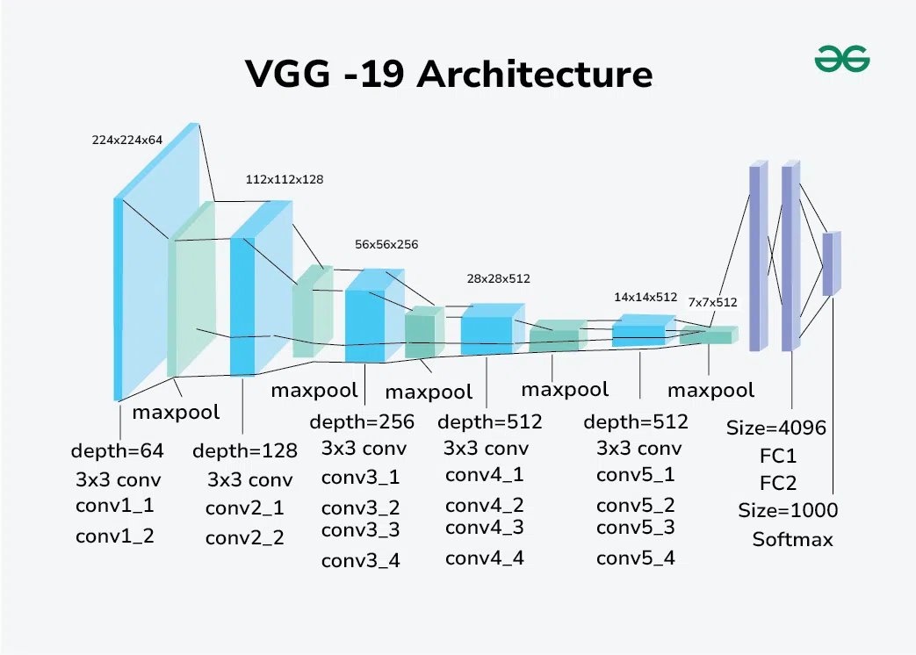

1. **onvolutional Layers**: 3x3 filters with a stride of 1 and padding of 1 to preserve spatial resolution.
2. **Activation Function**: ReLU (Rectified Linear Unit) applied after each convolutional layer to introduce non-linearity.
3. **Pooling Layers**: Max pooling with a 2x2 filter and a stride of 2 to reduce the spatial dimensions.
4. **Fully Connected Layers**: Three fully connected layers at the end of the network for classification.
5. **Softmax Layer**: Final layer for outputting class probabiliti

Use in Transfer Learning

1. **Residual Networks (ResNet**

**Residual Network: This causes the gradient to become 0 or too large. Thus when we increases number of layers, the training and test error rate also increases.**In order to solve the problem of the vanishing/exploding gradient, this architecture introduced the concept called Residual Blocks. In this network, we use a technique called ***skip connections. The skip connection connects activations of a  layer to further layers by skipping some layers in between***

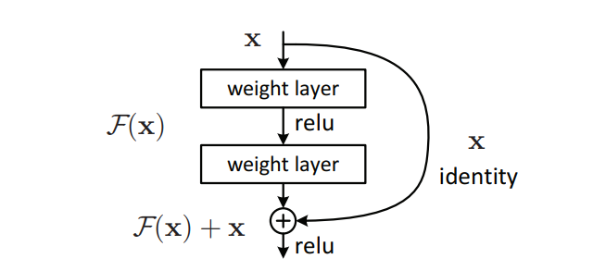

The advantage of adding this type of skip connection is that if any layer hurt the performance of architecture then it will be skipped by regularization. So, this results in training a very deep neural network without the problems caused by vanishing/exploding gradient.

This network uses a 34-layer plain network architecture inspired by VGG-19 in which then the shortcut connection is added

**📉 Vanishing Gradient**

**🧨 What is it?**

When gradients become **very small** (close to 0) as they’re backpropagated, **earlier layers learn very slowly** or **not at all**.

**🔬 Why does it happen?**

During backpropagation: If each partial derivative is < 1, multiplying many of them makes the gradient shrink **exponentially** — this is **vanishing gradient**.

**💥 Exploding Gradient**

**🧨 What is it?**

When gradients become **very large**, causing **weight updates to explode**, leading to **instability or NaNs**.

**🔬 Why does it happen?**

If derivatives > 1, repeated multiplication during backpropagation causes them to **grow exponentially**.

🛠️ Solutions

| **Problem** | **Solutions** |
| --- | --- |
| Vanishing Gradient | - Use ReLU instead of sigmoid/tanh- Use Batch Normalization- Use Residual Connections (ResNet)- Use LSTM/GRU (for RNNs) |
| Exploding Gradient | - Gradient Clipping- Weight Regularization- Better Weight Initialization (He/Xavier)- Use smaller learning rates |

Gradient Clipping - A technique to **cap the magnitude of gradients** during backpropagation

**✨ Xavier Initialization (Glorot Init)**

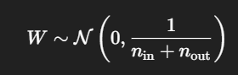Used with **tanh/sigmoid**

* Keeps **variance of activations and gradients stable**
* Suitable when activations are **symmetric** (like tanh)

**⚡ He Initialization**

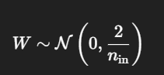Used with **ReLU** and its variants:

* Designed to preserve variance through **ReLU layers**
* Prevents **dying ReLU** and vanishing gradient

🧠 Backpropagation in Convolutional Neural Networks (CNNs)

Loss → FC Gradients → Pool Routing → ReLU Derivative Mask →conv Gradients (via conv math) → Update Filters