RNN

Works very well with sequential data like for nlp tasks we are using bag of words or word to vec but in all of these the sequence is discarded. Another application is time series, some real life exaples is google image search or image captioning

the output from one step is fed back as input to the next, allowing them to retain information from previous inputs, hidden state—also called the memory state—which preserves essential information from previous inputs in the sequence

Forward propogation overtime
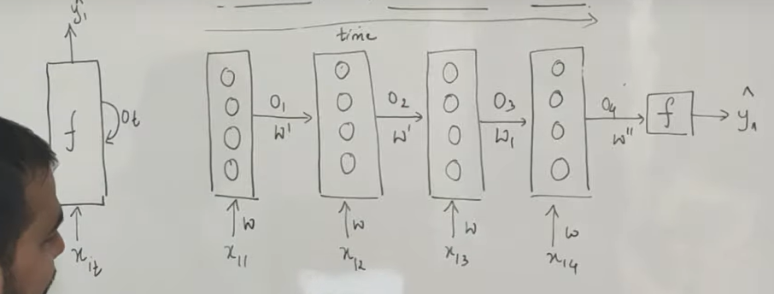
Each unit contains an internal hidden state, which acts as memory by retaining information from previous time steps
The loss function L(θ)L(θ) is dependent on the final hidden state h3h3​​, but each hidden state relies on the preceding states, forming a sequential chain This unique approach is called Backpropagation Through Time (BPTT),
Weight are only changed when we are in back propogation in forward propogation weights remain the same
Exploding Gradient?
The exploding gradient problem is a challenge encountered during training deep neural networks. It occurs when the gradients of the network's loss function with respect to the weights (parameters) become excessively large

Bi-directional Recurrent Neural Network
In order for the network to use information from both the past and future context in its predictions, BRNNs process input sequences in both the forward and backward directions.

LSTM
Solves the short term memory problem in rnn
single hidden state that is passed through time, which can make it difficult for the network to learn long-term dependencies. LSTMs model address this problem by introducing a memory cell,
Forget Gate: This gate determines which information from the previous cell state should be discarded or "forgotten" based on the current input. It takes input from the current input and the previous hidden state and produces a forget gate vector, which is multiplied element-wise with the previous cell state.
Input Gate: This gate decides which new information should be added to the cell state. It consists of two sub-components: the input gate, which determines which values to update, and the tanh layer, which creates a new candidate value to add to the cell state.
output gate: This step combines the decisions from the forget gate and the input gate to update the cell state. what information is output from the memory cell

Output Gate: This gate determines which parts of the cell state should be output to the next hidden state. It considers the current input and the previous hidden state to produce the output gate vector, which is multiplied element-wise with the cell state to produce the next hidden state.

Eg. Mr Watson likes to go on trips with her wife, where as mrs Watson likes to go by himself
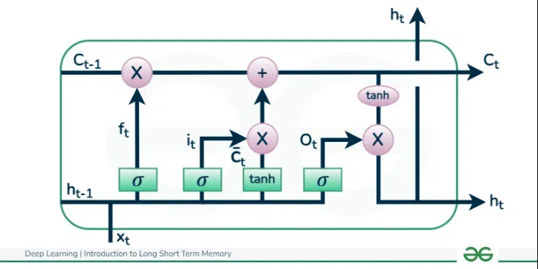

Bidirectional RNN
Whenever the output has dependency on future words it consists of two separate LSTM (Long Short-Term Memory) layers: one processing the input data in a forward direction, and the other processing the input data in a backward direction.
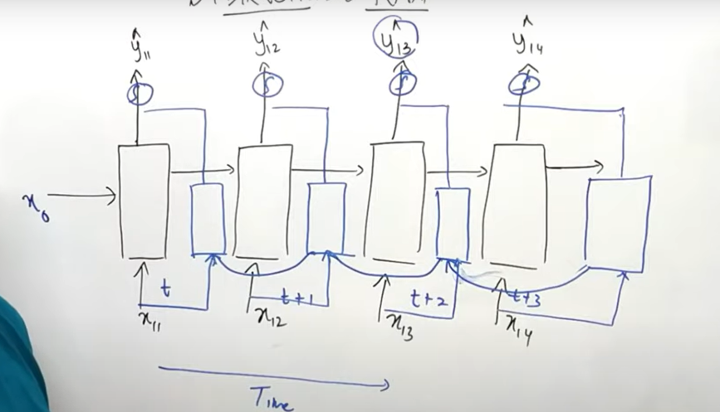
By combining the outputs of both the forward and backward LSTMs, the BiLSTM model is able to capture information from both past and future context for each time step in the input sequence.
This allows it to better understand the context and dependencies within the sequence, making it particularly useful for tasks such as sequence labeling, sentiment analysis, and machine translation.

Attention layer
An attention layer is a component used in neural network architectures, particularly in sequence-to-sequence models, to selectively focus on parts of the input sequence that are more relevant for producing the output at each step. It helps the model to learn which parts of the input sequence to pay attention to, allowing it to weigh the importance of different elements dynamically during the processing of the sequence.

