Internet Programming
Name: Parth Pravin Shikhare
Class: TE-IT
Roll No.: 53
Date: 1/8/2025
Experiment No.: 2

Title:
Design a basic web page using advanced HTML5

Problem Definition:
Design web pages using advanced HTML5 features including List, Frames, Forms, and Multimedia tags.

Pre-requisites:
1. Understanding of basic HTML5 structure and syntax
2. Familiarity with HTML5 form elements, multimedia, and lists
3. Basic knowledge of HTML frames and layout structure
4. A text editor or IDE and a web browser for testing

Theory:
Advanced HTML5 features allow developers to create more interactive and media-rich webpages.
Key elements include:
- Lists: <ul>, <ol>, and <li> are used to create unordered and ordered lists.
- Frames: Though <frameset> is deprecated in HTML5, iframes (<iframe>) can be used to embed external web pages.
- Forms: Include form controls like <input>, <textarea>, <select>, <button>, etc., allowing user interaction.
- Multimedia: Tags like <audio> and <video> are used to embed media files with controls for play, pause, etc.

Procedure:
1. Open a text editor or IDE.
2. Create a new HTML file and set up the basic structure.
3. Add list elements (ordered/unordered) to demonstrate list usage.
4. Use <iframe> to embed another webpage or document.
5. Create a form using various input controls (text, radio, checkbox, etc.).
6. Embed audio and video elements using <audio> and <video> tags.
7. Save the file with a .html extension and test it in a browser.
8. Modify and re-test as necessary.

Program:
First Code:
<!DOCTYPE html>
<html lang="en">
<head>
<meta charset="UTF-8"/>
<meta name="viewport" content="width=device-width, initial-scale=1.0"/>
<title>SE Marksheet</title>
<style>
body{font-family:Arial,sans-serif;margin:0;padding:20px}
h1{text-align:center;margin-bottom:20px}
.marksheet-container{max-width:1000px;margin:auto}
table{width:100%;border-collapse:collapse}
th,td{border:1px solid #000;padding:8px;text-align:center}
td table{width:100%;border:none}
td table td{border:none;padding:4px}
tr:nth-child(even){background-color:#f5f5f5}
.footer-row td{border:none;font-weight:bold;text-align:left}
button{display:block;margin:20px auto 0;padding:8px 15px;border:1px solid #000;background:none;cursor:pointer}
a{text-decoration:none;color:inherit}
</style>
</head>
<body>
<h1>Second Year Marksheet</h1>
<div class="marksheet-container">
<table>
<tr><th>Sr No</th><th>Course Name</th><th>Credits</th><th>ESE<table><tr><th>Min</th><th>Obtained</th></tr></table></th><th>IA<table><tr><th>Min</th><th>Obtained</th></tr></table></th><th>Total<table><tr><th>Max</th><th>Obtained</th></tr></table></th><th>Grades</th><th>Pointers</th></tr>
<tr><td>1</td><td>Maths IV</td><td>4</td><td><table><tr><td>32</td><td>73</td></tr></table></td><td><table><tr><td>8</td><td>19</td></tr></table></td><td><table><tr><td>100</td><td>92</td></tr></table></td><td>O</td><td>10</td></tr>
<tr><td>2</td><td>Computer Networks</td><td>3</td><td><table><tr><td>32</td><td>66</td></tr></table></td><td><table><tr><td>8</td><td>19</td></tr></table></td><td><table><tr><td>100</td><td>85</td></tr></table></td><td>O</td><td>10</td></tr>
<tr><td>3</td><td>Operating System</td><td>4</td><td><table><tr><td>32</td><td>57</td></tr></table></td><td><table><tr><td>8</td><td>16</td></tr></table></td><td><table><tr><td>100</td><td>73</td></tr></table></td><td>B</td><td>8</td></tr>
<tr><td>4</td><td>Automata Theory</td><td>3</td><td><table><tr><td>32</td><td>44</td></tr></table></td><td><table><tr><td>8</td><td>20</td></tr></table></td><td><table><tr><td>100</td><td>64</td></tr></table></td><td>D</td><td>7</td></tr>
<tr><td>5</td><td>Computer Organisation and Architecture</td><td>3</td><td><table><tr><td>32</td><td>64</td></tr></table></td><td><table><tr><td>8</td><td>19</td></tr></table></td><td><table><tr><td>100</td><td>83</td></tr></table></td><td>O</td><td>10</td></tr>
<tr class="footer-row"><td colspan="3">Remark: SUCCESSFUL</td><td colspan="3">SGPI: 9.35</td><td colspan="2">Marks Obtained: 657 / 775</td></tr>
</table>
</div>
<a href="./profile.html"><button>Go Back</button></a>
</body>
</html>
Second Code:
<!DOCTYPE html>
<html lang="en">
<head>
<meta charset="UTF-8">
<meta name="viewport" content="width=device-width, initial-scale=1.0">
<title>Forms</title>
<style>
body{font-family:Arial,sans-serif;margin:0;padding:20px}
h1{text-align:center;margin-bottom:20px}
form{max-width:600px;margin:auto;padding:20px;border:1px solid #000}
label{font-weight:bold;display:block;margin-bottom:5px}
input[type="text"],input[type="password"],input[type="date"],select{width:100%;padding:8px;margin-bottom:15px;border:1px solid #000}
.radio-group{margin-bottom:15px}
.radio-group label{font-weight:normal;margin-right:10px}
button{padding:8px 15px;border:1px solid #000;background:none;cursor:pointer}
.back-link{text-align:center;margin-top:15px}
a{text-decoration:none;color:inherit}
</style>
</head>
<body>
<h1>Student Details Form</h1>
<form action="submit">
<label for="name">Name:</label>
<input type="text" id="name" name="name" required>
<label>Department:</label>
<div class="radio-group">
<input type="radio" id="comps" name="fav_language" value="COMPS"><label for="comps">COMPS</label>
<input type="radio" id="it" name="fav_language" value="IT"><label for="it">IT</label>
<input type="radio" id="extc" name="fav_language" value="EXTC"><label for="extc">EXTC</label>
<input type="radio" id="mech" name="fav_language" value="MECH"><label for="mech">MECH</label>
</div>
<label for="password">Roll No:</label>
<input type="text" id="password" name="password" required>
<label for="dob">Date of Birth:</label>
<input type="date" id="dob" name="dob">
<label for="gender">Gender</label>
<select name="gender_opt" id="gender">
<option value="Male">Male</option>
<option value="Female">Female</option>
<option value="Other">Other</option>
</select>
<button type="submit">Submit</button>
</form>
<div class="back-link">
<a href="./profile.html"><button>Go Back</button></a>
</div>
</body>
</html>

Output:
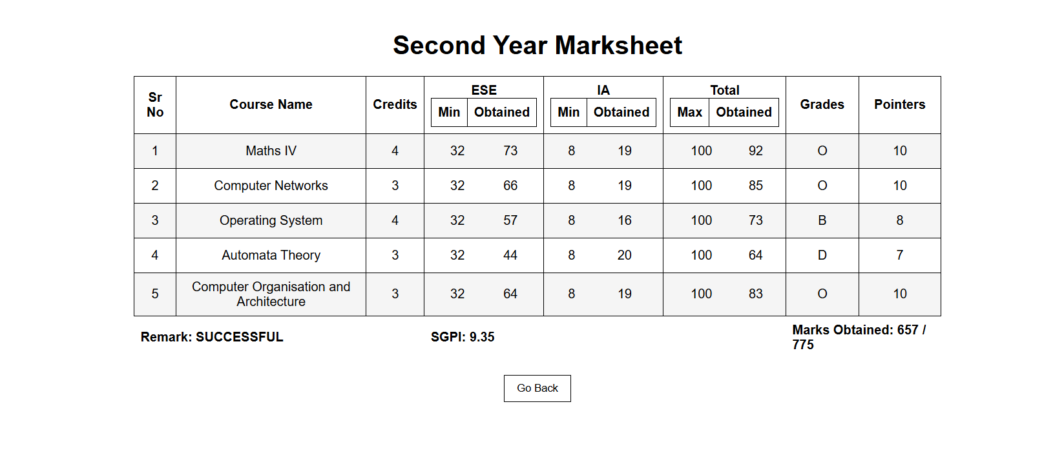
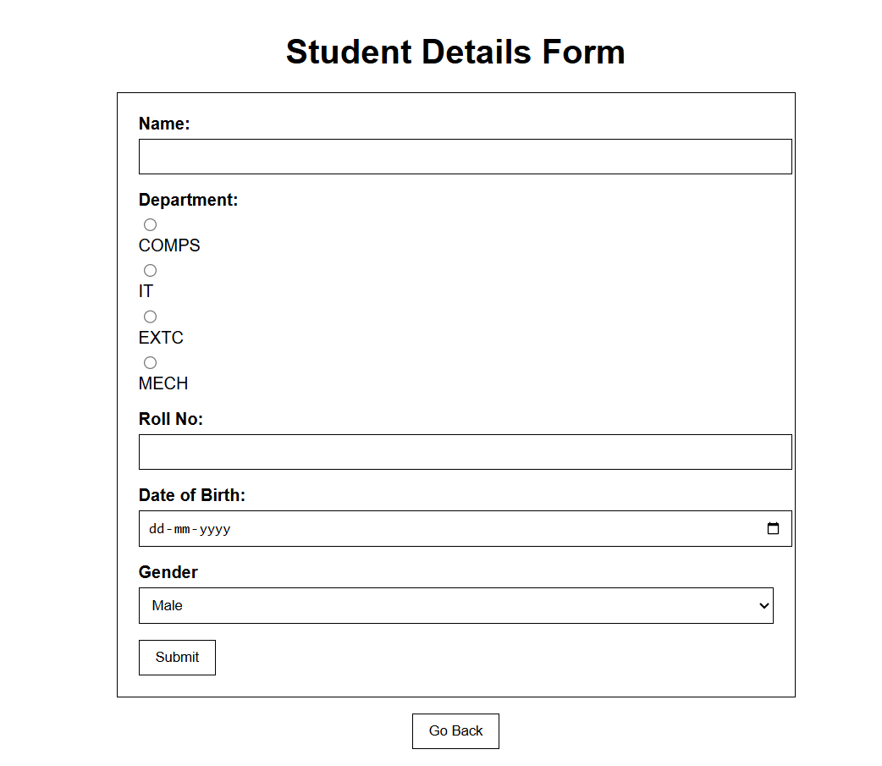

Results:
Successfully created an advanced HTML5 webpage using lists, frames, forms, and multimedia elements.

References:
1. https://developer.mozilla.org/en-US/docs/Web/HTML
2. https://www.w3schools.com/html/

