Don Bosco Institute of Technology
Kurla (W), Mumbai 400 070
Internet Programming
Name: Parth Pravin Shikhare
Class: TEIT
Roll No.: 53
Date: 17/09/25
Experiment No.: 6

Title:
Design a web page using JavaScript Validation

Problem Definition:
Design a web page using JavaScript concepts such as Variables, Operators, Conditions, Loops, Functions, Events, Classes, Objects, and implement form validation.

Pre-requisites:
1. Basic knowledge of HTML5 and CSS3
2. Understanding of JavaScript syntax and basic programming concepts
3. Familiarity with web browsers and developer tools
4. A text editor or IDE for coding and testing

Theory:
JavaScript is a powerful client-side scripting language used to enhance the interactivity of web pages. It supports programming constructs such as variables, operators, conditions, loops, functions, events, and object-oriented features like classes and objects.
Key JavaScript Concepts used in this experiment:
- Variables: Used to store data values (var, let, const).
- Operators: Arithmetic, relational, logical, and assignment operators to perform computations.
- Conditions: if, if-else, and switch statements to implement decision-making.
- Loops: for, while, do-while loops for iteration.
- Functions: Block of reusable code that performs a specific task.
- Events: Actions like onClick, onChange, onSubmit that trigger JavaScript functions.
- Classes & Objects: Used for object-oriented programming, encapsulating properties and methods.
- Validation: Ensuring user input meets certain criteria (e.g., email format, required fields).

Procedure:
1. Create a basic HTML form with input fields such as name, email, password, etc.
2. Write JavaScript code to declare variables and use operators for simple calculations.
3. Implement conditions (if, switch) to validate input values.
4. Use loops to process multiple inputs or repeated actions.
5. Define functions to modularize the validation logic.
6. Attach event listeners to form fields and buttons to trigger validation functions.
7. Create a simple class and object to demonstrate object-oriented concepts.
8. Test the form by entering various inputs and verifying the validation messages.
9. Debug errors using browser developer console and refine the script.
10. Save final files and capture screenshots of the outputs.

Program:
<!DOCTYPE html>
<html lang="en">
<head>
<meta charset="UTF-8" />
<meta name="viewport" content="width=device-width, initial-scale=1.0" />
<title>Form</title>
<style>
body {
font-family: Arial, sans-serif;
background: linear-gradient(135deg, #e3f2fd, #bbdefb);
margin: 0;
padding: 0;
}

h1,
h2,
h3 {
text-align: center;
padding: 5px;
margin: 5px 0;
}

form {
max-width: 500px;
margin: 30px auto;
padding: 20px;
background: #ffffff;
border-radius: 12px;
box-shadow: 0 4px 12px rgba(0, 0, 0, 0.15);
}

input[type="text"],
input[type="email"],
input[type="number"],
input[type="tel"],
input[type="password"],
textarea,
select {
width: 95%;
padding: 10px;
margin: 8px 0 15px 0;
border: 1px solid #ccc;
border-radius: 6px;
font-size: 14px;
transition: 0.3s;
}

input:hover,
select:hover {
border-color: #2196f3;
}
input:focus,
select:focus {
outline: none;
border-color: #1976d2;
box-shadow: 0 0 6px rgba(25, 118, 210, 0.4);
}

label {
display: inline-block;
margin-bottom: 6px;
font-weight: bold;
}

.inline-options {
margin-bottom: 15px;
}
.inline-options input {
margin-right: 6px;
}
.inline-options label {
margin-right: 15px;
font-weight: normal;
}

button {
padding: 10px 20px;
margin: 10px 8px 0 0;
border: none;
border-radius: 8px;
font-size: 15px;
cursor: pointer;
transition: 0.3s;
}

button[type="submit"] {
background: #2196f3;
color: white;
}

button[type="submit"]:hover {
background: #1976d2;
}

button[type="reset"] {
background: #f44336;
color: white;
}

button[type="reset"]:hover {
background: #d32f2f;
}
</style>

</head>
<body>
<h1>Don Bosco Institue of Technology</h1>
<h3>Department of Information Technology</h3>
<h2>TE Form</h2>

<form id="myForm">
<label>Username :</label>
<input
type="text"
name="name"
placeholder="Enter your username"
required
/><br />

<label>Password :</label>
<input
type="password"
name="password"
placeholder="Enter your password"
required
/><br />

<label>Phone No. :</label>
<input
type="tel"
name="tel"
placeholder="Enter your phone number"
required
/><br />

<label>Address :</label>
<textarea name="Address" id="Address" placeholder="Enter your address"></textarea>

<label>Age :</label>
<input type="number" name="age" required /><br />

<div class="inline-options">
<label>Gender :</label>
<input type="radio" name="Gender" /> Male
<input type="radio" name="Gender" /> Female
</div>

<div class="inline-options">
<label>Hobbies :</label>
<input type="checkbox" name="hobby" /> Sports
<input type="checkbox" name="hobby" /> Reading
<input type="checkbox" name="hobby" /> Music
</div>

<label>Technology :</label>
<select name="Technology">
<option value="Java">Java</option>
<option value="C">C</option>
<option value="Python">Python</option></select
><br />

<label>Personal Information :</label>
<textarea name="info" id="info" placeholder="Enter your personal information"></textarea>

<button type="submit">Submit</button>
<button type="reset" id="cancelBtn">Cancel</button>
</form>

<script>
document.getElementById("myForm").addEventListener("submit", function (e) {
e.preventDefault();
let username = document.getElementsByName("name")[0].value;
let password = document.getElementsByName("password")[0].value;
let phone = document.getElementsByName("tel")[0].value;
let age = document.getElementsByName("age")[0].value;
let nameRegex = /^[A-Za-z]+$/;
if (!nameRegex.test(username)) {
alert("Username should not contain numbers");
return;
}
if (password.length < 8) {
alert("Password should be at least 8 characters long");
return;
}
if (age < 8 || age > 80) {
alert("Age should be between 8 and 80");
return;
}
let phoneRegex = /^[0-9]{10}$/;
if (!phoneRegex.test(phone)) {
alert("Phone number should contain exactly 10 digits");
return;
}
let pname = prompt("Enter your name");
if (pname !== null) {
let conf = confirm("Do you want to submit?");
if (conf) {
alert("Confirm Successful");
}
}
});

document.getElementById("cancelBtn").addEventListener("click", function (e) {
e.preventDefault();
let pname = prompt("Enter your name");
if (pname !== null) {
let conf = confirm("Do you want to cancel?");
if (conf) {
alert("Cancel Successful");
}
}
});
</script>
</body>
</html>

Output:

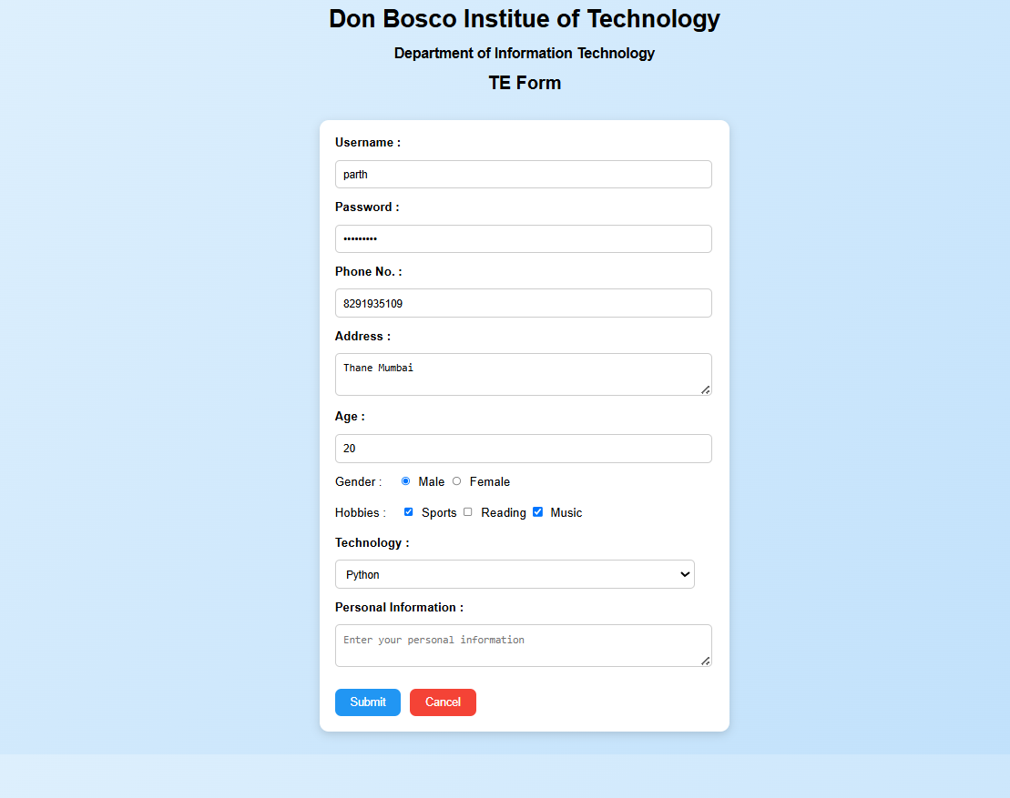

Results:
Successfully created a web page using JavaScript that demonstrates variables, operators, conditions, loops, functions, events, classes, objects, and input validation.

References:
1. https://developer.mozilla.org/en-US/docs/Web/JavaScript
2. https://www.w3schools.com/js/
3. Eloquent JavaScript by Marijn Haverbeke

