Don Bosco Institute of Technology
Kurla (W), Mumbai 400 070
Internet Programming
Name: Parth Pravin Shikhare
Class: TEIT
Roll No.: 53
Date:22/08/25
Experiment No.: 5

Title:
Design a web pages using Bootstrap

Problem Definition:
Design web pages using Bootstrap framework implementing Grid system, Forms, Buttons, and Navbar.

Pre-requisites:
1. Understanding of HTML5 and CSS3 basics
2. Basic knowledge of responsive design concepts
3. Familiarity with Bootstrap framework structure
4. A text editor or IDE and a modern web browser
5. Internet connection to include Bootstrap CDN or downloaded Bootstrap files

Theory:
Bootstrap is a popular front-end open-source framework used for developing responsive and mobile-first web pages. It provides pre-styled components and a grid system for easier design and faster development.
Key Bootstrap Features used in this experiment:
- Grid System: Bootstrap uses a 12-column grid system with responsive breakpoints (xs, sm, md, lg, xl) to create layouts.
- Forms: Pre-styled form elements such as input fields, checkboxes, radio buttons, and validation classes.
- Buttons: Various button classes like btn, btn-primary, btn-success, btn-danger, and customization options.
- Navbar: Responsive navigation bar with support for branding, links, dropdowns, and toggler for smaller screens.

Procedure:
- Create a new HTML file and include Bootstrap via CDN in the <head> section.
2. Implement the Bootstrap grid system using <div class='container'>, <div class='row'>, and <div class='col'> classes.
3. Add form elements styled with Bootstrap classes (form-control, form-group, etc.).
4. Insert buttons using predefined classes like btn btn-primary and customize their appearance.
5. Create a responsive navigation bar using <nav class='navbar'> and related classes.
6. Test the webpage in a browser and resize the window to verify responsiveness.
7. Refine the design and ensure all components are functioning correctly.
8. Save final files and capture screenshots of the results.

Program:

<!DOCTYPE html>

<html lang="en">

<head>

<meta charset="UTF-8" />

<meta name="viewport" content="width=device-width, initial-scale=1.0" />

<title>Bootstrap Example Page</title>

<link

href="https://cdn.jsdelivr.net/npm/bootstrap@5.3.3/dist/css/bootstrap.min.css"

rel="stylesheet"

/>

</head>

<body>

<nav class="navbar navbar-expand-lg navbar-dark bg-primary">

<div class="container">

<a class="navbar-brand" href="#">MyWebsite</a>

<button

class="navbar-toggler"

type="button"

data-bs-toggle="collapse"

data-bs-target="#navbarNav"

>

<span class="navbar-toggler-icon"></span>

</button>

<div class="collapse navbar-collapse justify-content-end" id="navbarNav">

<ul class="navbar-nav">

<li class="nav-item"><a class="nav-link active" href="#">Home</a></li>

<li class="nav-item"><a class="nav-link" href="#">Features</a></li>

<li class="nav-item"><a class="nav-link" href="#">Pricing</a></li>

<li class="nav-item"><a class="nav-link" href="#">Contact</a></li>

</ul>

</div>

</div>

</nav>

<div class="container mt-5">

<div class="row g-4">

<div class="col-md-8">

<h2 class="mb-3">Welcome to My Page</h2>

<p class="mb-4">

This page demonstrates the usage of Bootstrap Grid System, Navbar,

Forms, and Buttons.

</p>

<div class="row g-3">

<div class="col-md-6">

<div class="p-4 bg-light border text-center rounded">Column 1</div>

</div>

<div class="col-md-6">

<div class="p-4 bg-secondary text-white border text-center rounded">

Column 2

</div>

</div>

</div>

</div>

<div class="col-md-4">

<div class="card shadow">

<div class="card-body">

<h5 class="card-title text-center mb-4">Sign Up Form</h5>

<form>

<div class="mb-3">

<label for="username" class="form-label">Username</label>

<input

type="text"

class="form-control"

id="username"

placeholder="Enter username"

/>

</div>

<div class="mb-3">

<label for="email" class="form-label">Email address</label>

<input

type="email"

class="form-control"

id="email"

placeholder="Enter email"

/>

</div>

<div class="mb-3">

<label for="password" class="form-label">Password</label>

<input

type="password"

class="form-control"

id="password"

placeholder="Enter password"

/>

</div>

<div class="d-flex justify-content-between">

<button type="submit" class="btn btn-primary w-50 me-2">Submit</button>

<button type="reset" class="btn btn-danger w-50">Reset</button>

</div>

</form>

</div>

</div>

</div>

</div>

</div>

<footer class="bg-primary text-white text-center py-3 mt-5">

<p class="mb-0">&copy; 2025 MyWebsite. All rights reserved.</p>

</footer>

<script src="https://cdn.jsdelivr.net/npm/bootstrap@5.3.3/dist/js/bootstrap.bundle.min.js"></script>

</body>

</html>

Output:

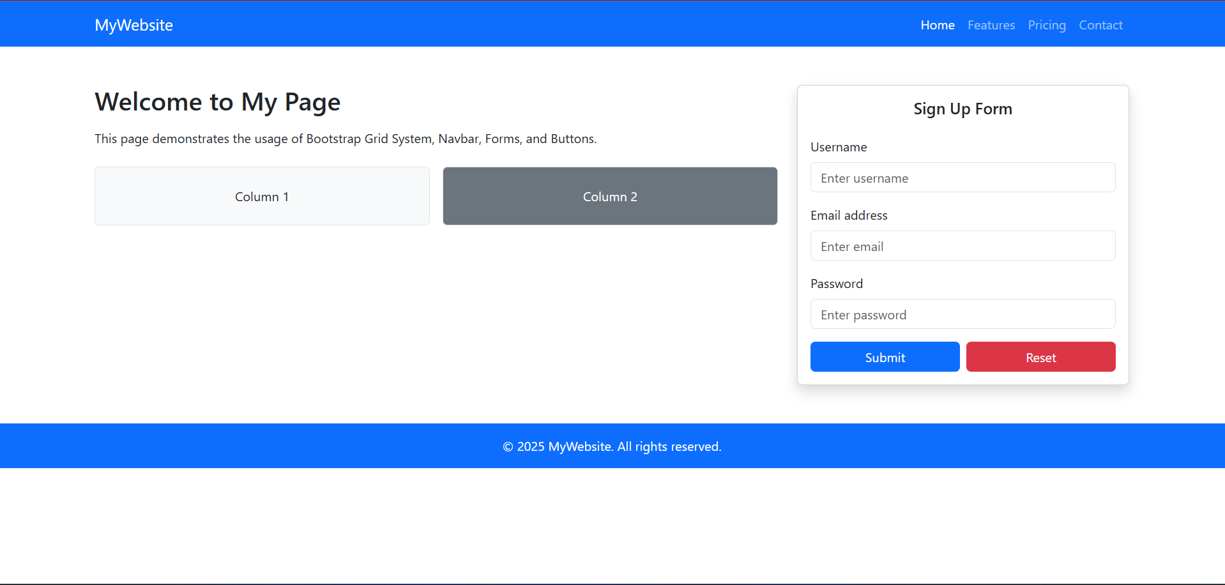

Results:
Successfully created responsive web pages using Bootstrap Grid system, Forms, Buttons, and Navbar.

References:
1. https://getbootstrap.com/
2. https://www.w3schools.com/bootstrap/
3. https://developer.mozilla.org/en-US/docs/Learn/CSS/CSS_layout/Responsive_Design

