Installation Guide
Organizer-only. This describes installing the CTF onto a clean Ubuntu Server VM. See NETWORK_GUIDE.md for how to provision that VM in Proxmox first.

1. Prerequisites
- Ubuntu Server 24.04 LTS (or 22.04 LTS), freshly installed, nothing else running on it that you care about — install_ctf.sh will overwrite the Apache default site and the SSH configuration.
- Root access.
- Outbound internet access during installation (apt-get install needs it). It can be removed afterward if you like — nothing in the running challenge requires it.
- Your own copy of rockyou.txt available somewhere you can read a line out of it. These scripts never download or bundle it.

2. Get the project onto the VM
Copy the whole ctf-project directory onto the VM (scp, a shared folder, git clone, whatever you normally use). Whatever you do, always run install_ctf.sh from that copy, never from /opt/ctf/src (the persisted copy install creates on the VM) — see TROUBLESHOOTING.md for why that distinction matters if you're iterating on the scripts.

3. Configure
Everything configurable lives in one file: scripts/config.sh. Open it and review:
Variable | Default | Must you change it?
STEGHIDE_PASSPHRASE | placeholder | Yes. Pick a real, uncommon-but-not-absurd entry from your own rockyou.txt. Install refuses to run until this is changed.
ROCKYOU_PATH | /usr/share/wordlists/rockyou.txt | Only if your rockyou.txt lives elsewhere. Used purely to sanity-check STEGHIDE_PASSPHRASE is a real entry; if the path doesn't exist the check is skipped with a warning.
SSH_PORT | 2222 | Optional. Any non-22 port players are expected to find via nmap.
AGENT99_USER / AGENT999_USER | Agent99 / Agent999 | Optional.
Everything else | — | Leave as-is unless you have a specific reason to change it — paths, hidden directory names, sudo rule, etc. are all cross-referenced by the scripts and templates.

Flags and the account/.beroot passwords are not set in config.sh — install_ctf.sh generates them randomly on every install and records them only in /opt/ctf/.organizer/secrets.env (root-only, mode 600).

4. Install
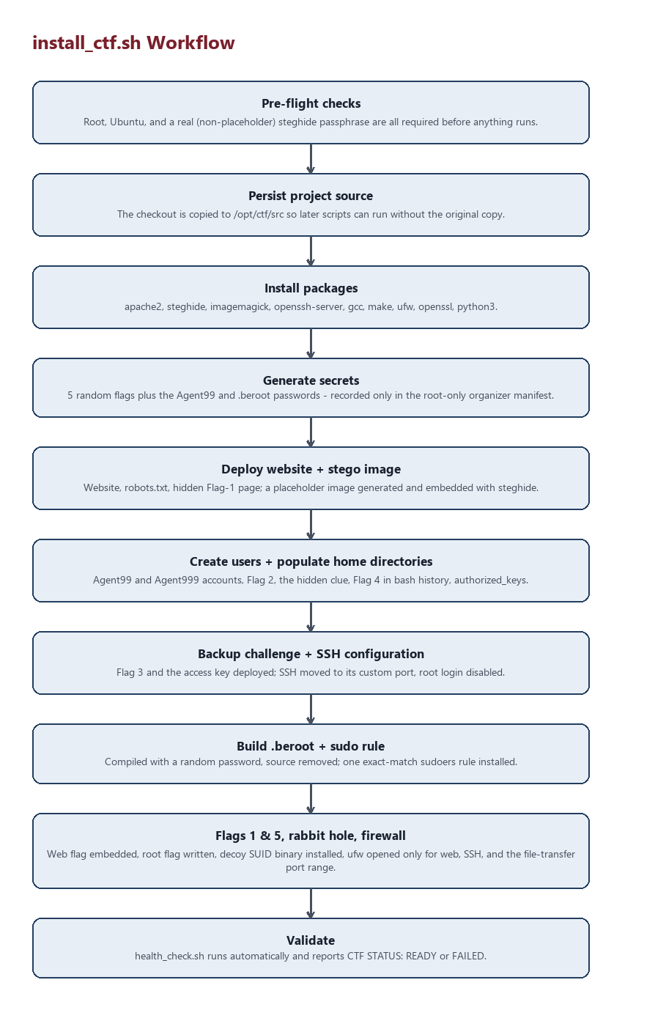
Figure: install_ctf.sh step-by-step workflow
cd ctf-project
sudo bash scripts/install_ctf.sh
This is safe to re-run from a fresh/updated copy of the project at any time — it will regenerate flags, passwords, the .beroot binary, and reconfigure everything from scratch. It performs, in order:
- Pre-flight checks (root, Ubuntu, passphrase not left as placeholder).
- Persists the project checkout to /opt/ctf/src.
- Installs packages: apache2, steghide, imagemagick, openssh-server, gcc, make, ufw, openssl, python3.
- Generates the 5 flags and the Agent99 / .beroot passwords.
- Deploys the website, robots.txt, and the hidden Flag 1 page.
- Generates the placeholder "team photo" and embeds the steghide payload.
- Creates Agent99 and Agent999.
- Populates both home directories (Flag 2, the hidden clue, Flag 4 in .bash_history, authorized_keys).
- Deploys the backup challenge (Flag 3, the Agent999 access key) and the decoy backup directory.
- Configures SSH (custom port, root login disabled, Agent999 key-only).
- Compiles .beroot and removes its source from disk.
- Installs the exact-match sudoers.d rule for Agent999.
- Writes Flag 1 into the hidden page and Flag 5 into /root.
- Installs the decoy SUID binary (rabbit hole 3).
- Configures the firewall (ufw: only your SSH port and 80/tcp open).
- Confirms the deployed copies of the scripts are executable.
- Runs health_check.sh and prints the result.
At the end it prints:
CTF Server IP: <IP>
That's the only thing players should ever receive.

5. Verify
sudo bash scripts/health_check.sh
Expect CTF STATUS: READY with all 14 checks PASS. If anything fails, see TROUBLESHOOTING.md.
For a deeper, end-to-end verification that actually walks the intended player path (not just presence checks), see tests/test_attack_path.sh in ORGANIZER_GUIDE.md.

6. Snapshot
Once health_check.sh reports READY, take a Proxmox snapshot immediately. That snapshot is your reset point for future events — see RESET_GUIDE.md.

