Network Guide — Proxmox Deployment & Isolation
Organizer-only.

VM specification
Resource | Recommendation
OS | Ubuntu Server 24.04 LTS
CPU | 2–4 cores
RAM | 2–4 GB
Disk | 20–40 GB
Network | VirtIO NIC
Bridge | vmbr0, or preferably a dedicated CTF bridge/VLAN (see below)

Deployment steps
- Create the VM in Proxmox with the specs above.
- Install Ubuntu Server 24.04 LTS, minimal install is fine (the install script pulls in everything else it needs via apt-get).
- Configure networking — attach the VM's NIC to the bridge/VLAN you've decided to isolate the CTF on (see below), not directly to a bridge that routes to production.
- Determine the VM's IP (ip a or hostname -I once it's up).
- Run the installation script — see INSTALLATION.md.
- Run the health check — sudo bash scripts/health_check.sh, confirm CTF STATUS: READY.
- Take a Proxmox snapshot of the VM in this known-good state. This is your reset point — see RESET_GUIDE.md.
- Test from another machine on the LAN, not from the Proxmox host itself, before the event: confirm the website loads, nmap finds the custom SSH port, and the full path in ORGANIZER_SOLUTIONS.md works end to end.

Network isolation
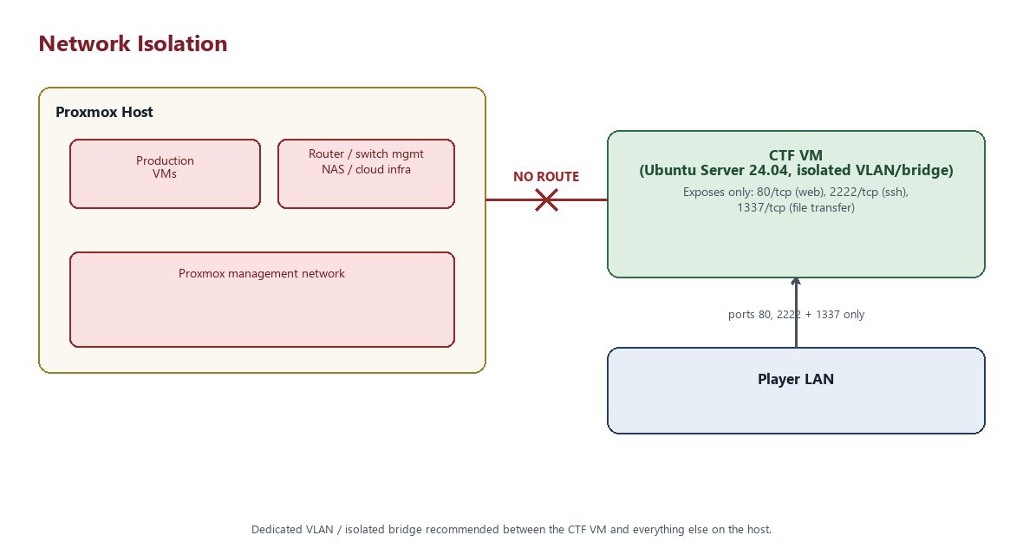
Figure: network isolation boundaries
The CTF VM is intentionally vulnerable. It must never provide a route to:
- The Proxmox host itself
- Other production VMs
- Router / switch management interfaces
- NAS or file servers
- Company servers or production databases
- Any cloud infrastructure
Prefer a dedicated VLAN or an isolated CTF-only bridge with no gateway back into your production network. If you only have vmbr0 available and it's shared with production traffic, treat that as a stop-gap, not a long-term setup — a stray misconfiguration on a shared bridge is exactly the kind of blast radius this project is built to avoid.
Internet access during installation (for apt-get) is fine and can be left in place or removed afterward — nothing in the running challenge itself requires outbound access once installed.

What the CTF VM exposes
After installation, ufw allows these inbound TCP ports:
- 80 — the website
- 2222 — SSH (configurable via SSH_PORT in scripts/config.sh)
- 1337 — reserved for the Flag 5 stage, where Agent999 is expected to stand up a temporary python3 -m http.server 1337 to move .beroot off the target for analysis. Without this port open, that step only works when tested from the VM itself (ufw doesn't filter loopback traffic) and silently fails for a real remote player — see TROUBLESHOOTING.md.
Everything else inbound is denied by default.

