Organizer Guide
This is the operational guide for running the event. For step-by-step solving details (commands, expected output, decoding) see ORGANIZER_SOLUTIONS.md. For install/reset mechanics see INSTALLATION.md and RESET_GUIDE.md.

Intended attack path
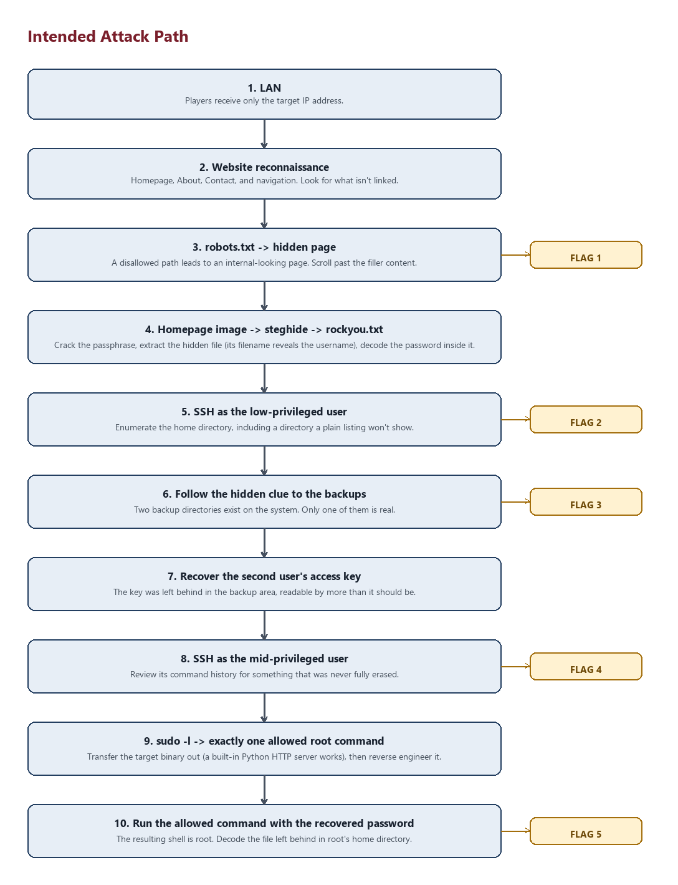
Figure: the intended player path, flag by flag
LAN
│
▼
Website (http://<IP>/)
│
├── robots.txt → hidden page → Flag 1 (base64)
│
└── Website image (steghide, rockyou-crackable passphrase)
│
▼
Extracted file is literally named Agent99.txt (reveals the username)
→ contains a base64-encoded password
│
▼
ssh -p 2222 Agent99@<IP>
│
├── Flag 2 (base64, in a disguised cache file)
│
└── Hidden directory (.cache-index/)
│
▼
Encoded clue → points to the backup area
│
▼
/var/backups/legacy-ops/
│
├── Flag 3 (base64, in ops-notes.txt)
│
└── keys/legacy_agent999_access (world-readable "forgotten" key)
│
▼
ssh -p 2222 -i legacy_agent999_access Agent999@<IP>
│
▼
.bash_history → Flag 4 (base64)
│
▼
sudo -l → reveals the ONE allowed command:
sudo /home/Agent999/.system-audit/.beroot
│
▼
(this is also how the hidden .system-audit/ dir is found)
│
▼
python3 -m http.server <port> → pull .beroot to attacker box
│
▼
Ghidra / strings → recover hardcoded password
│
▼
sudo /home/Agent999/.system-audit/.beroot
Password: <recovered password>
│
▼
whoami → root
│
▼
/root/.sysconfig_cache → decode → Flag 5
This path must remain internally consistent across every install — it's generated fresh (new random flags and passwords) every time install_ctf.sh runs, but the structure never changes.

Users
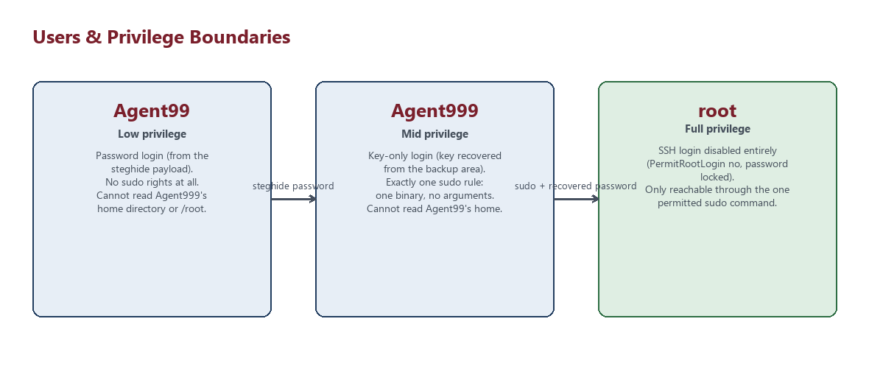
Figure: privilege boundaries between Agent99, Agent999, and root
User | Role | Access
Agent99 | Low-privileged entry point | Password auth (from steghide payload), no sudo
Agent999 | Mid-privileged | Key-only SSH auth (from backup key), exactly one sudo command
root | Normal Linux root | Reachable only through .beroot; direct SSH login disabled

Agent99 cannot read Agent999's home directory or vice versa (both are 700), and Agent99 has no sudo privileges at all.

Hint mechanism
Hints are riddles, dispensed manually by the organizer on request (there is no in-game hint system). Suggested riddles, one per major stage — read only what's needed for the stage a team is stuck on:
- robots.txt — "Every polite crawler is told where not to look. Read the instructions it was given."
- Steganography — "The photograph remembers more than the moment it shows you."
- rockyou/brute force — "The key isn't clever. It's just been used by someone else before."
- Agent99's hidden directory — "Not everything in a home directory answers to ls."
- Backup investigation — "Nothing is ever really deleted here — only relocated and forgotten."
- SSH key — "A door's key doesn't have to live near the door."
- Agent999's history — "Someone tried to erase their tracks and only half-succeeded."
- Sudo/privilege escalation — "Ask the system what it will let you do as someone else."
- Reverse engineering — "If it won't tell you the password, take it apart until it does."
Do not hand these out unprompted, and never reveal rabbit hole content — see ORGANIZER_SOLUTIONS.md for what those are and why they're safe dead ends.

Difficulty
Medium → Hard. Expected skills: Nmap, web enumeration, Base64, steghide, rockyou-style brute forcing, SSH, Linux permissions/enumeration, backup investigation, SSH private keys, bash history review, sudo, Python's http.server, Ghidra/basic reverse engineering, and general Linux privilege escalation reasoning.

Testing
Two levels of verification, both organizer/dev-only — never expose either to players:
- sudo bash scripts/health_check.sh — fast presence/configuration check, used automatically at the end of install_ctf.sh.
- sudo bash scripts/check_flags.sh — decodes every flag currently on disk and compares it against the manifest in /opt/ctf/.organizer/secrets.env.
- sudo bash tests/test_attack_path.sh — full end-to-end walk of the intended path against 127.0.0.1 (requires sshpass, steghide, curl, ssh-keygen, strings, python3 on the box you run it from). This is the closest thing to "did we just verify a player could actually do this."
- sudo bash tests/test_permissions.sh and tests/test_services.sh for narrower checks (isolation, sudo rule shape, service/port state).
Run all of the above after every install and after every reset, before handing out the IP.

Running an event
- Install, verify READY, take a Proxmox snapshot.
- Give players only the IP.
- During the event, dispense hints manually per the list above.
- After the event (or between sessions), restore the snapshot or run scripts/reset_ctf.sh — see RESET_GUIDE.md for the tradeoffs between the two.

