Organizer Solutions
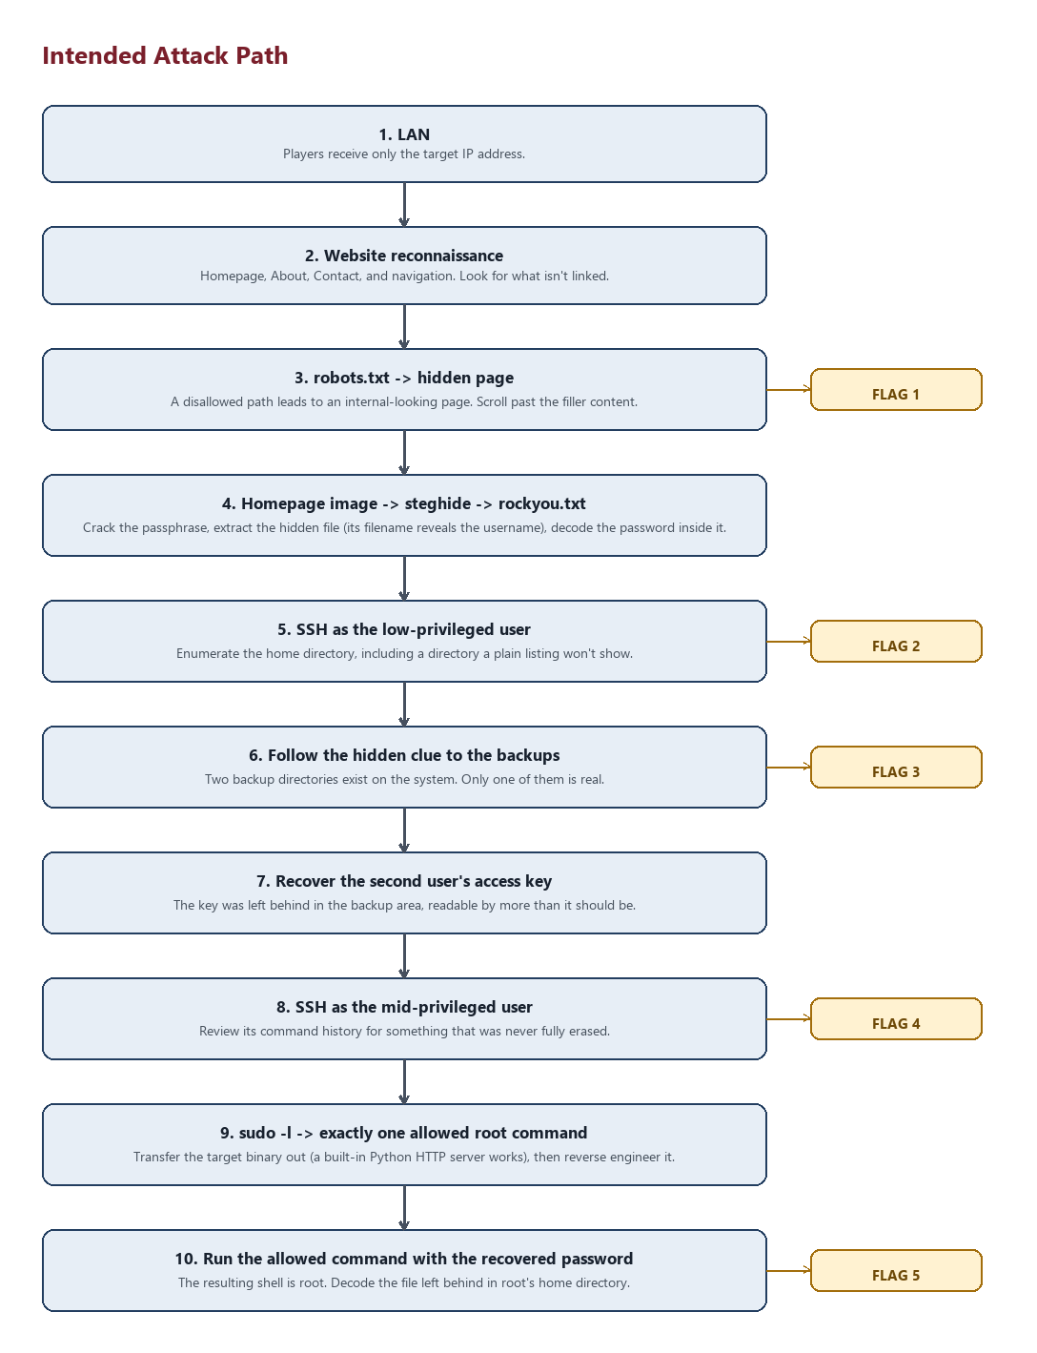
Figure: the intended player path, flag by flag
Full solve walkthrough, organizer-only. Never share this file or its contents with players.
Flags are generated randomly on every install (CTF{<32 hex chars>}, base64-encoded wherever they're stored). To see the actual current values for a live install:
sudo cat /opt/ctf/.organizer/secrets.env
or validate them in place without printing plaintext into your terminal history:
sudo bash scripts/check_flags.sh
Everything below uses the fixed values from scripts/config.sh (paths, usernames, port, hidden directory names) — those don't change between installs, only the flags/passwords do.

FLAG 1 — Website / robots.txt
- Discovery: GET /robots.txt on the website lists a disallowed path.
- Commands:
curl http://<IP>/robots.txt
curl http://<IP>/hidden/classified-briefing-7f3a2b/
- Expected output: robots.txt shows Disallow: /hidden/classified-briefing-7f3a2b/. The page at that path is a plausible internal "briefing archive" — the flag sits at the very bottom, after enough legitimate-looking content that the player has to scroll, as Ref: <base64>.
- Encoding: Base64.
- Decoding: echo '<base64>' | base64 -d
- Flag: see FLAG1 in secrets.env.

FLAG 2 — Agent99
- Discovery: The steghide passphrase (real entry in your rockyou.txt, configured as STEGHIDE_PASSPHRASE in scripts/config.sh) must be brute-forced against the homepage image, assets/team-photo.jpg.
- Commands:
curl -O http://<IP>/assets/team-photo.jpg
steghide extract -sf team-photo.jpg # prompts for passphrase, no -xf given
cat Agent99.txt
echo '<base64 from Agent99.txt>' | base64 -d
ssh -p 2222 Agent99@<IP>
ls -la ~
cat ~/.net-cache.idx
- Expected output: extracting without -xf restores steghide's original embedded filename, Agent99.txt — this is deliberate: the filename itself is how the player learns the SSH username, since the file's content never names Agent99 in plaintext, only holding a base64-encoded password. Once logged in, ls -la in the home directory shows README.txt and .net-cache.idx — the latter has an entry_hash=<base64> line.
- Encoding: Base64 (both the SSH password and the flag).
- Decoding: echo '<base64>' | base64 -d
- Flag: see FLAG2 in secrets.env.

Hidden directory clue (bridges Flag 2 → Flag 3)
- Discovery: ls -la ~ alone won't show it if the player doesn't look closely; find ~ -maxdepth 1 or plain ls -la reveals .cache-index/.
cat ~/.cache-index/clue.dat | base64 -d
- Content (base64-encoded, not a flag): points the player at "what the system backs up" — i.e., towards /var/backups/.

FLAG 3 — Backup
- Discovery: Following the hidden-directory clue toward backups:
find /var/backups -maxdepth 1 -type d
This surfaces two candidates: /var/backups/legacy-ops/ (real) and /var/backups/website-backup-2021/ (rabbit hole #1 — see below). The real one is world-readable.
cat /var/backups/legacy-ops/ops-notes.txt
- Expected output: A migration log plus an "Archive checksum" line containing the base64 flag, and a note pointing at keys/ for the Agent999 credential.
- Encoding: Base64.
- Decoding: echo '<base64>' | base64 -d
- Flag: see FLAG3 in secrets.env.

id_rsa (bridges Flag 3 → Agent999)
- Discovery:
ls -la /var/backups/legacy-ops/keys/
A file named legacy_agent999_access (not called id_rsa, but is one) — world-readable, which is the intended lax-permissions vulnerability.
- Commands:
scp -P 2222 Agent99@<IP>:/var/backups/legacy-ops/keys/legacy_agent999_access .
chmod 600 legacy_agent999_access # ssh refuses group/world-readable keys
ssh -p 2222 -i legacy_agent999_access Agent999@<IP>

FLAG 4 — Agent999 .bash_history
- Discovery:
cat ~/.bash_history
- Expected output: A realistic sequence of commands (checking the backup, sudo -l, disk usage, etc.) followed by:
export LEGACY_TOKEN='<base64>'
echo $LEGACY_TOKEN | base64 -d
unset LEGACY_TOKEN
history -c
exit
Note the file still shows all of this despite the history -c — that command only clears the *in-memory* history for the session that ran it; it never rewrote the file on disk. That inconsistency is the intended "why is this still here" moment for this stage.
- Encoding: Base64.
- Decoding: echo '<base64>' | base64 -d
- Flag: see FLAG4 in secrets.env.

FLAG 5 — Root
- Discovery: sudo -l as Agent999:
sudo -l
Output shows exactly one allowed command:
(root) NOPASSWD: /home/Agent999/.system-audit/.beroot ""
This is also how the hidden .system-audit/ directory is discovered — it was never listed by a normal ls in the home directory.
- Transfer for analysis (the intended technique is a Python HTTP server, never stated outright to players). Port 1337 is the only transfer port ufw allows inbound - see NETWORK_GUIDE.md:
# on the target, as Agent999:
cd ~/.system-audit && python3 -m http.server 1337
# on the attacker box:
curl -O http://<IP>:1337/.beroot
- Reverse engineering: Open .beroot in Ghidra, decompile main. It's a single strcmp() against a hardcoded string — recoverable via Ghidra's decompiler or just strings .beroot | less.
- Root transition:
sudo /home/Agent999/.system-audit/.beroot
Password: <recovered password>
whoami # root
cat /root/.sysconfig_cache
echo '<base64>' | base64 -d
- Why the sudo rule can't be abused for more than this: the rule names the exact absolute path to .beroot and pins its argument list to "" (no arguments). sudoers gives free rein over arguments when a command is listed without any — the explicit empty-argument spec is what prevents sudo /home/Agent999/.system-audit/.beroot -c "some other command" or similar from ever reaching sudo's parser as a valid invocation.
- Encoding: Base64.
- Decoding: echo '<base64>' | base64 -d
- Flag: see FLAG5 in secrets.env.

Rabbit holes (do not reveal to players)

Rabbit hole 1 — Decoy backup directory
/var/backups/website-backup-2021/ — an old static export of the marketing site (index.html.bak, old_notes.txt) with genuinely irrelevant content. Deliberately sits alongside the real /var/backups/legacy-ops/ so that a plain find /var/backups -type d surfaces both and the player has to actually read the contents to tell them apart. No flag, no credentials, no path forward.

Rabbit hole 2 — Fake admin login
http://<IP>/admin/ — a static "Staff Portal" login form. It is listed in robots.txt alongside the real hidden path specifically so it reads as equally interesting. The form has no backend at all; every submission is rejected client-side by a few lines of JavaScript. There is no injection, no bypass, and nothing to find in the page source beyond that.

Rabbit hole 3 — Decoy SUID binary
/usr/local/bin/sysdiag — genuinely installed SUID-root (chmod 4755), so find / -perm -4000 2>/dev/null will flag it as interesting. It only calls uname() and statvfs() and prints fixed diagnostic text; it never shells out, never trusts an environment variable or relative path, and takes no input at all. There is no GTFOBins-style technique that turns this into a shell — it is a dead end by design.

Anti-shortcut checklist
Confirm all of these after every install (tests/test_permissions.sh automates most of it):
- sudo -l as Agent99 shows no usable rule (in fact, no sudo entry at all for that user).
- Agent99 cannot read /home/Agent999 or /root.
- Agent999's only sudo rule is the exact .beroot path with no arguments — never ALL.
- The .beroot password appears nowhere under /home/Agent999 in plaintext (not in history, not in a stray file).
- grep -RIsE "CTF\{[0-9a-f]{32}\}" / (excluding /proc, /sys, and /opt/ctf/.organizer) turns up nothing — every on-disk flag representation is base64, never the raw CTF{...} string.

