Reset Guide
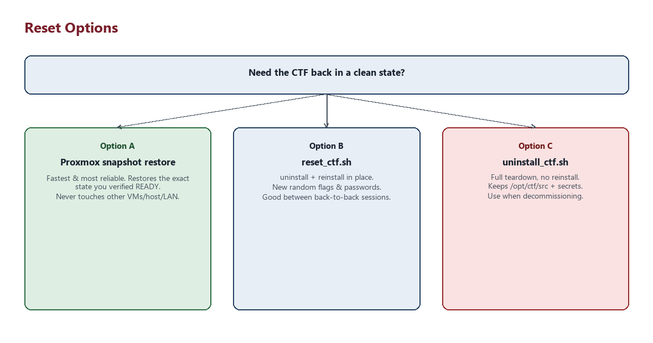
Figure: choosing a reset option
Organizer-only.
There are two ways to get back to a clean state between events, plus a third for when you're done with the CTF entirely.

Option A — Proxmox snapshot (recommended)
If you took a snapshot right after a verified CTF STATUS: READY (see INSTALLATION.md), restoring it is the fastest and most reliable reset: it exactly reproduces the state you tested, including the specific random flags/passwords from that install. Do this from the Proxmox web UI or:
qm rollback <vmid> <snapshot-name>
Restoring a snapshot never touches the Proxmox host, other VMs, or the LAN — it only affects the CTF VM itself.

Option B — reset_ctf.sh (in-place reset, new random flags)
Run this on the VM itself when you want a fresh install without going back to Proxmox:
sudo bash /opt/ctf/src/scripts/reset_ctf.sh
This runs uninstall_ctf.sh followed by install_ctf.sh (from the persisted copy at /opt/ctf/src), which resets:
- Users and passwords
- SSH configuration (port, host keys are left alone, drop-in config is rewritten)
- Web files
- Flags (freshly generated — different from the previous install)
- Backup files and the Agent999 access key (freshly generated keypair)
- .bash_history
- .beroot (recompiled with a freshly generated password)
- Permissions
- Sudo configuration
- Temporary challenge files
It does not touch Proxmox, other VMs, the host filesystem, or anything else on the LAN — everything it does is local to this VM.
Run sudo bash scripts/health_check.sh afterward to confirm READY before handing out the IP again.

Option C — uninstall_ctf.sh (full teardown, no reinstall)
sudo bash /opt/ctf/src/scripts/uninstall_ctf.sh
Removes the live deployment (users, web content, SSH/sudo configuration, backup/decoy directories, the decoy SUID binary, firewall rules) but deliberately leaves /opt/ctf/src (the persisted project checkout) and /opt/ctf/.organizer (the secrets manifest from the last install) in place, so it's safe to run from the persisted copy and safe to follow with install_ctf.sh again later.
If you want those removed too — for example, decommissioning the VM entirely — do it manually afterward:
sudo rm -rf /opt/ctf

Which should you use?
- Between back-to-back sessions of the same event, same day: reset_ctf.sh.
- Before a new event, or after any doubt about VM state: restore the Proxmox snapshot.
- Decommissioning the CTF VM: uninstall_ctf.sh, then rm -rf /opt/ctf manually, or simply delete the VM in Proxmox.

