Security Notes
Organizer-only. This documents what is *intentionally* insecure (the challenge itself) versus what must remain secure regardless (containment).

Everything in this list is intentional
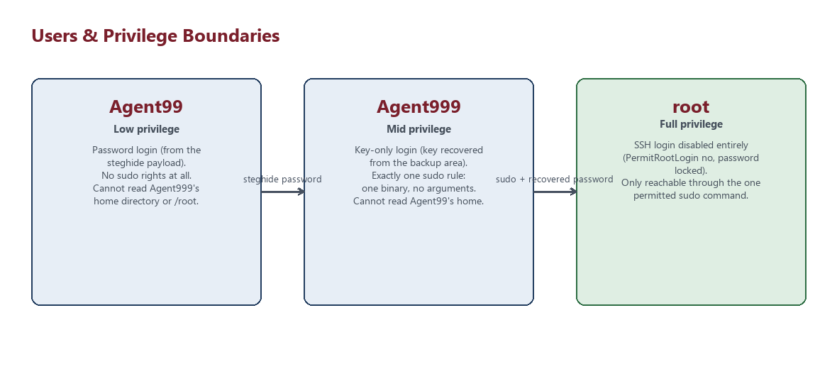
Figure: privilege boundaries between Agent99, Agent999, and root
These are the vulnerabilities players are meant to find and exploit. Do not "fix" them — they are the CTF:
- Agent99's SSH password is discoverable via web enumeration + steganography + a rockyou-crackable passphrase.
- Agent999's SSH private key is stored world-readable (644) outside its owner's home directory, in a backup location.
- Agent999's .bash_history contains an encoded flag left over from a prior session.
- Agent999 has a narrowly-scoped but real sudo rule to a custom binary (.beroot) whose hardcoded password is recoverable via reverse engineering.
- A SUID-root decoy binary (sysdiag) exists and is a deliberate red herring — see ORGANIZER_SOLUTIONS.md for why it is *not* exploitable.

What must remain true regardless
- No real credentials, keys, or identifying data anywhere in this project. Every password, SSH key, and flag is generated randomly by install_ctf.sh at install time and lives only inside the target VM's filesystem (/opt/ctf/.organizer/secrets.env, root-only, mode 600).
- rockyou.txt is never downloaded, bundled, or committed by any script here. The organizer must supply their own copy from wherever they already have security tooling installed; install_ctf.sh only reads a line out of it to sanity-check STEGHIDE_PASSPHRASE.
- The CTF VM must not be able to reach the Proxmox host, other VMs, or any production system — see NETWORK_GUIDE.md. Nothing in this project is designed with the assumption that it's network-isolated on its own; that isolation is the organizer's responsibility to set up (VLAN/dedicated bridge) and this project's responsibility not to undermine (it never tries to reach outside the host except during apt-get install).
- Flags are never stored in plaintext outside the root-only organizer manifest. Every on-disk copy a player can reach is base64-encoded; the raw CTF{...} string does not appear in any web-servable file, any world-readable file, or any file under a non-root user's home directory.
- root cannot be reached via SSH. PermitRootLogin no is set unconditionally, and passwd -l root locks the account's password. The only path to root is .beroot, run through the one sudo rule granted to Agent999.
- Test scripts (tests/*.sh) and this documentation must never be exposed to players. They live in the same repository as the challenge content as a matter of convenience, not because they belong on the target VM's attack surface — install_ctf.sh does deploy the whole project (including tests/ and every .md file) to /opt/ctf/src for the organizer's own later use, so make sure /opt/ctf stays root-only (700, as the install script sets it) and is never web-servable.

Firewall posture
Only 80/tcp, the configured SSH port, and 1337/tcp (reserved for the Flag 5 file-transfer step) are allowed inbound; default deny otherwise (ufw). See NETWORK_GUIDE.md.

Reporting a problem with these scripts
If you find a way for a player to reach further than intended (root without .beroot, reading another user's home directory, recovering a flag without decoding it, etc.), treat it as a bug in this project: fix the underlying script or permission, then reset and re-verify with tests/test_attack_path.sh and tests/test_permissions.sh before running another event.

