[Create a repository](https://docs.github.com/en/repositories/creating-and-managing-repositories/quickstart-for-repositories" \l "create-a-repository)

* GitHub repositories store a variety of projects. In this guide, you'll create a repository and commit your first change.
* In the upper-right corner of any page, select , then click New repository.

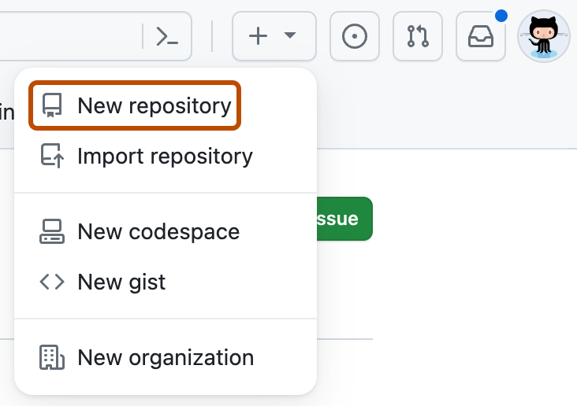

* Type a short, memorable name for your repository. For example, "hello-world".

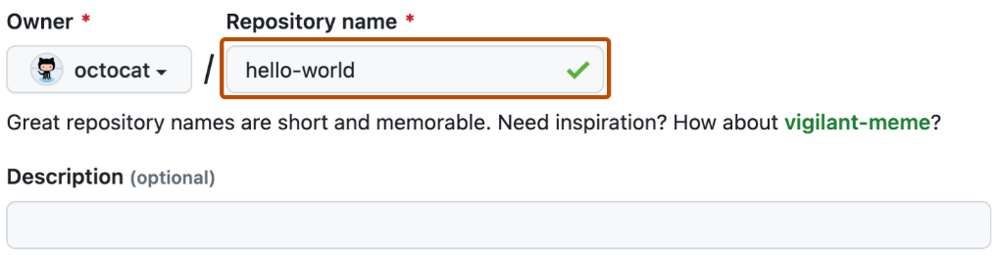

* Optionally, add a description of your repository. For example, "My first repository on GitHub."
* Choose a repository visibility. For more information, see "[About repositories](https://docs.github.com/en/repositories/creating-and-managing-repositories/about-repositories#about-repository-visibility)."
* Select Initialize this repository with a README.
* Click Create repository.