GUI – Drawing w/ a JPanel

**Purpose**

This lab was designed to review loops and introduce and demonstrate how to draw on a JPanel.

**Description**

Create the image below by using one loop and control statements to draw lines. The figures should scale accordingly as you resize the window.

**Program Shell**

Drawing.java

**Sample Execution**

One Corner Four Corners

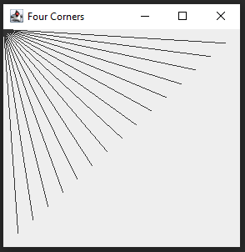 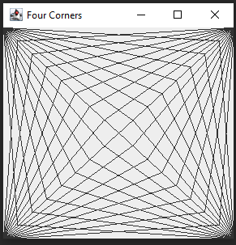

**Algorithm Help**

Define the number of lines you want (the number doesn’t matter).

Calculate the number of steps required to move horizontally and vertically. If you had 2 lines, what would you divide the width and height by?

Loop thru the number of lines and invoke drawLine 4 times.

g.drawLine(x1, y1, x2, y2); // clearly x1, and y1 are both zero for the top left corner

// bottom right corner is identical to the code above except change x1 and y1

// 2 more lines of code