GUI – Pizza

**Purpose**

This lab was designed to introduce swing components and to review the JOptionPane class.

**Description**

Create an application that allows a user to select the different choices for ordering a pizza.

**Program Shell**

Create your own

**Sample Execution**

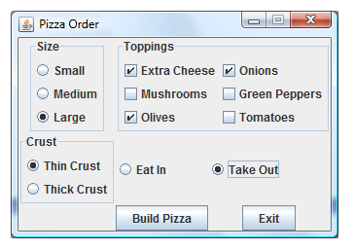

And clicking build pizza should output:

