GUI – Guess My Color

**Purpose**

This lab was designed to introduce swing components and layout managers.

**Description**

The Guess My Color game shows a sample color, initially black, and a target color. The object of the game is to slowly add or remove small amounts of red, green, and blue from the sample to try to match the target color. Even if you don't see color differences well, consider writing this game anyway. Guess My Color is a good introduction for how to work with colors, panels, layouts, buttons, and message dialogs.

I recommend using the default BorderLayout but you don’t have to. Moreover, I would choose a random color that has RGB values that are factors of 30 such as (60, 30, 240) and increment/decrement by 30(other numbers could work but don’t use anything too small).

**Program Shell**

Create your own.

**Sample Execution**

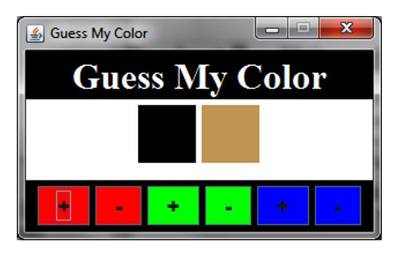

Upon successful completion output a message such as the following:

