GUI – Stopwatch

**Purpose**

This lab was designed to introduce GridBag layout, panels, buttons, and text fields.

**Description**

Create a stopwatch application using GridBag layout. The controls will be placed in the

following grid.

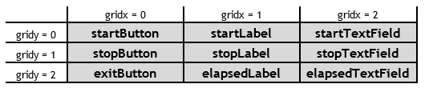

**long startTime = System.currentTimeMillis();**

**long stopTime = System.currentTimeMillis();**

**long elapsed = // the difference**

**Program Shell**

Create your own.

**Sample Execution**

