GUI – Drawing w/ a JPanel

**Purpose**

This lab was designed to review loops and introduce and demonstrate how to draw on a JPanel.

**Description**

Create the image below by using one loop and control statements to draw lines. It works best if you divide the length and the width into an even number of steps. The figures should scale accordingly as you resize the window.

**Program Shell**

Drawing.java

**Sample Execution**

One corner:

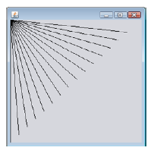

And w/ the other 3 corners:

