GUI – Drawing2 w/ a JPanel

**Purpose**

This lab was designed to review loops and introduce and demonstrate how to draw on a JPanel.

**Description**

Create the images below by using one loop and drawing lines. It works best if you divide the length and the width into an even number of steps. The figures should scale accordingly as you resize the window.

**Program Shell**

Drawing2.java

**Sample Execution**

One corner:

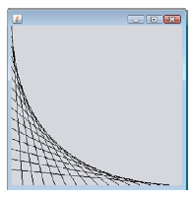

And w/ the other 3 corners:

