Part 4 GUI – Maze Generator and Anti-Maze Lab Value - 100

Lab Description : Add a button that creates a new maze. In createMaze(), remove all the components from mazePanel at the beginning of the method. (Hint: use JPanel's removeAll() method.) At the end of the method, rebuild all the components that are in mazePanel. (Hint: use JPanel's revalidate() method.) The JFrame will have lost focus after you add the button and the key strokes won’t work. Set the button’s focus to false(setFocusable(false)) or requestFocusInWindow(true) for the JFrame.

Play around with different sizes for rows and cols. Change your code to create an anti-maze which has the user move thru walls and not open spaces. In the draw the walls section of paintComponent(), instead of drawing the line on the top or left if the top or left edge is a wall, draw the line if the top or left edge is not a wall. As you can tell from the picture it might take a little bit of practice to solve the anti-maze(try a smaller grid).

Sample Output :
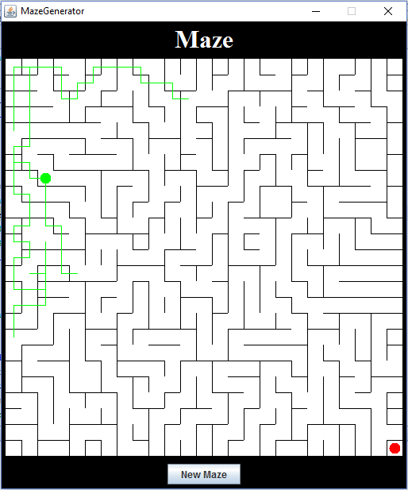
Files Needed ::
MazeGenerator.java

