Part 6 GUI – Maze Generator and Anti-Maze Lab Value - 100

Lab Description : Add a button or a drop down menu to visualize the maze being created. Then choose a different algorithm from the list below and implement it(I put the difficulty level next to it). A google search will quickly reveal how each one works. Afterwards update your project to be more aesthetically appealing.

{Recursive Division(8), Prim's(6), Kruskal's(8), Aldous-Broder(4), Wilson's(4), Hunt and Kill(5), Binary Tree(4),
Sidewinder(5), Growing Tree(5), Eller's(9)}
Files Needed ::
MazeGenerator.java

Sample Output :

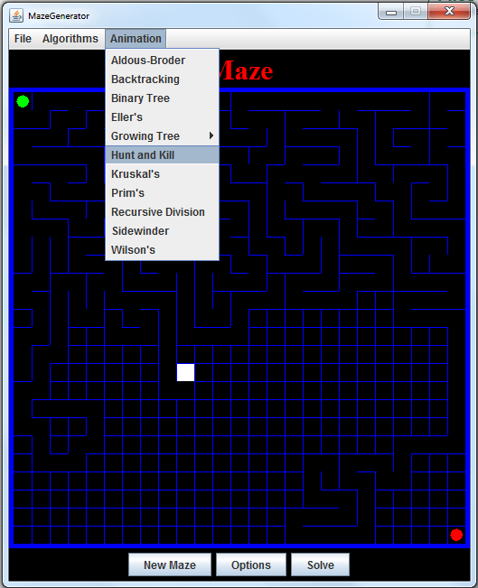

// and after solving

