A+ Computer Science Matrices – PASCAL’S TRIANGLE Lab Value - 100

Lab Goal : This lab was designed to teach you how to use a matrix, an array of arrays.

Lab Description : Read in each number from the file and print out a pascal’s triangle of that size.

Sample Data :
6
# of data sets in the file - 6
3
6
7
Files Needed ::
PascalsTriangle.java
PascalsTriangleRunner.java
triangle.dat

2
4
5

Sample Output :
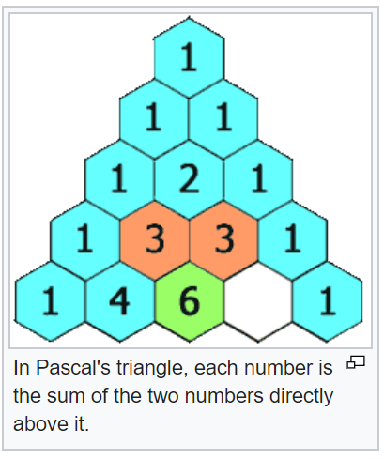
1
1 1
1 2 1

1
1 1
1 2 1
1 3 3 1
1 4 6 4 1
1 5 10 10 5 1

1
1 1
1 2 1
1 3 3 1
1 4 6 4 1
1 5 10 10 5 1
1 6 15 20 15 6 1

1
1 1

//BONUS +30
//OUTPUT EACH TRIANGLE
//AS AN EQUILATERAL TRIANGLE

1
1 1
1 2 1
1 3 3 1
1 4 6 4 1
1 5 10 10 5 1

1
1 1
1 2 1
1 3 3 1

1
1 1
1 2 1
1 3 3 1
1 4 6 4 1

