Part 5 GUI – Maze Generator and Anti-Maze Lab Value - 100

Lab Description : Add a button that provides options for the user(Hint: create a class that extends JDialog). Allow the user to enter permissable values for rows and cols and allow them to choose between the anti–maze version and the maze version. At the start of your create maze method clear the JPanel and at the end of it be sure to call pack() so that the JFrame will resize appropriately. Add a menu bar and provide options as well.

Add a solve button that will solve the maze using BFS or DFS and then output the optimal path(keep track using a HashMap<Cell,Cell>()). Add a timer to watch the maze be solved.
Files Needed ::
MazeGenerator.java

Sample Output :

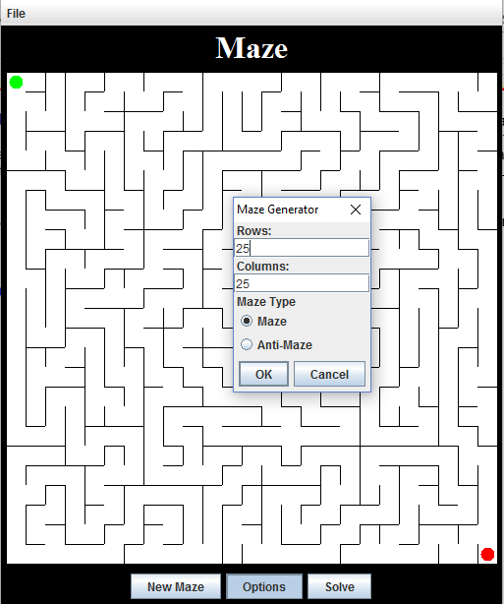

// And after calling solve

