Java – Review

**Purpose**

This lab was designed to review classes (constructors, accessors, mutators), methods and problem solving.

**Description**

Complete the class CreditCard that represents a credit card account. The instructions are provided at the top of CreditCard.java.

Write a complete class called InchWorm that models an inch worm moving along a horizontal line. The instructions are provided at the top of InchWorm.java.

Write a class that describes a flower. A flower has a location, a constructor and a draw method. The graphics are done for you and the flower should look like the picture below with (x, y) at the top left indicated by the red arrow. More detailed instructions are provided on Flower.java. Not all of the files provided are required to complete the lab.

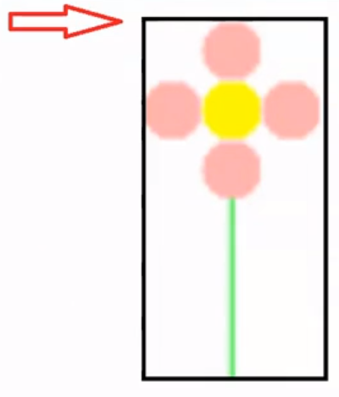

**Program Shell**

CreditCard.java CreditCardTesterFinal.java

InchWorm.java InchWormTesterFinal.java

Canvas.java Color.java Demo.java Ellipse.java Flower.java FlowerViewer.java Line.java OneFlowerViewer.java Picture.java Rectangle.java Shape.java Text.java

**Sample Execution** – for flower

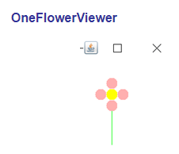

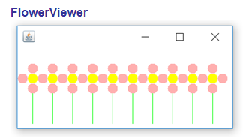

**Link to Solutions**

https://www.wevideo.com/view/1817432681