THE GRAIL COLLECTOR
CFD Simulation Report — Rev 4.1 edition
Sections 1–17: the Rev 2 report, unchanged, kept for provenance. Part V (Sections 18–24): the repaired 3-D conjugate CFD, the corrected closure, Dataset Rev 4 and the final claims. Where they differ, Part V governs.
Item | Value
Geometry | Converging roll-bond absorber, 12 channels, G = 0.539935
3-D solvers | OpenFOAM v1912: simpleFoam; chtMultiRegionSimpleFoam (frozenFlow)
Reduced-order conjugate model | GRAIL-CHT (2-D plate + 1-D per-channel fluid)
Current dataset | Rev 4.1 — Nu 4.48, Richardson plate grid, audited; 300 / 300
Superseded dataset | Rev 2 (Nu 2.9238), reported in Sections 1–17
3-D conjugate solutions | 12 converged (Section 19)
Experimental validation | None claimed; V5 reference rejected (Section 23)
Hardware | 2 CPU cores, 7 GB RAM

Contents

(In Word: right-click the field and choose Update Field.)

Supersession notice — read first
Nothing in Sections 1–17 was deleted or edited. The statements below were correct descriptions of what had been done at Rev 2 but are no longer the project's conclusions. Each is replaced by the section shown.
Table R1 — Statements in Sections 1–17 that Part V supersedes.
Statement in Sections 1–17 | Status | Now
Nu = 2.9238 is the grid-converged closure | SUPERSEDED | H2-type value; conjugate Nu 4.48 (Sec. 20)
Reported dataset Rev 2, 0 rejected | SUPERSEDED | Rev 4, 300 / 300 at two grids (Sec. 21)
Efficiency difference −4.94 / −4.33 % | SUPERSEDED | Group mean −7.3 %, p = 2e-8 (Sec. 21)
RMS uniformity benefit survives (−21.09 %, −11.52 %) | WITHDRAWN | Overall −1.1 %, n.s.; flow-dependent (Sec. 21)
Section 14: the 3-D conjugate run did not converge | RESOLVED | Root cause found, repaired (Sec. 18)
Plate grid 110 × 120 adequate | SUPERSEDED | First-order, ~3 pp error; Richardson used (Sec. 21)
Uncertainty headline (Section 16) | SUPERSEDED | Rev 4 budget (Sec. 22)

1. What this document is, and how to read it
This report describes the computational work behind the GRAIL collector: every simulation that was run, in the order it was run, with the numbers each one produced. It is written to be checked. Where a result was later found to be wrong, the wrong result is still here, together with what replaced it and why — because a study whose corrections are invisible cannot be audited.
The companion document, the CAD Model Report, describes the geometry. Everything in Section 3 onwards takes that geometry as given.

1.1 The staged ladder
Nothing was run at full complexity first. Each stage had to pass an acceptance test before the next was allowed to start. This is what the report follows:
Gate | What it established | Outcome
Gate 0 | Environment and solver capability audit | PASS — capability matrix recorded
Gate 1 | Geometry acceptance: 12 invariants on the CAD | PASS — 12/12
Gate 2 | Meshing strategy: snappyHexMesh rejected, direct NURBS adopted | PASS
Gate 3 | 3-D single-channel flow + energy verification | PASS — mass 2.2e-16, energy -0.198 %
Gate 4 | 3-D grid convergence, Nusselt extraction | PASS with a caveat — Nu not converged
Gate 5 | Conjugate plate solver, limit tests | PASS — both limits collapse to zero
Gate 6 | Domain equivalence (how much plate is needed) | PASS — 2-channel periodic validated
Gate 7 | Production campaign, 300 cases | PASS — 0 rejected
Gate 8 | Uncertainty, sensitivity, validation, closeout | PASS — 3 of 4 claims survive
Gate 9 | 3-D conjugate run on the meshed solid | FAILED — reported as failed

1.2 Rules the work was held to
- SI units internally. Kelvin wherever an absolute temperature appears — in every fourth power, every Stefan-Boltzmann term and every sky-temperature relation. Celsius appears only in prose, never in a formula.
- No invented OpenFOAM capability. Every solver, dictionary entry, boundary condition and function object named here was verified present in the installed v1912 binaries first.
- The superseded diverging-channel geometry is never used as a baseline, a validation case, a comparison or a figure. It appears in this document only as a correction entry.
- No row was ever deleted to improve a result. The one place where rows went missing is Section 10.2, and it is reported as a defect of the earlier revision, not a cleanup.
- Every assumed dimension or property is labelled ENGINEERING_ASSUMPTION and none is attributed to the design roadmap.

2. Gate 0 — the machine and what the solver could actually do
The audit was performed before a single case directory was created, because the hardware decides the campaign size and the installed solver decides which physics can be claimed.
Table 1 — Platform.
Item | Value
Operating system | Ubuntu 24.04.4 LTS (x86_64)
CPU cores | 2
RAM | 7 GB
Free disk | 26 GB
MPI | Open MPI 4.1.6
Mesh tool | gmsh 4.15.2
Python stack | numpy 2.4.4, scipy 1.17.1, pyvista 0.48.4
OpenFOAM | ESI v1912, package 1912.200626-2build3
The capability matrix was built by inspecting the installed binaries and libraries, not by recalling what OpenFOAM can do in general. Everything the study would need was confirmed present: chtMultiRegionSimpleFoam for steady conjugate heat transfer, simpleFoam for the laminar verification stages, viewFactor / fvDOM / P1 radiation, solarLoad, turbulentTemperatureRadCoupledMixed for the coupled interface, externalWallHeatFluxTemperature for ambient loss with thicknessLayers, the fvOption solidificationMeltingSource for phase change, createPatch cyclics, splitMeshRegions and checkMesh.
Two gaps were found and routes recorded rather than papered over. Temperature-dependent glazing transmittance is not a native boundary condition and had to be implemented as an outer-loop controller updating the absorbed flux from the previous iterate. And v1912 solid thermophysics is isotropic per region, so the two anisotropic materials in the database — PC honeycomb (0.075 perpendicular / 0.16 parallel) and the graphite interface layer (300 / 5) — are carried at their through-thickness value, which is the governing direction, with the simplification documented rather than silently averaged.
The binding constraint
Two cores and 7 GB. This does not limit fidelity — a structured hex mesh of any level fits.
It limits CAMPAIGN SIZE. The per-case cost therefore had to be measured on the real mesh before any campaign size was committed, and it is why the 300-case production campaign runs on the reduced-order conjugate solver of Section 9 rather than on 300 3-D cases.

2.1 The material database
Taken verbatim from the design roadmap's material table. These are handbook values for the material class, not supplier datasheet values; the roadmap's own verification item V6 requires confirmation against datasheets before final runs, and that has not happened. Every uncertainty in Section 13 is therefore an ENGINEERING_ASSUMPTION.
Table 2 — Materials used by the simulations.
Material | rho (kg/m³) | cp (J/kg·K) | k (W/m·K) | Other | Role
Water at 300 K | 997 | 4180 | 0.610 | mu = 8.55e-4 Pa·s | fluid region
Aluminium AA1050 | 2705 | 900 | 229 | — | absorber sheets
Low-iron solar glass | 2500 | 750 | 1.05 | eps = 0.88 | glazing
PC honeycomb | 85 | 1200 | 0.075 perp | tau = 0.82 | TIM
TiNOX coating | — | — | surface BC | alpha 0.95, eps 0.04 | absorber surface
RT55 + 10 % EG, solid | 880 | 2000 | 2.80 | L = 170 kJ/kg | PCM
RT55 + 10 % EG, liquid | 770 | 2200 | 2.40 | T_m = 51–57 °C | PCM
Graphite interface | 1100 | 710 | 5 perp | — | PCM contact layer
VIP fumed silica | 190 | 850 | 0.006 | derate 20 % / 25 y | rear insulation

2.2 The optical chain and the external relations
Every thermal result in this study begins at the same absorbed flux. The chain is four multiplications and it is worth stating exactly, because an earlier revision of the design documentation carried the single-pane transmittance and would have put 8.5 % more energy into the absorber:
q″ = G_T × tau_glz_sys × tau_TIM × alpha_abs = 800 × 0.833 × 0.82 × 0.95 = 519.13 W/m²
The 0.833 is the two-pane system value. Using the superseded 0.91 would give 567.1 W/m². The change is recorded as correction CR-02 and it invalidates any efficiency computed from the old figure.
Table 3 — External boundary relations. Kelvin only.
Relation | Form
Sky temperature | T_sky = 0.0552 · T_amb^1.5 (T_amb in K)
Wind convection | h_wind = 5.7 + 3.8 · v_wind (W/m²K, v in m/s)
Rear external, still air | h_rear = 3 W/m²K
Surface radiation | q_rad = eps · sigma · (T_s⁴ − T_sur⁴), sigma = 5.670374419e-8

3. Gate 2 — how the mesh was made, and why not snappyHexMesh
The obvious route was rejected on measured evidence, not on preference.

3.1 What failed
snappyHexMesh needs a surface tessellation. gmsh's 2-D mesher could not produce one. Three attempts at progressively relaxed sizing — minimum element 0.12 mm through 0.35 mm, curvature refinement on and off, algorithms 1, 5 and 6 — each ran for more than ten minutes without completing a single surface, and one aborted outright with “Impossible to mesh periodic surface”.
The diagnosis matters because it is not what it looks like. The geometry is not pathological: the boolean that cuts the channels completes in 3.3 seconds and the cut solid has only 16 faces. The problem is that each channel wall is a single B-spline surface 1100 mm long:
CH05 faces:
face 1187 Plane x[ 550.000 550.000] area = 7.8630
face 1188 Plane x[-550.000 -550.000] area = 28.0652
face 1189 BSpline surface x[-550.000 550.000] area = 18069.7603
Its parametric domain is stretched 1100 mm in one direction against roughly 21 mm of section perimeter in the other, which is pathological for Delaunay meshing in parameter space.

3.2 What the surface probe found instead
The same wall carries a clean unit parameterisation — u around the section perimeter, v along the channel:
wall face 1189 param bounds u[0, 1] v[0, 1]
varying u -> dx = 0.000 dy = 8.4993 dz = 4.1021 (section perimeter)
varying v -> dx = 1100.000 dy = 2.0845 dz = 0.0963 (axial)
200 x 400 = 80,000 surface points evaluated in 0.05 s
Direct evaluation is about four orders of magnitude faster than meshing the same surface, and it lands exactly on the NURBS rather than on a tessellation of it.

3.3 The route adopted
- Sample the channel wall on a structured (u, v) grid — u around the section, v along the flow.
- Build an O-grid inside each section: wall ring, then graded radial layers, then a square core. This gives genuine boundary-layer control through radial grading rather than through snappyHexMesh's addLayers heuristics.
- Sweep along v to form hexahedra.
- Build the solid region as conforming H-grid blocks around the channels, sharing the wall nodes exactly, so the conjugate interface is conformal by construction.
- Write polyMesh directly, then splitMeshRegions -cellZones and createPatch for the cyclics.
Table 4 — Why this was the right choice, not merely the workable one.
Criterion | snappyHexMesh | Structured by direct evaluation
Geometry fidelity | snapping error on top of tessellation error | exact on the NURBS
Cell type | hex-dominant, split cells at the 0.5 mm fillet | 100 % hexahedral
Boundary layers | addLayers, often fails in tight fillets | radial grading, deterministic
Cells for given accuracy | high — octree refines the neighbourhood too | low — placed only where needed
Grid-independence study | rerun per level, quality varies | change N; levels exactly self-similar
Campaign regeneration | re-export CAD per design point | change parameters
Cost on 2 cores | prohibitive | tractable
The last two rows decide it. The campaign requires regenerable geometry, and a pure-hex mesh is the only way this problem fits on two cores without coarsening below the resolution it needs.
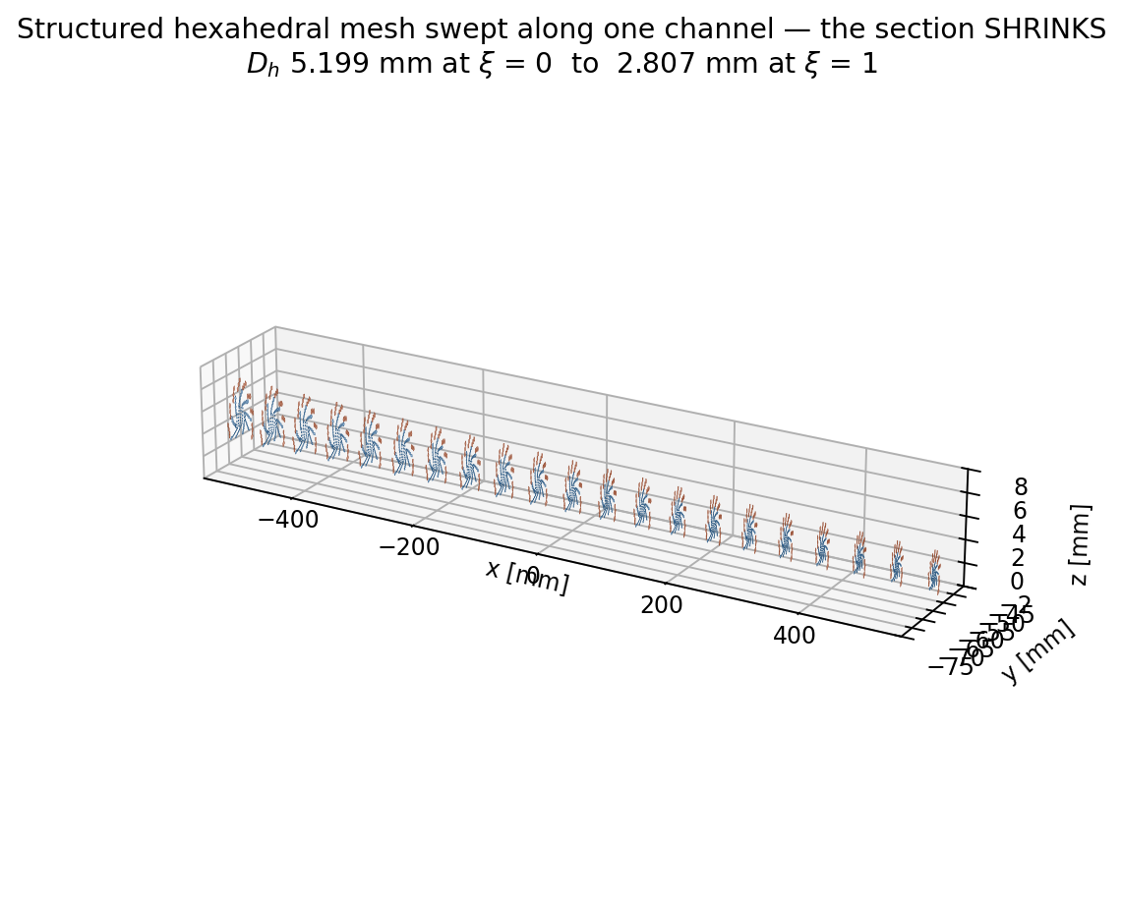
Figure 1 — The swept structured mesh in a single converging channel: an O-grid section swept along the flow, graded radially towards the wall.
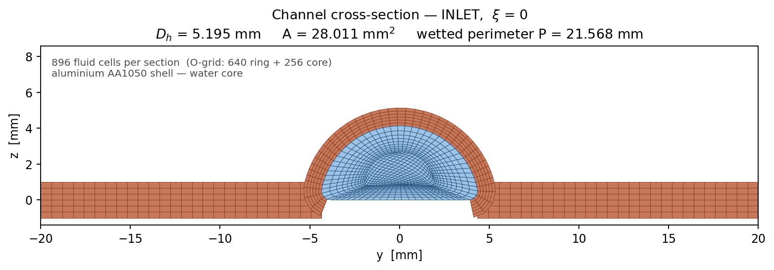
Figure 2 — The O-grid at the inlet station, where the section is widest (A = 28.057 mm²).
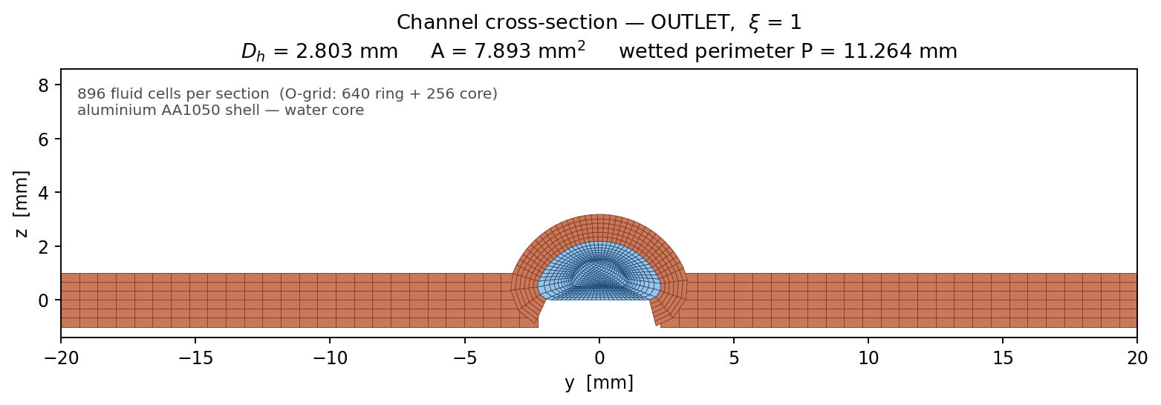
Figure 3 — The same topology at the outlet, A = 7.921 mm². The levels are self-similar, which is what makes the grid study clean.

4. Gate 3 — the 3-D single-channel verification run
This is the foundation case. It is fluid-only: the absorbed solar flux is imposed on the channel wall and there is no solid region. Its purpose is to verify geometry, mesh, hydraulics and energy transport before any conjugate physics is switched on, and to measure the heat-transfer closure that the plate solver will later use.
Table 5 — Case definition.
Item | Value
Solver | OpenFOAM v1912 simpleFoam (laminar, SIMPLEC), then scalarTransportFoam
Mesh | structured O-grid, 105,600 hexahedra, 100 % hex, checkMesh = Mesh OK
Domain | single channel CH05, x = −550 to +550 mm, from the verified CAD NURBS
Turbulence model | none — the flow is deeply laminar (see Section 4.4)
Total mass flow | 0.0025 kg/s → 2.0833e-04 kg/s per channel
Inlet temperature | 300 K
Absorbed flux | 519.13 W/m² of plate → 22.8415 W per channel → 1264.07 W/m² on the wall
That last conversion is worth following. The 519.13 W/m² falls on the plate. Each channel owns a 40 mm × 1100 mm strip of plate, which is 0.044 m², giving 22.8415 W. That power is then applied to the channel's own wetted wall area, which is much smaller than the plate strip, so the wall flux is 1264.07 W/m².

4.1 Convergence — numerical and physical
Residuals alone are not evidence. Two independent physical balances were checked as well:
Table 6 — Convergence of the baseline case.
Level | Criterion | Achieved
Numerical | p, U, T residuals | p 2.3e-08, Ux 5.6e-08, Uy 1.9e-07, T 4.6e-05
Physical — mass | sum of face fluxes, in + out | 2.18e-16 m³/s (0.0000 %)
Physical — energy | Q_u against Q_imposed | 22.7962 W against 22.8415 W → −0.198 %

4.2 Hydraulic results
Table 7 — Hydraulics at the design point.
Quantity | CFD | Reference | Deviation
Pressure drop | 35.31 Pa | 33.31 Pa (laminar, f·Re = 16) | +6.0 %
Pumping power | 7.3778e-06 W | — | —
Peak velocity | 52.86 mm/s | — | —
Outlet bulk velocity | 31.81 mm/s | 26.38 mm/s (mdot/rho·A) | —
Peak / bulk ratio | 2.01 | 2.0, laminar duct | +0.5 %
The +6 % on pressure drop has the right sign and a physical explanation. The reference uses the circular-duct f·Re = 16, whereas a lenticular section with a 0.5 mm root fillet runs higher, and the flow accelerates 4.8× through the convergence. The peak-to-bulk ratio landing on 2.01 against the textbook laminar 2.0 is the strongest single check here: it is a profile-shape result the mesh could not fake.
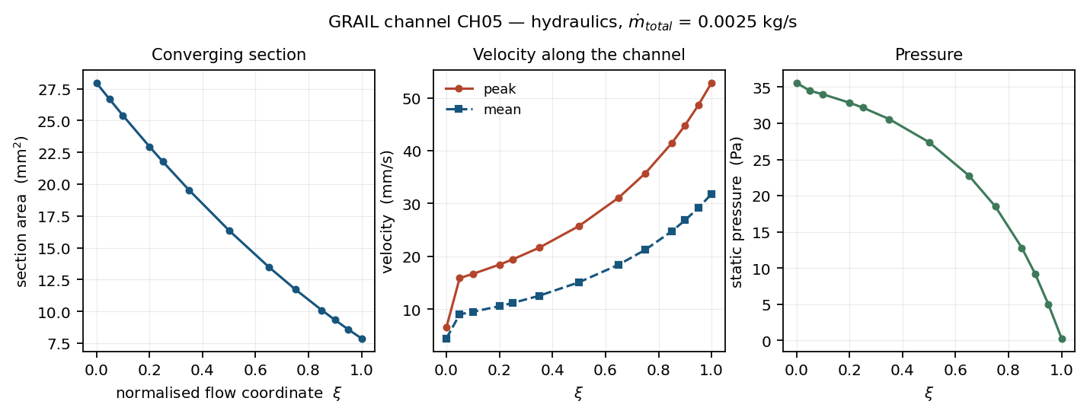
Figure 4 — Baseline hydraulics along the channel.
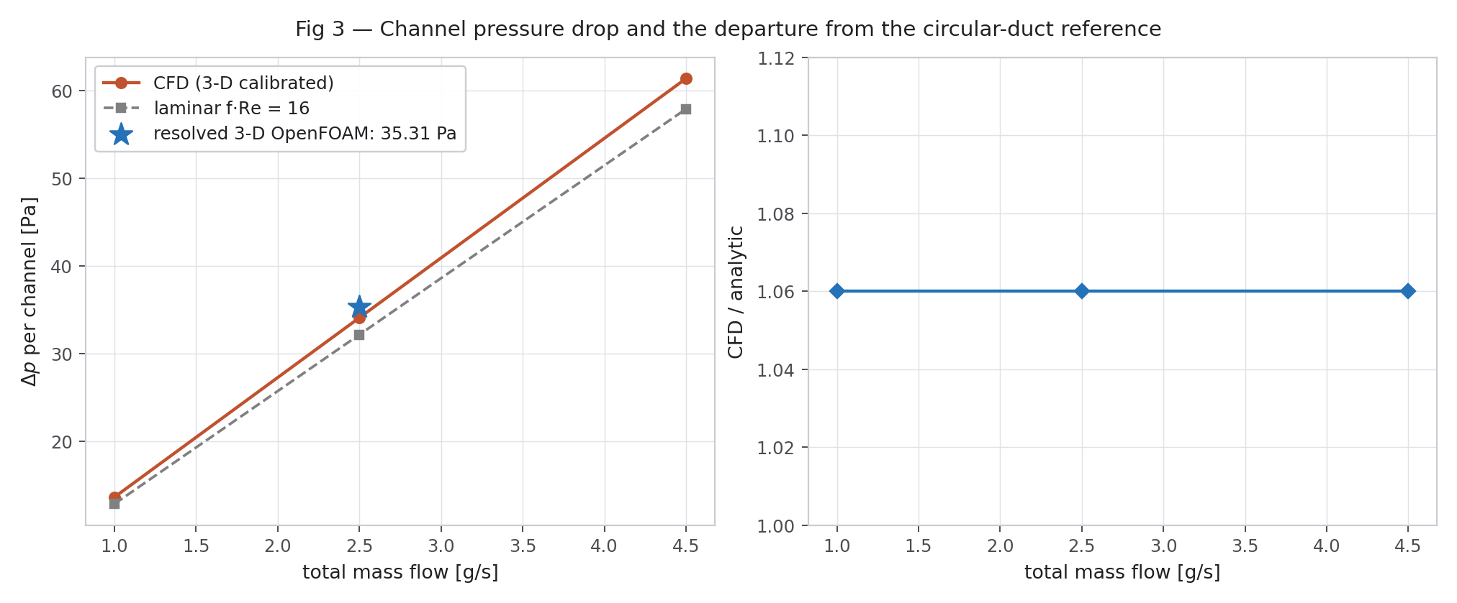
Figure 5 — Pressure drop against mass flow across the operating range.

4.3 Thermal results
Table 8 — Thermal results at the design point.
Quantity | Value
T_out, flux-weighted bulk | 326.1775 K (53.03 °C)
Fluid temperature rise dT | 26.1775 K
Analytic Q/(m·cp) | 26.230 K
Deviation | −0.200 %
Wall-adjacent temperature | 300.21 min / 316.57 mean / 328.84 max K
Useful heat Q_u | 22.7962 W
Table 9 — Section by section, at xi measured from the channel's own inlet.
xi | x (mm) | A (mm²) | u_max (mm/s) | u_mean | p (Pa) | T_mean (°C) | T_max (°C)
0.00 | −550 | 27.975 | 6.557 | 4.458 | 35.593 | 26.922 | 27.376
0.10 | −440 | 25.408 | 16.678 | 9.506 | 34.000 | 30.649 | 35.079
0.25 | −275 | 21.787 | 19.423 | 11.178 | 32.164 | 35.351 | 39.905
0.50 | 0 | 16.373 | 25.742 | 15.094 | 27.393 | 42.262 | 46.255
0.75 | +275 | 11.736 | 35.730 | 21.250 | 18.514 | 48.182 | 51.501
0.90 | +440 | 9.325 | 44.814 | 26.833 | 9.214 | 51.258 | 54.141
1.00 | +550 | 7.872 | 52.857 | 31.814 | 0.285 | 53.099 | 55.686
Two physical signatures in that table are worth pointing out to a reader, because both are correct and both would look like errors to someone skimming.
- Entrance development. At xi = 0 the peak velocity is 6.56 mm/s against a mean of 4.46, a ratio of 1.47 rather than 2. That is the imposed uniform inlet profile, not yet developed. By xi = 0.10 the ratio has reached the laminar value and holds to the outlet.
- Concave temperature rise. dT(xi) lies above the straight line Q·xi/(m·cp). The wall flux is uniform, but the wetted perimeter falls from 21.59 mm to 11.29 mm, so more heat enters per unit length upstream than downstream. The curvature is a direct consequence of the convergence, not a numerical artefact.
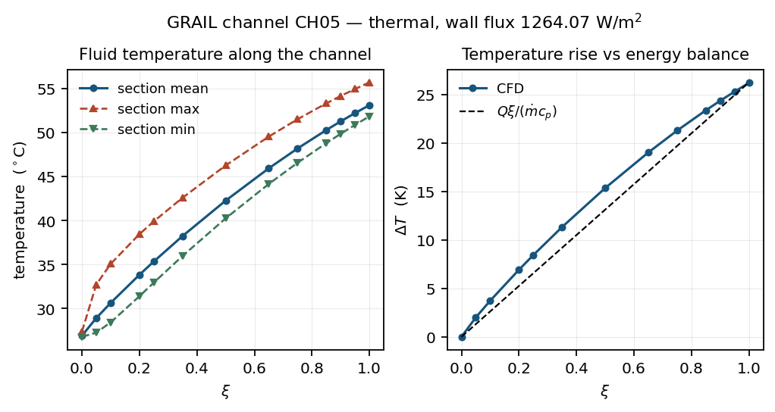
Figure 6 — Baseline thermal development along the channel.
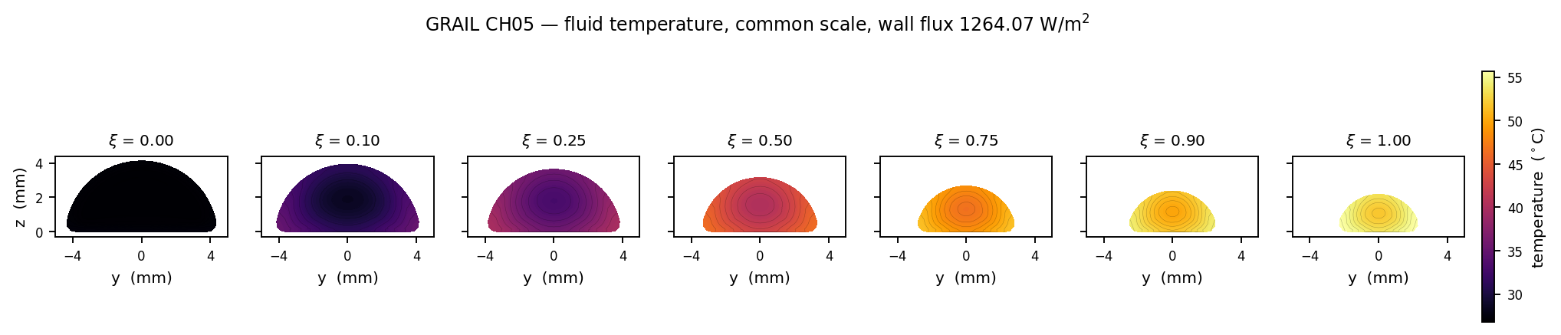
Figure 7 — Temperature field at successive sections.
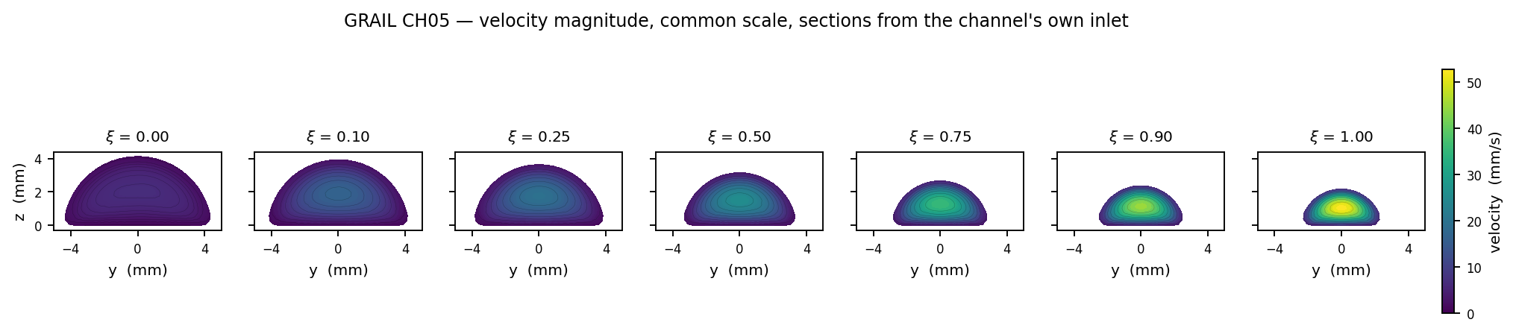
Figure 8 — Velocity field at successive sections: the flow accelerates 4.8× as the section converges.

4.4 Two Reynolds numbers, and why both are reported
The design brief specifies Re = 4·mdot/(pi·D_h·mu). That is the circular-duct form. It equals the physical duct Reynolds number rho·u·D_h/mu only when A = pi·D_h²/4, which this section does not satisfy:
Table 10 — The section is not circular, so the two definitions differ.
Station | A actual (mm²) | pi·D_h²/4 (mm²) | ratio
inlet | 28.057 | 21.229 | 1.322
outlet | 7.921 | 6.188 | 1.280
Table 11 — Reynolds number across the operating range, both definitions.
mdot_total (kg/s) | Re brief, inlet → outlet | Re physical, inlet → outlet
0.0010 | 23.87 → 44.21 | 18.06 → 34.54
0.0025 | 59.67 → 110.53 | 45.15 → 86.34
0.0045 | 107.41 → 198.95 | 81.27 → 155.41
Deeply laminar under either definition, which is what justifies running with no turbulence model. But any f·Re or Nusselt correlation quoted from this work must state which definition it uses, or it is wrong by about 30 %.
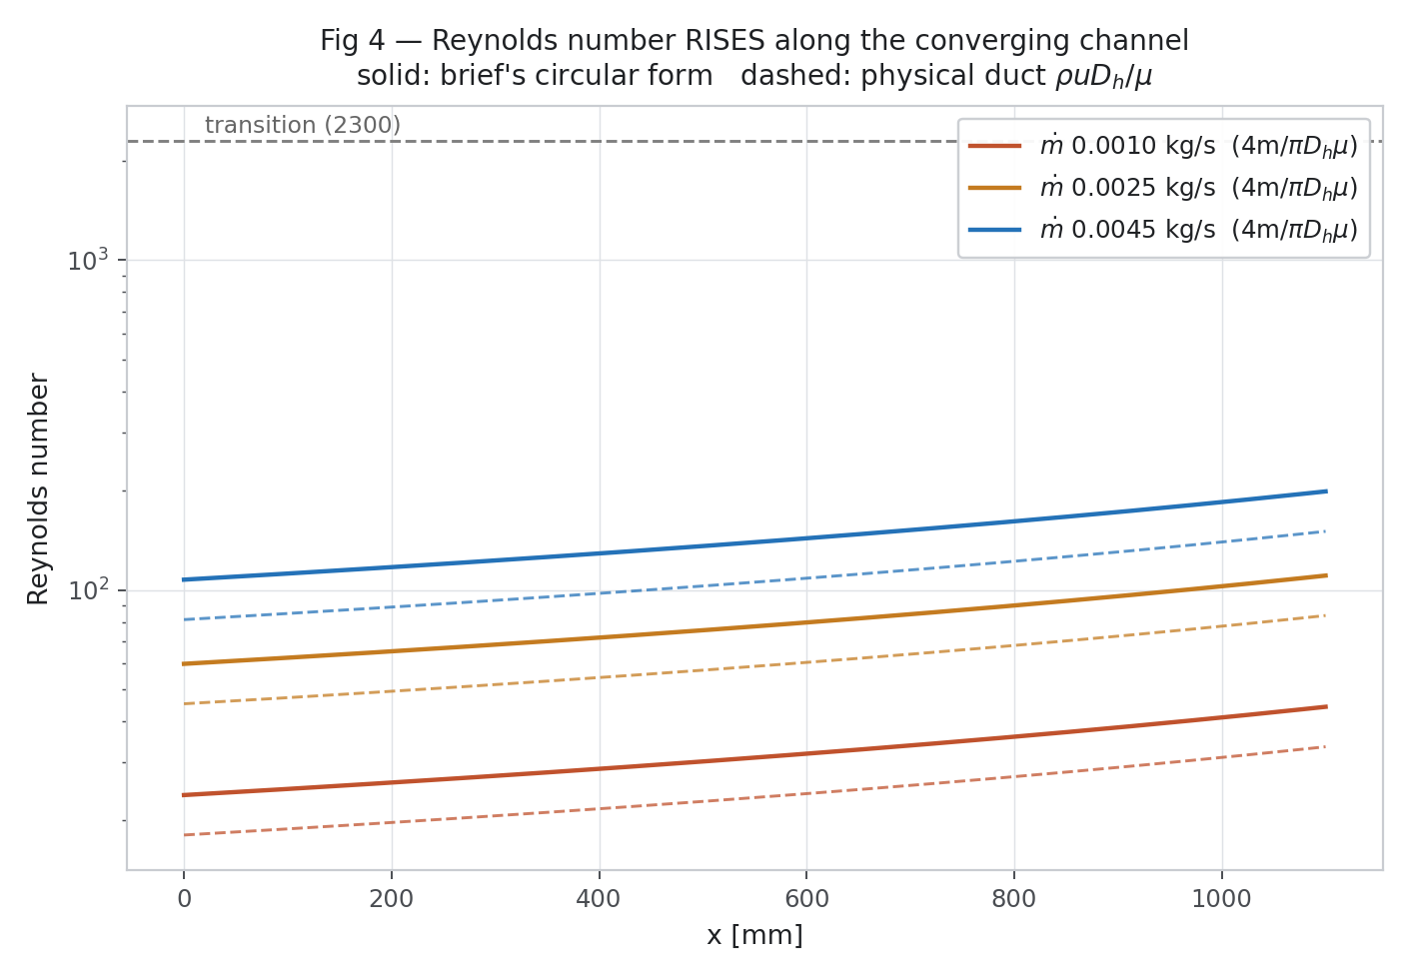
Figure 9 — Reynolds number along the channel across the campaign flow range. It rises along the flow because the section shrinks faster than the perimeter.

4.5 Buoyancy — checked, not assumed away
The flow is slow enough that natural convection inside the channel is a fair question. It was evaluated rather than dismissed; Figure 10 records the result.
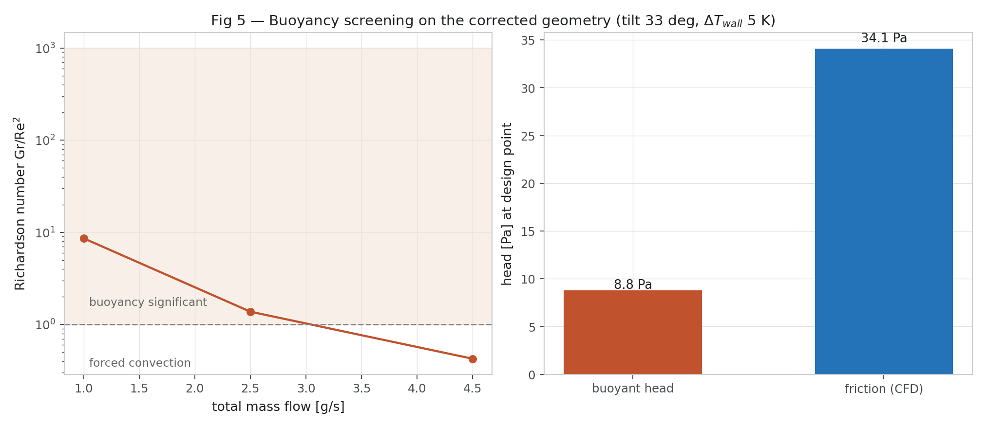
Figure 10 — Buoyancy assessment for the channel flow.
Figure 11 — 3-D hydraulic field summary.
Figure 12 — 3-D thermal field summary.
Figure 13 — 3-D velocity field.
Figure 14 — 3-D temperature field.
What this stage is NOT
There is no solid region here, therefore no bridge conduction, no lateral transfer between neighbouring channels and no alternating-flow mechanism.
Nothing in Section 4 speaks to the central hypothesis. It verifies the tools that will be used to test it.

5. Gate 4 — 3-D grid convergence, and the one number that would not converge
Three grids at a refinement ratio of about 1.5 in cell count per direction, each run to its own residual controls. The fine grid reported “SIMPLE solution converged” after 360 iterations — it was not stopped at an endTime.
Table 12 — Three-level 3-D grid study, Roache GCI.
Quantity | L1 (34,304) | L2 (105,600) | L3 (356,400) | order p | GCI
Pressure drop (Pa) | 35.872 | 35.592 | 35.468 | 2.278 | 0.290 %
Temperature rise (K) | 25.859 | 25.964 | 25.975 | 6.311 | 0.004 %
Meshed volume (mm³) | 18,500 | 18,579 | 18,617 | 2.159 | 0.179 %
Peak / bulk velocity | 1.8274 | 2.0617 | 1.9274 | 1.442 | 10.972 %
Nu, developed region | 4.1272 | 3.9129 | 3.7519 | 0.937 | 11.610 %
Pressure drop, temperature rise and meshed volume are converged at second order with grid convergence indices of 0.29 %, 0.004 % and 0.18 %. The hydraulic side of the baseline is sound and needs no further refinement.

5.1 The Nusselt number is not converged
Applying the original extraction method unchanged — developed region taken as xi > 0.15 — to all three grids:
Table 13 — Nusselt number against grid, and the Richardson extrapolation.
Grid | Cells | Nu
L1 | 34,304 | 3.7397
L2 | 105,600 | 3.4282
L3 | 356,400 | 3.2236
Richardson extrapolation | — | 2.9238
observed order p = 1.283 → GCI = 11.63 % → u(nu_cfd) = 9.30 %
First order, not second. Two independent extraction methods agree on this: the alternative gives p = 0.937 and GCI 11.61 %. The Monte Carlo of Section 13 had assumed a 5 % standard uncertainty on this input; 9.30 % is nearly double that.
This is a bias, not merely an uncertainty
Every conjugate result in the first revision of this study ran at nu_cfd = 3.4282, the MEDIUM-grid value. The grid-converged value is 2.9238.
The solver had therefore been running +17.25 % high on the one input that Section 13 shows controls 91 % of the uniformity difference.
Rather than extrapolate a linear sensitivity model nearly three standard deviations outside its sampled range, the corrected value was RUN. That is the Rev 1 → Rev 2 recomputation of Section 12.
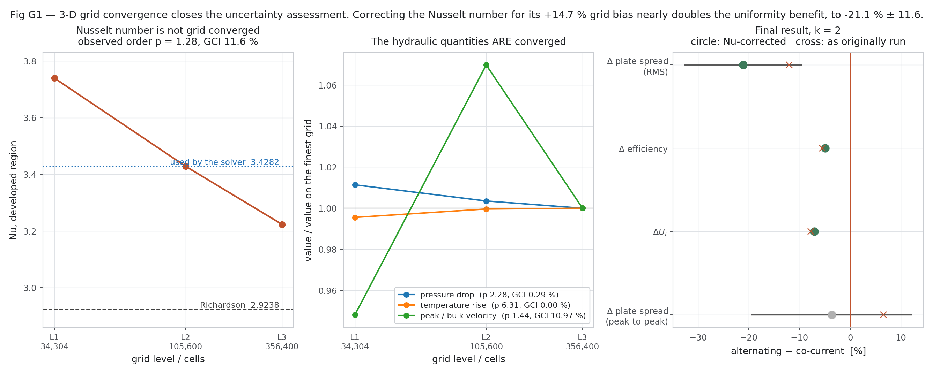
Figure 15 — The three-level 3-D grid study. Pressure drop and temperature rise converge cleanly; the Nusselt number is still falling at 356,400 cells.
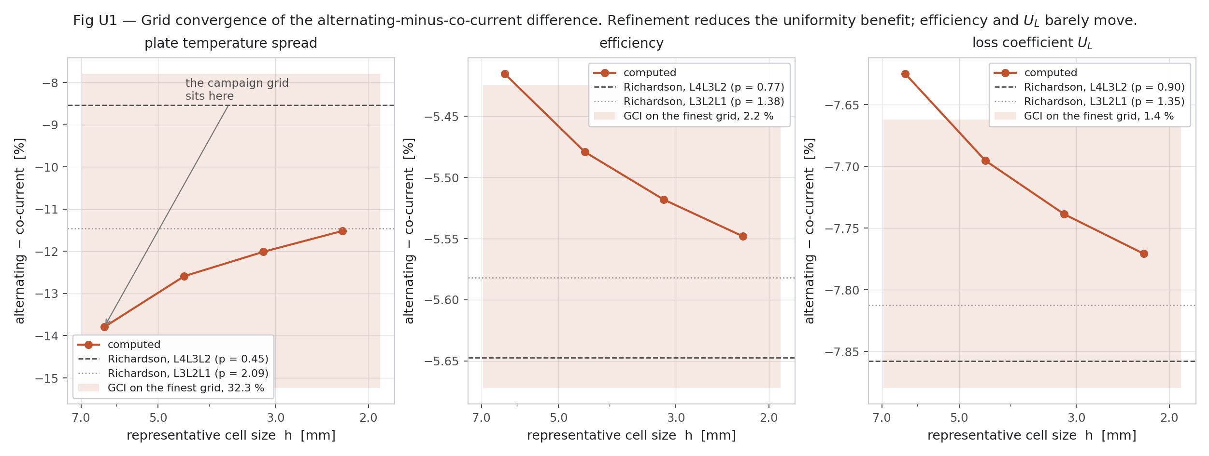
Figure 16 — Grid convergence, both the 3-D study and the conjugate plate grid.
A fourth grid level would be needed to tighten the 11.6 % band on Nu. It was estimated at more than 20 hours on the two cores available and is declared infeasible here rather than quietly omitted.

6. Gate 5 — the conjugate plate solver
The central hypothesis is about what happens across the whole 12-channel absorber when alternate channels run in opposite directions. A single 3-D channel cannot answer it, and 300 three-dimensional conjugate cases do not fit on two cores. A purpose-built conjugate solver, GRAIL-CHT 1.0, was written to close that gap.

6.1 What it solves
Region | Physics
Plate | 2-D steady conduction over the whole absorber, with anisotropic sheet thickness, solar gain, top loss through the real glazing stack with explicit radiation, rear loss through PCM and VIP, and local convective coupling to each channel
Fluid | 1-D energy per channel, marched in that channel's OWN flow direction, so an alternating arrangement is represented exactly rather than approximated
Closure | h(x) = Nu · k / D_h(x), with Nu taken from the resolved 3-D OpenFOAM solution
Everything is SI internally and Kelvin appears wherever a fourth power does. The geometry class carries the Gate 1 measured values directly: A_in 28.056939 mm², A_out 7.921436 mm², P_in 21.5865 mm, P_out 11.2884 mm, D_h,in 5.198875 mm, D_h,out 2.807053 mm, w_ch,in 8.714056 mm, G = 0.539935, lambda_G = 1.0, pitch 40 mm, L 1100 mm, plate 1100 × 480 mm, both sheets 1.0 mm.
The section law is the one confirmed on the CAD:
D_h(xi) = D_h,in · [1 − (1 − G) · xi^lambda_G], A(xi) = A_in · s², P(xi) = P_in · s, s = D_h(xi)/D_h,in

6.2 Verification before any conclusion
The difference between the two flow arrangements must vanish in two independent limits: when lateral conduction cannot act at all, and when it acts perfectly. If a solver does not reproduce both, whatever difference it reports is numerical. Both limits were tested by sweeping the plate conductivity over eight orders of magnitude.
Table 14 — Plate-conductivity limit test. The effect must and does collapse at both ends.
k_plate (W/m·K) | dQ_u | dR4 | Comment
0.01 | +0.0006 % | −0.0008 % | no lateral path → arrangements identical
1 | −0.126 % | +0.217 %
22.9 | −2.618 % | +7.861 %
229 (AA1050) | −5.415 % | +17.048 % | the real material
2290 | −3.456 % | +10.384 %
2.29e6 | −0.009 % | +0.024 % | isothermal plate → arrangements identical
Both limits collapse to zero and the effect peaks at finite conductivity, which is the signature of a genuinely conduction-mediated mechanism. The energy balance closes to 1e-5 % in every case in this table, and the outer-loop tolerance is 1e-8.
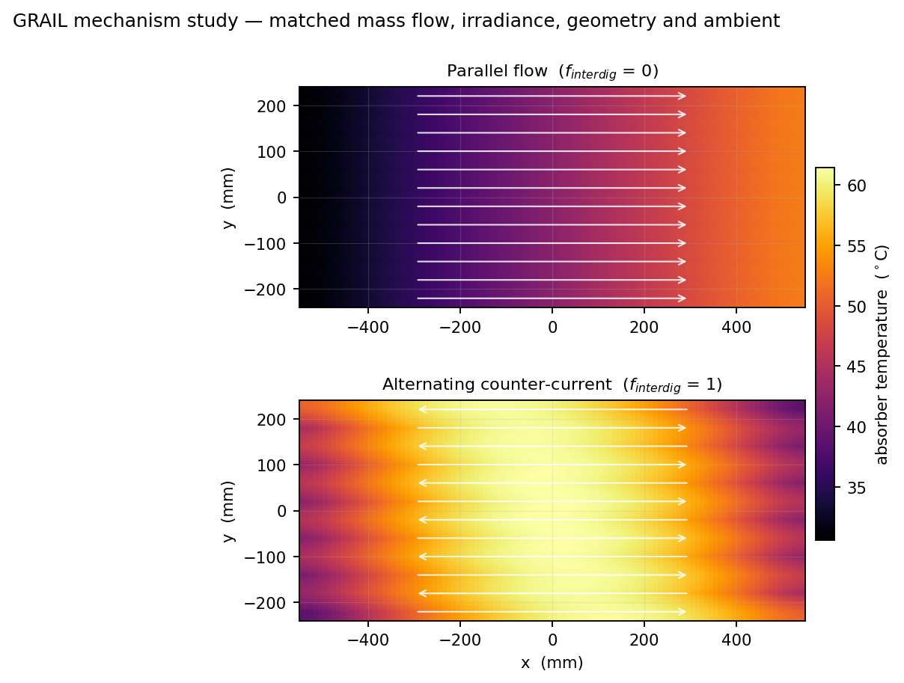
Figure 17 — Plate temperature fields, co-current against alternating, on the full 12-channel absorber.

7. The mechanism, tested link by link
The claim behind Filing 1 is a chain of seven steps: opposite flow creates opposing gradients, metal carries heat sideways, the absorber field flattens, hot regions shrink, the mean of T⁴ falls, radiative loss falls, and efficiency rises. Each link was tested separately, because a chain reported only at its end cannot be diagnosed.
These runs were made at nu_cfd = 3.428 — the Rev 1 value. Section 10 gives the corrected campaign numbers. The chain's verdicts are unchanged by the correction; the magnitudes in Table 16 are Rev 1 magnitudes and are labelled as such.
Table 15 — The causal chain, link by link.
# | Hypothesised link | Verdict | Evidence
1 | Opposite flow → opposing local gradients | CONFIRMED | per-channel outlets spread 319.97–326.45 K instead of a uniform 324.11 K
2 | Lateral heat transfer through the metal bridge | CONFIRMED, LARGE | 218.35 W across the 11 bridge planes; lateral:axial conduction ratio 175.8
3 | Absorber temperature homogenisation | CONFIRMED | T_p standard deviation −8.8 % at matched mean (−13.8 % at matched flow)
4 | Reduction of high-temperature regions | NOT CONFIRMED | P99 only −1.05 %; the plate spread actually RISES +10.8 %
5 | Reduction in mean(T⁴) | NEGLIGIBLE | −0.045 % at matched mean
6 | Reduction in radiative loss | NEGLIGIBLE | Q_rad 2.62906 → 2.62384 W, −0.20 %, i.e. 5.2 mW out of 274 W
7 | Improvement in useful heat | NO | +0.001 % at matched mean; −5.4 % at matched mass flow

7.1 The fair test: matched mean plate temperature
Comparing two arrangements at the same mass flow compares two different operating states. The inlet temperature was therefore tuned to 285.689 K so that both cases sit at exactly the same mean absorber temperature, 315.10 K, and only the field SHAPE differs.
Table 16 — Matched-mean comparison (Rev 1 magnitudes).
Quantity | Co-current | Alternating | Change
T_p mean (K) | 315.0961 | 315.0980 | +0.0006 %
T_p standard deviation (K) | 6.7240 | 6.1307 | −8.82 %
Plate spread dT_p (K) | 21.9319 | 24.3024 | +10.81 %
P99 (K) | 325.5911 | 322.1869 | −1.05 %
mean(T⁴) (K⁴) | 9.884533e+09 | 9.880069e+09 | −0.045 %
Q_rad (W) | 2.62906 | 2.62384 | −0.20 %
Q_u (W) | 251.9842 | 251.9870 | +0.001 %
Efficiency | 0.59655 | 0.59656 | +0.001 %
mean(T⁴) / mean(T)⁴ | 1.002731 | 1.002253 | —
The crux is the last row
Nonuniformity contributes only 0.27 % to mean(T⁴) in the co-current case. Flattening the field removes part of that 0.27 %. There is nothing else to win.
The selective coating has already won. With TiNOX at eps = 0.04, radiative loss is 2.63 W out of 274.10 W absorbed — under 1 %. Eliminating radiation entirely would gain less than one per cent, and a mechanism whose purpose is to reduce radiative loss has almost nothing left to reduce.
Jensen's inequality still holds: at fixed mean, a flatter field has strictly lower mean(T⁴). The direction is right and the model confirms it. The magnitude is 0.045 %.
The honest reading for the filings is that the flattening is real and measurable — 218 W crosses the bridges and the standard deviation falls — but the step from flattening to reduced loss does not pay on THIS collector, because the loss it targets is already negligible. The claim should rest on the demonstrated homogenisation. The same mechanism on a NON-selective absorber, where eps is 0.9 rather than 0.04, is the configuration in which it should pay, and that case has not been simulated.
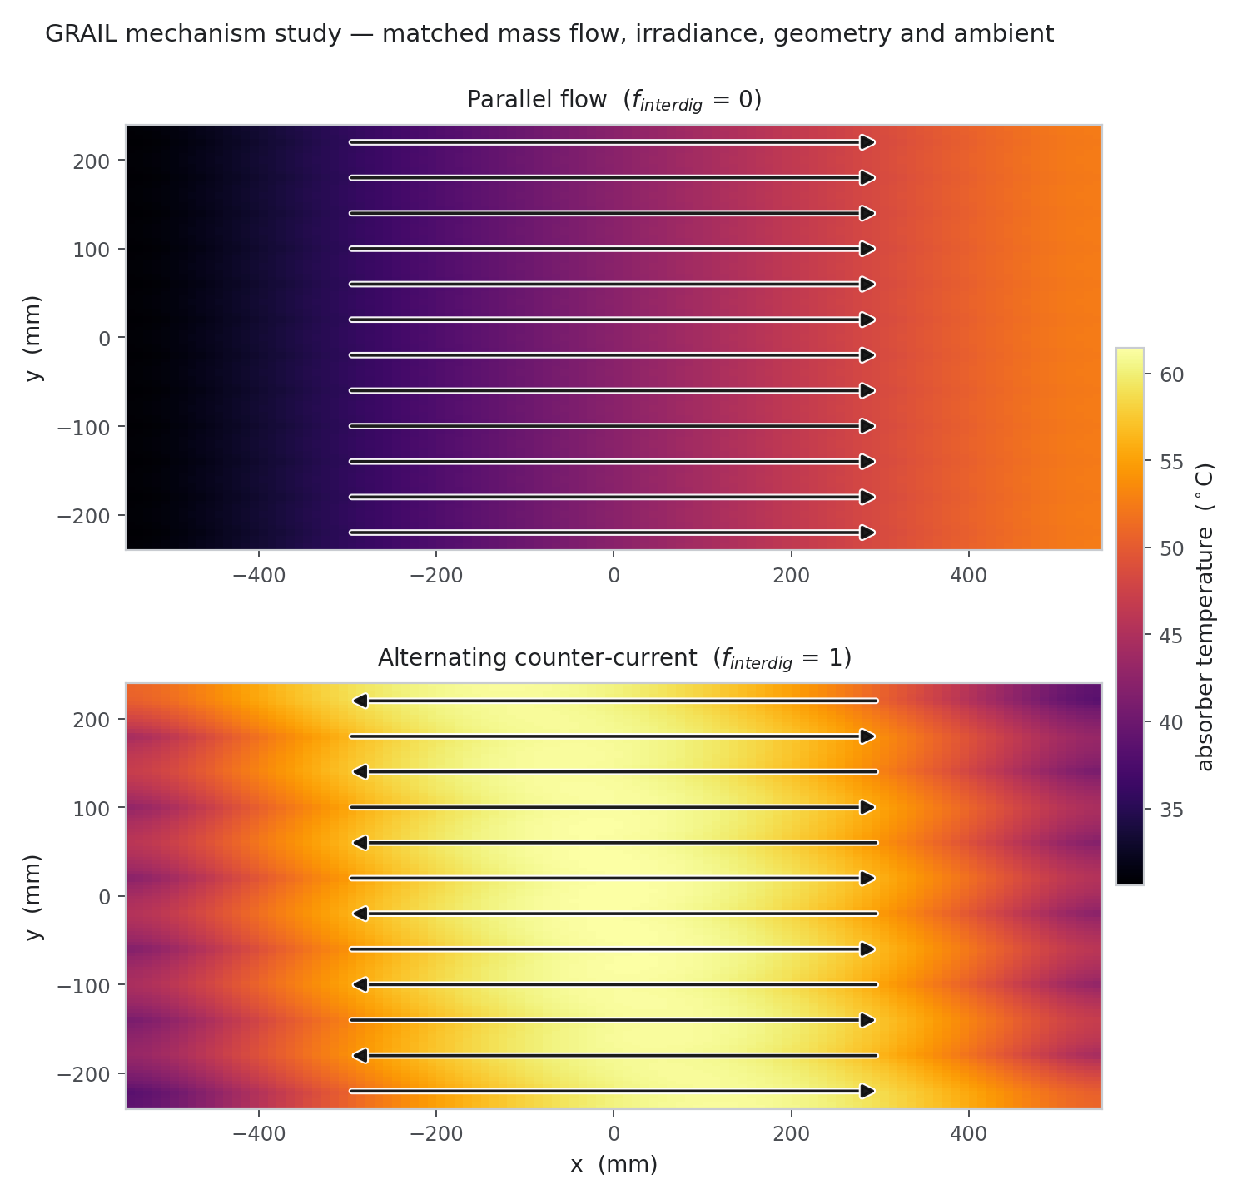
Figure 18 — The mechanism in the field: co-current, alternating, and the difference.
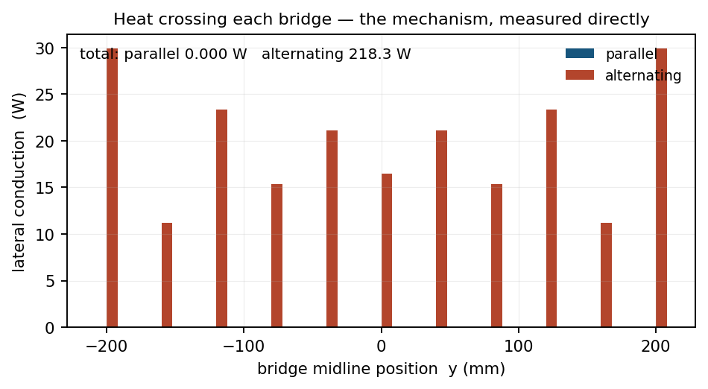
Figure 19 — Lateral conduction across the eleven bridge planes.

7.2 A correction to how the bridge contrast is quoted
An earlier statement in this project read “170.84 W against 0.0000 W”. That is arithmetically true and rhetorically misleading, and it has been corrected (CR-12).
The co-current figure is exactly zero BY SYMMETRY, not merely small. With every channel flowing the same way the plate field is periodic in y and the temperature gradient at the bridge midline vanishes identically. The campaign reads 6.5e-11 to 9.1e-11 W, which is round-off. The grid study reads 0.000, 8.892, 0.000 and 3.345 W across four levels — those nonzero values are a sampling artefact that appears when the midline does not coincide with a cell face, not physics.
The contrast is real, but the denominator is zero. It must be quoted as an absolute figure — alternating reads 67 to 303 W across the campaign, about 20 W per midline at the design point — and never as a ratio.

8. Gate 6 — how much of the plate has to be simulated
A reduced domain would make future work far cheaper, but only if it reproduces the full plate. This was measured rather than assumed, and the measurement overturned the original plan.

8.1 Glide symmetry, not mirror symmetry
Under alternating flow the neighbour across a bridge midline runs in the OPPOSITE direction. The field is therefore glide-symmetric, not mirror-symmetric, and its period is TWO channels, not one. An ordinary symmetry plane at the midline is adiabatic, and an adiabatic midline suppresses exactly the lateral conduction the whole hypothesis depends on.
Five domains were run at identical cell size, with co-current as a control in which all four reduced domains must — and do — reproduce the full plate exactly.
Table 17 — Domain equivalence, alternating arrangement, against the full 12-channel plate.
Domain | Δ efficiency | Δ plate spread | Bridge conduction (W) | Verdict
Full 12-channel plate | — | — | 20.23 | reference
2-channel periodic | −0.308 % | +2.513 % | 19.412 (−4.06 %) | VALID
2-channel adiabatic | — | — | 33.729 (+66.7 %) | INVALID
3-channel strip | — | — | 1.050 | INVALID — wrong period
An adiabatic symmetry plane inflates lateral bridge conduction by +66.70 %. A 3-channel strip is invalid under either boundary condition because the glide period is two channels, not three. The 2-channel periodic domain reproduces the full plate to −0.31 % on efficiency, +2.51 % on plate spread and −4.06 % on bridge conduction, and is validated for future use.
Nothing reported in this study used a reduced domain
The campaign, the mechanism study and every figure were computed on the full 12-channel plate. Section 8 is a result for future work, not a shortcut taken in this one.
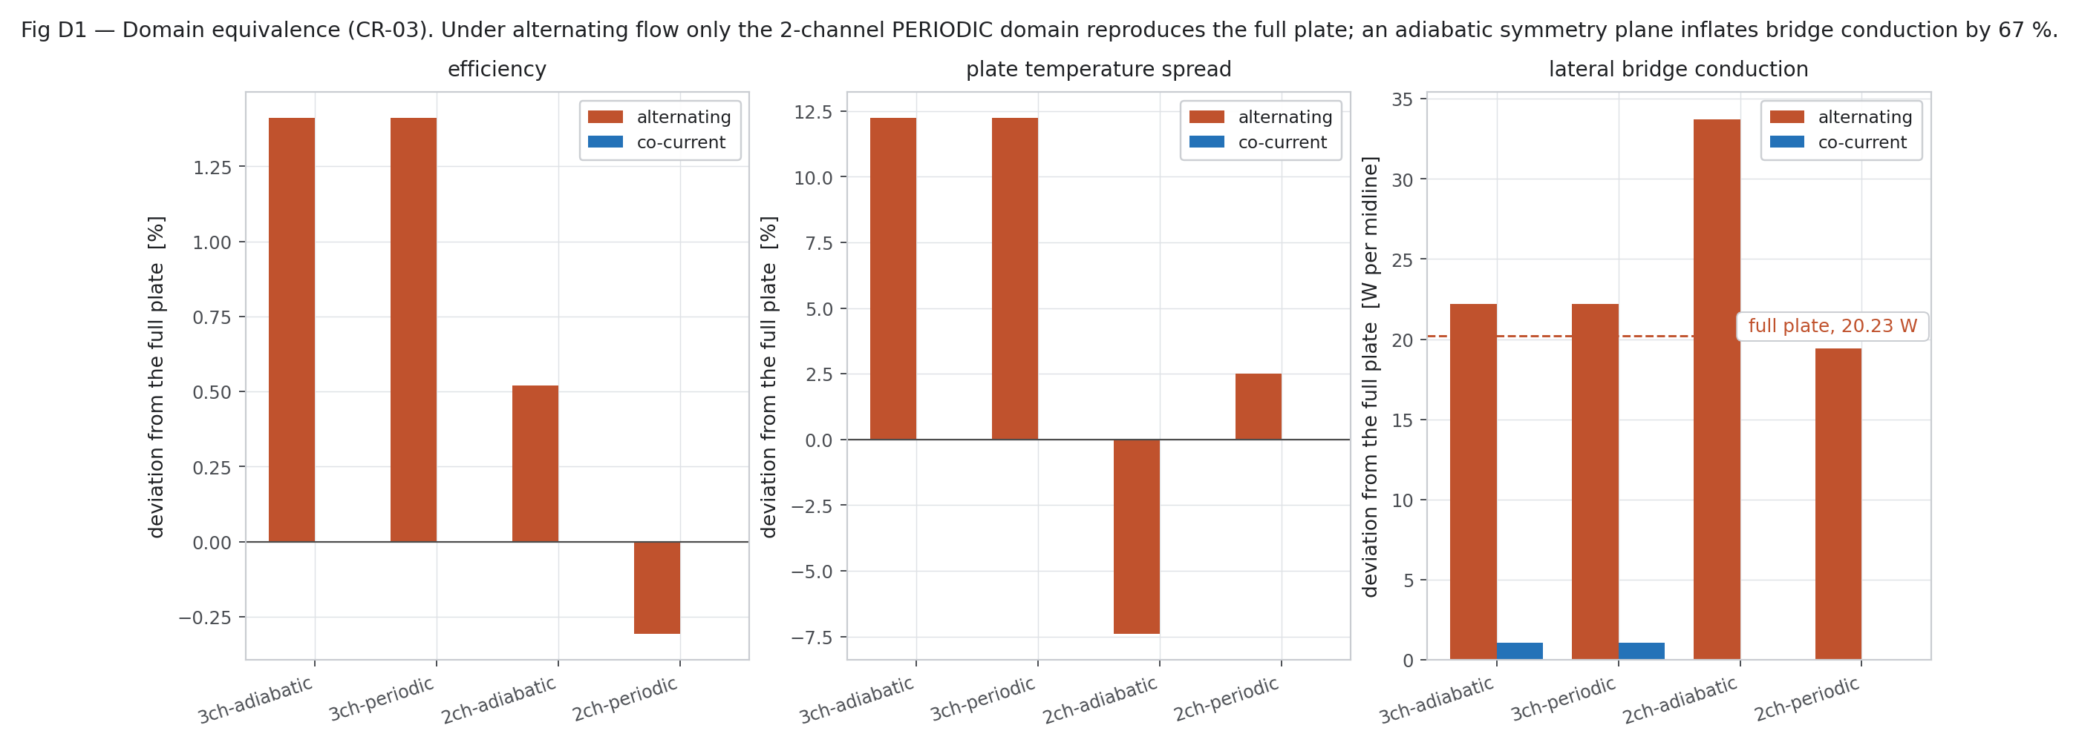
Figure 20 — Domain equivalence across the five domains.
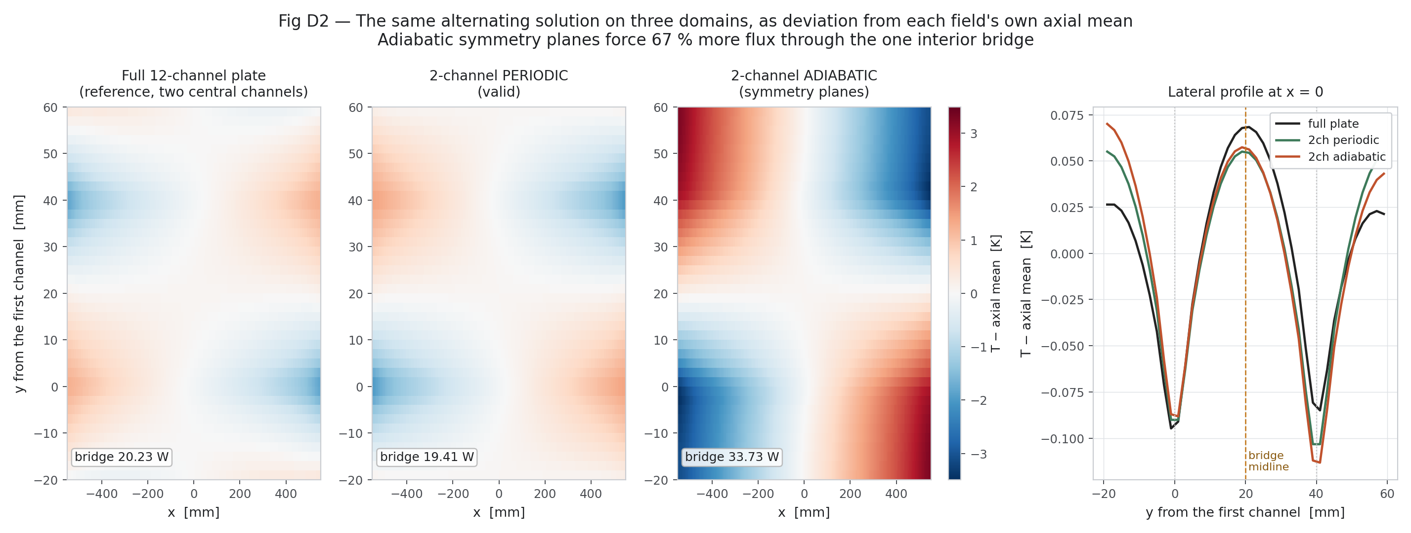
Figure 21 — The fields each domain produces. The adiabatic 2-channel case is visibly different at the midline.

9. Gate 7 — the production campaign
Three hundred cases: 150 co-current and 150 alternating, each half an independent Latin Hypercube draw over the same eight design and operating variables, with a fixed seed so the whole campaign is reproducible.
Table 18 — Campaign design.
Item | Value
Sampler | scipy.stats.qmc.LatinHypercube, d = 8, seed = 20260915
Cases per arrangement | 150
Plate grid | 110 × 120 = 13,200 cells
Outer-loop tolerance | 1e-6, maximum 900 outer iterations
Geometry version tag | GateA_converged_v1
Cases rejected in Rev 2 | 0 of 300
Table 19 — The eight sampled variables and their bounds.
Variable | Lower | Upper | Why this range
G_T (W/m²) | 400 | 1000 | documented operating envelope
T_in (K) | 288 | 333 | inlet range of interest
T_amb (K) | 283 | 313 | ambient range
v_wind (m/s) | 0.0 | 5.0 | still air to moderate wind
mdot_total (kg/s) | 0.0010 | 0.0045 | pump operating range
bridge (mm) | 20.0 | 37.0 | hard geometric limit: bridge = pitch − w_ch < 40 mm
g_ratio | 0.35 | 1.00 | capped at 1.00 by Filing 1 dependent claim 1
lambda_G | 0.5 | 2.0 | grading exponent, around the confirmed baseline of 1.0
A pre-run validation gate rejects impossible geometry before the solver is called, so an unphysical sample never becomes a failed case that has to be explained afterwards.

9.1 The pressure-drop closure
Pressure drop is not solved in the campaign; it is integrated along the converging channel and calibrated once against the resolved 3-D CFD:
mu(T) = 2.414e-5 * 10 ** (247.8 / (T_mean - 140.0)) # water, Vogel relation
dp = integral over x of 32 * mu * u(x) / Dh(x)**2 # laminar, 60 stations
DP_CAL = 35.31 / 33.31 = 1.0600 # CFD / laminar integral
The calibration factor is the +6.0 % of Table 7 and it is applied uniformly. Viscosity is evaluated at the mean fluid temperature of each case, so the campaign carries a temperature-dependent viscosity even though the baseline 3-D case did not.

9.2 What each row carries
Fifty-two columns per case. Every row carries its own geometry provenance tag, its convergence flag, its outer-iteration count, its final residual and its independent energy balance error, so no number can be quoted without its quality flags travelling with it. The recorded quantities include, per case: the eight inputs; the derived geometry (D_h in and out, A in and out, Re in and out, mu); hydraulics (dp_channel, pumping power); the absorbed flux, sky temperature and wind coefficient; the fluid result (T_out, dT, Q_u, efficiency); the plate statistics (mean, max, min, spread, standard deviation, P90, P95, P99); the radiative quantities (mean of T⁴, mean(T)⁴, the equivalent radiative temperature); the full loss balance (Q_solar, Q_rad, Q_conv, Q_rear, U_L, mean glass temperature); and the lateral bridge conduction.
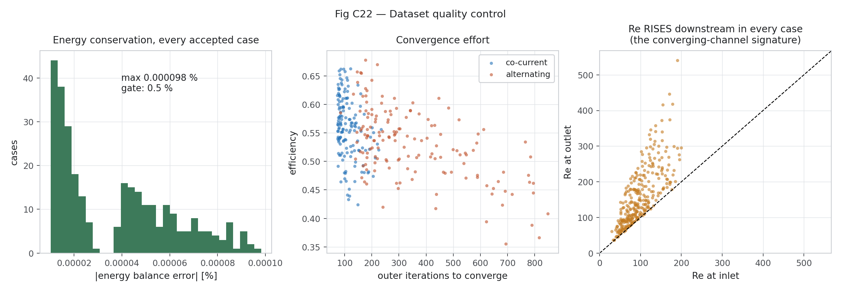
Figure 22 — Campaign quality: convergence, residuals and energy-balance error across all 300 cases.
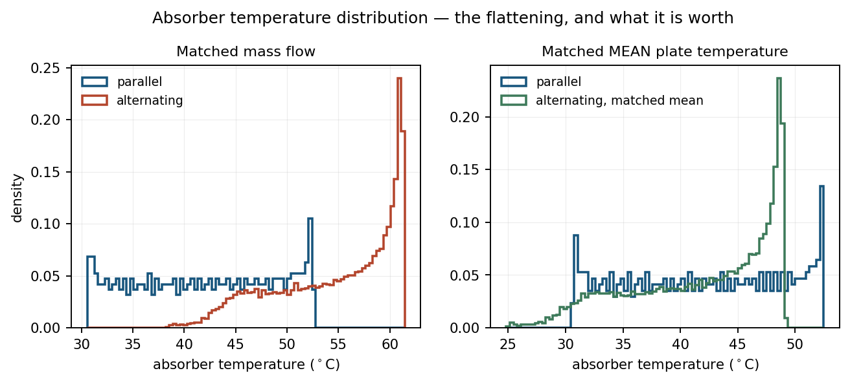
Figure 23 — Distribution of the sampled inputs across the campaign.
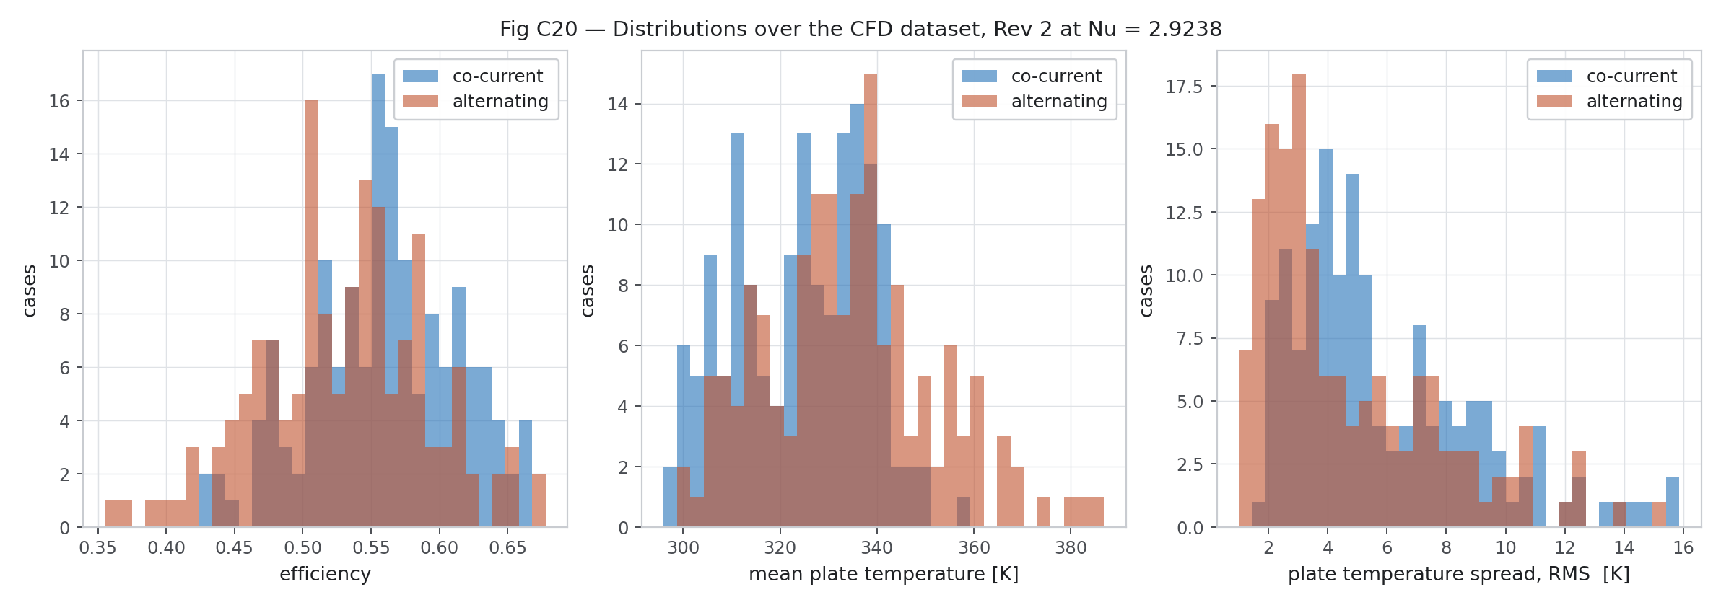
Figure 24 — Distribution of the campaign outputs.
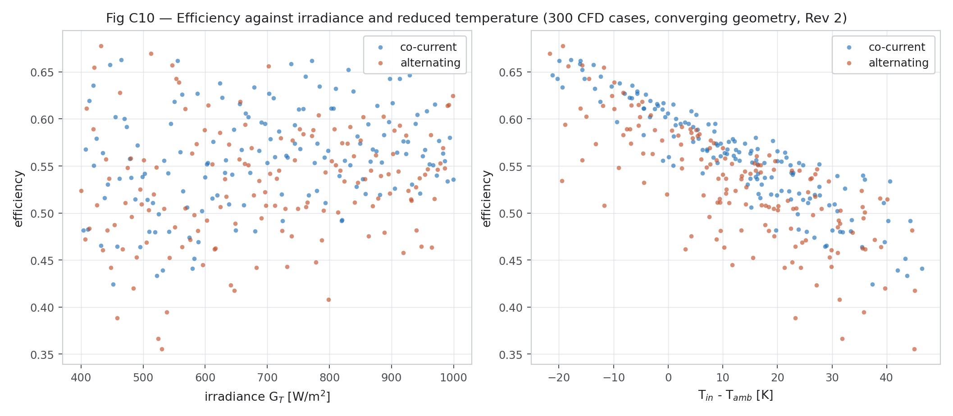
Figure 25 — Efficiency across the campaign, both arrangements.
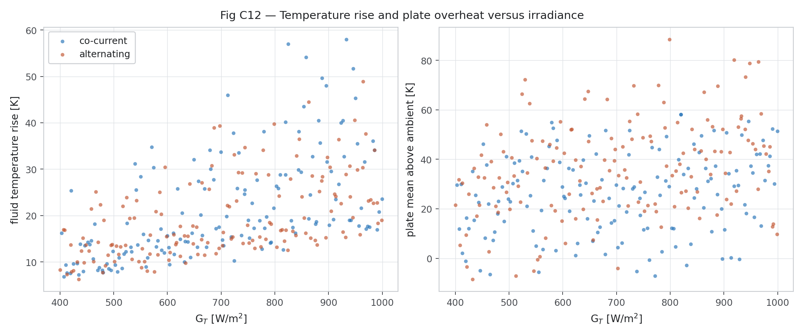
Figure 26 — Fluid temperature rise against mass flow.
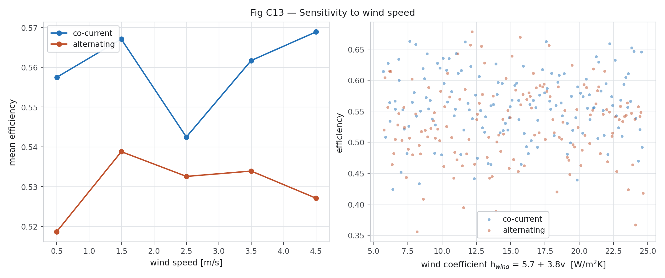
Figure 27 — Effect of wind speed through h_wind = 5.7 + 3.8·v.
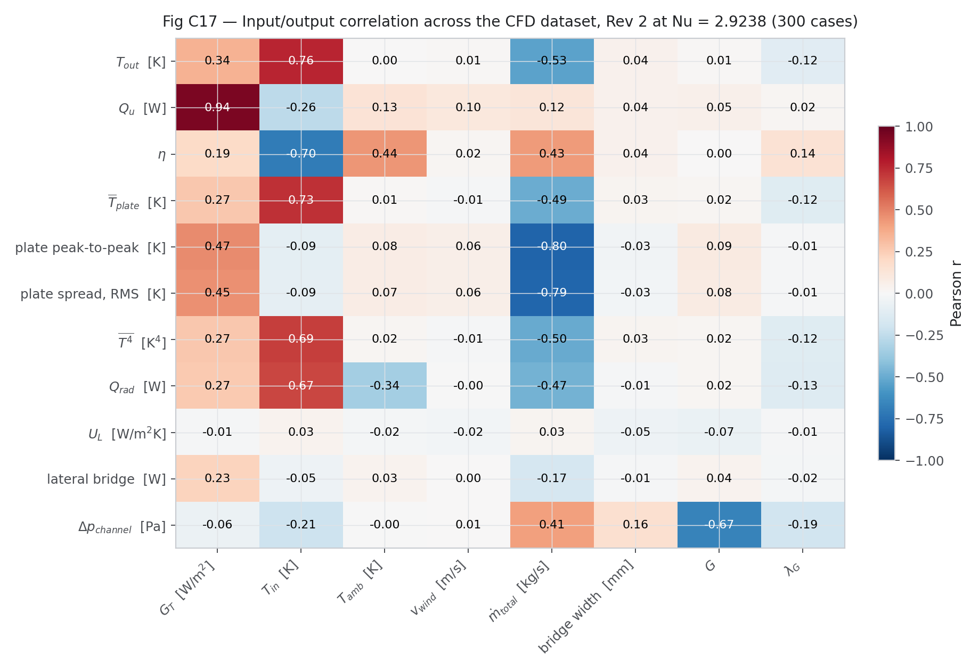
Figure 28 — Correlation structure of the campaign.
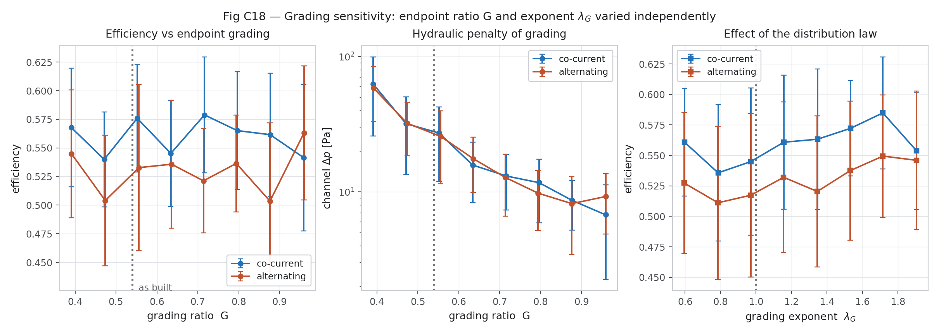
Figure 29 — Effect of the grading ratio G and exponent lambda_G.
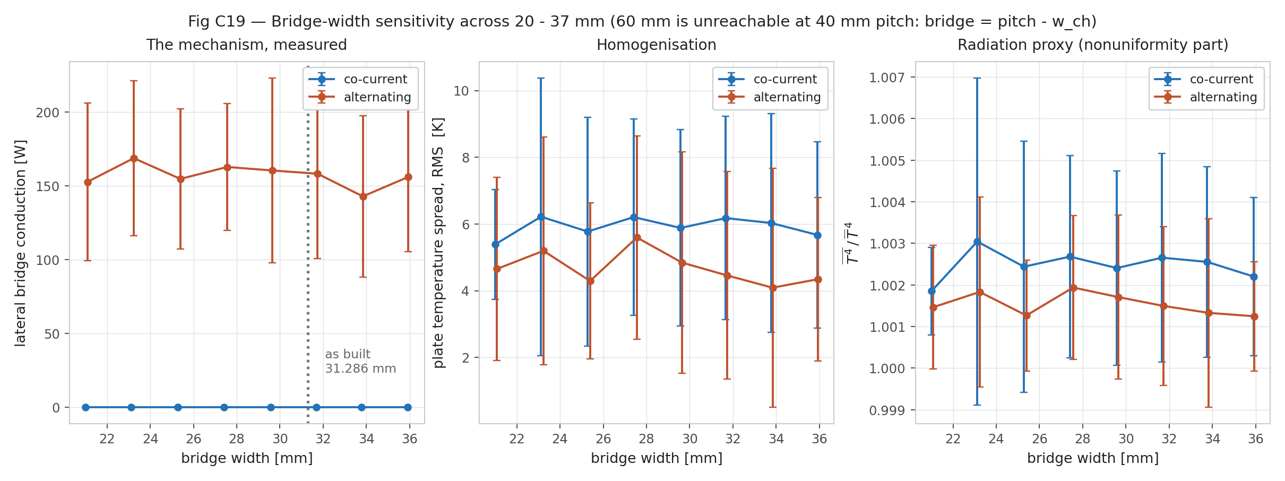
Figure 30 — Effect of bridge width over the 20–37 mm sweep.
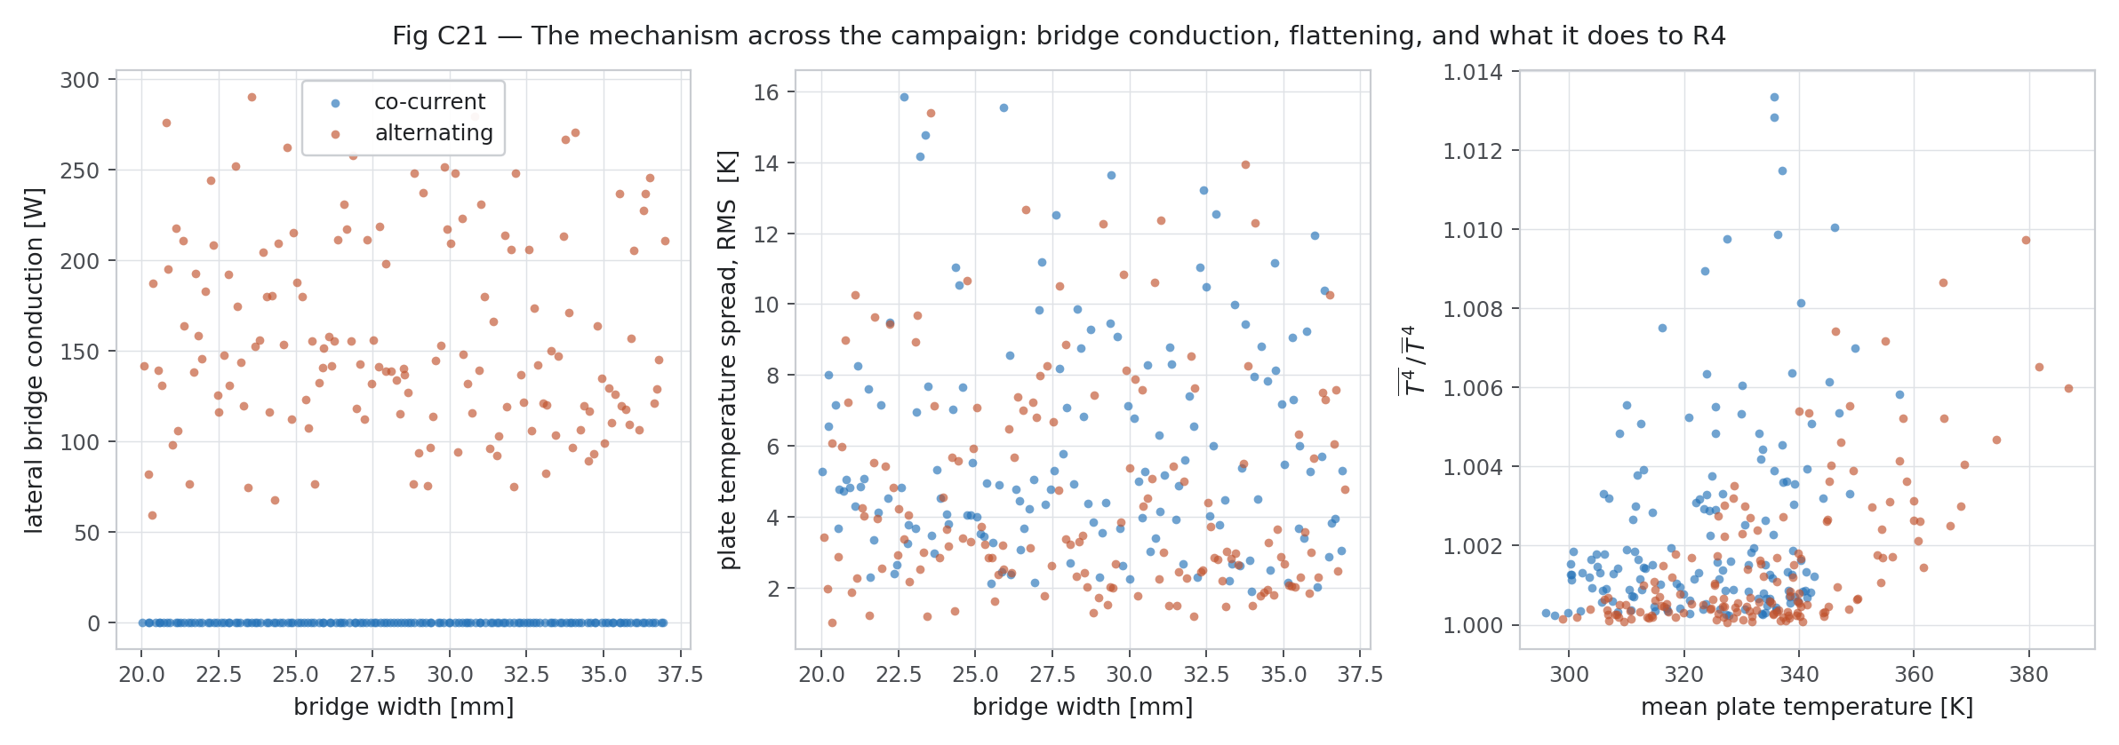
Figure 31 — The mechanism across the whole campaign rather than at a single design point.

10. The campaign was recomputed — Rev 1 to Rev 2
Section 5 established that the solver had been running +17.25 % high on nu_cfd. Section 10 is what was done about it.

10.1 A one-variable recomputation
Same seed, same Latin Hypercube, same bounds, same gates, same grid. ONLY nu_cfd changed, from 3.4282 to the Richardson-extrapolated 2.9238. Because nothing else moved, every Rev 2 row pairs one-to-one with its Rev 1 twin and the difference between them is attributable to nothing else.
Table 20 — Paired, case by case: what the correction did.
Quantity | Co-current | Alternating
Plate spread, RMS | −0.036 K | −0.473 K
Plate peak-to-peak | −0.194 K | −1.822 K
Efficiency | −0.0009 | +0.0022
Mean plate temperature | +0.288 K | −0.722 K
The correction moves the alternating cases and barely touches the co-current ones, which is exactly what a bias on the wall-to-fluid coupling coefficient should do. Rev 1 is kept on disk in full, with its own figures, and is not deleted.

10.2 Rev 1's campaign average had been censored
Rev 1 lost 9 rows to the convergence gate. Rev 2 loses none, because the lower Nusselt number leaves the coupled solve better conditioned. That makes the 9 recoverable, and recovering them showed they were not a random 9:
- All 9 were ALTERNATING cases.
- All 9 were the lowest-flow cases in the whole sample: mean 1.10 g/s against a campaign mean of 2.75 g/s, and none above 1.19 g/s.
- Their mean plate spread was 10.97 K against 4.69 K for alternating overall — they were the hardest cases in the draw.
Averaging a sample with its own hardest cases removed flatters the arrangement those cases belonged to. The headline number therefore changes:
Table 21 — Δ plate spread, alternating minus co-current.
Basis | Value
Rev 1, the 291 rows both revisions share | −20.09 %
Rev 2, the same 291 rows | −27.60 %
Rev 2, all 300 rows — the figure to quote | −20.83 ± 12.09 % (k = 2)
Two corrections of opposite sign and similar size, which nearly cancel. The uncensored figure is the one to use, because it is the only average taken over the sample that was actually drawn. No row was ever removed to improve a result; the censoring is reported as a defect of Rev 1.

10.3 The mass-flow threshold is withdrawn
Rev 1 supported a claim that below about 1.81 g/s the alternating arrangement is WORSE than co-current. In Rev 2 every one of the eight mass-flow bins from 1.23 to 4.27 g/s favours alternating. In Rev 1 the lowest bin read +7.75 %.
Both causes are in Sections 10.1 and 10.2: the biased Nusselt number, and the fact that the censored rows were precisely the low-flow ones that set the threshold. There is no minimum operating flow claim to make, and the threshold is withdrawn.
One caution on reading the bins: the co-current and alternating halves are two INDEPENDENT Latin Hypercube draws, so bin-to-bin scatter is sampling noise. Only the sign, which is consistent across all eight bins, is robust.
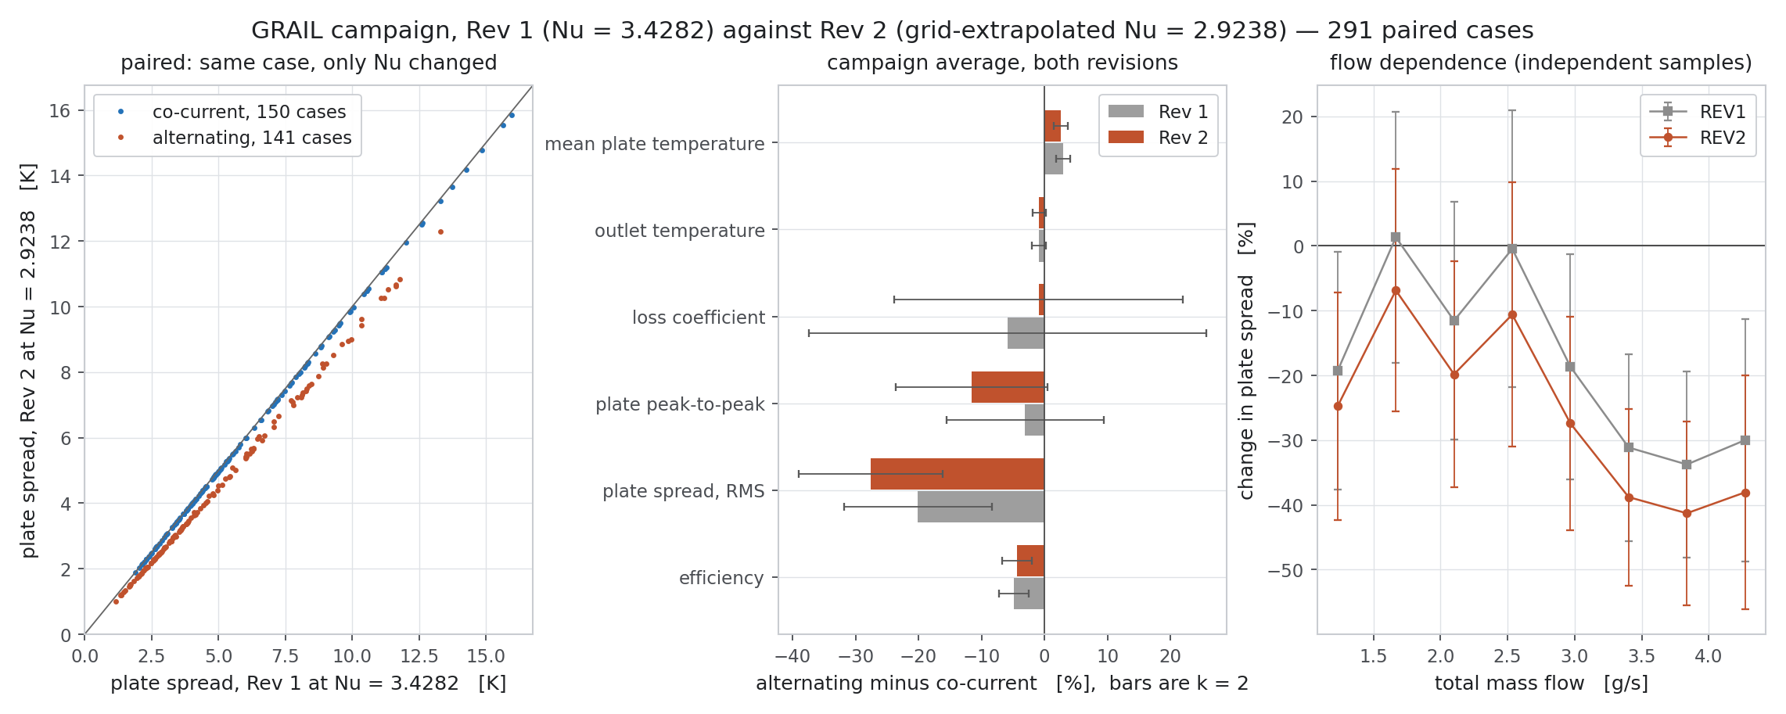
Figure 32 — Rev 1 against Rev 2: the paired shift, the recovered rows, and the withdrawn threshold.
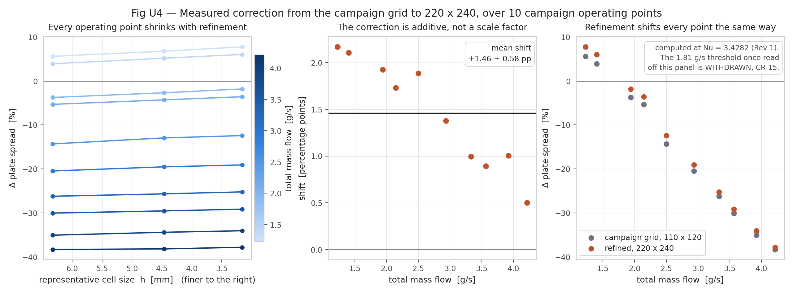
Figure 33 — The campaign grid correction, measured on ten operating points at three grid levels.

10.4 The campaign grid correction
The campaign runs on the coarsest plate grid tested. Ten campaign operating points, stratified by mass flow, were re-run at three levels to measure that correction directly rather than assume it.
Table 22 — Grid correction measured on ten campaign points.
Case | mdot (g/s) | Δstd @110×120 | @156×170 | @220×240 | shift (pp)
PAR_065 | 1.23 | +5.584 % | +6.756 % | +7.754 % | +2.17
PAR_117 | 1.41 | +3.905 % | +5.163 % | +6.012 % | +2.11
PAR_091 | 1.94 | −3.757 % | −2.691 % | −1.831 % | +1.93
PAR_120 | 2.14 | −5.324 % | −4.304 % | −3.594 % | +1.73
PAR_079 | 2.50 | −14.316 % | −12.951 % | −12.431 % | +1.88
PAR_112 | 2.94 | −20.469 % | −19.528 % | −19.092 % | +1.38
PAR_018 | 3.33 | −26.222 % | −25.670 % | −25.227 % | +0.99
PAR_005 | 3.57 | −30.048 % | −29.547 % | −29.156 % | +0.89
PAR_010 | 3.92 | −35.065 % | −34.409 % | −34.058 % | +1.01
PAR_020 | 4.21 | −38.318 % | −38.183 % | −37.816 % | +0.50
The correction is ADDITIVE, not multiplicative. Expressed as a ratio it ranges from 0.49 to 1.54 and is meaningless, because Δstd changes sign across the range. The clean description is a linear map, which fits to R² = 0.99990:
Δstd(220×240) = 1.0349 × Δstd(110×120) + 2.0314

11. Gate 8a — uncertainty assessment
Framework: ASME V&V 20-2009. Three contributions are quantified separately and combined in quadrature — discretisation (Roache grid convergence index), input uncertainty (paired Monte Carlo), and iterative convergence. Round-off is not carried: the solver is float64 and the independent energy balance closes to 1e-7 %.

11.1 Discretisation on the conjugate plate grid
Four levels at a refinement ratio of 1.41 in cells per direction, both arrangements on every level.
Table 23 — Four-level plate grid study.
Grid | Cells | h (mm) | co-current η | alternating η | co std (K) | alt std (K) | Δstd
110 × 120 (campaign) | 13,200 | 6.3246 | 0.596553 | 0.564249 | 6.7240 | 5.7964 | −13.795 %
156 × 170 | 26,520 | 4.4620 | 0.596641 | 0.563951 | 6.7368 | 5.8887 | −12.590 %
220 × 240 | 52,800 | 3.1623 | 0.596697 | 0.563771 | 6.7370 | 5.9277 | −12.013 %
311 × 339 | 105,429 | 2.2379 | 0.596735 | 0.563627 | 6.7407 | 5.9643 | −11.517 %
Table 24 — Observed orders and GCI, from the two independent triplets.
Quantity | p (fine triplet) | p (coarse triplet) | GCI | Asymptotic?
Δ plate standard deviation | 0.446 | 2.087 | 32.34 % | no
Δ efficiency | 0.766 | 1.385 | 2.24 % | no
Δ loss coefficient | 0.905 | 1.347 | 1.40 % | yes
Δ peak-to-peak spread | 1.208 | 0.429 | 98.40 % | no
Only ΔU_L is cleanly in the asymptotic range. Δη is borderline, but its GCI is 2.2 %, so the practical conclusion is unaffected. ΔT_p,std is the problem: its two triplets give observed orders of 0.45 and 2.09 and Richardson extrapolations of −8.54 % and −11.46 %. The LARGER of the two GCIs is carried and the disagreement is reported, rather than resolved by choosing the flattering triplet.
Co-current quantities are essentially grid-independent (GCI 0.003 to 0.19 %). All of the grid sensitivity sits on the alternating side, where the lateral gradient across each bridge is what the grid has to resolve. That is a physically sensible place for it to sit.

11.2 Input uncertainty — a paired Monte Carlo
Two hundred samples, all accepted, on the campaign grid. Every draw is run through BOTH arrangements with identical inputs. The pairing is not a convenience: the claim is a DIFFERENCE, and a difference between two runs sharing one property draw and one grid has most of its systematic error cancelled.
Table 25 — What the pairing is worth.
Quantity | Paired sd | sd if unpaired | Factor
Δ efficiency | 0.304 pp | 3.959 pp | 13.0×
Δ plate standard deviation | 3.092 pp | 6.857 pp | 2.2×
Δ loss coefficient | 0.848 pp | 4.682 pp | 5.5×
Δ peak-to-peak spread | 3.464 pp | 6.696 pp | 1.9×
Treating the two arrangements as independent would inflate the efficiency-difference band by thirteen times and would have made a firm result look indistinguishable from noise.
Table 26 — The thirteen sampled inputs. Every entry is an ENGINEERING_ASSUMPTION.
Input | Nominal | Standard uncertainty | Basis
k_al | 229 W/m·K | 2.0 % (rel) | AA1050 handbook; temper and purity spread
nu_cfd | 3.428 | 5.0 % (rel) | from this study's own 3-D CFD — see the revision below
alpha_abs | 0.95 | 0.01 (abs) | TiNOX datasheet tolerance
eps_abs | 0.04 | 0.01 (abs) | TiNOX datasheet tolerance
tau_glz_sys | 0.833 | 0.01 (abs) | two-pane system
tau_tim | 0.82 | 0.02 (abs) | homogenised PC honeycomb
k_tim | 0.075 W/m·K | 5.0 % (rel) | handbook, perpendicular direction
k_vip | 0.006 W/m·K | 13.0 % (rel) | fumed-silica VIP, 20 % derate over 25 y
h_wind_fac | 1 | 15.0 % (rel) | scatter of the linear wind-convection correlation
h_rear | 3 W/m²K | 0.5 (abs) | still-air external coefficient
mdot_total | 0.0025 kg/s | 2.0 % (rel) | pump and flowmeter class
G_T | 800 W/m² | 2.0 % (rel) | class-A pyranometer
T_amb | 298.15 K | 0.5 (abs) | ambient measurement
None of these tolerances comes from a supplier datasheet, because the material table does not carry any. They are stated here rather than buried, and the sensitivity ranking below shows which of them actually matter.
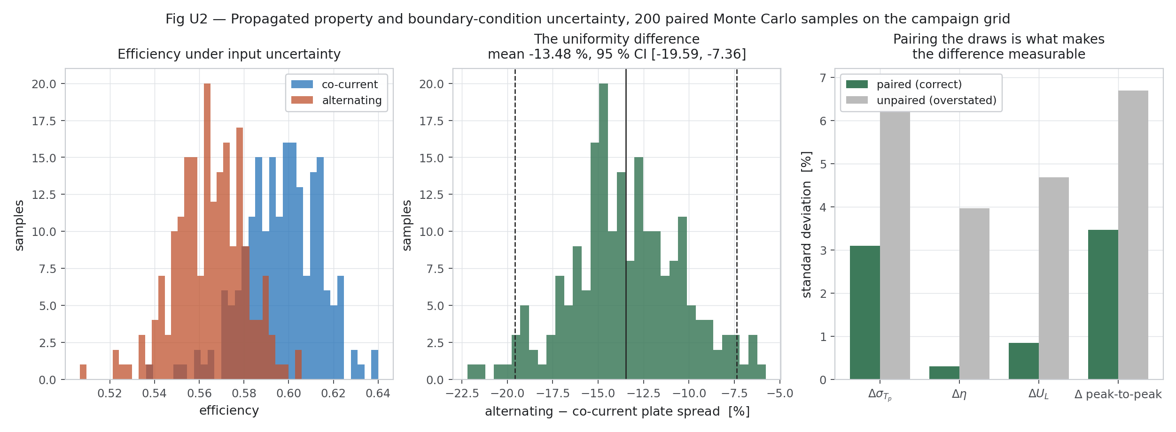
Figure 34 — Input uncertainty: the Monte Carlo distributions.

11.3 Sensitivity — which inputs control which answer
Table 27 — Standardised regression coefficients, variance shares.
Output | Dominant inputs (share of variance) | Linear-model R²
Efficiency | tau_tim 68 %, tau_glz_sys 19 %, alpha_abs 12 % | 0.9998
Uniformity difference | nu_cfd 91 %, mdot_total 9 % | 0.9991
Two things follow, and both shaped the rest of the study.
- Efficiency is an OPTICAL result. Ninety-nine per cent of its variance is the transmittance chain and the absorptance — not anything thermal. No amount of thermal cleverness moves it much; the glazing and the coating decide it.
- The uniformity difference is almost entirely controlled by nu_cfd, the single constant Nusselt number carried from the 3-D CFD into the plate solver. That is the one input worth improving, and its assumed ±5 % covers discretisation but NOT the modelling assumption that one constant Nu represents a graded, developing channel.
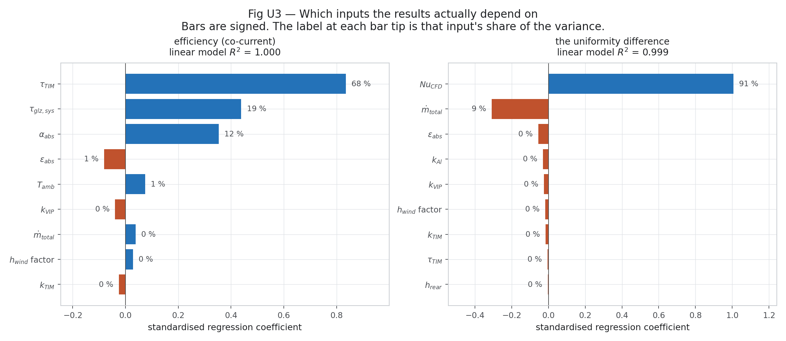
Figure 35 — Sensitivity: variance shares for efficiency and for the uniformity difference.

11.4 Iterative convergence
Table 28 — Iterative contributions, three orders below the other two.
Solver | Measure | Value
Conjugate plate | outer-loop tolerance | 1e-8
Conjugate plate | energy balance (independent check) | < 1e-6 %
simpleFoam baseline | Ux initial residual | 5.3461e-11
simpleFoam baseline | p initial residual | 1.5287e-08
simpleFoam baseline | continuity | 2.4805e-10
Three orders of magnitude below the other two contributions, so it is not carried into the combined band.

11.5 The final combined result
Uncertainty is recombined using the MEASURED local sensitivity dQ/d(Nu) from the two campaign revisions, rather than the Monte Carlo's rescaled coefficient, plus the contribution of all other inputs, plus the plate-grid discretisation term.
Table 29 — Final uncertainty statement, design point, k = 2.
Quantity | Value | u_input | u_numerical | Expanded, k = 2 | Verdict
Δ plate spread (RMS) | −21.09 % | 4.983 pp | 2.979 pp | ± 11.61 pp | distinguishable
Δ efficiency | −4.94 % | 0.393 pp | 0.099 pp | ± 0.81 pp | distinguishable
Δ loss coefficient | −7.07 % | 0.442 pp | 0.087 pp | ± 0.90 pp | distinguishable
Δ peak-to-peak spread | −3.64 % | 5.595 pp | 5.590 pp | ± 15.82 pp | NOT distinguishable
What survives and what does not
The efficiency DEFICIT is firm: −4.94 % ± 0.81 pp. The alternating arrangement is less efficient at matched flow, and that is not noise.
The loss-coefficient benefit is firm: −7.07 % ± 0.90 pp.
The RMS uniformity benefit survives with a wide band: −21.09 % ± 11.61 pp at the design point, −20.83 ± 12.09 % as a campaign average.
The PEAK-TO-PEAK uniformity claim does NOT survive. Its 95 % interval spans zero under every grid and every Nusselt value tested. It should not be claimed.
It is worth recording that an earlier version of this assessment, written before the fine 3-D grid finished, concluded that the uniformity benefit was “not yet demonstrated to be distinguishable from zero”. With the Nusselt bias corrected, that statement is superseded. It was correct given what was then known and wrong given what is known now, and it is left in the project record rather than edited, so the reasoning stays traceable.

12. The largest remaining term: one Nusselt number for a graded channel
The sensitivity analysis put 91 % of the uniformity difference on nu_cfd. A grid study can bound the discretisation part of that input. It cannot bound the modelling choice of collapsing a varying Nu(xi) to a single constant — so that choice was tested directly.
The same solver was run at 220 × 240 three ways: with a constant Nu, with the measured L3 profile, and with that profile rescaled to the constant's developed-region mean. The third run is what separates the cost of the profile's SHAPE from the cost of its LEVEL.
Table 30 — Closeout check A: constant Nu against the measured profile.
Nusselt model | Δ plate spread | Δ efficiency
constant, 2.9238 | −21.09 % | −4.94 %
measured profile, rescaled to the same mean | −6.85 % | −5.51 %
measured profile, as measured | −2.14 % | −5.88 %
This is the honest limit of the uniformity claim
Collapsing Nu(xi) to one number is worth +14.24 percentage points on the uniformity difference — LARGER than every numerical and input uncertainty in this assessment combined.
It costs only −0.57 pp on efficiency, so the efficiency result is untouched.
The sign of the uniformity result does not change. Its magnitude is model-form limited, and it must be quoted that way: the campaign carries a constant Nu, and a campaign carrying Nu(xi) has not been run.
For context on how much variation is being collapsed: local Nu runs from 3.29 to 3.65 over the developed region and reaches 29.8 at the inlet, where the thermal boundary layer has not yet formed.

13. Gate 8b — validation
A word used carefully here. Agreement with the project's own design targets is SELF-CONSISTENCY. Agreement with a model that shares none of this solver's discretisation is closer to validation. No experimental data was used in this study, and nothing here is claimed as experimental validation.

13.1 Against Hottel-Whillier-Bliss
Matching someone else's measurement on a different collector validates the combination of their geometry, their instrument and this model, and cannot separate the three. Hottel-Whillier-Bliss is the standard closed-form flat-plate model, it is the accepted reference for a bonded-fin absorber, and it shares NONE of this solver's discretisation. Agreement with it tests the fin and flow solution directly.
fin efficiency F = tanh(m (W-D)/2) / (m (W-D)/2), m = sqrt(U_L / (k delta))
collector eff. factor F' = (1/U_L) / ( W [ 1/(U_L (D + (W-D) F)) + 1/(h_fi P) ] )
heat removal factor F_R = (mdot cp/(Ac U_L)) [1 - exp(-Ac U_L F'/(mdot cp))]
efficiency eta = F_R (tau alpha) - F_R U_L (T_in - T_amb) / G_T
The channel is graded, so W−D, D_h, P and h_fi all vary along the flow. F and F' are evaluated at 400 stations and averaged over the flow path; averaging the geometry first would bias F, which is nonlinear in D. U_L is NOT fitted — it is taken from the solver's own loss balance, so the comparison tests the fin and flow solution rather than the loss model, which both share.
Table 31 — Solver against Hottel-Whillier-Bliss.
Arrangement | Solver η | HWB η | Deviation | U_L used
co-current | 0.596697 | 0.597995 | +0.218 % | 2.4731 W/m²K
alternating | 0.563771 | 0.601730 | +6.733 % | 2.2817 W/m²K
Co-current agrees to +0.218 %. For a model with no shared discretisation and no fitted parameter, that is a strong result, and it validates the conjugate solver's fin and flow treatment on this geometry.
Alternating differs by +6.733 %, and that is expected and informative rather than a failure. Hottel-Whillier-Bliss assumes every tube is alike and every fin is symmetric about its own channel; it has no way to represent neighbours flowing in opposite directions. The 6.7 % gap is a measure of how far the alternating arrangement departs from the classical model — it is the part of the physics the standard model cannot see. HWB OVER-predicts, because it cannot represent the mean-temperature rise that costs the alternating arrangement its efficiency.
Table 32 — The analytical chain, co-current.
Quantity | Value
fin efficiency F, inlet | 0.9996
fin efficiency F, outlet | 0.9994
collector efficiency factor F' | 0.9883
heat removal factor F_R | 0.9297
(tau·alpha) | 0.6489
η₀ = F_R (tau·alpha) | 0.6033
The single most physically important number in this report
The fin efficiency is 0.9995 — essentially unity. With 2 mm of aluminium at 229 W/m·K spanning a 31.3 mm bridge against a loss coefficient near 2.5 W/m²K, the fin parameter m(W−D)/2 is tiny and the bond land is very nearly isothermal.
THIS is why the absorber conducts laterally so readily, and it is the physical basis of the alternating mechanism. It is also why flattening the field wins so little: a plate that conducts this well is already nearly flat.
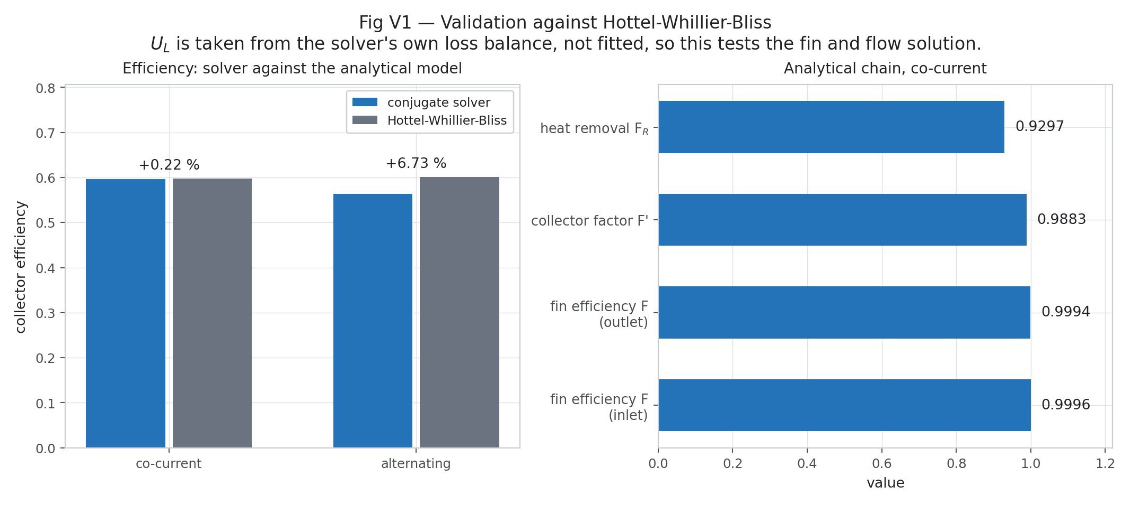
Figure 36 — Validation against Hottel-Whillier-Bliss.
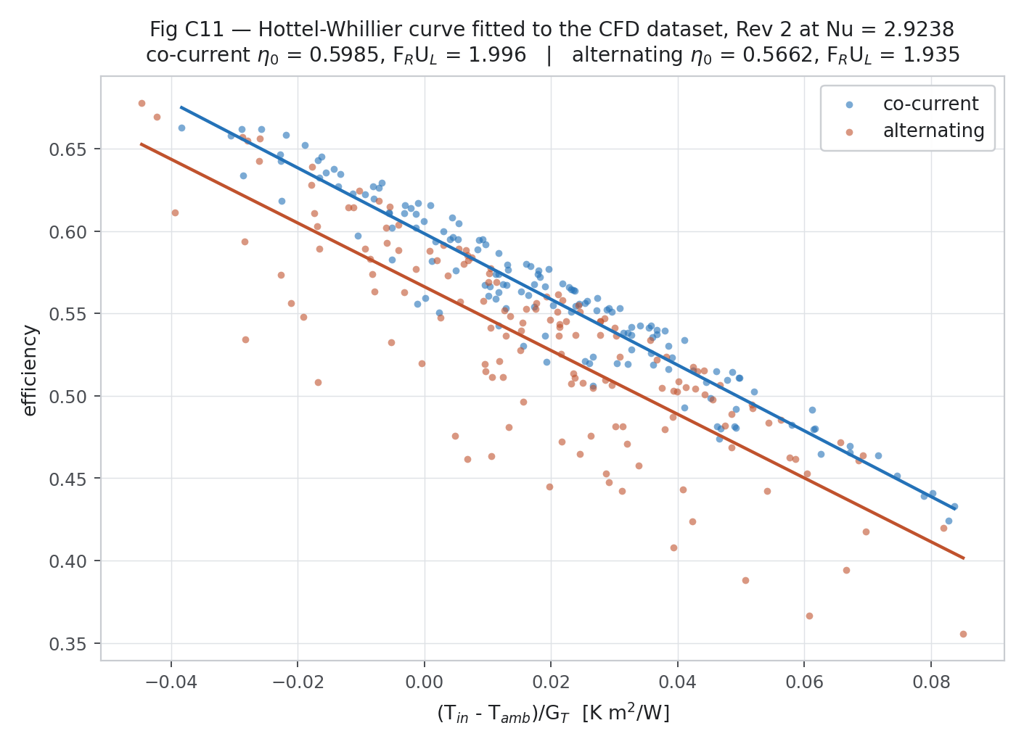
Figure 37 — The Hottel-Whillier-Bliss efficiency curve against the campaign.

13.2 The efficiency-curve estimator
Six inlet temperatures from 288 to 338 K, fitted as the ISO 9806 / ASHRAE 93 straight line:
Table 33 — Closeout check C: the fitted efficiency curve.
Arrangement | η₀ | F_R·U_L (W/m²K) | R²
co-current | 0.60010 | 1.9227 | 0.999932
alternating | 0.57053 | 1.8500 | 0.999939
The roadmap's design targets are η₀ = 0.60 and F_R·U_L = 2.00. The co-current fit lands on 0.60010 and 1.92. That also settles an earlier 15 % discrepancy between two estimators of F_R·U_L: the curve-slope value is the one to quote, and the Hottel-Whillier-Bliss point-wise product (2.2993 W/m²K) is a DIFFERENT quantity evaluated at a single operating point. Neither should be called “the” loss coefficient without saying which estimator produced it.
This is self-consistency with the design intent, not experimental validation, and it is labelled as such.

13.3 The metal itself — a 2-D finite-element conduction check
The plate solver lumps the two roll-bond sheets into a single conducting layer. That assumption, and the bridge conduction it predicts, were checked against an independent discretisation: a 2-D finite-element conduction solution in the ACTUAL roll-bond cross-section, over one glide period, with cyclic boundaries.
Table 34 — Section conduction check.
Check | Result
Through-thickness temperature difference | 0.021 – 0.057 K
Area-averaged T against the plate solver | within −0.44 to +0.21 K
Energy balance | 0.000 W/mm exactly
Co-current bridge flux | −0.00012 to +0.00013 W/mm (zero, as symmetry requires)
Alternating bridge flux | −0.0244 to +0.0240 W/mm → 174 W for the plate
Campaign value for comparison | 154 W (agreement to 13 %)
Smoothing by the metal | 15.2 K reduced to 2.01 K, a factor of 7.5
Metal cross-section area, as meshed | −2.33 % against CAD (known fillet deficit)
Through-thickness value, grid convergence | NOT converged: 0.0420 → 0.0540 K, 29 %
The three things this establishes: the plate solver's absorber temperature is right to 0.44 K; its lumped-thickness assumption is right to 0.06 K; and the alternating bridge magnitude it predicts is confirmed to 13 % by a completely different discretisation. The through-thickness difference itself is not grid-converged, but it is two orders of magnitude smaller than anything that depends on it.
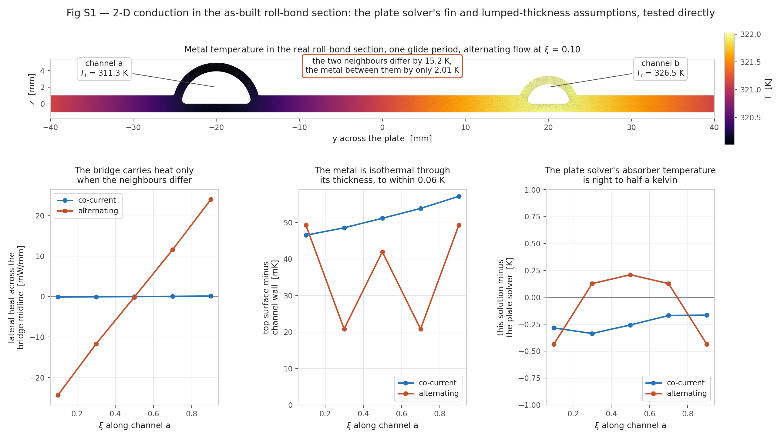
Figure 38 — The 2-D section conduction solution over one glide period.
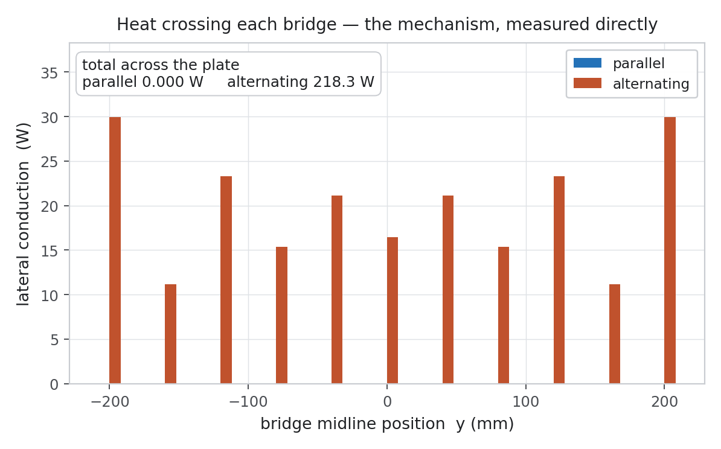
Figure 39 — Bridge conduction: the lateral heat path that the mechanism depends on.
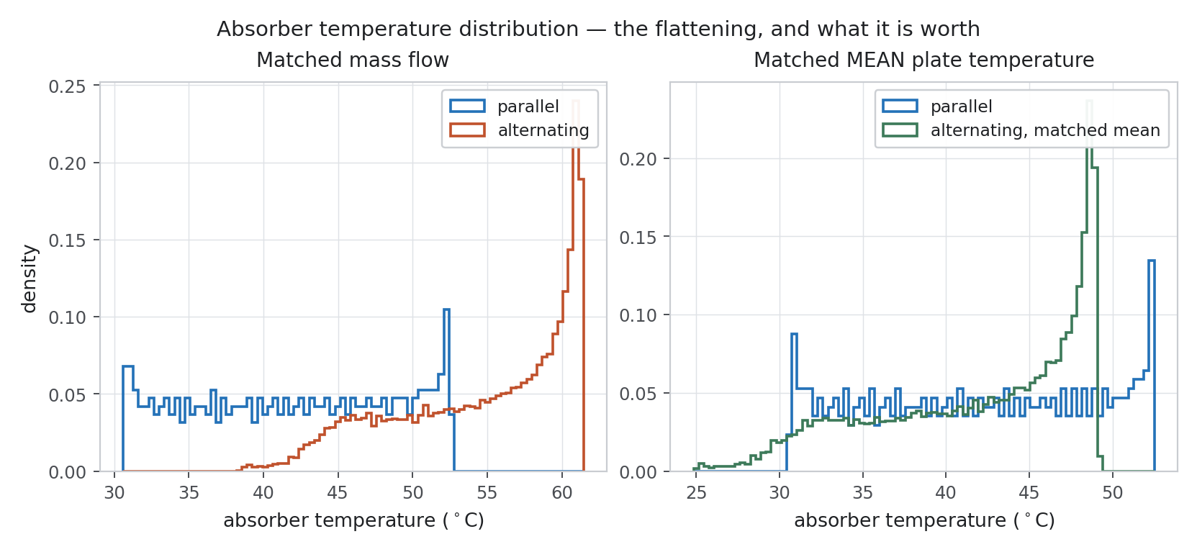
Figure 40 — Absorber temperature distribution, both arrangements.

14. Gate 9 — the 3-D conjugate run that did not converge
This section reports a failure. It is here because the alternative — listing it as an “open item” and letting a reader assume it was simply not reached — would misrepresent what was done.

14.1 What was built and verified
A two-region mesh of the roll-bond absorber: the fluid channels and the surrounding metal, sharing wall nodes exactly so the conjugate interface is conformal by construction.
Table 35 — The two-region mesh: every acceptance test passed.
Check | Result
Inverted cells | 0 at every level tested (NU 64, 96, 192)
Conjugate interface | conformal at exactly NU × NX × 2 faces
Fluid skewness | 0.63, against 1.24 on the validated baseline mesh
Coincident-node weld | 427 nodes welded by KD-tree union-find, tolerance 1e-6
Metal cross-section area | 83.29 mm² at NU 96 → 83.33 mm² at NU 192 (converging)
Known deficit | −2.2 % as meshed, −3.14 % as a converged continuum integral (corner fillet)
Building that mesh took a sequence of non-obvious fixes, each of which is a real lesson about this geometry:
- Ring resampling had to be distribution-preserving, not uniform-arc. Uniform-arc resampling took fluid skewness from 1.24 to 3.34; pinning the corners as fixed node indices and preserving each branch's original node spacing brought it to 0.63.
- The channel corner is not a node. Because the root fillet is CONCAVE, the widest point of the section sits at z = 0.447 mm and the wall reaches z = 0 only 0.54 mm further in. A monotonicity assertion built on the assumption that the corner is a node failed at station 0 by 0.9 micrometres in y and 0.155 mm in z.
- The two channels had to be snapped to a uniform station ladder. They run in OPPOSITE directions, so a 1.4e-5 mm mismatch in x meant the coincident-node weld found 14 of 427 nodes instead of all of them.
- The inlets initially fed BOTH channels at the narrow end, because the feed ends were assumed rather than read from the mesh metadata. The generator now records feed_ends and asserts the two inlet x-coordinates differ.

14.2 What failed
chtMultiRegionSimpleFoam diverges from the first iteration: maximum |U| reaches 155 m/s against an expected 0.00745 m/s. Six OpenFOAM dictionary errors were found and fixed first (constant/g at the case root, turbulenceProperties, 0/solid/p, the top-level system fvSchemes and fvSolution, and a leading + on a scalar), so the case is well-formed. Seven further solver-setting changes were then tried, including transplanting the exact scheme and relaxation set from the validated baseline case. None fixed it.
The diagnosis, and why it is stated as open
simpleFoam on the IDENTICAL fluid region is stable, with maximum |U| of 0.098 m/s. The mesh is therefore solvable; the compressible segregated multi-region solver on it is not.
No conjugate result is reported anywhere in this study. The attempt is documented in full in the project record.
The question this run was meant to close was answered instead by the independent 2-D finite-element conduction solution of Section 13.3 — which confirms the plate solver's absorber temperature to 0.44 K, its lumped-thickness assumption to 0.06 K, and its alternating bridge magnitude to 13 %.
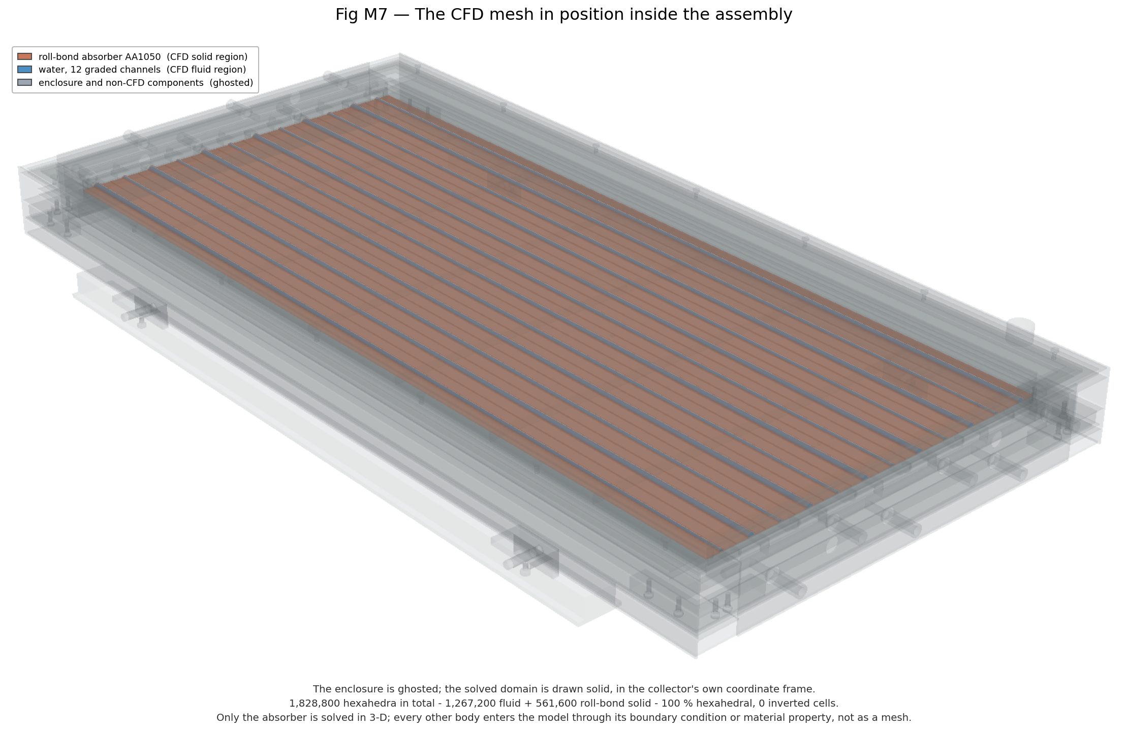
Figure 41 — The CFD mesh in its place in the full assembly.
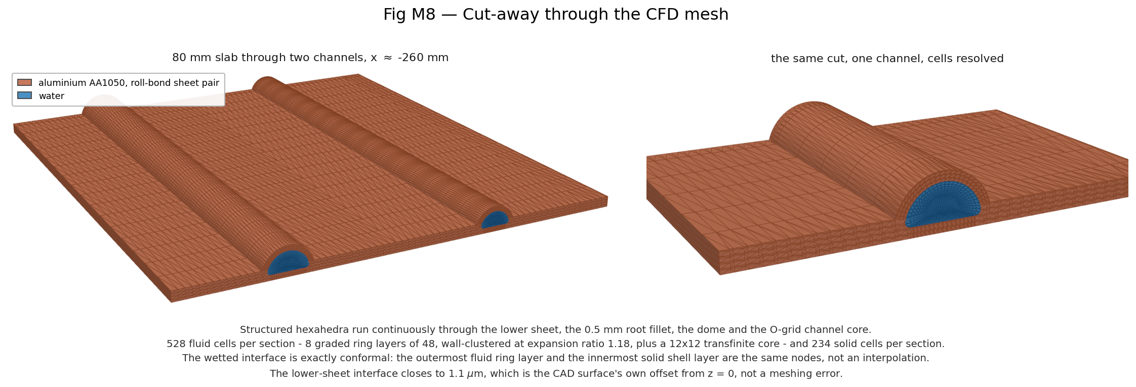
Figure 42 — Cutaway of the meshed absorber.
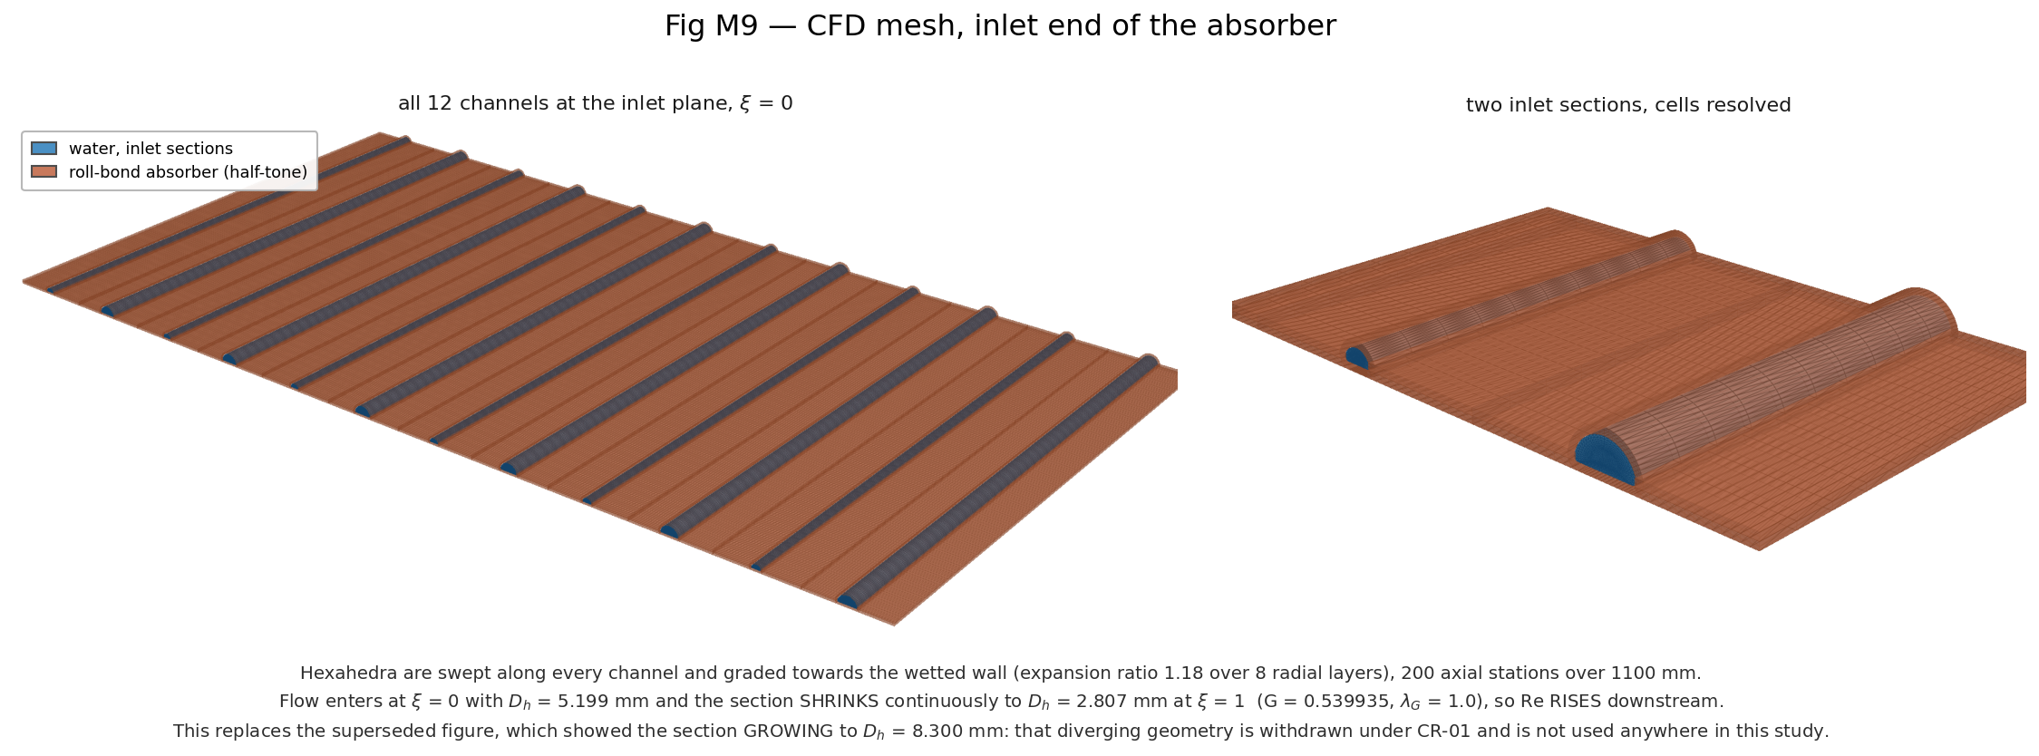
Figure 43 — Detail at the inlet end.

15. The two patent-supporting studies
Filings 2 and 3 concern the graded PCM tray and the thermotropic glazing layer. Both were simulated on the same conjugate plate solver, in transient mode for the PCM and in steady state for the thermotropic layer.

15.1 The graded PCM tray (Filing 2)
RT55 with 10 % expanded graphite: solid 880 / 2000 / 2.80, liquid 770 / 2200 / 2.40, latent heat 170 kJ/kg across 51–57 °C. The apparent-heat-capacity form is used, c_eff = c_p(f) + L·df/dT, with a linear liquid fraction over the 6 K interval — the form the design roadmap itself specifies. The tray is one lumped node per plate cell, eliminated analytically each time step so the plate-tray coupling stays fully implicit.
Each scenario is run TWICE: once with latent capacity, and once with the tray as a pure resistance with no capacity. The difference between the two is what the PCM actually buys.
Table 36 — PCM transient scenarios.
Scenario | Peak plate T with tray | Without | Benefit | Largest difference | Stored
Charge, cold start at design point, 4 h | 59.0 °C | 61.5 °C | −2.5 K | +10.7 K at 900 s | 1.07 MJ/m², f_liq 0.471
Cloud, irradiance to zero for 2 h | 53.5 °C | 54.7 °C | −1.2 K | +18.9 K at 1200 s | −0.00 MJ/m², f_liq 0.000
Stagnation, flow cut to 2 %, 1000 W/m², 4 h | 205.3 °C | 263.8 °C | −58.5 K | +134.4 K at 4200 s | 4.23 MJ/m², f_liq 1.000
Stagnation is where the tray earns its place: peak plate temperature falls from 264 °C to 205 °C while the tray absorbs 4.23 MJ/m² and melts completely. During charging it is nearly free, and on cloud passage it buffers and gives back exactly what it stored — liquid fraction returns to 0.000 and stored energy to −0.001 MJ/m².
The caveat that decides how this may be claimed
At stagnation the model runs the tray to 200 °C. RT55 is a paraffin and would have decomposed long before that. The apparent-heat-capacity formulation contains no degradation, no vapour pressure and no upper service limit, so it will report protection a real tray could not deliver more than once.
That is itself the design finding. The 58 K stagnation benefit is real in the model and CONDITIONAL in hardware: it holds only if the tray stays below its decomposition temperature, which on this collector means the stagnation problem must be solved by something else before the PCM can be relied on for it.
The charge and cloud results, which stay inside 51–62 °C, are not subject to this caveat.
Numerics: grid 110 × 120, dt = 10 s, implicit Euler. The time step was verified in closeout check B at dt = 20, 10 and 5 s. Refining 20 → 10 s moves the mean plate temperature by +0.068 K and the stored energy by +1.55 %; refining 10 → 5 s moves them by +0.033 K and +0.76 %. Both ratios are close to one half, which is the first-order convergence backward Euler requires, and Richardson extrapolation puts dt = 5 s within 0.033 K of converged. The PCM time step is adequate and no PCM result changes.
One stated simplification: lateral conduction inside the PCM is neglected. k_pcm × t_pcm is 0.028 W/K against the absorber's 0.458 W/K, so the tray carries about 6 % of the plate's in-plane conductance and cannot redistribute heat on these timescales.
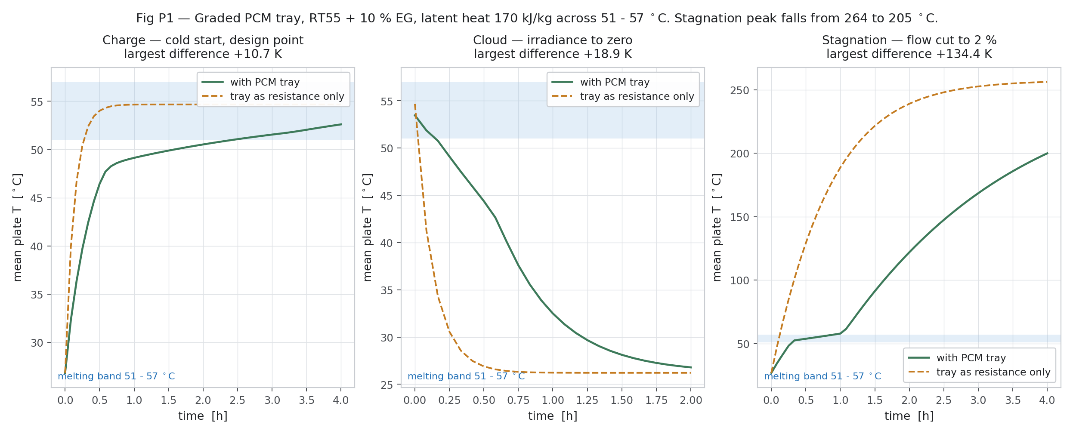
Figure 44 — PCM transients: charge, cloud passage and stagnation.
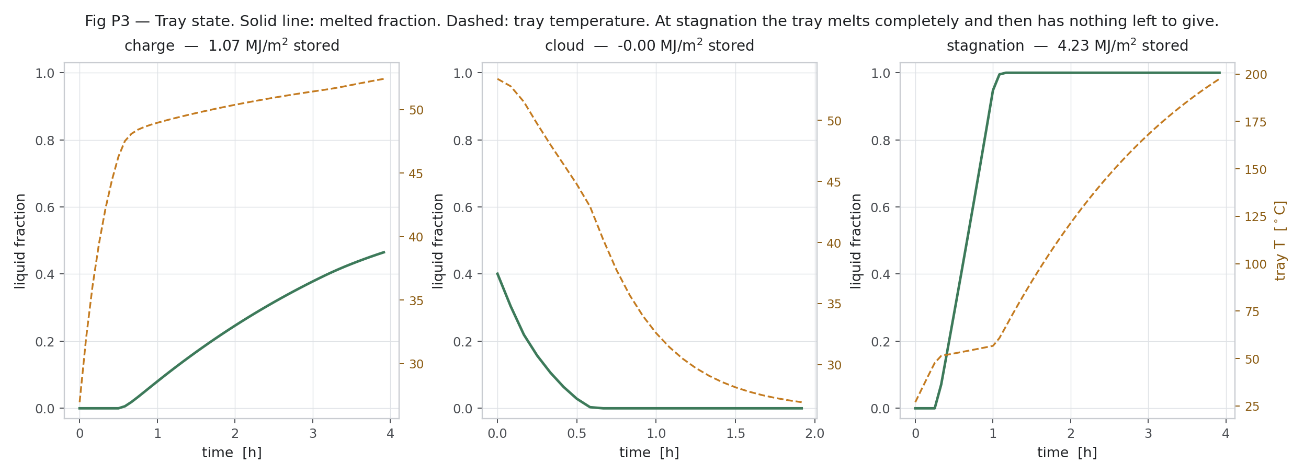
Figure 45 — PCM state: liquid fraction and stored energy through each scenario.

15.2 The thermotropic glazing layer (Filing 3)
The question asked was not “does scattering reduce absorbed flux” — it must — but two sharper ones: does the layer ever reach its own switching band in service, and what does it cost when switching is not wanted? Both matter because the layer is passive and cannot tell overheating from a good day.
Modelling note: what is applied is the RATIO tau(T)/tau_clear multiplying the established system transmittance, not tau(T) itself. That keeps the clear-state baseline exactly as established (tau_glz_sys = 0.833, q″ = 519.1 W/m² at 800 W/m²) and applies only the switching effect.
Table 37 — Result 1: the layer never switches where it is currently placed.
G_T (W/m²) | Flow | Peak glazing T | Peak absorber T
400 | trickle | 32.2 °C | 117.6 °C
400 | stagnation | 35.5 °C | 142.1 °C
600 | trickle | 38.2 °C | 161.7 °C
600 | stagnation | 42.9 °C | 194.6 °C
800 | design | 25.2 °C | 61.5 °C
800 | quarter | 35.3 °C | 141.1 °C
800 | trickle | 44.2 °C | 203.5 °C
800 | stagnation | 50.2 °C | 242.0 °C
1000 | trickle | 50.3 °C | 242.7 °C
1000 | stagnation | 57.3 °C | 284.9 °C
1200 | trickle | 56.4 °C | 279.5 °C
1200 | stagnation | 64.3 °C | 323.7 °C
Across the whole envelope — up to 1200 W/m² at stagnation — the glazing peaks at 64.3 °C, below its own 72 °C switching threshold. It never switches, anywhere.
The reason is the transparent insulation, and it is doing exactly its job: at 1200 W/m² stagnation the absorber reaches 324 °C while the glass sits 259 K below it. A layer that senses GLASS temperature is blind to the condition it exists to protect against.
Table 38 — Result 2: the same layer, moved onto the absorber.
Operating point | Glazing-mounted | Absorber-mounted
design | dTp_max +0.0 K, dη +0.00 % | dTp_max +0.0 K, dη +0.00 %
high irradiance (1000 W/m², design flow) | dTp_max +0.0 K, dη +0.00 % | dTp_max +0.0 K, dη +0.00 %
trickle | dTp_max +0.0 K, dη +0.00 % | dTp_max −112.8 K, dη −52.51 %
stagnation | dTp_max +0.0 K, dη +0.00 % | dTp_max −127.9 K, dη −49.57 %
At the design point and at 1000 W/m² with design flow, BOTH placements do nothing at all — exactly 0.000 K and 0.000 %. The absorber peaks at 70.3 °C there, just under the 72 °C threshold, so an absorber-coupled layer costs nothing during normal collection. At trickle flow it removes 112.8 K of peak plate temperature, and at stagnation 127.9 K.
The efficiency figures for those two cases should not be read as a loss worth weighing: at trickle flow efficiency is already 0.175, and at stagnation it is 0.002. Halving a number that small is not a cost; it is the point.
Verdict for the filing, and one unresolved question
The mechanism works and the PLACEMENT decides everything. In the glazing stack, following glass temperature, the layer is inert across the entire operating envelope. Coupled to the absorber, it gives passive overheating protection worth 128 K at stagnation for zero cost in normal collection.
This is a steady-state result. Switching speed, cycling, and the transient into stagnation are not modelled.
DESIGN_REVIEW_REQUIRED: tau_glz_sys = 0.833 is two panes of low-iron glass (0.91² = 0.828) and does not visibly account for a thermotropic layer, yet the CAD carries THERMOTROPIC_LAYER_T2 as a separate body. Either 0.833 already absorbs the layer's clear-state transmittance, or the baseline optical chain omits a real optical element and overstates absorbed flux by roughly 12 %. This cannot be resolved from the roadmap and needs a human decision. The ratio formulation used here is the conservative reading.
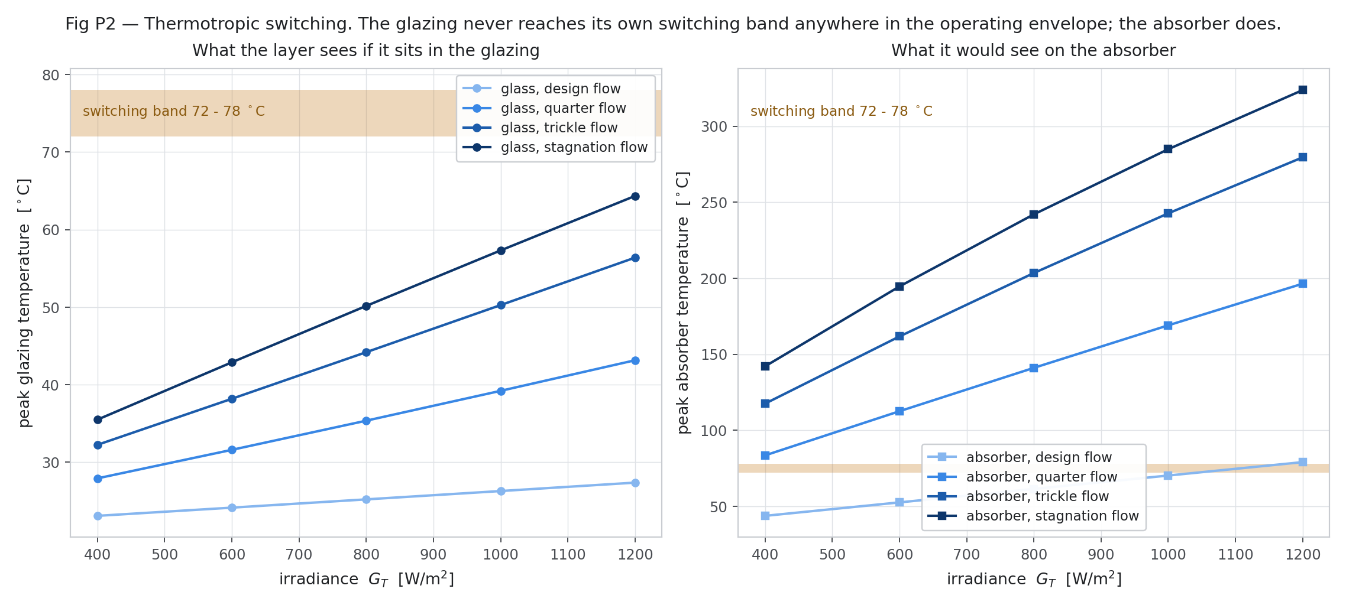
Figure 46 — Thermotropic layer: glazing and absorber temperatures across the envelope.
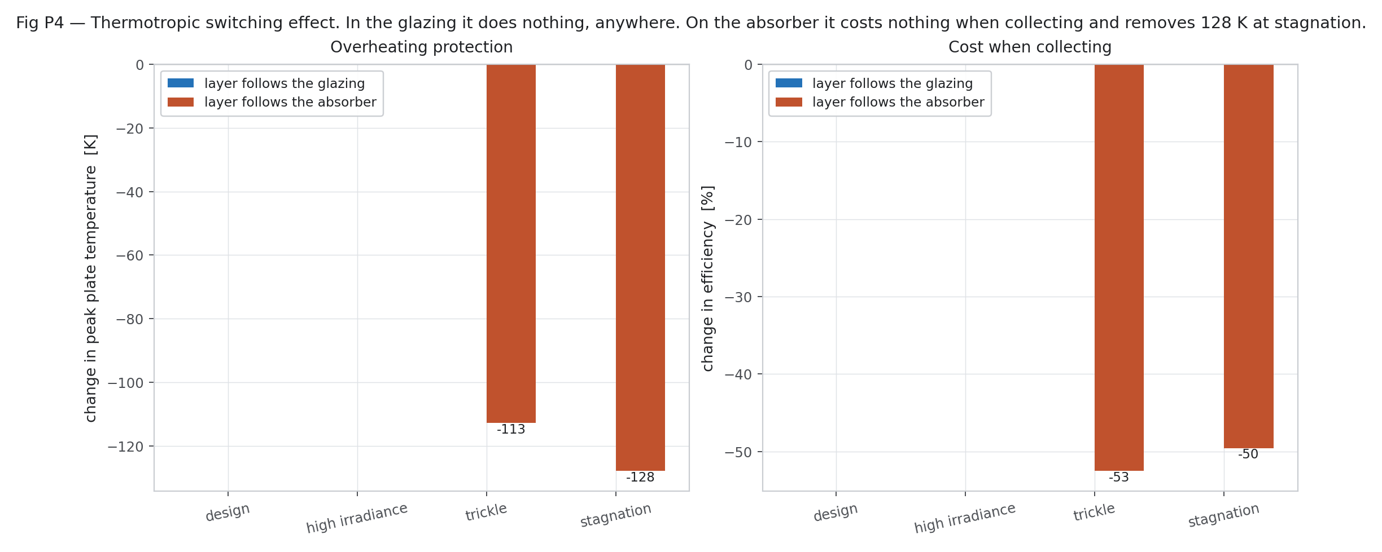
Figure 47 — The effect of the layer at each placement and operating point.

16. The correction register
Seventeen corrections were raised during this work. Each records the old assumption, the corrected one, the reason, what it affects, and — the column that matters — whether prior results had to be discarded.
Table 39 — Correction register, summarised.
ID | What changed | Discard old results?
CR-01 | Channel DIVERGES → channel CONVERGES, D_h 5.199 → 2.807 mm | YES — scientifically invalid
CR-02 | Single glazing 0.91 → two-pane system 0.833; q″ 567.1 → 519.1 W/m² | YES for anything computed from 0.91
CR-03 | Symmetry planes are not valid under alternating flow | Closed by Gate 6 — no
CR-04 | lambda_G confirmed = 1.0 against the as-built geometry | No
CR-05 | Root fillet 1.0 → 0.5 mm; at 1.0 mm G = 0.54 is unreachable | YES for any G = 0.54 result at 1.0 mm
CR-06 | Bridge 34.8 mm → 31.286 mm as built; sweep 20–37 mm | No
CR-07 | Manifold pockets deliberately reduced by ~452.9 mm³ | No — deliberate
CR-08 | WITHDRAWN — its premise was wrong | —
CR-09 | The geometry is faithful; the MEASUREMENT TOOL was wrong (OCC, −0.72 %) | YES — discard CR-08 itself
CR-10 | Assembly renders rebuilt on the corrected STEP | YES — old renders withdrawn
CR-11 | Manifold barrels rendered without port holes; solid at nominal 1.0 mm | No — rendering only, quantified
CR-12 | Bridge contrast must be quoted absolutely, never as a ratio to zero | No
CR-13 | nu_cfd 3.4282 → 2.9238; the whole campaign recomputed | No — Rev 1 kept; Rev 2 supersedes
CR-14 | Rev 1's campaign average was censored by 9 low-flow alternating rows | No result discarded; the headline changes
CR-15 | The 1.81 g/s mass-flow threshold is withdrawn | YES — withdraw the claim
CR-16 | Constant Nu is the largest model-form term: +14.24 pp | No — but the claim is model-form limited
CR-17 | The 3-D conjugate run was attempted and failed, not merely pending | No — nothing was reported from it

17. What this study establishes, and what is still open

17.1 The four claims, as they finally stand
Table 40 — Final statement of results, k = 2.
Claim | Design point | Campaign average | Verdict
Efficiency difference | −4.94 ± 0.81 % | −4.33 ± 2.34 % | FIRM — a deficit, not a gain
Loss-coefficient difference | −7.07 ± 0.90 % | — | FIRM
Plate spread, RMS | −21.09 ± 11.61 % | −20.83 ± 12.09 % | REAL, but model-form limited
Plate spread, peak-to-peak | −3.64 ± 15.82 % | −11.57 ± 12.06 % | NOT distinguishable — do not claim
Mean plate temperature | — | +2.62 ± 1.11 % | alternating runs hotter
Loss coefficient U_L | — | −0.90 ± 22.93 % | NOT distinguishable over the campaign
The plain-language version: the alternating arrangement really does flatten the absorber temperature field, and roughly 20 W per bridge midline of lateral conduction is what does it. But at matched mass flow it costs about 5 % of efficiency, and the radiative loss it was meant to reduce is already under 1 % of the absorbed energy because the selective coating has taken it. The homogenisation is the defensible claim. The efficiency gain is not, and the peak-to-peak uniformity gain is not.

17.2 What is still open
- Nu(xi) in the campaign. Section 12 bounds the effect at +14.24 pp but does not remove it. This is the largest single outstanding item.
- A fourth 3-D grid level, to tighten the 11.6 % GCI on Nu. Estimated at more than 20 hours on two cores and declared infeasible here rather than quietly skipped.
- A converged 3-D conjugate run. The mesh is built and verified; the solver is not.
- No experimental validation. Every “validation” in Section 13 is either self-consistency with the design targets or agreement with an independent analytical model. No measurement of a real GRAIL collector has been used.
- The alternating mechanism on a NON-selective absorber (eps = 0.9 instead of 0.04), which is the configuration in which it should actually pay.
- DESIGN_REVIEW_REQUIRED: whether tau_glz_sys = 0.833 already includes the thermotropic layer.
- Temperature-dependent viscosity in the 3-D baseline. It does not enter the thermal result while Nu is held constant, so it affects pressure drop and pumping power only — but that is an assumption, not a proof, and it is untested.

17.3 Scope boundary
This report ends where the CFD phase ends. No artificial neural network, machine-learning surrogate, optimisation, topology optimisation, systems simulation or annual-performance model was built, and none is implied by anything above.

PART V — Rev 4 / 4.1: repaired conjugate CFD and corrected results

18. Root cause of the 3-D conjugate divergence, and the repair
Controlled one-change experiments showed the divergence reported in Section 14 comes from the buoyant p_rgh SIMPLE formulation on this O-grid mesh family. buoyantSimpleFoam diverges identically on the fluid region alone (no solid, no interface) and on the previously validated single-channel mesh; pressure reference, wall pressure condition, cell quality, relaxation, schemes and correctors were each eliminated. After one iteration the face fluxes satisfy continuity but the cell velocities are wrong by ~10⁵ in the cross-section plane, consistent with an ill-conditioned rebuild of cell velocity from face flux on cells micrometres thick and millimetres long (stated as consistent with the evidence; the source line was not quoted).
Repair: with constant ρ, μ, k and cp the steady flow does not depend on temperature. The flow is solved with simpleFoam (which converges), then the conjugate energy equation with chtMultiRegionSimpleFoam's frozenFlow switch — the same steady solution as a coupled solve. Verified: frozenFlow present in the installed binary; zero pressure and momentum solves; supplied flux unchanged to 1.5e-8. Two further errors in the old case were corrected: solar input had been applied per curved area (+12.2 %), now per plan area (h = U·n_z); the meshed inlet carries 0.30 % less flow, so the ROM is run at the 3-D flow.

19. The 3-D conjugate benchmark
Domain: 2-channel periodic strip, 1100 × 80 mm, the CAD plate. Top q″ 519.1256 W/m² minus 4.191176 W/m²K × (T − 298.15 K) per plan area; rear 3.0 W/m²K; inlet 300 K, 2.077072e-4 kg/s per channel. A linear loss model by design (ENGINEERING_ASSUMPTION): the benchmark tests coupling, not glazing.
Table R2 — 3-D conjugate results, alternating vs co-current.
Grid | η co / alt | std co / alt (K) | Δη | Δ std | Δ spread | balance
NX 60, NU 64 | 0.51484 / 0.42212 | 5.771 / 5.254 | −18.01 % | −8.96 % | −2.52 % | ≤ 0.035 %
NX 120, NU 64 | 0.51597 / 0.41817 | 5.791 / 5.508 | −18.95 % | −4.88 % | +3.40 % | —
NX 240, NU 64 | 0.51594 / 0.41840 | 5.784 / 5.474 | −18.91 % | −5.37 % | +3.07 % | ≤ 0.049 %
NX 120, NU 48 | 0.51605 / 0.41786 | 5.792 / 5.526 | −19.03 % | −4.59 % | +3.42 % | ≤ 0.030 %
NX 120, NU 96 | 0.51586 / 0.41849 | 5.789 / 5.481 | −18.88 % | −5.32 % | +3.20 % | ≤ 0.037 %
Best estimate | — | — | −18.9 ± 0.1 % | ≈ −6.6 ± 1.0 % | +3.1 % | —
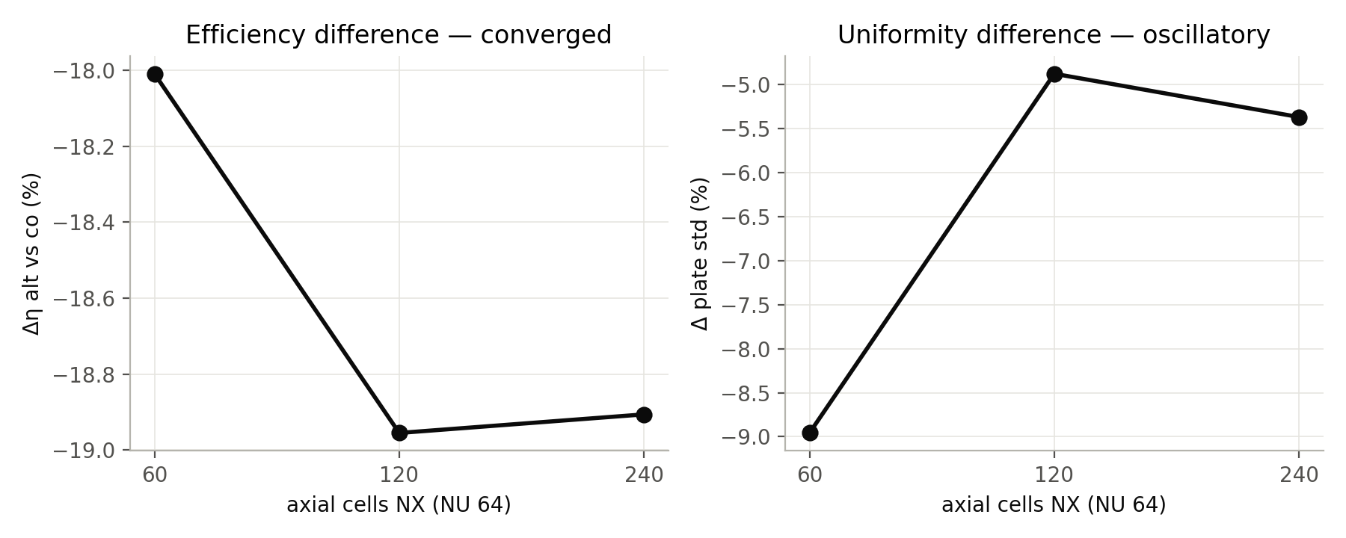
Figure R1 — 3-D axial grid study: Δη converges, Δ std oscillates.
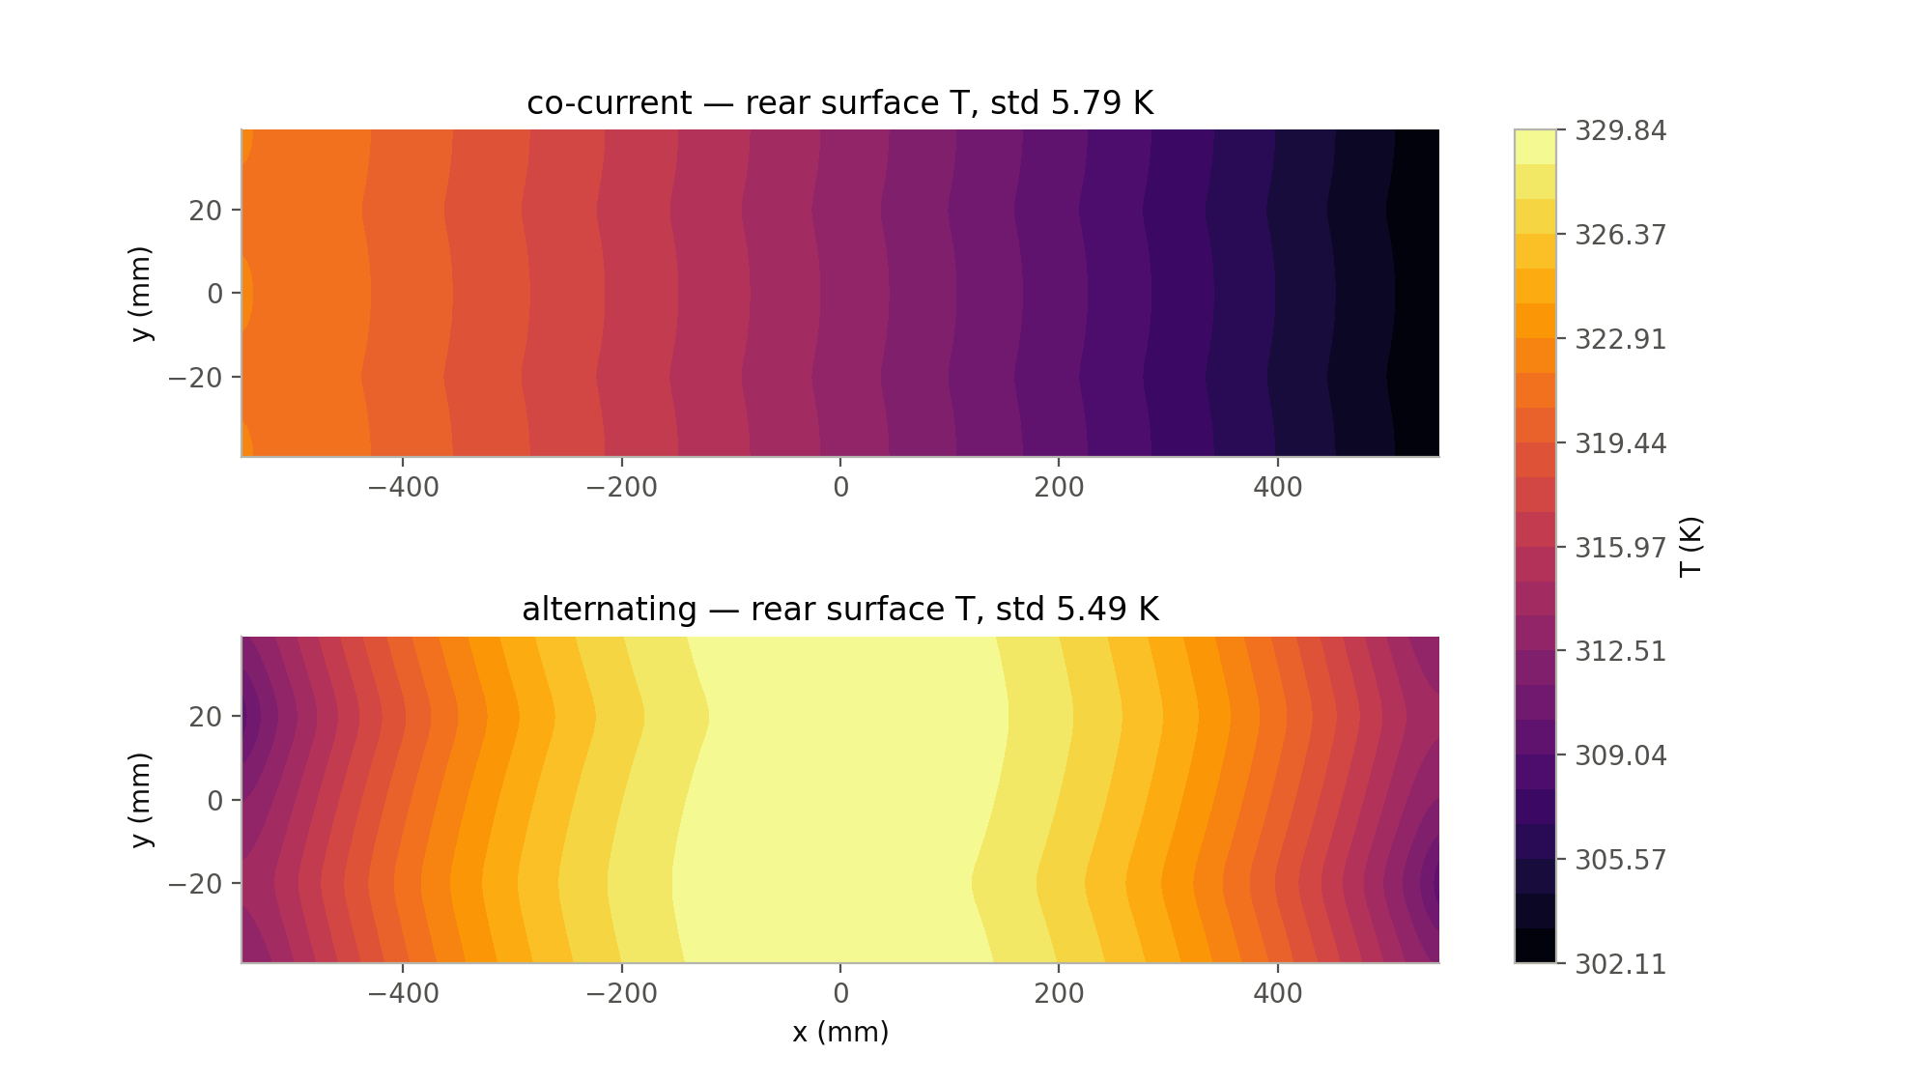
Figure R2 — 3-D rear-surface temperature, NX 240.
Mechanism: the two counter-flowing channels form a counter-flow heat exchanger through the metal. In the alternating case 40 % of the heat a channel absorbs (9.94 of 24.80 W) is handed back to the plate over 41 % of its length; the fluid peaks mid-channel (328.6 K) and leaves cooler (317.1 K) than in co-current flow (320.9 K).
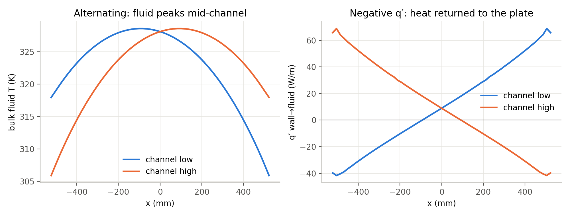
Figure R3 — Heat recirculation, alternating, NX 60.

20. The corrected Nusselt closure
Nu 2.9238 (Sections 1–17) came from a fluid-only case with heat flux uniform around the perimeter — the H2 condition. The aluminium wall is close to isothermal around the perimeter (H1). The 3-D conjugate developed-region Nu is 4.646 / 4.602 / 4.556 on NU 48 / 64 / 96 (p = 1.12), extrapolated to 4.48 (GCI 2.1 %); it is axially converged (4.592 / 4.602 / 4.602) and flow-independent (4.599 at 1.0 g/s). Reference H1, semicircular duct: 4.088 (Erdoğan & Imrak 2005), 4.089 (Shah & London table in Hesselgreaves 2001). The H2 value ≈ 2.92 is recalled, not verified; nothing depends on it.
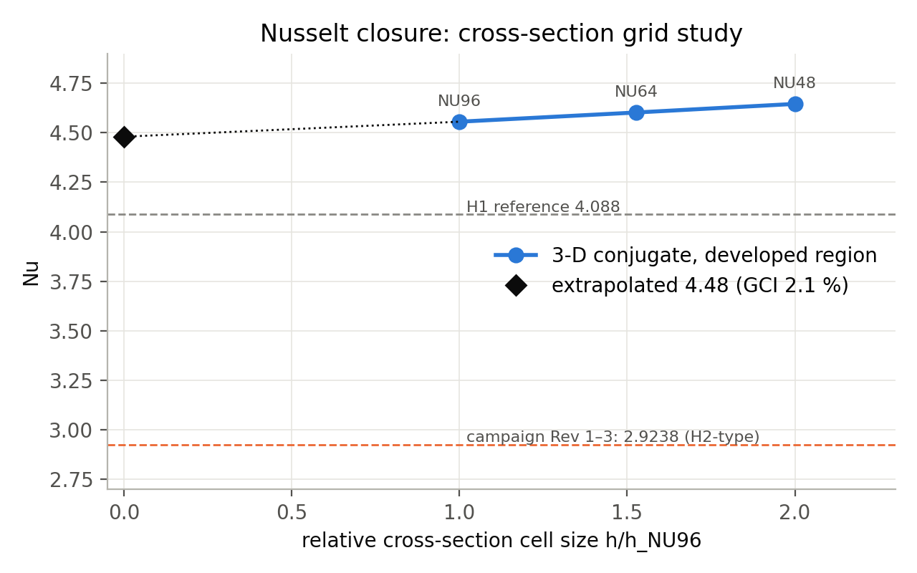
Figure R4 — Cross-section grid study of the conjugate Nu.
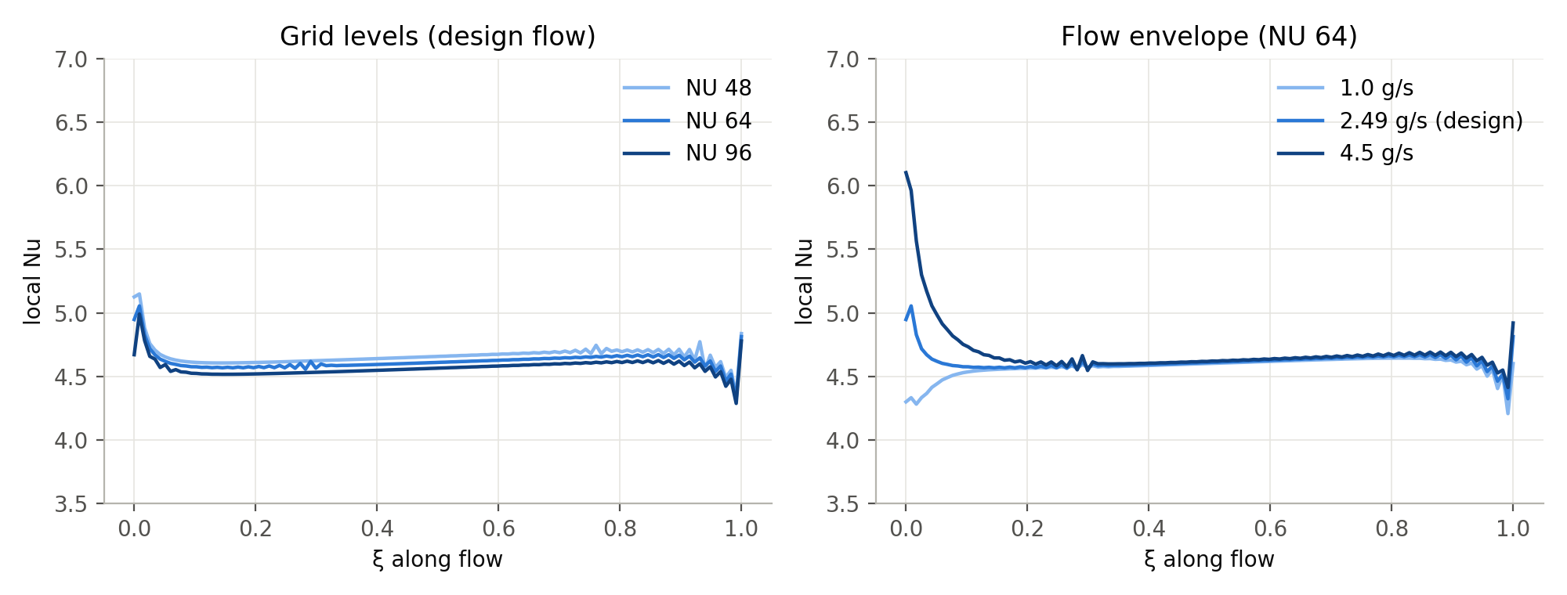
Figure R5 — Local Nu along the channel: grid levels and flow envelope.
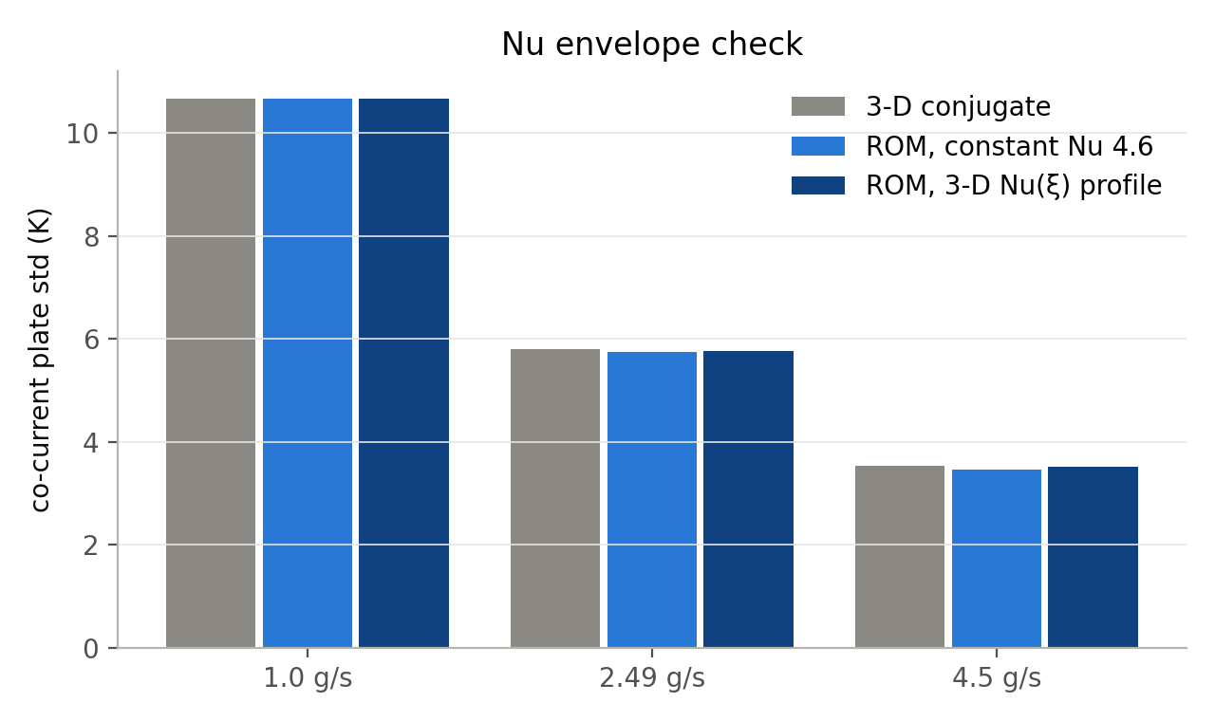
Figure R6 — Co-current plate std, 3-D vs ROM across the flow envelope.
ROM check: with the conjugate Nu, GRAIL-CHT reproduces the co-current 3-D solution to 0.01 % in η and 0.6 % in std. For the alternating arrangement it overstates the uniformity benefit by ≈ 2.0 pp and understates the efficiency penalty by ≈ 0.5 pp, because local Nu is undefined where q′ changes sign.
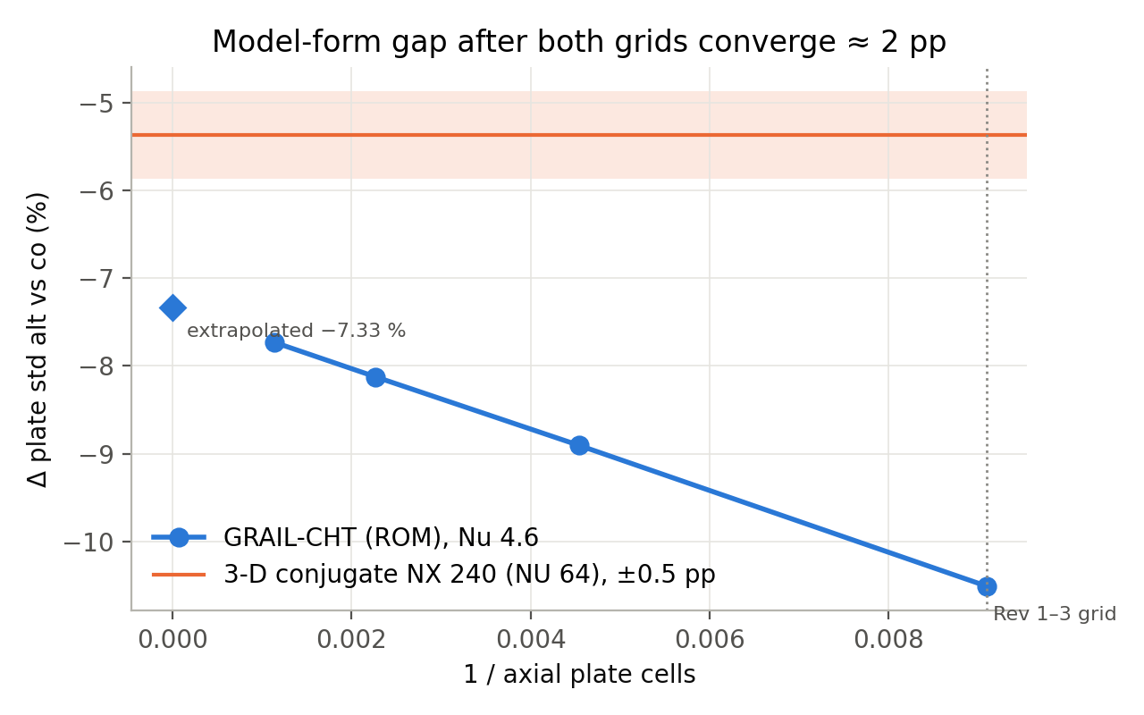
Figure R7 — ROM axial convergence (p = 1.01) against the 3-D result.
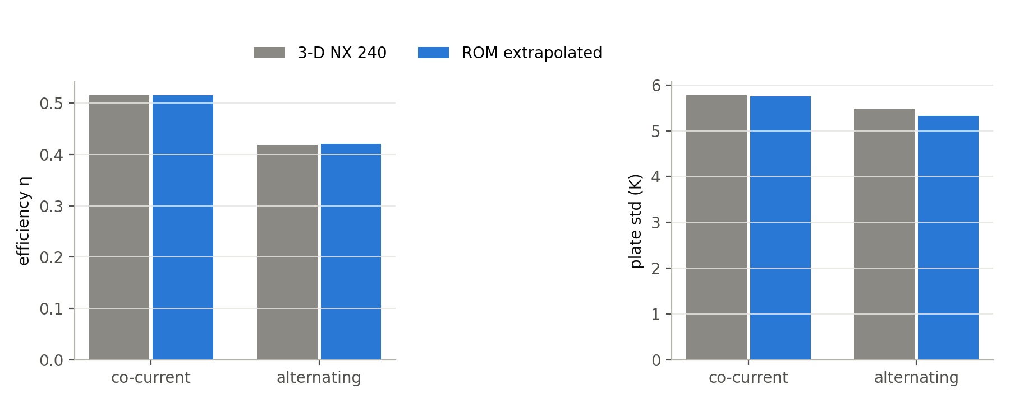
Figure R8 — ROM vs 3-D per arrangement, design point.

21. Dataset Rev 4
Changed from Rev 3: Nu 2.9238 → 4.48, and plate grid 110 → 110 and 220 with per-row Richardson 2f(220) − f(110). Unchanged: seed, Latin Hypercube, bounds, geometry gate, k(T), acceptance gates (tolerance 1e-6 asserted, |energy error| < 0.5 %, 250 < T_plate < 500 K). Iteration cap 900 → 3000. 300 / 300 accepted at both grids; no row deleted; Rev 1–3 untouched.
Rev 4.1 then corrected three derived-column groups found by an independent audit (radiative temperature quantities, U_L, Reynolds number); every thermal result is unchanged. Details: Correction Report §6.1 and the Rev 4.1 change log.
Table R3 — Arrangement comparison, Rev 4.1, two independent 150-case groups (unpaired).
Quantity | Parallel | Alternating | Difference | Mann–Whitney p
η, mean | 0.5620 | 0.5209 | −7.3 % | 2e-8
Plate std, median (K) | 5.013 | 4.960 | −1.1 % | 0.76 (n.s.)
Plate spread, median (K) | 16.57 | 19.61 | +18.4 % | 0.001
Mean plate T | — | — | +13.9 K | 2e-10
Table R4 — Rev 4.1 by total flow rate (unpaired).
Total flow | Δ mean η | Δ median plate std | p (std)
1.0 – 2.2 g/s | −12.7 % | +16.8 % | 0.03
2.2 – 3.3 g/s | −6.0 % | +7.9 % | 0.14 (n.s.)
3.3 – 4.5 g/s | −3.5 % | −13.4 % | 0.02
ALT_n and PAR_n come from two independent Latin-Hypercube draws and do not share inputs; the groups are statistically identical in every input (KS p = 1.00). All comparisons are therefore group-wise. Paired statistics in earlier drafts are withdrawn.
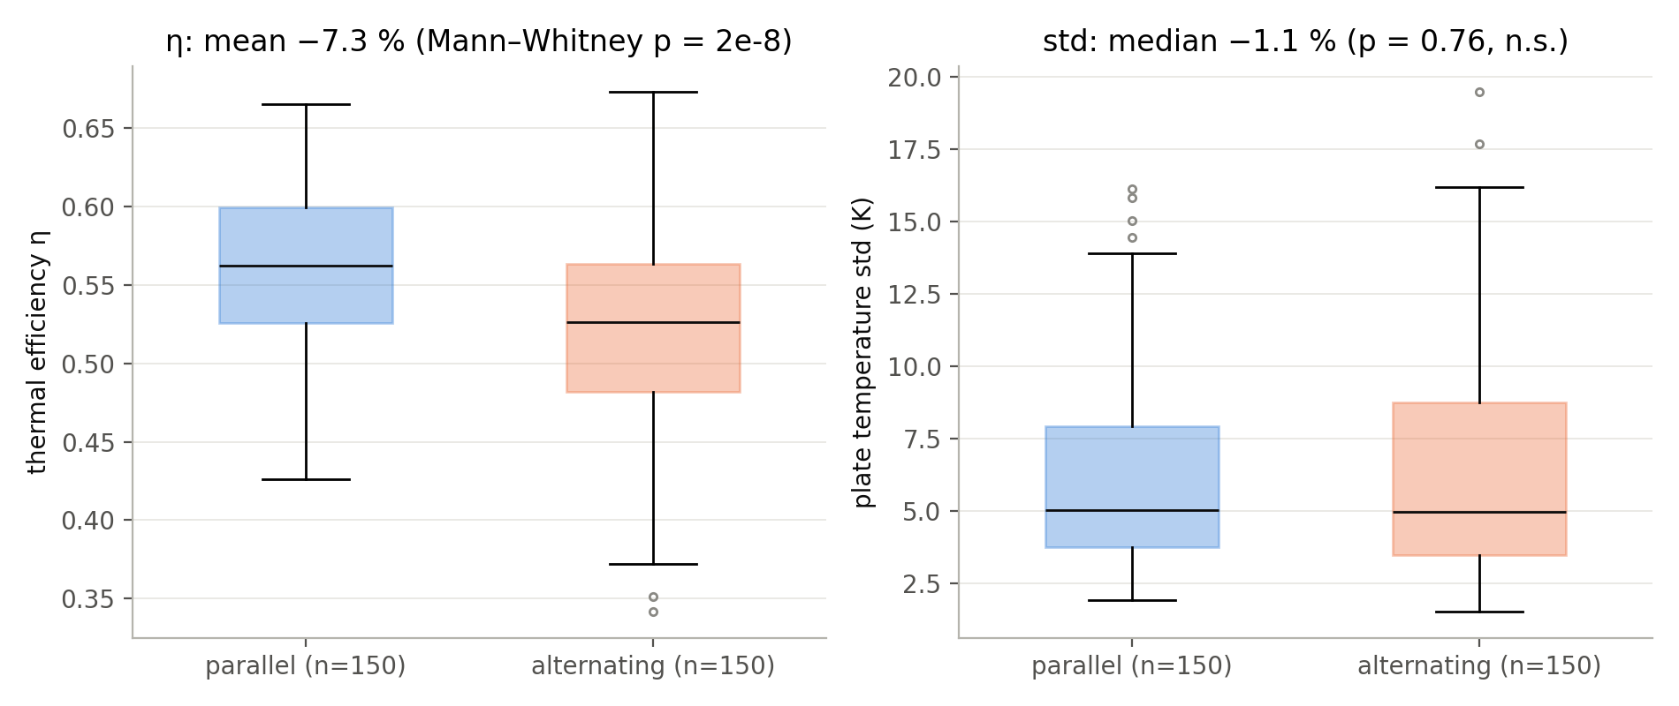
Figure R9 — Arrangement groups, Rev 4.1 (unpaired).
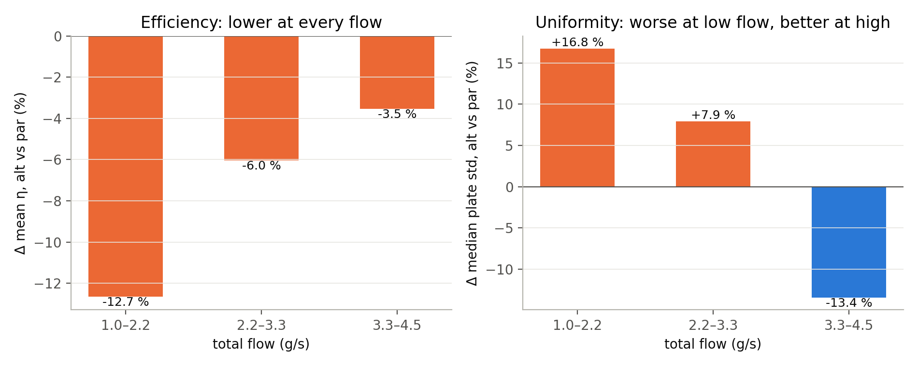
Figure R10 — Arrangement differences by flow tercile, Rev 4.1 (unpaired).
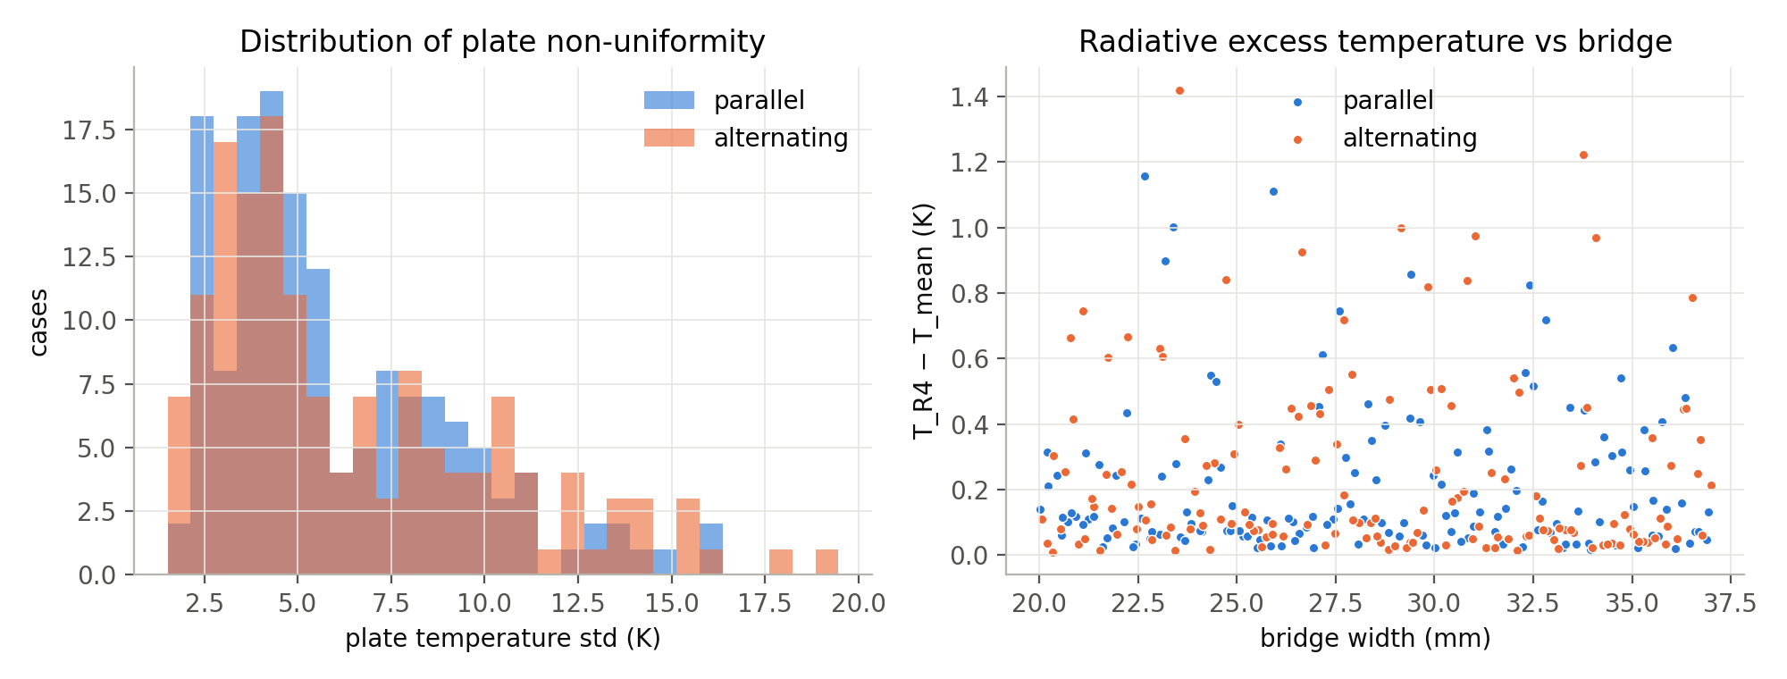
Figure R11 — Plate-std distributions and radiative excess temperature vs bridge width, Rev 4.1.
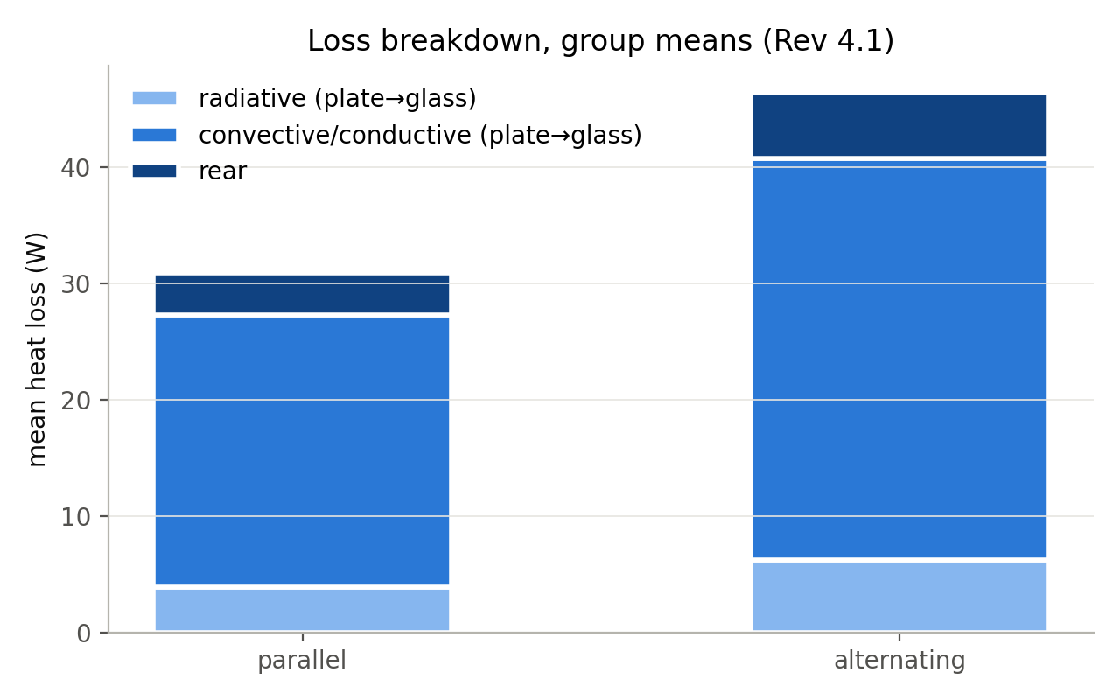
Figure R12 — Loss breakdown, group means (signed net flows).
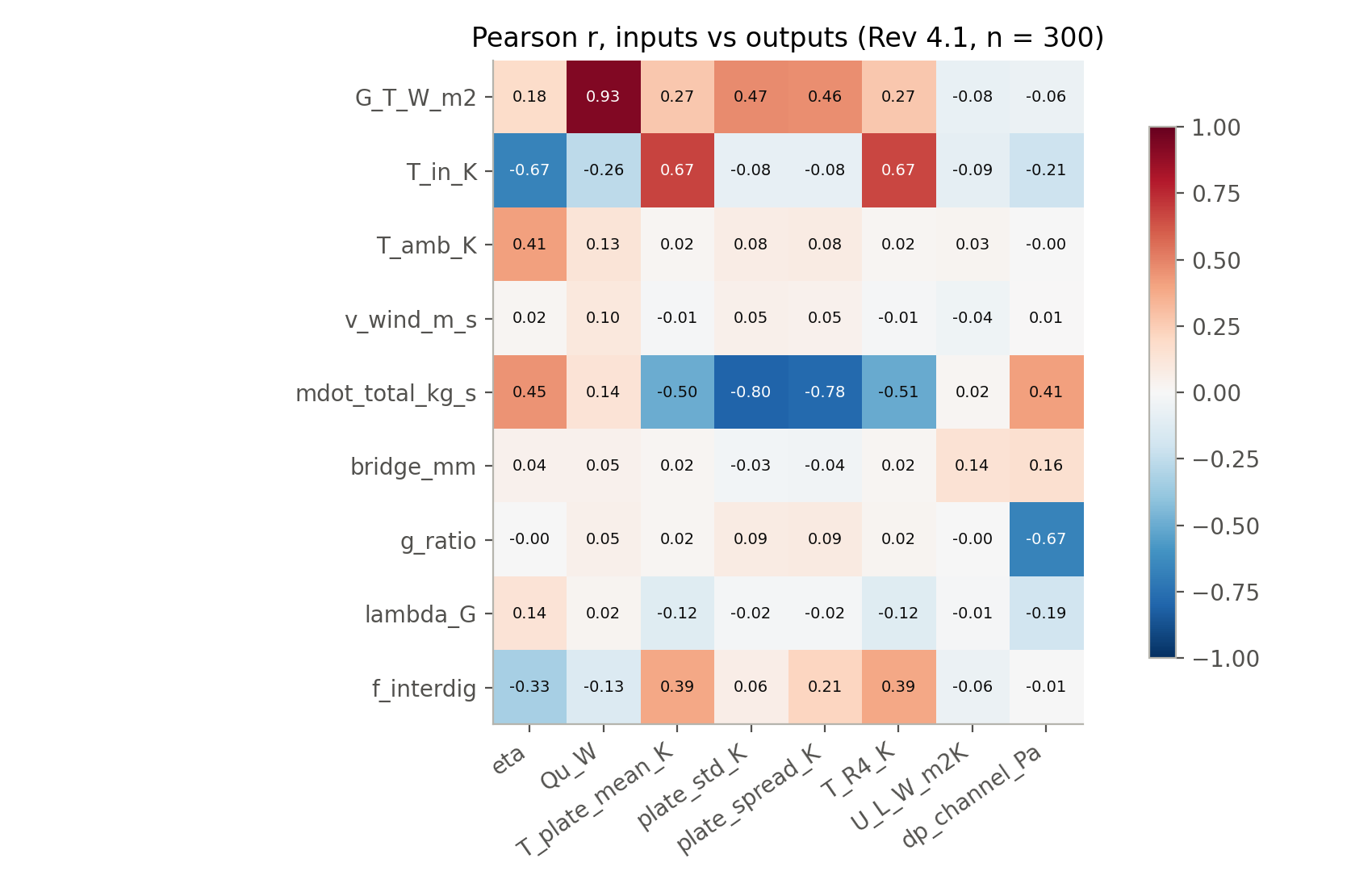
Figure R13 — Pearson correlation, inputs vs outputs.
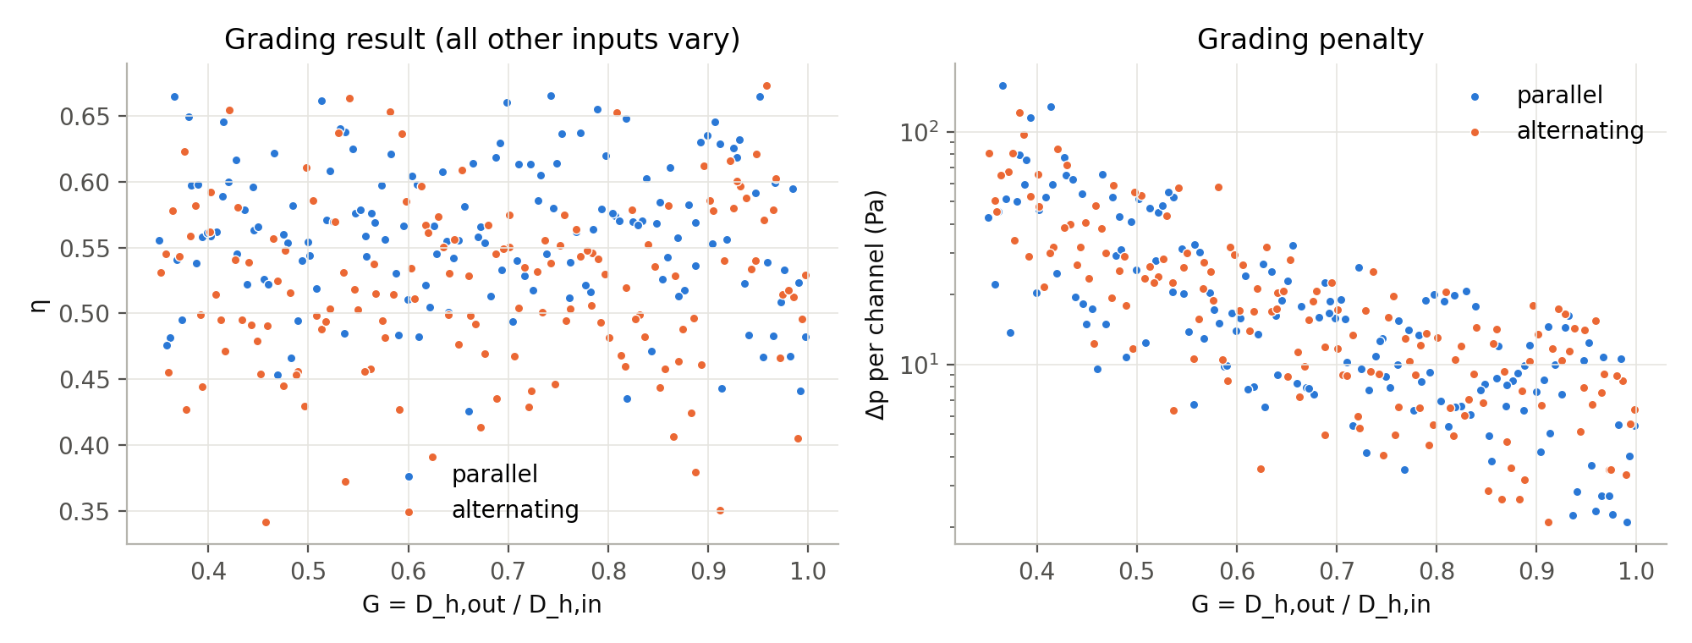
Figure R14 — Efficiency and pressure drop against grading ratio G.
The 35 rows needing more than 900 iterations are all alternating low-flow cases; a subset that excludes them is biased in favour of the alternating arrangement and is not used as a result.

22. Uncertainty budget (Rev 4, design flow)
Source | Δη | Δ std
3-D discretisation | ± 0.1 pp | ± 1.0 pp (bound)
ROM axial after Richardson | < 0.1 pp | ≈ 0.4 pp
ROM model form (alternating) | 0.5 pp | 2.0 pp
Nu band 4.46 – 4.65 | ≈ 0.1 pp | ≈ 1.1 pp
Entry-region Nu at 4.5 g/s | < 0.1 % | ≤ 2.1 % of std
Glazing / radiation loss model | not quantified | not quantified

23. Roadmap V5 — experimental reference assessed
Gunjo, Mahanta & Robi, Renewable Energy 2017 (doi:10.1016/j.renene.2016.12.041) was read in full and rejected as a reference (DESIGN_REVIEW_REQUIRED): its simulated outlet rise (≈ 33 K at noon) needs 1.7–3.4 kW against ≈ 1.53 kW of total solar input; its error is taken on absolute kelvin, hiding a > 100 % error on the temperature rise; its measured outlet does not respond to a doubled flow rate (implying η ≈ 95 % against its own 56 %); wind speed and (ατ) are not given and tube thickness is stated two ways; and it is a sheet-and-tube, not roll-bond, collector. No GRAIL result is compared with it. There is no experimental validation in this study.

24. Final claims

24.1 Supported
The 40 % heat-return figure: 9.94 of 24.80 W per channel returned over 41 % of the length (3-D, NX 60, design point); net 14.86 W against ṁc_pΔT = 14.85 W. It needs the full channel length including end segments; quote as ≈ 40 %.
- Alternating flow lowers efficiency: group mean −7.3 % (p = 2e-8), lower in every flow tercile.
- Plate uniformity depends on flow rate: better at high flow (−13.4 % median std above 3.3 g/s), worse at low flow (+16.8 % below 2.2 g/s); overall −1.1 %, not significant.
- The alternating plate runs hotter: +13.9 K mean, +12.6 K mean P90.
- Mechanism: counter-flow heat recirculation through the plate (40 % of absorbed heat returned).
- The conjugate channel Nu is 4.48 (H1-type), not 2.92.
- GRAIL-CHT with that closure matches 3-D co-current flow closely; it overstates the alternating uniformity benefit by ≈ 2 pp.

24.2 Not to be claimed
- A general uniformity benefit of alternating flow, or one 'at no cost'.
- Any ALT_n-vs-PAR_n paired statistic (they are independent samples).
- Any Rev 1–3 arrangement number as final.
- A geometric taper benefit (a constant-Nu model cannot see one).
- A reduced peak-to-peak plate temperature (group median +18.4 %).
- Experimental validation of any kind.
- Mesh-independent Δ std from the 3-D study (bounded, not extrapolated).
- 3-D validation of the glazing, radiation, PCM or VIP models.
Scope
CFD phase complete. No ANN, surrogate, optimisation or systems modelling was performed.

