THE GRAIL COLLECTOR
Engineering Report — complete technical record
Converging roll-bond solar absorber with transparent insulation, PCM and vacuum insulation: design, CFD, reduced-order model, surrogate, optimisation, system model, annual and economic analysis, verification and validation
Item | Value
Project | B.Tech minor project — GRAIL Collector
Document type | Simple engineering report (working record). A formal engineering report will be prepared from it.
Revision | Rev 1.0, 25 September 2026 (dataset Rev 4.2; Simulink V21)
Authors / institution | [to be filled in by the authors]
Units | SI throughout; temperatures in kelvin (K) in all equations, °C only where stated
Status | All stages complete. V5 validation closed at method/component level. No experimental test of the GRAIL collector itself.

Contents

1. Summary of results
This report records everything done on the GRAIL collector in one place: the inputs, every method, every result, every figure and table, all verification checks and the validation against published experiments. It is written plainly so that each number can be traced to its source file.
Area | Key result
Collector | 12-channel aluminium roll-bond absorber, 1.10 × 0.48 m (0.528 m² per module), channels converging along the flow (G = 0.539935, λ = 1.0), bridge 31.29 mm; glass + honeycomb TIM cover; PCM + VIP rear; optical factor 0.649
3-D CFD | Conjugate OpenFOAM model; developed Nusselt number 4.48 (GCI 2.1 %), H1-type condition; replaces the earlier 2.92
Reduced-order model (GRAIL-CHT) | Matches 3-D co-current solution within 0.01 % (η) and 0.6 % (plate std); Hottel-Whillier-Bliss check +0.22 %
Campaign | 300 Latin-hypercube cases (150 alternating, 150 parallel), all converged, energy error < 0.5 %, none removed
Alternating vs parallel (equal inputs) | Alternating: efficiency −7.3 % (p = 2 × 10⁻⁸), plate +13.9 K hotter; uniformity better only above 3.3 g/s (−13.4 %), worse below 2.2 g/s (+16.8 %)
Alternating vs parallel (same plate temperature, V7) | Efficiency equal (Δη = −0.001 points); R4 not reduced (+0.04 %); alternating 8–11 % less uniform; needs ≈ 15 K cooler inlet
Mechanism | ≈ 40 % of the heat each channel absorbs is returned to the plate in alternating flow (9.94 of 24.80 W)
ANN surrogate (Stage 3) | Test R² 0.9994–0.9998 on 60 unseen cases; mean error 0.14 %
NSGA-II (Stage 5) | 8 optima re-run in GRAIL-CHT agree within 0.13 efficiency points, 2.4 % std, 5.8 % Δp
Efficiency curves (Stage 6) | Parallel η0 0.637, a1 2.10 W/m²K; alternating η0 0.597, a1 2.00 W/m²K (a1 up to 2.5 with measured VIP conductivity)
Annual, Berhampur (Stage 7) | POA 1,976 kWh/m²/yr; yield at 40 °C inlet 1,030 (parallel) / 965 (alternating) kWh/m²/yr
Economics | Best size 2 modules (1.06 m²): solar fraction 86 % / 83 %; cost of heat Rs 4.34 / 4.49 per kWh vs Rs 4.95 for electric geyser; payback ≈ 7.4 / 7.6 years
System models | Python, GNU Octave, Scilab Xcos and MATLAB/Simulink agree; Simulink V20/V21 PASS in all 4 cases (solar heat within 0.05 %)
Validation (V5) | Method checked on tested roll-bond collectors (Del Col 2013): a1, a2 within test uncertainty, η0 within 8 % (+6.0 / +7.8 %). TIM front loss matches Beikircher 2015. Partial pass, method level
Patent | First-pass search: combination appears new; inventive step weak–moderate; decision: publish, no filing

Statements that must be kept exactly as they are
1. Parallel flow is more efficient than alternating flow at equal inputs in every stage of the work.
2. At the same mean plate temperature the two arrangements have the same efficiency; alternating flow is less uniform at the design flow.
3. Within the studied range, converging the channels does not raise efficiency; the optimiser moves G towards 1. The converging channel can be argued only for plate uniformity.
4. All results are model results. The method was checked against published experiments; the GRAIL collector itself has not been tested.

2. Project definition

2.1 Objective
Design a flat-plate solar water-heating collector with a roll-bond aluminium absorber whose channels converge along the flow, add a low-loss cover and rear (glass + transparent insulation, phase-change material + vacuum insulation panel), and find out by simulation whether alternating (counter-current) flow in neighbouring channels is better than ordinary parallel flow. Then estimate its annual performance and cost for a household in Berhampur, Odisha.

2.2 Work chain
Step | What was done | Tool
1 CAD | Parametric 3-D model, 948 features, 131 parameters, verified gates | Autodesk Fusion
2 Geometry audit | Channel sections measured from the CAD (Gate 1) | Python (NURBS integration)
3 Mesh | Structured hexahedral channel meshes from the CAD surfaces | Python + OpenFOAM blockMesh
4 3-D CFD | Flow (simpleFoam) + conjugate heat transfer (chtMultiRegionSimpleFoam, frozenFlow) | OpenFOAM v1912
5 Reduced-order model | GRAIL-CHT: 2-D plate conduction + 1-D channel flow + glazing/radiation + rear stack | Python (own code)
6 Campaign | 300 Latin-hypercube cases, Rev 4.2 dataset | GRAIL-CHT
7 Stage 3 | ANN ensemble surrogate, GPR benchmark, SHAP | scikit-learn, shap
8 Stage 5 | NSGA-II multi-objective optimisation + verification | pymoo + GRAIL-CHT
9 Stage 6 | Virtual ISO 9806 test, efficiency curves, dynamic collector–tank model | GRAIL-CHT + Python
10 Stage 7 | Annual simulation with PVGIS TMY; sizing; economics | Python
11 System models | Independent implementations | GNU Octave, Scilab Xcos, MATLAB/Simulink
12 V7 | Alternating vs parallel at matched mean plate temperature | GRAIL-CHT
13 V5 | Validation against published experimental work (16 papers screened) | HWB model, GRAIL-CHT
14 V1 | First-pass patent/prior-art search | Google Patents, literature

2.3 Flags used in this report
Flag | Meaning
ENGINEERING_ASSUMPTION | A value chosen by the engineer without a datasheet or roadmap source. Must be stated as an assumption.
DESIGN_REVIEW_REQUIRED | A result or input that needs a design decision or better data before it is used in a design.
Deferred | Deliberately left out of scope (PCM latent heat, 3-D optics, full 3-D campaign, topology optimisation).

2.4 Rules followed
- Only the converging geometry is used. The old diverging geometry is never used.
- No data point was deleted or changed. Outliers were never removed.
- SI units; kelvin inside every T⁴ term.
- No result was tuned to make alternating flow win.
- No experimental validation of the GRAIL collector is claimed.

3. Collector design and inputs

3.1 Description
One GRAIL module is a flat-plate collector 1.10 m long and 0.48 m wide. The absorber is two 1 mm aluminium sheets roll-bonded together, with 12 channels inflated between them. Each channel narrows from inlet to outlet. Above the absorber sit an air gap, a 10 mm honeycomb transparent-insulation layer, a second gap and the glass. Below it sit a 10 mm phase-change-material layer and a 20 mm vacuum insulation panel. In the alternating arrangement odd and even channels carry water in opposite directions; in the parallel arrangement all flow the same way.

3.2 Geometry
Quantity | Value | Source
Channel length L | 1.100 m | Roadmap / CAD
Plate width W | 0.480 m | Roadmap / CAD
Aperture per module | 0.528 m² | L × W
Number of channels | 12 | Roadmap
Channel pitch | 40 mm | CAD
Upper / lower sheet thickness | 1.0 / 1.0 mm | Roadmap
Inlet section area A_in | 28.057 mm² | Measured (Gate 1)
Outlet section area A_out | 7.921 mm² | Measured (Gate 1)
Inlet / outlet wetted perimeter | 21.587 / 11.288 mm | Measured
Inlet / outlet hydraulic diameter | 5.1989 / 2.8071 mm | Measured
Grading ratio G = Dh_out / Dh_in | 0.539935 | Measured
Grading exponent λ | 1.0 | Roadmap
Widest channel footprint | 8.714 mm | Measured
Bridge (metal land) width | 31.286 mm | pitch − footprint
Channel section | Lenticular: flat floor, root fillets, tangent dome | CAD
Table 3.1. Absorber geometry (as built, converging)
Axial grading law (hydraulic diameter along the flow, x from inlet):
Dh(x) = Dh_in · [1 − (1 − G) · (x / L)^λ], with G = 0.539935 and λ = 1.0
The ends do not depend on λ; λ shapes only the middle of the channel. The channel section is self-similar, so area scales with the square of the section scale.
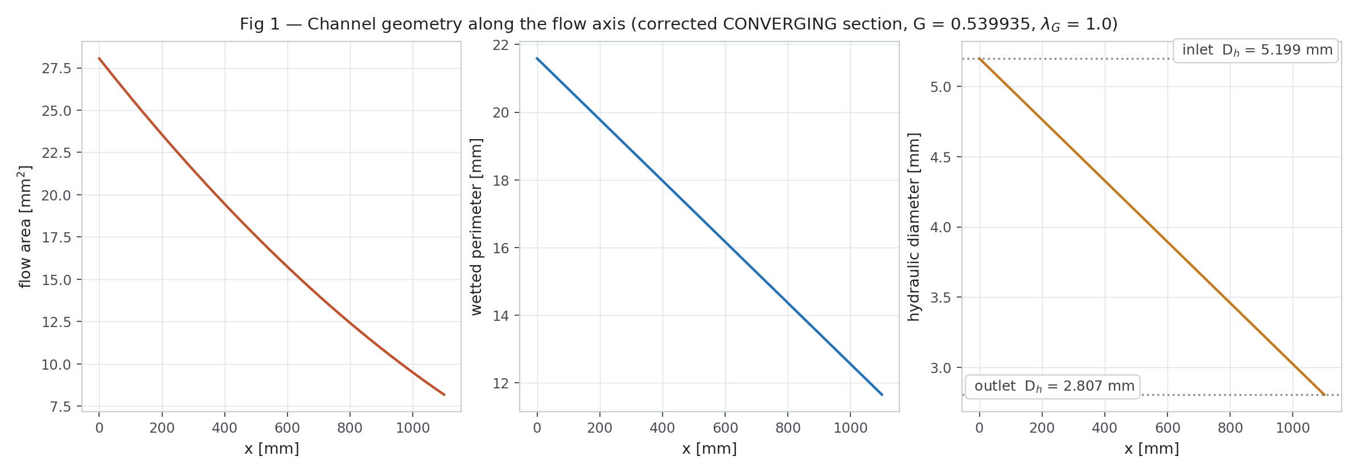
Figure 3.1. Absorber geometry (CAD)
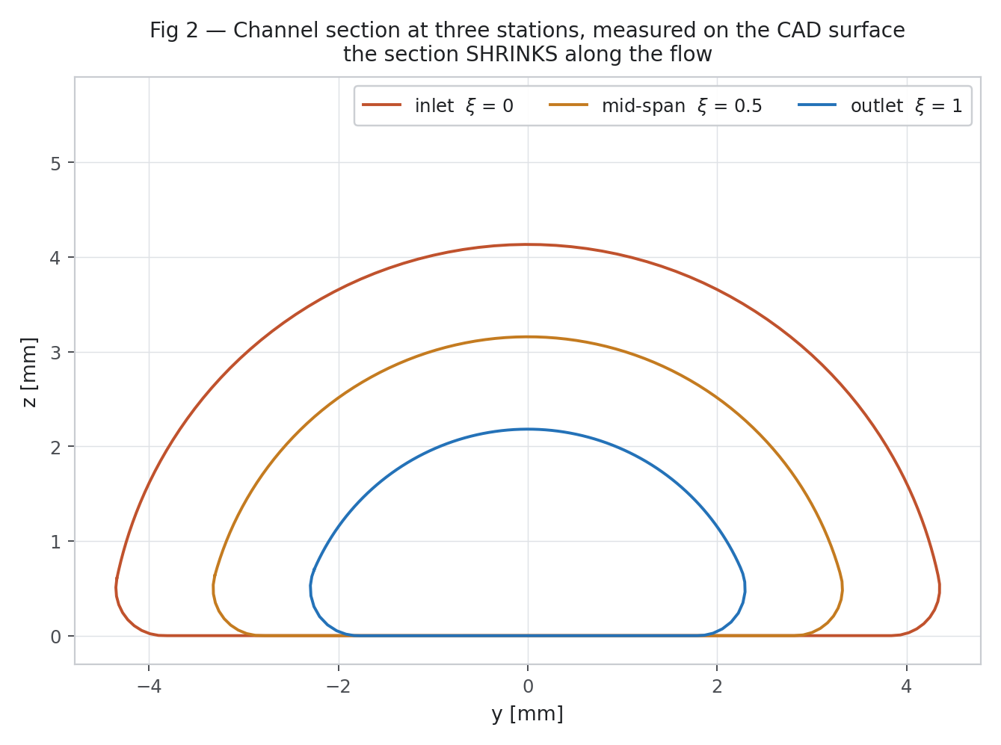
Figure 3.2. Channel cross-sections at inlet and outlet

3.3 Materials, optics and loss stack
Property | Value | Note
Absorber | AA1050 aluminium, k = 229 W/m·K | Roadmap
Absorber coating | α = 0.95, ε = 0.04 (TiNOX-type selective) | Roadmap
Glazing | 3.2 mm glass, k = 1.05 W/m·K, ε = 0.88; system τ = 0.833 | Roadmap
Transparent insulation (TIM) | 10 mm honeycomb, k = 0.075 W/m·K, τ = 0.82 | Roadmap
Air gaps | Lower 7.45 mm, upper 4.30 mm, k = 0.026 W/m·K | CAD
Optical factor | 0.833 × 0.82 × 0.95 = 0.6489 | Absorbed flux = 0.6489 × G_T
PCM layer | 10 mm, k = 2.80 W/m·K (sensible only in the models) | Roadmap; latent heat deferred
Vacuum insulation panel (VIP) | 20 mm, k = 0.006 W/m·K (catalogue) | DESIGN_REVIEW_REQUIRED: measured in-collector 0.010–0.018
Rear outer film | h_rear = 3.0 W/m²K | ENGINEERING_ASSUMPTION
Water | ρ 997, cp 4180 J/kg·K, μ 8.55e-4 Pa·s (3-D); k(T), μ(T) in GRAIL-CHT | —
Sky temperature | T_sky = 0.0552 T_amb^1.5 | Swinbank
Wind coefficient | h_wind = 5.7 + 3.8 v | McAdams
Table 3.2. Materials and stack used in every model

3.4 CAD model identity
Property | Value
Document | Grail_Collector 2, version 3
Timeline features | 948
Unhealthy features | 0
Suppressed features | 0
Occurrences | 123
Bodies | 145 (135 physical, 10 non-physical reference)
Non-solid bodies | 0
Stray bodies at root | 0
Sketches | 285, every one with a closed profile
Joints | 4, all healthy
External references | None
Design type / units | Parametric, millimetres
User parameters | 131, no unresolved expression tokens
Materials in use | 16, every body assigned
Table 3.3. CAD model verified state (Fusion, Grail_Collector 2 v3)
Source class | Count | What it means, and how far you may trust it
ROADMAP | 73 | The value is specified in the design roadmap, with the roadmap tag recorded in the comment. Quote freely, but cite the roadmap clause rather than the model.
MEASURED | 9 | Read back off the built geometry rather than typed in. These are results, not inputs, and they are the numbers to quote when describing what the model actually is.
DERIVED | 3 | Computed from other parameters by an expression. Correct by construction as long as its inputs are.
CHECKED | 2 | A hand calculation run against the model to test whether something invented is defensible. Weaker than MEASURED: it tests plausibility, not truth.
ENGINEERING_ASSUMPTION | 23 | No roadmap source. A physically reasonable value chosen so the model could be built. Never present one of these as a roadmap figure. 19 of them are actual dimensions.
Review and control | 21 | Flags, counters and records rather than dimensions, including the DESIGN_REVIEW register.
Table 3.4. Classes of the 131 CAD parameters (full register in Appendix A)

3.5 Mass and materials of the assembly
Group | Components | Bodies | Mass (kg) | Volume (mm³)
00_FRAME | 41 | 54 | 8.291 | 3,044,683
01_GLAZING | 4 | 3 | 10.271 | 4,446,080
02_TIM | 3 | 3 | 0.463 | 11,304,006
03_ABSORBER_ASSEMBLY | 5 | 15 | 3.272 | 1,350,591
04_MANIFOLD | 17 | 18 | 4.360 | 1,748,273
05_PCM_TRAY | 10 | 9 | 6.095 | 5,939,571
06_INSULATION | 6 | 5 | 2.209 | 11,794,743
07_BACKSHEET | 2 | 1 | 1.921 | 710,007
08_SEALS | 6 | 5 | 0.611 | 530,948
09_SENSING | 9 | 8 | 0.030 | 21,712
10_MOUNTING | 15 | 14 | 6.378 | 2,362,358
90_CFD_REFERENCE | 3 | 3 | 7.491 | 3,046,916
90_CFD_STRIP_2CH_PERIODIC | 1 | 3 | 1.767 | 225,105
90_CFD_STRIP_3CH_MASTER | 1 | 4 | 2.650 | 337,626
TOTAL |  | 145 | 55.810
Table 3.5. Assembly groups
Material | Bodies | Mass (kg)
AA1050 | 19 | 17.385
Al6063T6 | 24 | 14.563
SolarGlass | 2 | 9.491
RT55_EG | 7 | 4.645
Steel | 7 | 4.417
VIP_silica | 1 | 2.090
Water300K | 18 | 0.877
PMMA_thermo | 1 | 0.780
EPDM | 5 | 0.611
PC_honeycomb | 1 | 0.456
Graphite | 1 | 0.232
Aerogel | 4 | 0.119
SS316 | 44 | 0.106
Electronics | 8 | 0.030
Air | 2 | 0.007
TiNOX | 1 | 0.001
Table 3.6. Materials in the CAD assembly

4. Three-dimensional CFD

4.1 Solver and set-up
Item | Setting
Software | OpenFOAM v1912
Flow | simpleFoam, steady laminar, constant properties
Heat transfer | chtMultiRegionSimpleFoam with frozenFlow (flow held fixed, energy solved in fluid and solid)
Domain | 2-channel periodic strip, 1100 × 80 mm, cut from the CAD plate; translational cyclic sides
Mesh | Structured hexahedra built from the CAD surfaces; axial NX 60/120/240, cross-section NU 48/64/96
Inlet | 300 K, uniform velocity; 2.077072 × 10⁻⁴ kg/s per channel
Top boundary | q″ − U_top (T − T_amb) per plan area; q″ = 519.1256 W/m², U_top = 4.191176 W/m²K (benchmark ENGINEERING_ASSUMPTION)
Rear boundary | h_rear (T − T_amb), 3.0 W/m²K; T_amb = 298.15 K
Solid | AA1050, k = 229 W/m·K
Convergence | All reported quantities change ≤ 2 × 10⁻⁶ over the last 2000 iterations; energy balance 0.005 % (co-current), 0.035 % (alternating)

4.2 Problems found and fixed
- The buoyant p_rgh solver diverged on the thin O-grid cells. Repair: solve the flow with simpleFoam, then the conjugate energy equation with frozenFlow — the same steady solution, verified (zero pressure/momentum solves, flux unchanged to 1.5 × 10⁻⁸).
- Solar input had been applied per curved area (+12.2 %); corrected to plan area.
- The meshed inlet carries 0.30 % less flow than nominal; the reduced-order model is run at the 3-D flow for comparison.
- The earlier Nusselt number 2.92 came from a fluid-only case with heat flux uniform around the perimeter (H2). The real aluminium wall is nearly isothermal around the perimeter (H1). Corrected closure: 4.48.

4.3 Grid study — axial and cross-section
grid | eta_co | eta_alt | std_co_K | std_alt_K | d_eta_pct | d_std_pct | d_spread_pct
NX60_NU64 | 0.51484 | 0.42212 | 5.7713 | 5.2543 | -18.01 | -8.96 | -2.52
NX120_NU64 | 0.51597 | 0.41817 | 5.7907 | 5.5083 | -18.95 | -4.88 | 3.4
NX240_NU64 | 0.51594 | 0.4184 | 5.7842 | 5.4737 | -18.91 | -5.37 | 3.07
NX120_NU48 | 0.51605 | 0.41786 | 5.7921 | 5.5263 | -19.03 | -4.59 | 3.42
NX120_NU96 | 0.51586 | 0.41849 | 5.7888 | 5.481 | -18.88 | -5.32 | 3.2
Table 4.1. 3-D conjugate grid study (η, plate std, differences alternating vs co-current)
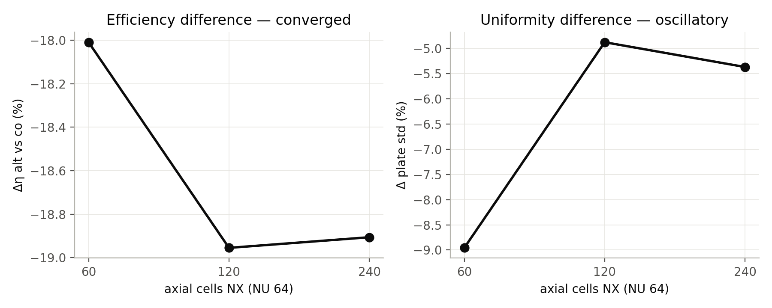
Figure 4.1. 3-D axial grid study

4.4 Nusselt closure
level | fluid_cells | Nu_developed_mean
NU48 | 80640 | 4.6455
NU64 | 138240 | 4.6022
NU96 | 322560 | 4.5557
extrapolated (p=1.12, GCI 2.1%) |  | 4.48
H1 reference semicircular duct |  | 4.088
campaign Rev1-3 (superseded) |  | 2.9238
Table 4.2. Developed Nusselt number: grid levels, extrapolation, references
The developed Nu is flow-independent (4.60 at 1.0, 2.49 and 4.5 g/s) and axially converged (4.592 / 4.602 / 4.602). Reference: H1 semicircular duct 4.088 (Erdoğan & Imrak 2005; Shah & London table in Hesselgreaves 2001). The conjugate value lies above H1 because the section is not an exact semicircle and the wall has finite conduction.
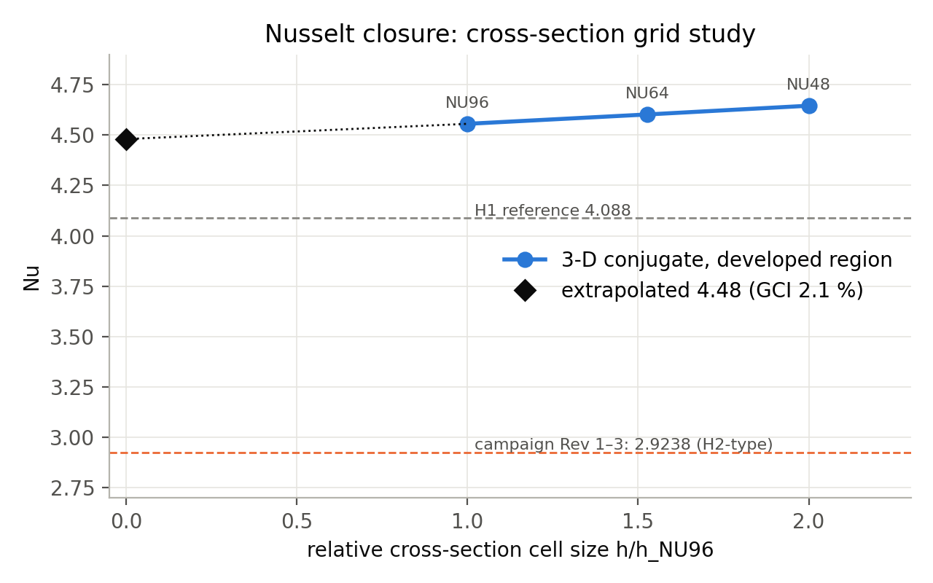
Figure 4.2. Cross-section grid study of Nu
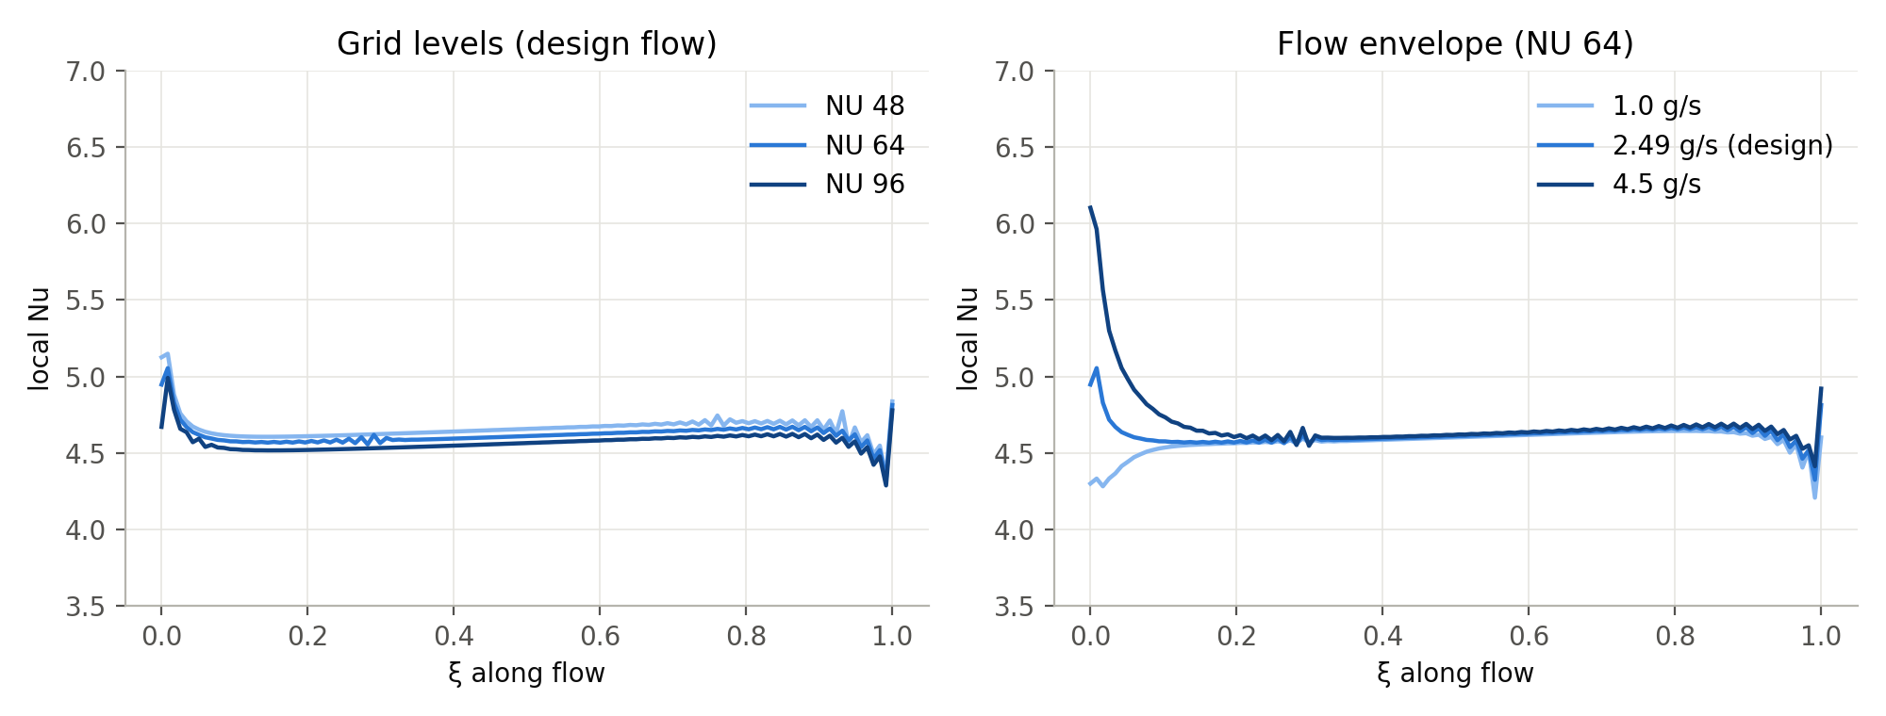
Figure 4.3. Local Nu along the channel
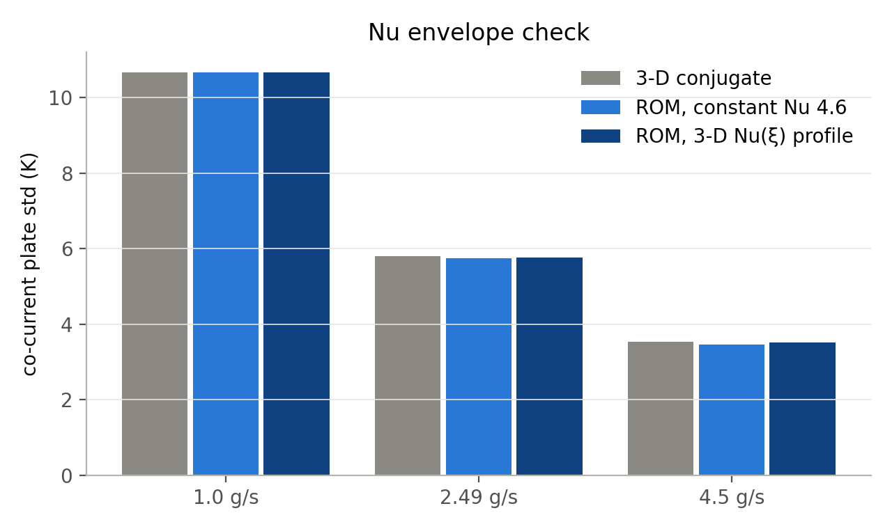
Figure 4.4. Nu envelope over the flow range
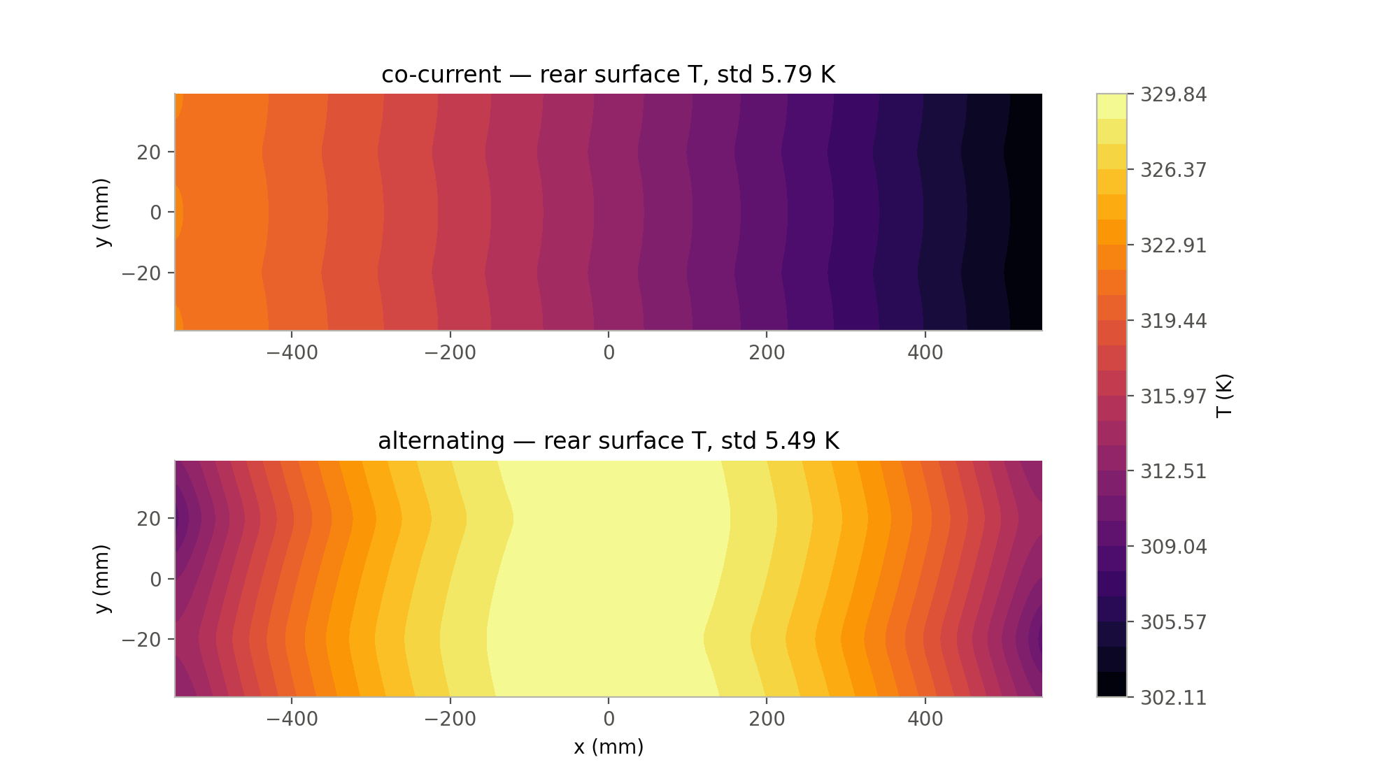
Figure 4.5. 3-D plate temperature maps, co-current and alternating

4.5 Mesh and computational domain
Meshes were generated directly from the CAD surfaces. The channel section is swept along the graded length so every cell follows the converging wall. These figures show geometry and mesh only and remain valid.
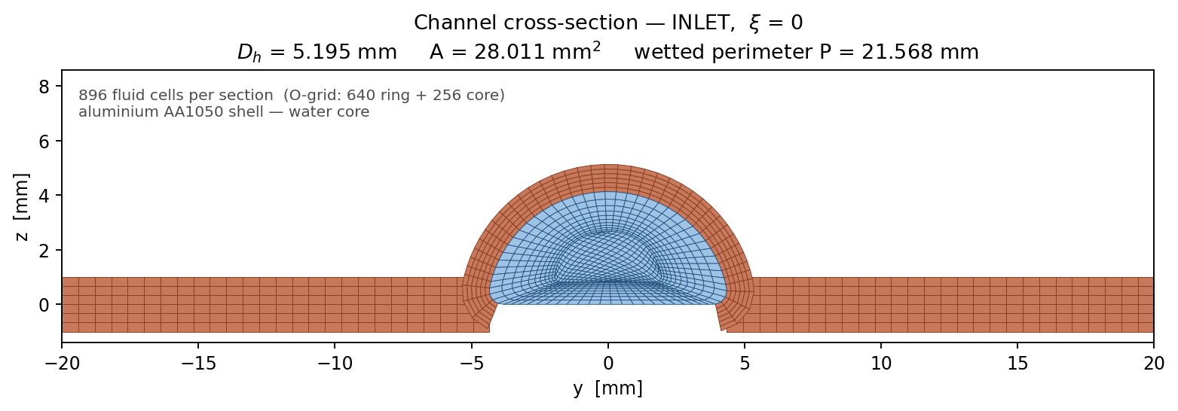
Figure 4.6. Channel section mesh at the inlet
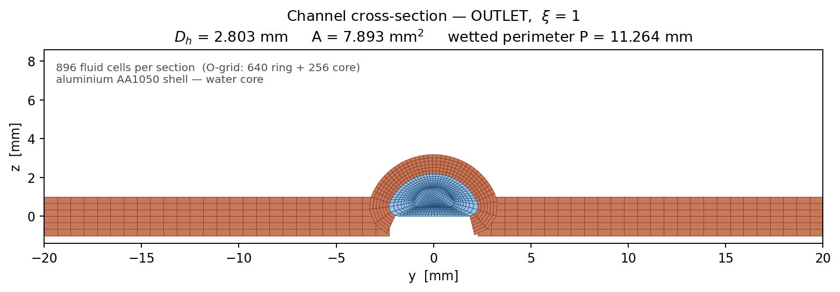
Figure 4.7. Channel section mesh at the outlet
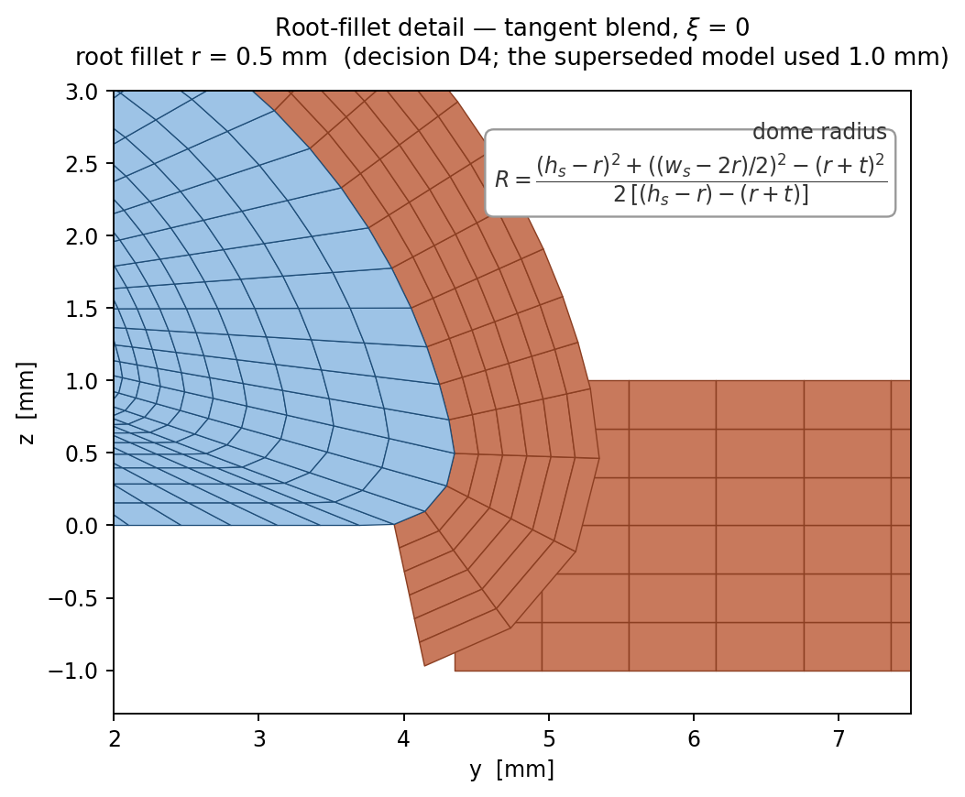
Figure 4.8. Root-fillet detail of the section mesh
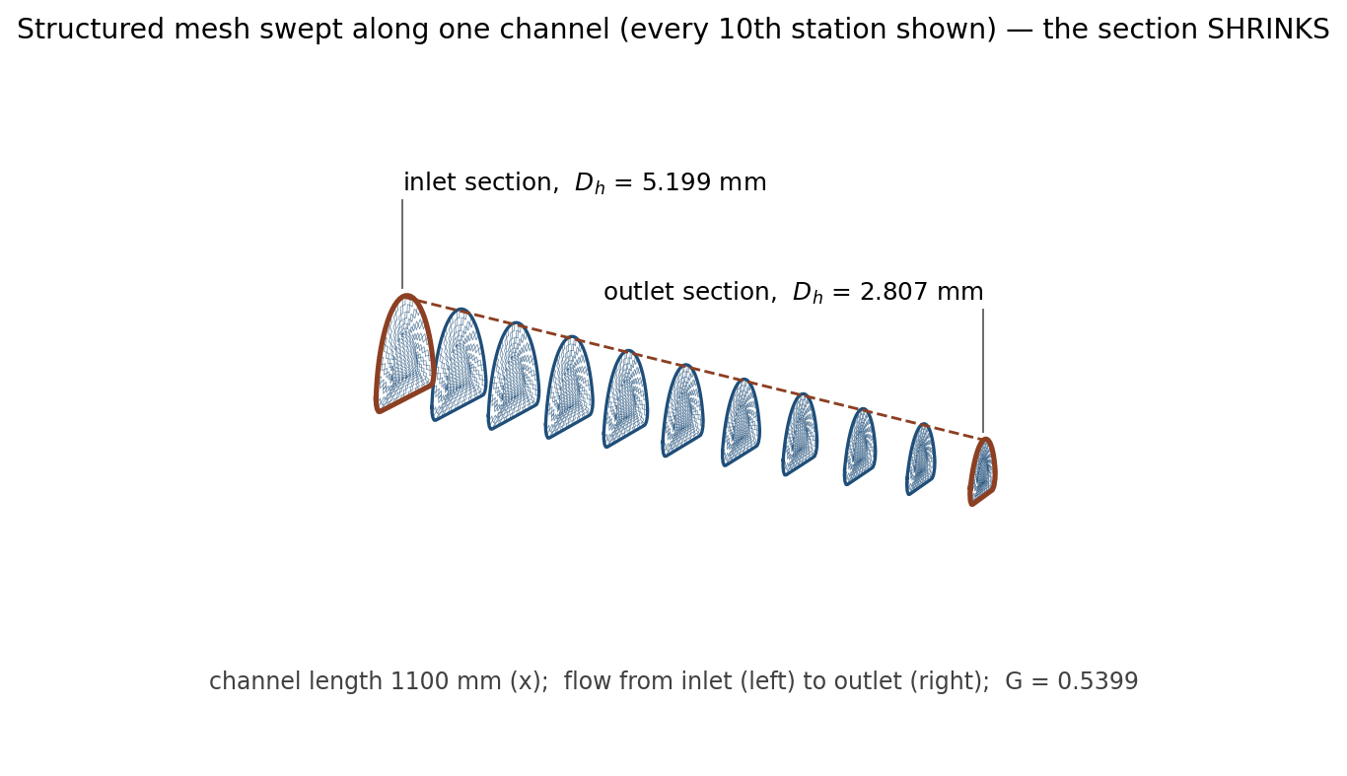
Figure 4.9. Swept structured mesh along the graded channel
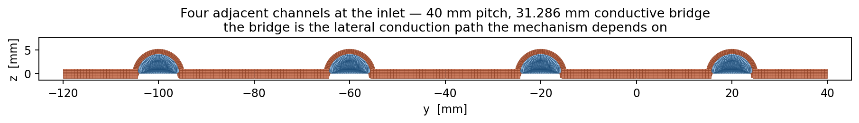
Figure 4.10. Multi-channel strip mesh
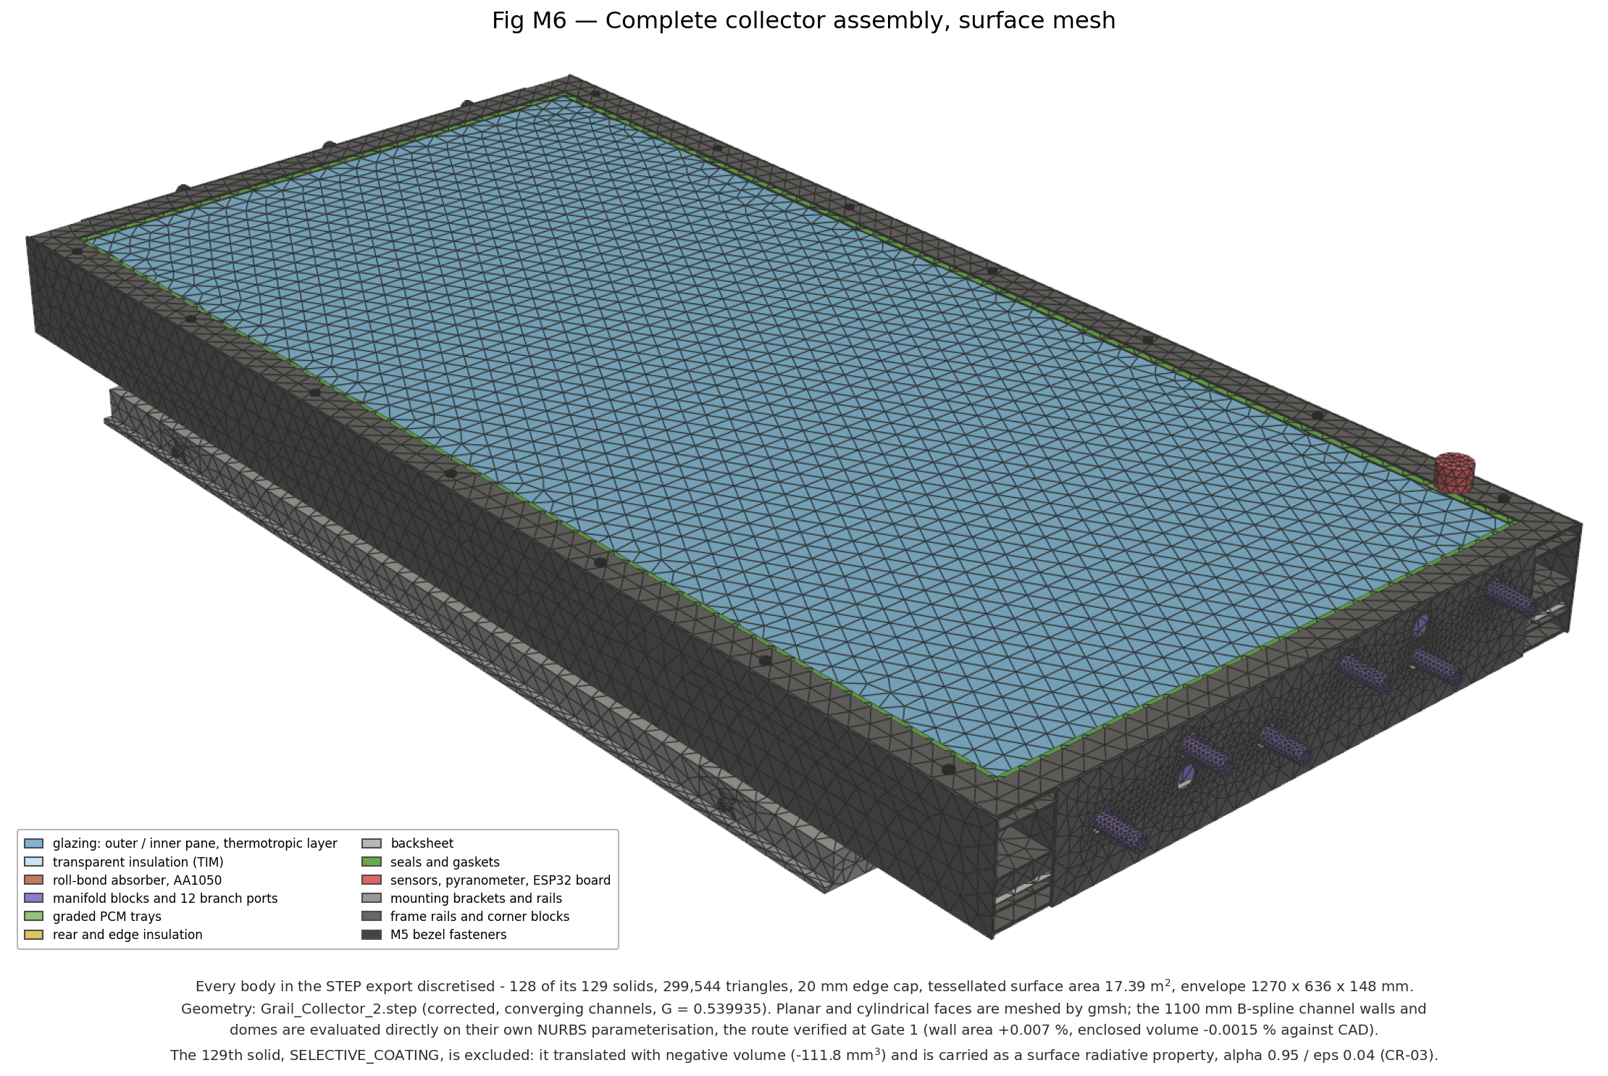
Figure 4.11. Assembly surface mesh
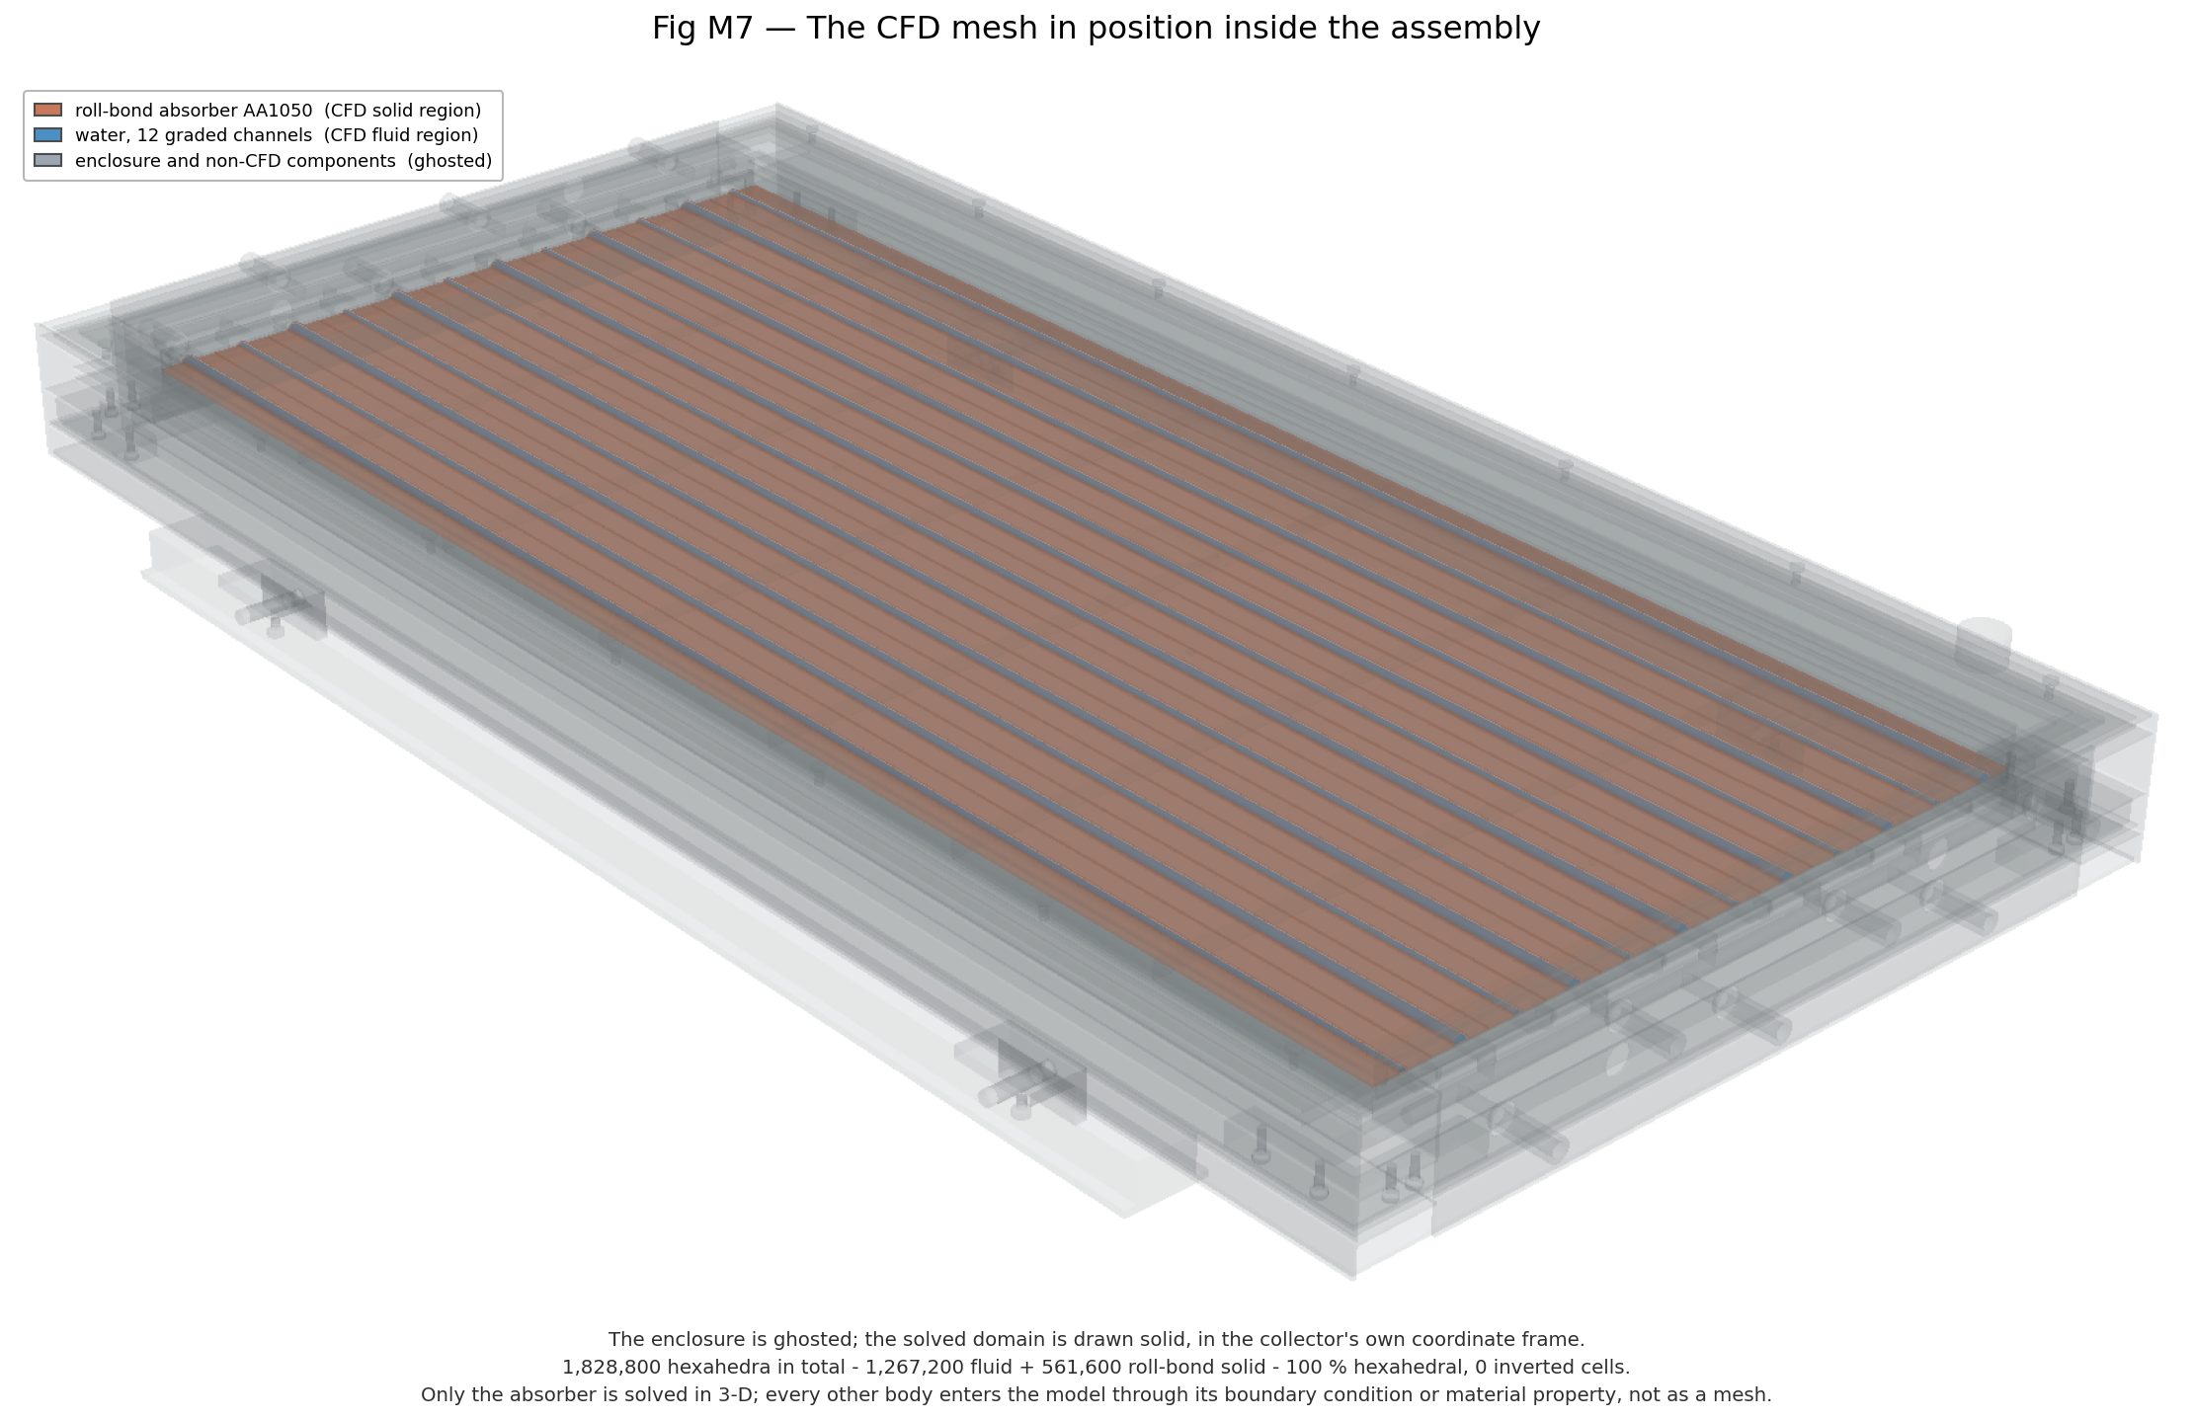
Figure 4.12. CFD domain located in the assembly
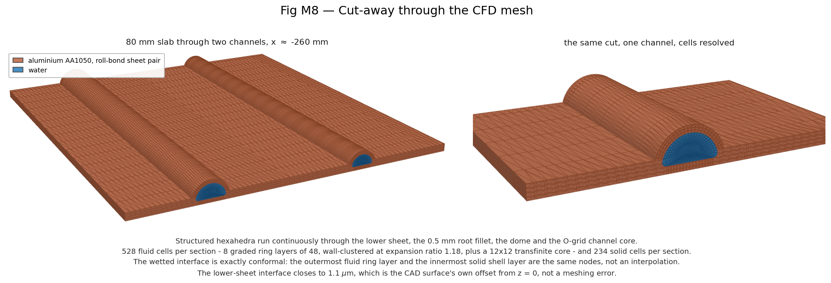
Figure 4.13. Cut-away of the collector stack
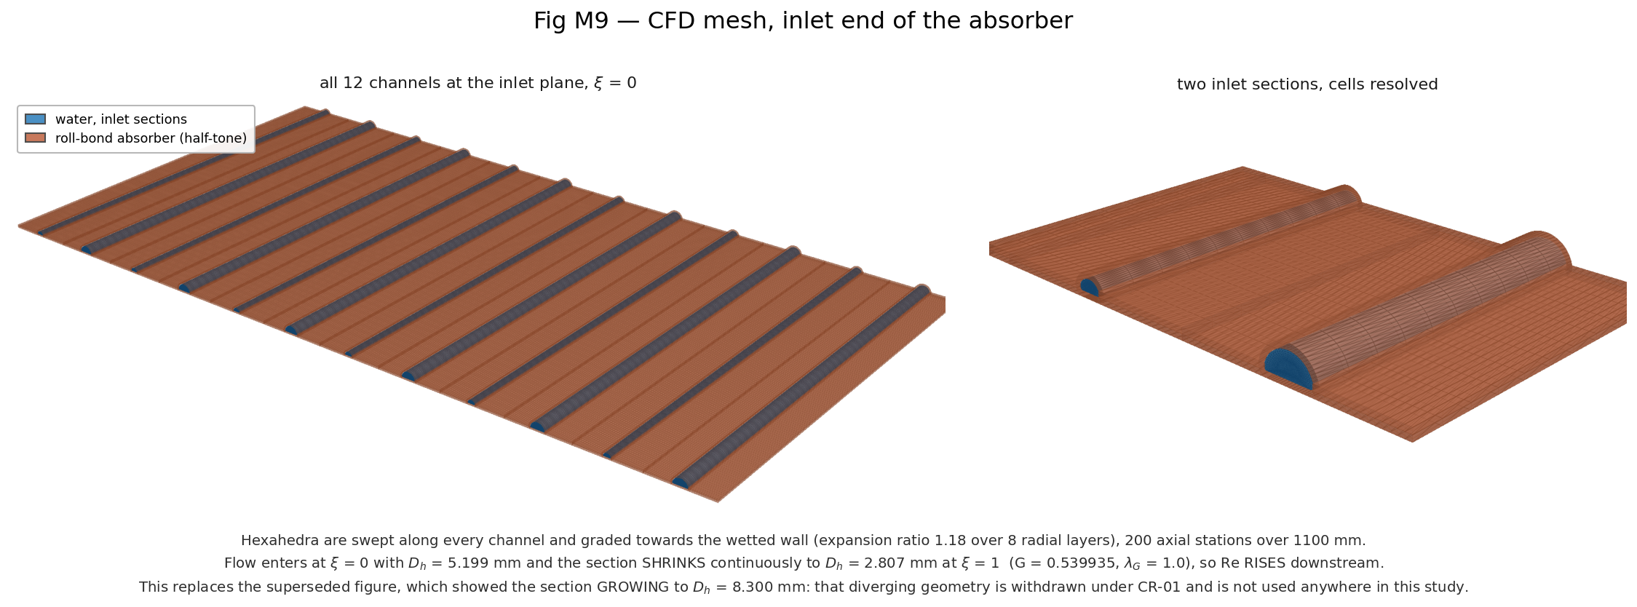
Figure 4.14. Inlet end of the absorber
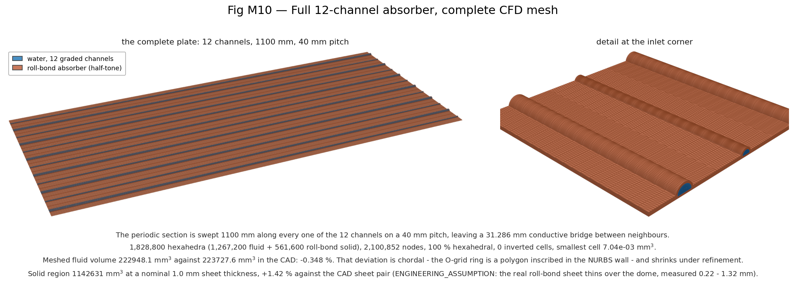
Figure 4.15. Full-plate mesh

4.6 Channel hydraulics (flow field)
The flow field does not depend on the thermal closure (constant properties), so the Rev 2 hydraulic results remain valid: laminar flow, pressure drop rising as the channel converges.
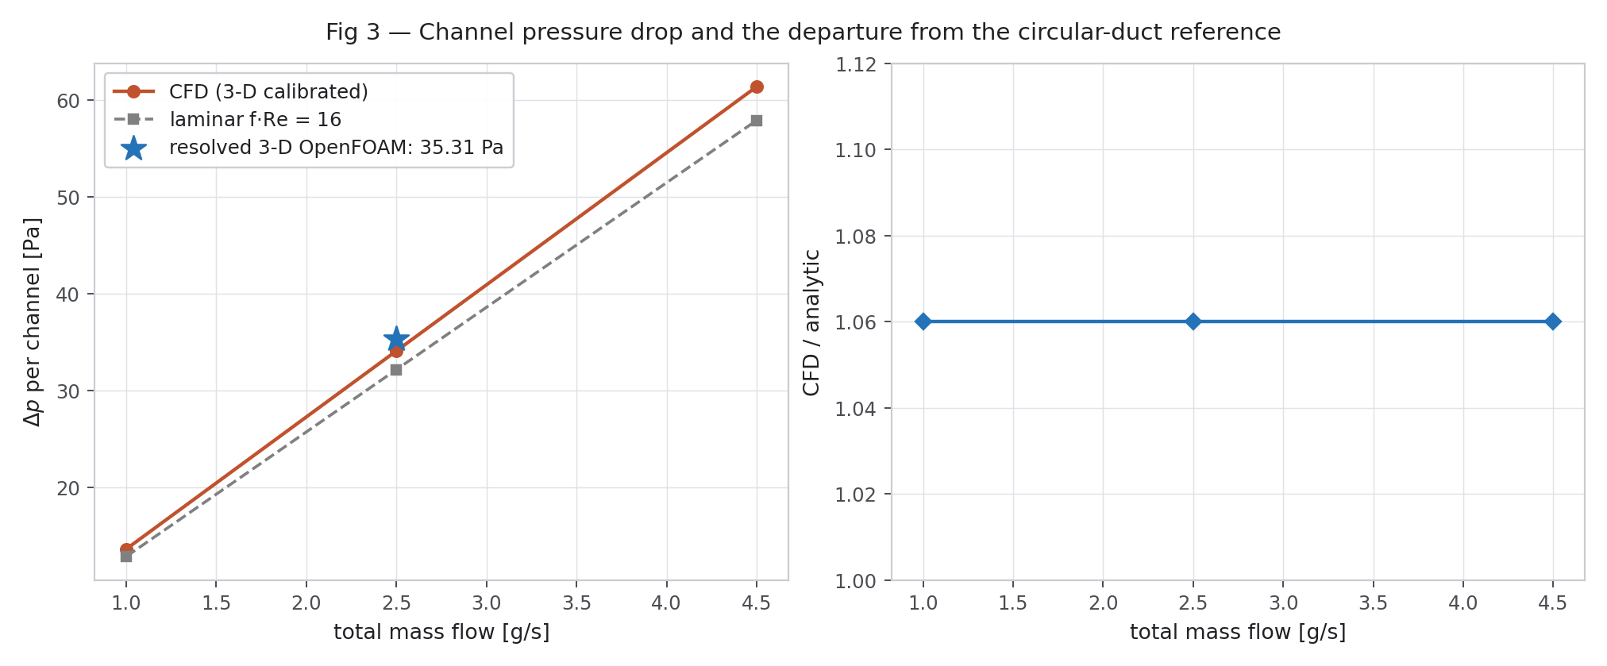
Figure 4.16. Channel pressure drop against flow
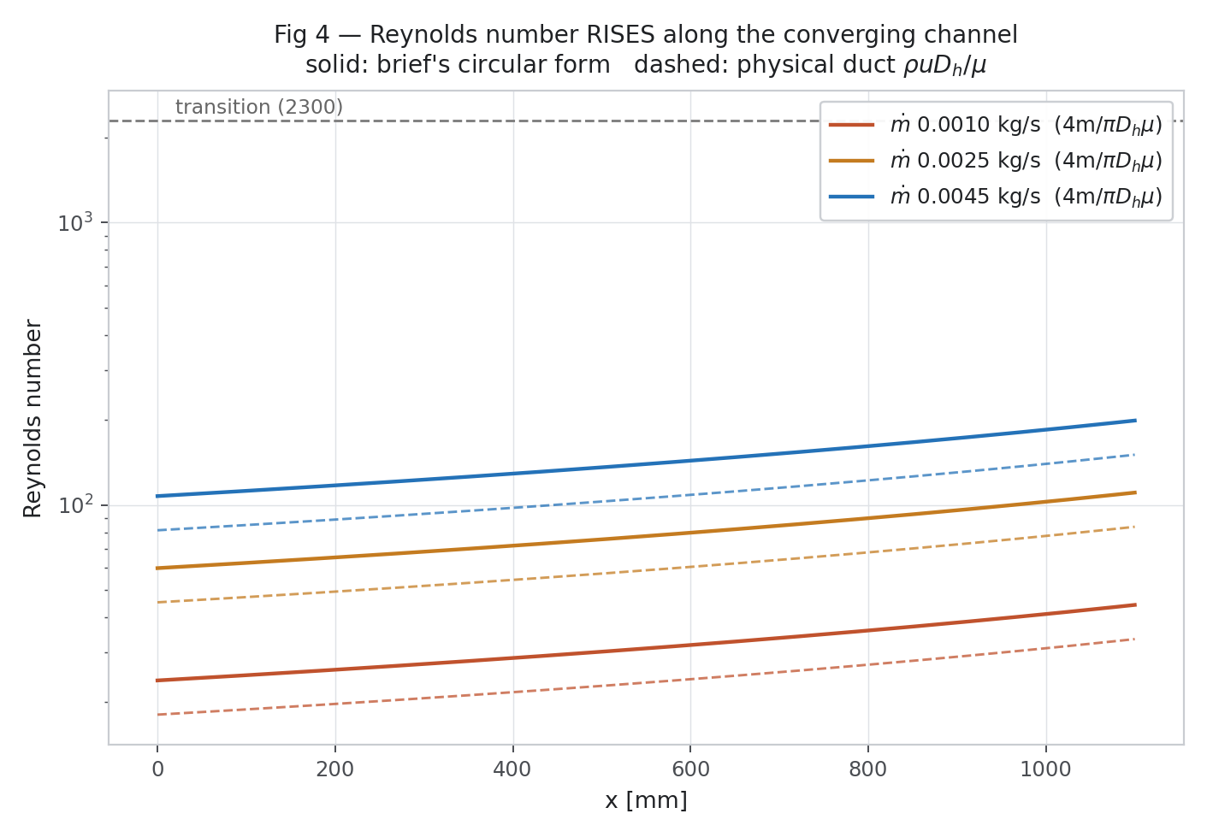
Figure 4.17. Reynolds number along the channel
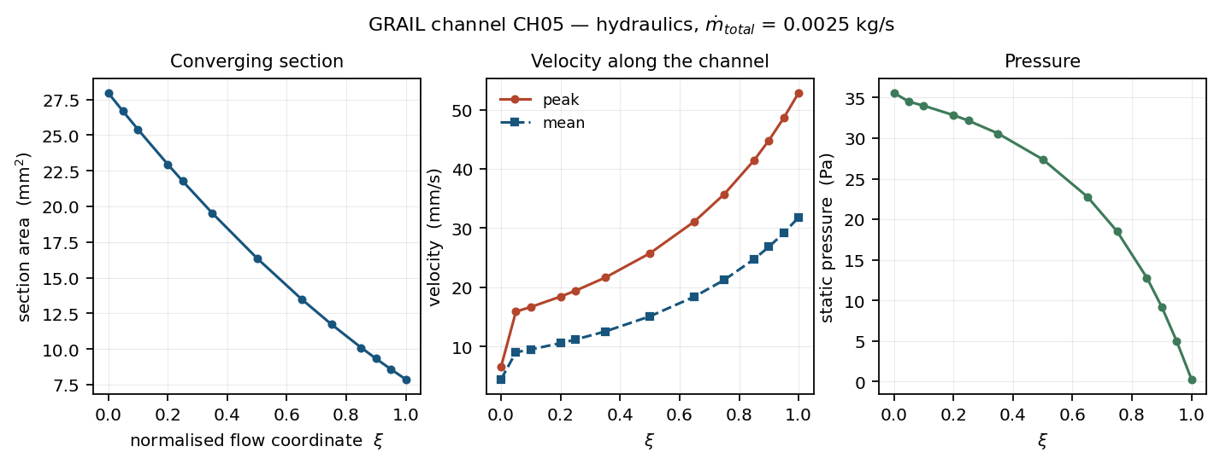
Figure 4.18. 3-D hydraulics summary
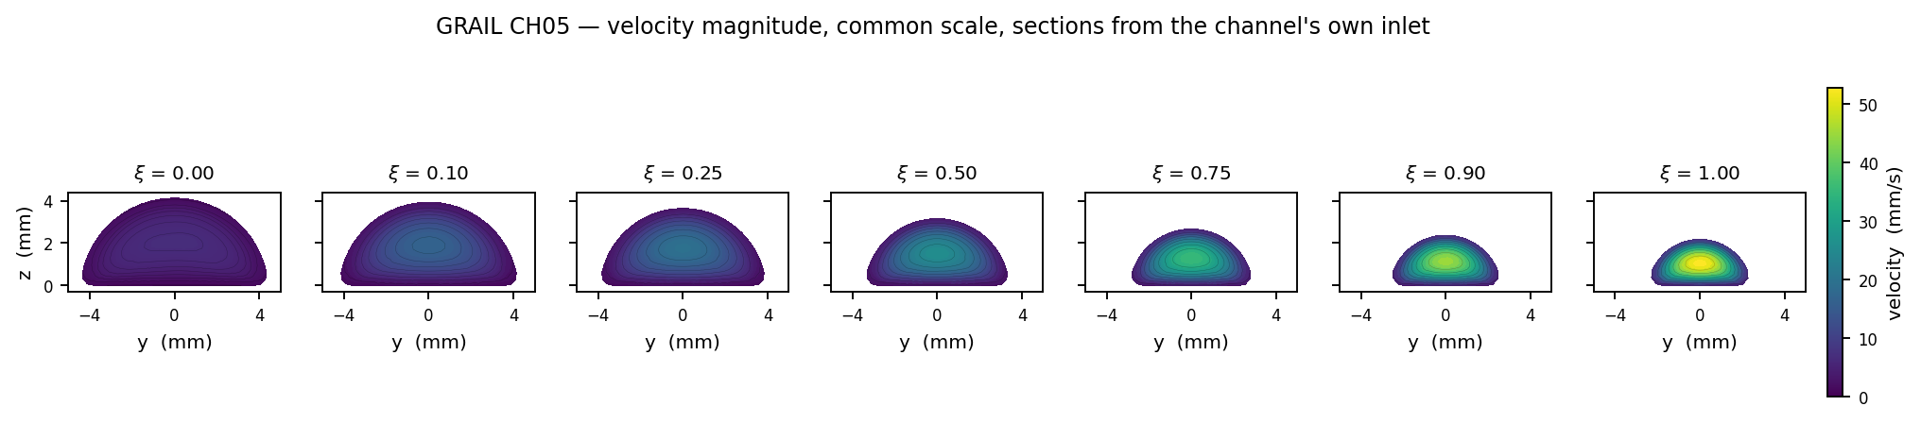
Figure 4.19. Velocity in cross-sections along the channel

4.7 Converged 3-D conjugate solution (video frames)
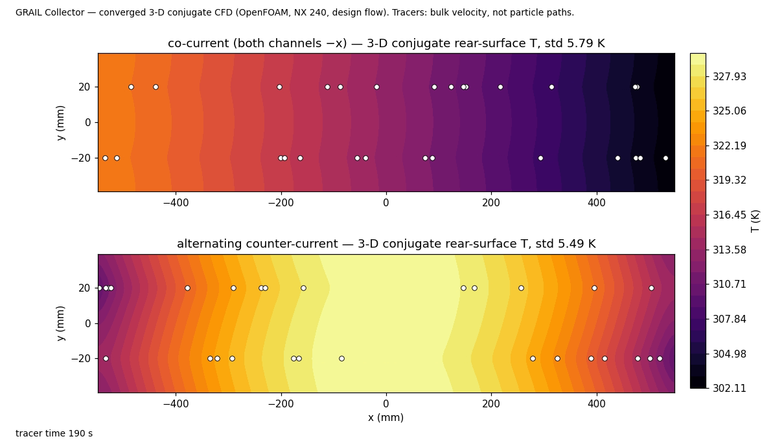
Figure 4.20. Converged rear-surface temperature, co-current vs alternating (NX 240, design flow)

5. Reduced-order conjugate model (GRAIL-CHT)

5.1 What it solves
- Plate: 2-D steady conduction in the aluminium sheets (upper + lower) on a 110 × 120 and 220 × 120 grid; the two grids are combined by Richardson extrapolation 2 f(220) − f(110).
- Channels: 1-D energy balance per channel, ṁ cp dT_f/dx = h P (T_wall − T_f), with h = Nu k / Dh, Nu = 4.48, k(T) of water.
- Top loss: plate → glazing by conduction through the TIM and gaps (series resistance) plus radiation σ(T_p⁴ − T_g⁴)/(1/ε_p + 1/ε_g − 1); glazing → ambient by wind convection and sky radiation ε_g σ(T_g⁴ − T_sky⁴). Glass temperature solved by Newton iteration at every cell. Temperatures in K.
- Rear loss: series resistance PCM + VIP + outer film, U_rear = 1/(t_pcm/k_pcm + t_vip/k_vip + 1/h_rear) = 0.272 W/m²K.
- Absorbed flux: q_abs = 0.6489 G_T (uniform).
- Pressure drop: laminar integral along the graded channel with a calibration factor from the 3-D CFD.
- Convergence: outer-iteration residual tolerance 1 × 10⁻⁶; acceptance |energy error| < 0.5 % and 250 K < T_plate < 500 K.

5.2 Checks of the model
Check | Result
GRAIL-CHT vs 3-D conjugate CFD, co-current | η within 0.01 %, plate std within 0.6 %
GRAIL-CHT vs 3-D, alternating | Overstates the uniformity benefit by ≈ 2.0 points and understates the efficiency penalty by ≈ 0.5 points (local Nu undefined where heat flow reverses) — carried as uncertainty
GRAIL-CHT with Nu 4.6 vs 3-D at NX 60 | η 0.2 %, std 0.5 %, arrangement difference 0.1 points
Hottel-Whillier-Bliss (Duffie & Beckman) vs GRAIL-CHT | +0.22 % (co-current), U_L taken from the solver, not fitted
Axial convergence of GRAIL-CHT | Observed order p = 1.01; Richardson used
Energy balance | Every campaign case < 0.5 %; measured range −0.00015 to +0.00014 %
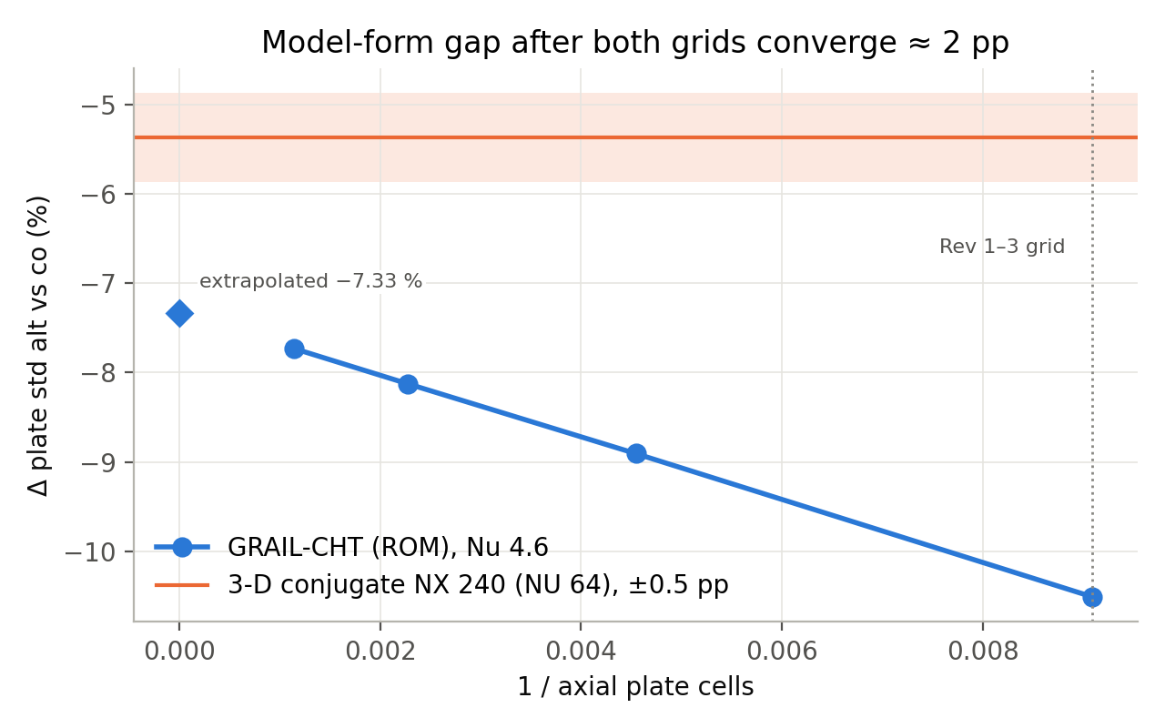
Figure 5.1. GRAIL-CHT axial convergence against the 3-D result
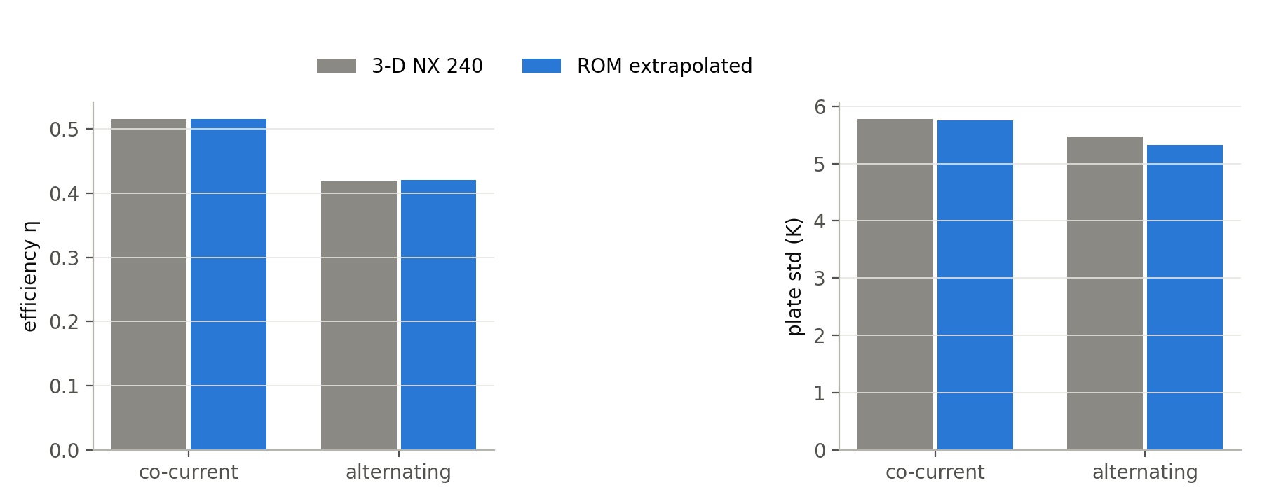
Figure 5.2. GRAIL-CHT vs 3-D CFD

6. Simulation campaign and dataset

6.1 Design of the campaign
Input | Range | Sampling
Irradiance G_T | 400–1000 W/m² | Latin hypercube
Inlet temperature T_in | 288–333 K | Latin hypercube
Ambient temperature T_amb | 283–313 K | Latin hypercube
Wind speed | 0–5 m/s | Latin hypercube
Total mass flow | 1.0–4.5 g/s (Re_in 22–151, laminar) | Latin hypercube
Bridge width | 20–37 mm | Latin hypercube
Grading ratio G | 0.35–1.0 | Latin hypercube
Grading exponent λ | 0.5–2.0 | Latin hypercube
Arrangement | 150 alternating + 150 parallel | Two independent draws (not paired)
Acceptance gates: converged to 10⁻⁶, |energy error| < 0.5 %, 250 K < T_plate < 500 K. Result: 300 / 300 accepted; no row deleted. The two groups are statistically identical in every input (Kolmogorov–Smirnov p = 1.00), so all comparisons are group-wise. ALT_n and PAR_n must never be paired.

6.2 Dataset summary (Rev 4.2, 300 rows, 59 columns)
Column | All: min / mean / median / max | Alternating: min / mean / median / max | Parallel: min / mean / median / max
Irradiance G_T (W/m²) | 400.1 / 700.0 / 701.0 / 999.5 | 400.1 / 700.0 / 700.0 / 998.9 | 403.4 / 700.1 / 701.1 / 999.5
Inlet T (K) | 288.09 / 310.51 / 310.44 / 332.98 | 288.27 / 310.51 / 310.44 / 332.98 | 288.09 / 310.51 / 310.41 / 332.89
Ambient T (K) | 283.04 / 298.00 / 298.02 / 312.87 | 283.04 / 298.00 / 298.01 / 312.83 | 283.04 / 298.00 / 298.02 / 312.87
Wind (m/s) | 0.01 / 2.50 / 2.49 / 4.99 | 0.02 / 2.50 / 2.49 / 4.99 | 0.01 / 2.50 / 2.50 / 4.97
Total flow (kg/s) | 0.00101 / 0.00275 / 0.00274 / 0.00449 | 0.00101 / 0.00275 / 0.00275 / 0.00449 | 0.00102 / 0.00275 / 0.00274 / 0.00448
Bridge (mm) | 20.02 / 28.50 / 28.51 / 36.99 | 20.08 / 28.51 / 28.51 / 36.99 | 20.02 / 28.50 / 28.47 / 36.93
Grading ratio G | 0.351 / 0.675 / 0.674 / 0.998 | 0.353 / 0.675 / 0.674 / 0.998 | 0.351 / 0.675 / 0.674 / 0.998
Exponent λ | 0.503 / 1.250 / 1.247 / 1.999 | 0.503 / 1.250 / 1.249 / 1.999 | 0.505 / 1.250 / 1.246 / 1.991
Re at inlet | 21.8 / 73.4 / 68.4 / 151.3 | 21.8 / 72.8 / 69.1 / 151.3 | 25.1 / 74.0 / 67.4 / 147.8
Channel Δp (Pa) | 2.10 / 22.03 / 14.52 / 158.61 | 2.11 / 21.88 / 15.44 / 120.75 | 2.10 / 22.18 / 14.28 / 158.61
Outlet T (K) | 298.17 / 330.76 / 331.87 / 373.41 | 298.34 / 329.53 / 329.82 / 370.28 | 298.17 / 331.99 / 333.82 / 373.41
Fluid ΔT (K) | 6.18 / 20.25 / 17.28 / 58.27 | 6.18 / 19.02 / 16.41 / 46.85 | 6.82 / 21.48 / 17.82 / 58.27
Useful heat (W) | 90.1 / 201.2 / 200.3 / 327.6 | 90.1 / 193.4 / 190.6 / 327.6 | 101.6 / 209.0 / 213.8 / 318.6
Efficiency η | 0.3415 / 0.5414 / 0.5446 / 0.6732 | 0.3415 / 0.5209 / 0.5264 / 0.6732 | 0.4260 / 0.5620 / 0.5626 / 0.6653
Mean plate T (K) | 295.48 / 330.32 / 330.96 / 394.41 | 299.48 / 337.27 / 337.02 / 394.41 | 295.48 / 323.38 / 324.54 / 356.50
Max plate T (K) | 298.95 / 338.79 / 338.83 / 412.63 | 301.97 / 344.76 / 342.93 / 412.63 | 298.95 / 332.82 / 334.39 / 374.02
Plate std (K) | 1.513 / 6.239 / 4.991 / 19.468 | 1.513 / 6.464 / 4.960 / 19.468 | 1.915 / 6.013 / 5.013 / 16.130
Plate spread (K) | 6.33 / 22.53 / 17.82 / 74.19 | 6.38 / 25.29 / 19.61 / 74.19 | 6.33 / 19.77 / 16.57 / 52.84
Energy error (%) | -0.00015 / 0.00003 / -0.00001 / 0.00014 | -0.00015 / 0.00007 / 0.00008 / 0.00014 | -0.00004 / -0.00002 / -0.00002 / 0.00002
Outer iterations | 93 / 401 / 274 / 1541 | 217 / 647 / 530 / 1541 | 93 / 156 / 135 / 345
Table 6.1. Statistics of the campaign inputs and outputs
case_id | arrangement | G_T_W_m2 | T_in_K | T_amb_K | v_wind_m_s | mdot_total_kg_s | bridge_mm | g_ratio | lambda_G | T_out_K | eta | T_plate_mean_K | plate_std_K | dp_channel_Pa
ALT_000 | alternating | 833.0998 | 292.0654 | 289.5495 | 3.0065 | 0.0038 | 23.8296 | 0.9382 | 1.9269 | 308.5433 | 0.5874 | 311.4657 | 4.0634 | 14.3053
ALT_001 | alternating | 484.5321 | 326.7904 | 287.0671 | 3.3326 | 0.0028 | 20.2109 | 0.6723 | 0.5626 | 335.8182 | 0.4134 | 338.7247 | 2.8683 | 15.5155
ALT_002 | alternating | 419.9503 | 290.3044 | 297.2822 | 3.0624 | 0.0023 | 28.3827 | 0.8241 | 1.4522 | 303.7276 | 0.5787 | 308.8907 | 4.5555 | 11.973
ALT_003 | alternating | 882.5161 | 309.9996 | 296.5432 | 2.4391 | 0.0024 | 24.9194 | 0.6607 | 1.528 | 334.6626 | 0.5288 | 344.29 | 8.5077 | 11.263
ALT_004 | alternating | 475.1487 | 302.6358 | 311.7342 | 4.9431 | 0.0015 | 27.5294 | 0.7969 | 1.9054 | 324.2092 | 0.5295 | 336.7688 | 8.7875 | 5.4925
PAR_000 | parallel | 665.0261 | 289.923 | 289.9617 | 1.8451 | 0.0032 | 29.2248 | 0.5216 | 1.2415 | 305.7192 | 0.6082 | 299.6618 | 4.4378 | 44.9145
PAR_001 | parallel | 913.2767 | 295.4192 | 310.78 | 1.4079 | 0.0032 | 20.2386 | 0.4153 | 1.2974 | 318.9878 | 0.6455 | 309.8163 | 6.6274 | 59.4854
PAR_002 | parallel | 550.2224 | 294.4523 | 306.8768 | 0.7646 | 0.0015 | 34.4898 | 0.5823 | 0.8952 | 322.9835 | 0.6211 | 311.1776 | 7.9585 | 15.0681
PAR_003 | parallel | 990.3464 | 323.6548 | 283.0374 | 0.1349 | 0.0039 | 20.7219 | 0.8877 | 0.8737 | 340.66 | 0.5363 | 334.2487 | 4.7928 | 9.8807
PAR_004 | parallel | 750.5296 | 288.091 | 289.1408 | 4.707 | 0.003 | 27.5461 | 0.7223 | 0.5767 | 307.1957 | 0.6129 | 299.7744 | 5.3586 | 26.1354
Table 6.2. Sample rows (first five of each arrangement); full file: GRAIL_CFD_dataset_FINAL_rev4.2.csv

6.3 Alternating vs parallel at equal inputs
quantity | parallel | alternating | difference | mann_whitney_p
eta_mean | 0.562 | 0.5209 | -7.3% | 2e-8
plate_std_median_K | 5.013 | 4.96 | -1.1% | 0.76
plate_spread_median_K | 16.57 | 19.61 | +18.4% | 0.001
T_plate_mean_diff_K |  |  | +13.9 | 2e-10
P90_diff_K |  |  | +12.6 | 2e-6
Table 6.3. Group comparison (150 vs 150, Mann-Whitney)
total_flow_g_s | n_alt | n_par | d_eta_mean_pct | d_std_median_pct | p_std
1.0-2.2 | 50 | 50 | -12.7 | 16.8 | 0.033
2.2-3.3 | 50 | 50 | -6.0 | 7.9 | 0.14
3.3-4.5 | 50 | 50 | -3.5 | -13.4 | 0.017
Table 6.4. Differences by flow tercile
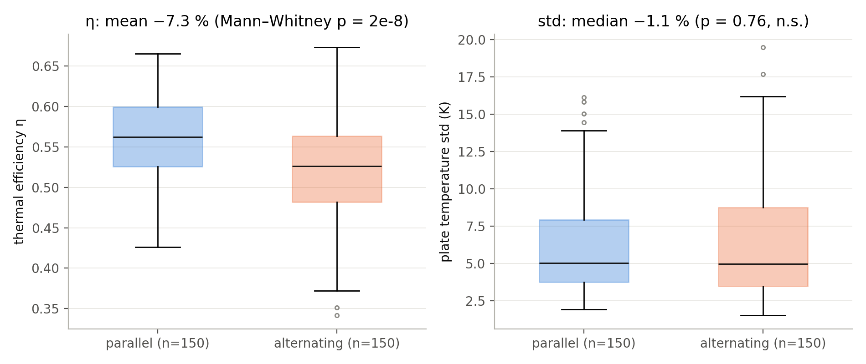
Figure 6.1. Arrangement groups
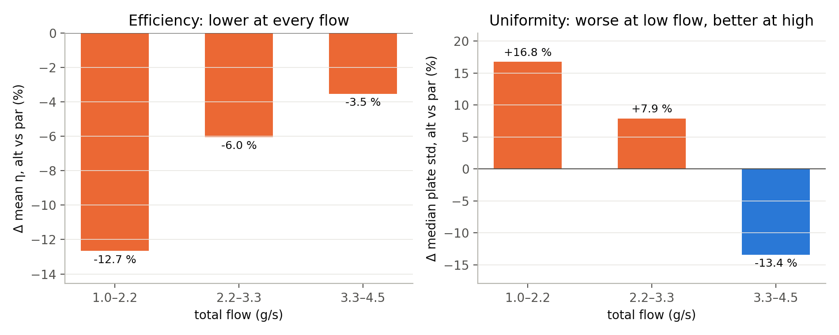
Figure 6.2. Arrangement effect by flow
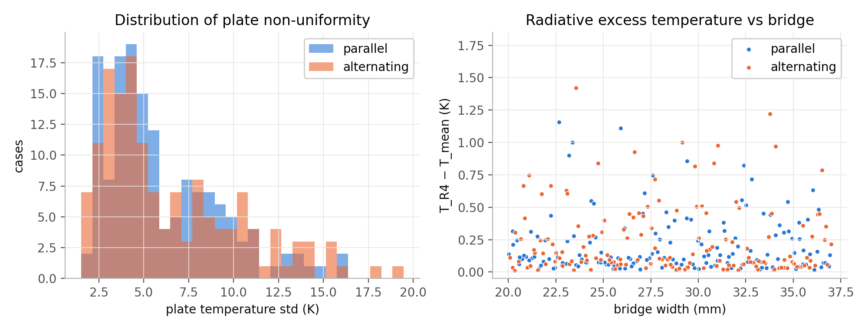
Figure 6.3. Plate-std distributions and radiative excess vs bridge width
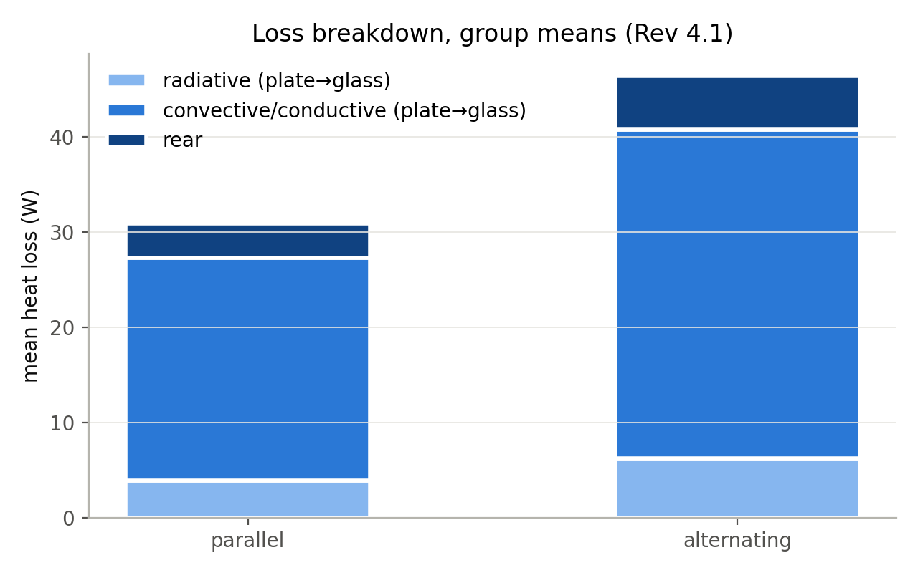
Figure 6.4. Loss breakdown (group means)
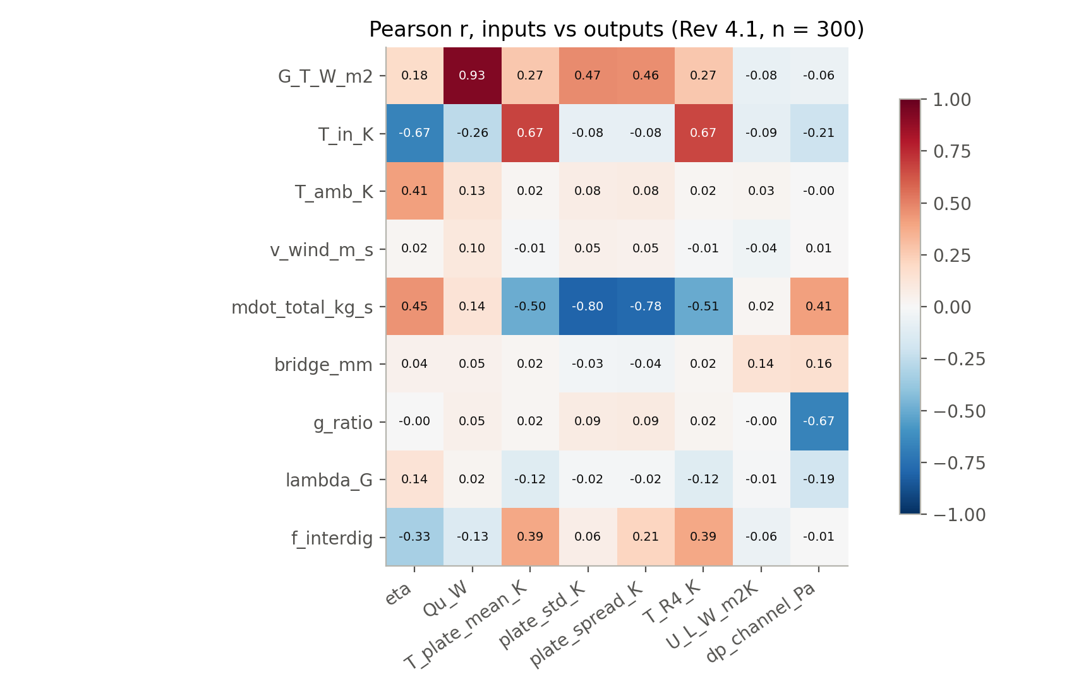
Figure 6.5. Correlation between inputs and outputs
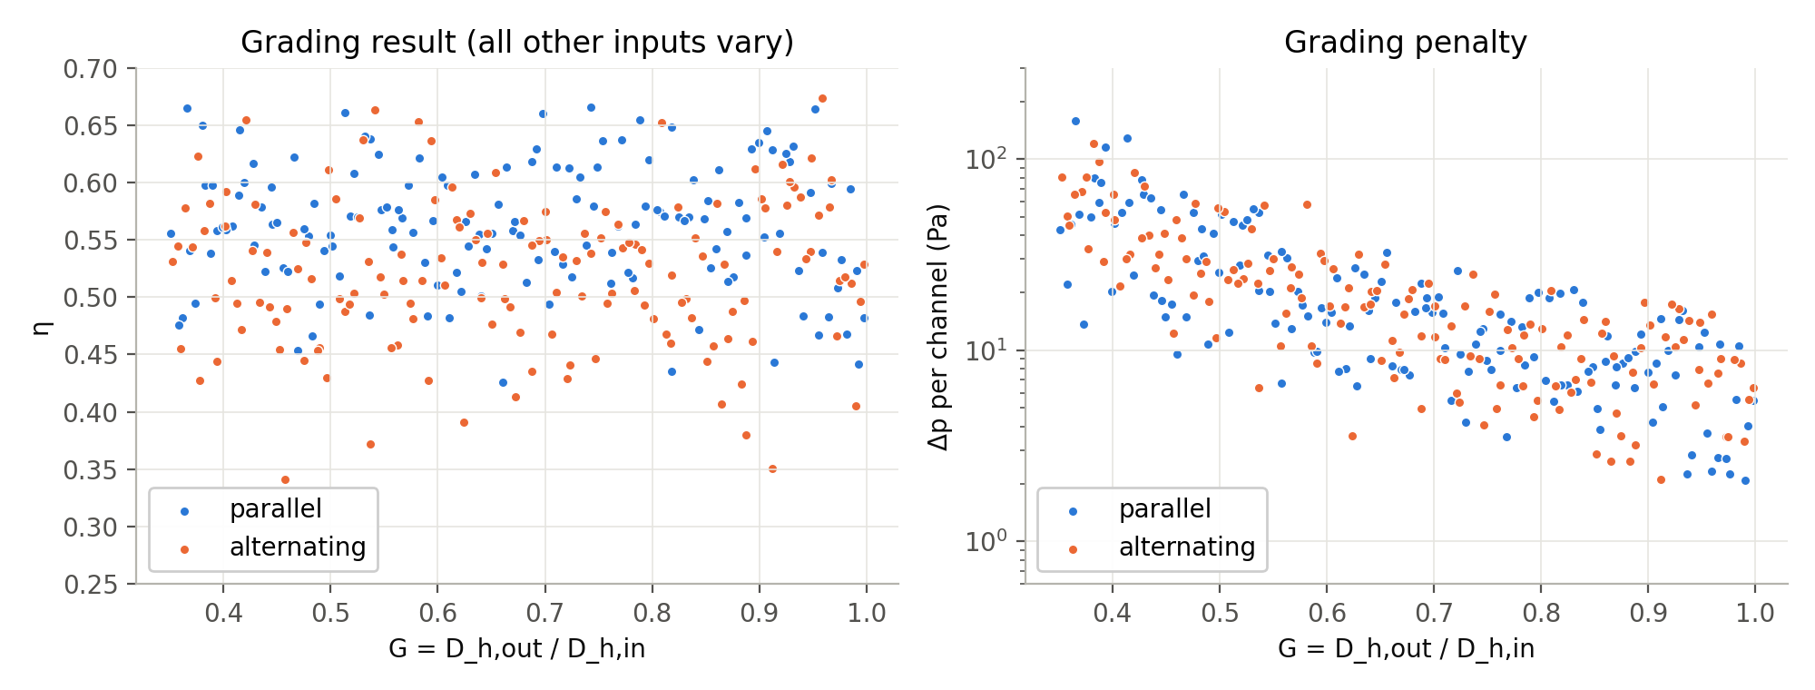
Figure 6.6. Efficiency and pressure drop against grading ratio

7. Mechanism, uncertainty and matched-temperature study (V7)

7.1 Why alternating flow loses efficiency
quantity | value
absorbed_per_channel_W | 24.8
returned_per_channel_W | 9.94
returned_fraction_pct | 40.1
length_with_negative_qprime_pct | 41
net_W | 14.86
mdot_cp_dT_W | 14.85
Table 7.1. Heat recirculation in alternating flow (3-D, design point)
Counter-flowing neighbours act as a counter-flow heat exchanger through the metal. About 40 % of the heat a channel absorbs is handed back to the plate over 41 % of its length. The fluid peaks mid-channel (328.6 K) and leaves cooler (317.1 K). The plate runs hotter and loses more heat to the front.
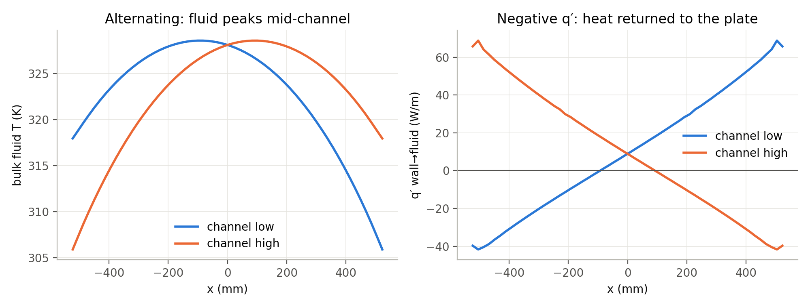
Figure 7.1. Heat recirculation along the channel, alternating

7.2 Uncertainty budget
source | d_eta | d_std
3D discretisation | ±0.1 pp | ±1.0 pp
ROM axial after Richardson | <0.1 pp | ~0.4 pp
ROM model form (alternating) | 0.5 pp | 2.0 pp
Nu band 4.46-4.65 | ~0.1 pp | ~1.1 pp
entry Nu at 4.5 g/s | <0.1% | <=2.1% of std
glazing/radiation model | not quantified | not quantified
Table 7.2. Uncertainty budget of the campaign results

7.3 V7 — matched mean plate temperature
Question: at the same mean plate temperature, does alternating flow reduce R4 = mean(T⁴) and raise efficiency? Method: as-built geometry, 2.75 g/s, G 800 W/m², T_amb 303.15 K, wind 3 m/s. For each target the inlet temperature was found by a secant search until the plate mean matched within 0.001 K. All runs converged with energy error < 0.5 %.
Target plate mean (K) | Inlet needed alt / par (K) | η alt / par | Δη (points) | ΔR4 (%) | ΔT_R4 (K) | Plate std alt / par (K) | Δ std (%)
320 | 291.3 / 306.7 | 0.59889 / 0.59890 | -0.0012 | 0.036 | 0.029 | 6.68 / 6.17 | +8.3
330 | 302.4 / 317.3 | 0.57245 / 0.57246 | -0.0013 | 0.038 | 0.032 | 6.49 / 5.90 | +9.9
340 | 313.5 / 328.0 | 0.54567 / 0.54568 | -0.0014 | 0.037 | 0.032 | 6.26 / 5.63 | +11.2
Table 7.3. V7 results
- Efficiency is the same (difference 0.001 points).
- R4 is not reduced; it rises 0.04 %.
- Alternating is 8–11 % less uniform at the design flow.
- Alternating needs an inlet ≈ 15 K cooler for the same plate temperature. That is why it is less efficient at equal inputs.

8. Stage 3 — ANN surrogate
- Inputs (9): G_T, T_in, T_amb, wind, total flow, bridge, grading ratio, grading exponent, arrangement flag.
- Targets: η, plate std, ln(Δp), mean plate temperature.
- Split: 240 training / 60 test, stratified by arrangement, seed 42. Test set never used in tuning.
- Tuning: 5-fold cross-validation over 6 architectures × 5 L2 penalties; tanh; L-BFGS; standardised data.
- Final: ensemble of 10 networks; baselines: linear regression and Gaussian-process regression.
Target | Architecture, α | CV R² | ANN test R² | ANN MAPE % | GPR test R² | Linear test R²
eta | [64, 32], 0.01 | 0.9994 | 0.9997 | 0.14 | 0.9999 | 0.8897
plate_std_K | [32, 32], 0.01 | 0.9993 | 0.9996 | 0.53 | 1.0000 | 0.8519
log_dp_Pa | [64, 32], 0.01 | 0.9992 | 0.9998 | 0.92 | 1.0000 | 0.9747
T_plate_mean_K | [64, 32], 0.01 | 0.9992 | 0.9994 | 0.06 | 1.0000 | 0.8813
Table 8.1. Surrogate accuracy on the 60 held-out cases
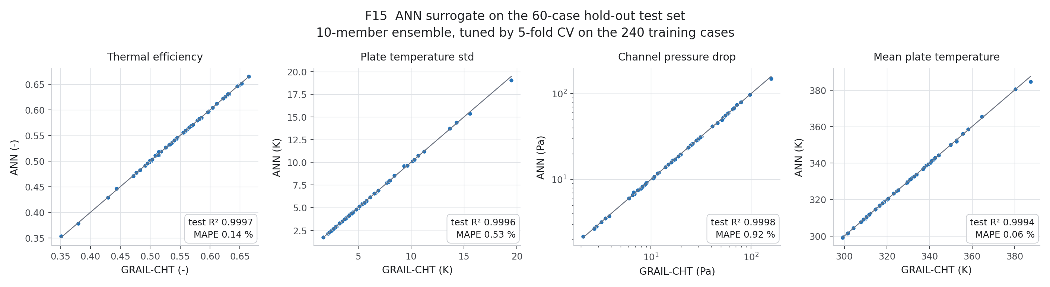
Figure 8.1. Parity plots, test set
SHAP: efficiency is driven by T_in, T_amb, flow and arrangement; the three geometric inputs are about two orders of magnitude weaker. Plate uniformity is driven by flow and irradiance; pressure drop by grading ratio and flow.
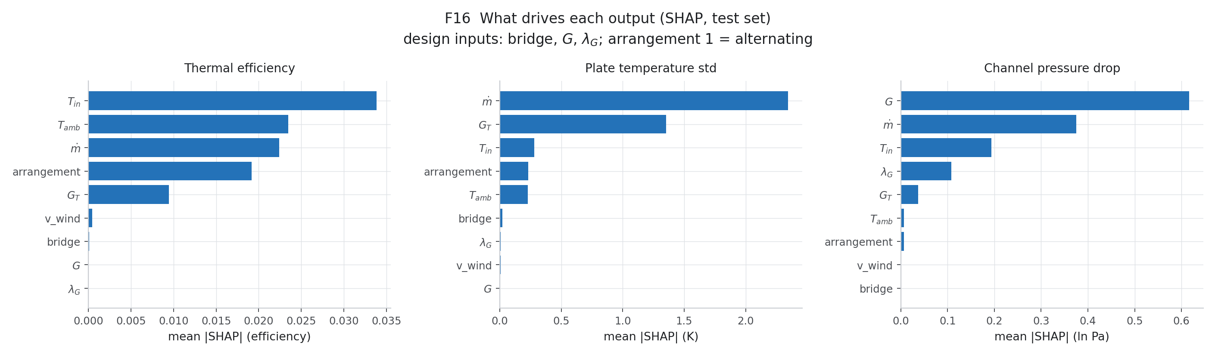
Figure 8.2. SHAP importance

9. Stage 5 — NSGA-II optimisation
- Variables: flow 1.0–4.5 g/s, bridge 20–37 mm, G 0.35–1.0, λ 0.5–2.0; each arrangement separately.
- Objectives: maximise η, minimise plate std, minimise pumping power.
- Reference point (ENGINEERING_ASSUMPTION, Berhampur clear-sky noon): G 800 W/m², T_in 313.15 K, T_amb 303.15 K, wind 3 m/s.
- Population 200, 250 generations, seed 7.
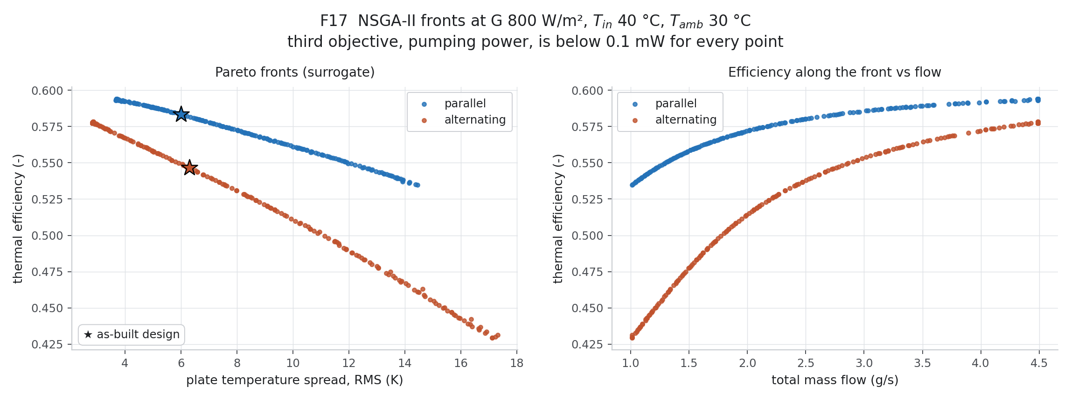
Figure 9.1. Pareto fronts with GRAIL-CHT verification points
Arrangement | Pick | Flow g/s | Bridge mm | G | λ | η ANN | η CHT | std ANN K | std CHT K | Δp err %
alternating | max_eta | 4.49 | 31.9 | 0.998 | 0.50 | 0.5783 | 0.5784 | 2.87 | 2.83 | 5.8
alternating | min_std | 4.49 | 37.0 | 0.708 | 1.35 | 0.5773 | 0.5782 | 2.83 | 2.87 | 0.0
alternating | knee | 3.28 | 31.0 | 0.997 | 1.21 | 0.5599 | 0.5601 | 4.80 | 4.82 | -0.5
parallel | max_eta | 4.49 | 33.9 | 0.998 | 0.50 | 0.5940 | 0.5943 | 3.71 | 3.76 | 5.3
parallel | min_std | 4.49 | 37.0 | 0.998 | 2.00 | 0.5931 | 0.5944 | 3.68 | 3.76 | -0.3
parallel | knee | 2.94 | 27.6 | 0.998 | 1.40 | 0.5852 | 0.5850 | 5.64 | 5.64 | -0.7
alternating | as_built | 2.75 | 31.3 | 0.540 | 1.00 | 0.5467 | 0.5466 | 6.29 | 6.27 | -0.2
parallel | as_built | 2.75 | 31.3 | 0.540 | 1.00 | 0.5834 | 0.5830 | 6.00 | 6.01 | -0.0
Table 9.1. Selected optima and as-built design re-run in GRAIL-CHT
All points converged; the surrogate holds to 0.13 efficiency points. The optimum sits at the top flow bound with G → 1 (straight channel). Channel pumping power is below 0.1 mW everywhere, so manifold and pump losses (not modelled) dominate in practice.

10. Stage 6 — Efficiency curves and system model

10.1 Virtual steady-state test (ISO 9806 form)
As-built geometry (bridge 31.29 mm, G 0.539935, λ 1.0) at the design flow 2.75 g/s. Fit form: q = η0 G − a1 ΔT − a2 ΔT², ΔT = T_m − T_amb on the mean fluid temperature, on the 0.528 m² aperture and incident irradiance.
Arr. | G W/m² | T_in K | T_amb K | Wind m/s | T_out K | ΔT_fluid K | Q_u W | η | Plate mean K | Plate std K | Δp Pa
alt | 500 | 293.15 | 303.15 | 3.0 | 307.06 | 13.91 | 159.9 | 0.6056 | 311.23 | 4.20 | 37.4
alt | 500 | 308.15 | 303.15 | 3.0 | 320.76 | 12.61 | 145.0 | 0.5491 | 324.70 | 3.89 | 27.9
alt | 500 | 323.15 | 303.15 | 3.0 | 334.45 | 11.30 | 129.9 | 0.4921 | 338.08 | 3.54 | 21.7
alt | 500 | 332.15 | 303.15 | 3.0 | 342.66 | 10.51 | 120.8 | 0.4575 | 346.08 | 3.32 | 19.1
alt | 900 | 293.15 | 303.15 | 3.0 | 317.64 | 24.49 | 281.5 | 0.5923 | 325.18 | 7.48 | 33.4
alt | 900 | 308.15 | 303.15 | 3.0 | 331.31 | 23.16 | 266.2 | 0.5603 | 338.68 | 7.21 | 25.3
alt | 900 | 323.15 | 303.15 | 3.0 | 344.97 | 21.82 | 250.9 | 0.5279 | 352.09 | 6.89 | 20.0
alt | 900 | 332.15 | 303.15 | 3.0 | 353.16 | 21.01 | 241.5 | 0.5083 | 360.09 | 6.67 | 17.7
alt | 900 | 323.15 | 303.15 | 0.5 | 345.05 | 21.90 | 251.7 | 0.5297 | 352.19 | 6.92 | 20.0
alt | 900 | 323.15 | 303.15 | 4.9 | 344.95 | 21.80 | 250.6 | 0.5273 | 352.05 | 6.88 | 20.0
par | 500 | 293.15 | 303.15 | 3.0 | 307.93 | 14.78 | 169.9 | 0.6434 | 302.10 | 4.14 | 37.0
par | 500 | 308.15 | 303.15 | 3.0 | 321.58 | 13.43 | 154.4 | 0.5847 | 316.25 | 3.77 | 27.7
par | 500 | 323.15 | 303.15 | 3.0 | 335.21 | 12.06 | 138.6 | 0.5250 | 330.40 | 3.39 | 21.6
par | 500 | 332.15 | 303.15 | 3.0 | 343.37 | 11.22 | 129.0 | 0.4886 | 338.89 | 3.15 | 19.0
alt | 700 | 332.15 | 288.15 | 3.0 | 346.62 | 14.47 | 166.3 | 0.4500 | 351.36 | 4.58 | 18.5
par | 900 | 293.15 | 303.15 | 3.0 | 319.20 | 26.05 | 299.5 | 0.6302 | 308.90 | 7.29 | 32.8
par | 900 | 308.15 | 303.15 | 3.0 | 332.84 | 24.69 | 283.9 | 0.5974 | 323.02 | 6.92 | 25.0
par | 900 | 323.15 | 303.15 | 3.0 | 346.46 | 23.31 | 268.0 | 0.5639 | 337.16 | 6.55 | 19.8
par | 900 | 332.15 | 303.15 | 3.0 | 354.62 | 22.47 | 258.3 | 0.5436 | 345.63 | 6.31 | 17.5
par | 900 | 323.15 | 303.15 | 0.5 | 346.48 | 23.33 | 268.1 | 0.5643 | 337.15 | 6.55 | 19.8
par | 900 | 323.15 | 303.15 | 4.9 | 346.46 | 23.31 | 267.9 | 0.5638 | 337.16 | 6.54 | 19.8
par | 700 | 332.15 | 288.15 | 3.0 | 347.61 | 15.46 | 177.7 | 0.4809 | 341.43 | 4.35 | 18.4
Table 10.1. Virtual test matrix (22 GRAIL-CHT runs)
Arrangement | η0 | a1 W/m²K | a2 W/m²K² | Fit RMS (points) | Held-out errors (points)
alternating | 0.5966 | 2.004 | 0.00038 | 0.15 | 0.24, -0.01, 0.15
parallel | 0.6368 | 2.104 | 0.00000 | 0.23 | 0.15, 0.10, -0.04
Table 10.2. Efficiency correlations
Parallel's free fit gave a2 = −0.0006 (unphysical); refitted with a2 = 0. The fit covers T_m − T_amb from −3 to 40 K. Wind changes η by < 0.3 points. With the measured in-collector VIP conductivity, a1 would be 2.3–2.5 W/m²K (Section 14).
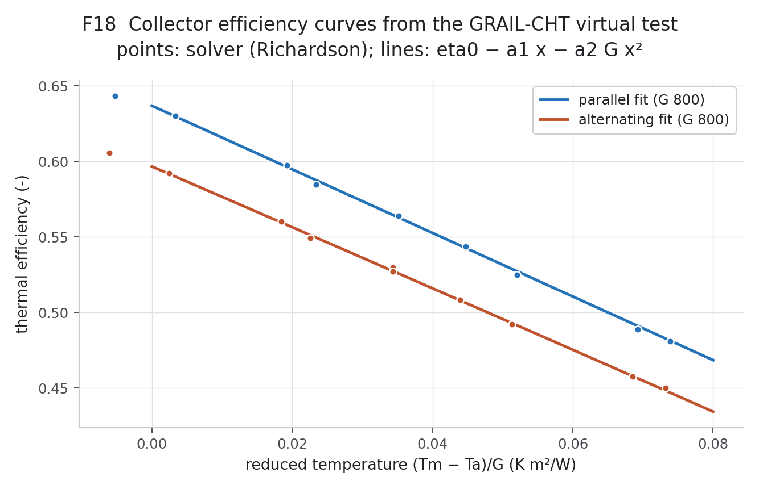
Figure 10.1. Efficiency curves

10.2 Dynamic collector–tank model
Collector: C dTc/dt = A [η0 G_eff − a1 (Tc − Ta) − a2 (Tc − Ta)²] − g2 (Tc − Tt) P
Tank: M cp dTt/dt = g2 (Tc − Tt) P − UA (Tt − Ta) − m_t cp (Tt − Tmains)
Valve: m_t = m_draw · min(1, (Tset − Tmains)/(Tt − Tmains)); electric top-up to Tset
Pump P: on at Tc − Tt ≥ 7 K, off at ≤ 2 K; off while Tt > 358.15 K
Parameter | Value
tilt_deg | 19.3
azimuth_deg | 180
transposition | Hay-Davies, albedo 0.20
iam | Kb = 1 - b0 (1/cos(theta) - 1), b0 = 0.10, Kb = 0 beyond 80 deg; diffuse Kd = Kb(60 deg) = 0.90
n_modules | 4
aperture_m2 | 2.112
mdot_per_module_kg_s | 0.00275
C_eff_J_m2K | 33500
C_eff_basis | Al sheets 4.87 + channel water 7.46 + PCM sensible only 16.0 + 0.5x(glass 6.72 + TIM 0.36 + VIP 3.2) kJ/m2K; PCM latent heat NOT modelled (deferred)
tank_kg | 100
tank_UA_W_K | 1.5
T_set_K | 318.15
daily_draw_kg | 100
draw_profile | 40% 06-08h, 20% 12-13h, 40% 18-20h IST
mains | trailing 24-h mean ambient
pump_on_dT_K | 7
pump_off_dT_K | 2
tank_max_K | 358.15
pump_power_W | 15
geyser_efficiency | 0.95
Table 10.3. System-model inputs (base case record; recommended size is 2 modules)
Other fixed values: C = 33.5 kJ/m²K × A; g2 = 2 ṁ cp with ṁ = 0.00275 kg/s per module.

11. Stage 7 — Annual performance and economics, Berhampur

11.1 Weather
- PVGIS TMY, 19.313° N, 84.810° E, 2005–2023, 8,760 hours.
- Time alignment tested: GHI = DNI cos z + DHI closes to 0.17 W/m² at the stated UTC stamp (14.3 W/m² with a half-hour shift).
- Plane: 19.3° tilt, south, Hay-Davies, albedo 0.2 → POA 1976 kWh/m²/yr (after incidence-angle modifier 1855); GHI 1865.
- Cross-check at 35° tilt: 1,935 vs 1,965 kWh/m²/yr in the PVGIS PV report (−1.5 %).

11.2 Collector-only yield
Month | POA kWh/m² | Parallel @40 °C | Parallel @60 °C | Alternating @40 °C | Alternating @60 °C
Jan | 185.7 | 96.2 | 84.6 | 90.1 | 79.0
Feb | 185.1 | 97.8 | 86.5 | 91.7 | 80.8
Mar | 205.6 | 109.3 | 96.7 | 102.5 | 90.4
Apr | 186.9 | 99.1 | 86.5 | 92.9 | 80.8
May | 177.8 | 95.1 | 81.6 | 89.2 | 76.2
Jun | 149.8 | 78.4 | 65.8 | 73.5 | 61.5
Jul | 124.6 | 61.5 | 48.9 | 57.6 | 45.5
Aug | 134.4 | 67.8 | 55.0 | 63.5 | 51.2
Sep | 136.7 | 70.3 | 57.9 | 65.8 | 54.0
Oct | 161.6 | 84.5 | 72.3 | 79.2 | 67.4
Nov | 170.8 | 89.5 | 77.6 | 83.8 | 72.4
Dec | 157.1 | 80.4 | 68.9 | 75.3 | 64.3
Table 11.1. Monthly collector yield per m² at fixed inlet temperature (kWh/m²)
Arrangement | Yield @40 °C inlet (kWh/m²/yr) | Yield @60 °C | Annual efficiency on POA @40 °C | Operating hours @40 °C
parallel | 1030 | 882 | 52.1 % | 3858
alternating | 965 | 823 | 48.8 % | 3853
Table 11.2. Annual collector-only yield
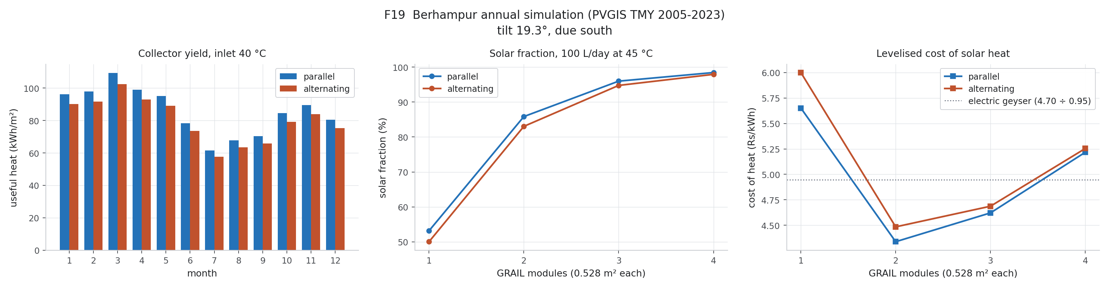
Figure 11.1. Monthly yield, sizing and cost of heat

11.3 Household system sizing (100 L/day at 45 °C)
Arr. | Mod. | Area m² | SF | Solar kWh/yr | Tank loss kWh | Max Tc K | Capex Rs | Payback yr | NPV Rs | Cost of heat Rs/kWh
alt | 1 | 0.53 | 50.0 % | 385 | 111 | 329 | 16500 | 10.8 | -3464 | 6.00
alt | 2 | 1.06 | 83.0 % | 638 | 242 | 349 | 21000 | 7.6 | 2526 | 4.49
alt | 3 | 1.58 | 94.7 % | 728 | 402 | 389 | 25500 | 8.0 | 1620 | 4.69
alt | 4 | 2.11 | 97.9 % | 753 | 509 | 427 | 30000 | 9.2 | -1976 | 5.25
par | 1 | 0.53 | 53.2 % | 409 | 118 | 331 | 16500 | 10.1 | -2461 | 5.65
par | 2 | 1.06 | 85.8 % | 660 | 266 | 353 | 21000 | 7.4 | 3435 | 4.34
par | 3 | 1.58 | 96.0 % | 738 | 436 | 405 | 25500 | 7.9 | 2053 | 4.62
par | 4 | 2.11 | 98.4 % | 757 | 533 | 442 | 30000 | 9.1 | -1748 | 5.22
Table 11.3. Sizing sweep (15 years, 8 % discount, 1 % O&M, 15 W pump)
Economic input | Value
tariff_Rs_kWh | 4.7
tariff_basis | TPSODL LT domestic 51-200 kWh/month slab, 470 paise/kWh (FY 2025-26, retained FY 2026-27); electricity duty excluded (conservative)
tariff_high_Rs_kWh | 5.7
capex_Rs | 30000
capex_range_Rs | 22000 – 45000
capex_basis | ENGINEERING_ASSUMPTION: market 100 LPD flat-plate system Rs 20,000-30,000 + installation Rs 3,000-10,000; GRAIL prototype cost unknown
om_frac_per_yr | 0.01
life_yr | 15
discount | 0.08
Table 11.4. Economic inputs
- Two modules give the lowest cost of heat: SF 86 % (parallel) / 83 % (alternating), Rs 4.34 / 4.49 per kWh vs Rs 4.95 for a geyser (Rs 4.70/kWh at 95 %).
- Four modules are oversized: the tank sits at its limit 533–726 h/yr, the collector stagnates at 427–442 K. DESIGN_REVIEW_REQUIRED: overheat protection for arrays of 3 or more modules.
- Capital cost is an ENGINEERING_ASSUMPTION (Rs 12,000 + Rs 4,500 per module); the GRAIL prototype cost is unknown.

12. System models: Python, Octave, Xcos and Simulink
The same collector–tank system was built four times, independently, to check the equations and the code. All use the same hourly input file (G_eff, T_amb, T_mains, draw for 8,760 h).
Implementation | What it is | Agreement
Python (Stage 7) | Reference model, 60 s step, draw as pulse at the start of each hour | Baseline
GNU Octave 8.4 | Same equations as .m files; own solar-position routine | SF within 0.000004; solar heat within 0.003 kWh/yr; peak Tc within 0.17 K
Scilab Xcos 2024 | 24-block diagram, LSodar, continuous draw | Solar heat within 0.04 % of Octave (same continuous-draw equations)
MATLAB/Simulink (V20, V21) | Built by script with add_block/add_line, ode45, data embedded | All 4 cases PASS vs Xcos: solar heat within 0.05 %, max Tc within 0.94 K
Arrangement | Modules | Q_coll kWh | Q_loss kWh | Q_solar kWh | Q_load kWh | Pump h | SF | Tt end K | Max Tc K
alternating | 2 | 875.1 | 247.5 | 626.0 | 768.9 | 2835 | 81.42 % | 311.68 | 347.96
parallel | 2 | 921.9 | 271.7 | 648.4 | 768.9 | 2840 | 84.34 % | 313.17 | 352.03
alternating | 4 | 1263.2 | 509.2 | 749.7 | 768.9 | 2153 | 97.51 % | 334.68 | 429.85
parallel | 4 | 1293.0 | 534.2 | 754.1 | 768.9 | 2056 | 98.08 % | 338.79 | 443.82
Table 12.1. Xcos annual results (continuous draw)
Arrangement | Modules | Solar kWh | SF % | Max Tc K | Tank end K | Closure kWh | vs Xcos solar % | vs Xcos max Tc K | Verdict
alternating | 2 | 626.28 | 81.45 | 347.963 | 311.435 | 4.9e-12 | +0.0408 | +0.0009 | PASS
parallel | 2 | 648.55 | 84.35 | 352.021 | 312.899 | −3.1e-11 | +0.0205 | −0.0089 | PASS
alternating | 4 | 749.79 | 97.52 | 430.787 | 334.159 | −6.0e-11 | +0.0108 | +0.9375 | PASS
parallel | 4 | 754.13 | 98.08 | 444.211 | 338.204 | −1.5e-10 | +0.0068 | +0.3892 | PASS
Table 12.2. Simulink V20 run in MATLAB Online (V21: same numerics, OVERALL PASS)
The continuous-draw models (Xcos, Simulink) give a solar fraction 1.5–1.6 points lower at 2 modules than the Stage 7 pulse-draw baseline. The ranking and the 2-module sizing do not change; the Stage 7 values remain the reported results. The larger max-Tc differences at 4 modules happen at stagnation (> 420 K) and depend on step placement; annual energy agrees within 0.011 %.
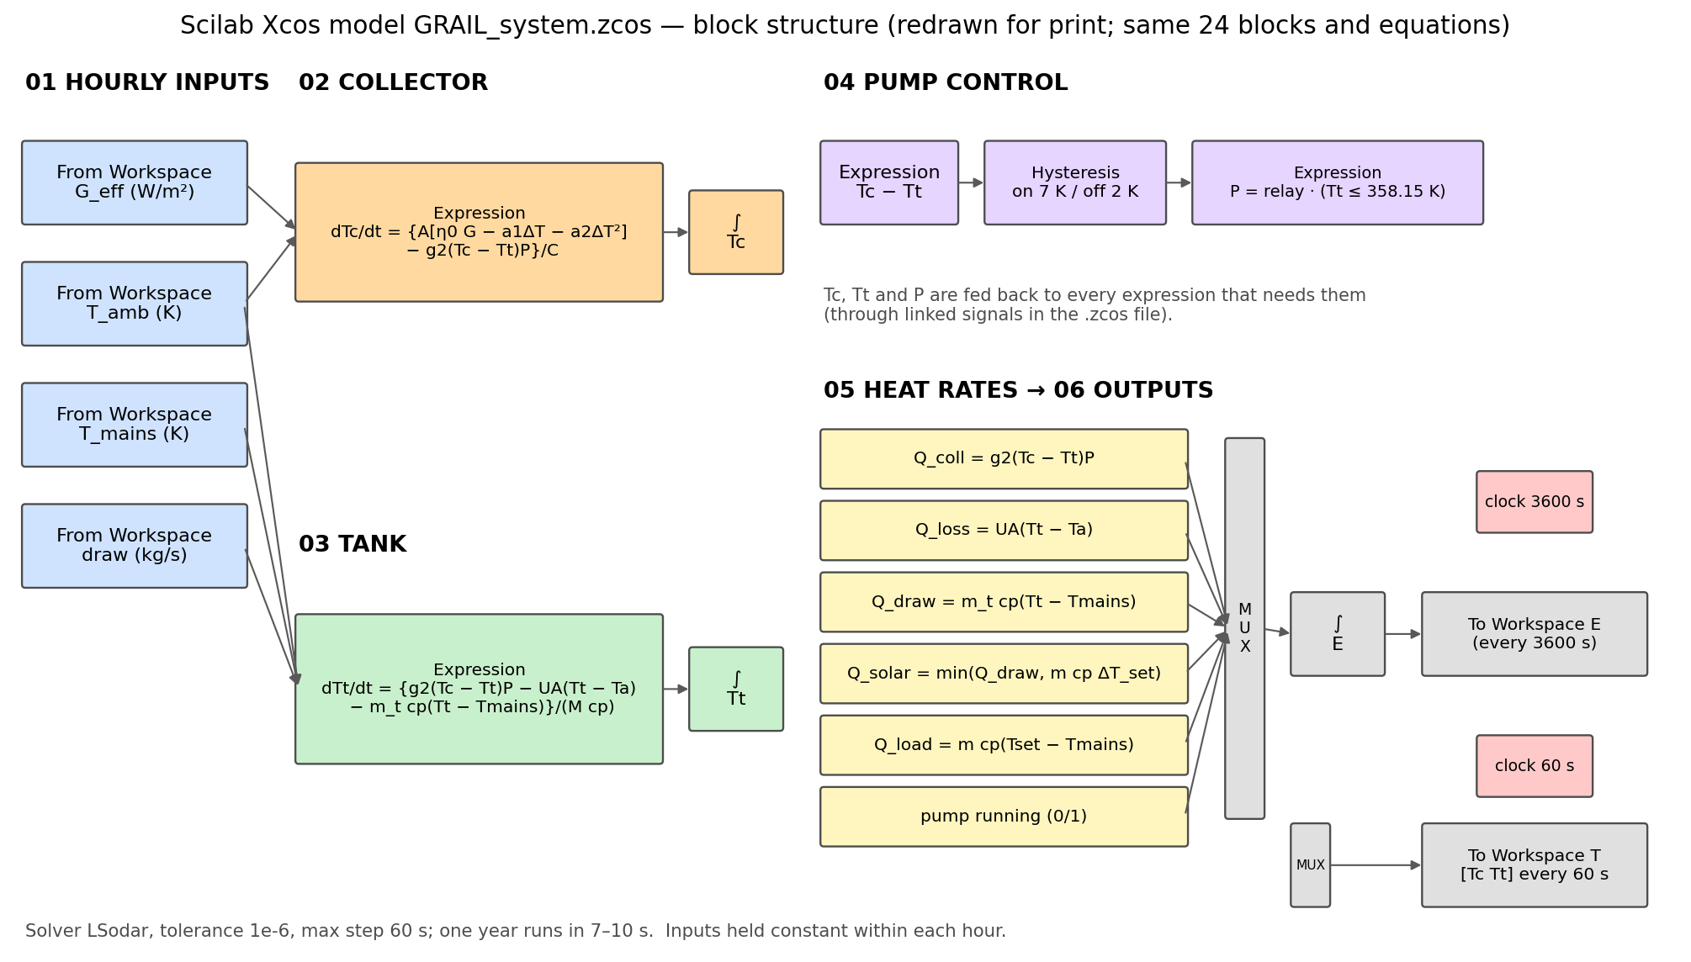
Figure 12.1. Scilab Xcos model — block structure (redrawn for print from GRAIL_system.zcos)
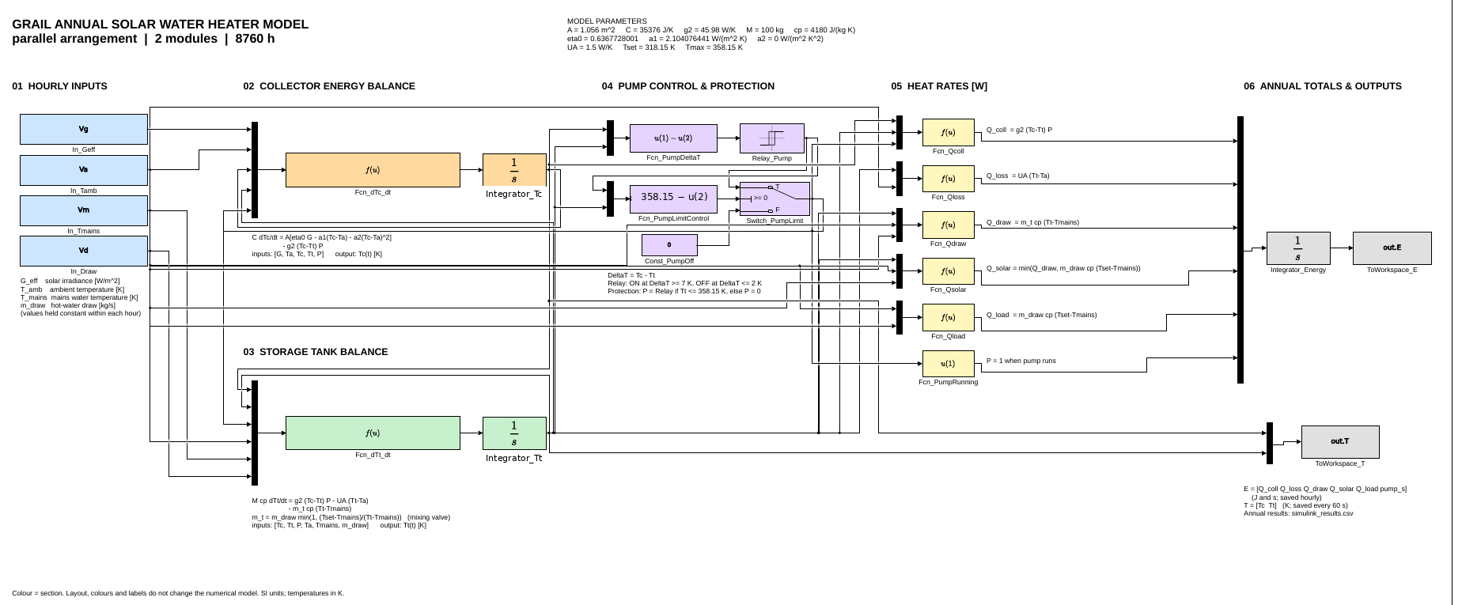
Figure 12.2. MATLAB/Simulink V21 block diagram (parallel, 2 modules); two duplicate labels removed for print — V22 script fixes them at source

13. Verification record (model checks)
Verification asks: are the equations solved correctly? Validation (Section 14) asks: do they describe reality?
# | Check | Result | Status
1 | 3-D grid convergence of Nu | GCI 2.1 %, p = 1.12 | PASS
2 | 3-D energy balance from raw fields | 0.005 % / 0.035 % | PASS
3 | 3-D iteration convergence | ≤ 2 × 10⁻⁶ | PASS
4 | frozenFlow honoured | 0 pressure/momentum solves; flux unchanged 1.5 × 10⁻⁸ | PASS
5 | GRAIL-CHT vs 3-D (co-current) | η 0.01 %, std 0.6 % | PASS
6 | GRAIL-CHT vs HWB textbook model | +0.22 % | PASS
7 | Campaign energy balance, 300 cases | all < 0.5 % (max 0.00015 %) | PASS
8 | Campaign convergence | 300 / 300 | PASS
9 | Independent dataset audit (Rev 4.1) | 3 derived-column groups corrected; thermal results unchanged | PASS after fix
10 | ANN hold-out | R² ≥ 0.9994 | PASS
11 | NSGA-II optima re-run in solver | ≤ 0.13 points η | PASS
12 | Efficiency-curve held-out points | ≤ 0.24 points | PASS
13 | Tank first law, annual | ≈ 10⁻¹⁰ kWh | PASS
14 | Weather time alignment | 0.17 W/m² closure | PASS
15 | Python vs Octave vs Xcos vs Simulink | ≤ 0.05 % solar heat | PASS
16 | V7 matched-temperature searches | matched within 0.001 K; energy < 0.5 % | PASS

14. Validation against published experimental work (V5)
V5 verdict
COMPLETE — PARTIAL PASS at method and component level (closed 25 Sep 2026).
The modelling method was checked against measurements on similar collectors. The GRAIL collector itself has not been built or tested; it is not experimentally validated.

14.1 Screening rules
- (a) measured data given in tables;
- (b) data pass an independent energy check;
- (c) the inputs needed to rerun the case are stated.

14.2 All papers screened (16)
# | Paper | Measured? | Tables | Energy check | Inputs | Use
1 | Gunjo et al. 2017, Renew. Energy | CFD vs test | – | Fails (CFD exceeds solar input) | – | Rejected
2 | Bharathiraja et al. 2024, J. Energy Storage 96 | Yes, outdoor | Yes | Pass (64.8 / 73.0 % vs 64.7 / 71.7 %) | Partly | Comparison
3 | Vahidinia & Khorasanizadeh 2024, Energy 304 | No | – | Pass (quoted points) | No | Pointer
4 | Zareie et al. 2024, Energy 286 | Yes, simulator | Plot | Not checkable | Partly | Rejected
5 | Parthiban et al. 2025, Appl. Therm. Eng. 258 | No | System | n/a | Yes | Comparison (TIM τ 0.89)
6 | Ding et al. 2025, Int. J. Therm. Sci. 208 | Heat sink | Partly | n/a | Yes | Physics support
7 | Li et al. 2024, Appl. Therm. Eng. 251 | No | n/a | n/a | n/a | Method support
8 | Alawi et al. 2024, Eng. Appl. AI 133 | No | n/a | n/a | n/a | ANN comparison
9 | Del Col et al. 2013, Energy 58 | Yes, EN 12975 | Yes, U95 | Pass | Mostly | REFERENCE — method check
10 | Mansour 2013, Energy 60 | Yes | Plots | Model table passes | Model | Model benchmark
11 | Zheng et al. 2024, Appl. Energy 355 | Yes | Plot | ~11 % uncertainty | Yes | Comparison
12 | Sakib et al. 2026, ECM:X 31 | No | n/a | n/a | n/a | Method comparison
13 | Beikircher et al. 2015, SOLMAT 141 | Yes | Yes | Pass (η0 0.89 < τα 0.91) | Partly | REFERENCE — component check
14 | Kessentini et al. (CTTC/UPC) | Yes | Fitted line | Plausible | Partly | Comparison (η = 0.732 − 7.19 x)
15 | Robles et al. 2014, Sol. Energy 110 | Yes | Plots | Not checkable | No | Background
16 | Oyinlola & Shire 2018, BSERT | Lab rig | Plots | n/a | Rig | Background

14.3 Method check — Del Col et al. 2013 (tested roll-bond collectors)
The same Hottel-Whillier-Bliss fin model with Klein's top-loss correlation was applied without any tuning. Stated inputs were used as given (aperture 1.81 m², 28 channels, Ø 3.7 mm, 1.5 mm Al, α/ε, 0.02 kg/s·m², G 800–1000 W/m², T_amb 8–12 °C, wind 1.4 m/s). The 11 unstated inputs (glass τ and ε, width, Al k, insulation, edge loss, Nu, bond footprint, wind coefficient, tilt, ambient) were sampled over typical ranges in 2,000 Monte Carlo runs (ENGINEERING_ASSUMPTION).
Collector | Coefficient | Model nominal | Model 95 % band | Measured ± U95 | Inside U95?
Black roll-bond | η0 | 0.862 | 0.848–0.876 | 0.7995 ± 0.0108 | No (+7.8 %)
 | a1 W/m²K | 5.37 | 5.05–5.77 | 4.69 ± 0.79 | Yes
 | a2 W/m²K² | 0.0185 | 0.0174–0.0198 | 0.0288 ± 0.0121 | Yes
Semi-selective roll-bond | η0 | 0.785 | 0.773–0.798 | 0.7409 ± 0.0110 | No (+6.0 %)
 | a1 W/m²K | 4.26 | 3.99–4.60 | 4.55 ± 0.69 | Yes
 | a2 W/m²K² | 0.0118 | 0.0113–0.0125 | 0.0131 ± 0.0100 | Yes
Table 14.1. Model vs measured efficiency coefficients
Tm* (m²K/W) | 0 | 0.01 | 0.02 | 0.03 | 0.04 | 0.06 | 0.08
Black: deviation % | +7.9 | +7.6 | +7.7 | +8.2 | +9.2 | +14.3 | +31.1
Semi-selective: deviation % | +6.0 | +6.8 | +7.9 | +9.1 | +10.8 | +15.7 | +25.8
Table 14.2. Efficiency-curve deviation, model vs measured (G = 1000 W/m²); absolute deviation ≤ 0.076 points
Result: the heat-loss side (a1, a2) is reproduced within the test uncertainty. η0 is over-predicted by 6–8 %, from optical losses (frame shading, soiling, absorptance) that the ideal model leaves out. Relative deviation grows at high Tm* only because the measured efficiency becomes small.

14.4 Component check — Beikircher et al. 2015 (TIM and vacuum insulation)
Plate − ambient (K) | GRAIL front U (W/m²K) | Conduction part | Radiation part
20 | 2.057 | 1.768 | 0.289
40 | 1.961 | 1.660 | 0.301
60 | 1.949 | 1.623 | 0.326
80 | 1.959 | 1.603 | 0.356
Table 14.3. GRAIL front heat loss (wind 3 m/s) vs measured 1.95–2.2 W/m²K for honeycomb covers → PASS
Rear case | k (W/m·K) | Rear U, GRAIL stack (W/m²K)
GRAIL input (catalogue VIP) | 0.006 | 0.272
Measured in collector, silica VSI | 0.010–0.018 | 0.43–0.69
Measured, perlite VSI | 0.020–0.034 | 0.75–1.07
Table 14.4. Rear loss: GRAIL is optimistic → a1 2.1 becomes 2.3–2.5 W/m²K (DESIGN_REVIEW_REQUIRED)

14.5 Comparison of GRAIL with tested collectors
Collector | η0 | a1 W/m²K | a2 W/m²K² | Source
GRAIL parallel | 0.637 | 2.10 (2.3–2.5) | 0 | Model
GRAIL alternating | 0.597 | 2.00 | 0.0004 | Model
Roll-bond black | 0.800 ± 0.011 | 4.69 ± 0.79 | 0.029 | Del Col 2013
Roll-bond semi-selective | 0.741 ± 0.011 | 4.55 ± 0.69 | 0.013 | Del Col 2013
VSI prototype, AR glass | 0.89 | 3.28 | 0.014 | Beikircher 2015
Honeycomb/slat TIM collector | 0.732 | 7.19 | – | Kessentini (poor coating ε 0.5)
Table 14.5. GRAIL trades optical efficiency for about half the heat loss; curves cross at Tm* ≈ 0.036–0.050 m²K/W

14.6 V5 verdict against the < 8 % criterion
Item | Result
Heat-loss coefficients a1, a2 | PASS — inside measured 95 % uncertainty
Optical efficiency η0 | PASS (< 8 %), outside test uncertainty
Efficiency curve Tm* ≤ 0.02 | PASS (< 8 %)
Efficiency curve Tm* > 0.03 | Relative deviation > 8 % (≤ 0.076 points absolute)
TIM front loss | PASS
VIP rear loss | Model optimistic; carried as uncertainty
Allowed wording: "The modelling method was checked against published experimental data. It reproduces the measured heat-loss coefficients of tested roll-bond collectors within test uncertainty and their optical efficiency within 8 %. No prototype of the present collector was tested." Not allowed: "experimentally validated".

15. Patent first pass (V1)
An engineering first-pass search (Google Patents, Justia, OSTI and literature; not a professional search, not legal advice) found no document combining a roll-bond absorber with channels converging along the flow by a grading law, alone or with the TIM/PCM/VIP stack.
Document | Status | Relation to GRAIL
EP2313705A1 / WO2010064078A1 roll-bond absorber | Withdrawn / ceased | Uniform parallel channels
EP1916486A2 solar collector system | Withdrawn | Different sizes between channels, not a taper
CN103557603A inflated flat-plate collector | Rejected | Fixed section
DE10344084A1 adapted flow resistance | Expired | No taper along the flow
EP2522927A2 aerogel + honeycomb TIM collector | Granted | Freedom-to-operate note if an aerogel layer is used
Li 2024, Ding 2025 (heat sinks) | Literature | Tapered / variable-width channels in heat sinks
Assessment: novelty possible; inventive step weak–moderate (alternating flow shows no benefit at matched plate temperature; the optimiser moves G towards 1). Decision recorded: publish, no patent filing.

16. Assumptions, open design items and limitations
Tag | Item
ENGINEERING_ASSUMPTION | Whole manifold geometry (header bore, length, risers, ports)
ENGINEERING_ASSUMPTION | 3-D benchmark loss model (U_top 4.19, h_rear 3.0); constant water properties in 3-D
ENGINEERING_ASSUMPTION | Tilt 19.3° S; IAM b0 0.10; C_eff 33.5 kJ/m²K; tank 100 kg, UA 1.5 W/K; 100 L/day at 45 °C; draw profile; mains = 24 h mean ambient; pump 15 W; geyser 95 %; capex model; 15 yr, 8 %, 1 % O&M
ENGINEERING_ASSUMPTION | NSGA-II reference point; design flow 2.75 g/s
ENGINEERING_ASSUMPTION | Unstated inputs of the Del Col check (Monte Carlo ranges)
DESIGN_REVIEW_REQUIRED | VIP conductivity: use a measured in-collector value (0.010–0.018 W/m·K)
DESIGN_REVIEW_REQUIRED | Stagnation above 420 K for ≥ 3 modules: overheat protection needed
DESIGN_REVIEW_REQUIRED | Converging-channel benefit: not supported for efficiency in the range studied
Open (C7, C8) | Manifold dimensions and frame wall thickness
Open (V6) | Supplier datasheets for TIM, PCM, VIP
Deferred | PCM latent heat; 3-D radiation/optics; full 3-D campaign; topology optimisation (Stage 4)

16.1 Limitations
- Simulation only; no measurement of the GRAIL collector.
- Optical efficiency may be optimistic by up to ≈ 7 % (Del Col check); a1 may be up to 2.5 W/m²K (Beikircher check).
- Single collector node and fully mixed tank in the annual model; capital cost assumed.
- Alternating-flow uniformity overstated by ≈ 2 points in GRAIL-CHT (Nu undefined where heat flow reverses).

17. Conclusions
- A converging roll-bond absorber with a glass + honeycomb TIM cover and PCM + VIP rear was modelled from CAD through 3-D CFD to annual economics, with every step verified.
- The corrected conjugate Nusselt number is 4.48 (GCI 2.1 %); GRAIL-CHT with this closure reproduces the 3-D solution.
- Alternating flow lowers efficiency by 7.3 % at equal inputs; at the same plate temperature efficiency is equal and uniformity is worse at design flow. The cause is heat returned to the plate (≈ 40 %).
- The ANN surrogate (R² ≥ 0.9994) and NSGA-II optimisation are verified against the solver; the optimum favours high flow and straight channels for efficiency.
- The collector has η0 0.637 and a1 2.1 (up to 2.5) W/m²K — about half the heat loss of tested roll-bond collectors — and outperforms them above Tm* ≈ 0.04–0.05 m²K/W.
- In Berhampur a 2-module system covers 83–86 % of a 100 L/day load at Rs 4.34–4.49 per kWh, cheaper than an electric geyser, payback ≈ 7.5 years.
- Four independent system models agree. The method was checked against published experiments (partial pass). A prototype test is the next step.

18. Files and folders
Folder | Contents
00_README.md | Package guide
01_Roadmap | Roadmap Rev I, completion status Rev 4.2
02_Reports | CFD report Rev 4.1, CAD report, correction report, audit addendum, paper draft, this report
03_CAD | Fusion (.f3d), STEP, strips, gate JSON, geometry scripts
04_Figures | F01–F14 (current), legacy figures
05_Videos | 3-D conjugate CFD video
06_Datasets | Rev 4.2 dataset, dictionary, workbook with Stages 3–7
07_Results_JSON | Benchmark, Nu profiles, ROM runs, uncertainty
08_Tables | T1–T6
09_Records_MD | Provenance records, audit outputs
10_Code | Model, CFD, post-processing, report scripts
11_Validation_V5 | Screening of 16 papers, V5 final record
12_Stages_3-5-6-7 | ANN, NSGA-II, efficiency curves, annual/economics
13_Octave_system_model | Octave model, compare_with_python.m
14_Xcos_block_diagram_model | GRAIL_system.zcos
15_Run_in_VSCode | One launcher for all re-runnable stages
16_JSON_Python_Mirror | 65 JSON results as Python
17_Simulink_MATLAB_model | GRAIL_simulink_complete_FINAL_v21.m, run records
18_V7_matched_mean_T | V7 record and results
19_V5_DelCol_method_check | Del Col method check
20_Patent_prior_art | V1 first pass
21_V5_Beikircher_component_check | Beikircher component check

Appendix A. CAD parameter register
Parameter | Value | Expression | Source note
ap_L | 1100.00 mm | 1100 mm | ROADMAP A1 plate length
ap_W | 480.00 mm | 480 mm | ROADMAP A2 plate width
ap_t | 2.00 mm | 2.0 mm | ROADMAP A3 plate thickness = 2 x 1.0mm roll-bond
n_ch | 12 | 12 | ROADMAP A4 number of channels
ch_pitch | 40.00 mm | ap_W / n_ch | ROADMAP A5 DERIVED channel pitch
ch_w_in | 8.7009537 mm | ch_h_in * 8.0 / 3.8 | DERIVED from ch_h_in holding ROADMAP A10 aspect ratio 2.105 (the 6.1 table ratio 8.0/3.8).
ch_h_in | 4.132953 mm | 4.132953 mm | RE-SOLVED 2026-09-14 after r_fillet moved to 0.5 mm. Chosen so the built inlet section gives Dh_in = 5.2000 mm exactly per ROADMAP A6; measured 5.199326. ch_w_in is driven from this holding the A10 aspect ratio 8.0/3.8 = 2.105; measured 2.1053. Previous value 4.02401 mm belonged to the r_fillet 1.0 mm construction.
ch_AR | 2.10526 | ch_w_in / ch_h_in | ROADMAP A10 DERIVED aspect ratio, target 2.1
Dh_in | 5.20 mm | 5.2 mm | ROADMAP A6 nominal inlet hydraulic diameter
G_ratio_A7_baseline | 1 | 1.00 | ROADMAP A7 stated baseline = NO grading
G_ratio_S61_fusion | 0.54 | 0.54 | ROADMAP 6.1 Fusion table value and A7 definition: the Dh RATIO Dh_out/Dh_in. NOW MATCHED BY THE GEOMETRY - measured 0.540014. This is the parameter that drives Dh_out.
G_ratio | 0.527853 | 0.527853 | AS-BUILT SECTION SCALE at the outlet, solved 2026-09-14 so the measured Dh ratio equals the ROADMAP A7/6.1 value 0.54 (achieved 0.540014). The channel CONVERGES. NOTE: this parameter is a SECTION SCALE, not the roadmap Dh ratio - the two differ because r_fillet is fixed and does not scale with the section. The roadmap Dh ratio lives in G_ratio_S61_fusion. Sweep range per A7 is 0.35-1.50 on the Dh ratio, but this construction floors the SECTION SCALE at 0.483915; below that the dome inverts silently.
Dh_out | 2.808 mm | Dh_in * G_ratio_S61_fusion | DRIVEN per ROADMAP 6.1: Dh_out = Dh_in * G_ratio. Uses G_ratio_S61_fusion (0.54), the roadmap Dh ratio. NOTE the parameter named G_ratio in this file holds the SECTION SCALE (0.527853), which is not the same quantity because r_fillet is fixed and does not scale. As-built measured value is in Dh_out_geom.
lam_G | 1 | 1.0 | ROADMAP A8 grading profile exponent. Baseline 1.0, range 0.5-3.0, SWEPT. SET TO THE A8 BASELINE 1.0 on 2026-09-14. PREVIOUSLY 2.0, justified only by the REFERENCE_IMAGE label Exponential. That image has since been shown to contradict A7, 6.1 and 8.2 on the grading DIRECTION, so it is not a valid source for the EXPONENT either, and the value reverts to the roadmap baseline. The law is Dh(x) = Dh_in*[1 - (1 - G_ratio)*(x/ap_L)^lam_G], so lam_G 1 is linear, below 1 concave (taper early), above 1 convex (taper late). ENDPOINTS ARE INDEPENDENT OF lam_G - at x = ap_L the scale equals G_ratio whatever the exponent - so Dh_in, Dh_out, the Dh ratio and the Reynolds band are unchanged by this. Only the interior profile and the fluid volume change. F10 should sweep it 0.5-3.0.
P_ratio | 1 | 1.00 | ROADMAP A9 pitch grading ratio, 1.0 = uniform pitch
r_fillet | 0.50 mm | 0.5 mm | ROADMAP A11 channel root fillet. Baseline 1.0 mm, range 0.5-2.0, Role FIXED. REDUCED to 0.5 mm by DECISION D4 on 2026-09-14, because at 1.0 mm the tangent-blend section degenerates at h_s = 3.0 mm and floors the section scale at 0.745525, which makes the ROADMAP 6.1 grading G_ratio 0.54 geometrically unreachable. 0.5 mm is the lower end of the A11 range, so this stays inside the roadmap. CONSEQUENCE TO REPORT: A11 Role reads FIXED, so Rev H must record that the fillet was moved within its stated range, and 6.3 notes the fillet carries the lateral conduction path, so F10 should sweep it alongside w_bridge.
f_interdig | 1 | 1 | ROADMAP B1 1 = alternating counter-current ACTIVE
n_alt | 1 | 1 | ROADMAP B2 channels per flow-direction group
w_bridge_B3_baseline | 34.80 mm | 34.8 mm | ROADMAP B3 stated baseline bridge width
w_bridge | 31.2990463 mm | ch_pitch - ch_w_in * max(1; G_ratio) | DERIVED minimum lateral conduction bridge = ch_pitch - ch_w_in*G_ratio. 26.195 mm at the as-built grading. ROADMAP B3 states 34.8 mm - see DESIGN_REVIEW_W_BRIDGE. Filing 1 claims a bridge width SELECTED to reduce the peak-to-mean plate temperature difference, so this is a claimed dimension and must be swept (Rev H F10, 20-60 mm), not assumed.
alpha_abs | 0.95 | 0.95 | ROADMAP C1 solar absorptance TiNOX
eps_abs | 0.04 | 0.04 | ROADMAP C2 emittance
coat_t | 0.0003 mm | 0.0003 mm | ROADMAP 5.1 sputtered TiNOX ~0.3 um
tau_glz | 0.91 | 0.91 | ROADMAP C5 glazing transmittance
glz_t | 3.20 mm | 3.2 mm | ROADMAP 5.1 low-iron tempered glass
glz_L | 1160.00 mm | 1160 mm | ROADMAP 5.2 BOM glazing length
glz_W | 560.00 mm | 560 mm | ROADMAP 5.2 BOM glazing width
t2_t | 1.00 mm | 1.0 mm | ROADMAP 5.1 thermotropic PMMA layer
T_sw | 75 | 75 | ROADMAP 5.1 thermotropic switching temperature in degC
tim_t | 10.00 mm | 10 mm | ROADMAP D1 transparent insulation thickness
tim_cell | 3.50 mm | 3.5 mm | ROADMAP D2 honeycomb cell size, cutaway block only
gap_t | 15.00 mm | 15 mm | ROADMAP D5 sealed dry air gap
vip_t | 20.00 mm | 20 mm | ROADMAP D6 vacuum insulation panel thickness
vip_W | 500.00 mm | 500 mm | ROADMAP 5.2 BOM VIP width
edge_t | 15.00 mm | 15 mm | ROADMAP D8 aerogel edge insulation
graph_t | 0.40 mm | 0.4 mm | ROADMAP 5.1 compressed graphite interface
pcm_t_S51 | 11.60 mm | 11.6 mm | ROADMAP 5.1 layer stack PCM thickness
pcm_t_S61 | 10.00 mm | 10 mm | ROADMAP 6.1 Fusion table PCM thickness, agrees with BOM 4.65 kg
tray_t | 0.80 mm | 0.8 mm | ROADMAP 5.2 BOM ribbed aluminium PCM tray
back_t | 1.00 mm | 1.0 mm | ROADMAP 5.1 recycled aluminium backsheet
frame_L | 1200.00 mm | 1200 mm | ROADMAP 5.0 gross length
frame_W | 600.00 mm | 600 mm | ROADMAP 5.0 gross width
frame_d | 92.00 mm | 92 mm | ROADMAP 5.1 frame overall depth
tilt | 33.0 deg | 33 deg | ROADMAP E6 nominal tilt
tilt_min | 10.0 deg | 10 deg | ROADMAP E6 lower adjustable limit
tilt_max | 45.0 deg | 45 deg | ROADMAP E6 upper adjustable limit
DESIGN_REVIEW_VIP_MASS | 0 | 0 | CONFIRMED AT SOURCE, ROADMAP CORRECTION REQUIRED. 5.2 lists the VIP as fumed silica 1120 x 500 x 20 mm at 1.05 kg, which implies 93.75 kg/m3, while 5.3 gives VIP fumed silica 190 kg/m3 - the roadmap contradicts itself. Fumed-silica VIP cores are 160-200 kg/m3, so 5.3 is correct and the 5.2 mass is wrong; it should read 2.13 kg for the BOM dimensions. The CAD uses 190 kg/m3 on a 1100 x 500 x 20 panel (trimmed to ap_L to clear the manifolds) = 2.090 kg. No CAD change required.
DESIGN_REVIEW_TIM_DENSITY | 0 | 0 | CLOSED 2026-09 as a FALSE ALARM. ROADMAP 5.3 lists PC honeycomb homogenised density 85 kg/m3, not 851 (transcription error in the earlier note). Model uses 85 -> TIM_PANEL 0.456 kg vs BOM 5.2 value 0.42 kg. No conflict remains.
frame_bot_z | -58.80 mm | frame_top_z - frame_d | DERIVED frame bottom, holds ROADMAP 92mm envelope
Dh_in_geom | 5.199685 mm | 5.199685 mm | MEASURED on the built solid at the inlet face after the 2026-09 grading correction. Target 5.2000 (ROADMAP A6). Error -0.0130 percent.
Dh_out_geom | 2.809592 mm | 2.809592 mm | MEASURED on the built solid at the outlet face after the 2026-09 grading correction. Target 2.8080 = Dh_in * 0.54 (ROADMAP 6.1). Error -0.0104 percent. The channel now CONVERGES, per A7, 6.1 and 8.2.
CFD_mdot_per_channel | 0.0002083 | 2.083E-04 | kg/s per channel at the ROADMAP E4 design point mdot 0.0025 kg/s over n_ch 12. Apply as Mass Flow on the 3 cold port faces per end.
CFD_Re_min | 23.9 | 23.9 | MEASURED-geometry Reynolds at mdot 0.001 kg/s on the CONVERGING channel, inlet Dh 5.1993 mm. ROADMAP 8.2 states the band 30-210. Correction C1 is now APPLIED in the geometry, so 8.2 and the model agree.
CFD_Re_max | 198.8 | 198.8 | MEASURED-geometry Reynolds at mdot 0.0045 kg/s, outlet Dh 2.8077 mm. Full span across the mass-flow range is 23.9 to 198.9, against ROADMAP 8.2 stating 30-210. Deeply laminar; the Laminar Flow interface stands.
CFD_swept_ratio | 211 | 211 | channel length / Dh_in. High aspect ratio - swept mesh along the channel is mandatory per ROADMAP 8.5.
CFD_suppress_count | 57 | 57 | Components to suppress before STEP export: 30 FASTENER_, 5 SEAL_, 14 MOUNT_, 8 SENSOR_ = 57, PLUS SELECTIVE_COATING = 58 bodies total. All four group counts were re-verified by component scan in the 2026-09 audit and match exactly. ROADMAP 8.3 handles the coating as a Thin Layer, not a meshed solid. The 12 PORT_ components are NOT suppressed - they carry the CFD inlet and outlet faces.
DESIGN_REVIEW_G_RATIO | 0 | 0 | CLOSED 2026-09-14 BY FIX. The grading now CONVERGES per ROADMAP A7, 6.1 and 8.2. Section scale solved to 0.527853 giving measured Dh_in 5.199326 and Dh_out 2.807707 mm, a Dh ratio of 0.540014 against the roadmap 0.54. Reynolds now spans 23.9 to 198.9 across mdot 0.001-0.0045, matching the 8.2 band 30-210. The REFERENCE_IMAGE diverging value 1.596 is superseded and was never a roadmap source. Applied by walking G_ratio down in ~20 small steps so the outlet sketch tangent constraints tracked continuously; a single jump fails.
G_ratio_sweep_min | 0.35 | 0.35 | ROADMAP A7 lower bound, verified at source.
G_ratio_sweep_max | 1.5 | 1.50 | CORRECTED AT SOURCE. ROADMAP A7 gives G_ratio range 0.35-1.50, baseline 1.00. The previous 1.60 exceeded the roadmap range and is withdrawn. NOTE: the as-built G_ratio 1.629546 and the REFERENCE_IMAGE Dh ratio 1.596 are BOTH outside A7 entirely.
DESIGN_REVIEW_W_BRIDGE | 0 | 0 | CLOSED AT SOURCE. ROADMAP B3 lists w_bridge as SWEPT with baseline 34.8 mm and range 20-60 mm. The derived value 26.195 mm is INSIDE that range, so there was never a conflict - only a difference from the baseline. The earlier pitch-minus-Dh hypothesis is withdrawn as unnecessary. Rev H F10 still sweeps 20-60 per B3. NOTE: if the grading is corrected to converging, the widest section moves to the INLET and the true minimum bridge becomes 40 - 8.4716 = 31.53 mm, which is much nearer the B3 baseline 34.8 - further corroboration that converging is the intended direction.
glz_n_panes | 2 | 2 | DECISION D2: the second pane is intentional DOUBLE GLAZING, not a modelling error. Must be added to ROADMAP 5.1 layer stack, 5.2 BOM and the U_L derivation.
gap_air_total | 11.75 mm | 11.75 mm | MEASURED total AIR depth = gap_t - glz_inner_t. The ROADMAP D5 envelope gap_t = 15 mm is honoured exactly (z 1.0 to 16.0), but 3.2 mm of it is glass, so the cavity is TWO gaps of 7.45 and 4.30 mm, not one of 15 mm. The U_L derivation must use two cavities.
DESIGN_REVIEW_GLZ_DOUBLE | 0 | 0 | CLOSED by decision D2 as a GEOMETRY question: the inner pane is intentional double glazing, not a stray body, and ROADMAP 5.1 / 5.2 / 6.1 now list it (correction C9). The 5.1 gap_t 15 mm envelope is preserved exactly; see gap_air_lower 7.45, glz_inner_t 3.2, gap_air_upper 4.30. NOTE: the OPTICAL consequence was missed at the time and is now tracked separately as DESIGN_REVIEW_GLZ_TRADE, because it decides whether the pane should stay at all.
MATERIALS_ASSIGNED | 135 | 135 | Hardware bodies carrying a ROADMAP 5.3 material (plus 3 CFD reference bodies = 138 total). 15 custom materials were created at the 5.3 densities. Previously every body was Fusion default Steel, so all mass output produced before this pass is void.
DRY_MASS_AS_MODELLED | 43.456 | 43.456 | MEASURED HARDWARE dry mass in kg at ROADMAP 5.3 densities, excluding the 90_CFD_REFERENCE duplicates, water and air. Re-measured 2026-09-14 after the converging grading correction and the r_fillet change.
DESIGN_REVIEW_COATING_T | 0 | 0 | CLOSED 2026-09 BY FIX. SELECTIVE_COATING_TiNOX was modelled at 0.05 mm, 167x the specified thickness, carrying 0.1365 kg of mass that does not exist. The OffsetFaces1 distance that drives the shell is now bound to the parameter coat_t (0.0003 mm per ROADMAP 5.1, sputtered TiNOX). Rebuilt result: volume 182.69 mm3, mass 0.000822 kg, measured uniform thickness 0.000301 mm against the 0.000300 target. Because the offset is now parametric, the thickness can never drift from coat_t again. 0 unhealthy features after the change.
DESIGN_REVIEW_BOM_TOTAL | 0 | 0 | CONFIRMED AT SOURCE, ROADMAP CORRECTION REQUIRED. The 5.2 table TOTAL row reads 17.82 kg, but its own line items sum to 22.42 kg (5.20+0.78+0.42+2.85+0.35+0.21+4.65+1.30+1.05+0.12+2.90+1.95+0.44+0.20; the selective coating is listed with no mass). The stated total is low by 4.60 kg. This is an arithmetic error in the roadmap, not a CAD issue. Correct the TOTAL row to 22.42 kg in Rev H.
DESIGN_REVIEW_FILLET_FLOOR | 0 | 0 | CLOSED 2026-09-14 BY DECISION D4. The outlet sketches build the dome radius with denominator 2*((h_s - r_fillet) - (r_fillet + ap_sheet_t)), which passes through zero at h_s = 2*r_fillet + ap_sheet_t and inverts the dome below it. At r_fillet 1.0 mm that floored the section scale at 0.745525 and made the roadmap G_ratio 0.54 UNREACHABLE. r_fillet was reduced to 0.5 mm, which ROADMAP A11 permits (range 0.5-2.0), lowering the threshold to h_s 2.0 mm and the floor to scale 0.483915. 0.527853 now sits safely above it. WARNING retained: never set the section scale below 0.4840 in this construction - at 0.62 with the old fillet the sketch solved with R = -0.8703 mm and Fusion reported only a warning, so an inverted dome can pass unnoticed.
DECISION_D4_FILLET | 1 | 1 | DECISION D4, taken 2026-09-14. r_fillet reduced from 1.0 to 0.5 mm, inside the ROADMAP A11 range 0.5-2.0, so that the 6.1 grading G_ratio 0.54 becomes geometrically achievable. It was the only option making A7, 6.1 and 8.2 simultaneously true. REJECTED ALTERNATIVES: hold r_fillet 1.0 and accept a Dh ratio near 0.78, which fails 6.1 and reaches only Re 135 against the stated 210; or hold the A7 baseline 1.00 with no grading, which abandons the graded absorber that 5.1 names. REV H MUST RECORD: A11 Role reads FIXED, so the move within its range is a documented deviation; and 6.3 notes the fillet carries the lateral conduction path, so F10 should sweep r_fillet alongside w_bridge.
DESIGN_REVIEW_PCM_T | 0 | 0 | ROADMAP CORRECTION PENDING, no CAD change. ROADMAP 5.1 layer stack gives PCM 11.6 mm; 6.1 Fusion table gives 10 mm. The CAD uses 10 mm (pcm_t_S61) because it reproduces the 5.2 BOM mass of 4.65 kg, which 11.6 mm would not. Both competing values are kept as pcm_t_S51 and pcm_t_S61. ACTION: reconcile 5.1 against 6.1 and the BOM in Rev H. Previously this conflict was noted only inside the pcm_t comment and had no flag, so it was invisible to the item count.
DESIGN_REVIEW_VIP_L | 0 | 0 | ROADMAP CORRECTION PENDING, no CAD change. ROADMAP 5.2 BOM specifies the VIP as 1120 mm long, but at that length it overlaps the manifold blocks at x = +/-550. The CAD trims it to ap_L = 1100 mm. ACTION: restate the VIP length in 5.2, or state the clearance that makes 1120 mm fit. Previously noted only inside the vip_L comment with no flag.
tau_glz_sys | 0.833 | 0.833 | ROADMAP C9 (added in Rev H, correction C11): glazing SYSTEM transmittance for ALL panes, DERIVED. First-order estimate for two identical low-iron panes of tau 0.91 and reflectance 0.08: tau^2/(1-rho^2) = 0.8281/0.9936 = 0.833. C5 tau_glz 0.91 is a SINGLE-PANE value and its range 0.88-0.92 cannot represent the built double-glazed stack. ROADMAP 8.4 now builds the absorber boundary condition from tau_glz_sys, not tau_glz. TREAT AS AN ESTIMATE: it ignores angular dependence, spectral mismatch and the AR/TiO2 coatings on the outer pane. Compute properly in the optical model before quoting any efficiency.
DESIGN_REVIEW_GLZ_TRADE | 1 | 1 | OPEN - NEW, raised by correction C11. The second glazing pane (decision D2, kept because the built collector has it) costs about 8.5 percent of absorbed flux: at the design point q falls from 800*0.91*0.82*0.95 = 567.1 W/m2 to 800*0.833*0.82*0.95 = 519.1 W/m2, and the ROADMAP Section 1 optical penalty rises from 18 to about 25 percent. In exchange it splits the 15 mm cavity into 7.45 and 4.30 mm, which lowers U_L. WHETHER THAT TRADE IS FAVOURABLE AT THE 40 K DESIGN DIFFERENCE HAS NOT BEEN COMPUTED. ACTION: run single-pane against double-pane at matched U_L method and matched mass flow before freezing the design. If the double-glazed stack loses, delete GLASS_INNER_PANE and revert roadmap correction C9. This is a design decision, not a modelling one.
Table A1. Roadmap-sourced parameters
Parameter | Value | Expression | Source note
CFD_inlet_area | 63.617 mm^2 | 63.617 mm^2 | MEASURED area of each port face at x=+/-635. 12 faces total, all identical. = pi*port_id^2/4 with port_id 9 mm.
glz_inner_t | 3.20 mm | 3.2 mm | MEASURED inner pane thickness, GLASS_INNER_PANE z 8.500 to 11.700. Same 3.2 mm low-iron tempered glass as the outer pane. Mass 4.294 kg, currently ABSENT from the 5.2 BOM.
gap_air_lower | 7.45 mm | 7.45 mm | MEASURED lower air cavity, absorber top to inner pane, z 1.050 to 8.500.
gap_air_upper | 4.30 mm | 4.30 mm | MEASURED upper air cavity, inner pane to TIM, z 11.700 to 16.000.
FLUID_MASS_AS_MODELLED | 0.445 | 0.445 | MEASURED hardware water plus sealed air in kg: 12 channel voids, 4 manifold voids, 2 air cavities. Excludes the 90_CFD_REFERENCE fluid duplicates.
MASS_assembly_kg | 43.901 | 43.901 | MEASURED v17. Mass of the REAL assembly, groups 00_FRAME through 10_MOUNTING, fluid included: 8.291 + 10.271 + 0.463 + 3.272 + 4.360 + 6.095 + 2.209 + 1.921 + 0.611 + 0.030 + 6.378 kg. Use this figure, never the number Fusion reports for the whole document.
MASS_phantom_cfd_kg | 11.908 | 11.908 | WARNING, MEASURED v17. Mass carried by NON-PHYSICAL reference bodies that duplicate real geometry: 90_CFD_REFERENCE 7.491 kg, 90_CFD_STRIP_3CH_MASTER 2.650 kg, 90_CFD_STRIP_2CH_PERIODIC 1.767 kg. A whole-document mass query returns 55.810 kg, which is 11.908 kg too high. This does not affect any dimension or any CFD result, but it WILL corrupt a BOM export or a mass figure quoted into the thesis. Subtract this, or exclude every 90_ group.
CFD_suppress_occurrences | 58 | 58 | MEASURED v17. Occurrences to suppress before a CFD export: 30 FASTENER, 14 MOUNT, 5 SEAL, 8 SENSOR, 1 SELECTIVE_COATING. NOTE these 58 occurrences carry 72 BODIES, not 58 - fastener components hold more than one body each. Count occurrences, not bodies, when checking the set. The 12 PORT_ components are deliberately NOT in this set; they are part of the flow path. SEALED_AIR_GAP bodies are also excluded - they are glazing cavity air, not seals.
CFD_suppress_bodies | 72 | 72 | MEASURED v17. Body count behind CFD_suppress_occurrences. Recorded because 58 and 72 have been confused before.
Table A2. Measured parameters
Parameter | Value | Expression | Source note
ap_sheet_t | 1.00 mm | ap_t / 2 | DERIVED single aluminium sheet thickness
pcm_t_max | 12.8571429 mm | pcm_t * 2 * pcm_grade_ratio / ( 1 + pcm_grade_ratio ) | DERIVED thickest PCM zone
pcm_t_min | 7.1428571 mm | pcm_t * 2 / ( 1 + pcm_grade_ratio ) | DERIVED thinnest PCM zone
Table A3. Derived parameters
Parameter | Value | Expression | Source note
CFD_hdr_dP_fraction | 4.8 | 4.8 | CHECKED in v16. Header pressure drop as a percentage of channel pressure drop at the E4 design point (mdot 0.0025 kg/s, 12 channels, water rho 984 kg/m3, mu 4.9e-4 Pa.s). Laminar Hagen-Poiseuille estimate: channel 19.43 Pa over 1100 mm at mean Dh 3.9 mm, header 0.93 Pa over 480 mm at 9 mm bore. 4.8 per cent, below the 10 per cent rule of thumb, so expected channel-to-channel maldistribution is a few per cent. NOTE the header bore area 63.617 mm2 is only 0.378 times the 168.331 mm2 total inlet area of the six channels it feeds, which fails the common area rule of thumb; it passes anyway because the channels are long and narrow enough to dominate the resistance. Section 8.1 excludes manifolds from the CFD domain, so this is never checked by simulation and rests on this hand calculation alone.
CFD_hdr_Re | 361 | 361 | CHECKED in v16. Reynolds number in the header bore at the design point, 6 channels per header. Laminar, consistent with the channel range 23.9 to 198.8.
Table A4. Checked parameters
Parameter | Value | Expression | Source note
pcm_zones | 7 | 7 | ENGINEERING_ASSUMPTION number of discrete axial PCM grading zones
pcm_grade_ratio | 1.8 | 1.8 | ENGINEERING_ASSUMPTION thickest zone / thinnest zone, mean held at pcm_t
frame_wall | 2.50 mm | 2.5 mm | ENGINEERING_ASSUMPTION 6063-T6 extrusion wall thickness
hdr_len | 45.00 mm | 45 mm | ENGINEERING_ASSUMPTION manifold block length outboard of absorber end
hdr_bore | 9.00 mm | 9 mm | ENGINEERING_ASSUMPTION non-branching header bore diameter, no Murray-law branching
port_od | 15.00 mm | 15 mm | ENGINEERING_ASSUMPTION external port boss outside diameter
port_id | 9.00 mm | 9 mm | ENGINEERING_ASSUMPTION external port bore
hdr_slot_d | 10.00 mm | 10 mm | ENGINEERING_ASSUMPTION depth the absorber plate inserts into the manifold slot
hdr_x | 17.50 mm | 17.5 mm | ENGINEERING_ASSUMPTION header bore axis distance inboard from absorber end face
hdr_z_cold | -11.00 mm | -11 mm | ENGINEERING_ASSUMPTION cold header bore axis height, below channel plane
hdr_z_hot | 14.00 mm | 14 mm | ENGINEERING_ASSUMPTION hot header bore axis height, above channel plane
riser_d | 9.00 mm | 9 mm | ENGINEERING_ASSUMPTION vertical riser bore connecting header to channel transition
port_len | 40.00 mm | 40 mm | ENGINEERING_ASSUMPTION external port protrusion beyond manifold block
port_y | 120.00 mm | 120 mm | ENGINEERING_ASSUMPTION external port transverse position
blk_z_bot | -18.00 mm | -18 mm | ENGINEERING_ASSUMPTION manifold block bottom
blk_z_top | 21.00 mm | 21 mm | ENGINEERING_ASSUMPTION manifold block top
frame_top_z | 33.20 mm | ap_sheet_t + gap_t + tim_t + t2_t + glz_t + 3 mm | ENGINEERING_ASSUMPTION frame top plane, 3mm lip over glazing
frame_prof_y | 55.00 mm | 55 mm | ENGINEERING_ASSUMPTION Y-side frame profile width, gives 490mm clear aperture
frame_prof_x | 40.00 mm | 40 mm | ENGINEERING_ASSUMPTION X-side frame profile width, gives 1120mm clear aperture
DESIGN_REVIEW_FRAME_MASS | 0 | 0 | CONFIRMED AT SOURCE, ROADMAP CORRECTION REQUIRED. 5.2 gives 3.6 m of recycled Al 6063-T6 at 2.90 kg = 0.806 kg/m = 298 mm2 of section at 2700 kg/m3. For the 92 mm deep snap-fit glazed profile of 5.1 that implies a wall of about 0.9 mm, below the practical minimum for structural 6063-T6 extrusion (1.2-1.5 mm). The BOM mass is therefore not achievable for the stated geometry. The CAD uses frame_wall 2.5 mm (an ENGINEERING_ASSUMPTION) giving 2.30 kg/m; a realistic 1.5 mm snap-fit wall would give roughly 4.9 kg for 3.6 m. ACTION: set a manufacturable wall in 5.1 and restate the 5.2 frame mass; then frame_wall can be driven from it.
DESIGN_REVIEW_MANIFOLD_MASS | 0 | 0 | CONFIRMED AT SOURCE, ROADMAP CORRECTION REQUIRED. 5.2 gives two CNC aluminium manifold blocks at 0.35 kg total = 0.175 kg each = 64.8 cm3. The roadmap specifies NO manifold dimensions anywhere, so every manifold dimension in the CAD is an ENGINEERING_ASSUMPTION (hdr_len, hdr_bore, blk_z_bot, blk_z_top, hdr_x). A block that spans the 480 mm absorber width and carries two headers plus six ports cannot be 64.8 cm3; the modelled block is 739 cm3 = 2.07 kg. ACTION: either state manifold dimensions in the roadmap or restate the 5.2 mass. No CAD change until the roadmap decides.
DESIGN_REVIEW_EDGE_INS | 0 | 0 | CLOSED-ACCEPTED as ENGINEERING_ASSUMPTION. ROADMAP D8 edge_t 15 mm cannot fit between the 480 mm absorber and the frame inner face. Modelled as four 15 mm aerogel strips around the VIP/tray perimeter in the rear cavity; mass 0.119 kg vs BOM 0.12 kg confirms the interpretation.
ENG_ASSUMPTION_TiNOX_RHO | 4500 | 4500 | ENGINEERING_ASSUMPTION, NOT FROM THE ROADMAP. ROADMAP 5.3 lists the TiNOX coating with NO density - the row reads "boundary condition", alpha 0.95 / eps 0.04 - and 5.2 lists the selective coating with NO mass. The CAD needs some density to own a solid body, so 4500 kg/m3 was assumed (typical for TiNOx on aluminium). Now immaterial: after the coating was rebuilt at coat_t 0.0003 mm its mass is 0.000822 kg, consistent with the roadmap carrying it as massless. Never quote this density as a roadmap value.
Table A5. Engineering assumptions
Parameter | Value | Expression | Source note
G_ratio_img | 1.596 | 1.596 | SUPERSEDED 2026-09-14. REFERENCE_IMAGE Dh_out 8.3 / Dh_in 5.2 = diverging. Retained only as provenance. It is outside the A7 range 0.35-1.50 and contradicts 6.1 and 8.2; it was never a roadmap source and must not be used.
vip_L | 1100.00 mm | ap_L | ACTIVE 1100 mm. NOTE: BOM 5.2 specifies 1120 mm, which overlaps the manifold blocks at x=+/-550. Trimmed to the absorber length. See DESIGN_REVIEW_VIP_L for the 1120 vs 1100 conflict; it is a roadmap text issue, not a CAD one.
pcm_t | 10.00 mm | pcm_t_S61 | ACTIVE mean PCM thickness. NOTE: 11.6 vs 10 See DESIGN_REVIEW_PCM_T for the 11.6 vs 10 conflict; it is a roadmap text issue, not a CAD one.
DESIGN_REVIEW_DH | 0 | 0 | CLOSED 2026-09-14 BY REBUILD. Re-measured on the CONVERGING loft: Dh_in 5.199326 mm against the A6 target 5.2000 (-0.013 percent) and Dh_out 2.807707 mm against the 6.1 target 2.8080 (-0.010 percent). The old +0.54 percent outlet residual belonged to the superseded diverging loft and no longer exists. ch_h_in was re-solved to 4.132953 mm to hold A6 exactly after the fillet change; ch_w_in follows at 8.700954 mm, aspect ratio 2.1053 against the A10 target 2.1.
DESIGN_REVIEW_TIM_SUPPORT | 0 | 0 | CLOSED. A 2 mm ledge was added to the two long frame rails at z 14-16 and TIM_PANEL widened to +/-244 mm so it bears 2 mm each side. End rails cannot carry a ledge because the manifold blocks occupy that space.
CFD_defeature_tol | 0.50 mm | 0.5 mm | COMSOL Remove Short Edges tolerance, retained as good practice only. The 0.1358 mm lands were ELIMINATED AT SOURCE by raising the manifold transition-pocket y-margin from 0.4 to 2.0 mm (land now 1.736 mm inlet / 4.402 mm outlet). Both CFD domains now measure ZERO edges below 0.5 mm.
SURFACE_OFFSET_SUPPRESSED | 1 | 1 | Timeline item 145 SurfaceOffset1 had 12 broken references and produced 13 orphaned surface bodies. SUPPRESSED, not deleted, so nothing is lost and it can be repaired later. After suppression: 0 unhealthy features, 0 stray root bodies, and all solid volumes bit-identical (LOWER 528000.0, UPPER 640217.3, FLUID 746959.9, CFD_ABS 2652326.9 mm3).
CFD_REFERENCE_MASS_EXCLUDED | 7.919 | 7.919 | Mass in kg of the 3 bodies in 90_CFD_REFERENCE, EXCLUDED from DRY_MASS_AS_MODELLED and FLUID_MASS_AS_MODELLED because they are CFD export duplicates, not hardware. CFD_ABSORBER_SOLID_MASTER is the defeatured union used for the COMSOL solid domain; CFD_FLUID_CIRCUIT_ODD and _EVEN sum to 746959.8 mm3, which equals the 12 channel voids plus 4 manifold voids to within 0.3 mm3, confirming they are duplicates and not extra volume. Counting them was what inflated an earlier mass check to 50.878 kg.
MOUNT_BRACKET_FIX | 3 | 3 | 2026-09 audit fix. Three of the four MOUNT_BRACKET occurrences carried spurious transform overrides: XMIN_YMIN was translated +700 mm in X, and both YMAX brackets carried a 180 degree rotation about X plus (0 or 700, 552, -149.6) mm. Effect: all four brackets sat at X 320..380 (the two XMIN ones fully coincident with the XMAX ones, 29131.68 mm3 of solid-solid overlap) and the YMAX pair sat 30 mm inboard and upside down, clashing with the YMAX tilt rail and missing its lock-bolt bore. The four bracket SKETCHES were always correct and were not touched. Fixed with three named FIX_POS_ move features that apply the exact inverse of each occurrence override. Verified: all four brackets now mirror-symmetric at X +/-(320..380), Y +/-(272..310), Z -90.8..-58.8, and a full 138-body interference test returns ZERO real hardware interferences.
ROADMAP_CORRECTION_REQUIRED | 6 | 6 | Roadmap TEXT corrections, all confirmed at source and all OUTSIDE the CAD: (1) 5.2 TOTAL reads 17.82 kg but the line items sum to 22.42 kg; (2) 5.2 VIP mass 1.05 kg contradicts the 5.3 density 190 kg/m3, should be 2.13 kg; (3) 5.2 frame mass 2.90 kg implies a 0.9 mm wall, below manufacturable minimum; (4) 5.2 manifold mass 0.35 kg is unachievable and no manifold dimensions are stated anywhere; (5) 5.1 PCM 11.6 mm contradicts 6.1 PCM 10 mm; (6) 5.2 VIP length 1120 mm overlaps the manifolds. Each carries its evidence in its own DESIGN_REVIEW_ parameter.
ROADMAP_VERIFIED_AT_SOURCE | 1 | 1 | Sections 4.1 (Group A), 4.2 (Group B), 5.1, 5.2, 5.3, 6.1 and 8.2 were read directly from GRAIL_Collector_Roadmap.docx on 2026-09-14 rather than from working notes. Findings recorded in the individual DESIGN_REVIEW_ parameters. Two earlier working-note claims were WITHDRAWN on that evidence: the w_bridge pitch-minus-Dh hypothesis (B3 is simply SWEPT 20-60 and 26.195 is in range) and the idea that 8.2 needed correcting (8.2 is right; the as-built grading direction is what is wrong).
CFD_MASTER_DELTA | 452.934 | 452.934 | Volume difference in mm3 between CFD_ABSORBER_SOLID_MASTER (2608699.950) and the four hardware solids it unions - absorber lower and upper sheets plus both manifold blocks (2608247.016), measured 2026-09-14 after the grading rebuild. The master carries slightly MORE material because its manifold transition pockets were deliberately shrunk (y-margin raised from 0.4 to 2.0 mm) to eliminate sub-0.5 mm lands before meshing. Expected and documented, not an error. The CFD fluid circuits match the 12 channel voids plus 4 manifold voids to 0.000 mm3 exactly.
CFD_strip_n_ch | 3 | 3 | Section 8.1: alternating counter-current is a multi-channel effect; strip carries 3 channels (odd-even-odd) so the middle channel has a counter-flowing neighbour on both sides.
CFD_strip_y_min | -80.00 mm | -80 mm | Strip cut plane, low y. Lands on the bridge midline between CH04 and CH05 - 11.098 mm clear of the nearest channel feature.
CFD_strip_y_max | 40.00 mm | 40 mm | Strip cut plane, high y. Bridge midline between CH07 and CH08.
CFD_strip_width | 120.00 mm | CFD_strip_y_max - CFD_strip_y_min | Strip width = 3 x ch_pitch = 120 mm.
CFD_strip_x_half | 550.00 mm | 550 mm | Strip x half-length. Solid trimmed to the channel ends so fluid inlet/outlet faces are coplanar with the solid end faces. Manifolds excluded - Section 8.1 names no-manifold-maldistribution as a limitation.
DESIGN_REVIEW_STRIP_BC | 1 | 1 | OPEN. Section 8.1 specifies a three-channel strip WITH SYMMETRY. A plain symmetry (adiabatic) plane at a bridge midline is not exact under alternating flow: the neighbour across the plane runs the opposite direction, so the field is glide-symmetric, not mirror-symmetric. Baseline kept as written in 8.1. Read results from the MIDDLE channel only and treat the two outer channels as buffers; or switch to a 2-channel domain with translational periodicity in y (period 2 x ch_pitch = 80 mm), which is exact and cheaper. Decide before the production sweep.
DESIGN_REVIEW_EVEN_CH_ASYM | 0 | 0 | CLOSED in v16. Tested by sampling 169 points on each fluid body lateral wall and querying pointContainment against the strip solid: CH05, CH06 and CH07 all returned 169 ON, 0 INSIDE, 0 OUTSIDE. The interface is conformal on every channel, with no gap and no interpenetration. All three fluid bodies also carry identical face areas (7.920, 28.055, 18073.283 mm2), so the even channel is an exact mirror. The 66.927 mm3 union deficit and 29.868 mm3 sample-box difference were boolean simplification artifacts, not geometry.
CFD_export_exclude_90 | 1 | 1 | v17. Any export of the FULL model for CFD must also exclude the three 90_ reference groups (90_CFD_REFERENCE, 90_CFD_STRIP_3CH_MASTER, 90_CFD_STRIP_2CH_PERIODIC). They duplicate real geometry and would appear as interpenetrating solids in the mesher. They are hidden in the browser for this reason, but hidden is not excluded.
DESIGN_REVIEW_REQUIRED | 1 | 1 | CAD-OPEN ITEMS (2): GLZ_TRADE and STRIP_BC. All GEOMETRIC conflicts are resolved: the channel converges per A7 and 6.1, the fillet floor is cleared by D4, the conjugate interfaces are conformal on every channel (169 of 169 boundary points, verified v16), and the timeline carries 0 unhealthy and 0 suppressed features. The two items that remain are MODELLING DECISIONS, not geometry, and neither can be closed by moving a face. GLZ_TRADE needs the single-pane against double-pane comparison at matched U_L method. STRIP_BC needs a choice between the three-channel symmetry domain and the two-channel periodic domain; both are built. This comment was stale between v16 and v17 - it still read ONE open item after STRIP_BC was raised. Update it whenever a DESIGN_REVIEW parameter is opened or closed.
Table A6. Review flags, counters and control parameters

Appendix B. CFD export domains and CAD verification gates
Component | 90_CFD_STRIP_3CH_MASTER
Extent in x | −550 to +550 mm, the full channel length
Extent in y | −80 to +40 mm, width 120 mm = 3 × channel pitch
Channels | CH05, CH06, CH07 — odd, even, odd
Cut planes | Both on bridge midlines, 11.098 mm clear of the nearest channel feature
Solid volume | 281,693.638 mm³
Fluid bodies | 3 × 18,643.963 mm³
Boundary condition | Symmetry, as the roadmap specifies — see the caveat below
Table B1. Three-channel symmetry strip
Component | 90_CFD_STRIP_2CH_PERIODIC
Extent in y | −80 to 0 mm, width 80 mm = 2 × channel pitch
Channels | CH05, CH06 — one of each direction
Solid volume | 187,817.190 mm³, about two thirds of the three-channel domain
Boundary condition | Translational periodicity, period 80 mm
Periodic faces | Exactly 2200.000000 mm² each, identical rectangles in the bridge material
Table B2. Two-channel periodic strip
Setting | Value
Occurrences to suppress | 58 — 30 fastener, 14 mount, 5 seal, 8 sensor, 1 selective coating
Bodies behind those 58 | 72 — fastener components hold more than one body each
Deliberately NOT suppressed | The 12 PORT_ components; they are part of the flow path
Also excluded from a full export | All three 90_ groups — they duplicate real geometry and would appear as interpenetrating solids
Minimum edge length | 0.50000 mm, no edges below the meshing floor, no sliver faces
Reynolds range | 23.9 to 198.8 — laminar throughout, no turbulence model required
Table B3. Export settings
Gate | Result | Detail
Timeline healthy | PASS | 948 features, 0 unhealthy
No suppressed features | PASS | 0
All bodies solid | PASS | 145
No stray bodies at root | PASS | 0
No duplicate body names | PASS | 0 duplicates
No degenerate bodies | PASS | none under 1 mm³
All bodies within envelope | PASS | 0 outliers
All sketches closed | PASS | 285 sketches
Joints healthy | PASS | 4 joints
No external references | PASS | 0
Every body has a material | PASS | 0 default or unassigned
Parameter expressions resolve | PASS | 0 unresolved tokens
Channel converges | PASS | Dh ratio 0.540339
Dome section not inverted | PASS | 4.133 mm against a 2.0 mm threshold
Conjugate interfaces conformal | PASS | 169 of 169 points on boundary, every channel
Review summary consistent | PASS | exactly 2 open, matching the register
Table B4. CAD verification gates

Appendix C. Dataset data dictionary (Rev 4.2)
column | unit | category | definition_and_source
case_id | - | METADATA | Case identifier. ALT_n = alternating, PAR_n = parallel. ALT_n and PAR_n are independent LHS samples and are NOT matched pairs
geometry_version | - | METADATA | Geometry build used (converging CAD, Gate A verified)
solver | - | METADATA | GRAIL-CHT reduced-order conjugate model (not a 3-D CFD solver)
arrangement | - | MODEL INPUT (sampled) | Flow arrangement: alternating (counter-current) or parallel
f_interdig | - | MODEL INPUT (sampled) | 1 = alternating, 0 = parallel
G_T_W_m2 | W/m² | MODEL INPUT (sampled) | Incident solar irradiance on the aperture
T_in_K | K | MODEL INPUT (sampled) | Water inlet temperature
T_amb_K | K | MODEL INPUT (sampled) | Ambient air temperature
v_wind_m_s | m/s | MODEL INPUT (sampled) | Wind speed
mdot_total_kg_s | kg/s | MODEL INPUT (sampled) | Total water mass flow
mdot_channel_kg_s | kg/s | DERIVED (computed from other columns) | mdot_total / 12
bridge_mm | mm | MODEL INPUT (sampled) | Bridge (metal land) width between channels
g_ratio | - | MODEL INPUT (sampled) | Grading ratio G = Dh_out / Dh_in
lambda_G | - | MODEL INPUT (sampled) | Grading exponent of the hydraulic-diameter profile
Dh_in_mm | mm | DERIVED (computed from other columns) | Inlet hydraulic diameter (same for all cases)
Dh_out_mm | mm | DERIVED (computed from other columns) | Dh_in × g_ratio
A_in_mm2 | mm² | DERIVED (computed from other columns) | Inlet cross-section area (same for all cases)
A_out_mm2 | mm² | DERIVED (computed from other columns) | A_in × (Dh_out/Dh_in)²
Re_in | - | DERIVED (computed from other columns) | mdot_channel·Dh_in/(A_in·mu) — non-circular definition (Rev 4.1)
Re_out | - | DERIVED (computed from other columns) | mdot_channel·Dh_out/(A_out·mu)
mu_Pa_s | Pa·s | DERIVED (computed from other columns) | Water viscosity, Vogel correlation at ½(T_in+T_out); evaluated with the nx220 T_out (≤0.17 % difference)
dp_channel_Pa | Pa | MODEL OUTPUT (solved) | Channel pressure drop: calibrated laminar integral (calibration factor from 3-D CFD); a model result, not a per-case 3-D CFD result
W_pump_W | W | DERIVED (computed from other columns) | dp_channel × mdot_total / 997
q_abs_W_m2 | W/m² | DERIVED (computed from other columns) | Absorbed flux = G_T × 0.833 × 0.82 × 0.95 (optical factor 0.6489)
T_sky_K | K | DERIVED (computed from other columns) | 0.0552 × T_amb^1.5
h_wind_W_m2K | W/m²K | DERIVED (computed from other columns) | 5.7 + 3.8 × v_wind
T_out_K | K | MODEL OUTPUT (solved) | Mixed-mean outlet temperature
dT_fluid_K | K | DERIVED (computed from other columns) | T_out − T_in
Qu_W | W | DERIVED (computed from other columns) | Useful heat = mdot_total × 4180 × dT_fluid
eta | - | DERIVED (computed from other columns) | Thermal efficiency = Qu / (G_T × 0.528 m²), on INCIDENT irradiance
T_plate_mean_K | K | MODEL OUTPUT (solved) | Area-mean plate temperature
T_plate_max_K | K | MODEL OUTPUT (solved) | Maximum plate temperature
T_plate_min_K | K | MODEL OUTPUT (solved) | Minimum plate temperature
plate_spread_K | K | DERIVED (computed from other columns) | T_plate_max − T_plate_min
plate_std_K | K | MODEL OUTPUT (solved) | Standard deviation of plate temperature (uniformity metric)
P90_K | K | MODEL OUTPUT (solved) | 90th-percentile plate temperature
P95_K | K | MODEL OUTPUT (solved) | 95th-percentile plate temperature
P99_K | K | MODEL OUTPUT (solved) | 99th-percentile plate temperature
R4_K4 | K⁴ | MODEL OUTPUT (solved) | Plate mean of T⁴ (radiative functional)
Tmean_pow4_K4 | K⁴ | DERIVED (computed from other columns) | (T_plate_mean)⁴ — NOTE: fourth power of the mean, not mean of T⁴
T_R4_K | K | DERIVED (computed from other columns) | R4^(1/4), effective radiative plate temperature
Q_solar_W | W | DERIVED (computed from other columns) | ABSORBED solar power = q_abs × 0.528 (not incident)
Q_rad_W | W | MODEL OUTPUT (solved) | Net radiative heat flow plate→glazing (signed; negative = heat gain)
Q_conv_W | W | MODEL OUTPUT (solved) | Net convective/conductive heat flow plate→glazing (signed)
Q_rear_W | W | MODEL OUTPUT (solved) | Net rear heat flow plate→ambient (signed; negative when plate below ambient)
U_L_W_m2K | W/m²K | DERIVED (computed from other columns) | (Q_solar − Qu)/(0.528 (T_plate_mean − T_amb)); undefined/unreliable when |T_plate_mean − T_amb| < 5 K
T_glass_mean_K | K | MODEL OUTPUT (solved) | Mean glazing temperature
lateral_bridge_W | W | MODEL OUTPUT (solved) | Heat conducted laterally through the bridges (≈0 in parallel flow by symmetry)
energy_error_pct | % | SOLVER RECORD | Solver energy-balance diagnostic (nx220 run)
outer_iters | - | SOLVER RECORD | Outer iterations (max of the two plate grids)
residual | - | SOLVER RECORD | Final outer-iteration residual (nx220 run)
converged | - | SOLVER RECORD | Convergence flag (tolerance 1e-6)
Nu_closure_input | - | FIXED MODEL INPUT (closure / constant) | **MODEL INPUT, NOT A PER-CASE CFD OUTPUT.** Fixed Nusselt closure applied to every case; derived once from grid-studied 3-D conjugate OpenFOAM CFD (4.48, GCI 2.1 %). Constant across all 300 cases by design (developed Nu was flow-independent in 3-D: 4.60 at 1.0, 2.49 and 4.5 g/s)
Nu_closure_basis | - | METADATA | Provenance of Nu_closure_input: conjugate 3-D benchmark, H1-type thermal condition
dataset_rev | - | METADATA | Integer revision field; file is Rev 4.2 (see filename and change log)
k_model | - | METADATA | Water thermal conductivity model k(T)
outer_cap | - | METADATA | Outer-iteration cap (3000)
plate_nx | - | METADATA | Plate-grid treatment: Richardson 2·f(220) − f(110)
plate_ny | - | METADATA | Plate grid cells across width (120)
Table C1. All 59 columns

Appendix D. CAD body inventory
Group | Body | Material | Volume | Mass
FRAME | FASTENER_M5_BEZEL_01 | SS316 | 141.372 | 0.0011
FRAME | FASTENER_M5_BEZEL_01_HEAD | SS316 | 190.852 | 0.0015
FRAME | FASTENER_M5_BEZEL_02 | SS316 | 141.372 | 0.0011
FRAME | FASTENER_M5_BEZEL_02_HEAD | SS316 | 190.852 | 0.0015
FRAME | FASTENER_M5_BEZEL_03 | SS316 | 141.372 | 0.0011
FRAME | FASTENER_M5_BEZEL_03_HEAD | SS316 | 190.852 | 0.0015
FRAME | FASTENER_M5_BEZEL_04 | SS316 | 141.372 | 0.0011
FRAME | FASTENER_M5_BEZEL_04_HEAD | SS316 | 190.852 | 0.0015
FRAME | FASTENER_M5_BEZEL_05 | SS316 | 141.372 | 0.0011
FRAME | FASTENER_M5_BEZEL_05_HEAD | SS316 | 190.852 | 0.0015
FRAME | FASTENER_M5_BEZEL_06 | SS316 | 141.372 | 0.0011
FRAME | FASTENER_M5_BEZEL_06_HEAD | SS316 | 190.852 | 0.0015
FRAME | FASTENER_M5_BEZEL_07 | SS316 | 141.372 | 0.0011
FRAME | FASTENER_M5_BEZEL_07_HEAD | SS316 | 190.852 | 0.0015
FRAME | FASTENER_M5_BEZEL_08 | SS316 | 141.372 | 0.0011
FRAME | FASTENER_M5_BEZEL_08_HEAD | SS316 | 190.852 | 0.0015
FRAME | FASTENER_M5_BEZEL_09 | SS316 | 141.372 | 0.0011
FRAME | FASTENER_M5_BEZEL_09_HEAD | SS316 | 190.852 | 0.0015
FRAME | FASTENER_M5_BEZEL_10 | SS316 | 141.372 | 0.0011
FRAME | FASTENER_M5_BEZEL_10_HEAD | SS316 | 190.852 | 0.0015
FRAME | FASTENER_M5_BEZEL_11 | SS316 | 141.372 | 0.0011
FRAME | FASTENER_M5_BEZEL_11_HEAD | SS316 | 190.852 | 0.0015
FRAME | FASTENER_M5_BEZEL_12 | SS316 | 141.372 | 0.0011
FRAME | FASTENER_M5_BEZEL_12_HEAD | SS316 | 190.852 | 0.0015
FRAME | FASTENER_M5_BEZEL_13 | SS316 | 141.372 | 0.0011
FRAME | FASTENER_M5_BEZEL_13_HEAD | SS316 | 190.852 | 0.0015
FRAME | FASTENER_M5_BEZEL_14 | SS316 | 141.372 | 0.0011
FRAME | FASTENER_M5_BEZEL_14_HEAD | SS316 | 190.852 | 0.0015
FRAME | FASTENER_M5_CORNER_XMAX_YMAX_1 | SS316 | 548.993 | 0.0043
FRAME | FASTENER_M5_CORNER_XMAX_YMAX_2 | SS316 | 548.993 | 0.0043
FRAME | FASTENER_M5_CORNER_XMAX_YMAX_3 | SS316 | 548.993 | 0.0043
FRAME | FASTENER_M5_CORNER_XMAX_YMAX_4 | SS316 | 548.993 | 0.0043
FRAME | FASTENER_M5_CORNER_XMAX_YMIN_1 | SS316 | 548.993 | 0.0043
FRAME | FASTENER_M5_CORNER_XMAX_YMIN_2 | SS316 | 548.993 | 0.0043
FRAME | FASTENER_M5_CORNER_XMAX_YMIN_3 | SS316 | 548.993 | 0.0043
FRAME | FASTENER_M5_CORNER_XMAX_YMIN_4 | SS316 | 548.993 | 0.0043
FRAME | FASTENER_M5_CORNER_XMIN_YMAX_1 | SS316 | 548.993 | 0.0043
FRAME | FASTENER_M5_CORNER_XMIN_YMAX_2 | SS316 | 548.993 | 0.0043
FRAME | FASTENER_M5_CORNER_XMIN_YMAX_3 | SS316 | 548.993 | 0.0043
FRAME | FASTENER_M5_CORNER_XMIN_YMAX_4 | SS316 | 548.993 | 0.0043
FRAME | FASTENER_M5_CORNER_XMIN_YMIN_1 | SS316 | 548.993 | 0.0043
FRAME | FASTENER_M5_CORNER_XMIN_YMIN_2 | SS316 | 548.993 | 0.0043
FRAME | FASTENER_M5_CORNER_XMIN_YMIN_3 | SS316 | 548.993 | 0.0043
FRAME | FASTENER_M5_CORNER_XMIN_YMIN_4 | SS316 | 548.993 | 0.0043
FRAME | FRAME_BOTTOM | Al6063T6 | 286,275 | 0.7729
FRAME | FRAME_CORNER_BLOCK_XMAX_YMAX | Al6063T6 | 46,821.903 | 0.1264
FRAME | FRAME_CORNER_BLOCK_XMAX_YMIN | Al6063T6 | 46,821.903 | 0.1264
FRAME | FRAME_CORNER_BLOCK_XMIN_YMAX | Al6063T6 | 46,821.903 | 0.1264
FRAME | FRAME_CORNER_BLOCK_XMIN_YMIN | Al6063T6 | 46,821.903 | 0.1264
FRAME | FRAME_SIDE_BOTTOM | Al6063T6 | 996,611.429 | 2.6909
FRAME | FRAME_SIDE_LEFT | Al6063T6 | 180,102.184 | 0.4863
FRAME | FRAME_SIDE_RIGHT | Al6063T6 | 180,102.184 | 0.4863
FRAME | FRAME_SIDE_TOP | Al6063T6 | 996,611.429 | 2.6909
FRAME | FRAME_TOP_BEZEL | Al6063T6 | 204,258 | 0.5515
GLAZING | GLASS_INNER_PANE | SolarGlass | 1,717,760 | 4.2944
GLAZING | GLASS_OUTER_PANE | SolarGlass | 2,078,720 | 5.1968
GLAZING | THERMOTROPIC_LAYER_T2 | PMMA_thermo | 649,600 | 0.7795
TIM | SEALED_AIR_GAP_LOWER | Air | 3,665,606.365 | 0.0044
TIM | SEALED_AIR_GAP_UPPER | Air | 2,270,400 | 0.0027
TIM | TIM_PANEL | PC_honeycomb | 5,368,000 | 0.4563
ABSORBER_ASSEMBLY | ABSORBER_LOWER_SHEET | AA1050 | 528,000 | 1.4282
ABSORBER_ASSEMBLY | ABSORBER_UPPER_SHEET | AA1050 | 598,692.05 | 1.6195
ABSORBER_ASSEMBLY | FLUID_CH01 | Water300K | 18,643.963 | 0.0186
ABSORBER_ASSEMBLY | FLUID_CH02 | Water300K | 18,643.963 | 0.0186
ABSORBER_ASSEMBLY | FLUID_CH03 | Water300K | 18,643.963 | 0.0186
ABSORBER_ASSEMBLY | FLUID_CH04 | Water300K | 18,643.963 | 0.0186
ABSORBER_ASSEMBLY | FLUID_CH05 | Water300K | 18,643.963 | 0.0186
ABSORBER_ASSEMBLY | FLUID_CH06 | Water300K | 18,643.963 | 0.0186
ABSORBER_ASSEMBLY | FLUID_CH07 | Water300K | 18,643.963 | 0.0186
ABSORBER_ASSEMBLY | FLUID_CH08 | Water300K | 18,643.963 | 0.0186
ABSORBER_ASSEMBLY | FLUID_CH09 | Water300K | 18,643.963 | 0.0186
ABSORBER_ASSEMBLY | FLUID_CH10 | Water300K | 18,643.963 | 0.0186
ABSORBER_ASSEMBLY | FLUID_CH11 | Water300K | 18,643.963 | 0.0186
ABSORBER_ASSEMBLY | FLUID_CH12 | Water300K | 18,643.963 | 0.0186
ABSORBER_ASSEMBLY | SELECTIVE_COATING_TiNOX | TiNOX | 171.05 | 0.0008
MANIFOLD | MANIFOLD_BLOCK_LEFT | AA1050 | 739,041.35 | 1.9991
MANIFOLD | MANIFOLD_BLOCK_RIGHT | AA1050 | 739,041.35 | 1.9991
MANIFOLD | MANIFOLD_FLUID_LEFT_COLD | Water300K | 50,842.13 | 0.0507
MANIFOLD | MANIFOLD_FLUID_LEFT_HOT | Water300K | 57,109.461 | 0.0569
MANIFOLD | MANIFOLD_FLUID_RIGHT_COLD | Water300K | 50,842.13 | 0.0507
MANIFOLD | MANIFOLD_FLUID_RIGHT_HOT | Water300K | 57,109.461 | 0.0569
MANIFOLD | PORT_COLD_INLET_LEFT_N200 | AA1050 | 4,523.893 | 0.0122
MANIFOLD | PORT_COLD_INLET_LEFT_N40 | AA1050 | 4,523.893 | 0.0122
MANIFOLD | PORT_COLD_INLET_LEFT_P120 | AA1050 | 4,523.893 | 0.0122
MANIFOLD | PORT_COLD_INLET_RIGHT_N200 | AA1050 | 4,523.893 | 0.0122
MANIFOLD | PORT_COLD_INLET_RIGHT_N40 | AA1050 | 4,523.893 | 0.0122
MANIFOLD | PORT_COLD_INLET_RIGHT_P120 | AA1050 | 4,523.893 | 0.0122
MANIFOLD | PORT_HOT_OUTLET_LEFT_N120 | AA1050 | 4,523.893 | 0.0122
MANIFOLD | PORT_HOT_OUTLET_LEFT_P200 | AA1050 | 4,523.893 | 0.0122
MANIFOLD | PORT_HOT_OUTLET_LEFT_P40 | AA1050 | 4,523.893 | 0.0122
MANIFOLD | PORT_HOT_OUTLET_RIGHT_N120 | AA1050 | 4,523.893 | 0.0122
MANIFOLD | PORT_HOT_OUTLET_RIGHT_P200 | AA1050 | 4,523.893 | 0.0122
MANIFOLD | PORT_HOT_OUTLET_RIGHT_P40 | AA1050 | 4,523.893 | 0.0122
PCM_TRAY | GRAPHITE_INTERFACE | Graphite | 211,152.876 | 0.2323
PCM_TRAY | PCM_CONTAINMENT_TRAY | AA1050 | 450,509.019 | 1.2186
PCM_TRAY | PCM_ZONE_01 | RT55_EG | 538,734.277 | 0.4741
PCM_TRAY | PCM_ZONE_02 | RT55_EG | 610,305.045 | 0.5371
PCM_TRAY | PCM_ZONE_03 | RT55_EG | 682,100.546 | 0.6002
PCM_TRAY | PCM_ZONE_04 | RT55_EG | 753,978.514 | 0.6635
PCM_TRAY | PCM_ZONE_05 | RT55_EG | 825,774.016 | 0.7267
PCM_TRAY | PCM_ZONE_06 | RT55_EG | 897,651.984 | 0.7899
PCM_TRAY | PCM_ZONE_07 | RT55_EG | 969,365.018 | 0.8530
INSULATION | EDGE_INSULATION_XMAX | Aerogel | 124,178.572 | 0.0186
INSULATION | EDGE_INSULATION_XMIN | Aerogel | 124,178.572 | 0.0186
INSULATION | EDGE_INSULATION_YMAX | Aerogel | 273,192.858 | 0.0410
INSULATION | EDGE_INSULATION_YMIN | Aerogel | 273,192.858 | 0.0410
INSULATION | VIP_PANEL | VIP_silica | 11,000,000 | 2.0900
BACKSHEET | BACKSHEET_PANEL | AA1050 | 710,007.124 | 1.9206
SEALS | SEAL_BACKSHEET_PERIMETER | EPDM | 202,982.412 | 0.2334
SEALS | SEAL_GLAZING_LOWER | EPDM | 204,410.221 | 0.2351
SEALS | SEAL_GLAZING_UPPER | EPDM | 102,205.111 | 0.1175
SEALS | SEAL_MANIFOLD_LEFT | EPDM | 10,675.2 | 0.0123
SEALS | SEAL_MANIFOLD_RIGHT | EPDM | 10,675.2 | 0.0123
SENSING | SENSOR_DS18B20_1 | Electronics | 49.087 | 0.0001
SENSING | SENSOR_DS18B20_2 | Electronics | 49.087 | 0.0001
SENSING | SENSOR_DS18B20_3 | Electronics | 49.087 | 0.0001
SENSING | SENSOR_DS18B20_4 | Electronics | 49.087 | 0.0001
SENSING | SENSOR_DS18B20_5 | Electronics | 49.087 | 0.0001
SENSING | SENSOR_DS18B20_6 | Electronics | 49.087 | 0.0001
SENSING | SENSOR_ESP32_BOARD | Electronics | 7,280 | 0.0102
SENSING | SENSOR_PYRANOMETER_Si | Electronics | 14,137.167 | 0.0198
MOUNTING | MOUNT_BRACKET_XMAX_YMAX | Al6063T6 | 29,131.681 | 0.0787
MOUNTING | MOUNT_BRACKET_XMAX_YMIN | Al6063T6 | 29,131.681 | 0.0787
MOUNTING | MOUNT_BRACKET_XMIN_YMAX | Al6063T6 | 29,131.681 | 0.0787
MOUNTING | MOUNT_BRACKET_XMIN_YMIN | Al6063T6 | 29,131.681 | 0.0787
MOUNTING | MOUNT_LOCK_BOLT_XMAX_YMAX | Al6063T6 | 578.053 | 0.0016
MOUNTING | MOUNT_LOCK_BOLT_XMAX_YMIN | Al6063T6 | 578.053 | 0.0016
MOUNTING | MOUNT_LOCK_BOLT_XMIN_YMAX | Al6063T6 | 578.053 | 0.0016
MOUNTING | MOUNT_LOCK_BOLT_XMIN_YMIN | Al6063T6 | 578.053 | 0.0016
MOUNTING | MOUNT_PIVOT_PIN_XMAX_YMAX | Al6063T6 | 3,534.292 | 0.0095
MOUNTING | MOUNT_PIVOT_PIN_XMAX_YMIN | Al6063T6 | 3,534.292 | 0.0095
MOUNTING | MOUNT_PIVOT_PIN_XMIN_YMAX | Al6063T6 | 3,534.292 | 0.0095
MOUNTING | MOUNT_PIVOT_PIN_XMIN_YMIN | Al6063T6 | 3,534.292 | 0.0095
MOUNTING | MOUNT_TILT_RAIL_YMAX | Al6063T6 | 1,114,690.708 | 3.0097
MOUNTING | MOUNT_TILT_RAIL_YMIN | Al6063T6 | 1,114,690.708 | 3.0097
CFD_REFERENCE | CFD_ABSORBER_SOLID_MASTER | AA1050 | 2,607,284.779 | 7.0527
CFD_REFERENCE | CFD_FLUID_CIRCUIT_EVEN_CH | Water300K | 219,815.369 | 0.2192
CFD_REFERENCE | CFD_FLUID_CIRCUIT_ODD_CH | Water300K | 219,815.369 | 0.2192
CFD_STRIP_2CH_PERIODIC | STRIP2_FLUID_CH05 | Steel | 18,643.963 | 0.1464
CFD_STRIP_2CH_PERIODIC | STRIP2_FLUID_CH06 | Steel | 18,643.963 | 0.1464
CFD_STRIP_2CH_PERIODIC | STRIP2_SOLID_2CH | Steel | 187,817.19 | 1.4744
CFD_STRIP_3CH_MASTER | STRIP_FLUID_CH05 | Steel | 18,643.963 | 0.1464
CFD_STRIP_3CH_MASTER | STRIP_FLUID_CH06 | Steel | 18,643.963 | 0.1464
CFD_STRIP_3CH_MASTER | STRIP_FLUID_CH07 | Steel | 18,643.963 | 0.1464
CFD_STRIP_3CH_MASTER | STRIP_SOLID_3CH | Steel | 281,693.638 | 2.2113
Table D1. Every body in the assembly

Appendix E. Earlier (Rev 2) figures kept for the record
Read before using these figures
These figures were made at Rev 2 with the superseded Nusselt closure 2.92 and other early settings. Their thermal numbers are NOT the project results. They are kept only to show the history of the work. Use Sections 4–14 for all results.
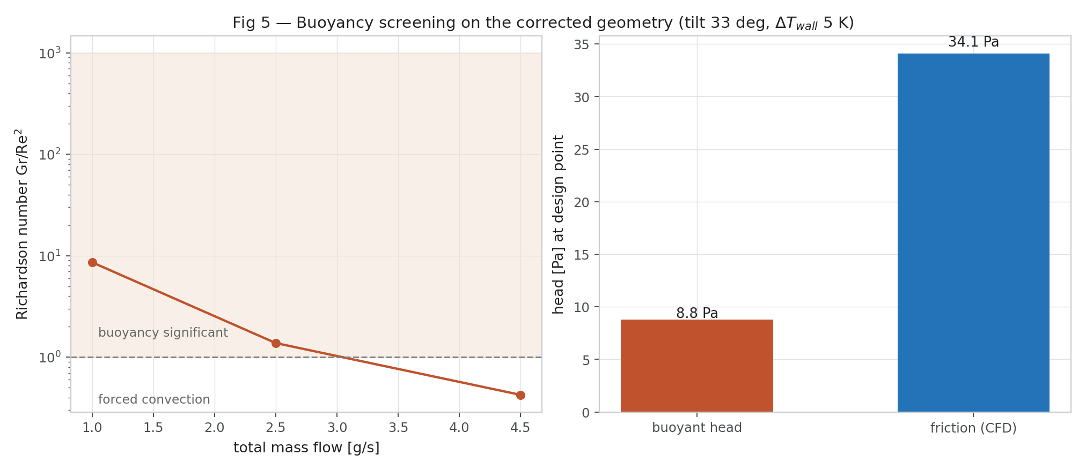
Figure E.1. Buoyancy check (Rev 2) — superseded numbers
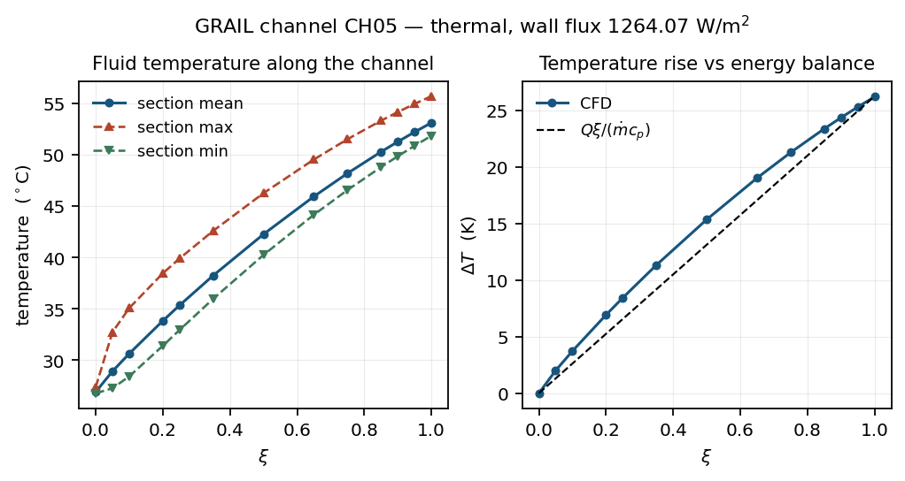
Figure E.2. 3-D thermal result (Rev 2) — superseded numbers
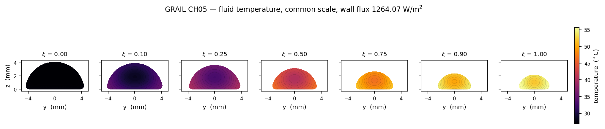
Figure E.3. 3-D temperature (Rev 2) — superseded numbers
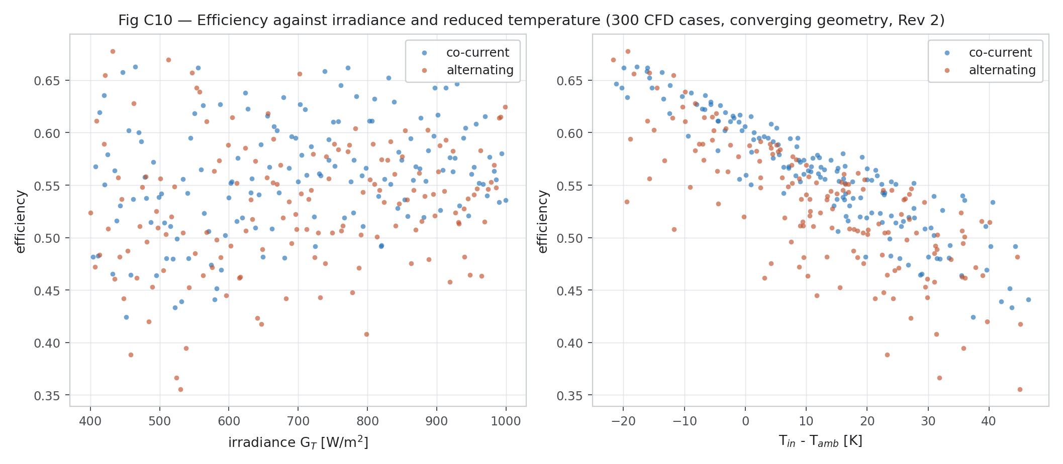
Figure E.4. Efficiency (Rev 2) — superseded numbers
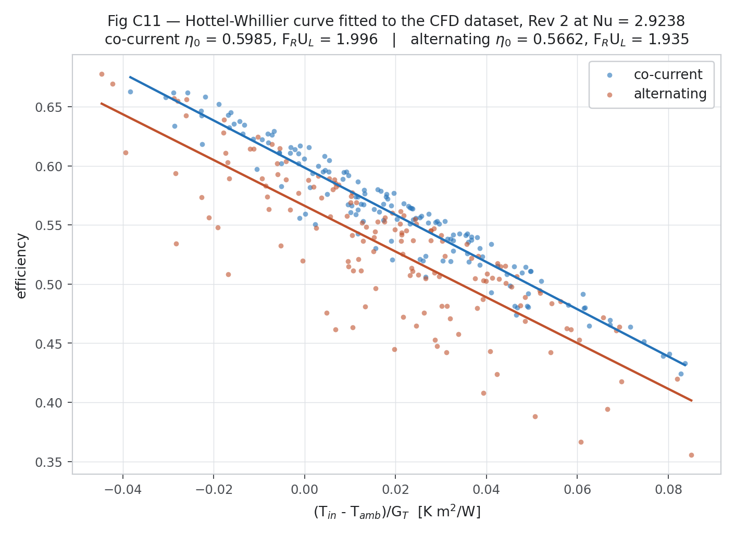
Figure E.5. Hottel-Whillier comparison (Rev 2) — superseded numbers
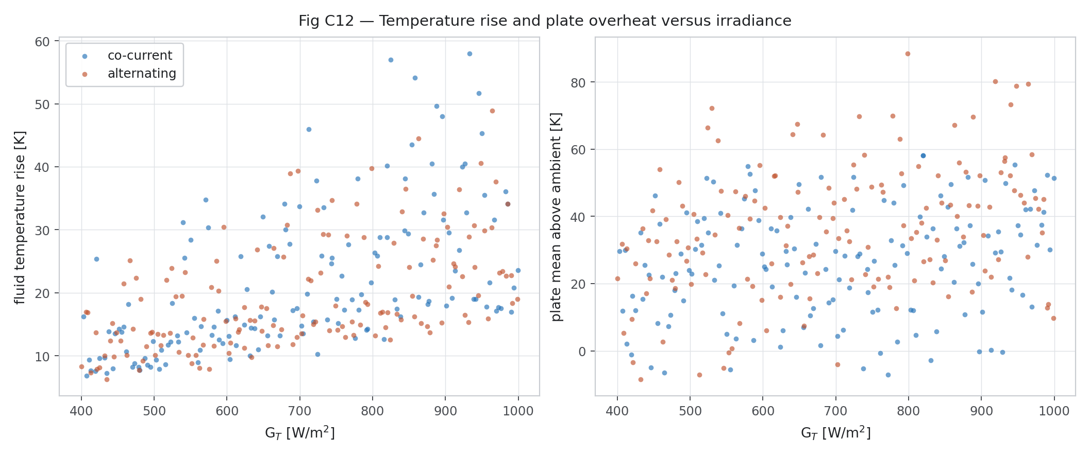
Figure E.6. Temperature rise (Rev 2) — superseded numbers
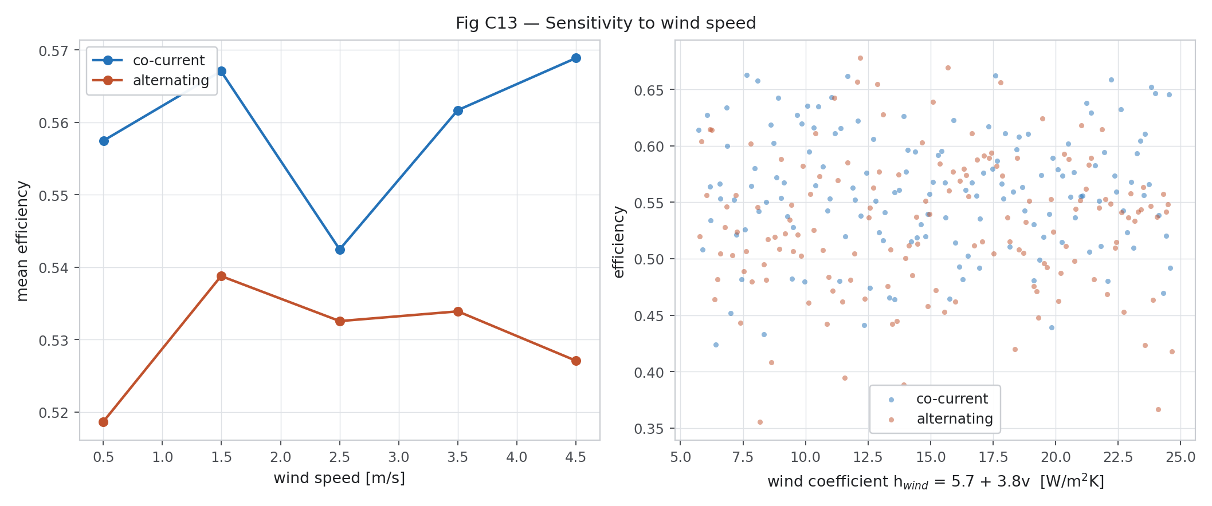
Figure E.7. Wind effect (Rev 2) — superseded numbers
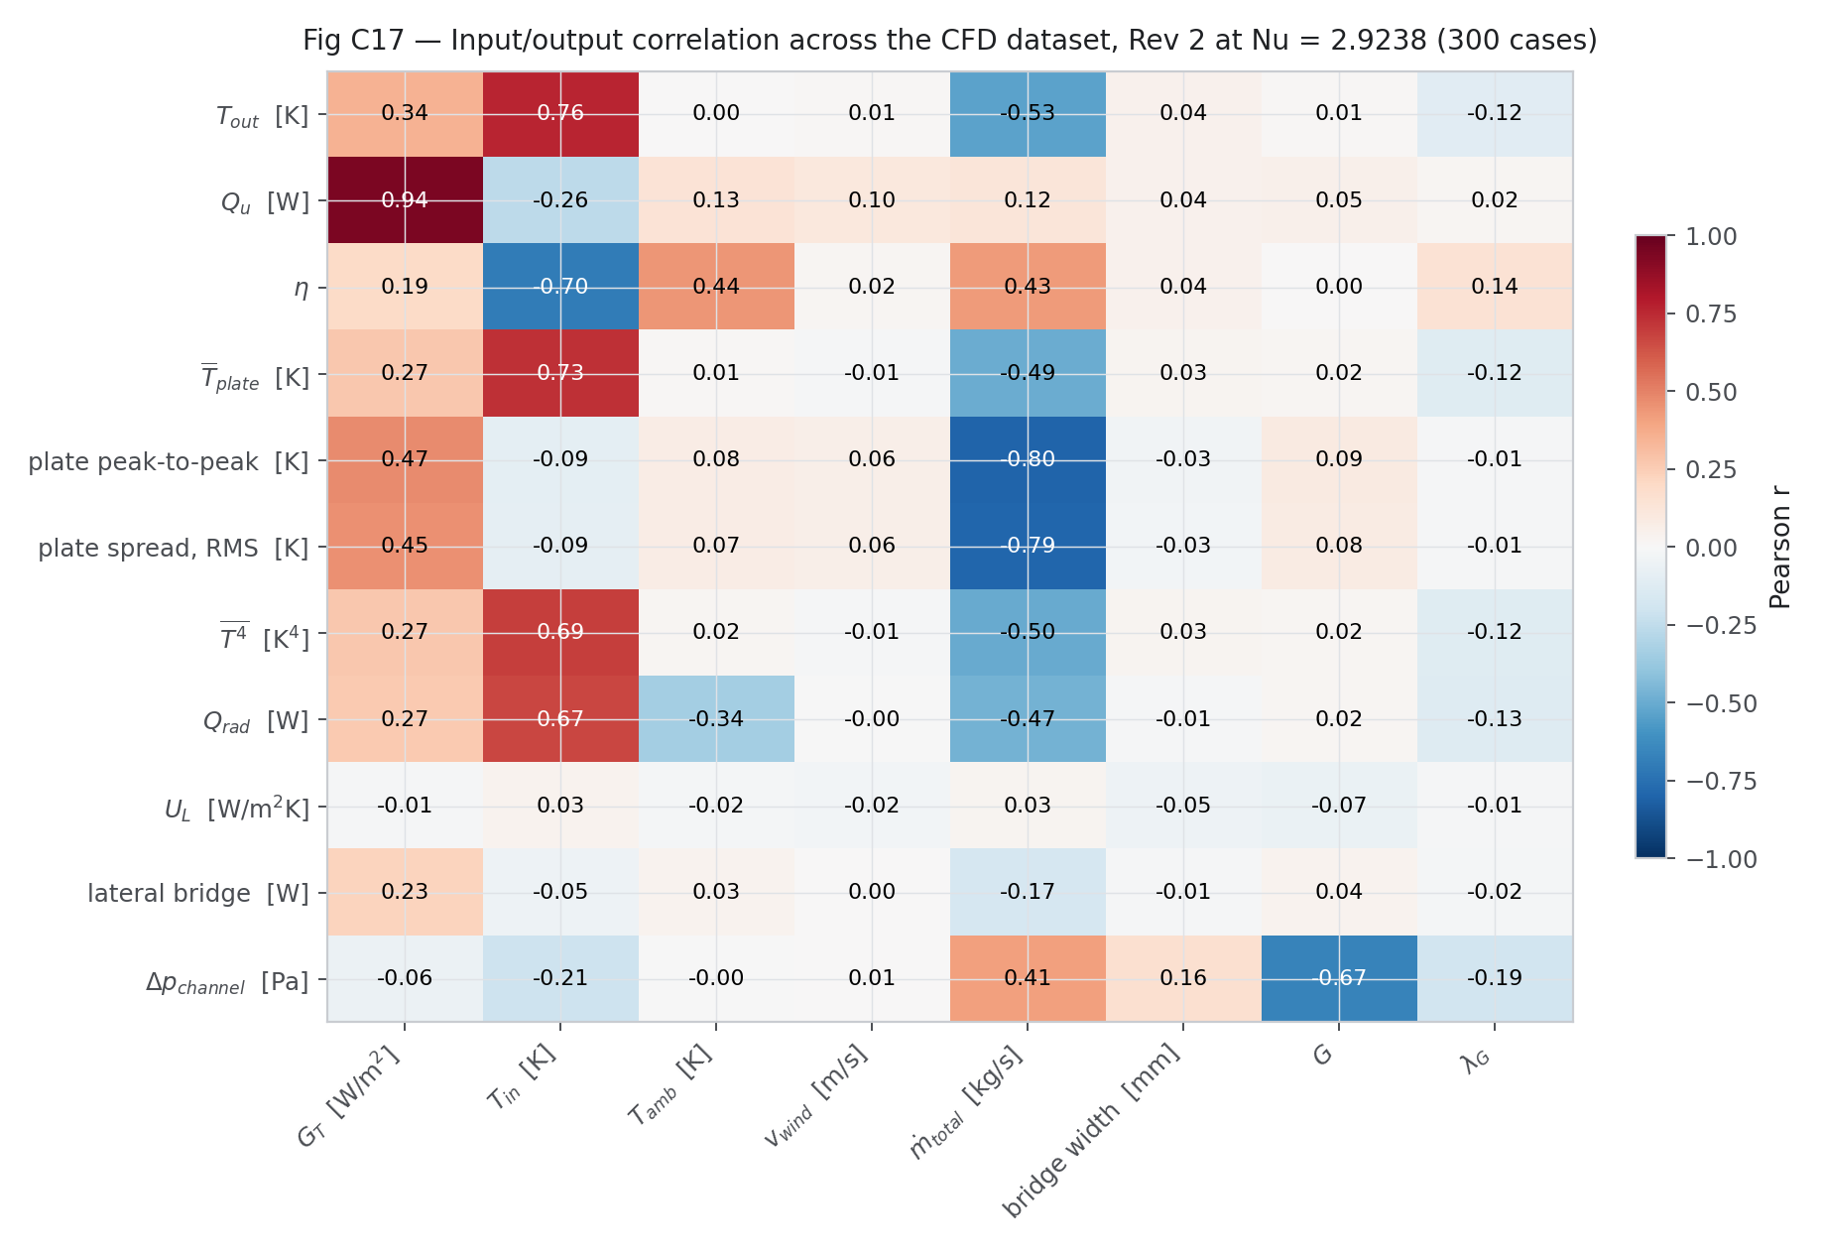
Figure E.8. Correlation (Rev 2) — superseded numbers
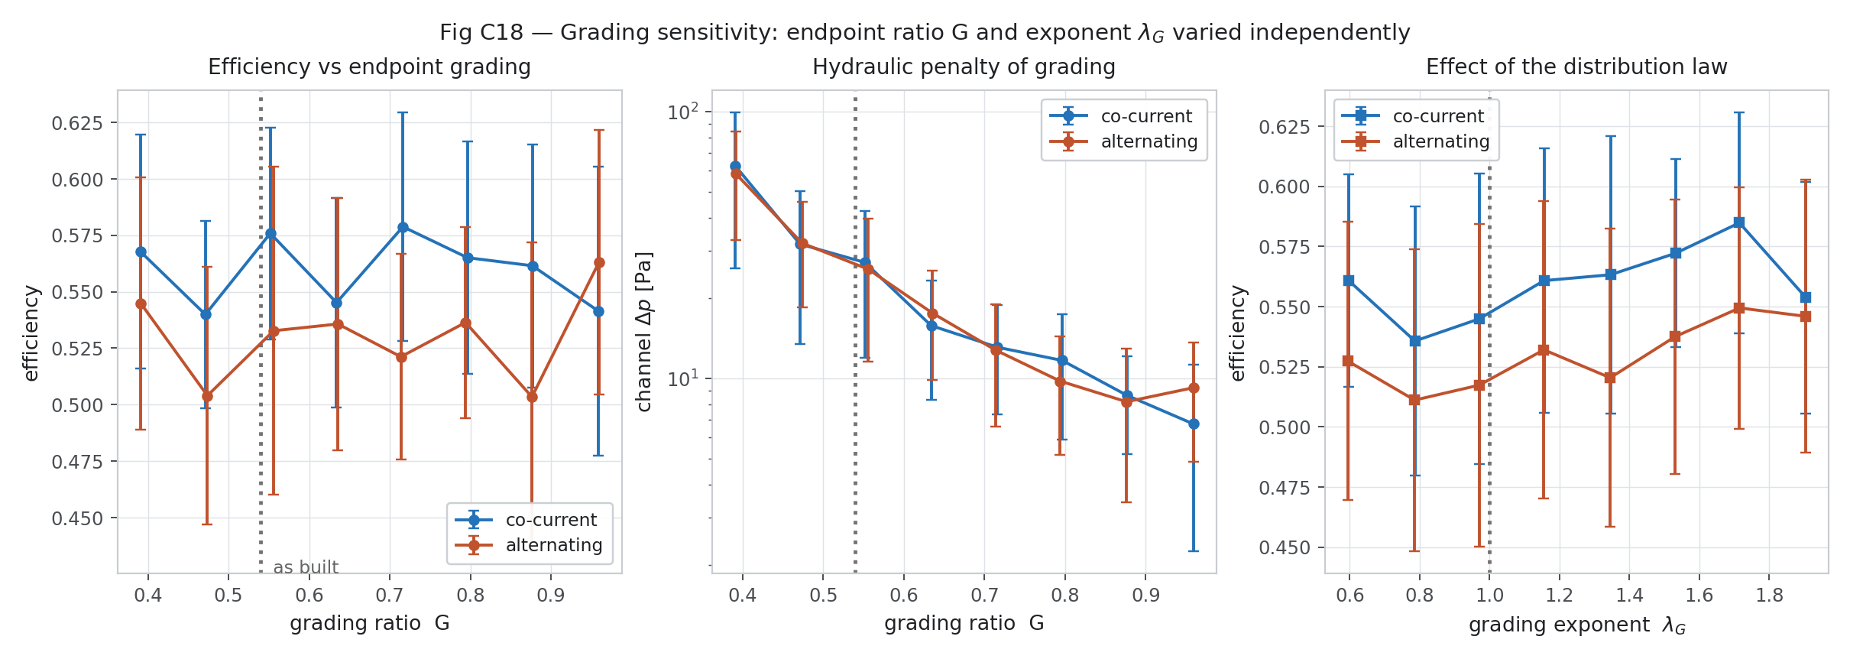
Figure E.9. Grading effect (Rev 2) — superseded numbers
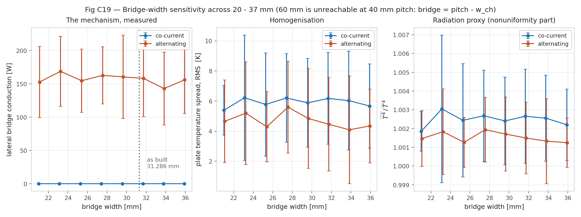
Figure E.10. Bridge effect (Rev 2) — superseded numbers
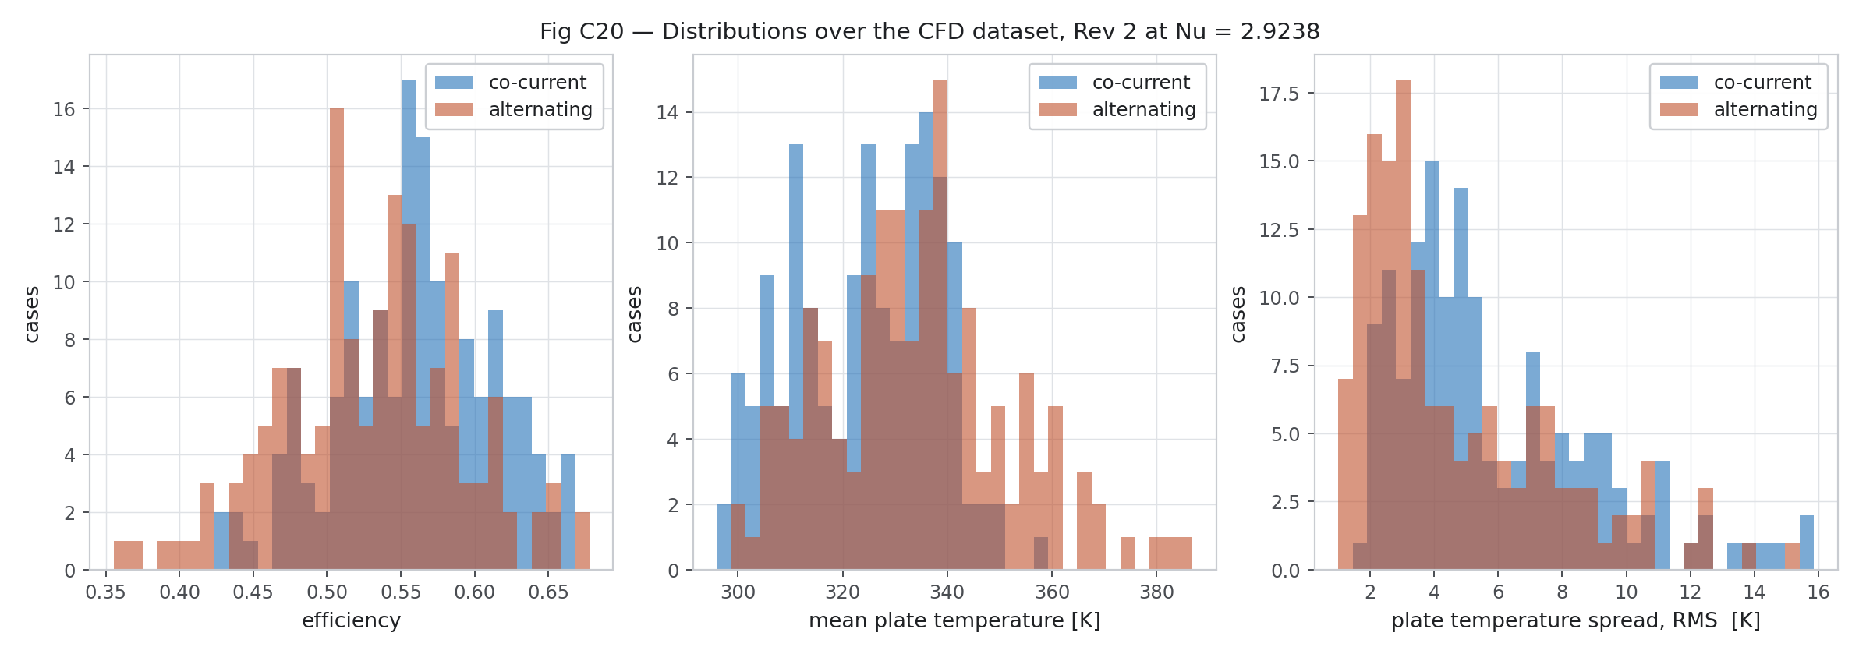
Figure E.11. Distributions (Rev 2) — superseded numbers
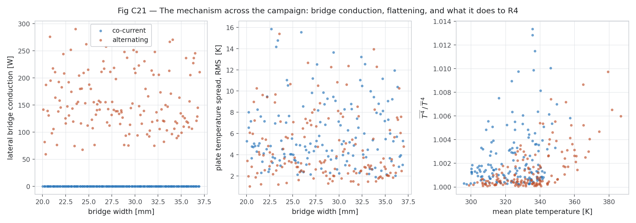
Figure E.12. Mechanism in campaign (Rev 2) — superseded numbers
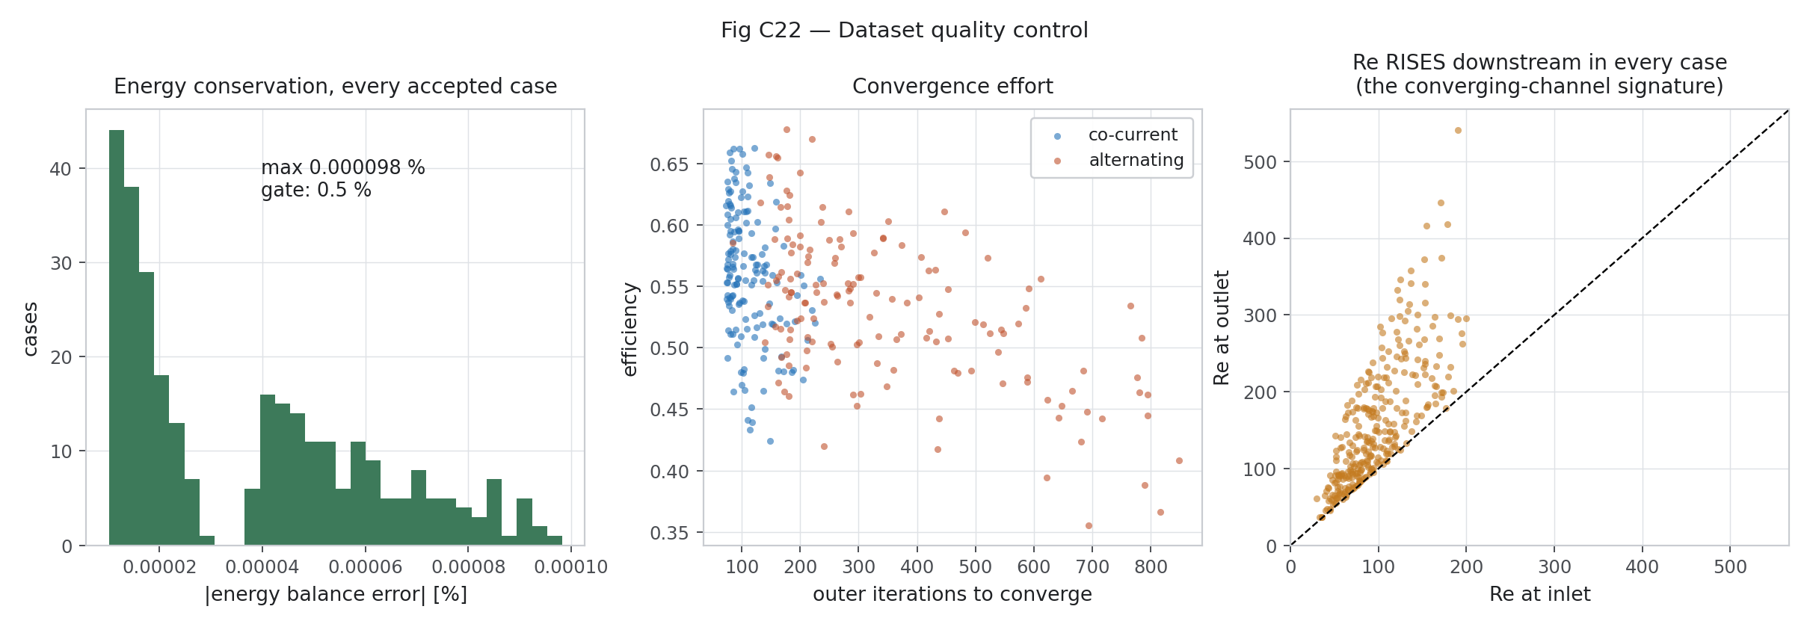
Figure E.13. Campaign quality (Rev 2) — superseded numbers
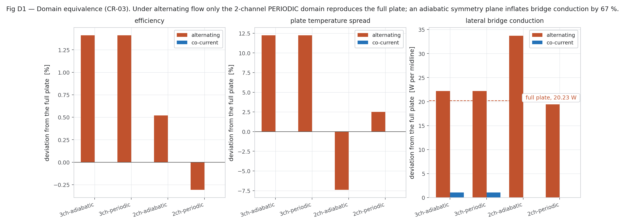
Figure E.14. Domain equivalence, 3-channel vs 2-channel (Rev 2) — superseded numbers
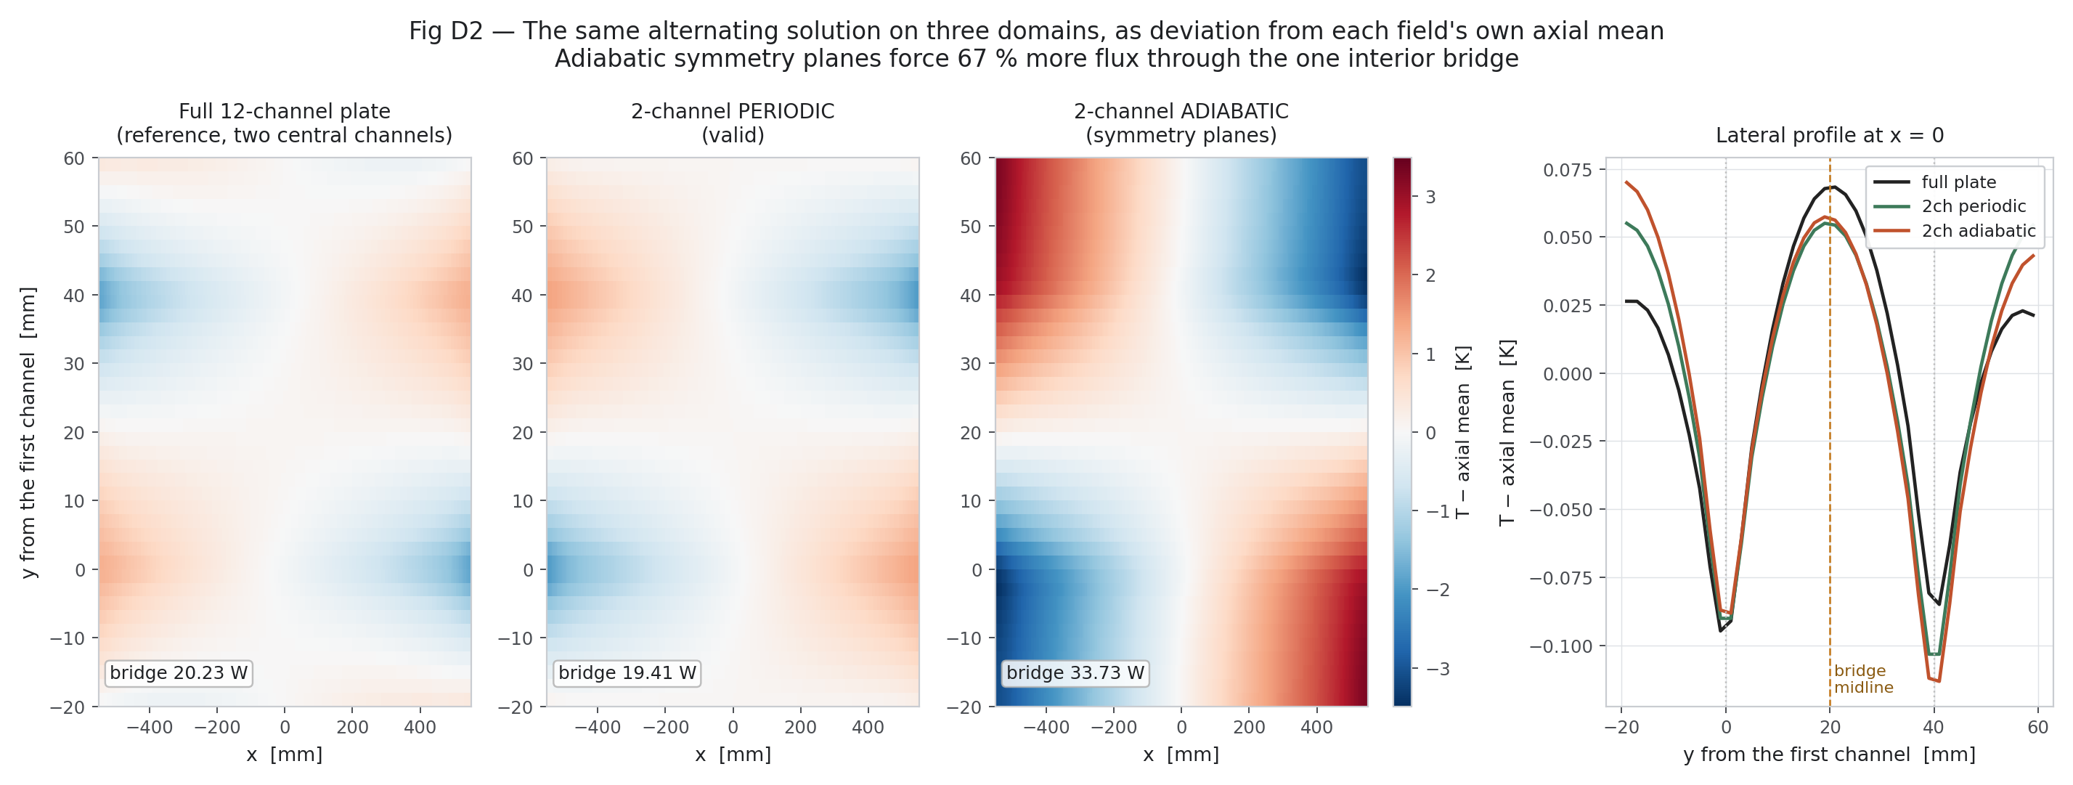
Figure E.15. Domain fields (Rev 2) — superseded numbers
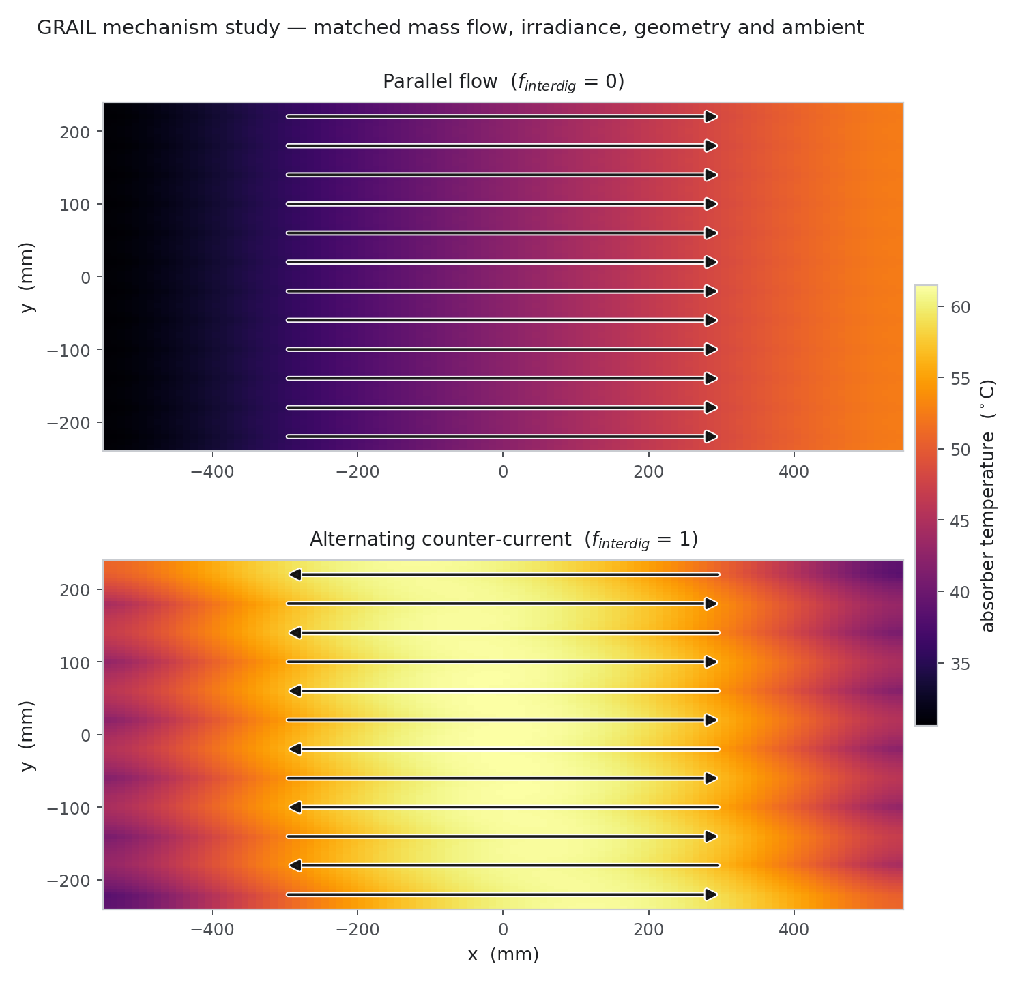
Figure E.16. Mechanism fields (Rev 2) — superseded numbers
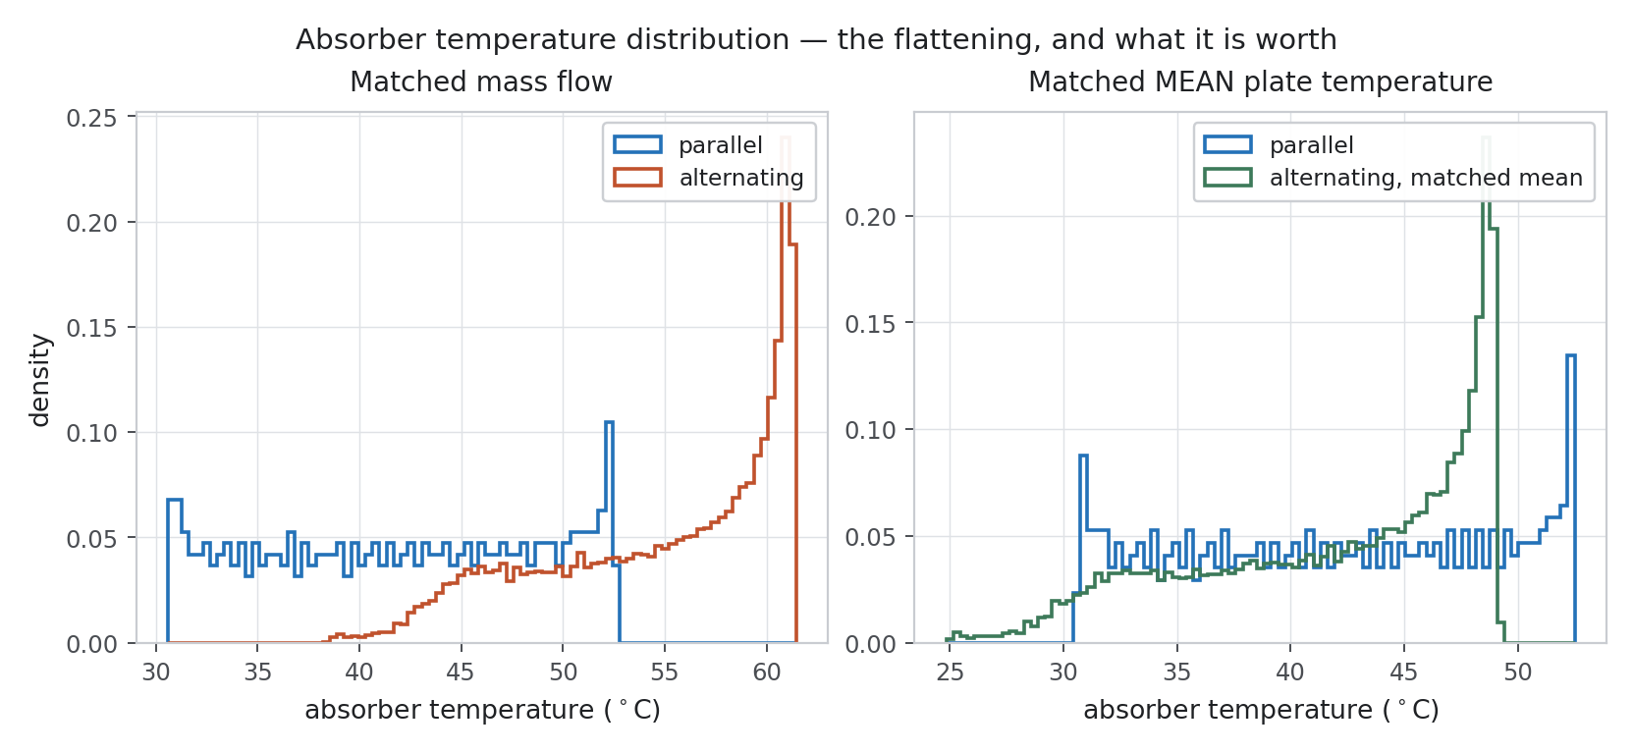
Figure E.17. Temperature distribution (Rev 2) — superseded numbers
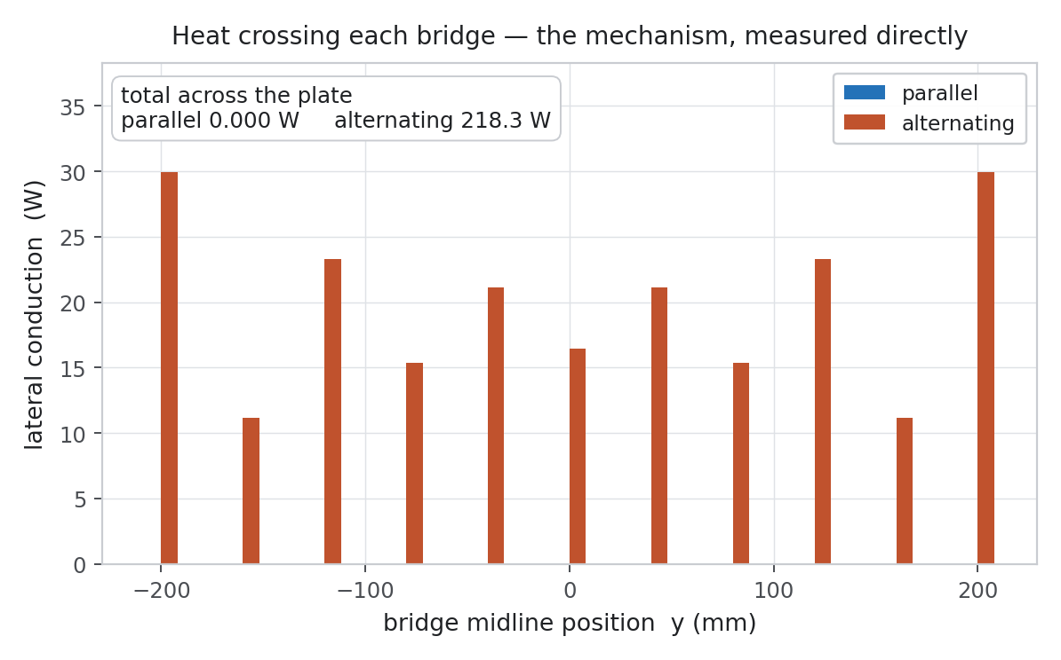
Figure E.18. Bridge conduction (Rev 2) — superseded numbers
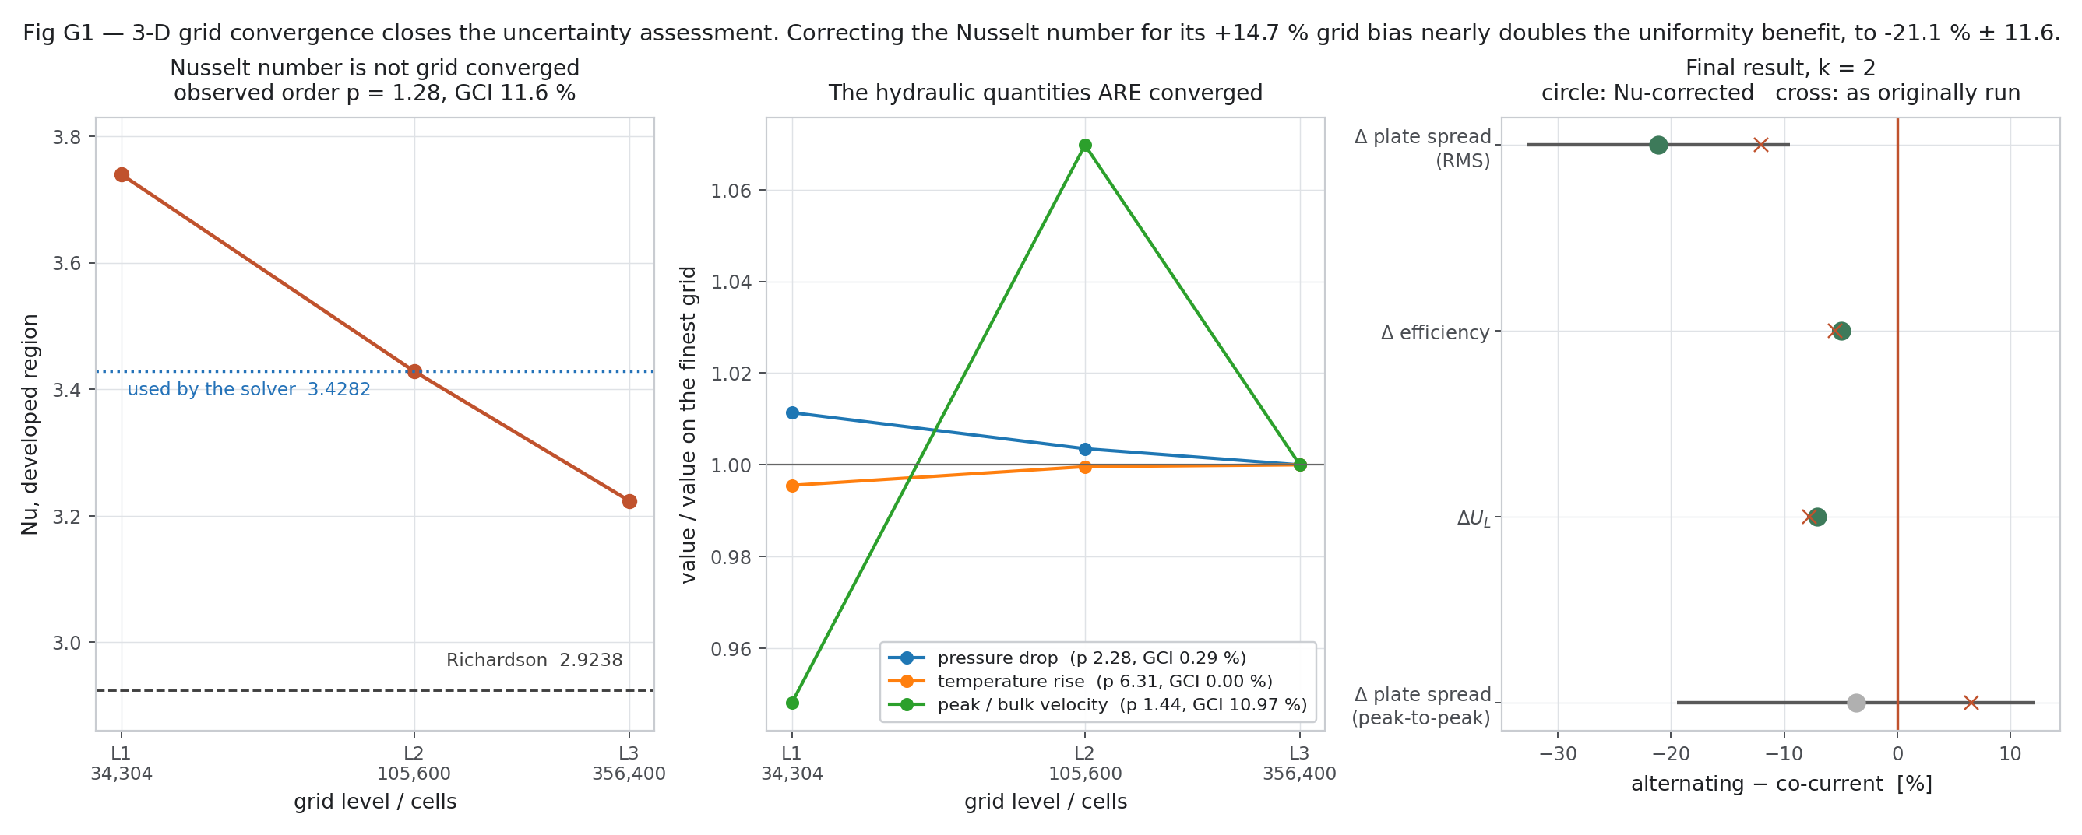
Figure E.19. 3-D grid convergence (Rev 2) — superseded numbers
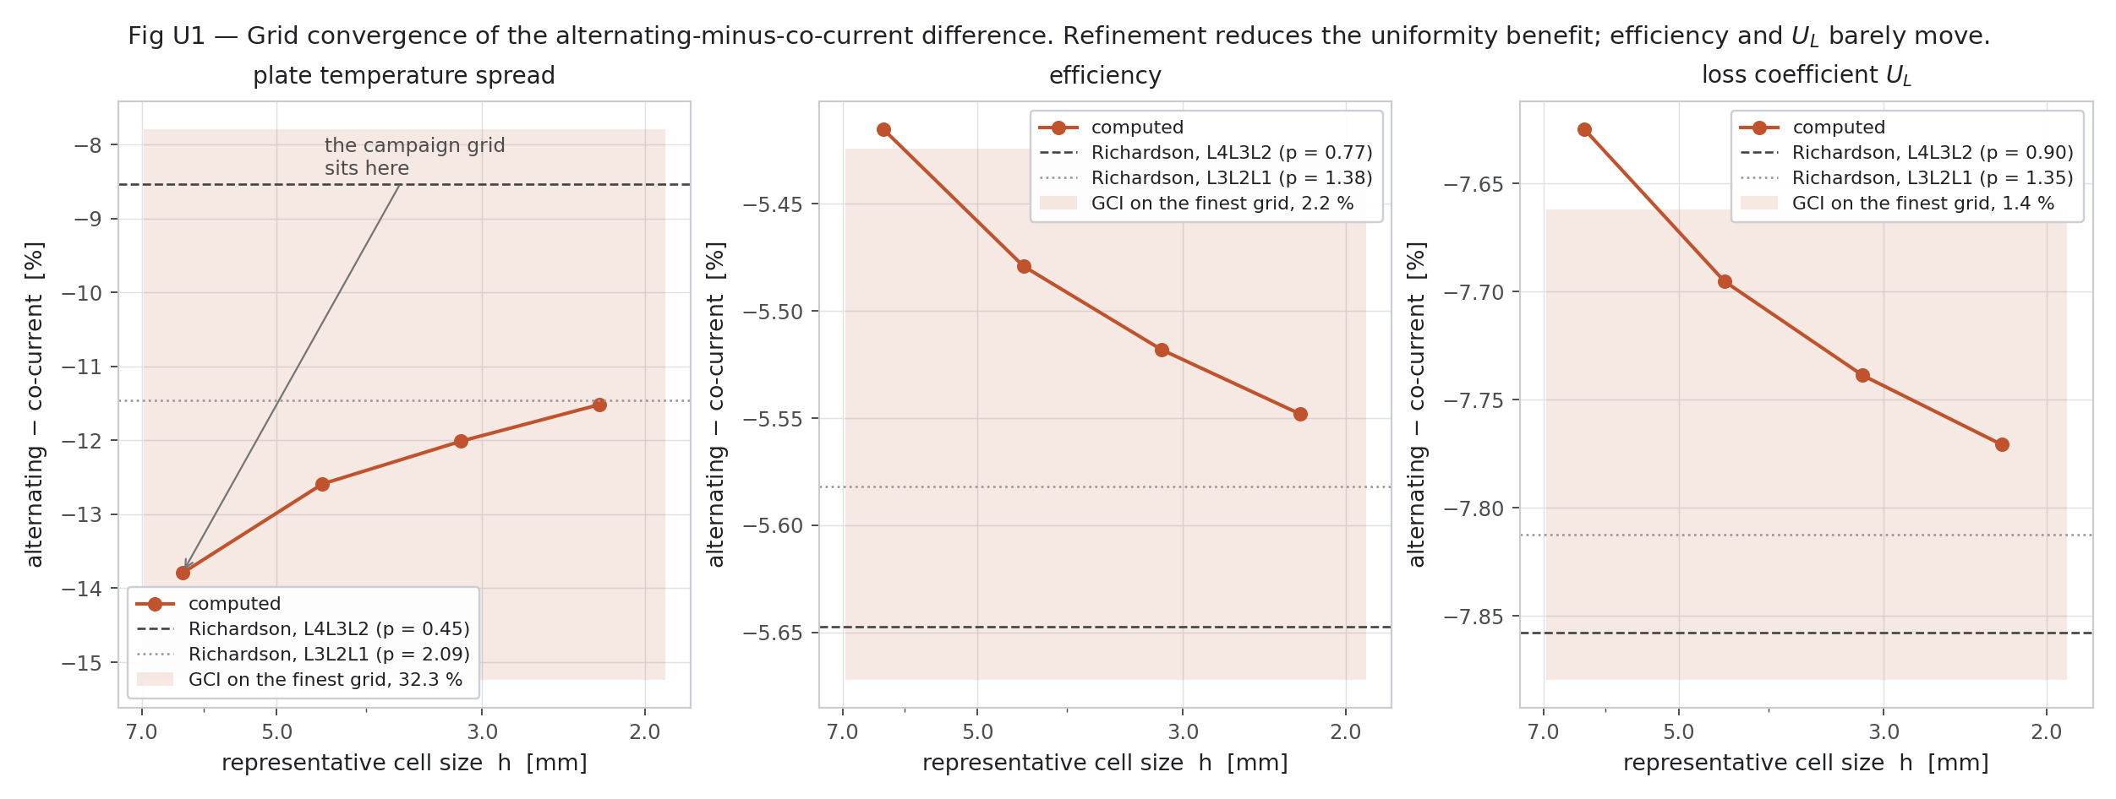
Figure E.20. Grid convergence (Rev 2) — superseded numbers
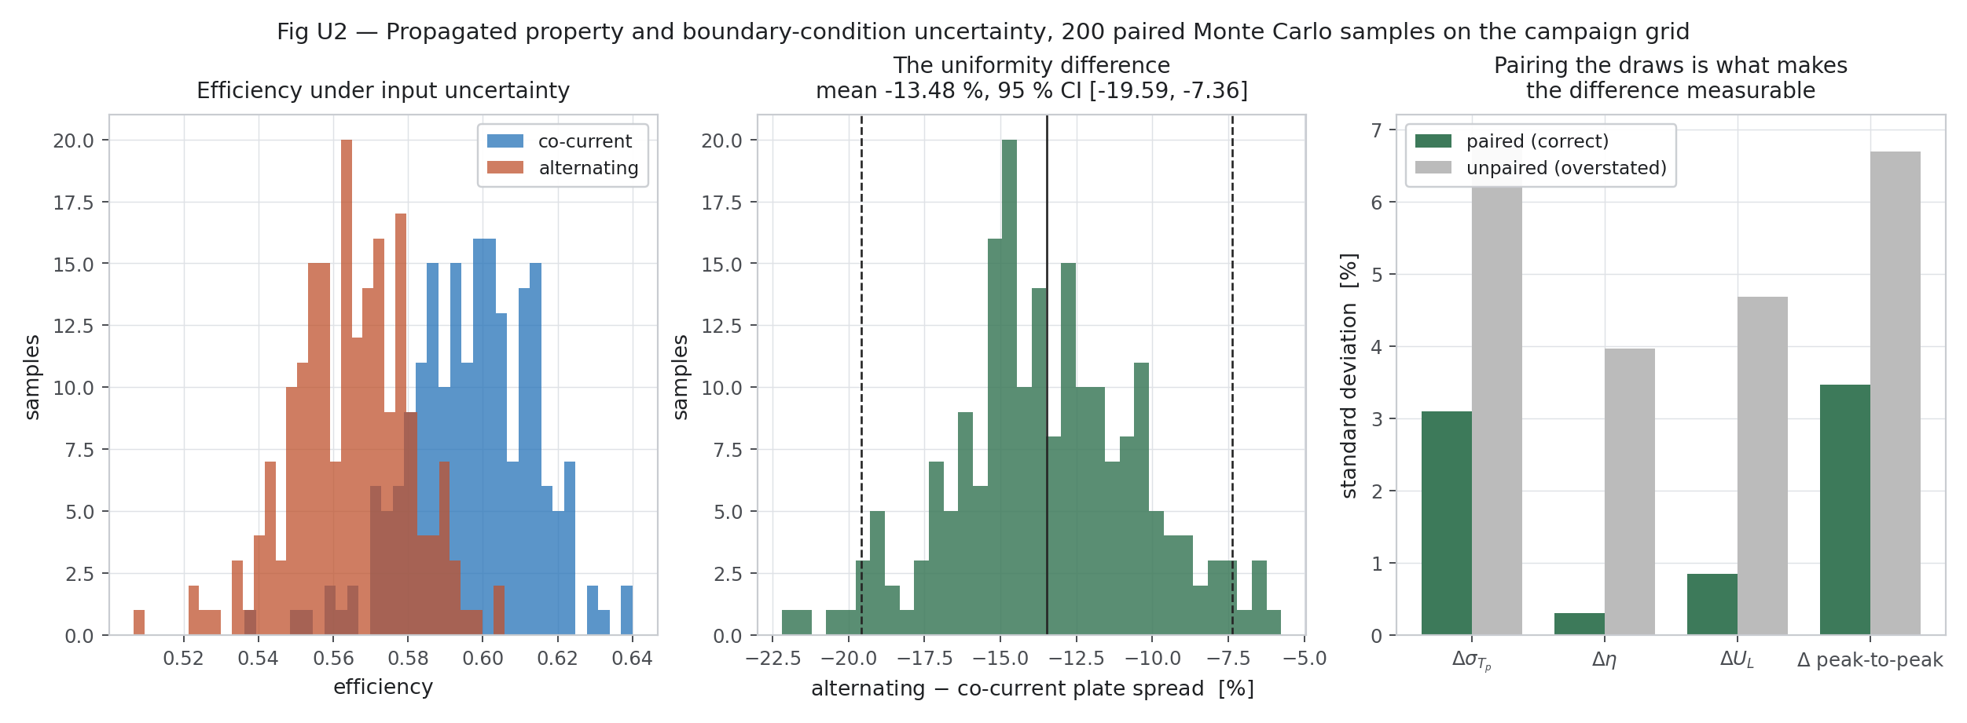
Figure E.21. Input uncertainty (Rev 2) — superseded numbers
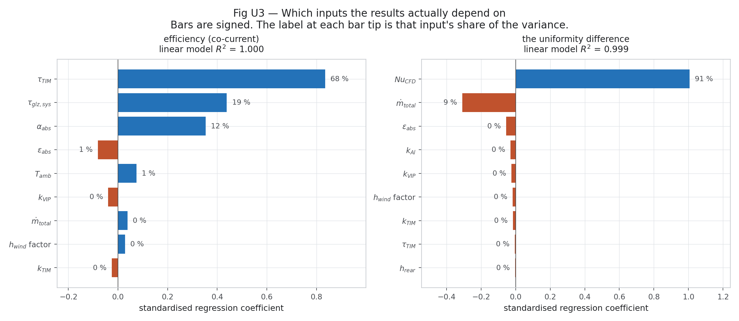
Figure E.22. Sensitivity (Rev 2) — superseded numbers
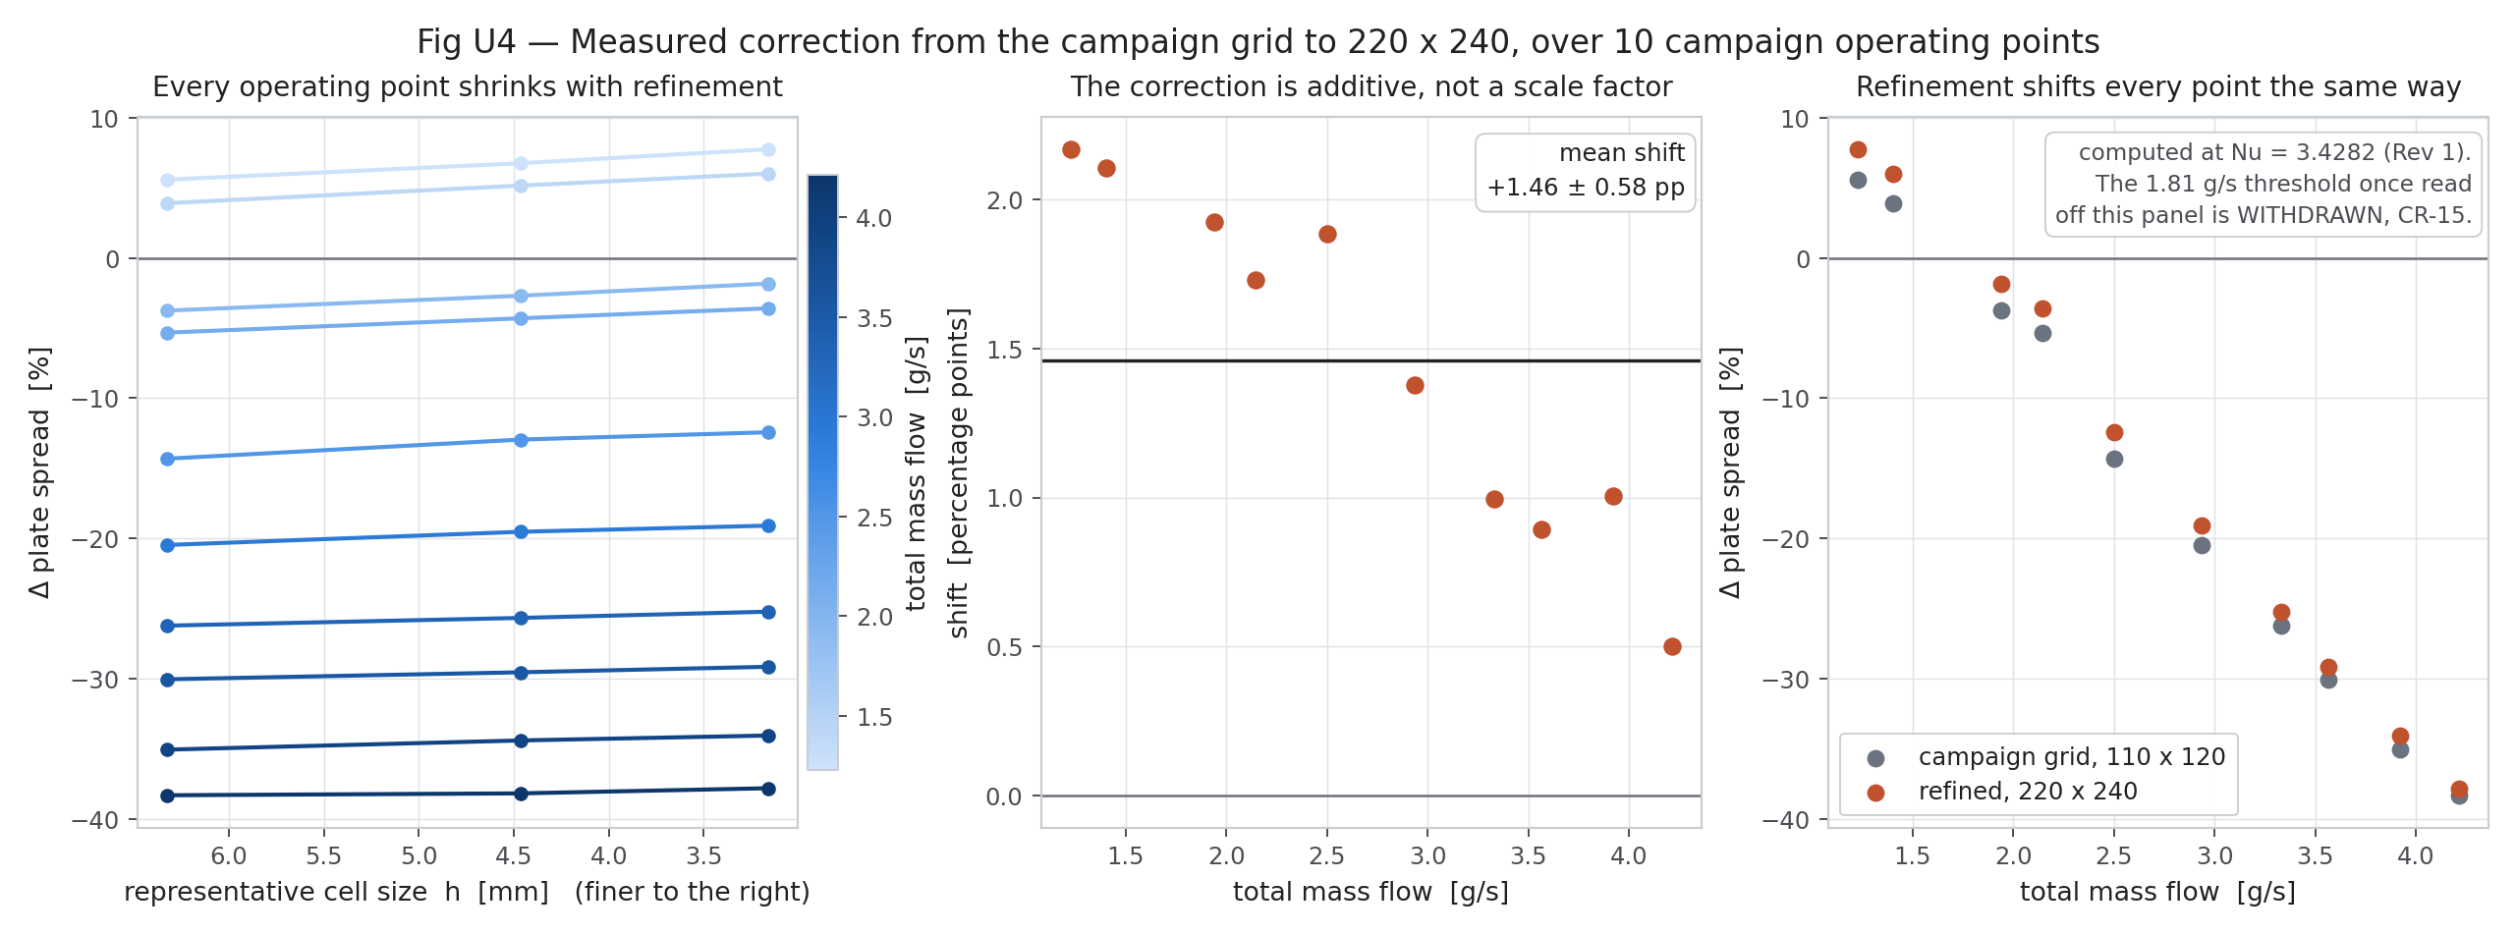
Figure E.23. Campaign correction (Rev 2) — superseded numbers
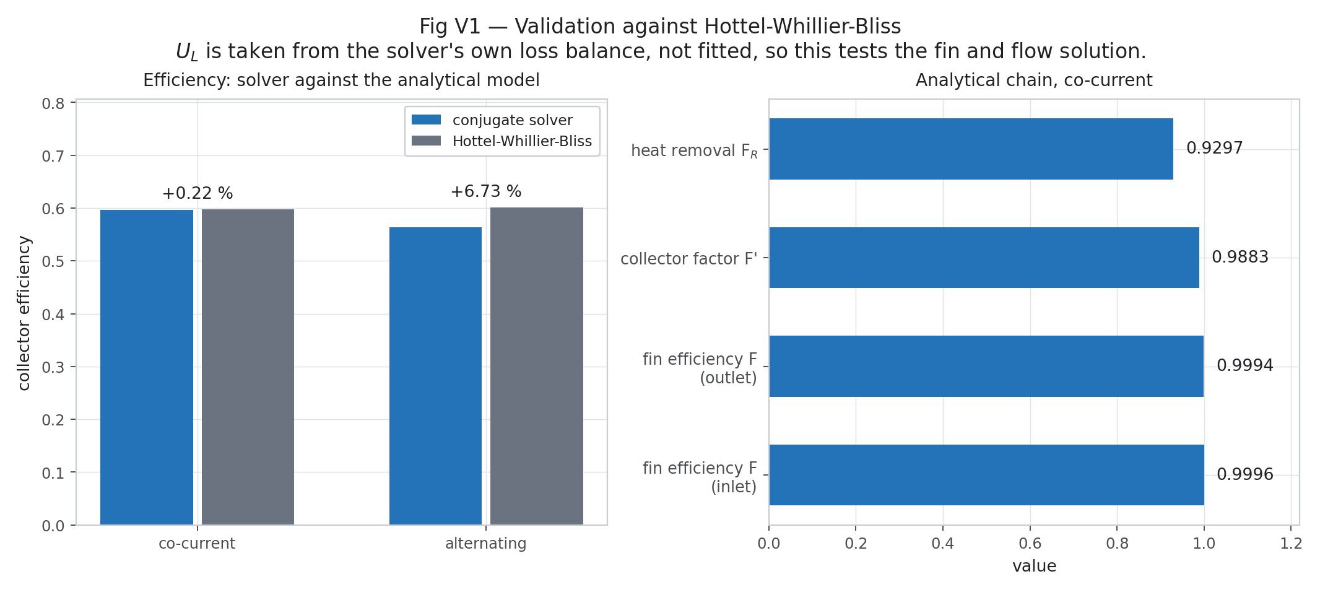
Figure E.24. HWB check (Rev 2) — superseded numbers
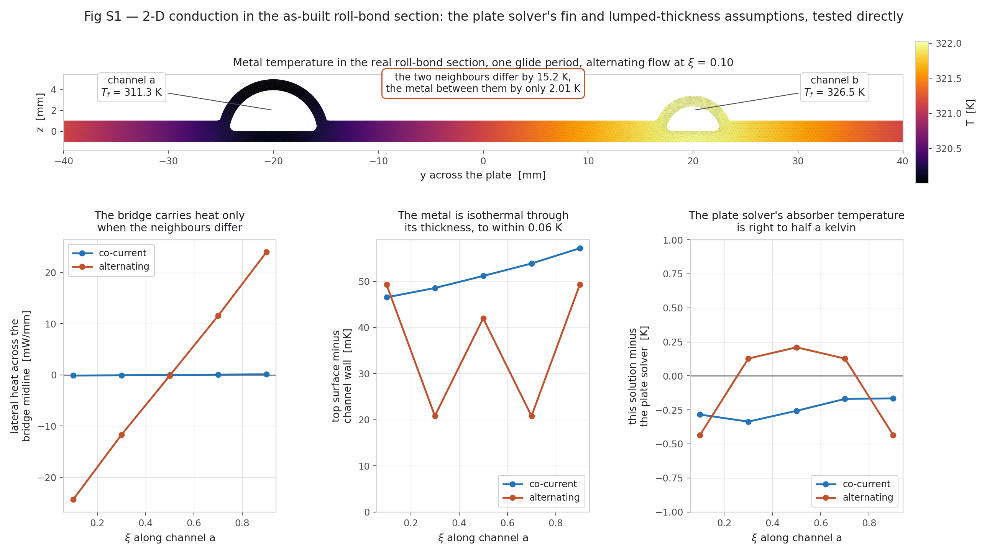
Figure E.25. Section conduction check (Rev 2) — superseded numbers
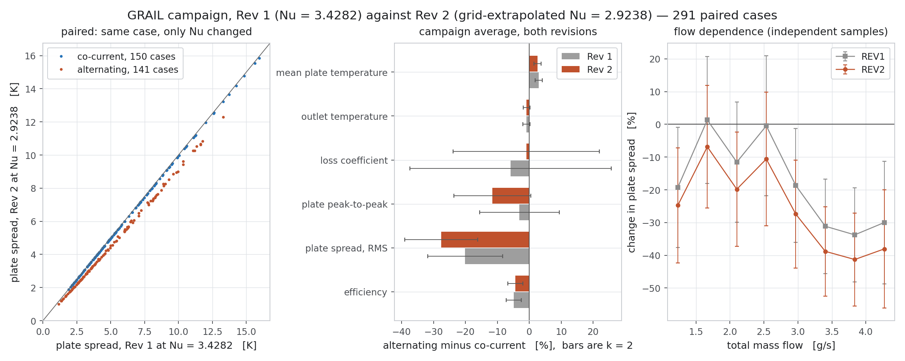
Figure E.26. Rev 1 vs Rev 2 — superseded numbers
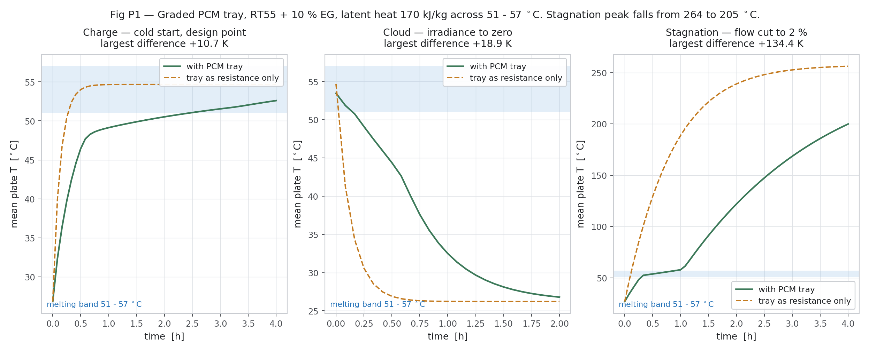
Figure E.27. PCM transient side study (Rev 2) — superseded numbers
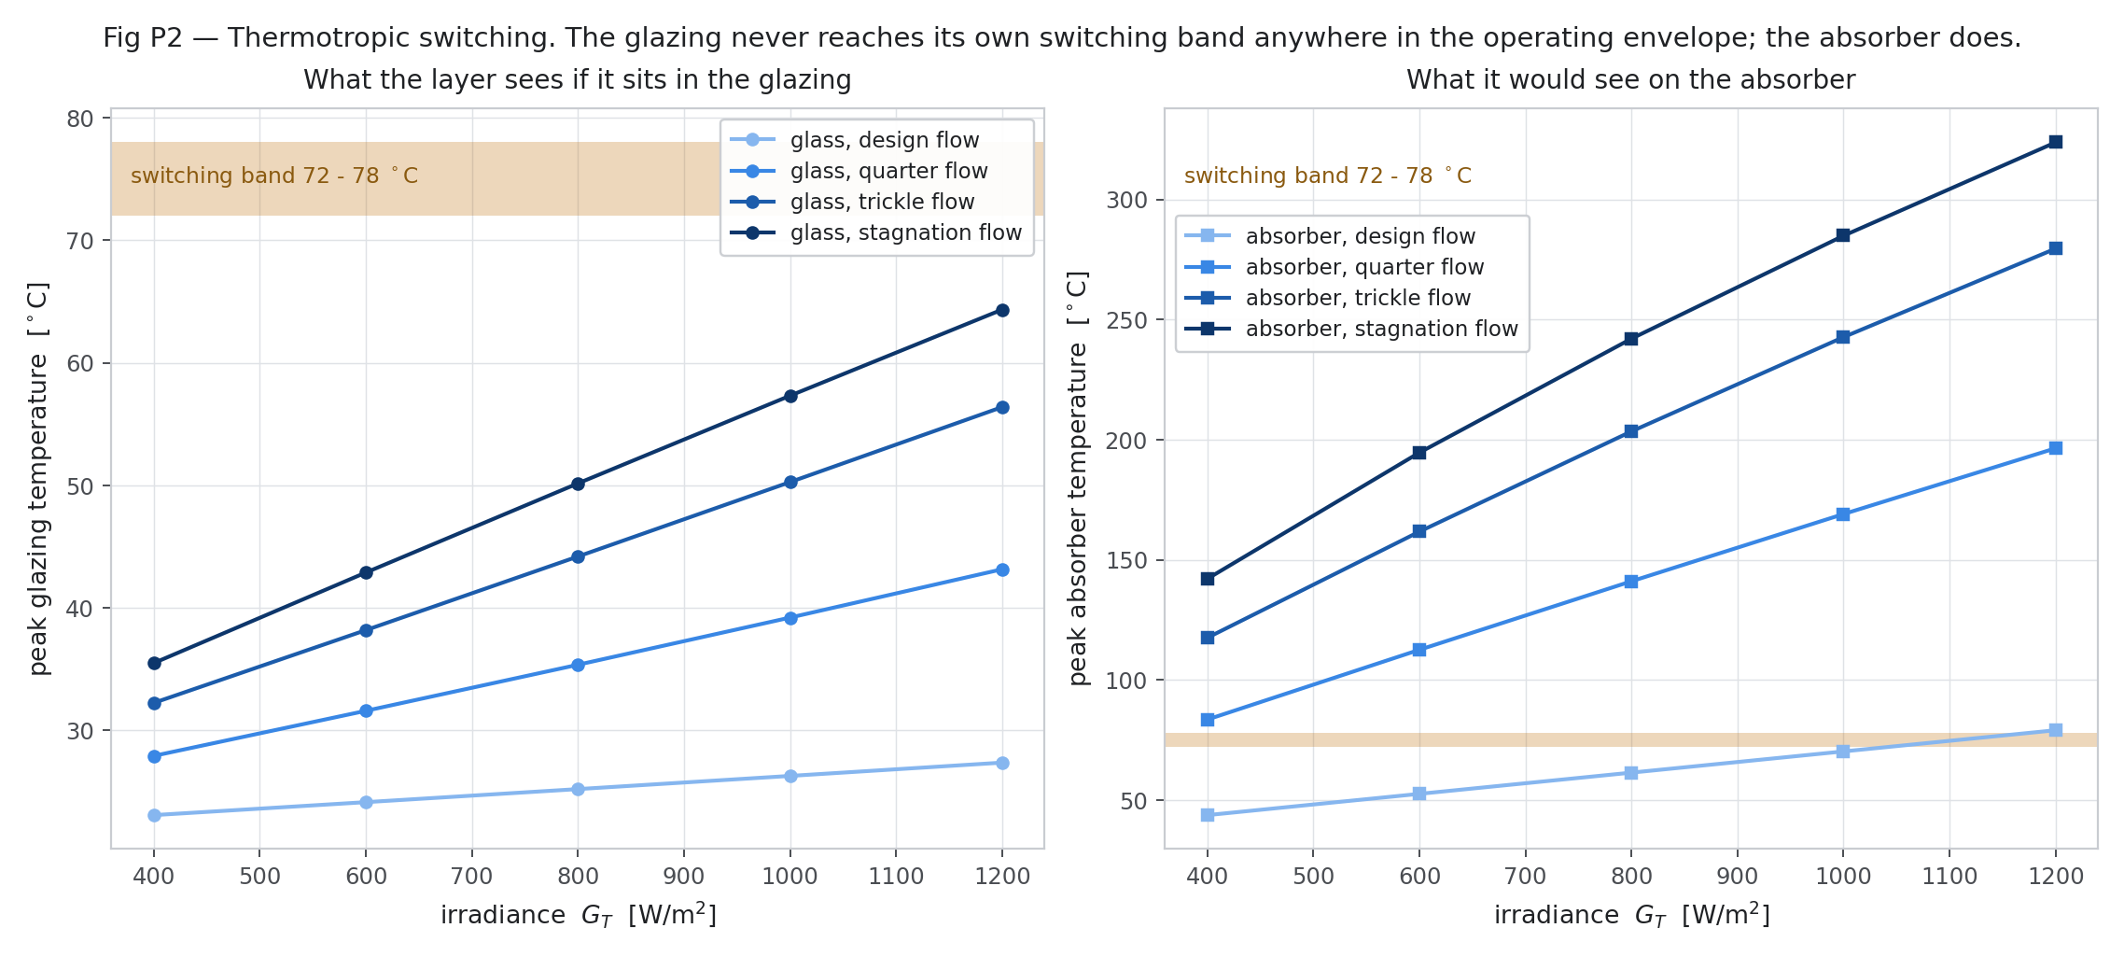
Figure E.28. Thermotropic layer side study (Rev 2) — superseded numbers
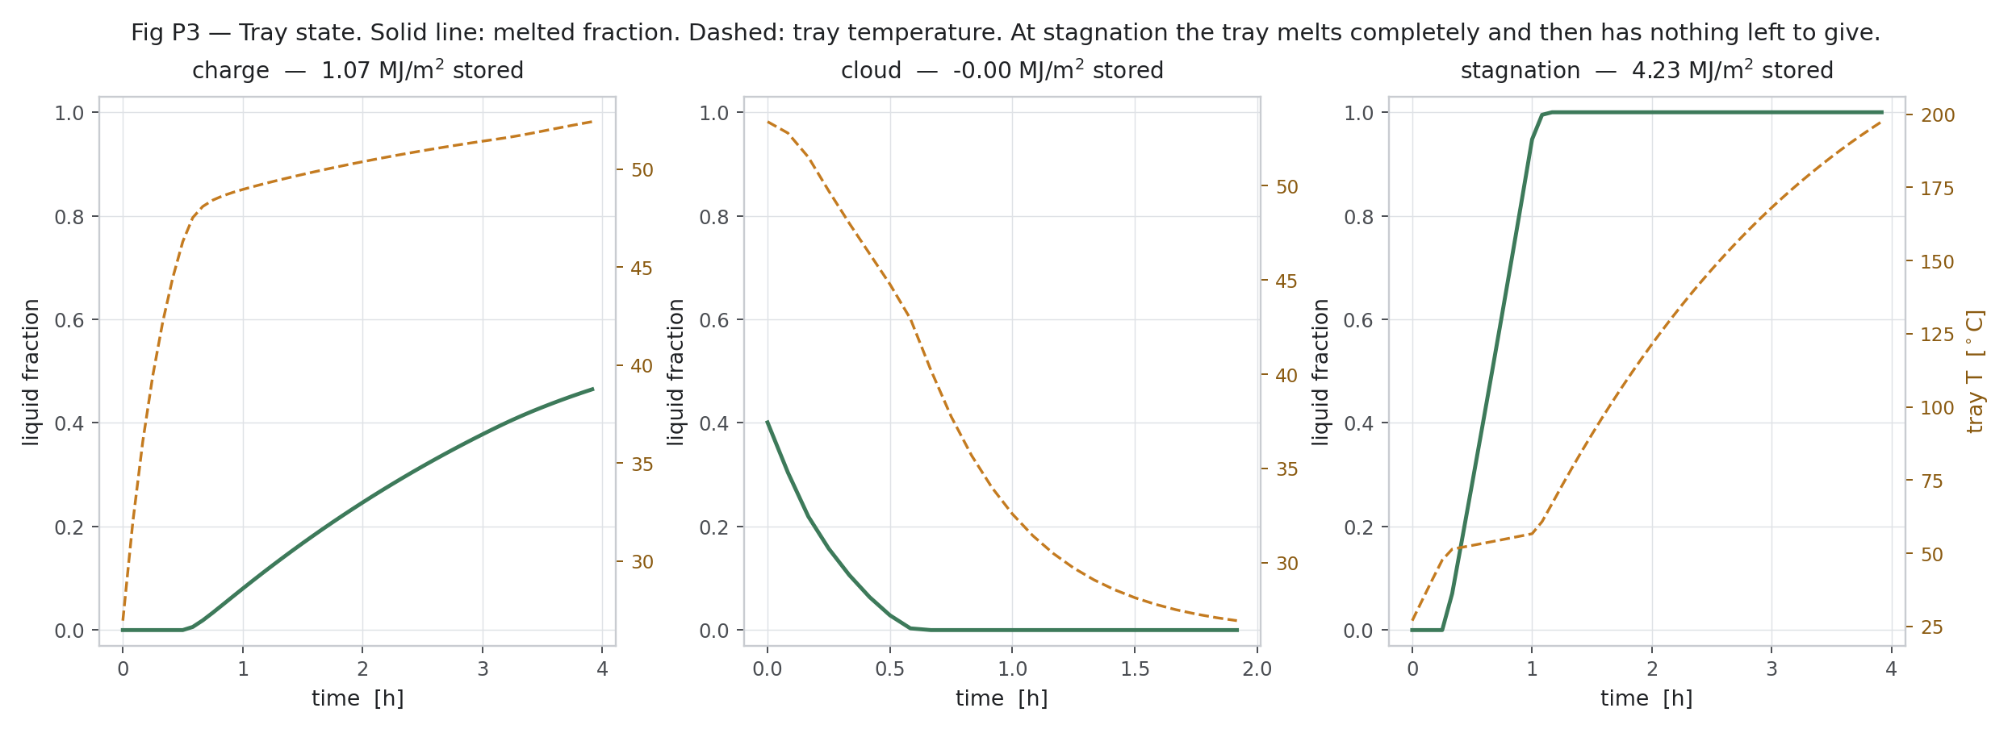
Figure E.29. PCM state (Rev 2) — superseded numbers
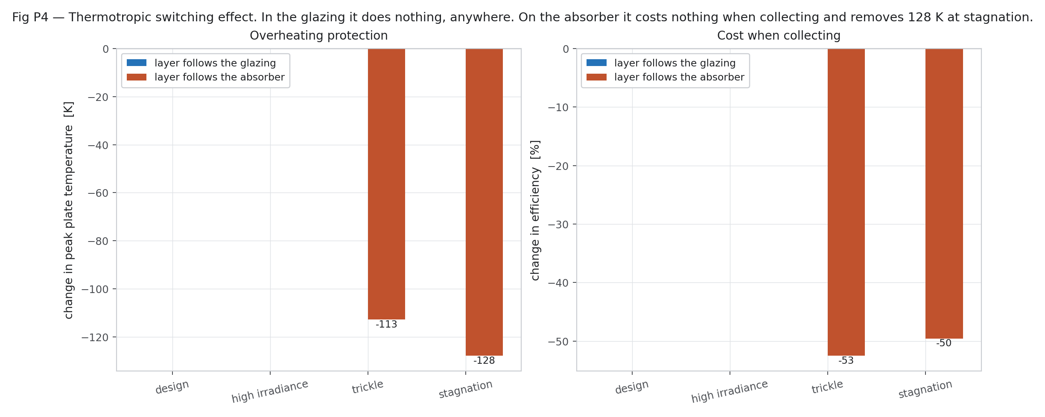
Figure E.30. Thermotropic effect (Rev 2) — superseded numbers

Appendix F. References
[1] Del Col D. et al., Thermal performance of flat plate solar collectors with sheet-and-tube and roll-bond absorbers, Energy 58 (2013) 258–269.
[2] Beikircher T., Möckl M., Osgyan P., Streib G., Advanced solar flat plate collectors with full area absorber, front side film and rear side vacuum super insulation, Sol. Energy Mater. Sol. Cells 141 (2015) 398–406.
[3] Duffie J.A., Beckman W.A., Solar Engineering of Thermal Processes, 4th ed., Wiley, 2013.
[4] Shah R.K., London A.L., Laminar Flow Forced Convection in Ducts, Academic Press, 1978.
[5] Celik I.B. et al., Procedure for estimation and reporting of uncertainty due to discretization in CFD applications, J. Fluids Eng. 130 (2008) 078001.
[6] ISO 9806:2017, Solar thermal collectors — Test methods.
[7] Deb K. et al., NSGA-II, IEEE Trans. Evol. Comput. 6 (2002) 182–197.
[8] Lundberg S.M., Lee S.-I., SHAP, NeurIPS 30 (2017).
[9] PVGIS TMY 2005–2023, European Commission JRC.
[10] Hay J.E., Davies J.A., Calculation of the solar radiation incident on an inclined surface, 1980.
[11] Other screened papers: see Table 14 (Gunjo 2017; Bharathiraja 2024; Vahidinia 2024; Zareie 2024; Parthiban 2025; Ding 2025; Li 2024; Alawi 2024; Mansour 2013; Zheng 2024; Sakib 2026; Kessentini; Robles 2014; Oyinlola & Shire 2018).

