PROJECT DIARY
B.Tech Minor Project — The GRAIL Collector
An advanced solar flat-plate collector — converging roll-bond absorber with transparent insulation, PCM and vacuum insulation
Item | Details
Student name(s) / Roll no.
Branch / Semester
Institution
Project guide
Start date | 03 August 2026
Final submission | 03 November 2026
Duration | 14 weeks

How this diary is kept
- This file is the text to copy by hand into the project diary. Each day has its own box: date, work done, papers read and result.
- Write one week per diary spread, from Day 1 (Monday) to Day 7 (Sunday), starting 03 August 2026. Final submission is 03 November 2026.
- At the end of each week write the week summary and the plan for next week, then get the guide's signature.
- The literature review section lists every paper we read; the day each paper was read is given in the weekly pages as [number] Author year.
- Figures are placed under the day on which the work was done — print and paste them in the diary under that day.
- Weeks 1–8 are completed work; weeks 9–14 are planned — write what was actually done on each day.
- Dates are nominal; change any day to the real date before signing.

Project in one paragraph
The GRAIL collector is an advanced solar flat-plate collector with a roll-bond aluminium absorber (1.10 × 0.48 m, 12 channels). The channels converge along the flow (grading ratio G = 0.540). The front has glass and a honeycomb transparent insulation; the rear has a PCM layer and vacuum insulation. The project designs the collector in CAD, simulates it with 3-D CFD and a reduced-order model, and compares alternating (counter-current) flow with parallel flow. It then builds a surrogate model, optimises the design, predicts annual performance in Berhampur and checks the method against published experiments.

Abbreviations
Term | Meaning
CFD | Computational fluid dynamics
GRAIL-CHT | Reduced-order conjugate heat-transfer model of the plate
TIM | Transparent insulation material (honeycomb)
PCM | Phase-change material
VIP | Vacuum insulation panel
Nu | Nusselt number
GCI | Grid convergence index
LHS | Latin-hypercube sampling
ANN | Artificial neural network
SHAP | Shapley additive explanations
NSGA-II | Multi-objective genetic algorithm
TMY | Typical meteorological year
SF | Solar fraction
η0, a1, a2 | Efficiency-curve coefficients (ISO 9806)

Project plan and progress overview
Week | Dates | Work | Status | Guide sign
1 | 03 Aug – 09 Aug 2026 | Topic selection and literature survey | Completed
2 | 10 Aug – 16 Aug 2026 | Concept design and design roadmap | Completed
3 | 17 Aug – 23 Aug 2026 | Parametric CAD model — absorber and channels | Completed
4 | 24 Aug – 30 Aug 2026 | Full CAD assembly, verification and CFD domains | Completed
5 | 31 Aug – 06 Sep 2026 | Meshing and 3-D channel hydraulics | Completed
6 | 07 Sep – 13 Sep 2026 | Reduced-order model GRAIL-CHT and first campaign | Completed
7 | 14 Sep – 20 Sep 2026 | 3-D conjugate CFD, Nu correction and final dataset | Completed
8 | 21 Sep – 27 Sep 2026 | ANN, optimisation, system models, validation and reports | Completed
9 | 28 Sep – 04 Oct 2026 | Professional engineering report | Planned
10 | 05 Oct – 11 Oct 2026 | Thesis / project report chapters | Planned
11 | 12 Oct – 18 Oct 2026 | Presentation and paper finalisation | Planned
12 | 19 Oct – 25 Oct 2026 | Corrections after guide review | Planned
13 | 26 Oct – 01 Nov 2026 | Final checks and viva preparation | Planned
14 | 02 Nov – 03 Nov 2026 | Final submission | Planned

Key results so far
- Conjugate Nusselt number 4.48 (grid convergence index 2.1 %) from 3-D CFD.
- Alternating flow: −7.3 % efficiency at equal inputs; equal efficiency at the same plate temperature.
- Efficiency curve (parallel): η0 0.637, a1 2.10 W/m²K.
- Berhampur, 2 modules: solar fraction 86 %, Rs 4.34/kWh, payback ≈ 7.4 years.
- Validation: method checked against published experiments (partial pass); no prototype test.

Literature review
This section records the papers we read for the project, what each one did, what it found, the gap it leaves and how it helped the GRAIL collector. Papers 1–16 are from our literature table (recent 2024–2026 papers on flat-plate and air collectors). Papers 17–31 are the papers we collected for design and validation (roll-bond and minichannel absorbers, transparent insulation, vacuum insulation, PCM, graded channels and machine learning). The day each paper was read is written in the weekly pages.

1. Themes in the literature
1. Absorber and riser enhancement (fins, wavy risers, wire mesh, coil inserts)
Most recent flat-plate papers add fins, wavy or elliptical risers, wire mesh or coil inserts and report efficiency gains of 13–41 % [2, 3, 11, 15]. The gains come with more material and higher friction. Our converging channel changes the channel itself instead of adding inserts.
2. Surface roughness in air collectors (ribs, dimples, jets)
Ribs, dimples and jet/promoter inserts raise Nu by up to 5× but raise friction by up to 3× [1, 5, 8, 12]. These are for turbulent air flow. Our water flow is laminar, so we judge heat transfer and pressure drop together.
3. Roll-bond and minichannel absorbers
Roll-bond and minichannel absorbers give high F′ and good efficiency; the best test data (EN 12975) are from Del Col 2013 [17]. Minichannel and aluminium absorbers perform as well as or better than copper sheet-and-tube [18, 24, 30, 31]. Channel layout changes uniformity [25]. All use constant-size channels in parallel flow — none uses converging channels or alternating flow.
4. Front and rear insulation (TIM, vacuum)
Honeycomb TIM lowers front loss (U ≈ 2 W/m²K) and vacuum insulation lowers rear loss (U 0.25–0.84 W/m²K) [19, 20, 21, 22]. Used to choose and check our glass + TIM front and VIP rear.
5. Thermal storage (PCM)
PCM behind the absorber raises daily efficiency and limits overheating [4, 9, 23]. Supports our PCM layer; studied as a side study.
6. Graded / variable cross-section channels
Channels whose width changes along the flow improve flow and temperature uniformity in micro-channel heat sinks [26, 27]. Physics basis for our converging channel — not yet applied to solar collectors.
7. Models, surrogates and optimisation
Analytical and reduced-order models give fast design checks [7]; CFD datasets with ML surrogates and NSGA-II are used for optimisation [13, 27, 28]. Same workflow as our surrogate model and optimisation.
8. Validation quality
Some papers report error on absolute kelvin or have CFD heat larger than the solar input [29, 25]. We used three checks (tables, energy balance, full inputs) before using any paper for validation.
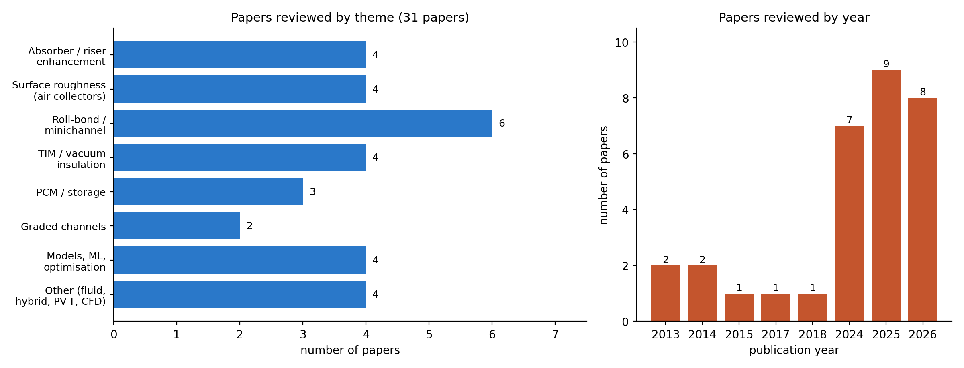
Figure L.1. Papers reviewed in this project, by theme and by year
Most papers are recent (24 of 31 are from 2024–2026). Roll-bond/minichannel absorbers are the largest group; only two papers deal with graded channels, and none of them is a solar collector.

2. Published collector test data used for comparison
Collector | η0 | a1 (W/m²K) | a2 (W/m²K²) | Source
Roll-bond, black (test) | 0.7995 ± 0.011 | 4.69 ± 0.79 | 0.029 ± 0.012 | Del Col 2013 [17]
Roll-bond, semi-selective (test) | 0.7409 ± 0.011 | 4.55 ± 0.69 | 0.013 ± 0.010 | Del Col 2013 [17]
TIM + vacuum super insulation (test) | 0.89 | 3.28 | 0.014 | Beikircher 2015 [19]
Slat TIM, ε 0.5 coating (test) | 0.732 | 7.19 | — | Kessentini [20]
GRAIL parallel (our model) | 0.637 | 2.10 | 0 | This project
GRAIL alternating (our model) | 0.597 | 2.00 | 0.0004 | This project
GRAIL has a lower η0 because the glass + TIM stack passes less light (optical factor 0.649), but its heat-loss coefficient is less than half of the tested roll-bond collectors. The curves cross at about 36–50 K above ambient at 1000 W/m².

3. Research gap and our contribution
- No published flat-plate collector uses channels that converge along the flow.
- Alternating (counter-current) flow in neighbouring channels has not been tested against parallel flow on the same absorber with full conjugate heat transfer.
- Few studies combine TIM front, PCM and vacuum rear insulation with a roll-bond absorber.
- Our project fills this with CAD, 3-D conjugate CFD, a verified reduced-order model, a 300-case dataset, surrogate optimisation and an annual study — and reports honestly that alternating flow is not better at equal inputs.

Literature review — paper-by-paper summary
[1] Numerical modelling of solar dryers focusing on heat exchangers and solar collectors – comparing flat and rib designs with varying airflows
Navaraj Adhikari, Martin Andersson, Bivek Baral, Himani Garg — Case Studies in Thermal Engineering, Vol. 80 (2026), Art. 107874. What they did: Conventional solar dryers lose performance because flat absorbers and heat exchangers restrict turbulence and airflow uniformity. What they found: Ribbed absorber/heat-exchanger surfaces improve turbulence and airflow uniformity, boosting solar dryer collector efficiency over flat designs. Research gap: Limited work on optimizing rib geometry/airflow combinations across varying dryer load conditions; mostly numerical, lacking broad experimental validation. How it helps our project: Enhancement always raises friction — we report pressure drop with every efficiency result. Our converging channel is a passive enhancement without inserts.
[2] Study the thermal response of a solar flat-plate collector under transient solar radiation experimentally and numerically
Basim Freegah, Mohammed Hussien Alkhafaji, Mohammed Hamed Alhamdo — Journal of Engineering Research, Vol. 13 (2025), pp. 898–908. What they did: Compares a traditional flat-plate collector to a new design with elliptical riser pipes and a wavy-finned, longitudinally channeled plate. What they found: Elliptical risers with wavy-finned channeled plate raised liquid temperature by 23.6%, mass flow by 7.9%, and thermal efficiency by 22.4%. Research gap: Prior studies mainly modified riser pipe shape alone; combined effect of pipe geometry with finned/wavy plates under transient conditions was under-explored. How it helps our project: Shows that riser and plate geometry change efficiency strongly, checked by CFD and experiment — the same CFD-first approach we follow.
[3] The effect of added wire mesh on the thermal efficiency of the flat plate solar water heater collector
Sabaa Theeyzen, Basim Freegah — Results in Engineering, Vol. 24 (2024), Art. 103203. What they did: Examines adding wire mesh to a flat-plate solar collector to boost thermal efficiency without changing its footprint, using numerical (ANSYS Fluent) and experimental methods. What they found: Wire mesh on both riser pipe and plate (Model C) gave the largest efficiency gain (41.4%) versus riser-only (14%) or plate-only (31.2%). Research gap: Wire mesh inserts had not been systematically compared by placement location (riser vs plate vs both) for efficiency gains without changing collector footprint. How it helps our project: Plate-side enhancement gives large gains; in our absorber the plate-side path is the bridge between channels.
[4] Synergistic freshwater production optimization via innovative solar distillation domes coupled with preheating heat pipes and spiral coil storage system: CFD modeling, 6-E analyses, and sustainability assessment
Mohamed E. Zayed, Mohamed Ghazy, Shafiqur Rehman, Kotb M. Kotb, Kashif Irshad — Results in Engineering, Vol. 30 (2026), Art. 111062. What they did: Develops and CFD-validates a modified solar distillation dome with a spiral-tube absorber basin, preheating heat pipes, and PCM storage, benchmarked against a reference dome under Dhahran's summer climate. What they found: Modified dome with spiral-tube absorber, preheating heat pipes, and PCM storage gave 63.4% more daily freshwater yield and higher energy/exergy efficiency. Research gap: Existing solar distillation domes lack integrated preheating and storage solutions validated with full 6-E (energy, exergy, economic, exergoeconomic, exergoenvironmental, enviroeconomic) assessment. How it helps our project: Supports PCM storage integration; the multi-criteria (6-E) evaluation idea is noted for our economics.
[5] Dimpled surfaces for thermal performance enhancement in solar collectors
Furqan Jamil, Taha Baig, Amna Adil, Aasia Farrukh — Solar Energy, Vol. 312 (2026), Art. 114582. What they did: A review of how dimpled surfaces enhance heat transfer and turbulence across many collector types — flat plate, solar water heaters, solar air collectors, parabolic trough, PV/T, and desalination systems. What they found: Review consolidates evidence that dimpled surfaces enhance turbulence and heat transfer across flat plate, air, PV/T, trough and desalination collectors, and identifies future research directions. Research gap: Effects of dimple geometry (shape, spacing, depth) are scattered across collector types without a unified synthesis or design guideline. How it helps our project: Design guideline for dimpled surfaces; not used in GRAIL, noted as future work.
[6] Numerical analysis of solar flat plate collector with cooling chamber partially filled with highly porous metal foams
Syed Mustafkhadri, Banjara Kotresha, Kishan Naik, Shashikumar C M — Applications in Engineering Science, Vol. 24 (2025), Art. 100275. What they did: 3D CFD study (ANSYS Workbench) of water flowing through a cooling channel partly filled with metal foam behind a solar flat-plate/PV collector, varying fill ratio (0.25H–H) and pore density (10–45 PPI). What they found: Metal foam in the cooling chamber cut peak surface temperature by 24–27°C and raised electrical efficiency to 13–14%, with 45 PPI at 0.75H filling best. Research gap: Limited studies on metal foam fill ratio and pore density combinations for cooling chambers behind flat-plate/PV collectors. How it helps our project: A cooling channel behind the plate — similar to our rear heat path; shows fill ratio matters.
[7] Parametric and sensitivity analysis of a nonlinear flat-plate solar air collector model: An analytical study
S.E. Ghasemi — Case Studies in Thermal Engineering, Vol. 76 (2025), Art. 107364. What they did: Presents a semi-analytical solution (Temimi–Ansari Method) for the nonlinear heat-transfer equation of a flat-plate solar air collector with temperature-dependent specific heat, validated against Runge–Kutta results. What they found: Temimi–Ansari semi-analytical solution matched Runge–Kutta results; outlet temperature rise increases with transmittance-absorptance product and width, decreases with heat-loss coefficient and mass flow rate. Research gap: Nonlinear flat-plate air collector models with temperature-dependent specific heat lacked a validated semi-analytical (non-numerical) solution. How it helps our project: Supports using a fast reduced-order model (our GRAIL-CHT) next to CFD for quick design checks.
[8] Impact of roughness parameters on heat transfer and fluid flow behaviour of solar thermal air collector: CFD-based analysis
Khushmeet Kumar, Sashank Thapa, Deoraj Prajapati, Sushant Samir, Raj Kumar, Tej Singh — Case Studies in Thermal Engineering, Vol. 76 (2025), Art. 107425. What they did: CFD study (RNG k-ε, ANSYS Fluent) of a solar air collector with S-shaped ribs on the absorber plate, varying pitch, height, arc angle, width, and Reynolds number (2400–20000). What they found: S-shaped ribs raised Nusselt number up to 5.33x and friction factor up to 2.84x over smooth surfaces, with best thermohydraulic performance parameter of 3.80. Research gap: Roughness-parameter effects (pitch, height, arc angle, width) for S-shaped ribs across a wide Reynolds number range had not been comprehensively mapped via CFD. How it helps our project: Nu up to 5.33× but friction up to 2.84× — the trade-off we must also report. Our water flow is laminar (Re 22–151).
[9] Impacts of collector configurations, absorber plate designs, thermal storage materials and waste heat recovery on performance of solar air heaters: A comprehensive review
Mothana M. Mohamed Salih, Mohd Azmi Ismail, Omar Rafae Alomar, Khaled Ali Mohammad Al-Attab — Solar Compass, Vol. 19 (2026), Art. 100179. What they did: Systematic review of solar air heater advances in geometry, thermal energy storage, and waste heat recovery, proposing a combined framework: a 45° wavy absorber plate, paraffin-wax PCM, and compressed-air waste-heat preheating. What they found: Proposed combined 45° wavy absorber, paraffin-wax PCM, and compressed-air waste-heat preheating framework is projected to reach 87% cumulative daily thermal efficiency, continuing output after sunset. Research gap: Fragmented literature on absorber design, thermal storage, and waste heat recovery for solar air heaters lacked an integrated design framework. How it helps our project: Framework combining absorber shape and PCM — supports our PCM layer behind the absorber.
[10] Velocity-based thermohydraulic design of evacuated flat-plate solar collector networks under scaling conditions
Hebert Gerardo Lugo-Granados, Lázaro Canizalez-Dávalos, Martín Picón-Núñez — Thermal Science and Engineering Progress, Vol. 76 (2026), Art. 104833. What they did: Proposes a velocity-based thermohydraulic design framework for evacuated flat-plate collector networks under calcium-carbonate fouling, coupling a validated thermal model with time-dependent fouling resistance and cost analysis. What they found: A velocity-based design framework identified 0.15 m/s as the optimal operating velocity, balancing efficiency, hydraulic stability, and cost for reliable 90°C delivery under fouling conditions. Research gap: Thermohydraulic design methods for evacuated flat-plate collector networks rarely accounted for scaling/fouling effects over time in a cost-linked model. How it helps our project: Flow velocity is a design variable; our channel velocities are 5–32 mm/s.
[11] Evaluation of a solar flat plate collector's performance using wavy riser tubes and coil inserts
Lakshmikant Shivanayak, Gowreesh Subramanya S, J S Srikantamurthy, R Thirumaleswara Naik, C. Durga Prasad, Nimona Hailu — International Journal of Thermofluids, Vol. 29 (2025), Art. 101378. What they did: Experimental and CFD evaluation of flat-plate collectors using wavy riser tubes fitted with coil inserts (10, 20, 30 mm pitch) across Reynolds numbers 5500–14,500. What they found: A 10 mm pitch coil insert gave the largest Nusselt number gains (41–49% over plain tubes) and reached 84% collector efficiency at Re = 14,500. Research gap: Combined use of wavy riser tubes with variable-pitch coil inserts had not been jointly evaluated across a wide Reynolds number range. How it helps our project: Coil inserts work at turbulent Re (5,500–14,500); our channels are laminar, so inserts are not applicable.
[12] Computational study of combined nozzle jet and spherical promoters for enhanced heat transfer in flat plate solar air collector
Anil Kumar, Mohd Aamir Mumtaz — Case Studies in Thermal Engineering, Vol. 78 (2026), Art. 107679. What they did: CFD study (RNG k-ε model) of a flat-plate solar air collector fitted with combined nozzle jets and spherical turbulence promoters, validated against smooth-duct correlations. What they found: Best performance found at PSPAN/DH=1.04, PSTREAM/DH=0.60, DON/DIN=0.45, showing combined nozzle jets and spherical promoters enhance heat transfer over smooth ducts. Research gap: Combined nozzle-jet and spherical-promoter turbulence enhancement strategies for flat-plate air collectors were not jointly optimized via CFD. How it helps our project: Air-collector enhancement; background only.
[13] Novel prediction modeling of flat plate solar collector using Kolmogorov–Arnold Networks (KAN) and Multi-Objective performance optimization via NSGA-II
Nazmush Sakib, Plaban Rudra Paul, Nahyan Ahnaf Pratik, Sanjukta Sarker, Tahmid Talukder, Pronab Debnath, Md. Hasan Ali — Energy Conversion and Management: X, Vol. 31 (2026), Art. 102073. What they did: Combines 1,000 CFD simulations with a Kolmogorov–Arnold Network (KAN) that predicts collector outlet temperature and pressure drop (R²=0.992/0.993), outperforming a standard MLP, plus symbolic regression for interpretability. What they found: A KAN surrogate model (R²=0.992/0.993) outperformed a standard MLP and enabled NSGA-II optimization, identifying mass flow rate, tube diameter, and tube length as dominant design variables. Research gap: Traditional CFD-only approaches for collector performance prediction are computationally expensive; interpretable, fast surrogate models for multi-objective design optimization were lacking. How it helps our project: Same workflow as our surrogate model and optimisation (CFD dataset → surrogate → NSGA-II). Their KAN R² 0.992; our ANN 0.9994–0.9998.
[14] Thermo-hydraulic performance assessment of mono and hybrid ceramic nanofluids in flat plate solar collectors: a CFD-based study
Abdel Salam Alsabagh, Ismail Masalha, Omer A. Alawi, Zaher Mundher Yaseen, Ali Alahmer — International Journal of Thermofluids, Vol. 30 (2025), Art. 101415. What they did: 3D CFD study (ANSYS) of mono (TiB2, B4C) and hybrid (TiB2:B4C) ceramic nanofluids in a propylene glycol-water base at 2 wt% concentration, across Re 100–900. What they found: The hybrid ceramic nanofluid gave up to 10% higher energy efficiency than the base fluid and about 60% lower pumping energy than B4C alone. Research gap: Mono nanofluids were well studied, but hybrid ceramic nanofluid blends (e.g., TiB2:B4C) in propylene glycol-water base lacked CFD-based thermo-hydraulic comparison. How it helps our project: Working-fluid option; we keep water — nanofluids noted as future work.
[15] Thermal performance enhancement of solar flat plate collectors under transient irradiation using novel longitudinal and wavy finned absorber plates: A validated CFD study
Assadour Khanjian, Mohammed Hussien Alkhafaji, Ibrahim S. Resen, Basim Freegah, Mohammed F. Mohammed Ali, Ahmed Mohsin Alsayah, Marwan Fahs, Mahmoud Khaled — Results in Engineering, Vol. 30 (2026), Art. 111196. What they did: ANSYS Fluent simulations, validated against experiment, compare a baseline collector to two finned absorber designs — four longitudinal fins (Model I) and four wavy fins (Model II) — under transient solar radiation. What they found: Wavy-finned absorber (Model II) performed best, raising outlet fluid temperature by 12.11%, tank water temperature by 12.9%, and thermal efficiency by 13.21%. Research gap: Absorber plate fin geometry effects (longitudinal vs wavy) under transient irradiation lacked validated CFD comparison against a common baseline. How it helps our project: Transient irradiation study; relates to our PCM transient side study.
[16] CFD-based optimization of solar water heating systems: Integrating evacuated tube and flat plate collectors for enhanced efficiency
Mukilarasan Nedunchezhiyan, Sathiyamoorthi Ramalingam, Poyyamozhi Natesan, Senthil Sampath — Case Studies in Thermal Engineering, Vol. 69 (2025), Art. 106017. What they did: CFD study of a hybrid system integrating evacuated tube collectors with flat-plate collectors, examining velocity, pressure, temperature, and turbulent kinetic energy (k-ε model) across flow rates of 1–10 lpm. What they found: Lower flow rates (1–4 lpm) gave the best convective heat transfer in the hybrid system, with peak efficiency of 68.5% at 1 lpm. Research gap: Integration of evacuated tube and flat-plate collectors in a single hybrid system had not been optimized across a range of flow rates using CFD. How it helps our project: Lower flow gave the best efficiency in their hybrid — consistent with our flow trends.
[17] Thermal performance of flat plate solar collectors with sheet-and-tube and roll-bond absorbers
Del Col D., Padovan A., Bortolato M., Dai Prè M., Zambolin E. — Energy 58 (2013) 258–269. What they did: Tested two roll-bond and two sheet-and-tube flat-plate collectors to EN 12975-2 (steady-state and quasi-dynamic). What they found: Roll-bond (black) η0 0.7995 ± 0.011, a1 4.69 ± 0.79 W/m²K, a2 0.029; semi-selective η0 0.741, a1 4.55. Both test methods agree within uncertainty. Research gap: Only constant-size channels in parallel flow; no converging channels, no alternating flow, no TIM. How it helps our project: Main published roll-bond reference. Used for our validation method check: our method reproduces a1 and a2 within their uncertainty.
[18] Thermal analysis of novel minichannel-based solar flat-plate collector
Khamis Mansour M. (Alexandria University) — Energy 60 (2013) 333–343. What they did: Analytical model and outdoor test (0.6 m² prototype, Beirut) of a minichannel absorber against a conventional collector. What they found: Minichannel absorber gives higher F′ and efficiency; model-test deviation up to 10 % (efficiency) and 20.4 % (U_L), shown in figures. Research gap: Experiment given only in plots; uniform channels. How it helps our project: Closest analogue to a channel plate; model tables used as a benchmark.
[19] Advanced solar flat plate collectors with full area absorber, front side film and rear side vacuum super insulation
Beikircher T., Möckl M., Osgyan P., Streib G. — Sol. Energy Mater. Sol. Cells 141 (2015) 398–406. What they did: Built and tested collectors with film/honeycomb front insulation and vacuum super insulation at the rear (EN 12975-2). What they found: VSI prototype η0 0.89, a1 3.28; honeycomb front U 2.2 W/m²K (30 mm), 1.95 (40 mm); rear VSI U 0.25–0.84 W/m²K. Research gap: Parallel flow only; no converging channels. How it helps our project: Component check for our TIM front U (1.95–2.06 W/m²K, matches) and VIP rear (our k 0.006 is optimistic → a1 2.3–2.5).
[20] Numerical and experimental study of a flat plate solar collector with transparent insulation and overheating protection system
Kessentini H., Capdevila R., Castro J., Oliva A. (CTTC/UPC) — conference paper; journal version Appl. Energy 133 (2014) 206–223. What they did: Flat-plate collector with slat TIM and an overheating channel; ISO 9806 test and numerical model. What they found: Measured η = 0.732 − 7.19 (Tav − Tamb)/G; model within 3 %. High a1 because the coating had ε 0.5. Research gap: Poor selective coating; overheating protection by ventilation, not PCM. How it helps our project: Second TIM collector for comparison; supports our overheating-protection discussion.
[21] A new high-performance flat plate solar collector. Numerical modelling and experimental validation
Zheng J., Febrer R., Castro J., Kizildag D., Rigola J. — Applied Energy 355 (2024) 122221. What they did: New high-performance flat-plate collector with honeycomb + silica-aerogel transparent insulation; numerical model and test. What they found: TIM raises efficiency at high reduced temperature; efficiency uncertainty ≈ 11 %; model calibrated by aerogel porosity (15 %). Research gap: Model tuned to the test, so not an independent validation. How it helps our project: Supports the choice of a honeycomb TIM in the GRAIL stack.
[22] Transparent insulation integration in solar thermal collector: advancing performance for domestic water heating in oceanic climates of Western Europe
Parthiban A., Fogarty C., McCloskey D. — Applied Thermal Engineering 258 (2025) 124715. What they did: Modelled a honeycomb-TIM collector and simulated the water-heating system in TRNSYS. What they found: τ = 0.89 for 20 mm polycarbonate honeycomb; model over-predicts outlet temperature by 7–20 % (RMSE 5.68 °C). Research gap: TIM model checked only against a cavity benchmark. How it helps our project: TIM transmittance value used to check our optical factor.
[23] Experimental and numerical analysis of hybrid nano-enhanced phase change material (PCM) based flat plate solar collector
Bharathiraja R., Ramkumar T., Selvakumar M., Sasikumar K. — Journal of Energy Storage 96 (2024) 112649. What they did: Outdoor test in Coimbatore (India) of a flat-plate collector with a nano-PCM layer, 100 L tank. What they found: Daily peak efficiency 64.7 % (no PCM) and 71.7 % (with PCM); our energy check reproduced 64.8 % and 73.0 %. Research gap: Transient data, whole-°C resolution, round tubes, no TIM. How it helps our project: Supports adding PCM behind the absorber; system-level comparison only.
[24] Comparative energy, exergy and entropy generation study of a minichannel and a conventional solar flat plate collector
Vahidinia F., Khorasanizadeh H. — Energy 304 (2024) 132232. What they did: Numerical comparison of minichannel and conventional collectors, validated against Yousefi 2012 and Mansour 2013. What they found: Minichannel collector gives higher energy and exergy efficiency; quoted test points pass our energy check (η ≈ 0.61–0.68). Research gap: Riser count, glazing and U_L not given. How it helps our project: Led us to Mansour 2013; supports small-channel absorbers.
[25] A comprehensive numerical investigation of a branch-inspired channel in roll-bond type PVT system using design of experiments
Zareie Z., Ahmadi R., Asadi M. — Energy 286 (2024) 129452. What they did: Design-of-experiments CFD of branch-shaped roll-bond channels in a PVT panel; small indoor test. What they found: Channel layout changes temperature uniformity and pressure drop strongly. Research gap: Validation error quoted on absolute kelvin (misleading); PV module, not a thermal collector. How it helps our project: Shows roll-bond channel layout is an active research topic; warned us how not to report validation error.
[26] Experimental and numerical investigation of the influence of varying micro-channel width on flow and heat transfer uniformity
Ding Y., Liu M., Jin Q. — International Journal of Thermal Sciences 208 (2025) 109394. What they did: Tested micro-channels whose width varies along the flow (electronics cooling). What they found: Varying the channel width improves flow and temperature uniformity. Research gap: Not a solar collector. How it helps our project: Physics support for our converging (graded) channel idea.
[27] Multi-objective parameter optimization design of tapered-type manifold/variable cross-section microchannel heat sink
Li J.-B., Zhang T.-Y., Li Z.-D., Chen L., Tao W.-Q. — Applied Thermal Engineering 251 (2024) 123587. What they did: CFD + surrogate + NSGA-II + TOPSIS for a tapered microchannel heat sink. What they found: Tapered (variable cross-section) channels improve uniformity; surrogate-based NSGA-II finds good trade-offs. Research gap: Heat sink, not a collector. How it helps our project: Method model for our machine-learning surrogate and NSGA-II optimisation.
[28] Development of optimized machine learning models for predicting flat plate solar collectors thermal efficiency associated with Al2O3-water nanofluids
Alawi O.A., Kamar H.M., Salih S.Q., Abba S.I., et al. — Engineering Applications of Artificial Intelligence 133 (2024) 108158. What they did: Machine-learning models trained on 504 literature data points. What they found: Best test R² about 0.93. Research gap: Data from mixed sources; no physics model behind it. How it helps our project: Comparison for our ANN (test R² 0.9994–0.9998 on consistent CFD data).
[29] CFD and experimental investigation of flat plate solar water heating system under steady state condition
Gunjo D.G., Mahanta P., Robi P.S. — Renewable Energy (2017), doi 10.1016/j.renene.2016.12.041. What they did: CFD and experiment of a flat-plate water heater (India). What they found: Reported close CFD–test agreement. Research gap: Our energy check failed: the CFD useful heat exceeds the solar input; error quoted on absolute kelvin. How it helps our project: Rejected as a validation reference; taught us the three checks (tables, energy balance, full inputs).
[30] Aluminum minichannel solar water heater performance under year-round weather conditions
Robles A., Duong V., Martin A.J., Guadarrama J.L., Diaz G. — Solar Energy 110 (2014) 356–364. What they did: Year-round outdoor comparison of an aluminium minichannel heater and a copper flat-plate heater. What they found: Minichannel aluminium heater performs as well as or better than copper sheet-and-tube. Research gap: Results only as daily curves; no steady-state table. How it helps our project: Supports an aluminium channel absorber (cited qualitatively).
[31] Characterising micro-channel absorber plates for building integrated solar thermal collectors
Oyinlola M.A., Shire G.S.F. — Building Services Engineering Research & Technology (2018), doi 10.1177/0143624418783173. What they did: Heated-rig tests of micro-channel absorber plates (Dh 0.44 and 0.8 mm). What they found: Channel-level heat-transfer coefficients measured (uncertainty < 20 %); above h ≈ 300 W/m²K, F′ changes little. Research gap: Rig test, no sun. How it helps our project: Supports our channel-level (correct conjugate boundary condition) heat-transfer approach.

Literature review — reference list
[1] Navaraj Adhikari, Martin Andersson, Bivek Baral, Himani Garg — Case Studies in Thermal Engineering, Vol. 80 (2026), Art. 107874. Numerical modelling of solar dryers focusing on heat exchangers and solar collectors – comparing flat and rib designs with varying airflows.
[2] Basim Freegah, Mohammed Hussien Alkhafaji, Mohammed Hamed Alhamdo — Journal of Engineering Research, Vol. 13 (2025), pp. 898–908. Study the thermal response of a solar flat-plate collector under transient solar radiation experimentally and numerically.
[3] Sabaa Theeyzen, Basim Freegah — Results in Engineering, Vol. 24 (2024), Art. 103203. The effect of added wire mesh on the thermal efficiency of the flat plate solar water heater collector.
[4] Mohamed E. Zayed, Mohamed Ghazy, Shafiqur Rehman, Kotb M. Kotb, Kashif Irshad — Results in Engineering, Vol. 30 (2026), Art. 111062. Synergistic freshwater production optimization via innovative solar distillation domes coupled with preheating heat pipes and spiral coil storage system: CFD modeling, 6-E analyses, and sustainability assessment.
[5] Furqan Jamil, Taha Baig, Amna Adil, Aasia Farrukh — Solar Energy, Vol. 312 (2026), Art. 114582. Dimpled surfaces for thermal performance enhancement in solar collectors.
[6] Syed Mustafkhadri, Banjara Kotresha, Kishan Naik, Shashikumar C M — Applications in Engineering Science, Vol. 24 (2025), Art. 100275. Numerical analysis of solar flat plate collector with cooling chamber partially filled with highly porous metal foams.
[7] S.E. Ghasemi — Case Studies in Thermal Engineering, Vol. 76 (2025), Art. 107364. Parametric and sensitivity analysis of a nonlinear flat-plate solar air collector model: An analytical study.
[8] Khushmeet Kumar, Sashank Thapa, Deoraj Prajapati, Sushant Samir, Raj Kumar, Tej Singh — Case Studies in Thermal Engineering, Vol. 76 (2025), Art. 107425. Impact of roughness parameters on heat transfer and fluid flow behaviour of solar thermal air collector: CFD-based analysis.
[9] Mothana M. Mohamed Salih, Mohd Azmi Ismail, Omar Rafae Alomar, Khaled Ali Mohammad Al-Attab — Solar Compass, Vol. 19 (2026), Art. 100179. Impacts of collector configurations, absorber plate designs, thermal storage materials and waste heat recovery on performance of solar air heaters: A comprehensive review.
[10] Hebert Gerardo Lugo-Granados, Lázaro Canizalez-Dávalos, Martín Picón-Núñez — Thermal Science and Engineering Progress, Vol. 76 (2026), Art. 104833. Velocity-based thermohydraulic design of evacuated flat-plate solar collector networks under scaling conditions.
[11] Lakshmikant Shivanayak, Gowreesh Subramanya S, J S Srikantamurthy, R Thirumaleswara Naik, C. Durga Prasad, Nimona Hailu — International Journal of Thermofluids, Vol. 29 (2025), Art. 101378. Evaluation of a solar flat plate collector's performance using wavy riser tubes and coil inserts.
[12] Anil Kumar, Mohd Aamir Mumtaz — Case Studies in Thermal Engineering, Vol. 78 (2026), Art. 107679. Computational study of combined nozzle jet and spherical promoters for enhanced heat transfer in flat plate solar air collector.
[13] Nazmush Sakib, Plaban Rudra Paul, Nahyan Ahnaf Pratik, Sanjukta Sarker, Tahmid Talukder, Pronab Debnath, Md. Hasan Ali — Energy Conversion and Management: X, Vol. 31 (2026), Art. 102073. Novel prediction modeling of flat plate solar collector using Kolmogorov–Arnold Networks (KAN) and Multi-Objective performance optimization via NSGA-II.
[14] Abdel Salam Alsabagh, Ismail Masalha, Omer A. Alawi, Zaher Mundher Yaseen, Ali Alahmer — International Journal of Thermofluids, Vol. 30 (2025), Art. 101415. Thermo-hydraulic performance assessment of mono and hybrid ceramic nanofluids in flat plate solar collectors: a CFD-based study.
[15] Assadour Khanjian, Mohammed Hussien Alkhafaji, Ibrahim S. Resen, Basim Freegah, Mohammed F. Mohammed Ali, Ahmed Mohsin Alsayah, Marwan Fahs, Mahmoud Khaled — Results in Engineering, Vol. 30 (2026), Art. 111196. Thermal performance enhancement of solar flat plate collectors under transient irradiation using novel longitudinal and wavy finned absorber plates: A validated CFD study.
[16] Mukilarasan Nedunchezhiyan, Sathiyamoorthi Ramalingam, Poyyamozhi Natesan, Senthil Sampath — Case Studies in Thermal Engineering, Vol. 69 (2025), Art. 106017. CFD-based optimization of solar water heating systems: Integrating evacuated tube and flat plate collectors for enhanced efficiency.
[17] Del Col D., Padovan A., Bortolato M., Dai Prè M., Zambolin E. — Energy 58 (2013) 258–269. Thermal performance of flat plate solar collectors with sheet-and-tube and roll-bond absorbers.
[18] Khamis Mansour M. (Alexandria University) — Energy 60 (2013) 333–343. Thermal analysis of novel minichannel-based solar flat-plate collector.
[19] Beikircher T., Möckl M., Osgyan P., Streib G. — Sol. Energy Mater. Sol. Cells 141 (2015) 398–406. Advanced solar flat plate collectors with full area absorber, front side film and rear side vacuum super insulation.
[20] Kessentini H., Capdevila R., Castro J., Oliva A. (CTTC/UPC) — conference paper; journal version Appl. Energy 133 (2014) 206–223. Numerical and experimental study of a flat plate solar collector with transparent insulation and overheating protection system.
[21] Zheng J., Febrer R., Castro J., Kizildag D., Rigola J. — Applied Energy 355 (2024) 122221. A new high-performance flat plate solar collector. Numerical modelling and experimental validation.
[22] Parthiban A., Fogarty C., McCloskey D. — Applied Thermal Engineering 258 (2025) 124715. Transparent insulation integration in solar thermal collector: advancing performance for domestic water heating in oceanic climates of Western Europe.
[23] Bharathiraja R., Ramkumar T., Selvakumar M., Sasikumar K. — Journal of Energy Storage 96 (2024) 112649. Experimental and numerical analysis of hybrid nano-enhanced phase change material (PCM) based flat plate solar collector.
[24] Vahidinia F., Khorasanizadeh H. — Energy 304 (2024) 132232. Comparative energy, exergy and entropy generation study of a minichannel and a conventional solar flat plate collector.
[25] Zareie Z., Ahmadi R., Asadi M. — Energy 286 (2024) 129452. A comprehensive numerical investigation of a branch-inspired channel in roll-bond type PVT system using design of experiments.
[26] Ding Y., Liu M., Jin Q. — International Journal of Thermal Sciences 208 (2025) 109394. Experimental and numerical investigation of the influence of varying micro-channel width on flow and heat transfer uniformity.
[27] Li J.-B., Zhang T.-Y., Li Z.-D., Chen L., Tao W.-Q. — Applied Thermal Engineering 251 (2024) 123587. Multi-objective parameter optimization design of tapered-type manifold/variable cross-section microchannel heat sink.
[28] Alawi O.A., Kamar H.M., Salih S.Q., Abba S.I., et al. — Engineering Applications of Artificial Intelligence 133 (2024) 108158. Development of optimized machine learning models for predicting flat plate solar collectors thermal efficiency associated with Al2O3-water nanofluids.
[29] Gunjo D.G., Mahanta P., Robi P.S. — Renewable Energy (2017), doi 10.1016/j.renene.2016.12.041. CFD and experimental investigation of flat plate solar water heating system under steady state condition.
[30] Robles A., Duong V., Martin A.J., Guadarrama J.L., Diaz G. — Solar Energy 110 (2014) 356–364. Aluminum minichannel solar water heater performance under year-round weather conditions.
[31] Oyinlola M.A., Shire G.S.F. — Building Services Engineering Research & Technology (2018), doi 10.1177/0143624418783173. Characterising micro-channel absorber plates for building integrated solar thermal collectors.
Textbook: Duffie J.A., Beckman W.A., Solar Engineering of Thermal Processes. Standard: ISO 9806:2017, Solar energy — Solar thermal collectors — Test methods.

Week 1 | 03 Aug – 09 Aug 2026 | Completed
Title of the week: Topic selection and literature survey
Dates: 03 Aug – 09 Aug 2026 (Monday to Sunday)
Status: Completed

Aim of this week
Choose the project topic, learn the basic theory of flat-plate solar collectors, survey recent papers and fix the research question.
Day 1 — Monday, 03 Aug 2026
Today we started the minor project. We met as a team and went through the project rules: the project runs for 14 weeks, the work has to be shown to our guide every week and the final submission is on 3 November 2026. We listed three possible topics in solar thermal energy — a PV-T hybrid panel, an evacuated-tube collector and an advanced flat-plate collector with an improved absorber. We compared them on novelty, the software we can use (Autodesk Fusion, OpenFOAM, Python, MATLAB), cost and the time needed. A PV-T panel needs electrical testing and evacuated tubes are already a mature product, while an advanced flat-plate collector can be studied completely with CAD and CFD within one semester. So we chose to work on an advanced solar flat-plate collector and shared the literature reading among the team members.
Main points of today's work:
- Held the project kick-off meeting within our team and discussed the minor-project rules (14 weeks, weekly guide sign-off, final submission 3 Nov 2026).
- Listed three possible topics in solar thermal energy: (a) a PV-T hybrid panel, (b) an evacuated-tube water heater, (c) an advanced solar flat-plate collector with an improved absorber.
- Compared them on four points: novelty, software available to us (Fusion, OpenFOAM, Python, MATLAB), cost, and time needed.
- PV-T needs electrical testing; evacuated tubes are already mature. An advanced flat-plate collector can be studied fully by CAD + CFD in one semester.
- Divided the literature reading among the team members.
Result / observation: Decided to work on an advanced solar flat-plate collector with an improved absorber.
What we learned: A good minor-project topic must be new but must also be finishable with the tools we have.
Day 2 — Tuesday, 04 Aug 2026
Today we studied the basic theory of flat-plate collectors from Duffie and Beckman (Chapter 6). The absorbed solar radiation is S = (τα)G_T, where τ is the transmittance of the cover and α the absorptance of the plate. The useful heat is Q_u = A_c[S − U_L(T_pm − T_a)], so the useful heat is the absorbed sunlight minus the heat lost to the surroundings. The overall loss coefficient U_L is the sum of the top, back and edge losses, and the top loss depends on the plate emittance, the glass, the wind and the plate temperature (Klein correlation). As a hand example we took U_L = 4 W/m²K and a plate 40 K above ambient: the loss is 160 W/m², which is about one fifth of 800 W/m² of sunshine. This showed us that reducing U_L is most important when the collector works at high temperature.
Main points of today's work:
- Studied flat-plate collector theory from Duffie & Beckman, Chapter 6.
- Wrote the absorbed radiation S = (τα) G_T and the energy balance Q_u = A_c [S − U_L (T_pm − T_a)].
- Studied the overall loss coefficient U_L = U_top + U_back + U_edge and the Klein correlation for top loss.
- Noted that the top loss depends on plate emittance ε_p, glass emittance, number of covers, wind and plate temperature.
- Worked out by hand: for U_L = 4 W/m²K and T_pm − T_a = 40 K, the loss is 160 W/m² — about 20 % of 800 W/m².
Result / observation: Efficiency is decided by optical gain (τα) minus heat loss (U_L); reducing U_L matters most at high temperature.
What we learned: Efficiency must always be quoted with its operating temperature and irradiance.
Day 3 — Wednesday, 05 Aug 2026
Today we studied how heat travels from the plate into the fluid. The Hottel-Whillier-Bliss model treats the plate between two tubes as a fin with fin efficiency F = tanh[m(W − D)/2] / [m(W − D)/2]. From this we get the collector efficiency factor F′ and the heat-removal factor F_R = (ṁc_p/A_cU_L)[1 − exp(−A_cU_LF′/ṁc_p)]. We solved the textbook example by hand and saw that a smaller tube pitch or a thicker plate raises F and F′. Then we read two basic papers on roll-bond and minichannel absorbers. In a roll-bond absorber the channels are blown between two aluminium sheets, so the fin between channels is short and F′ is close to 1; Del Col et al. measured an optical efficiency of up to 0.80 for such a collector.
Main points of today's work:
- Studied the Hottel-Whillier-Bliss fin model: fin efficiency F = tanh(m(W − D)/2)/(m(W − D)/2).
- Studied the collector efficiency factor F′ and heat-removal factor F_R = (ṁc_p/A_cU_L)[1 − exp(−A_cU_LF′/ṁc_p)].
- Solved the textbook example by hand to see how tube pitch W and sheet thickness change F and F′.
- Read two basic papers on roll-bond and minichannel absorbers and noted their channel sizes and test results.
- Noted that roll-bond plates have channels formed inside two bonded aluminium sheets, so the fin between channels is short.
Papers read today: [17] Del Col D. 2013; [18] Khamis Mansour M. (Alexandria University) 2013.
Result / observation: A roll-bond plate with many small channels gives F′ close to 1 (Del Col measured η0 up to 0.80).
Day 4 — Thursday, 06 Aug 2026
Today we read four recent papers that improve flat-plate absorbers. Freegah et al. used elliptical riser pipes with a wavy-finned plate and raised efficiency by 22.4 %. Theeyzen and Freegah added wire mesh to both the riser and the plate and reported a gain of 41.4 %. Shivanayak et al. used wavy riser tubes with coil inserts and raised the Nusselt number by 41–49 %, and Khanjian et al. used wavy fins under changing sunlight and gained 13.2 % in efficiency. For each paper we noted the method (CFD, experiment or both), what was changed and what it costs in extra material and friction. We noticed that all these papers add something to the absorber; none of them changes the size of the channel along the flow.
Main points of today's work:
- Read four recent papers on improving flat-plate absorbers: elliptical risers with wavy fins, wire mesh on riser and plate, wavy riser tubes with coil inserts, and longitudinal/wavy fins under transient sun.
- For each paper noted: method (CFD, experiment or both), what was changed, the gain reported and the cost (material, friction).
- Gains reported: +22.4 % (wavy fins + elliptical risers), +41.4 % (wire mesh on both), Nu +41–49 % (coil inserts), +13.2 % (wavy fins).
- Entered them in our literature table.
Papers read today: [2] Basim Freegah 2025; [3] Sabaa Theeyzen 2024; [11] Lakshmikant Shivanayak 2025; [15] Assadour Khanjian 2026.
Result / observation: Most papers add fins or inserts; none changes the size of the channel along the flow.
Day 5 — Friday, 07 Aug 2026
Today we read four papers on surface roughness: ribs in a solar dryer, a review of dimpled surfaces, S-shaped ribs on an air collector plate, and nozzle jets with spherical promoters. All of them are air collectors working at turbulent Reynolds numbers between about 2,400 and 20,000. The S-shaped ribs raised the Nusselt number up to 5.33 times, but the friction factor also rose up to 2.84 times. We discussed whether roughness makes sense for water flowing in small channels and concluded that our flow will be laminar, so these methods do not transfer directly. The main lesson was that every heat-transfer improvement costs pumping power, so we decided to always report pressure drop together with efficiency.
Main points of today's work:
- Read four papers on surface roughness: ribs in a solar dryer, a dimpled-surface review, S-shaped ribs, and nozzle jets with spherical promoters.
- Noted that these are air collectors at turbulent Re (2,400–20,000).
- S-shaped ribs gave Nu up to 5.33× but friction up to 2.84× the smooth duct.
- Discussed whether roughness makes sense for water flow in small channels — our flow will be laminar.
Papers read today: [1] Navaraj Adhikari 2026; [5] Furqan Jamil 2026; [8] Khushmeet Kumar 2025; [12] Anil Kumar 2026.
Result / observation: Heat-transfer enhancement always has a pumping-power cost, so we must report pressure drop with every efficiency result.
Day 6 — Saturday, 08 Aug 2026
Today we read papers on the working fluid and on design methods. One study compared ceramic nanofluids, another combined evacuated tubes with flat-plate collectors, a third designed collector networks by choosing the flow velocity (including scale build-up), and a fourth gave a semi-analytical model of a solar air collector. The hybrid evacuated-tube and flat-plate system gave its best efficiency (68.5 %) at the lowest flow rate. The semi-analytical model matched a full numerical (Runge-Kutta) solution and was much faster. From this we learned that a fast, simplified model is very useful next to CFD, because it lets us test many designs quickly.
Main points of today's work:
- Read papers on the working fluid and on design methods: hybrid ceramic nanofluids, an ETC + FPC hybrid system, a velocity-based design of collector networks with fouling, and a semi-analytical model of a solar air collector.
- Noted that the hybrid ETC + FPC system gave its best efficiency (68.5 %) at the lowest flow.
- Noted that the semi-analytical model matched Runge-Kutta results and is fast for design iteration.
Papers read today: [14] Abdel Salam Alsabagh 2025; [16] Mukilarasan Nedunchezhiyan 2025; [10] Hebert Gerardo Lugo-Granados 2026; [7] S.E. Ghasemi 2025.
Result / observation: A fast analytical or reduced-order model is useful next to CFD for quick design checks.
Day 7 — Sunday, 09 Aug 2026
Today we read papers on heat storage and cooling: a solar distillation dome with phase-change material (PCM), a metal-foam cooling channel behind a PV panel, and a review of solar air heaters with PCM storage. We then completed our literature table of 16 papers with the title, authors, journal, abstract, research gap, key findings and what we can learn from each. Looking at the whole table, we found the gap: no paper uses channels that become smaller along the flow, and none compares alternating (counter-current) flow in neighbouring channels with ordinary parallel flow. We wrote our research question — is alternating flow better than parallel flow in a converging roll-bond absorber? — and prepared the week summary for our guide.
Main points of today's work:
- Read papers on storage and PV-T cooling: solar distillation dome with PCM, a metal-foam cooling channel behind a PV panel and a review of solar air heaters with PCM.
- Completed our literature table with 16 papers (title, authors, journal, abstract, research gap, key findings, what we can do).
- Listed the gap: no paper uses channels that converge along the flow, and none compares alternating (counter-current) flow with parallel flow in neighbouring channels.
- Wrote the research question: is alternating flow in neighbouring channels better than parallel flow for a converging roll-bond absorber?
- Prepared the week summary for the guide.
Papers read today: [4] Mohamed E. Zayed 2026; [6] Syed Mustafkhadri 2025; [9] Mothana M. Mohamed Salih 2026.
Result / observation: Topic fixed: the GRAIL collector — converging roll-bond absorber, alternating vs parallel flow.

Week summary
Topic selected, theory studied (energy balance, U_L, F, F′, F_R) and 16 recent papers plus 2 basic roll-bond papers reviewed. Research gap: converging channels combined with alternating flow have not been studied for flat-plate collectors.

Plan for next week
Fix the collector size, the channel grading and the layer stack; write the design roadmap.

Guide sign-off
Work shown to guide on (date)
Guide remarks
Student(s) signature
Guide signature

Week 2 | 10 Aug – 16 Aug 2026 | Completed
Title of the week: Concept design and design roadmap
Dates: 10 Aug – 16 Aug 2026 (Monday to Sunday)
Status: Completed

Aim of this week
Turn the idea into a concept design with numbers, choose the layer stack, compute the optical factor and write the design roadmap.
Day 1 — Monday, 10 Aug 2026
Today we fixed the main size of the collector. We chose a module of 1.10 m × 0.48 m, which gives an aperture area of 0.528 m². Across the 480 mm width we placed 12 channels at 40 mm pitch. The absorber is made of two 1 mm AA1050 aluminium sheets joined by the roll-bond process, so the plate is 2 mm thick. We checked that 12 × 40 mm = 480 mm and that there is enough margin at the edges for the manifold seals.
Main points of today's work:
- Fixed the collector module size 1.10 m × 0.48 m, giving an aperture of 0.528 m².
- Chose 12 channels at 40 mm pitch across the 480 mm width.
- Chose two 1 mm AA1050 aluminium sheets bonded by roll-bond (total plate 2 mm).
- Checked that 12 × 40 mm = 480 mm leaves 20 mm edge margins for the manifold seals.
Result / observation: Basic plate layout fixed: 1.10 × 0.48 m, 12 channels, 40 mm pitch.
Day 2 — Tuesday, 11 Aug 2026
Today we designed how the channel becomes smaller along the flow. We wrote the grading law Dh(x) = Dh_in[1 − (1 − G)(x/L)^λ], where G is the outlet-to-inlet ratio of hydraulic diameter and λ decides the shape. We chose G = 0.54 and λ = 1, so the hydraulic diameter falls in a straight line from 5.2 mm at the inlet to 2.8 mm at the outlet. The idea is that the water warms up along the channel, and a smaller channel near the outlet makes the water flow faster and take heat better where the plate is hottest. We then read two papers on micro-channels whose width changes along the flow; both showed better flow and temperature uniformity, but neither was a solar collector.
Main points of today's work:
- Wrote the grading law for the channel hydraulic diameter: Dh(x) = Dh_in [1 − (1 − G)(x/L)^λ].
- G is the outlet-to-inlet ratio and λ the shape exponent. Chose G = 0.54 and λ = 1 (linear).
- So Dh falls from 5.2 mm at the inlet to 2.8 mm at the outlet (a converging channel).
- Reason: as the water heats up, a smaller channel raises the velocity and the heat-transfer coefficient near the outlet.
- Read two papers on channels whose width or cross-section changes along the flow.
Papers read today: [26] Ding Y. 2025; [27] Li J.-B. 2024.
Result / observation: Varying channel width is known to improve flow and temperature uniformity in micro-channel heat sinks — but it has not been applied to solar collectors.
Day 3 — Wednesday, 12 Aug 2026
Today we chose the layers of the collector from the sun side downwards: 3.2 mm low-iron glass, an air gap, a 10 mm polycarbonate honeycomb transparent insulation (TIM), another air gap, the selective absorber (absorptance 0.95, emittance 0.04), a 10 mm PCM tray and 20 mm vacuum insulation panel (VIP) at the back. We read two papers on transparent insulation. Parthiban et al. reported a transmittance of about 0.89 for a 20 mm polycarbonate honeycomb, and Zheng et al. showed that a honeycomb plus aerogel cover keeps the efficiency high at higher operating temperatures. This confirmed that honeycomb TIM cuts front heat loss without blocking much sunlight.
Main points of today's work:
- Chose the layer stack from the sun side: 3.2 mm low-iron glass, air gap, 10 mm polycarbonate honeycomb TIM, air gap, selective absorber, 10 mm PCM tray, 20 mm VIP, back sheet.
- Absorber coating: α = 0.95, ε = 0.04.
- Read two papers on transparent insulation (TIM) collectors.
- Noted: 20 mm PC honeycomb has τ ≈ 0.89; honeycomb + aerogel TIM raises efficiency at high temperature.
Papers read today: [22] Parthiban A. 2025; [21] Zheng J. 2024.
Result / observation: Honeycomb TIM reduces front heat loss without blocking much light.
Day 4 — Thursday, 13 Aug 2026
Today we calculated how much sunlight reaches the absorber. The optical factor is τ_glass × τ_TIM × α = 0.833 × 0.82 × 0.95 = 0.649, so about 65 % of the incoming light is absorbed. We then read Beikircher et al., who built collectors with honeycomb front insulation and vacuum rear insulation; they measured a front heat-loss coefficient of 2.2 W/m²K for 30 mm honeycomb and 1.95 W/m²K for 40 mm, and a rear coefficient of only 0.25–0.84 W/m²K with vacuum insulation. We also read Kessentini et al., whose TIM collector had a poor coating (emittance 0.5) and therefore a high loss coefficient of 7.19 W/m²K. We noted these measured values so we can compare our model with them later.
Main points of today's work:
- Calculated the optical factor: τ_glass 0.833 × τ_TIM 0.82 × α 0.95 = 0.6489.
- Read the paper on TIM + vacuum super insulation (full-area absorber) and the paper on a TIM collector with overheating protection.
- Noted measured values: honeycomb front U = 2.2 W/m²K (30 mm) and 1.95 W/m²K (40 mm); vacuum rear U = 0.25–0.84 W/m²K.
- Noted that a poor coating (ε 0.5) gave a1 = 7.19 W/m²K in the Kessentini test — the coating matters as much as the TIM.
Papers read today: [19] Beikircher T. 2015; [20] Kessentini H. 2014.
Result / observation: Optical factor 0.649. We now have measured U values to compare our model with later.
Day 5 — Friday, 14 Aug 2026
Today we studied the PCM layer behind the absorber. We chose RT55 paraffin with 10 % expanded graphite, which melts between 51 and 57 °C, to store heat and protect the collector from overheating. In the Bharathiraja et al. test in Coimbatore, a PCM layer raised the daily peak efficiency from 64.7 % to 71.7 %. In the afternoon we wrote the design and simulation roadmap. It lists every section of the work, ten verification checks, the check-points that must be passed before moving to the next step, and the rule that every value without a source must be marked as an assumed value. We also fixed that all work is in SI units and that temperatures are in kelvin inside every T⁴ radiation term.
Main points of today's work:
- Studied PCM behind the absorber for storage and overheating protection; chose RT55 + 10 % expanded graphite (melting 51–57 °C).
- Read the hybrid nano-PCM flat-plate collector paper (Coimbatore test).
- Wrote the Design & Simulation Roadmap: sections, ten verification checks, check-points (gates) that must be passed before moving on, and rules for marking assumed values.
- Rule fixed: SI units everywhere; temperatures in kelvin inside every T⁴ term.
Papers read today: [23] Bharathiraja R. 2024.
Result / observation: In the Bharathiraja test PCM raised the daily peak efficiency from 64.7 % to 71.7 %.
Day 6 — Saturday, 15 Aug 2026
Today we prepared a concept drawing package (revision A) with six sheets. Sheet 1 is the general arrangement, sheet 2 shows the absorber plan with alternating flow, and sheet 3 shows the layer stack and the channel section. Sheet 4 shows the manifold with four separate chambers so that the inlets and outlets of alternating channels never mix, sheet 5 is the bill of materials and sheet 6 lists the checks needed before release. All sheets are marked "concept / simulation — not for manufacture". The drawings made the alternating layout easy to explain: odd channels flow from left to right and even channels from right to left.
Main points of today's work:
- Prepared the concept drawing package Rev A (6 sheets) from the roadmap values.
- Sheet 1 general arrangement, sheet 2 absorber plan with alternating flow, sheet 3 layer stack and channel section.
- Sheet 4 manifold with four separate chambers, sheet 5 bill of materials, sheet 6 simulation and release plan (checks before release: comparison with published tests, supplier data, matched-temperature comparison, full-panel manifold check, prototype test).
- Marked all sheets 'CONCEPT / SIMULATION — not for manufacture'.
Result / observation: The drawings make the alternating layout easy to explain: odd channels flow left to right, even channels right to left.
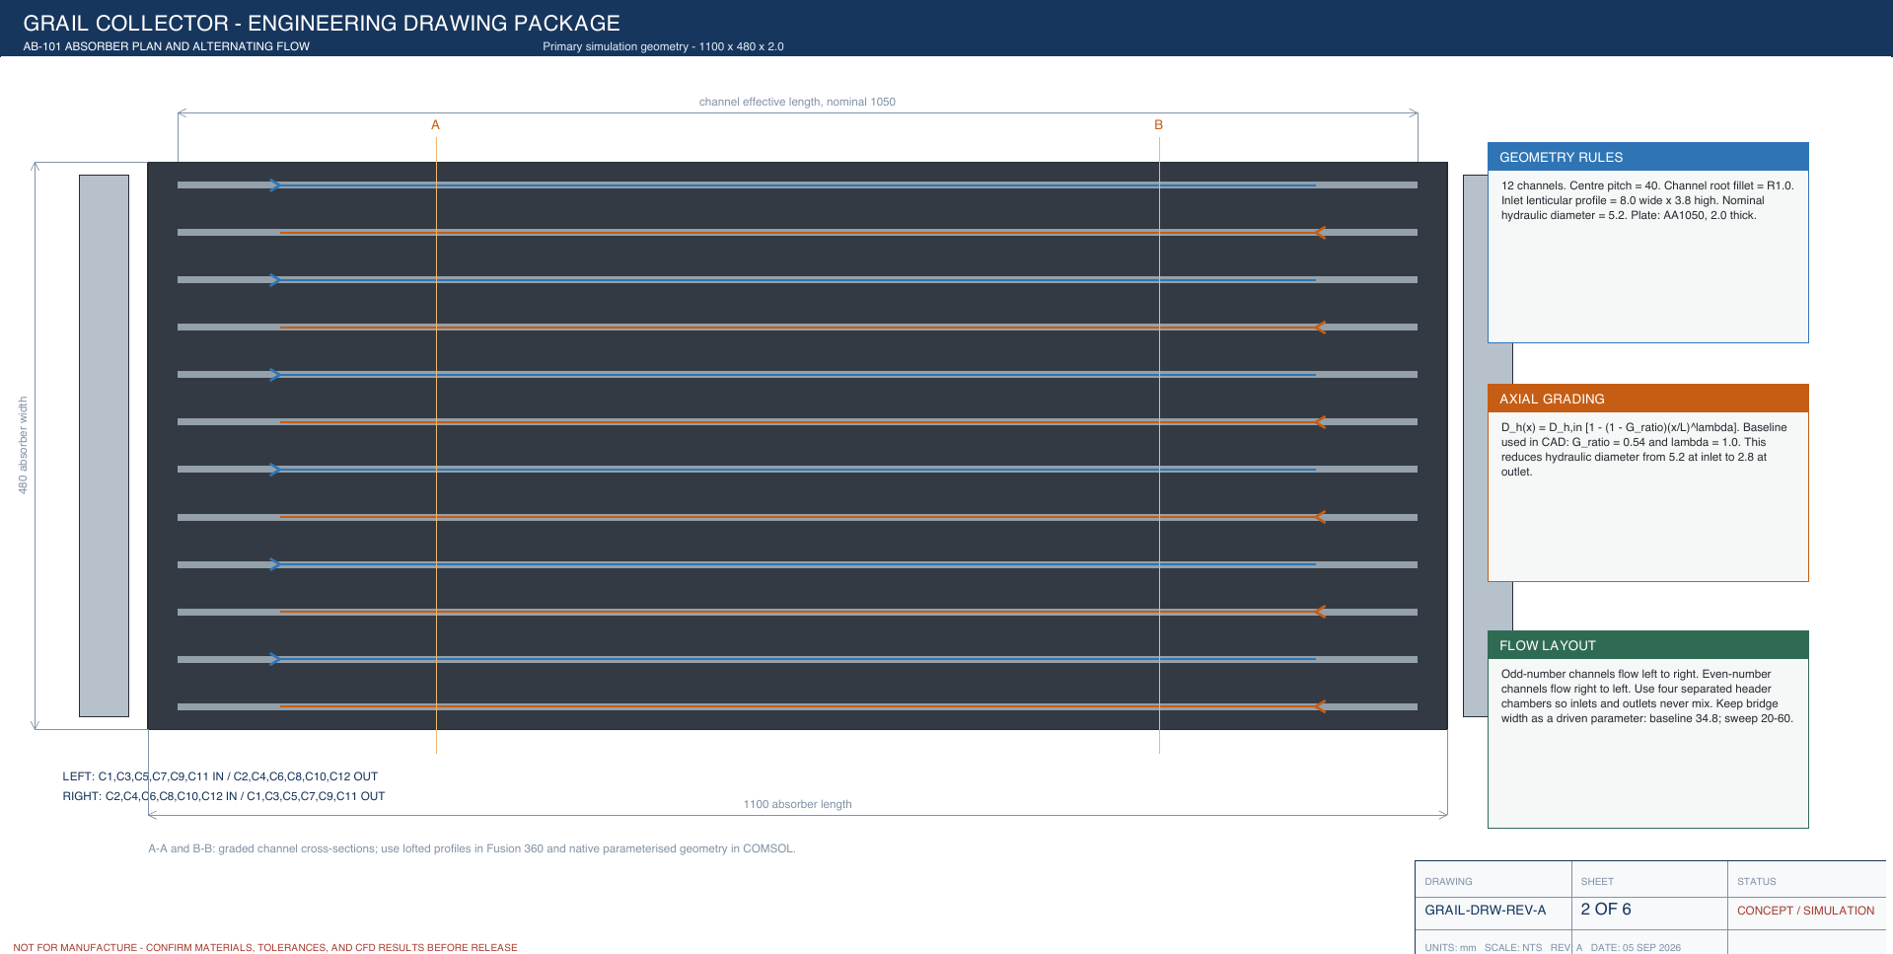
Figure W2.1 (Day 6). Concept drawing Rev A, sheet 2 — absorber plan and alternating flow
Twelve channels at 40 mm pitch. Blue arrows: odd channels flow left to right; orange arrows: even channels flow right to left. The side boxes give the geometry rule (inlet profile 8.0 × 3.8 mm, Dh 5.2 mm), the grading law (G = 0.54, λ = 1, Dh 5.2 → 2.8 mm) and the flow layout. The bridge width shown here (34.8 mm) is the concept value; the built CAD later gave 31.29 mm.
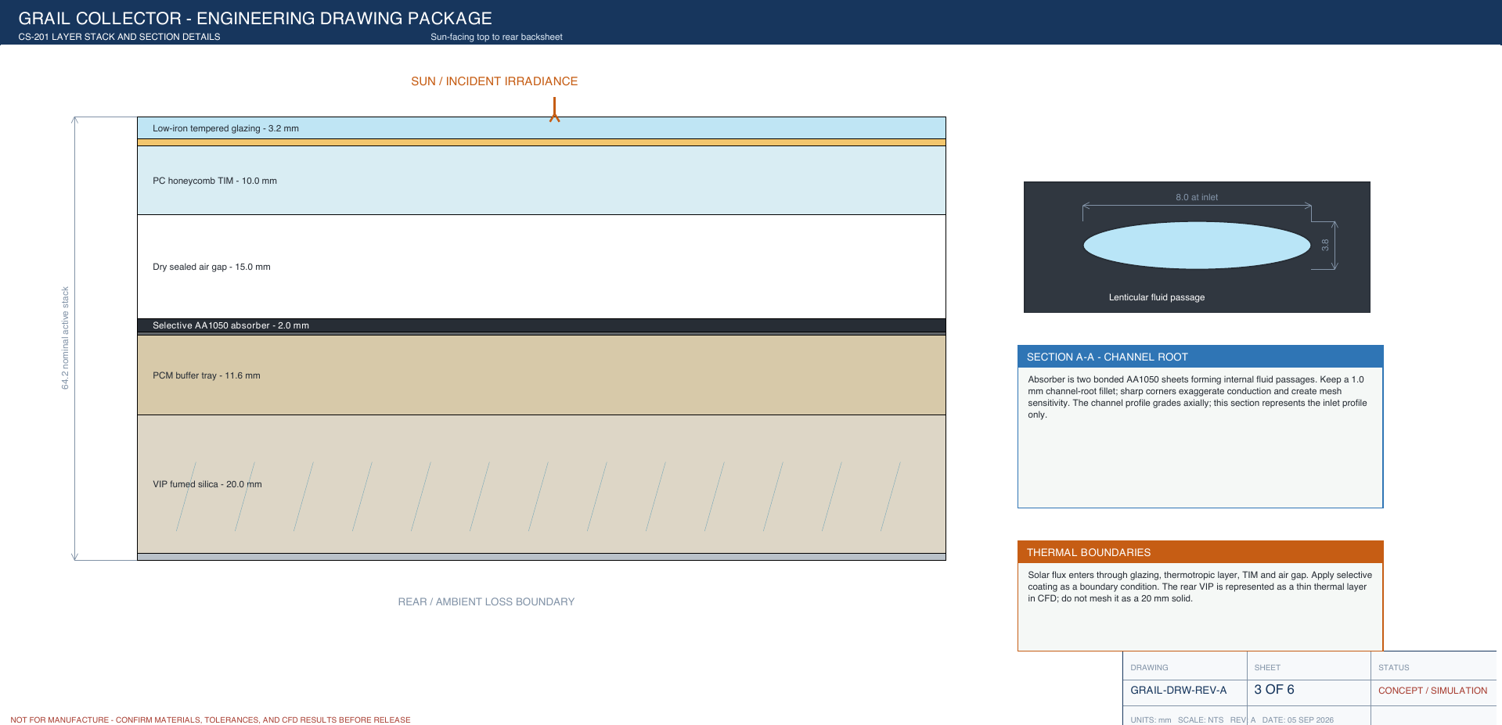
Figure W2.2 (Day 6). Concept drawing Rev A, sheet 3 — layer stack and channel section
Layers from the sun side: glazing 3.2 mm, TIM 10 mm, air gap, absorber 2.0 mm, PCM tray 11.6 mm, VIP 20 mm. The inset shows the lenticular fluid passage (8.0 mm wide at the inlet). The thermal-boundary note says the VIP is modelled as a thin thermal layer, not meshed as a solid.
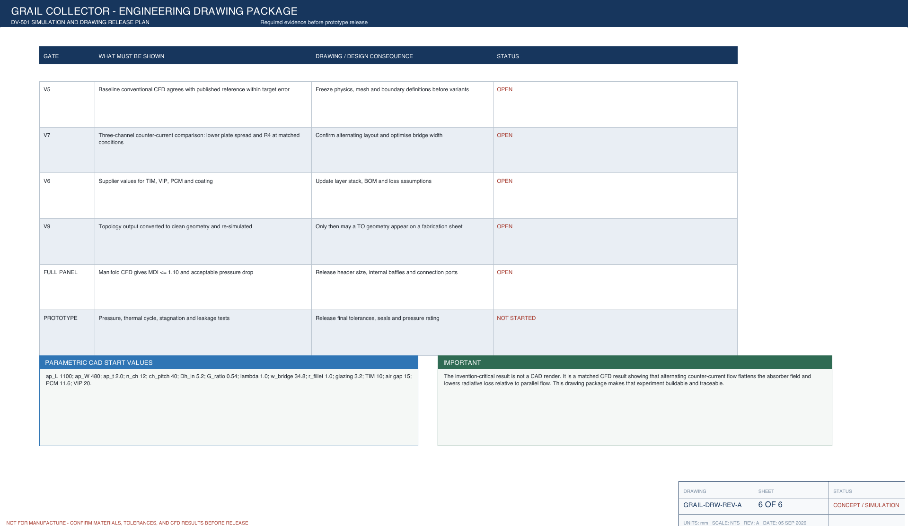
Figure W2.3 (Day 6). Concept drawing Rev A, sheet 6 — simulation and release plan
The checks that must be passed before anything is released: comparison with published test data, comparison at matched conditions, supplier data, a full-panel manifold check and a prototype test. At this stage all checks were open; the table also lists the parametric CAD start values.
Day 7 — Sunday, 16 Aug 2026
Today was the weekly review. We updated the roadmap from revision H to revision I and listed every design value with its source — measured, datasheet, literature or assumed. The manifold, the seals and the frame wall have no supplier data yet, so we marked them as assumed values to be reviewed later. We prepared the week summary and the drawings to show our guide.
Main points of today's work:
- Weekly review: roadmap updated from revision H to revision I.
- Listed every parameter with its source class (measured, datasheet, literature, an assumed value (to be reviewed)).
- Flagged the manifold, seals and frame wall as an assumed value (to be reviewed) (no supplier data yet).
- Prepared the week summary for the guide.
Result / observation: Concept design ready for CAD.

Week summary
Concept fixed: 1.10 × 0.48 m, 12 converging channels (G 0.54, λ 1, Dh 5.2 → 2.8 mm), glass + honeycomb TIM front, PCM + VIP rear, optical factor 0.649. Roadmap revision I and concept drawings (revision A) made.

Plan for next week
Build the parametric CAD model of the absorber in Autodesk Fusion.

Guide sign-off
Work shown to guide on (date)
Guide remarks
Student(s) signature
Guide signature

Week 3 | 17 Aug – 23 Aug 2026 | Completed
Title of the week: Parametric CAD model — absorber and channels
Dates: 17 Aug – 23 Aug 2026 (Monday to Sunday)
Status: Completed

Aim of this week
Build the absorber with graded channels as a parametric CAD model and measure the built geometry.
Day 1 — Monday, 17 Aug 2026
Today we started the CAD model in Autodesk Fusion. We created user parameters for the plate length and width, channel pitch, sheet thickness, channel width and height, fillet radius, grading ratio G and exponent λ. Every sketch dimension was linked to a parameter, so the whole design can be changed later without redrawing. We also read Zareie et al., who studied branch-shaped roll-bond channels in a PV-thermal panel and found that the channel layout strongly changes temperature uniformity and pressure drop.
Main points of today's work:
- Created the Fusion design and set up user parameters: plate length and width, pitch, sheet thickness, channel width and height, fillet radius, G and λ.
- Linked every sketch dimension to a parameter so that the design can be changed later without redrawing.
- Read the paper on branch-shaped roll-bond channels in a PVT panel.
Papers read today: [25] Zareie Z. 2024.
Result / observation: Roll-bond channel layout strongly changes temperature uniformity and pressure drop.
Day 2 — Tuesday, 18 Aug 2026
Today we drew the cross-section of one channel. The section is lens-shaped: a flat floor, 1 mm fillets at the roots and a curved dome on top. We worked out a formula for the dome radius from the width, height and fillet so that the dome always meets the fillets smoothly (tangentially). We checked the fillet detail on the section drawing. We also read Robles et al., who tested an aluminium minichannel water heater for a full year and found it performed as well as a copper sheet-and-tube collector, which supports our choice of an aluminium absorber.
Main points of today's work:
- Drew the lenticular channel section: flat floor, 1 mm root fillets and a tangent dome.
- Derived the dome-radius formula from width, height and fillet so the dome always meets the fillets tangentially.
- Checked the fillet detail on the section (see figure).
- Read the aluminium minichannel water-heater paper (year-round test).
Papers read today: [30] Robles A. 2014.
Result / observation: Section sketch complete. Aluminium minichannel absorbers perform as well as copper sheet-and-tube.
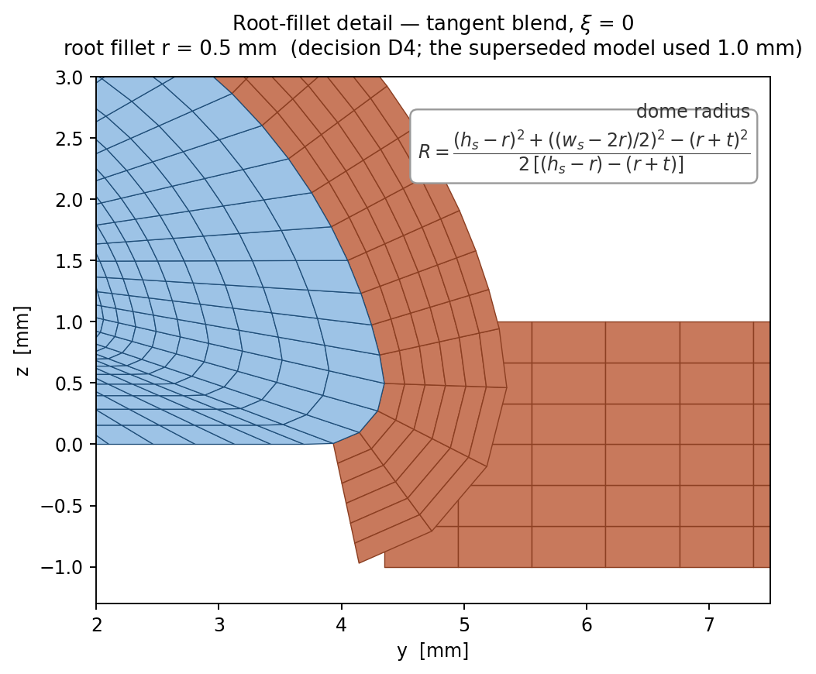
Figure W3.5 (Day 2). Root-fillet detail of the section mesh
Close-up of the 1 mm root fillet where the dome meets the floor. The boxed note gives the dome radius used for the tangent dome.
Day 3 — Wednesday, 19 Aug 2026
Today we checked that the channel shape is always possible to make. A dome can turn inside out if its height becomes too small compared with the fillet radius and sheet thickness, so we checked the condition h > 2r + t at every station along the channel. Even at the smallest section near the outlet the margin was more than 2 : 1, so the section can never invert.
Main points of today's work:
- Checked the dome inversion limit h > 2r + t at every station along the channel.
- Computed the margin with the smallest (outlet) section.
Result / observation: Margin is more than 2 : 1 — the section can never turn inside out.
Day 4 — Thursday, 20 Aug 2026
Today we built the full channel. Using the grading law we created section stations along the 1.10 m length, each one smaller than the one before. We lofted the section through all the stations to form one smooth converging channel and then patterned it to make 12 channels at 40 mm pitch. We plotted the sections at the inlet, middle and outlet to see how the channel shrinks.
Main points of today's work:
- Created graded section stations along the 1.10 m length using the grading law.
- Lofted the section through the stations to make one channel.
- Patterned it to 12 channels at 40 mm pitch.
Result / observation: Graded absorber with 12 converging channels modelled.
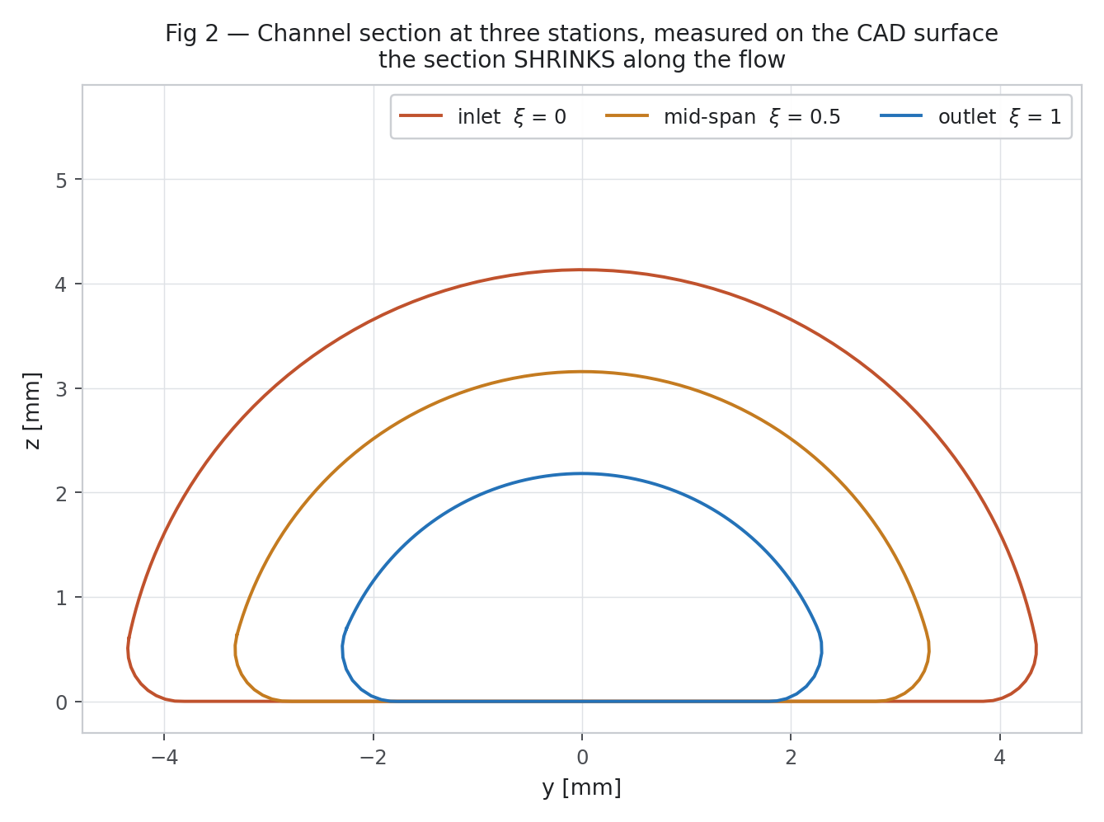
Figure W3.2 (Day 4). Channel cross-sections at inlet, mid-span and outlet
The lenticular section shrinks along the flow (inlet ξ = 0, mid-span ξ = 0.5, outlet ξ = 1). The floor stays flat and the dome keeps its shape.
Day 5 — Friday, 21 Aug 2026
Today we set up the alternating arrangement. In this arrangement the odd channels have their large inlet end on the left and the even channels on the right, so neighbouring channels carry water in opposite directions. We kept the ordinary parallel arrangement as a second configuration of the same model so that both can be compared under exactly the same conditions.
Main points of today's work:
- Set up the alternating arrangement: odd channels have their large (inlet) end on the left, even channels on the right.
- Kept the parallel arrangement as a separate configuration for comparison.
Result / observation: Both arrangements available from one model.
Day 6 — Saturday, 22 Aug 2026
Today we measured the geometry that was actually built. We wrote a Python script that reads the curved (NURBS) surfaces of the CAD model and measures the area and wetted perimeter of each section. At the inlet the area was 28.057 mm² and the hydraulic diameter 5.199 mm; at the outlet the area was 7.921 mm² and the hydraulic diameter 2.807 mm. This gives G = 2.807 / 5.199 = 0.5399, very close to our target of 0.54.
Main points of today's work:
- Wrote a Python script to read the NURBS surfaces from the CAD and measure each section.
- Measured A_in 28.057 mm², A_out 7.921 mm², Dh_in 5.199 mm, Dh_out 2.807 mm.
- Computed G = 2.807 / 5.199 = 0.5399.
Result / observation: Built G = 0.5399 — the channel converges as designed.
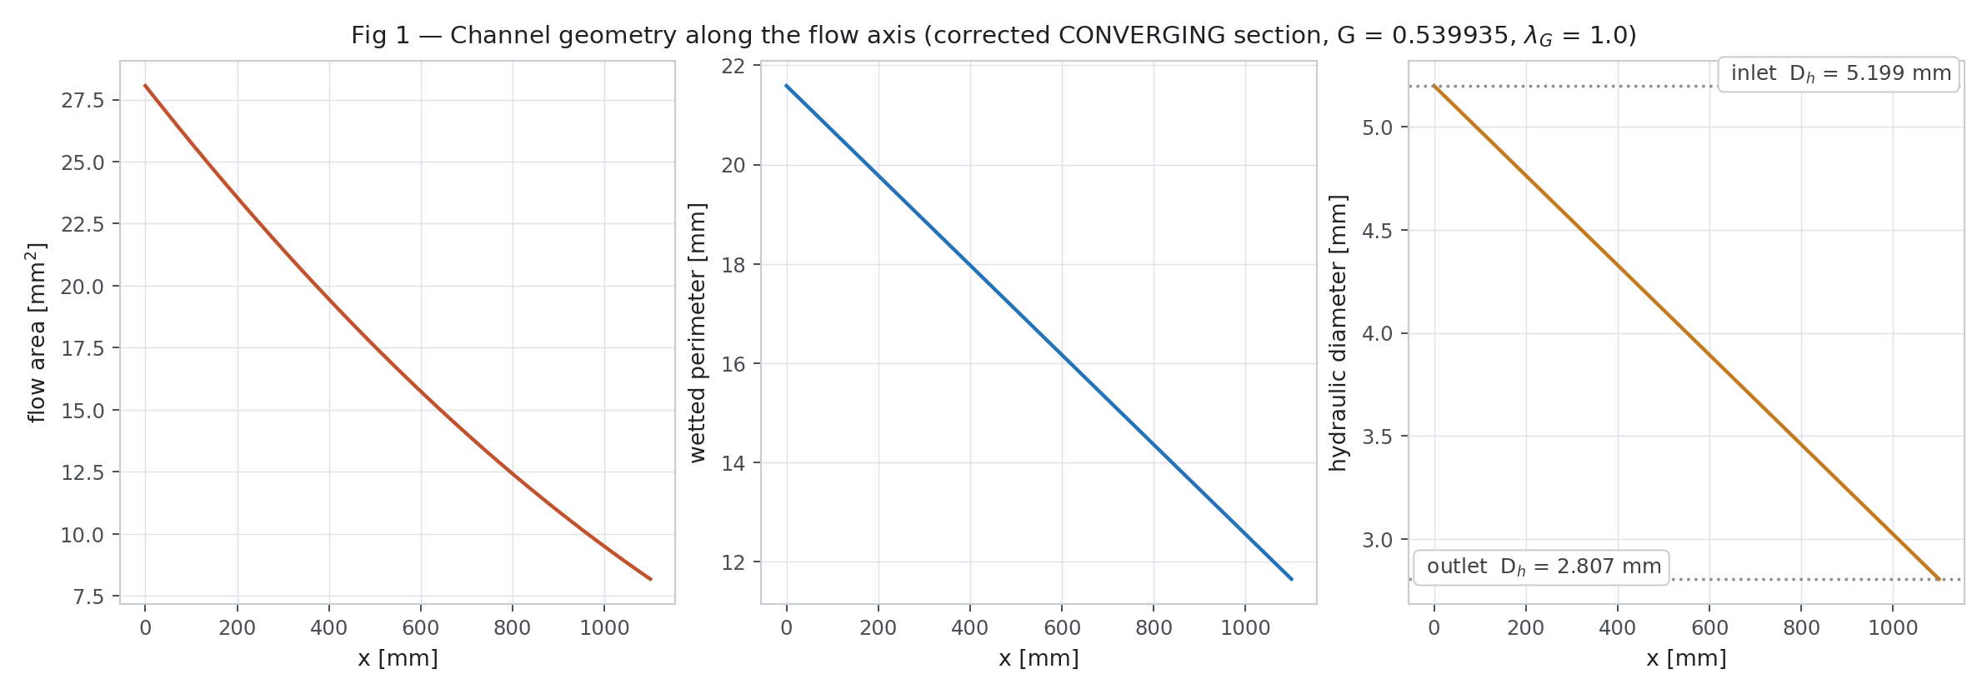
Figure W3.1 (Day 6). Channel geometry measured along the flow
Section area, hydraulic diameter and width measured from the CAD at stations along the 1.10 m channel. All three fall smoothly from inlet to outlet — the channel converges as designed.
Day 7 — Sunday, 23 Aug 2026
Today was the weekly review. The first model had not given the right G, because the 1 mm fillet does not scale down with the rest of the section. We fixed this by using a section scale of 0.5279, which is different from the diameter ratio. We measured the solid bridge between two channels as 31.29 mm wide. To be sure that the geometry can be used for CFD, we made the first structured meshes on the inlet and outlet sections, and both meshed cleanly.
Main points of today's work:
- Weekly review: the first built G did not match the target because the fillet does not scale with the section.
- Fixed it with a section scale of 0.5279 (not equal to the Dh ratio).
- Measured the bridge width between channels: 31.29 mm.
- Made the first section meshes on the inlet and outlet sections to check that the geometry can be meshed.
Result / observation: Geometry matches the target; sections mesh cleanly.
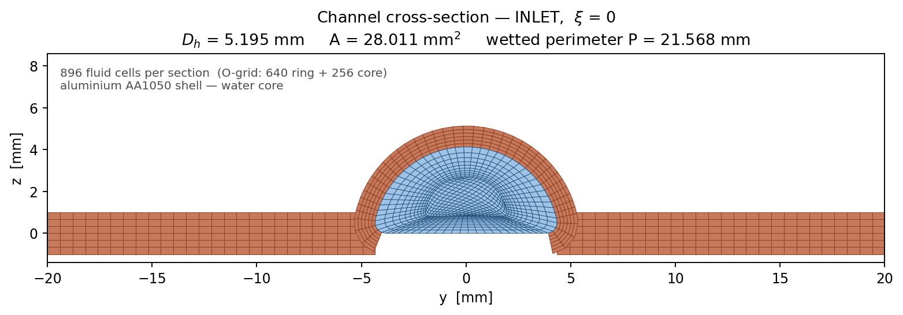
Figure W3.3 (Day 7). First structured section mesh at the inlet
Structured mesh on the inlet section, built directly from the CAD profile. This is the starting point for all CFD meshes.
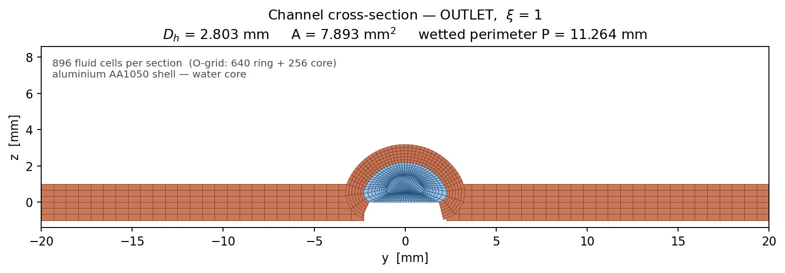
Figure W3.4 (Day 7). Section mesh at the outlet
The same topology on the smaller outlet section; cells shrink with the section so the mesh follows the converging wall.

Week summary
Parametric absorber built; converging channels measured from CAD (Dh 5.199 → 2.807 mm, G 0.540, bridge 31.29 mm). Only the converging geometry is used from now on.

Plan for next week
Complete the full collector assembly and verify it.

Guide sign-off
Work shown to guide on (date)
Guide remarks
Student(s) signature
Guide signature

Week 4 | 24 Aug – 30 Aug 2026 | Completed
Title of the week: Full CAD assembly, verification and CFD domains
Dates: 24 Aug – 30 Aug 2026 (Monday to Sunday)
Status: Completed

Aim of this week
Complete the full collector assembly, run the verification checks and export the CFD domains.
Day 1 — Monday, 24 Aug 2026
Today we started the full collector assembly around the absorber. We modelled the 3.2 mm glass cover, the 10 mm honeycomb transparent insulation and the two air gaps as separate bodies, and gave each one its material (glass, polycarbonate and air).
Main points of today's work:
- Modelled the 3.2 mm glazing, the 10 mm honeycomb TIM and the two air gaps as separate bodies.
- Assigned glass, polycarbonate and air materials.
Result / observation: Front stack done.
Day 2 — Tuesday, 25 Aug 2026
Today we modelled the back of the collector: the 11.6 mm PCM tray and the 20 mm vacuum insulation panel. We assigned 16 materials in total from the library and from datasheets, including AA1050 aluminium, glass, polycarbonate, RT55 PCM, fumed-silica VIP, Al 6063 for the frame and EPDM for the seals. We made a cut-away view to check the order and thickness of every layer.
Main points of today's work:
- Modelled the PCM tray (11.6 mm) and the 20 mm VIP rear insulation.
- Assigned 16 materials from the library and datasheets (AA1050, glass, PC, RT55 PCM, fumed-silica VIP, Al 6063 frame, EPDM seals …).
- Made a cut-away view to check the order and thickness of every layer.
Result / observation: Rear stack done; stack order checked.
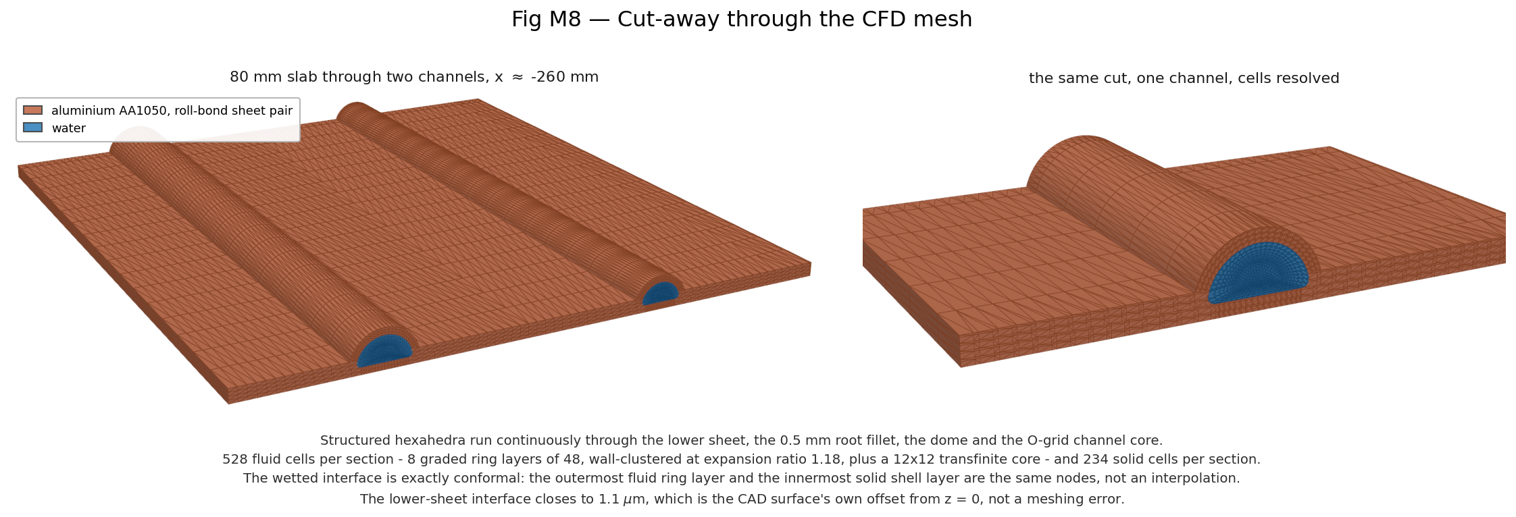
Figure W4.1 (Day 2). Cut-away of the collector stack
Section through the assembly showing the glazing, TIM, absorber with channels, PCM and VIP layers in their real positions.
Day 3 — Wednesday, 26 Aug 2026
Today we modelled the manifold blocks at both ends of the absorber. Each manifold has four separate chambers so that the inlets and outlets of the alternating channels never mix. Because we have no supplier data for the manifold, its dimensions are assumed and we marked them to be reviewed later. We checked the inlet end, where the large ends of the channels enter the manifold.
Main points of today's work:
- Modelled the manifold blocks with four separate chambers so that inlets and outlets of alternating channels never mix.
- Dimensions assumed (no supplier data) and marked as an assumed value (to be reviewed).
- Checked the inlet end where the large channel ends meet the manifold.
Result / observation: Manifold modelled — kept as an open item (no supplier data yet).
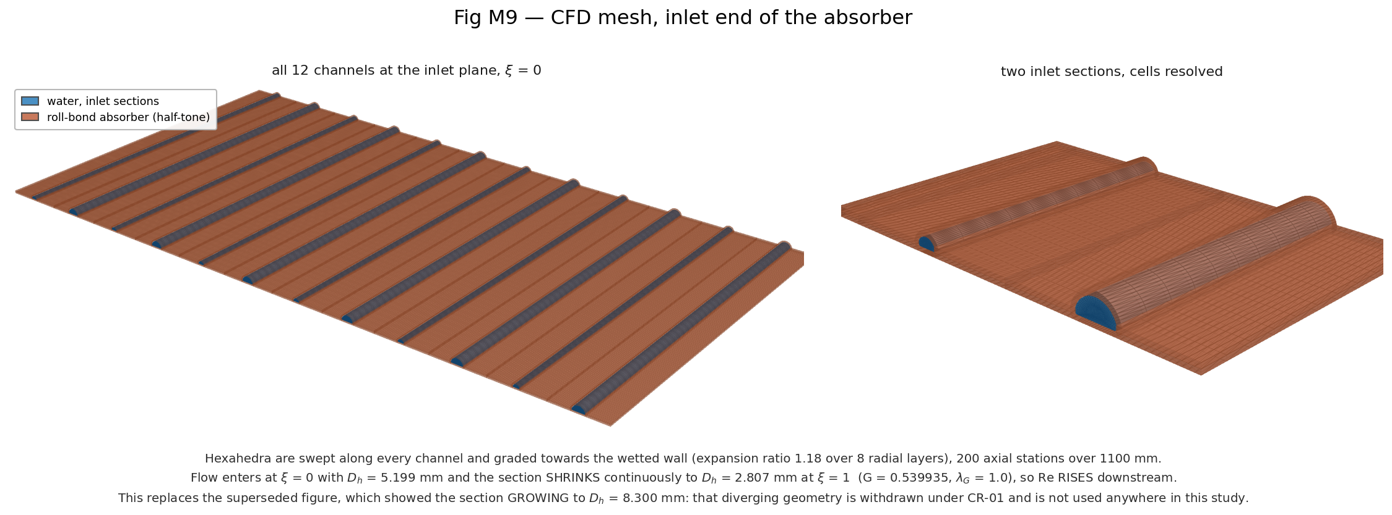
Figure W4.2 (Day 3). Inlet end of the absorber
Close-up of the absorber inlet end where the large channel sections enter the manifold.
Day 4 — Thursday, 27 Aug 2026
Today we ran the verification checks on the model: geometry health, section check, grading check, the contacts between bodies, and the body count. We also generated a surface mesh on the whole assembly to confirm that it is watertight. All the checks passed and the model had no unhealthy features.
Main points of today's work:
- Ran the verification checks: geometry health, section check, grading check, interfaces between bodies, body count.
- Generated a surface mesh on the whole assembly to confirm it is watertight.
Result / observation: All checks passed; 0 unhealthy features.
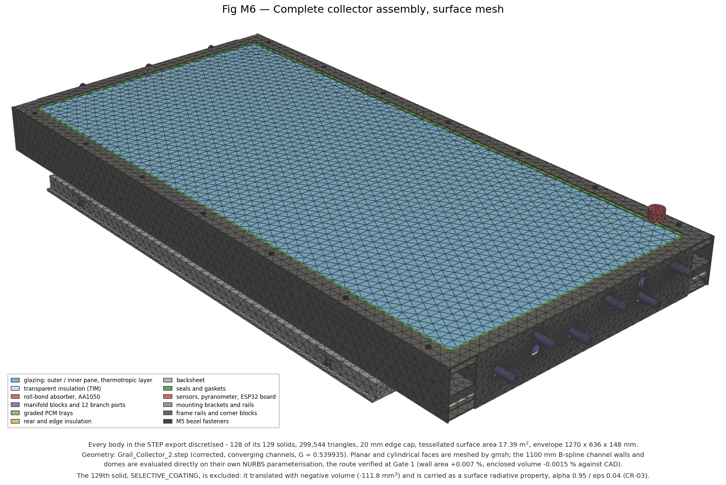
Figure W4.3 (Day 4). Assembly surface mesh
Surface mesh generated on the full assembly — used to check the geometry is watertight before extracting the CFD domain.
Day 5 — Friday, 28 Aug 2026
Today we prepared the regions for CFD. Because all channels are identical, we do not need to simulate the whole plate; we cut out a 3-channel strip with symmetry sides and a 2-channel strip (80 mm wide) with periodic sides. We exported both strips as STEP files for meshing and checked where the CFD strip sits inside the full collector.
Main points of today's work:
- Extracted the 3-channel symmetry strip and the 2-channel periodic strip (80 mm wide).
- Exported both as STEP files for meshing.
- Checked the location of the CFD strip inside the full assembly.
Result / observation: CFD domains ready.
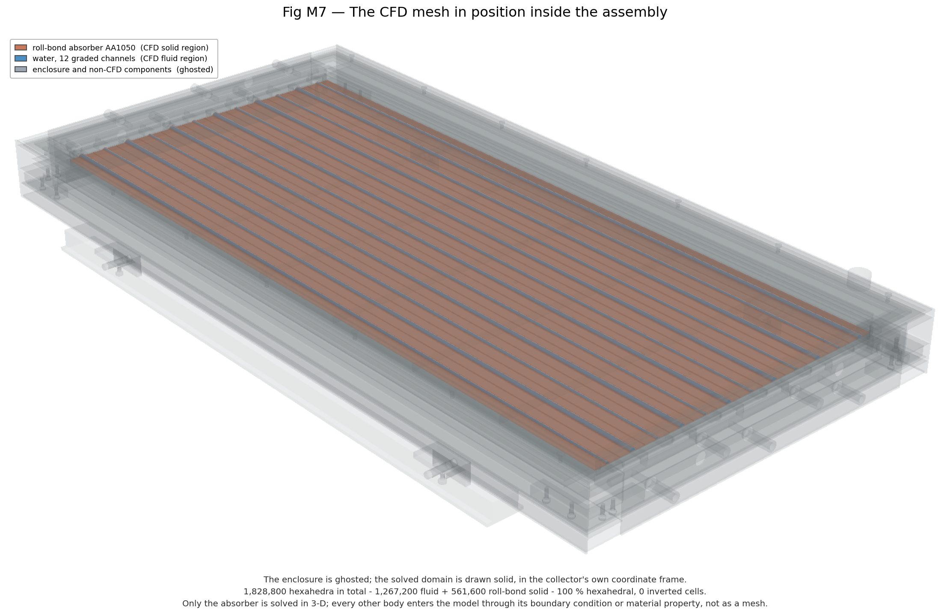
Figure W4.4 (Day 5). CFD domain located in the assembly
The CFD strip shown inside the full collector so that its position and boundaries are clear.
Day 6 — Saturday, 29 Aug 2026
Today we wrote the CAD design parameter and build record. For each of the 131 parameters it gives the value, the formula used in the model and where the value comes from.
Main points of today's work:
- Wrote the CAD Design Parameter & Build Record: every parameter with value, expression and source.
Result / observation: Record complete (131 parameters).
Day 7 — Sunday, 30 Aug 2026
Today was the weekly review. The final model has 948 features, 131 parameters, 145 bodies and 16 materials. We listed the two open items — the manifold design and the frame-wall thickness — which still need supplier data, and prepared the summary for our guide.
Main points of today's work:
- Weekly review: listed open items: manifold design and frame-wall thickness.
- Final model statistics: 948 features, 131 parameters, 145 bodies, 16 materials.
Result / observation: Assembly complete and verified.

Week summary
Full assembly complete and verified; CFD strips exported; assumptions recorded as open items.

Plan for next week
Generate structured meshes and solve the channel flow.

Guide sign-off
Work shown to guide on (date)
Guide remarks
Student(s) signature
Guide signature

Monthly review — August 2026
Weeks covered | Weeks 1–4
Main work | Topic, literature, concept, roadmap and full CAD model

Progress against plan
Planned | Achieved | Remarks

Guide's overall comments

Student(s) signature
Guide signature
Date

Week 5 | 31 Aug – 06 Sep 2026 | Completed
Title of the week: Meshing and 3-D channel hydraulics
Dates: 31 Aug – 06 Sep 2026 (Monday to Sunday)
Status: Completed

Aim of this week
Make structured meshes from the CAD and solve the laminar flow in the converging channel.
Day 1 — Monday, 31 Aug 2026
Today we started meshing. We wrote a Python program that takes the measured channel section at each station and sweeps it along the graded length. Because every station uses the real section from the CAD model, every cell of the mesh follows the converging wall. We plotted the section outline at every 10th station to check the sweep; it shrinks smoothly from 5.199 mm to 2.807 mm hydraulic diameter.
Main points of today's work:
- Wrote a Python mesher that sweeps the measured section along the graded length.
- Each station uses the real CAD section, so every cell follows the converging wall.
- Plotted section outlines at every 10th station to check the sweep.
Result / observation: Swept structured mesh follows the channel from Dh 5.199 mm to 2.807 mm.
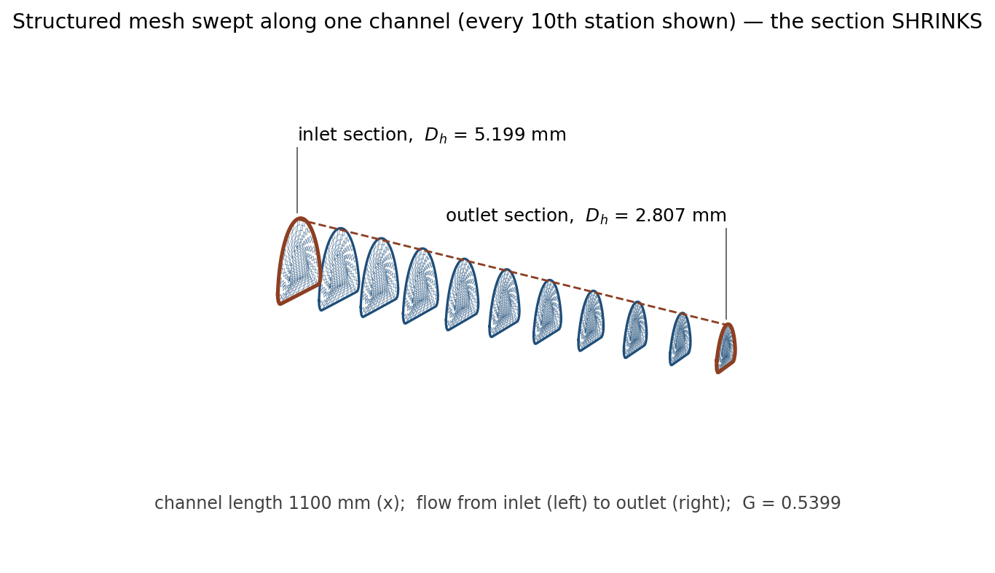
Figure W5.1 (Day 1). Swept structured mesh along the graded channel
Section outlines at every 10th station along one channel. The section shrinks from the inlet (Dh 5.199 mm) to the outlet (Dh 2.807 mm).
Day 2 — Tuesday, 01 Sep 2026
Today we made a family of meshes to check that the results do not depend on the mesh. We made meshes with 60, 120 and 240 cells along the channel and 48, 64 and 96 cells around the section. We also built a mesh of several neighbouring channels with the bridges between them, and a mesh of the full plate. A first grid study showed that 240 cells along the channel are enough for the final runs.
Main points of today's work:
- Generated grids with 60, 120 and 240 cells along the channel and 48, 64 and 96 cells around the section.
- Built a multi-channel strip mesh (channels + bridges) and a full-plate mesh.
- Ran a first axial grid study.
Result / observation: Grid family ready; 240 cells along the channel chosen for the final conjugate runs.
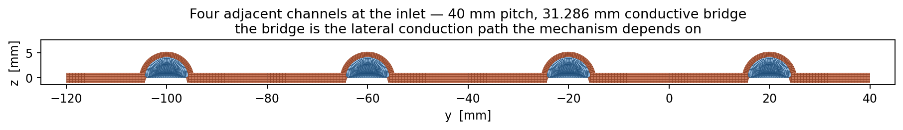
Figure W5.2 (Day 2). Multi-channel strip mesh
Mesh of several neighbouring channels with the bridges between them — used for the conjugate (fluid + metal) runs.
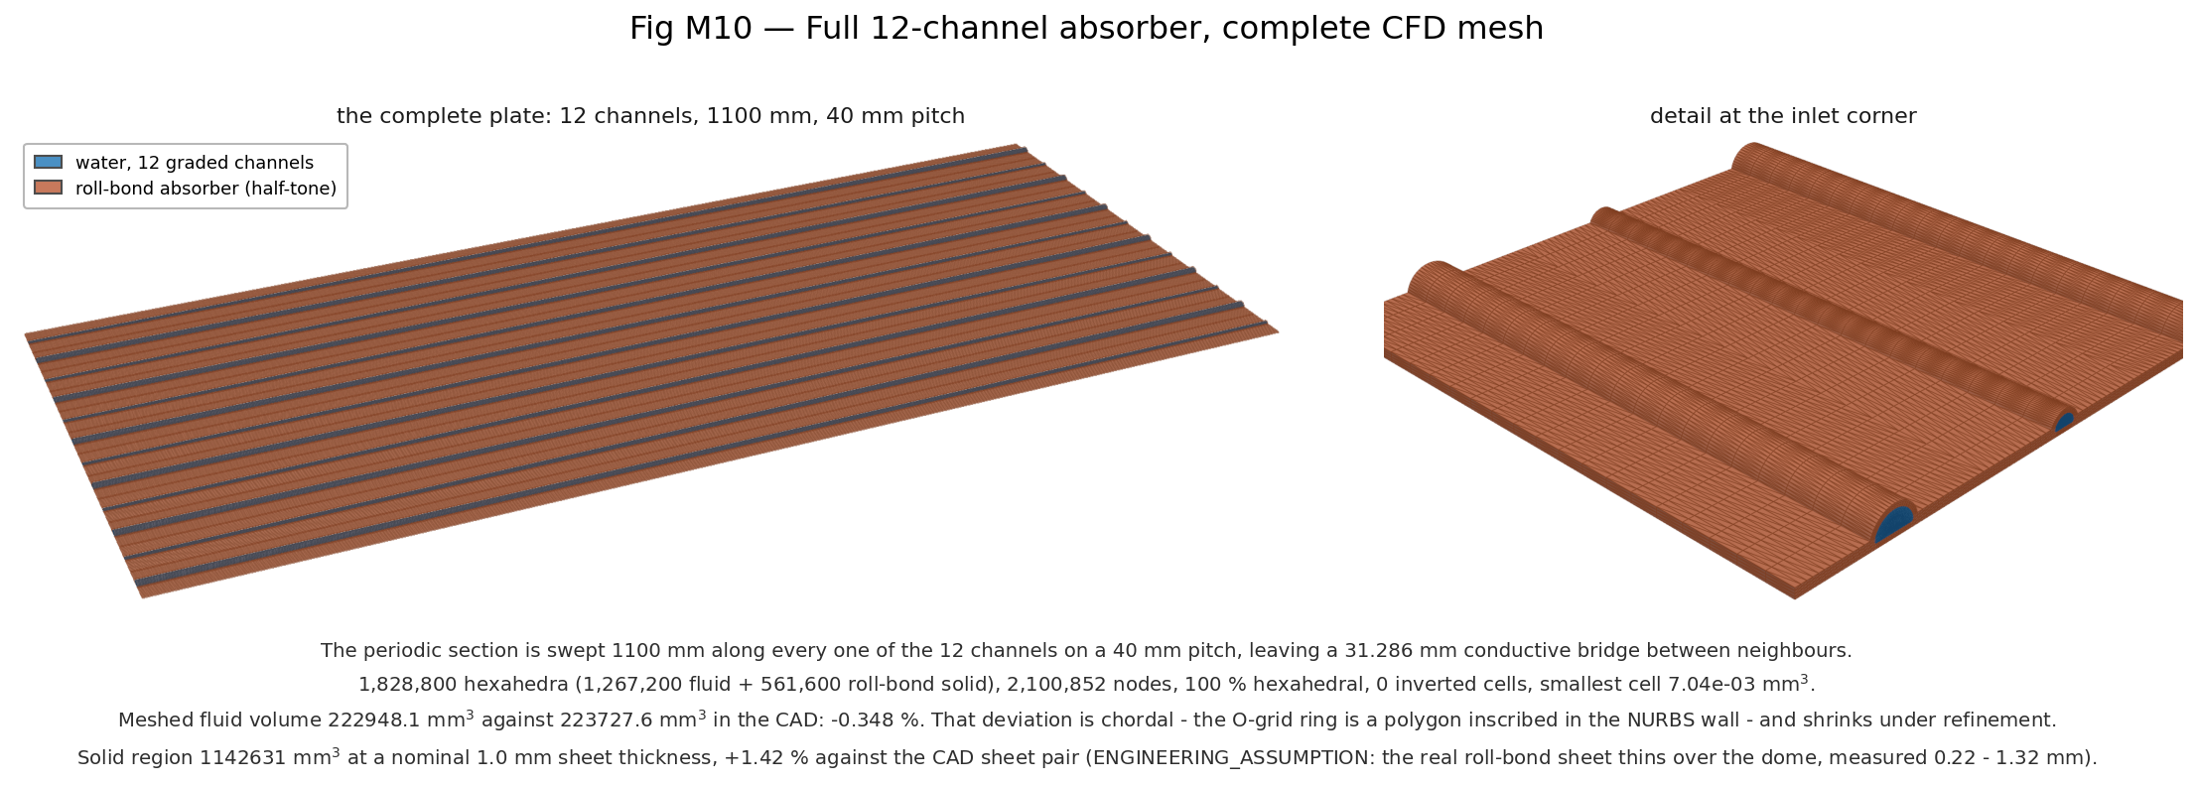
Figure W5.3 (Day 2). Full-plate mesh
Mesh of the whole absorber plate used by the plate-level model.
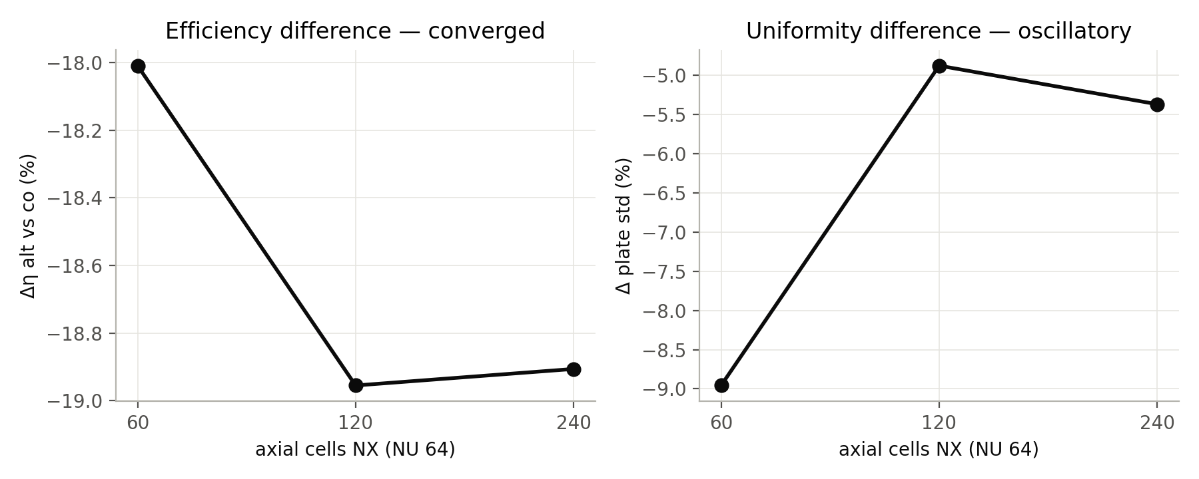
Figure W5.9 (Day 2). 3-D axial grid study
Grid study on the axial resolution used to choose 240 cells along the channel for the final conjugate runs.
Day 3 — Wednesday, 02 Sep 2026
Today we checked the quality of the meshes with the OpenFOAM checkMesh tool. Non-orthogonality, skewness and aspect ratio were all within the limits, so the meshes are suitable for the solver.
Main points of today's work:
- Checked mesh quality with checkMesh: non-orthogonality, skewness and aspect ratio.
Result / observation: All within OpenFOAM limits.
Day 4 — Thursday, 03 Sep 2026
Today we solved the water flow in the channel. We ran OpenFOAM's simpleFoam solver for steady laminar flow at total flow rates of 1.0, 2.5 and 4.5 g/s, with a fixed mass flow at the inlet, fixed pressure at the outlet and no-slip walls. The Reynolds number was between 22 and 151, so the flow is laminar everywhere. Because the section area falls from 28 to 8 mm², the mean velocity rises from about 5 to 32 mm/s along the channel, and the pressure drop along one channel is about 35 Pa at the design flow. We plotted the pressure drop, Reynolds number, velocity and pressure along channel 5.
Main points of today's work:
- Ran simpleFoam (laminar, steady) at total flows 1.0, 2.5 and 4.5 g/s.
- Boundary conditions: mass-flow inlet, fixed-pressure outlet, no-slip walls.
- Plotted pressure drop, Reynolds number, velocity and pressure along one channel (channel 5).
Result / observation: Re 22–151 (laminar). Area falls from 28 to 8 mm²; mean velocity rises from about 5 to 32 mm/s; channel Δp ≈ 35 Pa at design flow.
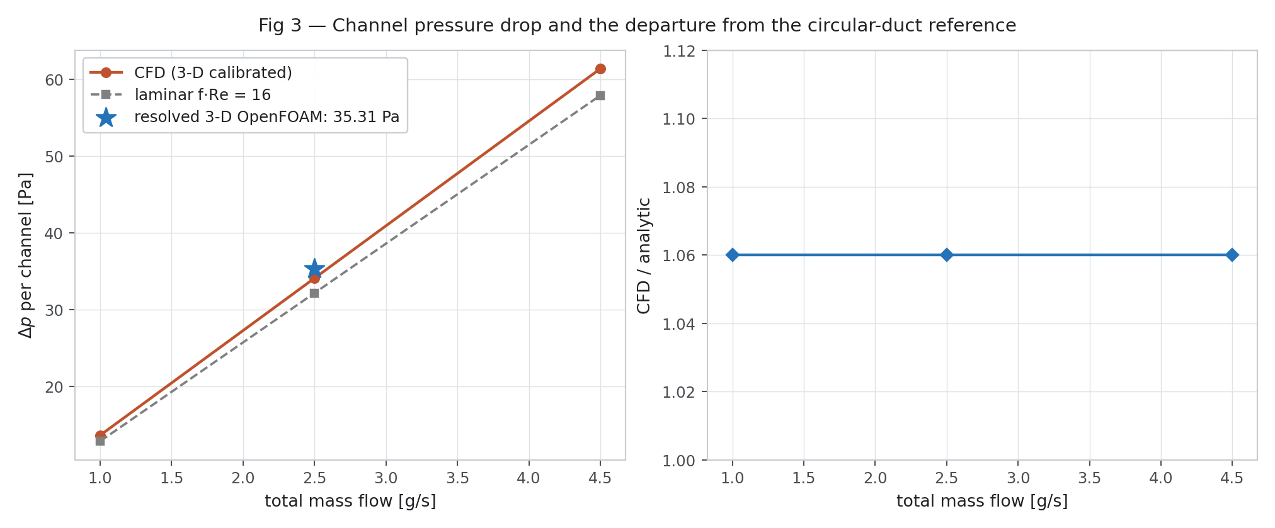
Figure W5.4 (Day 4). Channel pressure drop against flow
CFD pressure drop against total mass flow, compared with the circular-duct estimate. The difference is the developing-flow penalty.
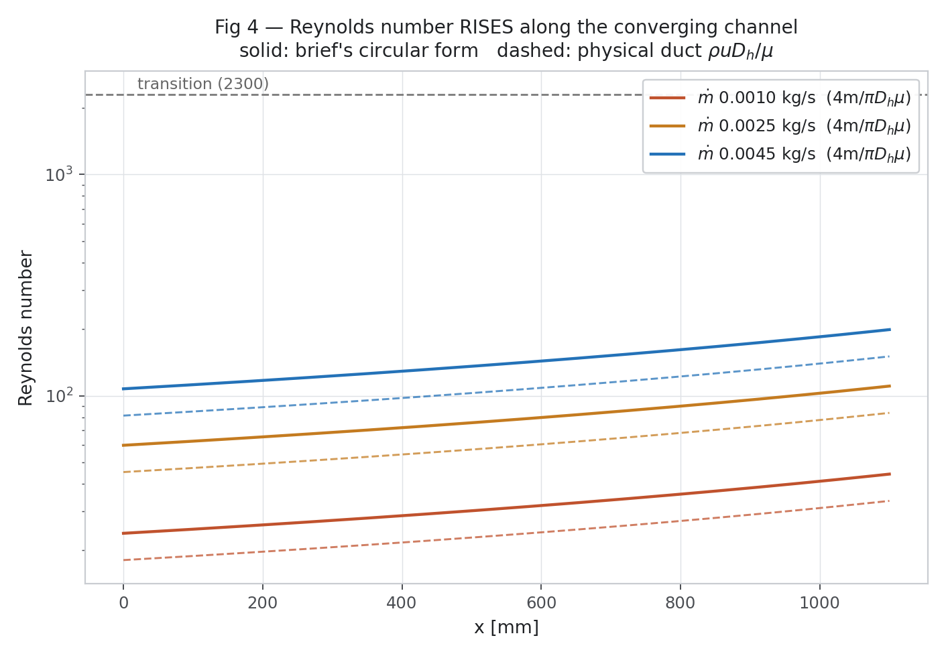
Figure W5.5 (Day 4). Reynolds number along the channel
Re rises along the converging channel at all three flow rates and stays far below the transition value 2300.
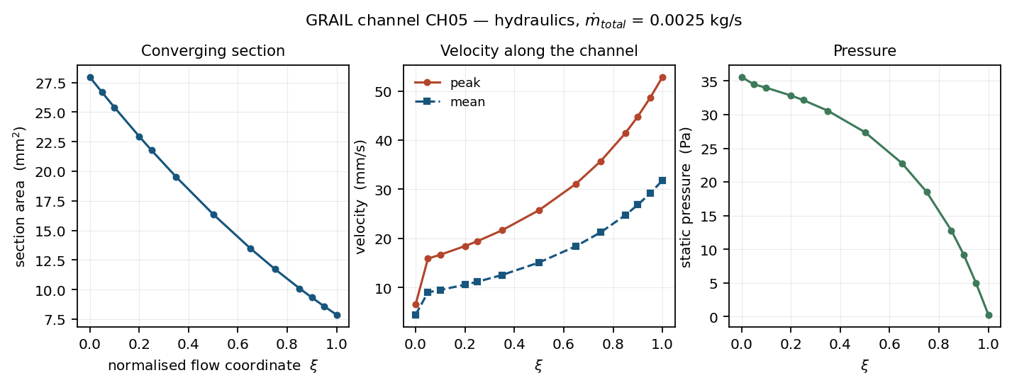
Figure W5.7 (Day 4). 3-D hydraulics of one channel (channel 5)
Section area, peak and mean velocity and static pressure along the channel at the design flow 0.0025 kg/s.
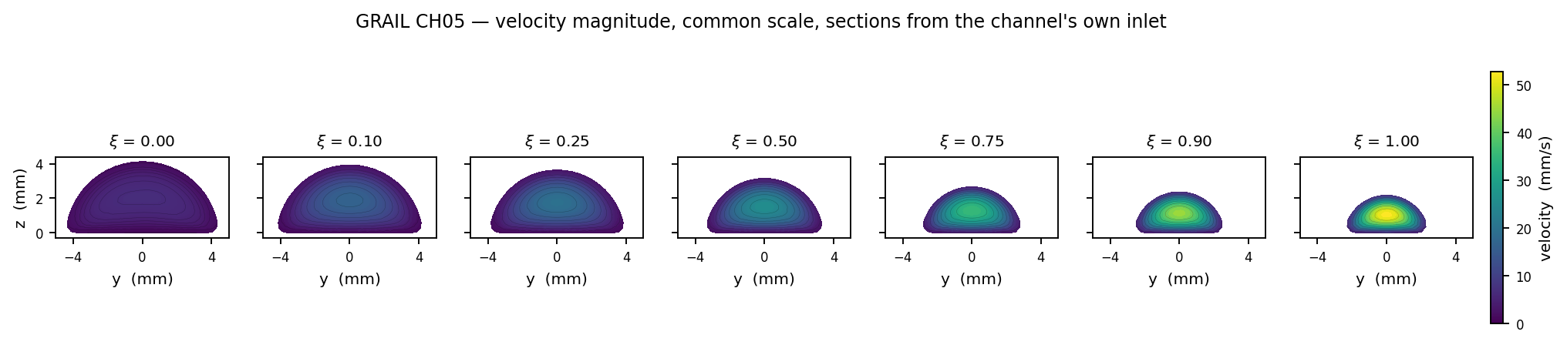
Figure W5.8 (Day 4). Velocity sections along the channel
Velocity magnitude on seven sections on a common scale: the peak rises towards the outlet as the section shrinks.
Day 5 — Friday, 04 Sep 2026
Today we checked whether warm water rising by buoyancy could disturb the flow. We calculated the Richardson number (Gr/Re²) at the three flow rates for a collector tilted at 33° with a 5 K wall temperature difference. At low flow the Richardson number is above 1, so buoyancy matters, but at the design flow the friction pressure drop (34.1 Pa) is much larger than the buoyant head (8.8 Pa), so forced flow dominates.
Main points of today's work:
- Buoyancy check: computed the Richardson number Gr/Re² at the three flows (tilt 33°, ΔT_wall 5 K).
- Compared the buoyant head with the friction pressure drop at the design point.
Result / observation: Buoyancy matters at low flow (Ri > 1), but at the design flow friction (34.1 Pa) is larger than the buoyant head (8.8 Pa).
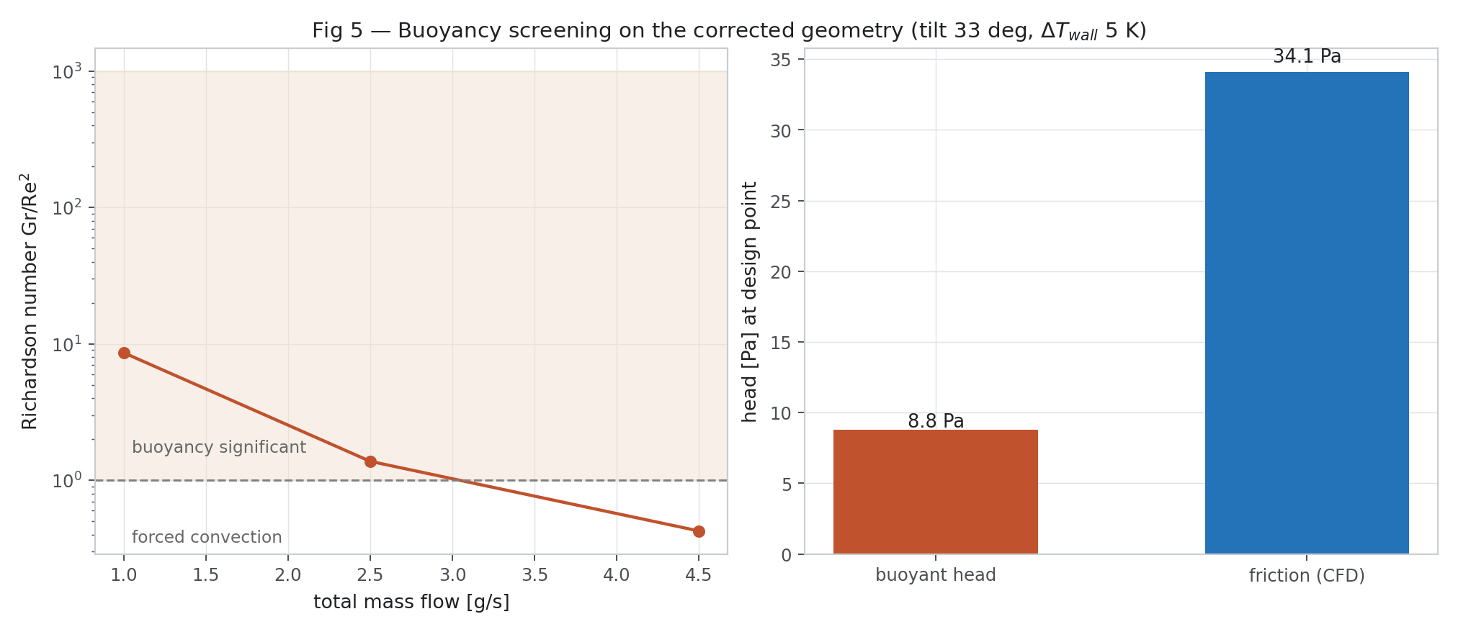
Figure W5.6 (Day 5). Buoyancy screening
Richardson number against total flow, and buoyant head against friction at the design point.
Day 6 — Saturday, 05 Sep 2026
Today we did the first heat-transfer run on a single channel with heat added at the wall, and obtained a Nusselt number of about 2.92. (In Week 7 we found that this value belongs to the wrong wall boundary condition; the correct value for our plate is 4.48.)
Main points of today's work:
- First single-channel thermal run with a wall heat flux.
Result / observation: Nu ≈ 2.92. (Week 7 showed this is the value for the wrong boundary condition (H2); the correct conjugate value is 4.48.)
Day 7 — Sunday, 06 Sep 2026
Today was the weekly review. On the coarse mesh we had seen a false pressure jump at the inlet, and we removed it by refining the mesh along the channel. We made the mesh and flow figures for the report. We noted that these flow results do not depend on the heat-transfer model, so they remain valid for the rest of the project.
Main points of today's work:
- Weekly review: found an inlet pressure artefact on the coarse grid and removed it by refining the axial grid.
- Made the mesh and hydraulics figures for the report.
Result / observation: Hydraulic results are independent of the thermal closure and stay valid.

Week summary
Structured meshes built from CAD; laminar flow solved; Re and velocity rise along the converging channel; channel pressure drop about 35 Pa at design flow.

Plan for next week
Write the reduced-order plate model GRAIL-CHT and run the first campaign.

Guide sign-off
Work shown to guide on (date)
Guide remarks
Student(s) signature
Guide signature

Week 6 | 07 Sep – 13 Sep 2026 | Completed
Title of the week: Reduced-order model GRAIL-CHT and first campaign
Dates: 07 Sep – 13 Sep 2026 (Monday to Sunday)
Status: Completed

Aim of this week
Write a fast whole-plate model (GRAIL-CHT), verify it and run the first 300-case campaign.
Day 1 — Monday, 07 Sep 2026
Today we started writing our own fast model of the whole plate, which we called GRAIL-CHT. The first part solves heat conduction in the absorber sheet in two dimensions using the finite-volume method. We assembled the equations as a sparse matrix and solved them with SciPy; the full plate temperature field is solved in a few seconds.
Main points of today's work:
- Wrote the 2-D plate conduction solver (finite volume on the absorber sheet).
- Assembled the equations as a sparse matrix and solved with SciPy.
Result / observation: Plate temperature field solved in a few seconds.
Day 2 — Tuesday, 08 Sep 2026
Today we connected the water channels to the plate. For each channel we wrote a one-dimensional energy balance along the flow, linked to the plate through the heat-transfer coefficient h = Nu·k/Dh. The channels can be set to flow all in the same direction (parallel) or in alternating directions, so the model now calculates the plate and the water together.
Main points of today's work:
- Coupled a 1-D energy balance for each channel to the plate through h = Nu k / Dh.
- Channels can run in parallel or alternating directions.
Result / observation: Conjugate plate–fluid model working.
Day 3 — Wednesday, 09 Sep 2026
Today we added the rest of the collector to the model: the glass cover with radiation using T⁴ in kelvin, convection in the air gaps, the transparent insulation layer, and the heat path through the PCM and vacuum insulation at the back. We checked the plate model against a detailed 2-D conduction model of the real roll-bond section and found that the metal is at the same temperature through its thickness to within 0.06 K. We also read Oyinlola and Shire, who showed that above a heat-transfer coefficient of about 300 W/m²K the collector efficiency factor hardly changes, which supports our channel-level approach.
Main points of today's work:
- Added the glazing node with T⁴ radiation (kelvin), convection in the air gaps, the TIM layer, and the PCM + VIP rear path.
- Checked 2-D conduction in the real roll-bond section against the plate solver.
- Read the paper on micro-channel absorber plate characterisation.
Papers read today: [31] Oyinlola M.A. 2018.
Result / observation: Metal is isothermal through its thickness within 0.06 K; above h ≈ 300 W/m²K, F′ changes little.
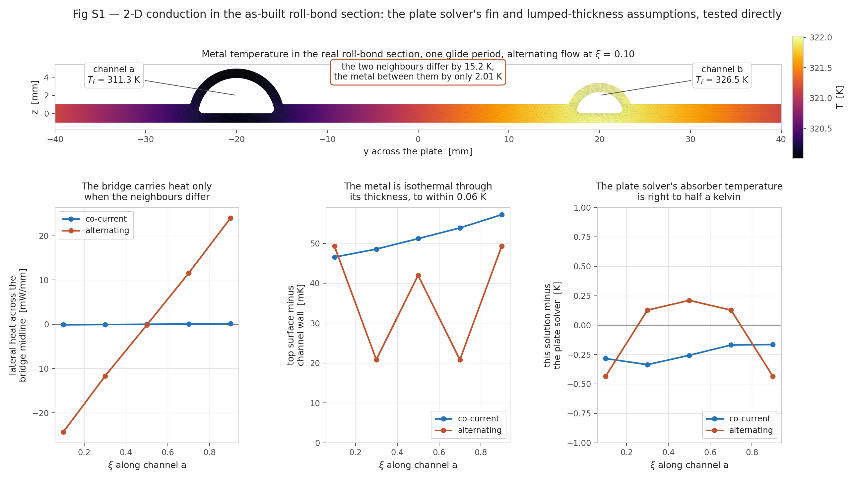
Figure W6.2 (Day 3). 2-D section conduction check (first campaign — numbers later corrected in Week 7)
Conduction in the real roll-bond section: the metal is isothermal through its thickness to within 0.06 K and the plate solver is right to about half a kelvin.
Day 4 — Thursday, 10 Sep 2026
Today we verified GRAIL-CHT against the classical Hottel-Whillier-Bliss model, taking the heat-loss coefficient from our own model's energy balance. For parallel flow the efficiency differed by only +0.22 %, and the model gave F_R = 0.930 and F′ = 0.988. We also read Vahidinia and Khorasanizadeh, who compared minichannel and conventional collectors and found higher energy and exergy efficiency for the minichannel design.
Main points of today's work:
- Verified GRAIL-CHT against the Hottel-Whillier-Bliss model (U_L from the solver's own balance).
- Read the minichannel vs conventional collector paper.
Papers read today: [24] Vahidinia F. 2024.
Result / observation: Hottel-Whillier-Bliss difference +0.22 % for parallel flow; F_R 0.930, F′ 0.988.
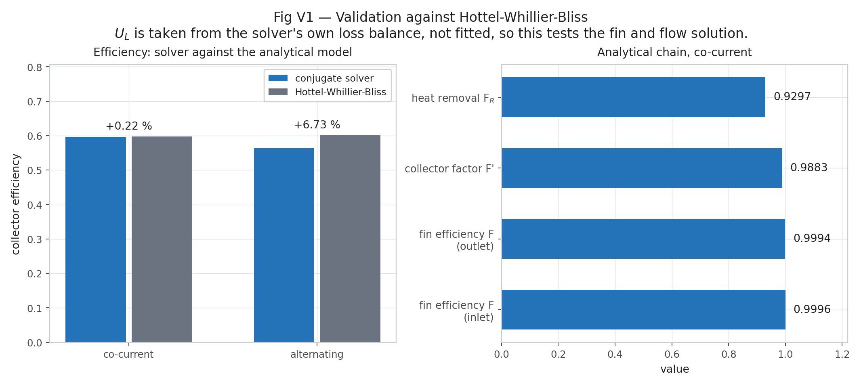
Figure W6.1 (Day 4). Check against Hottel-Whillier-Bliss (first campaign — numbers later corrected in Week 7)
Collector efficiency from GRAIL-CHT compared with the analytical Hottel-Whillier-Bliss model. The loss coefficient is taken from the solver's own balance, so this tests the fin and flow solution.
Day 5 — Friday, 11 Sep 2026
Today we planned a simulation campaign of 300 cases using Latin-hypercube sampling, which spreads the cases evenly over eight inputs: sunshine (400–1000 W/m²), inlet and ambient temperature, wind, total flow (1.0–4.5 g/s), bridge width (20–37 mm), G and λ. Half the cases use alternating flow and half use parallel flow. We also checked which small CFD region represents the whole plate correctly: only the 2-channel strip with periodic sides matched the full plate, while strips with adiabatic sides overestimated the heat through the bridges by 67 %.
Main points of today's work:
- Designed the 300-case Latin-hypercube campaign: G_T 400–1000 W/m², T_in, T_amb, wind, total flow 1.0–4.5 g/s, bridge 20–37 mm, G, λ (150 alternating + 150 parallel).
- Checked which CFD domain reproduces the full plate: full plate vs 2-channel periodic vs adiabatic strips.
Result / observation: Only the 2-channel periodic domain matches the full plate; adiabatic planes inflate bridge conduction by 67 %.
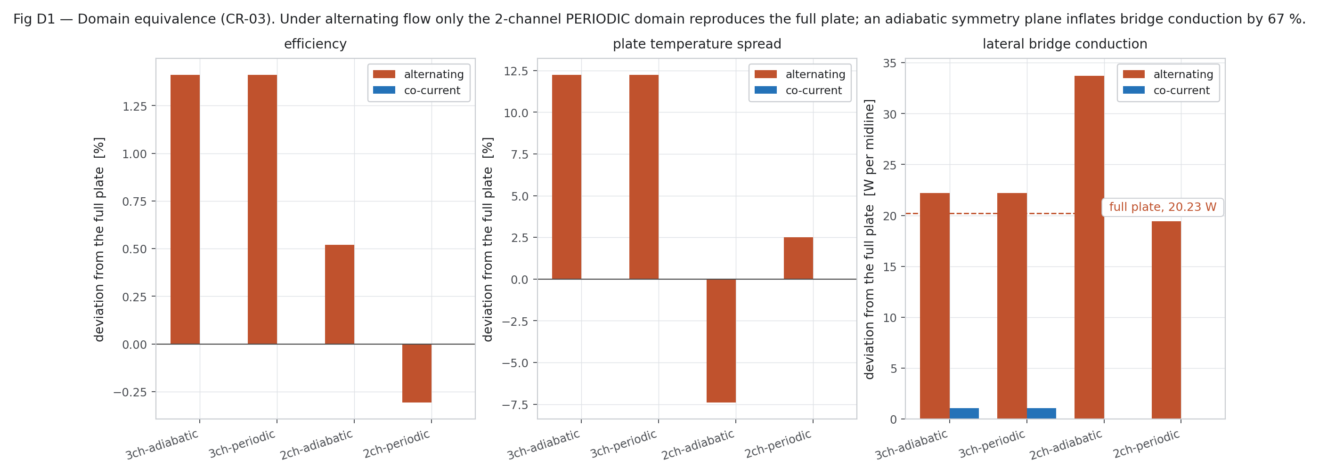
Figure W6.3 (Day 5). Domain equivalence check (first campaign — numbers later corrected in Week 7)
Only the 2-channel PERIODIC domain reproduces the full plate under alternating flow.
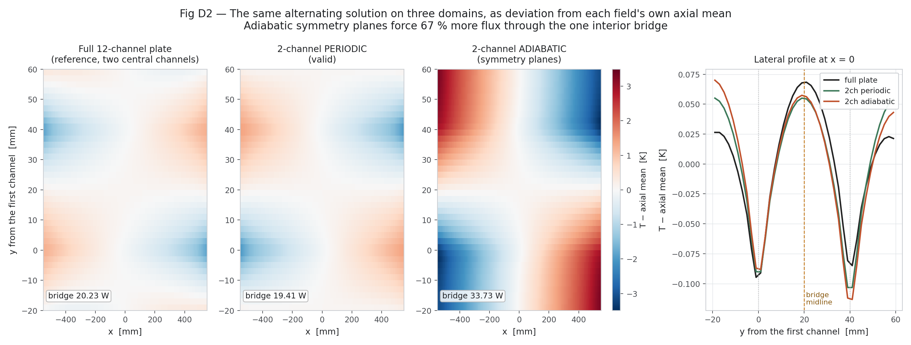
Figure W6.4 (Day 5). Same solution on three domains (first campaign — numbers later corrected in Week 7)
Temperature deviation fields for the full plate, 2-channel periodic and 2-channel adiabatic domains.
Day 6 — Saturday, 12 Sep 2026
Today we ran the first campaign of 300 cases with Nu = 2.92 and checked the energy balance of every case; the largest error was 0.000098 %, far below our limit of 0.5 %. We plotted efficiency against sunshine and reduced temperature, the temperature rise, the effect of wind, a first efficiency-curve fit and the quality-control plots. In every case the Reynolds number rose from inlet to outlet, as expected for a converging channel.
Main points of today's work:
- Ran the first campaign (first run, then second run) with Nu = 2.92.
- Checked the energy balance of every case.
- Plotted efficiency, temperature rise, wind sensitivity, the first efficiency-curve fit and quality control.
Result / observation: Worst energy-balance error 0.000098 % (limit 0.5 %). Re rises downstream in every case.
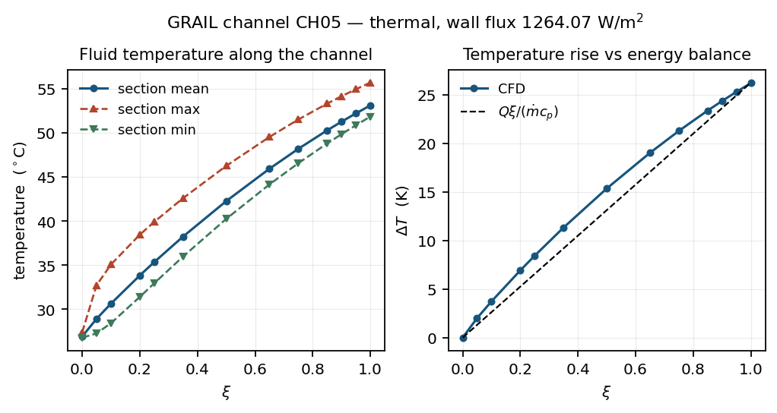
Figure W6.5 (Day 6). Thermal result along one channel (first campaign — numbers later corrected in Week 7)
Fluid temperature along the channel and the temperature rise against the energy balance Qξ/(ṁc_p).
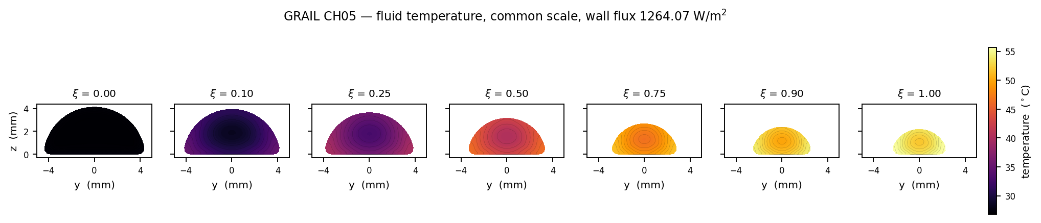
Figure W6.6 (Day 6). Fluid temperature sections (first campaign — numbers later corrected in Week 7)
Fluid temperature on seven sections on a common scale, inlet to outlet.
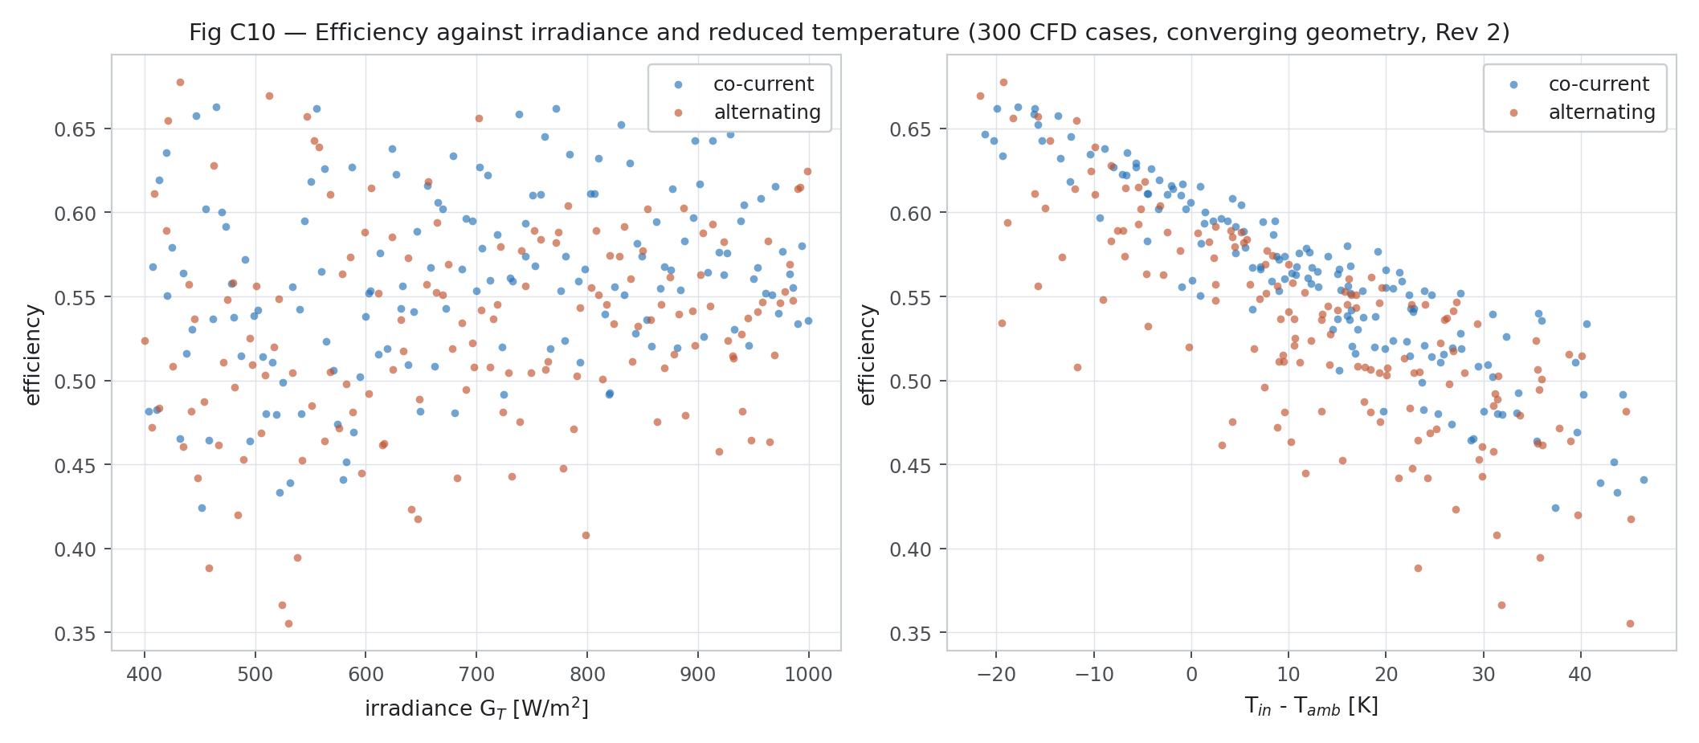
Figure W6.7 (Day 6). Efficiency against irradiance and reduced temperature (first campaign — numbers later corrected in Week 7)
All 300 cases: efficiency falls with reduced temperature as expected.
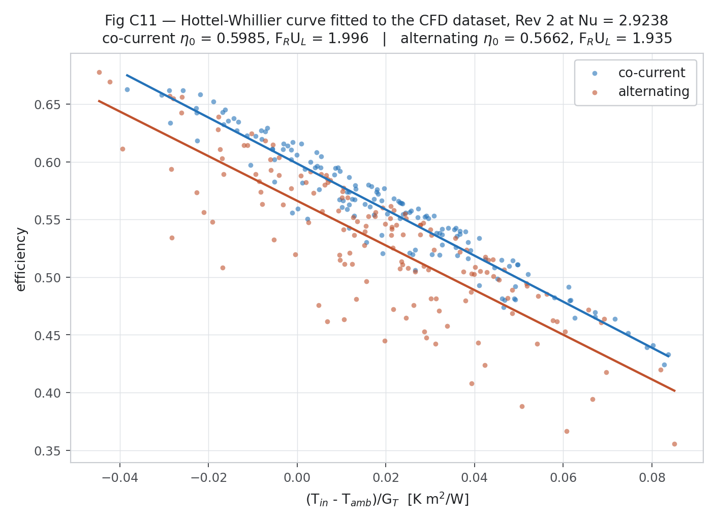
Figure W6.8 (Day 6). First efficiency-curve fit (first campaign — numbers later corrected in Week 7)
Hottel-Whillier line fitted to the first campaign for both arrangements.
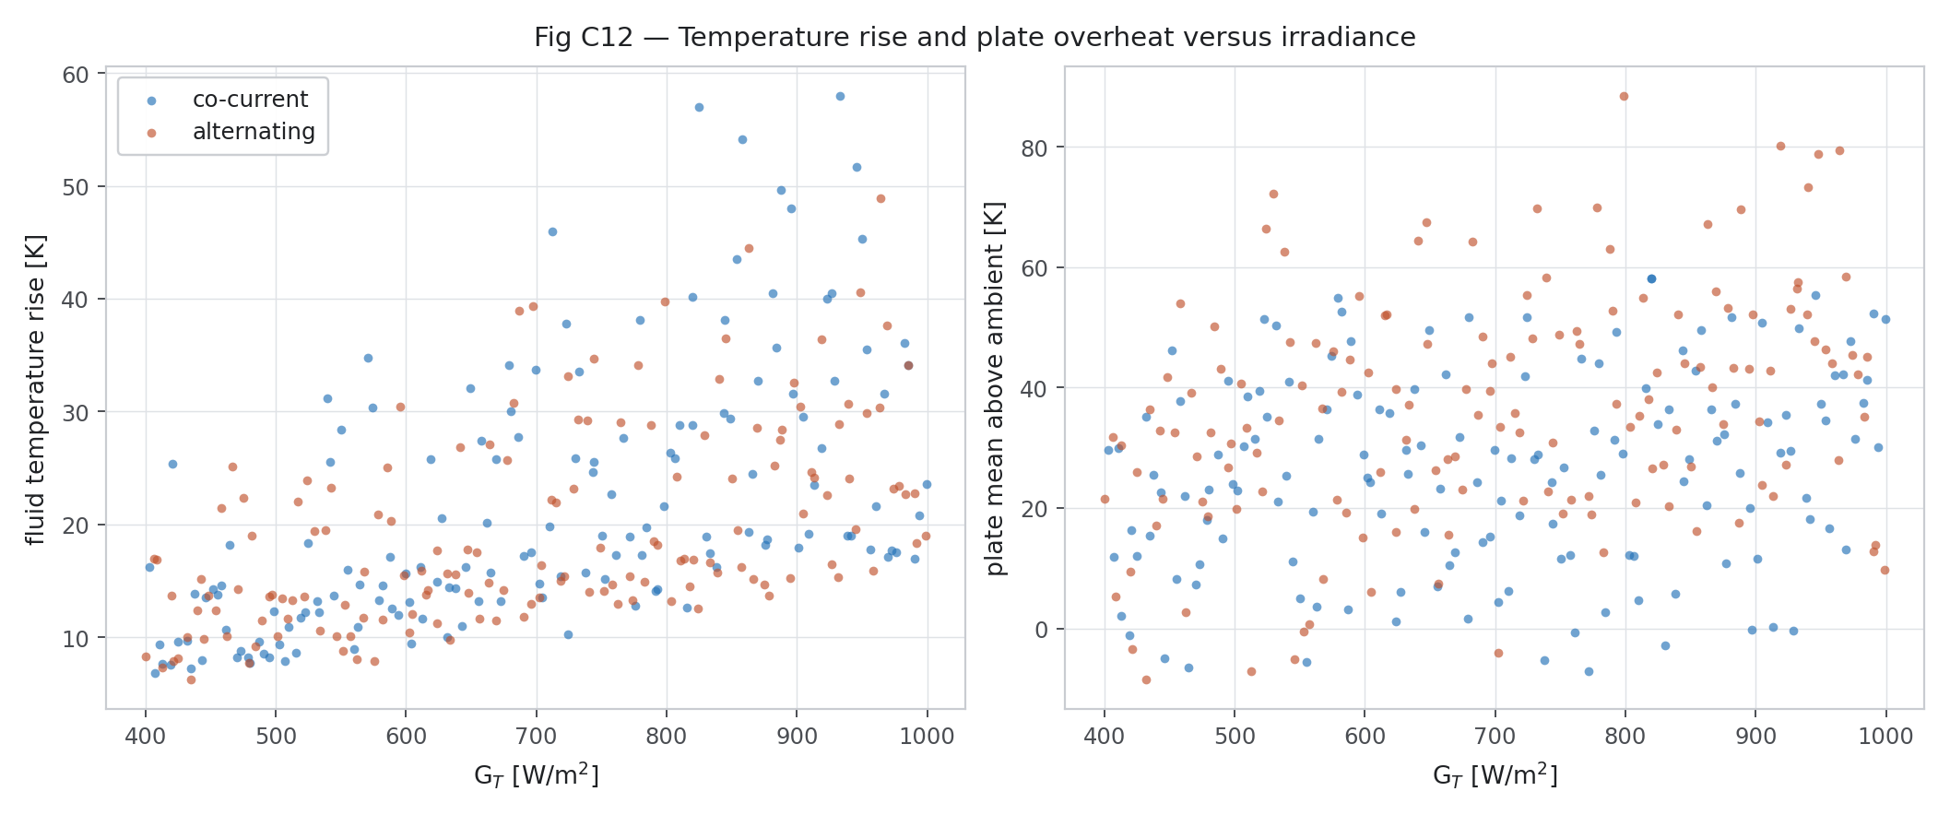
Figure W6.9 (Day 6). Temperature rise and plate overheat (first campaign — numbers later corrected in Week 7)
Fluid temperature rise and plate mean above ambient against irradiance.
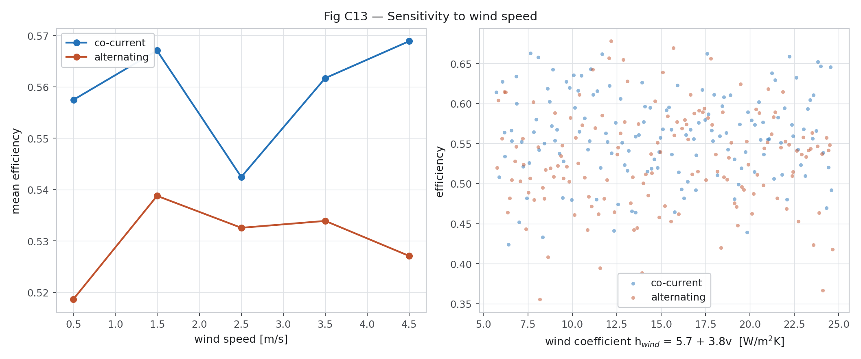
Figure W6.10 (Day 6). Sensitivity to wind speed (first campaign — numbers later corrected in Week 7)
Mean efficiency at five wind speeds and efficiency against the wind coefficient.
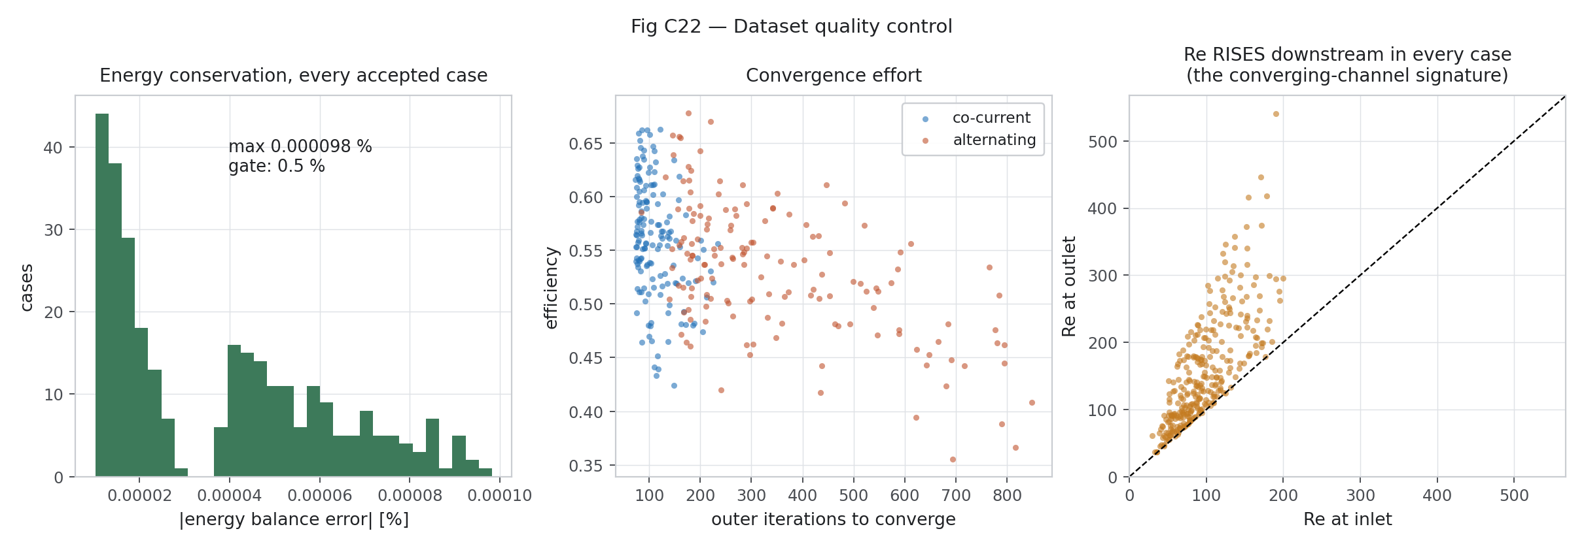
Figure W6.16 (Day 6). Dataset quality control (first campaign — numbers later corrected in Week 7)
Energy-balance error of every accepted case, convergence effort, and Re at outlet vs inlet (Re rises in every case).
Day 7 — Sunday, 13 Sep 2026
Today was the weekly review. We found that comparing the alternating and parallel cases in pairs was wrong, because the two groups were sampled independently, so we changed to group statistics. We then studied how alternating flow works: heat moves sideways through the bridges from the hot channel to the cold one (about 218 W in total across the plate), while in parallel flow no heat crosses the bridges. We also plotted the effect of grading and bridge width and the correlations between inputs and outputs, and wrote the first campaign report. These numbers were later corrected in Week 7.
Main points of today's work:
- Weekly review: found that paired case-by-case (paired) statistics were wrong because the two groups are independent samples — changed to group statistics.
- Studied the mechanism: bridge conduction, plate temperature maps, temperature distributions, grading and bridge-width sensitivity, correlations.
- Wrote the first campaign report.
Result / observation: Alternating flow moves heat sideways through the bridges (about 218 W in total); parallel flow moves none.
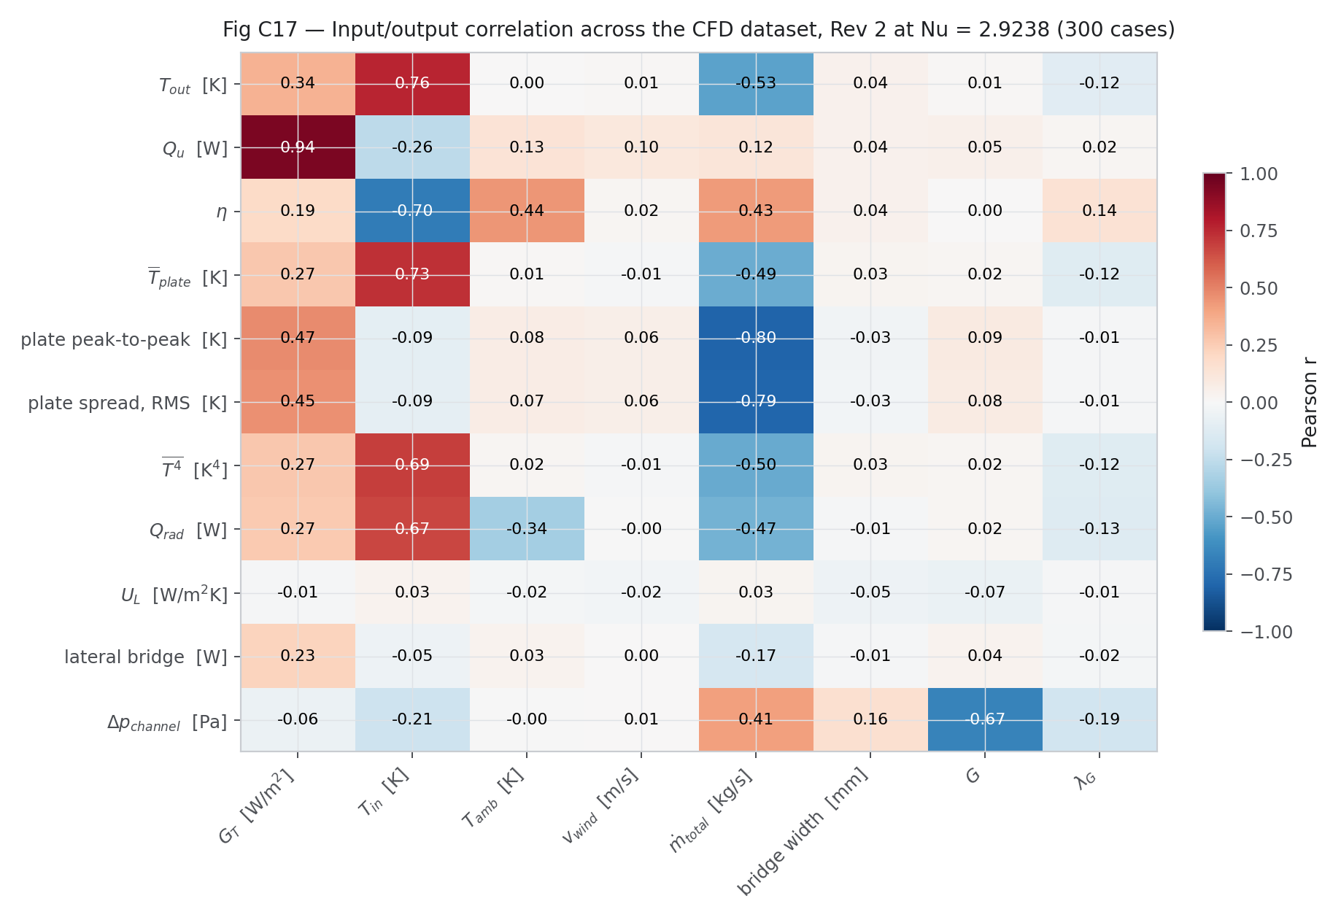
Figure W6.11 (Day 7). Input/output correlation (first campaign — numbers later corrected in Week 7)
Pearson correlation between the 8 inputs and the outputs of the first campaign.
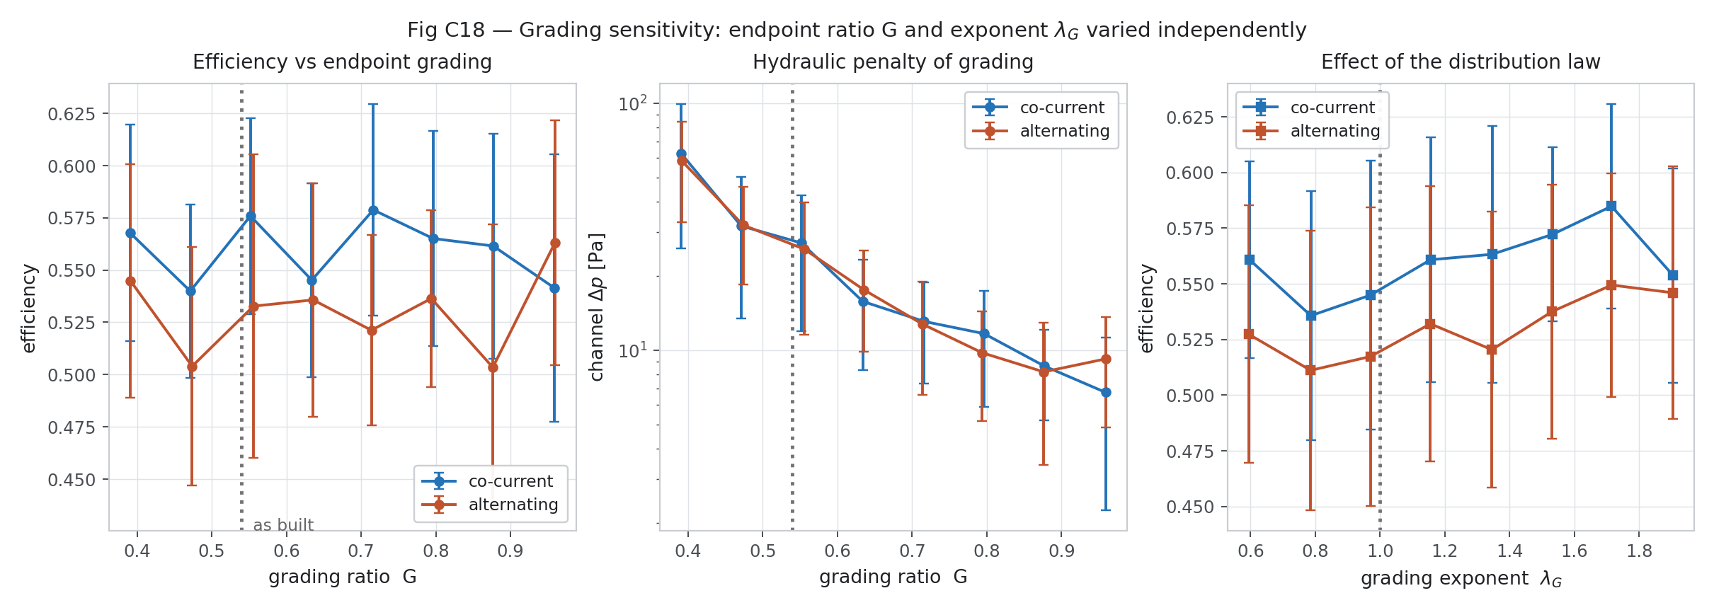
Figure W6.12 (Day 7). Grading sensitivity (first campaign — numbers later corrected in Week 7)
Effect of the grading ratio G and exponent λ on efficiency and pressure drop.
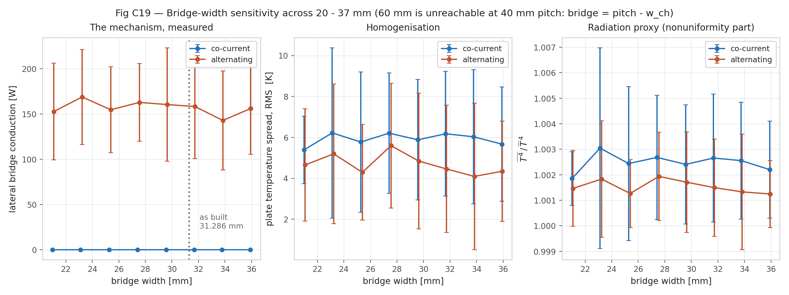
Figure W6.13 (Day 7). Bridge-width sensitivity (first campaign — numbers later corrected in Week 7)
Lateral bridge conduction, plate spread and radiation proxy against bridge width 20–37 mm.
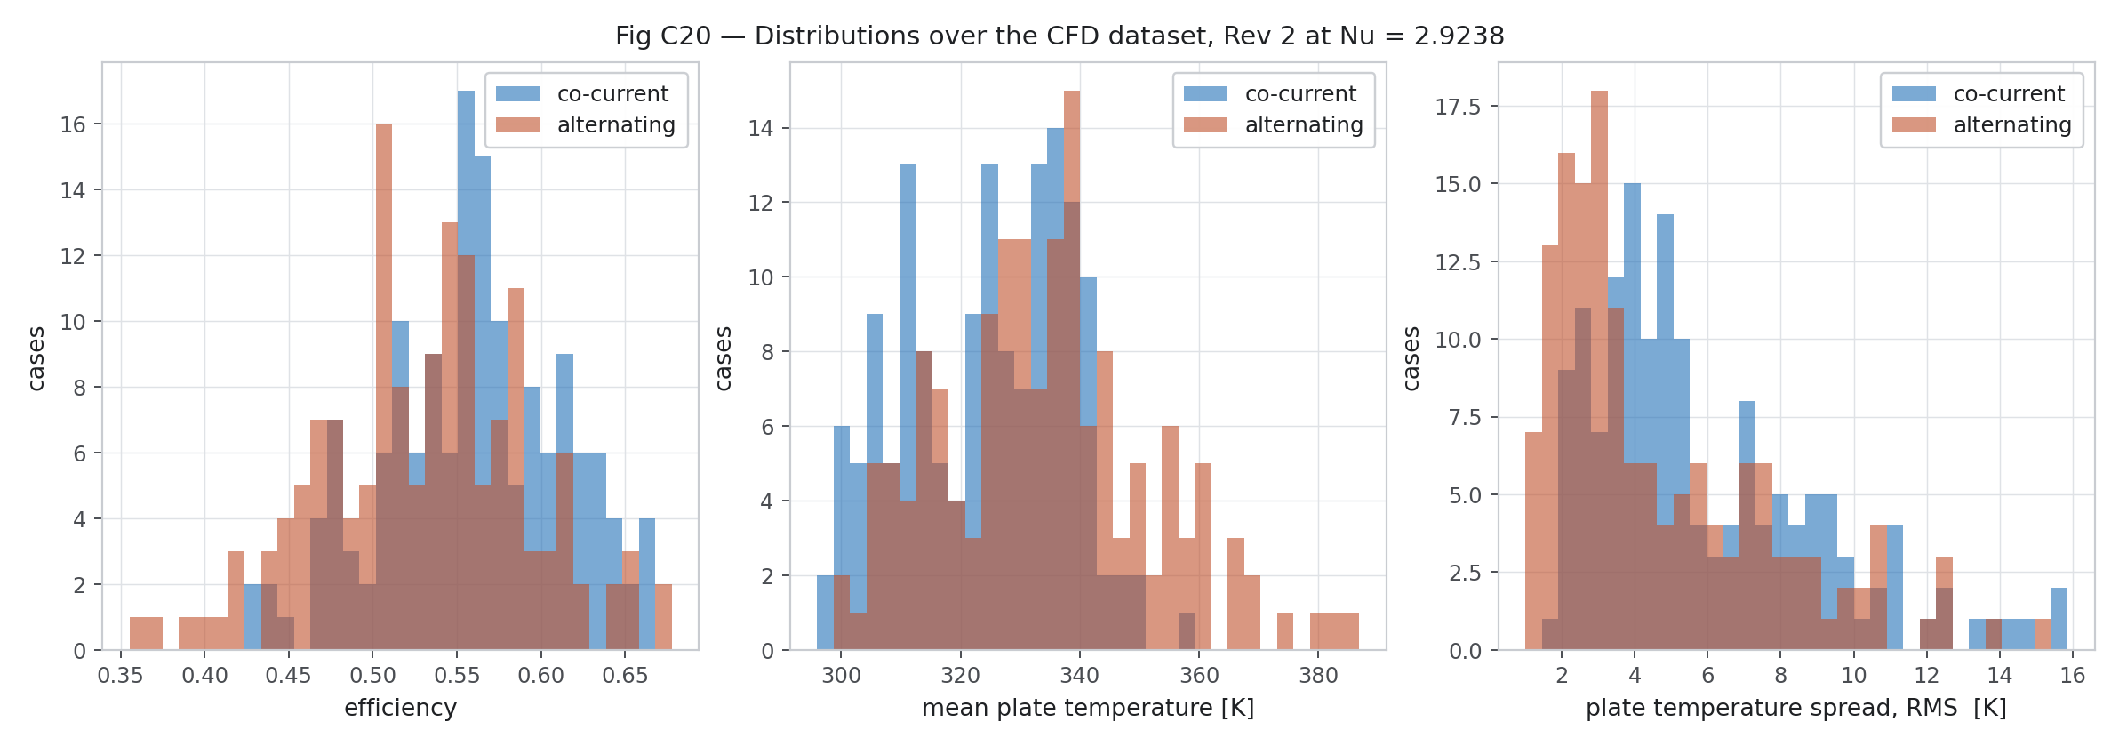
Figure W6.14 (Day 7). Distributions over the dataset (first campaign — numbers later corrected in Week 7)
Histograms of efficiency, mean plate temperature and plate spread for both arrangements.
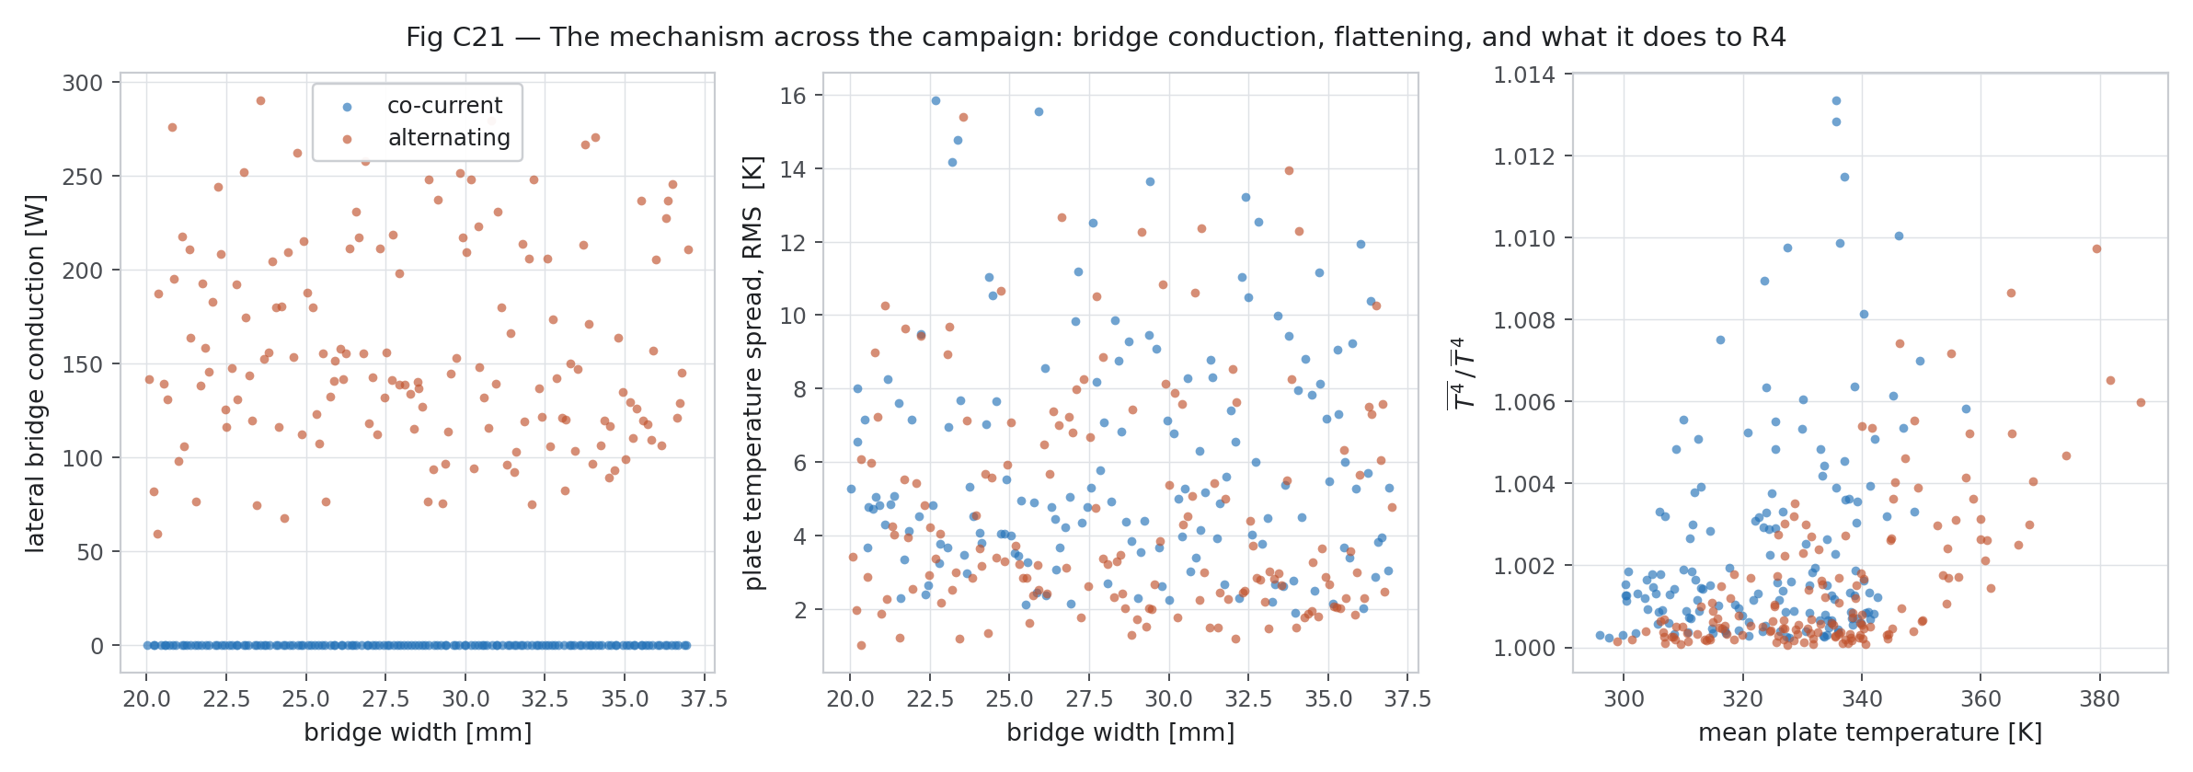
Figure W6.15 (Day 7). Mechanism across the campaign (first campaign — numbers later corrected in Week 7)
Bridge conduction, flattening and its effect on the radiation term across all cases.
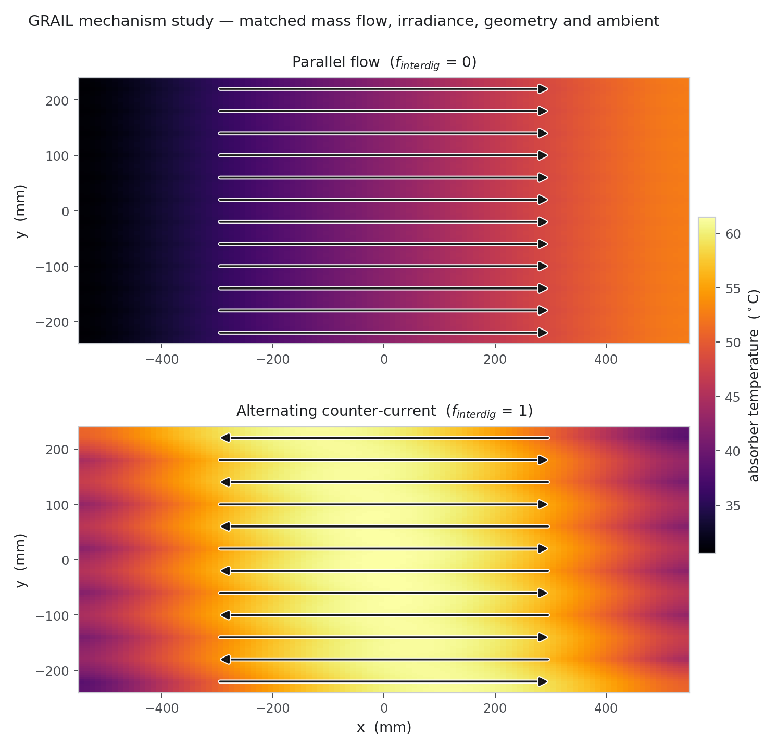
Figure W6.17 (Day 7). Mechanism study: plate temperature maps (first campaign — numbers later corrected in Week 7)
Parallel and alternating plate temperature at matched mass flow, irradiance, geometry and ambient. Arrows show the flow direction in each channel.
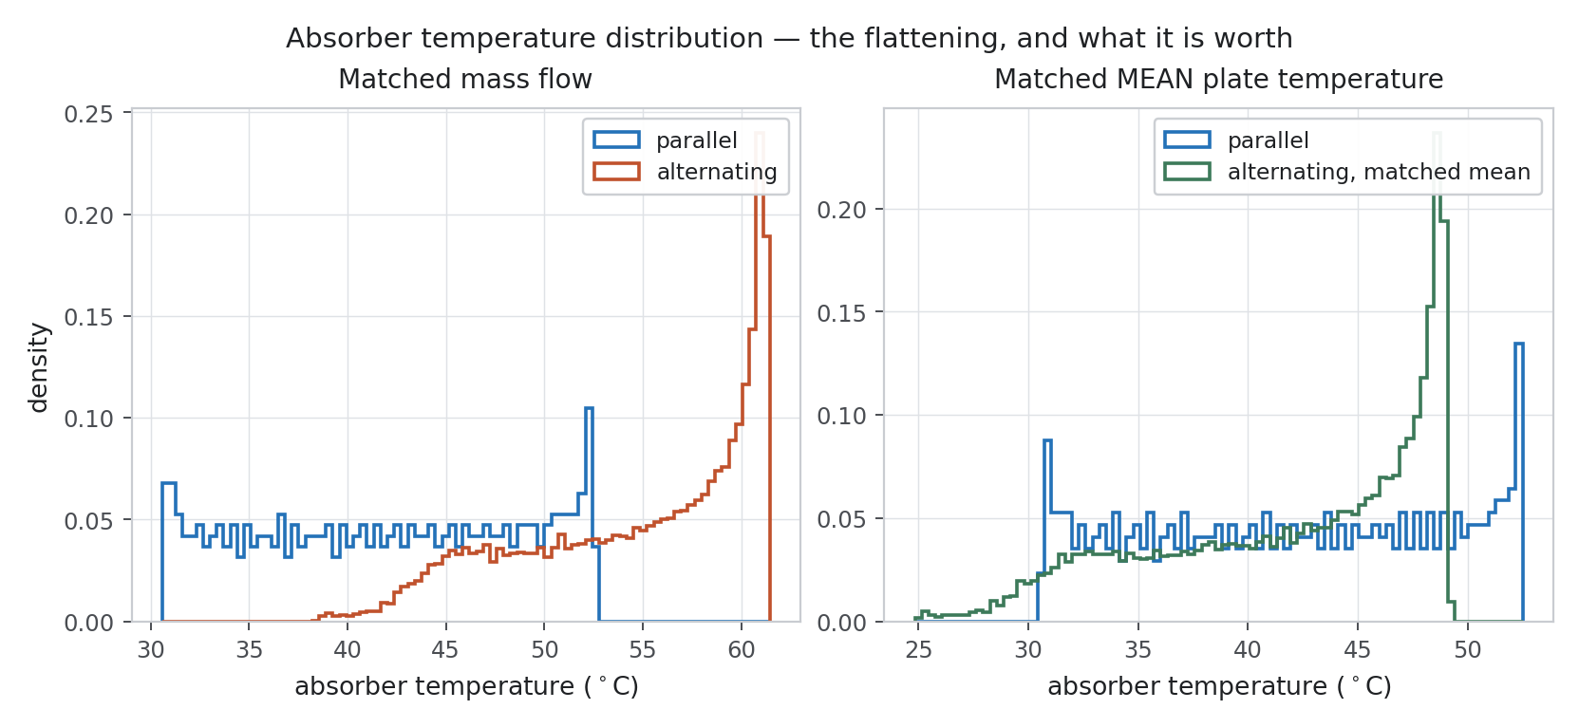
Figure W6.18 (Day 7). Absorber temperature distribution (first campaign — numbers later corrected in Week 7)
Histogram of absorber temperature for both arrangements, at matched mass flow and at matched mean plate temperature.
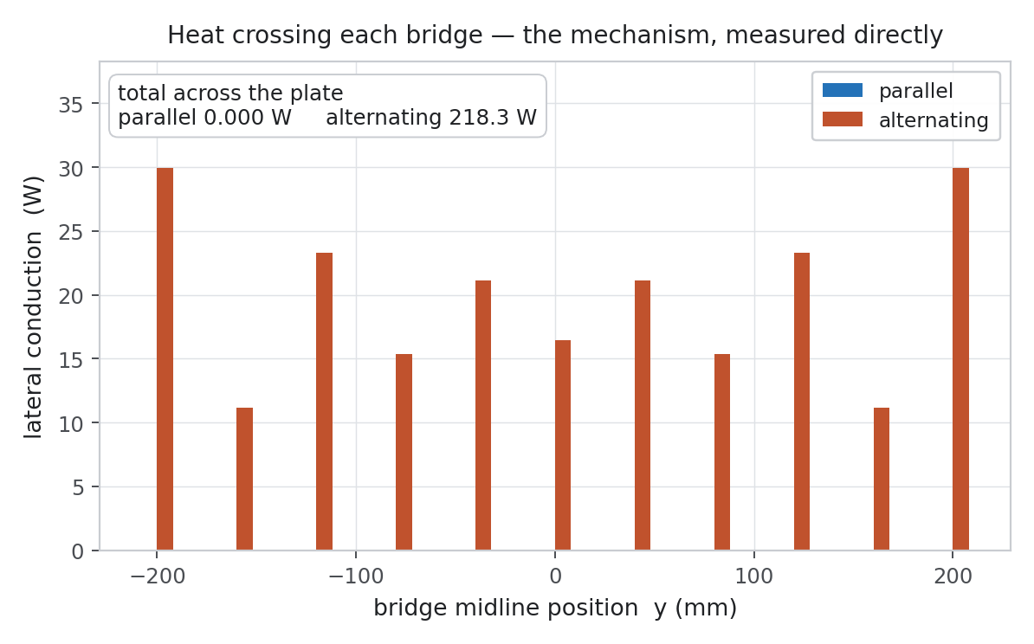
Figure W6.19 (Day 7). Heat crossing each bridge (first campaign — numbers later corrected in Week 7)
Lateral conduction through each bridge: zero for parallel flow, about 218 W in total for alternating flow — the mechanism measured directly.

Week summary
GRAIL-CHT written and verified; first 300-case campaign completed and analysed (numbers later corrected in Week 7).

Plan for next week
Check the Nusselt number with full 3-D conjugate CFD.

Guide sign-off
Work shown to guide on (date)
Guide remarks
Student(s) signature
Guide signature

Week 7 | 14 Sep – 20 Sep 2026 | Completed
Title of the week: 3-D conjugate CFD, Nu correction and final dataset
Dates: 14 Sep – 20 Sep 2026 (Monday to Sunday)
Status: Completed

Aim of this week
Check Nu with 3-D conjugate CFD, correct the model, re-run the campaign and freeze the final dataset.
Day 1 — Monday, 14 Sep 2026
Today we checked how reliable the first campaign was. We did a grid-convergence study on three grids, 200 paired Monte Carlo runs with uncertain material properties and boundary conditions, and a sensitivity analysis. We also measured the correction from the campaign grid to a finer 220 × 240 grid and compared the first run (Nu 3.43) with the second run (Nu 2.92) on 291 matching cases. The flow quantities were grid-converged, but the Nusselt number was not (grid convergence index 11.6 %), so we decided to check it with full 3-D conjugate CFD.
Main points of today's work:
- Uncertainty study on the first campaign: grid convergence index on three grids.
- 200-sample paired Monte Carlo on property and boundary-condition inputs; regression sensitivity.
- Measured the correction from the campaign grid to a 220 × 240 grid at 10 operating points.
- Compared the first run (Nu 3.43) with the second run (Nu 2.92) on 291 paired cases.
Result / observation: Nu was not grid-converged (grid convergence index 11.6 %) while the hydraulic quantities were — the closure had to be checked in 3-D.
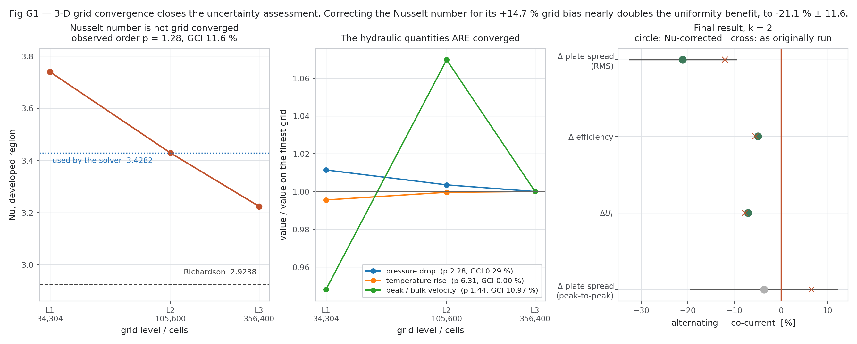
Figure W7.1 (Day 1). 3-D grid convergence of Nu (study that triggered the correction)
Nu was not grid-converged (observed order 1.28, grid convergence index 11.6 %), while the hydraulic quantities were converged.
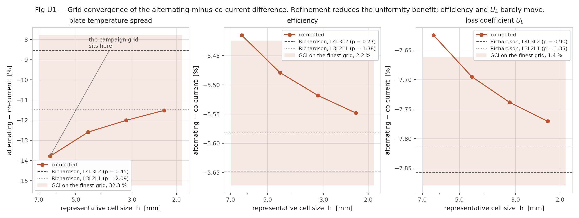
Figure W7.2 (Day 1). Grid convergence of the alternating − co-current difference (first campaign)
Refinement reduces the uniformity benefit; efficiency and U_L barely move.
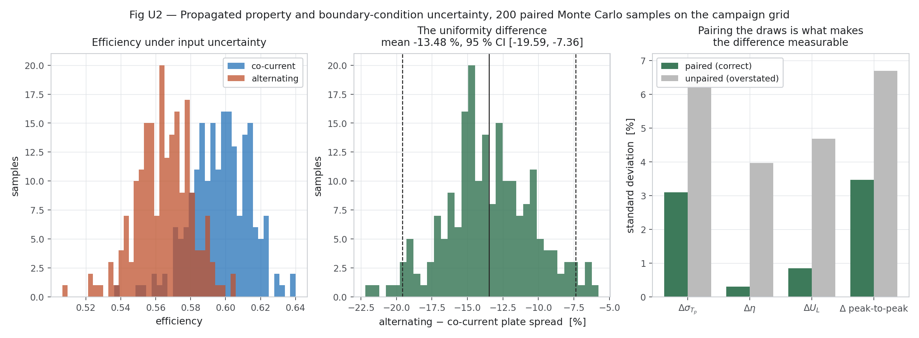
Figure W7.3 (Day 1). Monte Carlo input uncertainty (first campaign)
200 paired samples: the uniformity difference and why pairing the draws matters.
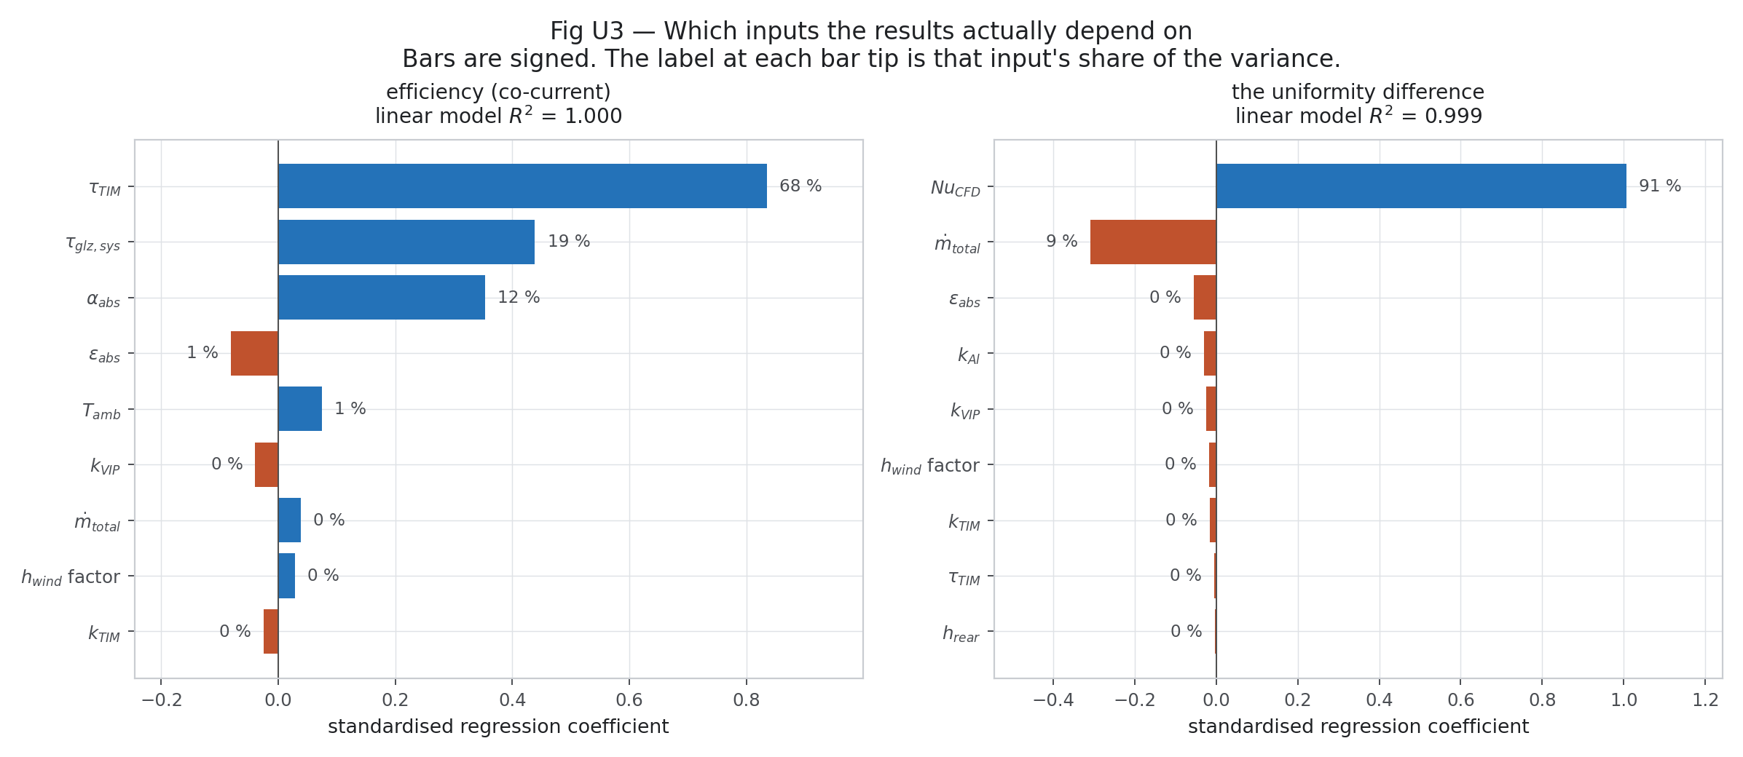
Figure W7.4 (Day 1). Which inputs the results depend on (first campaign)
Signed regression coefficients: TIM transmittance dominates efficiency; Nu dominates the uniformity difference.
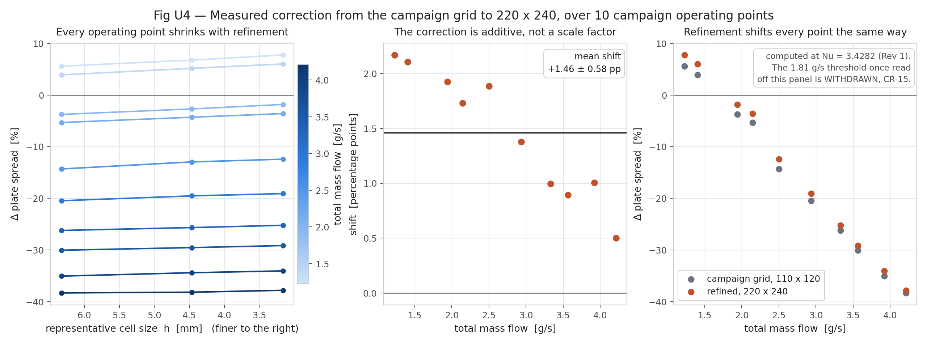
Figure W7.5 (Day 1). Grid correction over 10 operating points (first campaign)
The correction from the campaign grid to 220 × 240 is an additive shift of about +1.46 points.
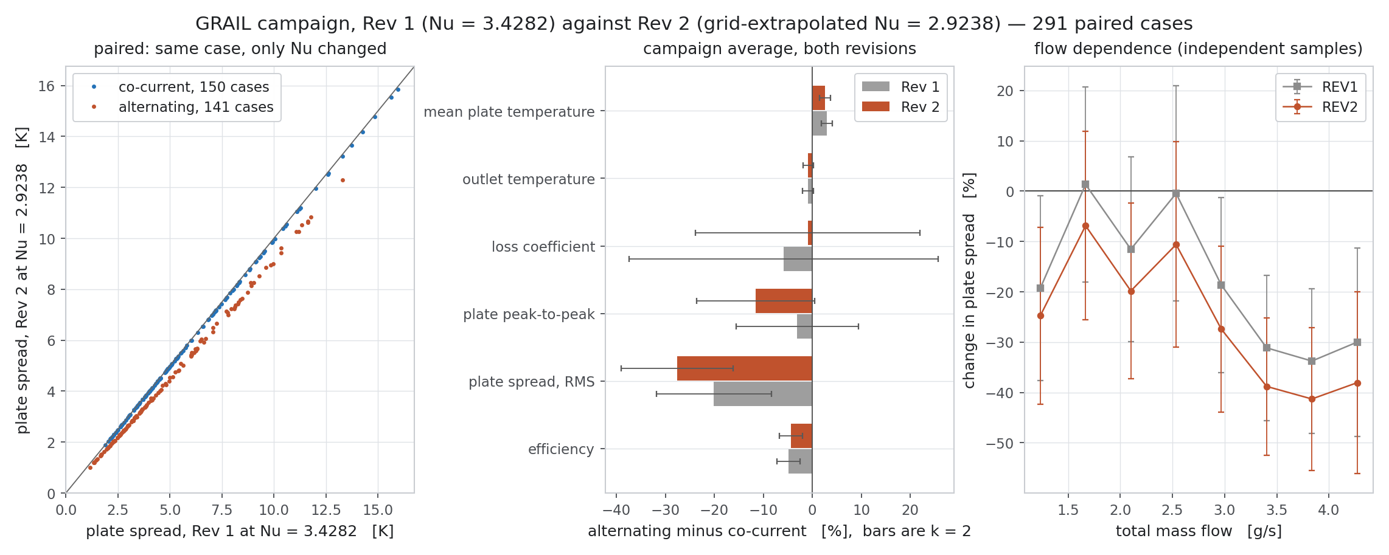
Figure W7.6 (Day 1). First run against second run (291 paired cases)
Same cases, only Nu changed: shows how strongly the closure changes the results.
Day 2 — Tuesday, 15 Sep 2026
Today we ran the full 3-D conjugate CFD, where the metal and the water are solved together (chtMultiRegionSimpleFoam). The solver with buoyancy diverged on the very thin cells. We fixed this by first solving the flow with simpleFoam and then solving only the energy equation with the flow frozen. The simulation converged: the rear-surface temperature spread was 5.79 K for co-current flow and 5.49 K for alternating flow. We also made a video of the result with tracer points moving with the water.
Main points of today's work:
- Ran 3-D conjugate CFD (chtMultiRegionSimpleFoam). The buoyant solver diverged on thin cells.
- Fixed it by solving the flow first with simpleFoam and then the energy equation with frozenFlow.
- Made the rear-surface temperature maps and the CFD video with tracers.
Result / observation: 3-D conjugate CFD converged: plate std 5.79 K (co-current) and 5.49 K (alternating).
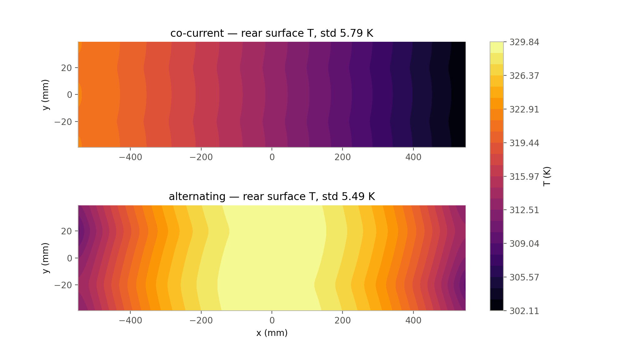
Figure W7.12 (Day 2). 3-D conjugate plate temperature maps
Rear-surface temperature for co-current (std 5.79 K) and alternating (std 5.49 K) flow.
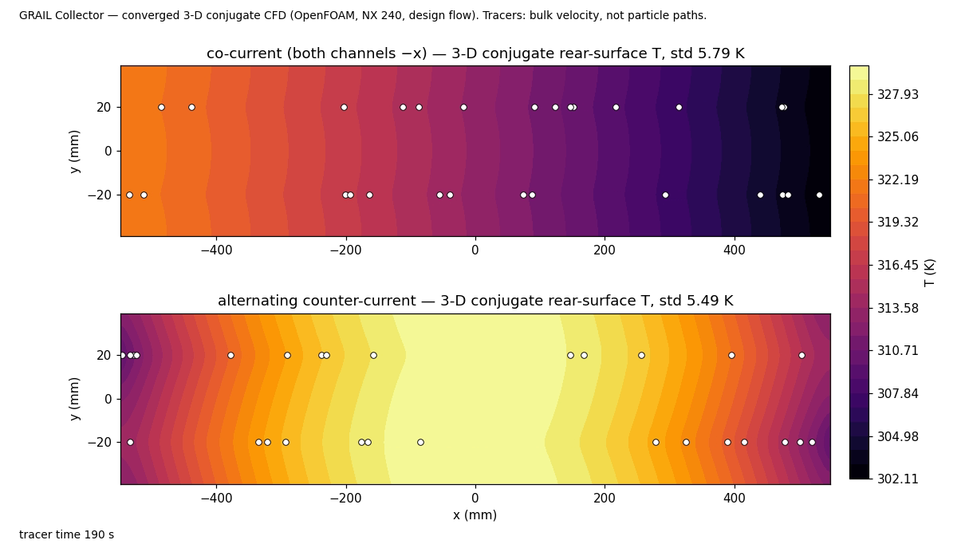
Figure W7.13 (Day 2). Frame from the 3-D CFD video
Converged conjugate CFD at the design flow with tracer points moving at the bulk velocity.
Day 3 — Wednesday, 16 Sep 2026
Today we found and removed two differences between the 3-D CFD and our fast model. The sunshine had been applied to the sloping surface area instead of the flat plan area, which gave 12.2 % too much heat; we corrected it to the plan area. The meshed inlet also carried 0.30 % less flow than planned, so we used the same flow in GRAIL-CHT for the comparison.
Main points of today's work:
- Corrected the solar input to the plan area (a +12.2 % error removed).
- Matched the 0.30 % lower flow of the meshed inlet in GRAIL-CHT.
Result / observation: Inputs are now the same in 3-D CFD and GRAIL-CHT.
Day 4 — Thursday, 17 Sep 2026
Today we calculated the correct Nusselt number from the 3-D CFD. On section grids with 48, 64 and 96 cells, the fully developed value was Nu = 4.48 with a grid convergence index of only 2.1 %. This value belongs to the correct boundary condition for a channel inside a conducting plate, while the old 2.92 belonged to a different wall condition. With Nu = 4.48, GRAIL-CHT matched the 3-D CFD within 0.01 % in efficiency and 0.6 % in plate temperature spread. We also checked that using a constant Nu is good enough compared with the local Nu profile along the channel.
Main points of today's work:
- Computed the developed conjugate Nu on section grids with 48, 64 and 96 cells and the local Nu along the channel.
- Checked constant-Nu vs 3-D Nu(ξ) profile in GRAIL-CHT and the axial convergence of GRAIL-CHT against 3-D.
Result / observation: Nu = 4.48 (grid convergence index 2.1 %, correct conjugate boundary condition, called H1) replaces 2.92. GRAIL-CHT now matches 3-D within 0.01 % (η) and 0.6 % (plate std).
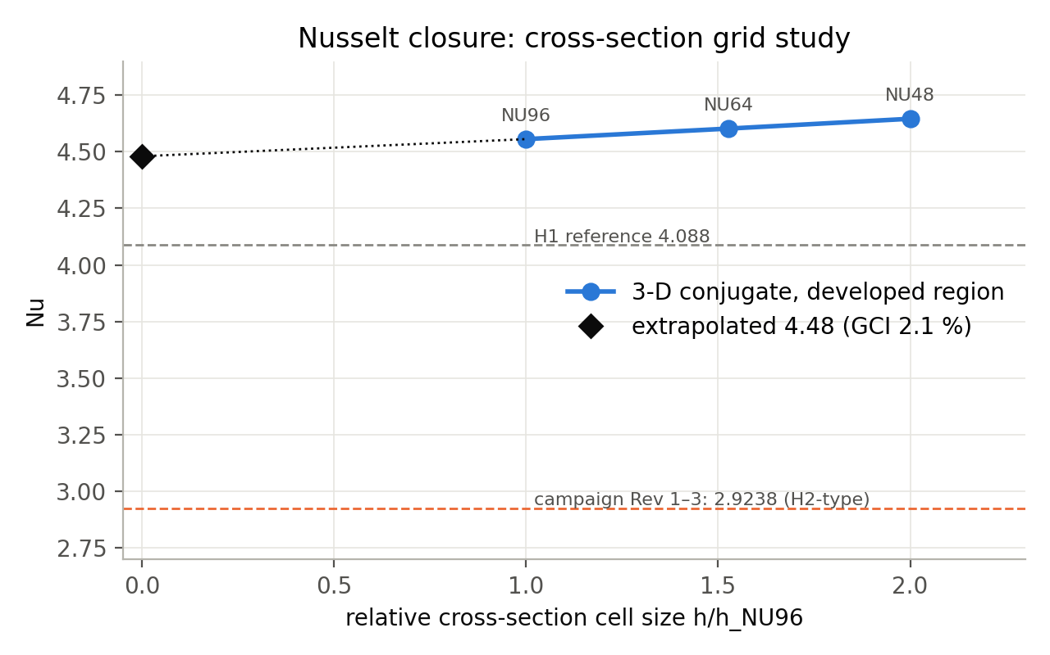
Figure W7.7 (Day 4). Cross-section grid study of Nu
Nu on section grids with 48, 64 and 96 cells — converged value used for the correction.
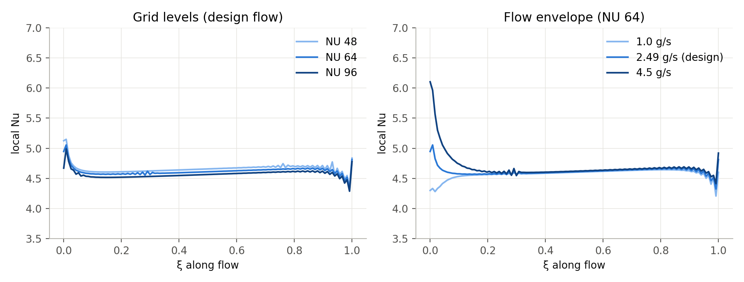
Figure W7.8 (Day 4). Local Nu along the channel
Local Nu from the conjugate CFD: short entrance region, then about 4.5–4.6 over most of the length, at three grids and three flows.
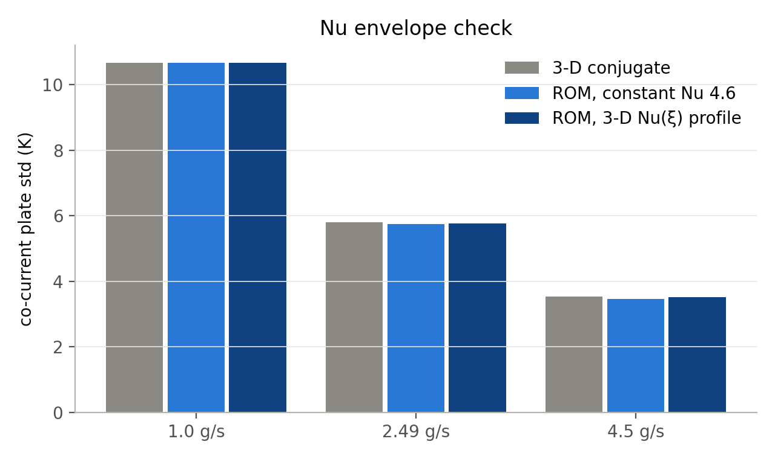
Figure W7.9 (Day 4). Nu envelope check
Co-current plate std from 3-D CFD, reduced-order model with constant Nu and reduced-order model with the 3-D Nu(ξ) profile at three flows — the constant-Nu reduced-order model is adequate.
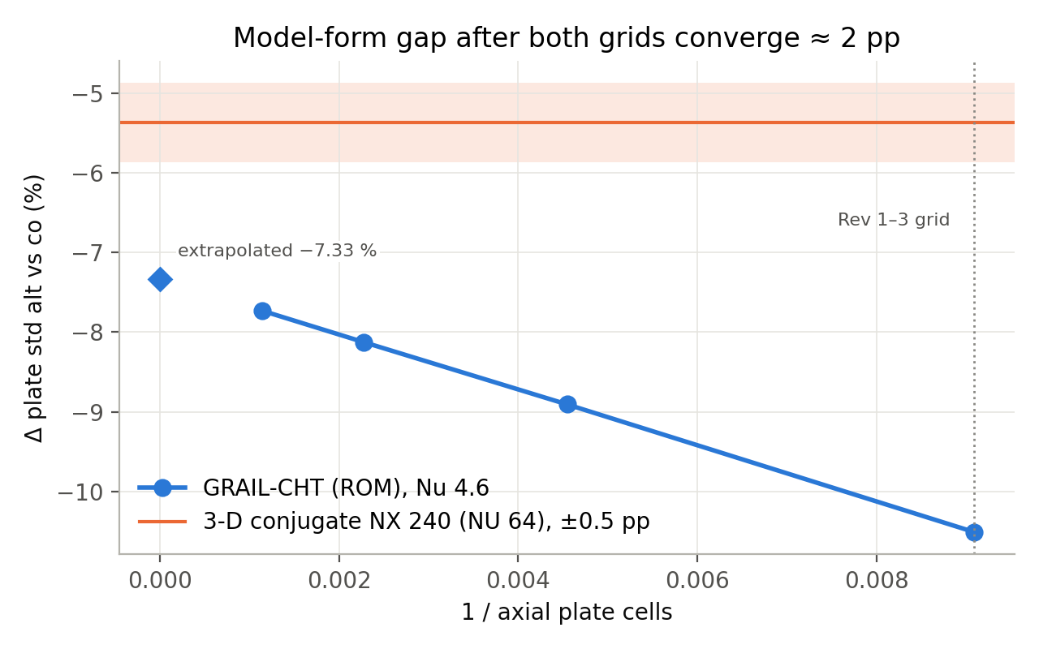
Figure W7.10 (Day 4). Reduced-order model vs 3-D: axial convergence
Reduced-order-model uniformity difference converges towards −7.33 %; 3-D gives −5.37 %: model-form gap about 2 points.
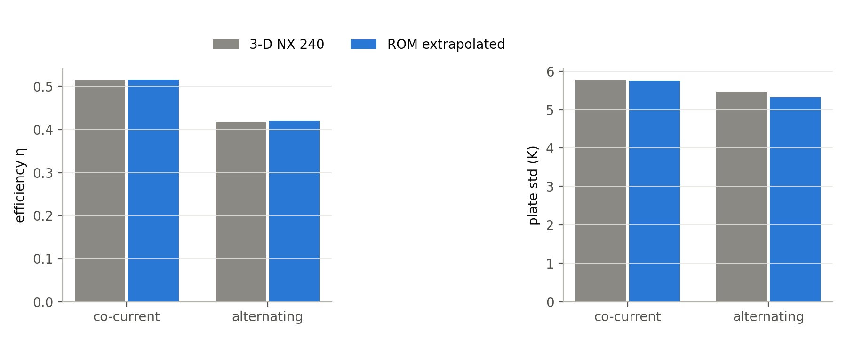
Figure W7.11 (Day 4). Reduced-order model vs 3-D: efficiency and plate std
After the correction the reduced-order model matches 3-D in efficiency and plate spread for both arrangements.
Day 5 — Friday, 18 Sep 2026
Today we re-ran all 300 cases with Nu = 4.48 and a refined plate grid, using Richardson extrapolation (2 × result on 220 cells − result on 110 cells) to remove the grid error. All 300 cases converged.
Main points of today's work:
- Re-ran all 300 cases (fourth run) with Nu 4.48 and the Richardson-extrapolated plate grid: f = 2 f(220) − f(110).
Result / observation: 300/300 cases converged.
Day 6 — Saturday, 19 Sep 2026
Today we did an independent audit of the new dataset. Every case was checked for convergence, energy balance and input range. No case had to be removed, and all were within the energy-balance limit. The final dataset has 300 cases with 59 columns each and was frozen.
Main points of today's work:
- Independent audit of the dataset: every case checked for convergence, energy balance and input ranges → the final dataset.
Result / observation: No case removed; all within the energy-balance limit. Final dataset: 300 × 59 columns.
Day 7 — Sunday, 20 Sep 2026
Today was the weekly review of the final results. We compared the two groups with the Mann-Whitney test: alternating flow gave 7.3 % lower efficiency (p = 2 × 10⁻⁸), and the difference in plate temperature spread (−1.1 %) was not significant. About 40 % of the heat taken by the water in an alternating channel is given back to the plate. We also plotted the results by flow rate, the heat recirculation, the heat-loss breakdown, the correlations and the effect of grading. The result does not favour alternating flow, and we are reporting it exactly as found.
Main points of today's work:
- Weekly review: group statistics (Mann-Whitney), results by flow rate, heat recirculation, loss breakdown, correlations and grading effect.
Result / observation: Alternating flow: −7.3 % efficiency (p = 2 × 10⁻⁸); plate spread −1.1 % (not significant); about 40 % of the heat is returned to the plate. Reported as found.
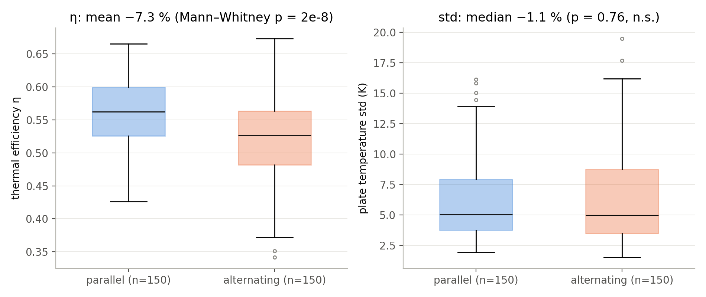
Figure W7.14 (Day 7). Final dataset: arrangement groups
Efficiency is 7.3 % lower with alternating flow (Mann-Whitney p = 2e-8); plate spread differs by only −1.1 % (not significant).
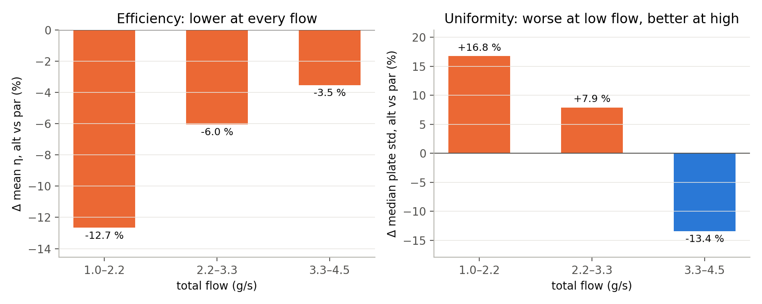
Figure W7.15 (Day 7). Final dataset: effect by flow rate
Efficiency lower at every flow (−12.7, −6.0, −3.5 %); uniformity worse at low flow and better at high flow.
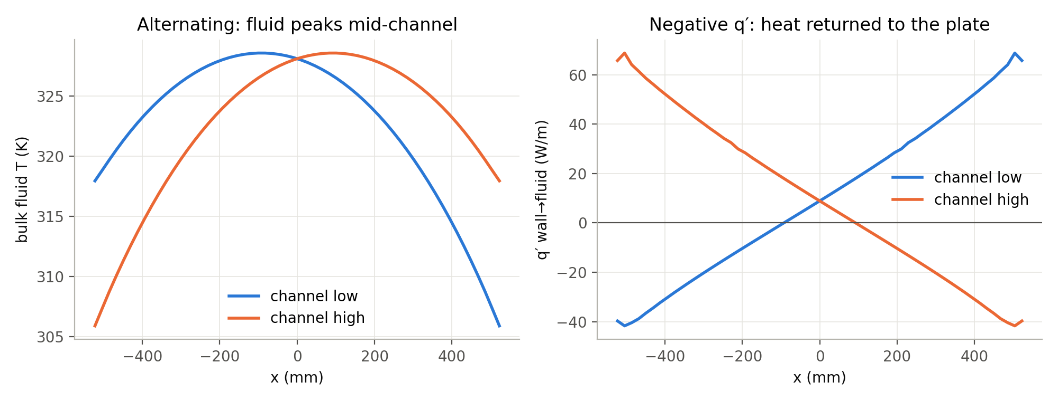
Figure W7.16 (Day 7). Heat recirculation in alternating flow
Fluid temperature peaks mid-channel and the wall heat flux turns negative: heat is returned from the fluid to the plate.
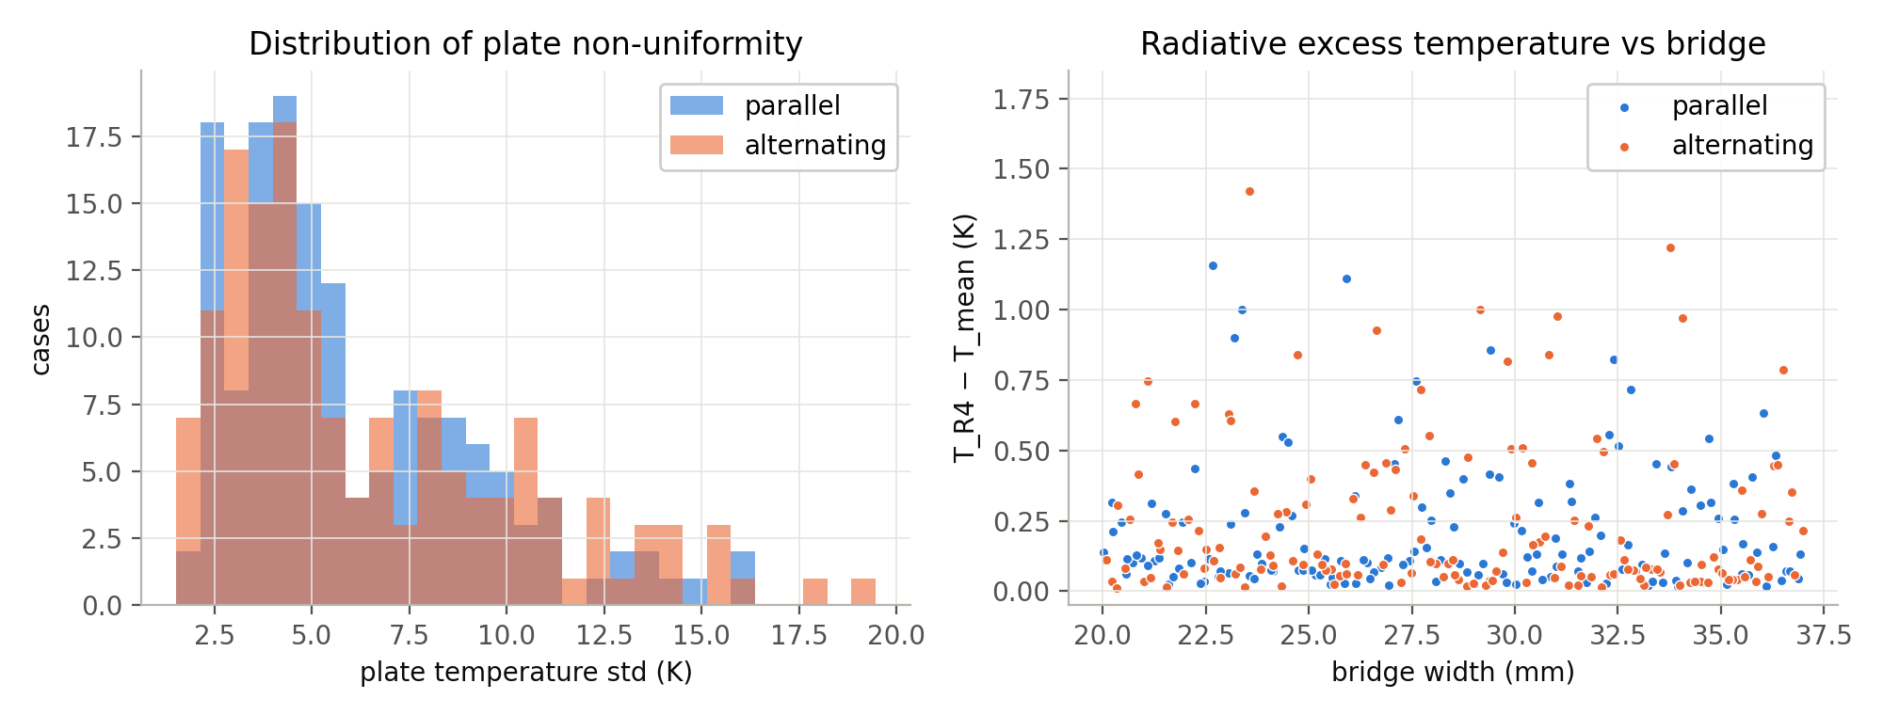
Figure W7.17 (Day 7). Plate non-uniformity and radiative excess
Distribution of plate std and the radiative excess temperature against bridge width.
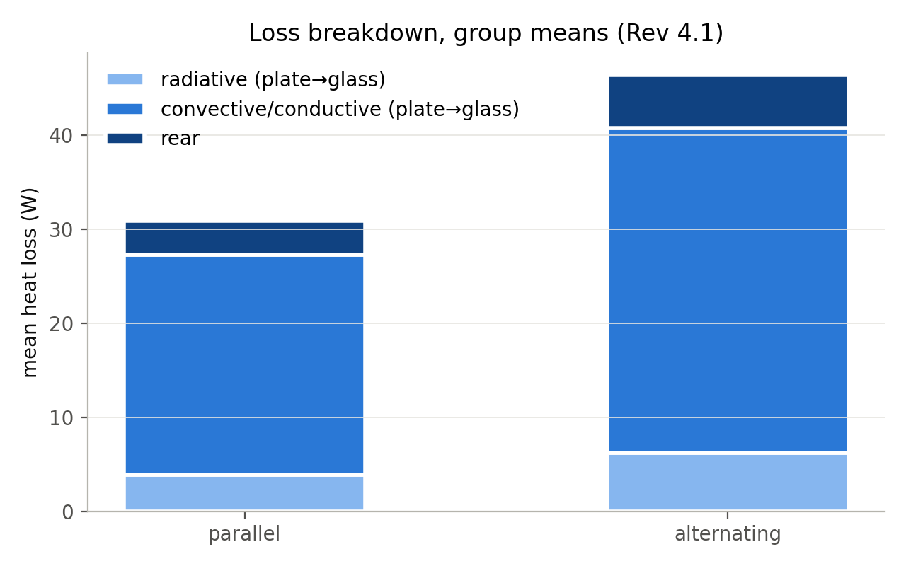
Figure W7.18 (Day 7). Loss breakdown (final dataset)
Radiative, convective and rear losses for both arrangements.
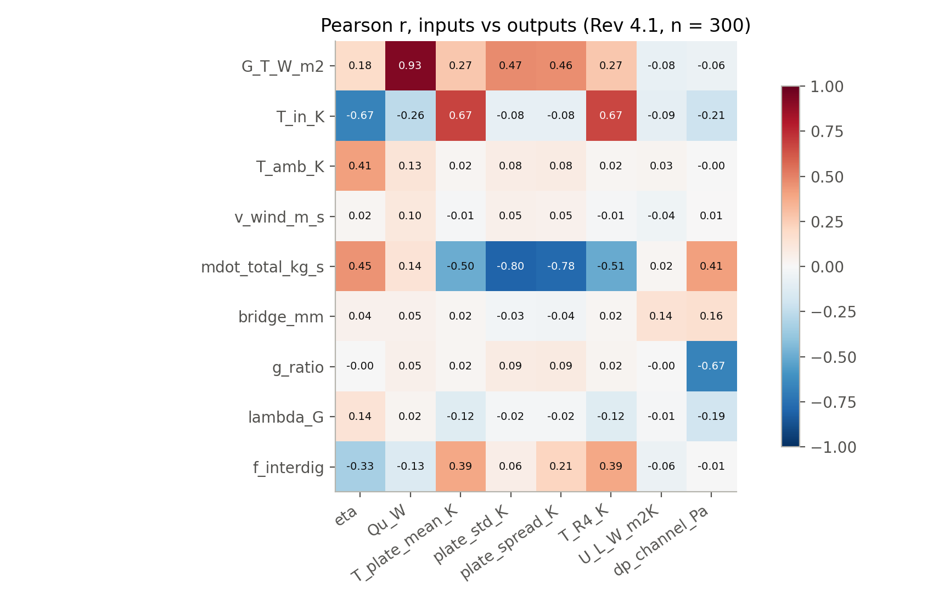
Figure W7.19 (Day 7). Correlation heatmap (final dataset)
Correlation of inputs and outputs in the final dataset.
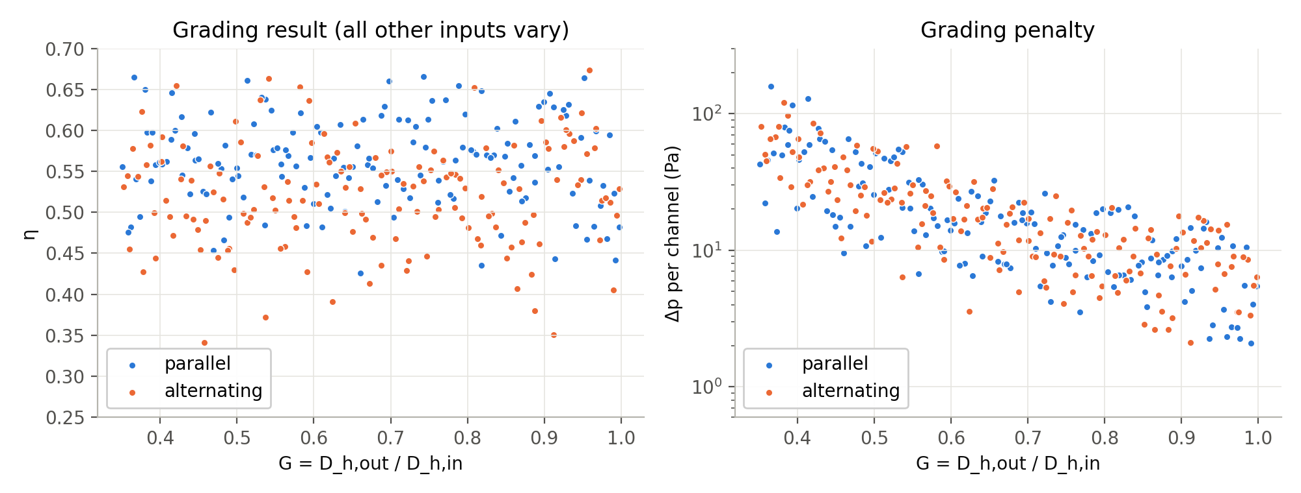
Figure W7.20 (Day 7). Grading effect (final dataset)
Efficiency and pressure drop against the grading ratio G.

Week summary
Nu corrected from 2.92 to 4.48 with 3-D conjugate CFD; whole campaign re-run and frozen as the final dataset with no case removed. Alternating flow is not better at equal inputs.

Plan for next week
Machine-learning surrogate model, design optimisation, virtual efficiency test, yearly performance study, system models and validation against published papers.

Guide sign-off
Work shown to guide on (date)
Guide remarks
Student(s) signature
Guide signature

Week 8 | 21 Sep – 27 Sep 2026 | Completed
Title of the week: ANN, optimisation, system models, validation and reports
Dates: 21 Sep – 27 Sep 2026 (Monday to Sunday)
Status: Completed

Aim of this week
Build the machine-learning surrogate model, optimise the design, run the virtual efficiency test and the yearly performance study, build the system model in three tools, validate against published papers and write the reports.
Day 1 — Monday, 21 Sep 2026
Today we built a machine-learning model that can predict our simulation results instantly. We split the 300 cases into 240 for training and 60 for testing, and trained an ensemble of 10 artificial neural networks, tuned with 5-fold cross-validation. On the 60 test cases the accuracy (R²) was 0.9994–0.9998. We then used SHAP analysis to see which inputs matter most: inlet and ambient temperature decide the efficiency, and flow rate decides the plate temperature spread. We also read two machine-learning papers; their models reached R² of about 0.93 and 0.992.
Main points of today's work:
- Machine-learning surrogate model: split the dataset (240 training, 60 test cases).
- Trained a 10-member ANN ensemble tuned by 5-fold cross-validation.
- Ran SHAP analysis to see which inputs drive each output.
- Read two machine-learning papers for comparison.
Papers read today: [28] Alawi O.A. 2024; [13] Nazmush Sakib 2026.
Result / observation: Test R² 0.9994–0.9998 (literature ML model ≈ 0.93; KAN surrogate 0.992). T_in and T_amb drive efficiency; flow drives plate spread.
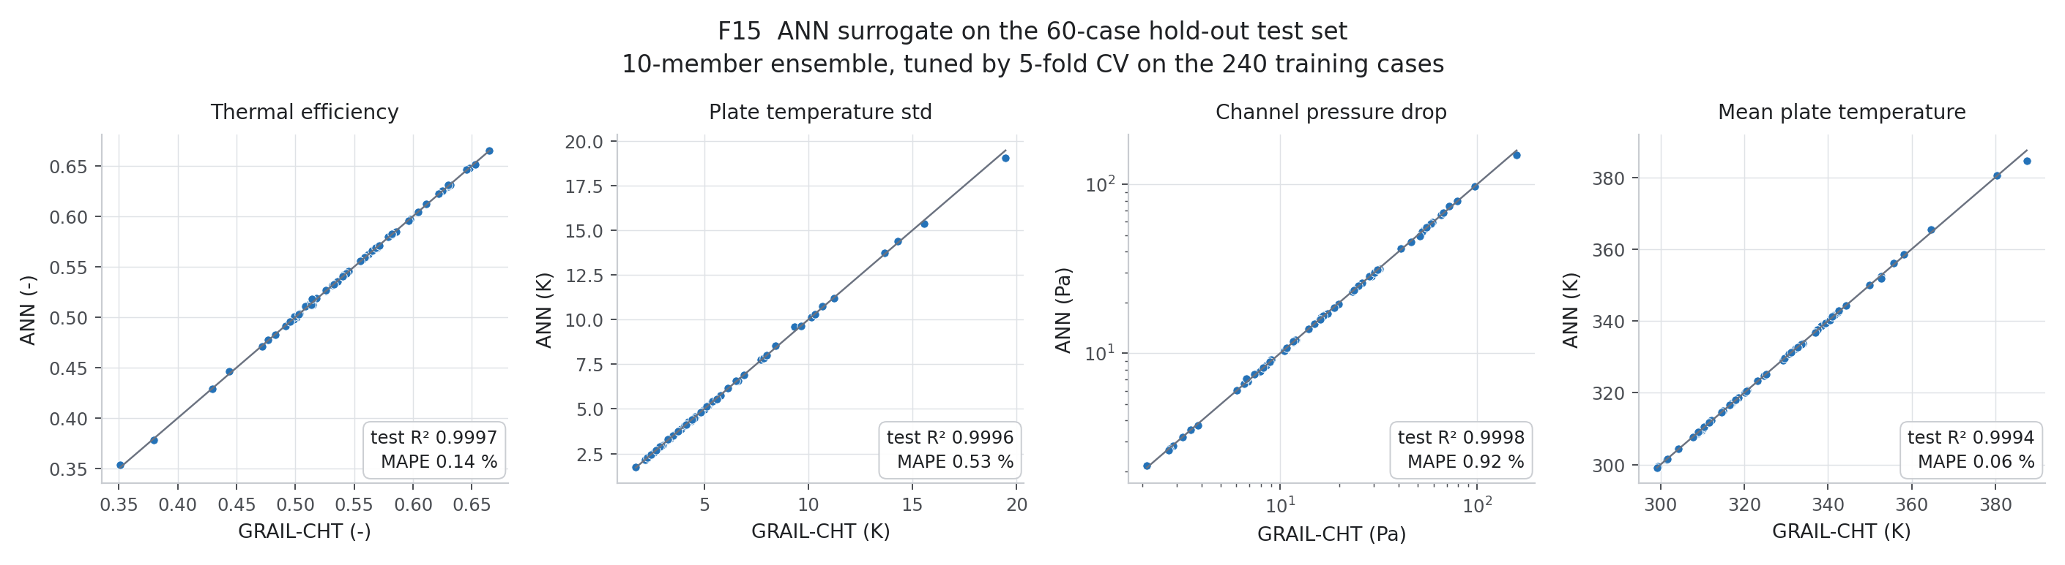
Figure W8.1 (Day 1). ANN surrogate on the 60-case test set
Predicted vs GRAIL-CHT values for efficiency, plate std, pressure drop and mean plate temperature — points lie on the diagonal.
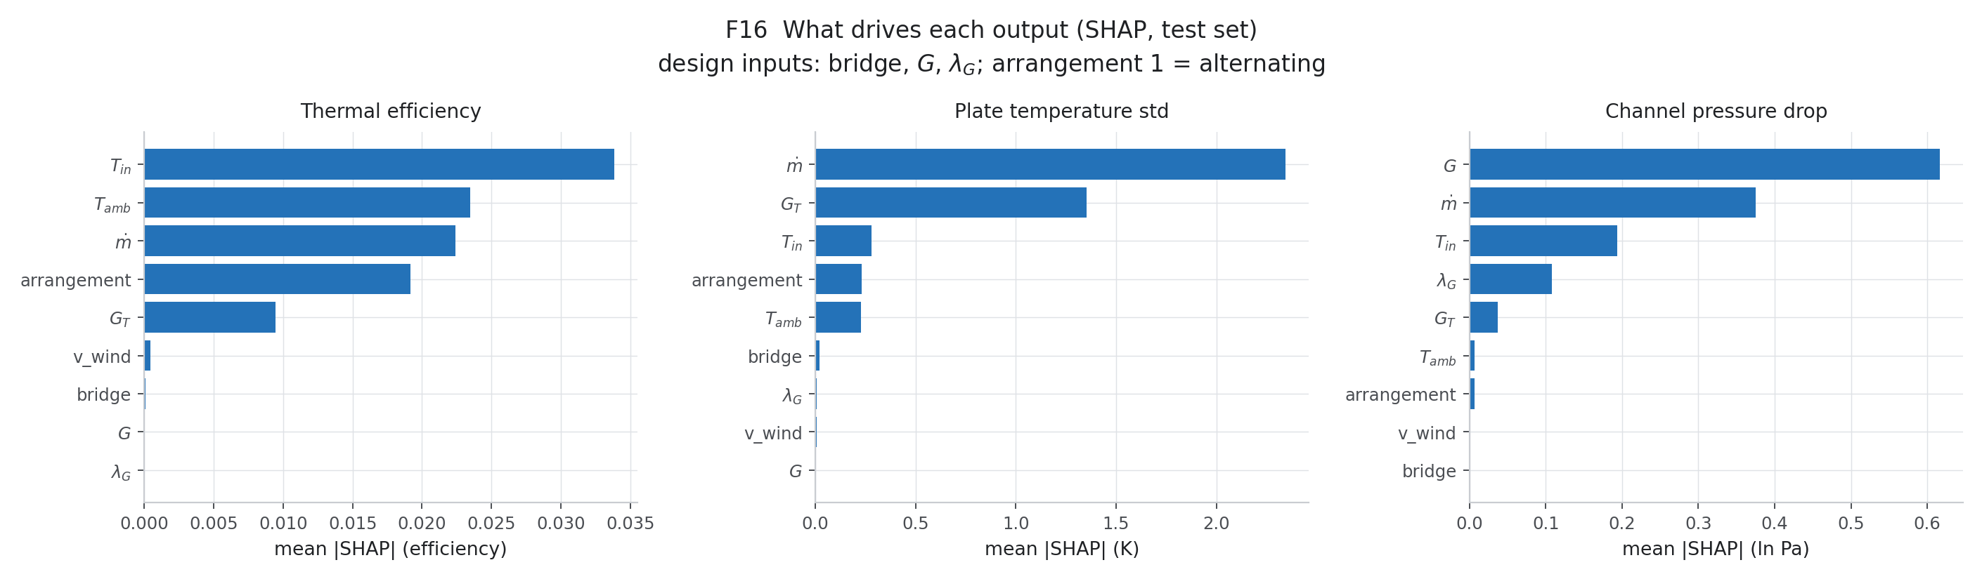
Figure W8.2 (Day 1). SHAP importance
Which inputs drive each output: T_in and T_amb drive efficiency; flow drives plate std; G drives pressure drop.
Day 2 — Tuesday, 22 Sep 2026
Today we optimised the design with the NSGA-II genetic algorithm, using the neural network to evaluate designs quickly. The goals were high efficiency and low plate temperature spread, with pumping power as a third goal. To make sure the neural network had not misled us, we re-ran 8 of the best designs in GRAIL-CHT; they agreed within 0.13 efficiency points, and the pumping power was below 0.1 mW for every design.
Main points of today's work:
- Design optimisation: NSGA-II optimisation with the ANN (maximise efficiency, minimise plate spread; pumping power as third objective).
- Re-ran 8 optimum designs in GRAIL-CHT to check the surrogate.
Result / observation: Optima agree within 0.13 efficiency points; pumping power < 0.1 mW for every point.
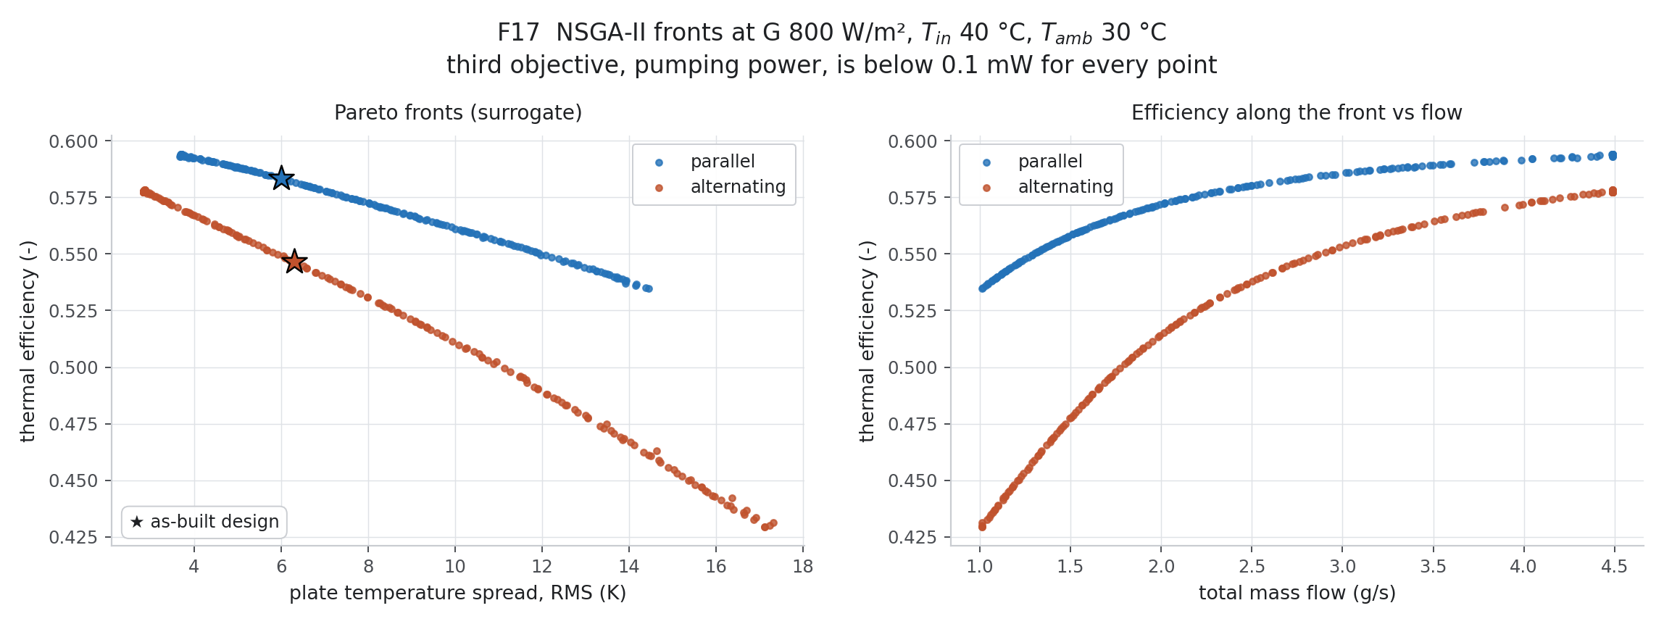
Figure W8.3 (Day 2). NSGA-II Pareto fronts
Efficiency against plate spread for both arrangements; stars mark the as-built design.
Day 3 — Wednesday, 23 Sep 2026
Today we did a virtual efficiency test of the collector following the ISO 9806 method. We ran GRAIL-CHT at several inlet temperatures and fitted the standard efficiency curve η = η0 − a1x − a2Gx². For parallel flow we obtained η0 = 0.637 and a1 = 2.10 W/m²K, and for alternating flow η0 = 0.597 and a1 = 2.00 W/m²K. We also studied the PCM tray and a thermotropic layer: with the PCM tray, the peak temperature when the flow stops falls from 264 °C to 205 °C.
Main points of today's work:
- Virtual collector efficiency test: virtual ISO 9806 steady-state test in GRAIL-CHT at several inlet temperatures.
- Fitted η = η0 − a1 x − a2 G x².
- Side study: PCM tray transient and thermotropic layer.
Result / observation: Parallel η0 0.637, a1 2.10; alternating η0 0.597, a1 2.00 W/m²K. PCM cuts the stagnation peak from 264 °C to 205 °C.
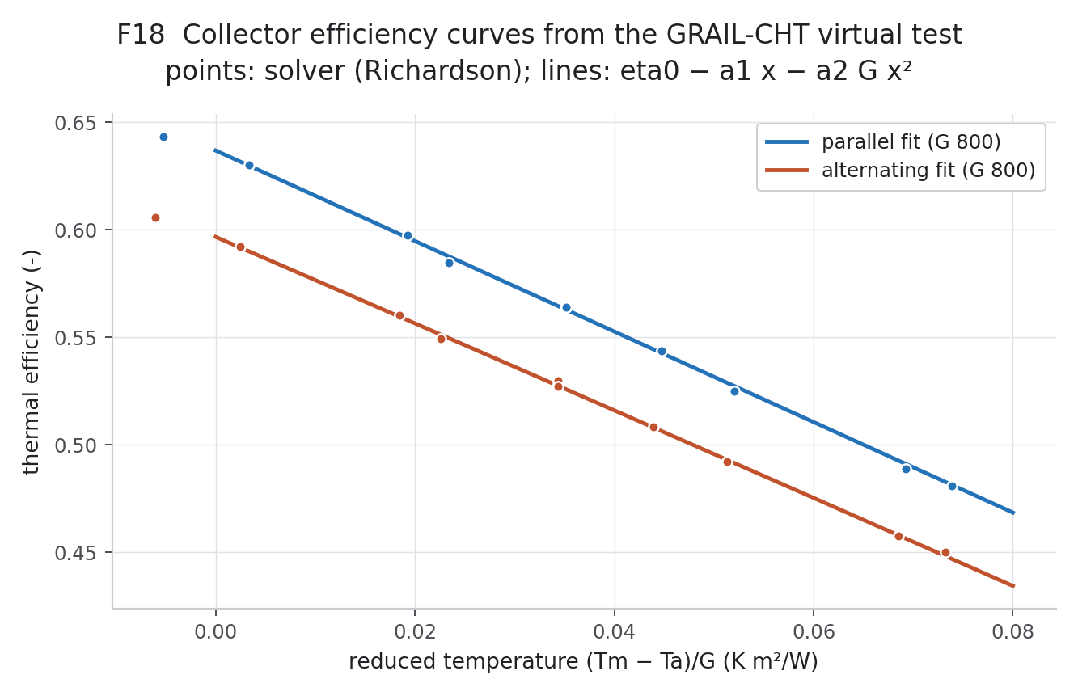
Figure W8.4 (Day 3). Efficiency curves from the virtual test
GRAIL-CHT test points and fitted ISO 9806 curves at G = 800 W/m².
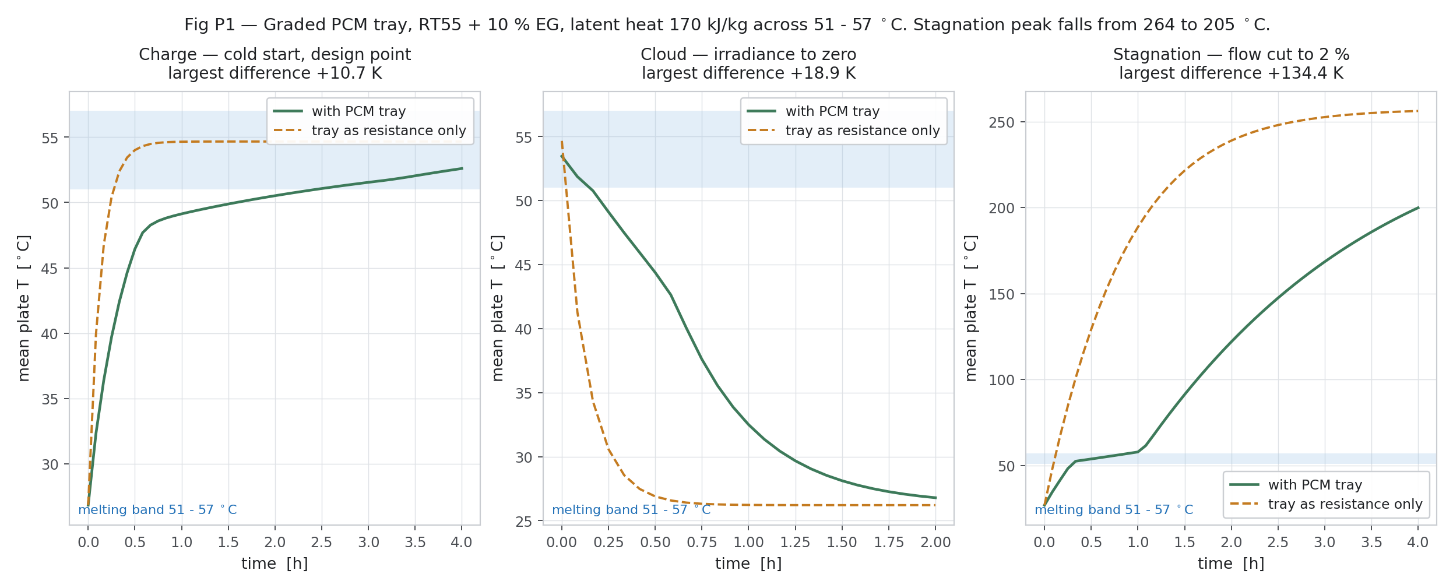
Figure W8.6 (Day 3). PCM tray transient (side study, first campaign)
With the PCM tray the stagnation peak falls from 264 °C to 205 °C.
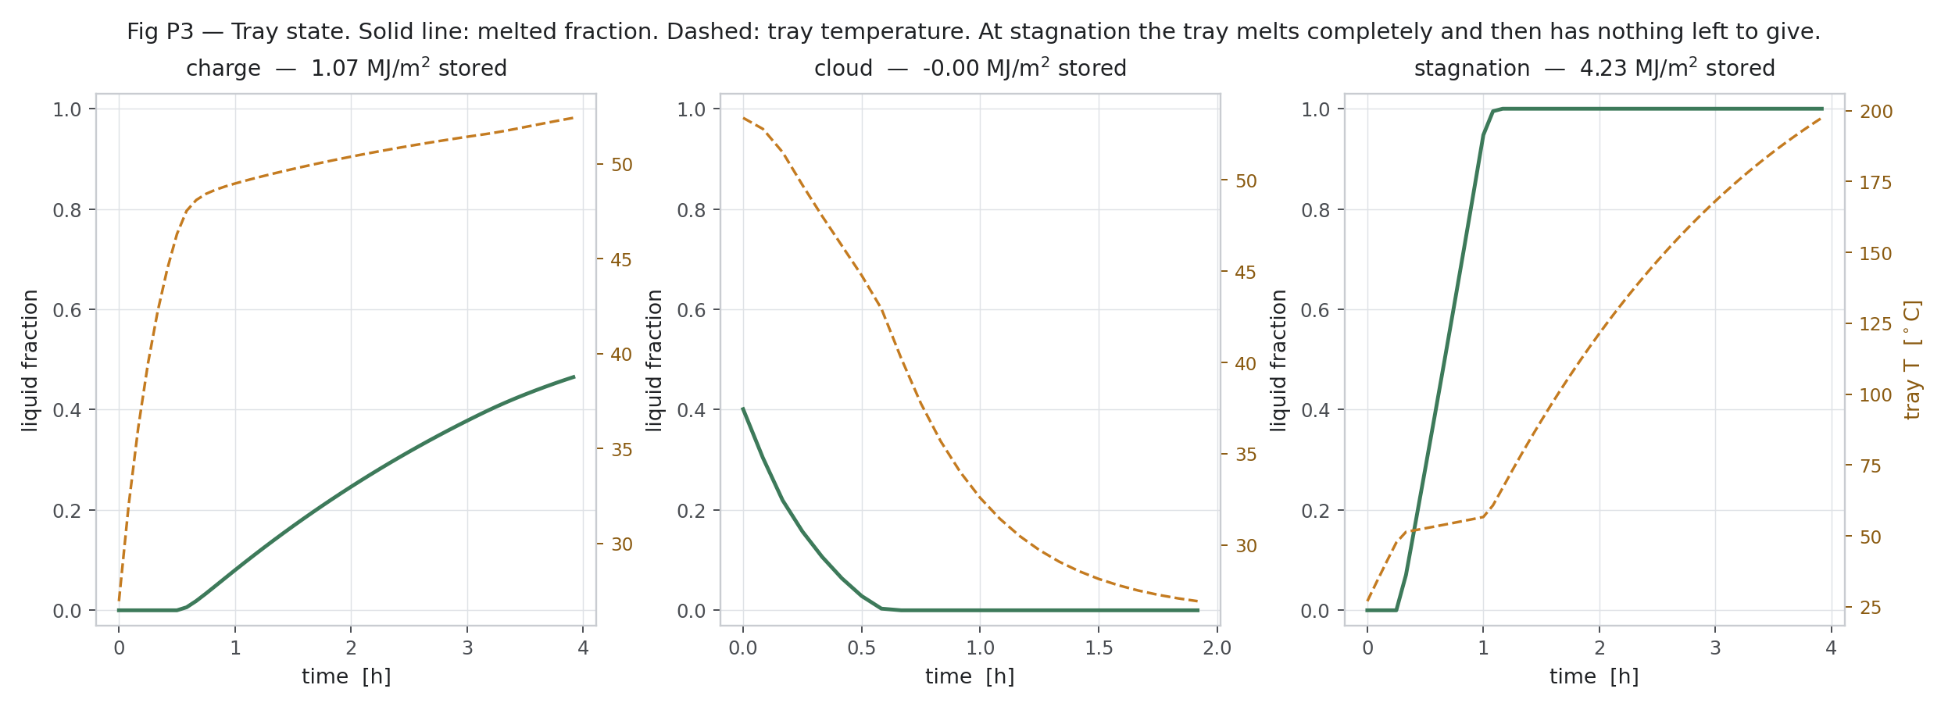
Figure W8.7 (Day 3). PCM tray state (side study, first campaign)
Melted fraction and tray temperature for charge, cloud and stagnation.
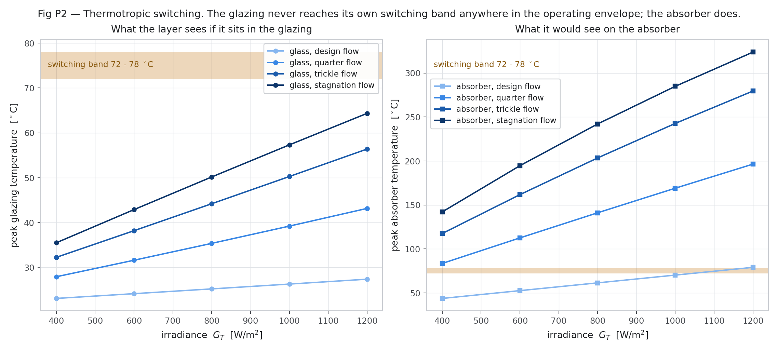
Figure W8.8 (Day 3). Thermotropic switching (side study, first campaign)
The glazing never reaches its switching band; the absorber does.
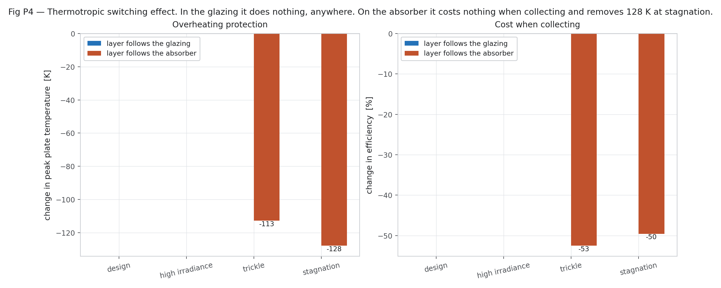
Figure W8.9 (Day 3). Thermotropic effect (side study, first campaign)
On the absorber the layer removes 113–128 K at trickle and stagnation flow.
Day 4 — Thursday, 24 Sep 2026
Today we calculated the yearly performance for Berhampur. We downloaded typical-year hourly weather data (PVGIS, 2005–2023) and calculated the sunshine on the tilted collector: 1,976 kWh/m² per year. We then simulated a household using 100 litres of hot water per day for every hour of the year. With two collector modules, the collector supplies 86 % (parallel) and 83 % (alternating) of the heat, at a cost of Rs 4.34 and Rs 4.49 per kWh, compared with Rs 4.95 for an electric geyser.
Main points of today's work:
- Yearly performance and cost study: downloaded the typical-year hourly weather for Berhampur (PVGIS, 2005–2023) and computed plane-of-array irradiation.
- Ran the hourly annual simulation with a 100 L/day household load; computed solar fraction and cost per kWh.
Result / observation: 1,976 kWh/m²/yr on the plane; 2 modules give a solar fraction of 86 % / 83 % and Rs 4.34 / 4.49 per kWh (geyser Rs 4.95).
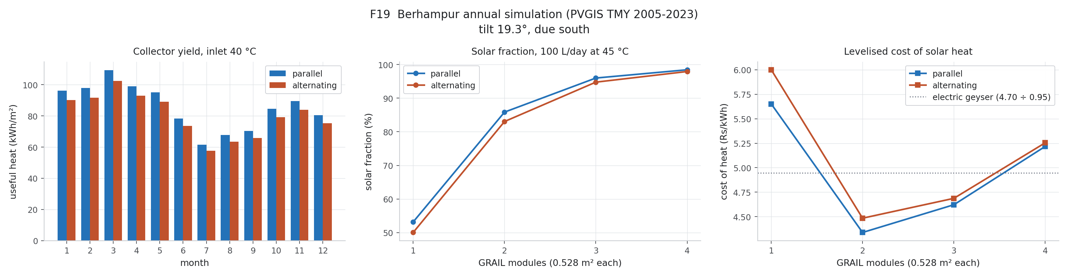
Figure W8.5 (Day 4). Annual performance, Berhampur
Monthly yield and solar fraction for the 2-module system.
Day 5 — Friday, 25 Sep 2026
Today we built a model of the whole hot-water system (collector, tank, pump and load). We built it first in GNU Octave and then in Scilab Xcos with 24 blocks: hourly inputs, collector, tank, pump control, heat rates and outputs; both gave the same results. We then wrote a MATLAB script that builds the same model in Simulink block by block. The first attempt failed with the message that MATLAB file names must start with a letter; after renaming the file, the script ran and we opened the generated Simulink model (version 19) in MATLAB Online.
Main points of today's work:
- Built the system model in GNU Octave and in Scilab Xcos (24 blocks: inputs, collector node, tank node, pump control, heat rates, outputs).
- Wrote a MATLAB script that builds the Simulink model block by block.
- First run failed: 'MATLAB file names must start with a letter' — renamed the file and it ran.
- Opened the generated Simulink model version 19 in MATLAB Online.
Result / observation: Octave and Xcos agree; Simulink model builds from the script.
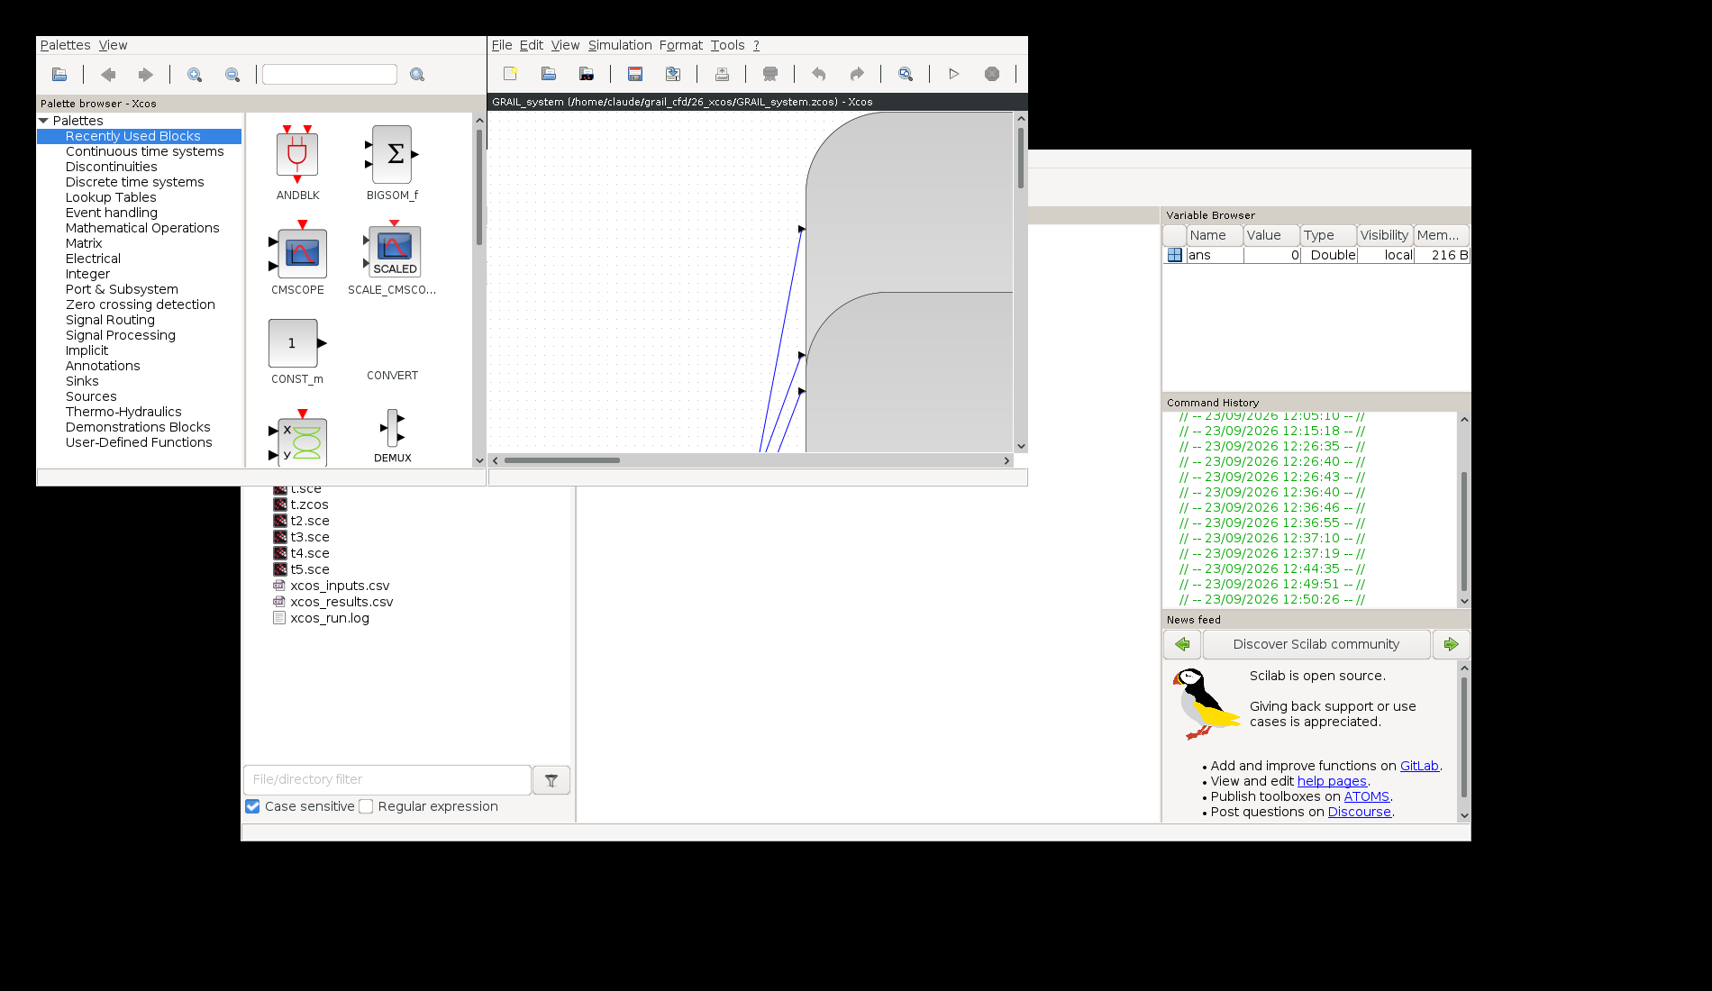
Figure W8.10 (Day 5). First Scilab Xcos session
Start of the system-model work: Xcos palette browser and the empty model, with the input CSV files prepared.
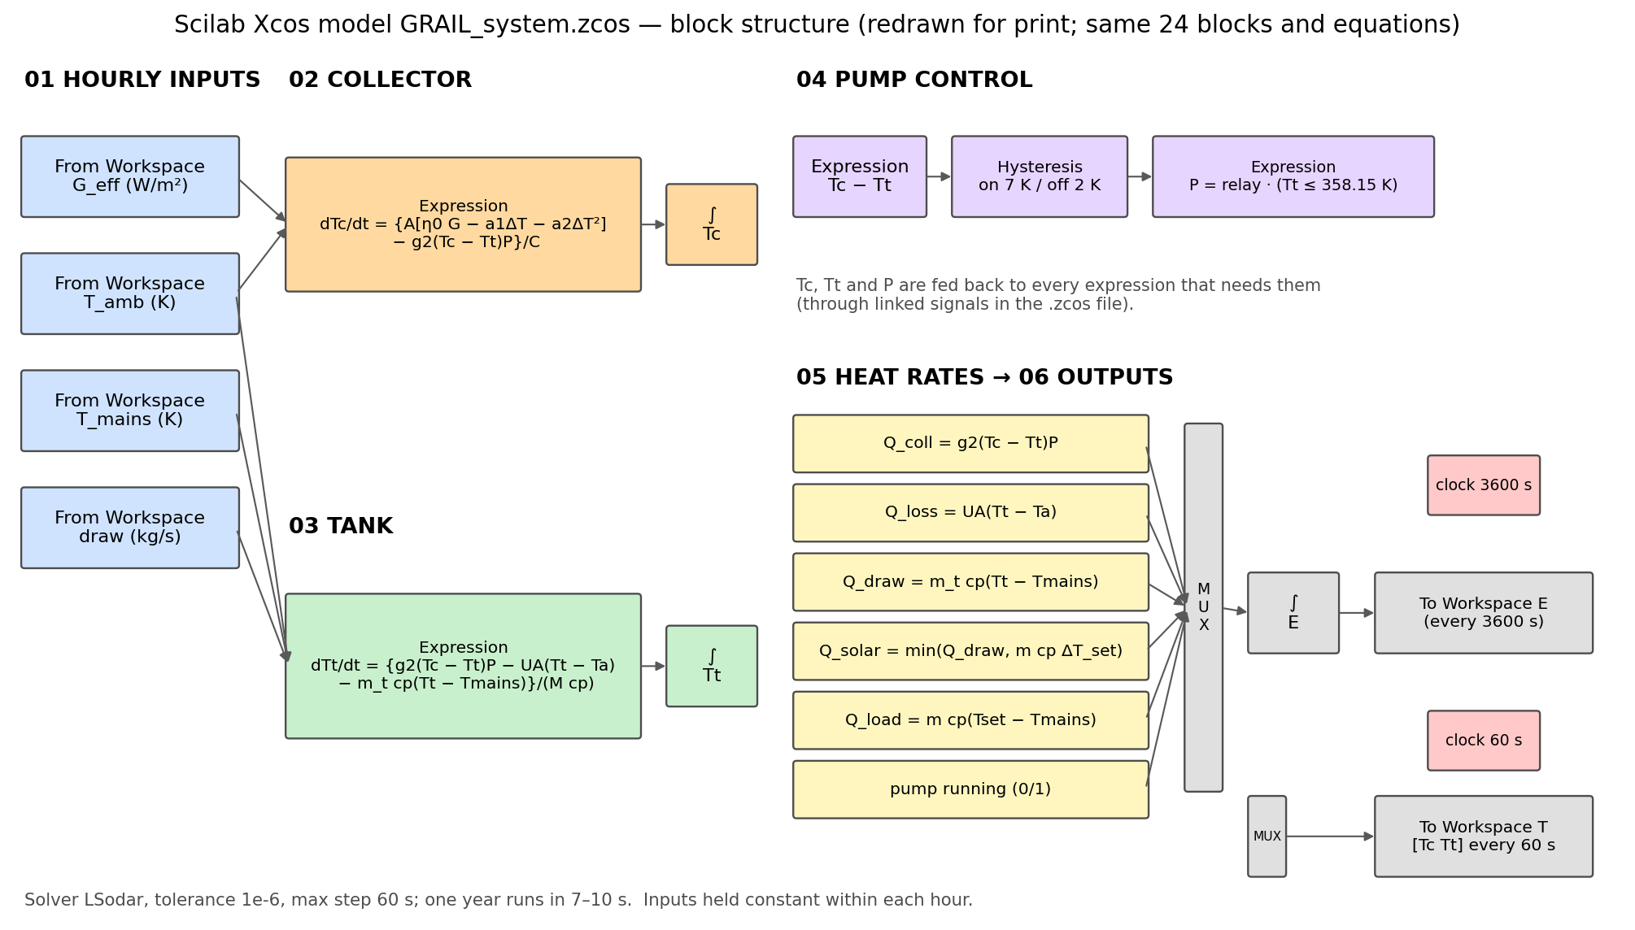
Figure W8.11 (Day 5). Xcos model block structure (redrawn for print)
The 24 blocks: hourly inputs, collector node, tank node, pump control, heat rates and outputs.
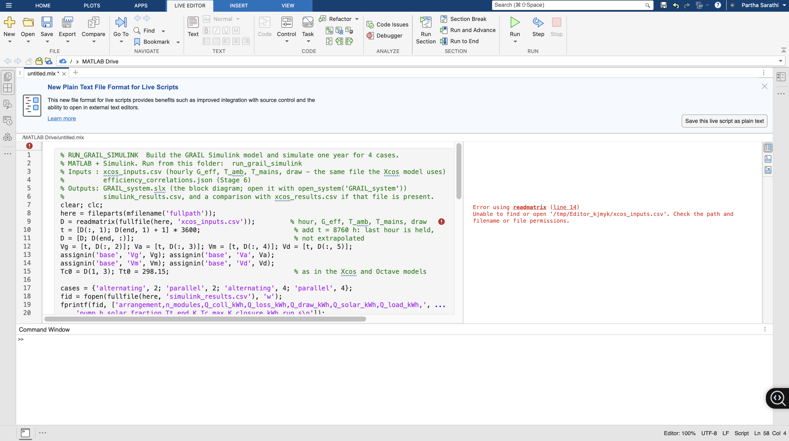
Figure W8.17 (Day 5). MATLAB script that builds the Simulink model
The .m script reads the hourly inputs, builds every block and line by code, runs the 4 cases and writes the results — so the model can be rebuilt exactly.
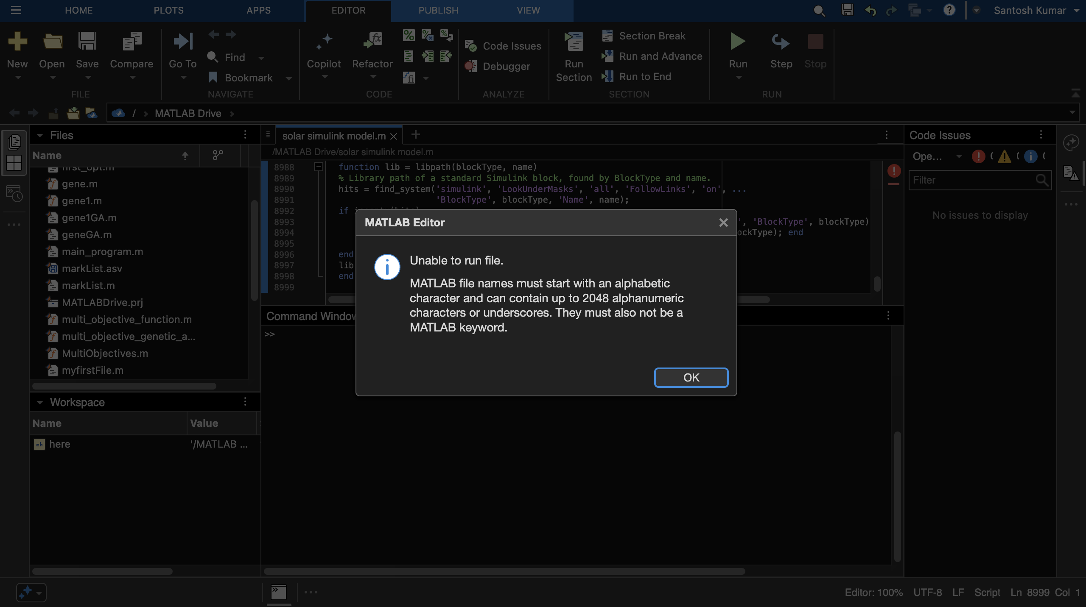
Figure W8.12 (Day 5). Problem faced: MATLAB could not run the script
MATLAB file names must start with a letter; the file was renamed and the script ran.
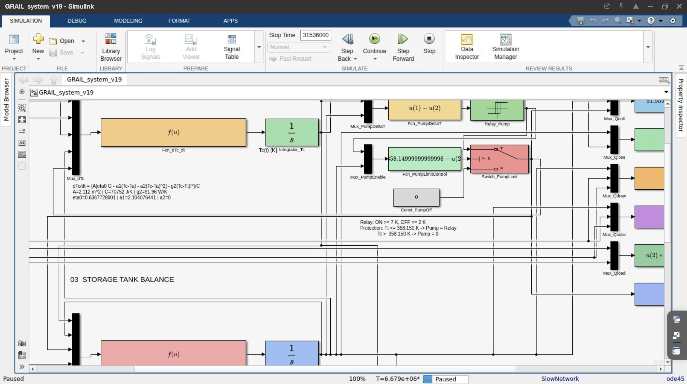
Figure W8.13 (Day 5). Simulink model version 19 running in MATLAB Online
The generated Simulink model: collector energy balance, tank balance, pump control and heat-rate blocks.
Day 6 — Saturday, 26 Sep 2026
Today we cleaned the Simulink layout (version 20) and fixed a bracket error in one function block that the Octave test had found (version 21). We ran all four cases — alternating and parallel, with one and two modules — and compared them with Xcos: the solar heat agreed within 0.05 % and the maximum collector temperature within 0.94 K, so all four cases passed. We also checked our method against published experiments. We screened 16 papers with three tests (tabulated data, energy balance and complete inputs). Gunjo et al. 2017 failed because its CFD heat was larger than the incoming sunlight, while Del Col et al. 2013 and Beikircher et al. 2015 were suitable for comparison.
Main points of today's work:
- Cleaned the Simulink layout (version 20) and fixed a Fcn bracketing bug found by the Octave test (version 21).
- Ran all four cases (alternating/parallel × 1/2 modules) and compared with Xcos.
- Validation against published experiments: screened 16 papers with three tests (tabulated data, energy balance, full inputs).
Papers read today: [29] Gunjo D.G. 2017; [17] Del Col D. 2013; [19] Beikircher T. 2015.
Result / observation: All 4 cases PASS: solar heat within 0.05 %, max T_c within 0.94 K. Gunjo 2017 rejected (CFD heat > solar input); Del Col 2013 and Beikircher 2015 used.
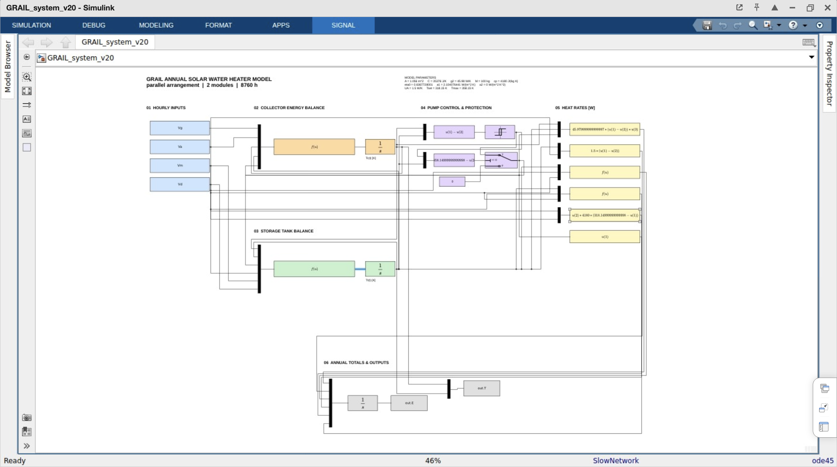
Figure W8.15 (Day 6). Simulink model version 20 — full diagram
The cleaned v20 layout with colour-coded sections.
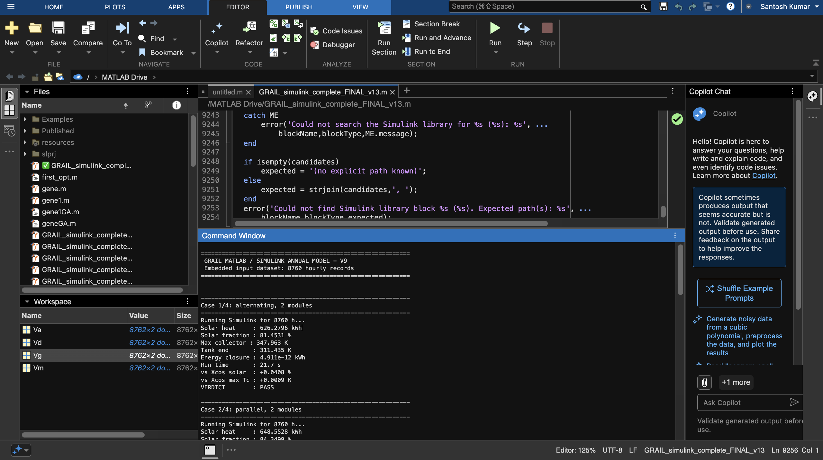
Figure W8.14 (Day 6). Simulink annual run — command window
Annual run for the 4 cases: solar heat, solar fraction, energy closure and comparison with Xcos; verdict PASS.
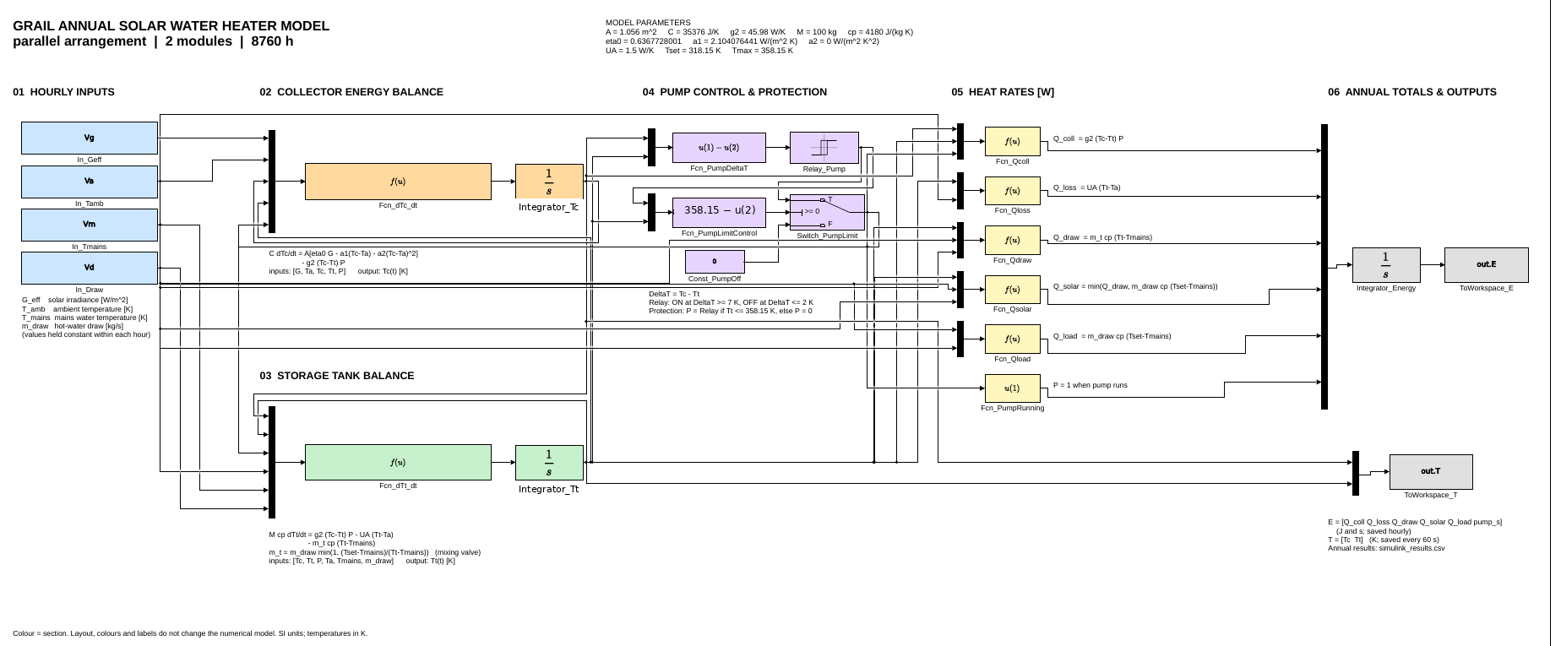
Figure W8.16 (Day 6). Simulink model version 21 (final)
Final block diagram used for the PASS results.
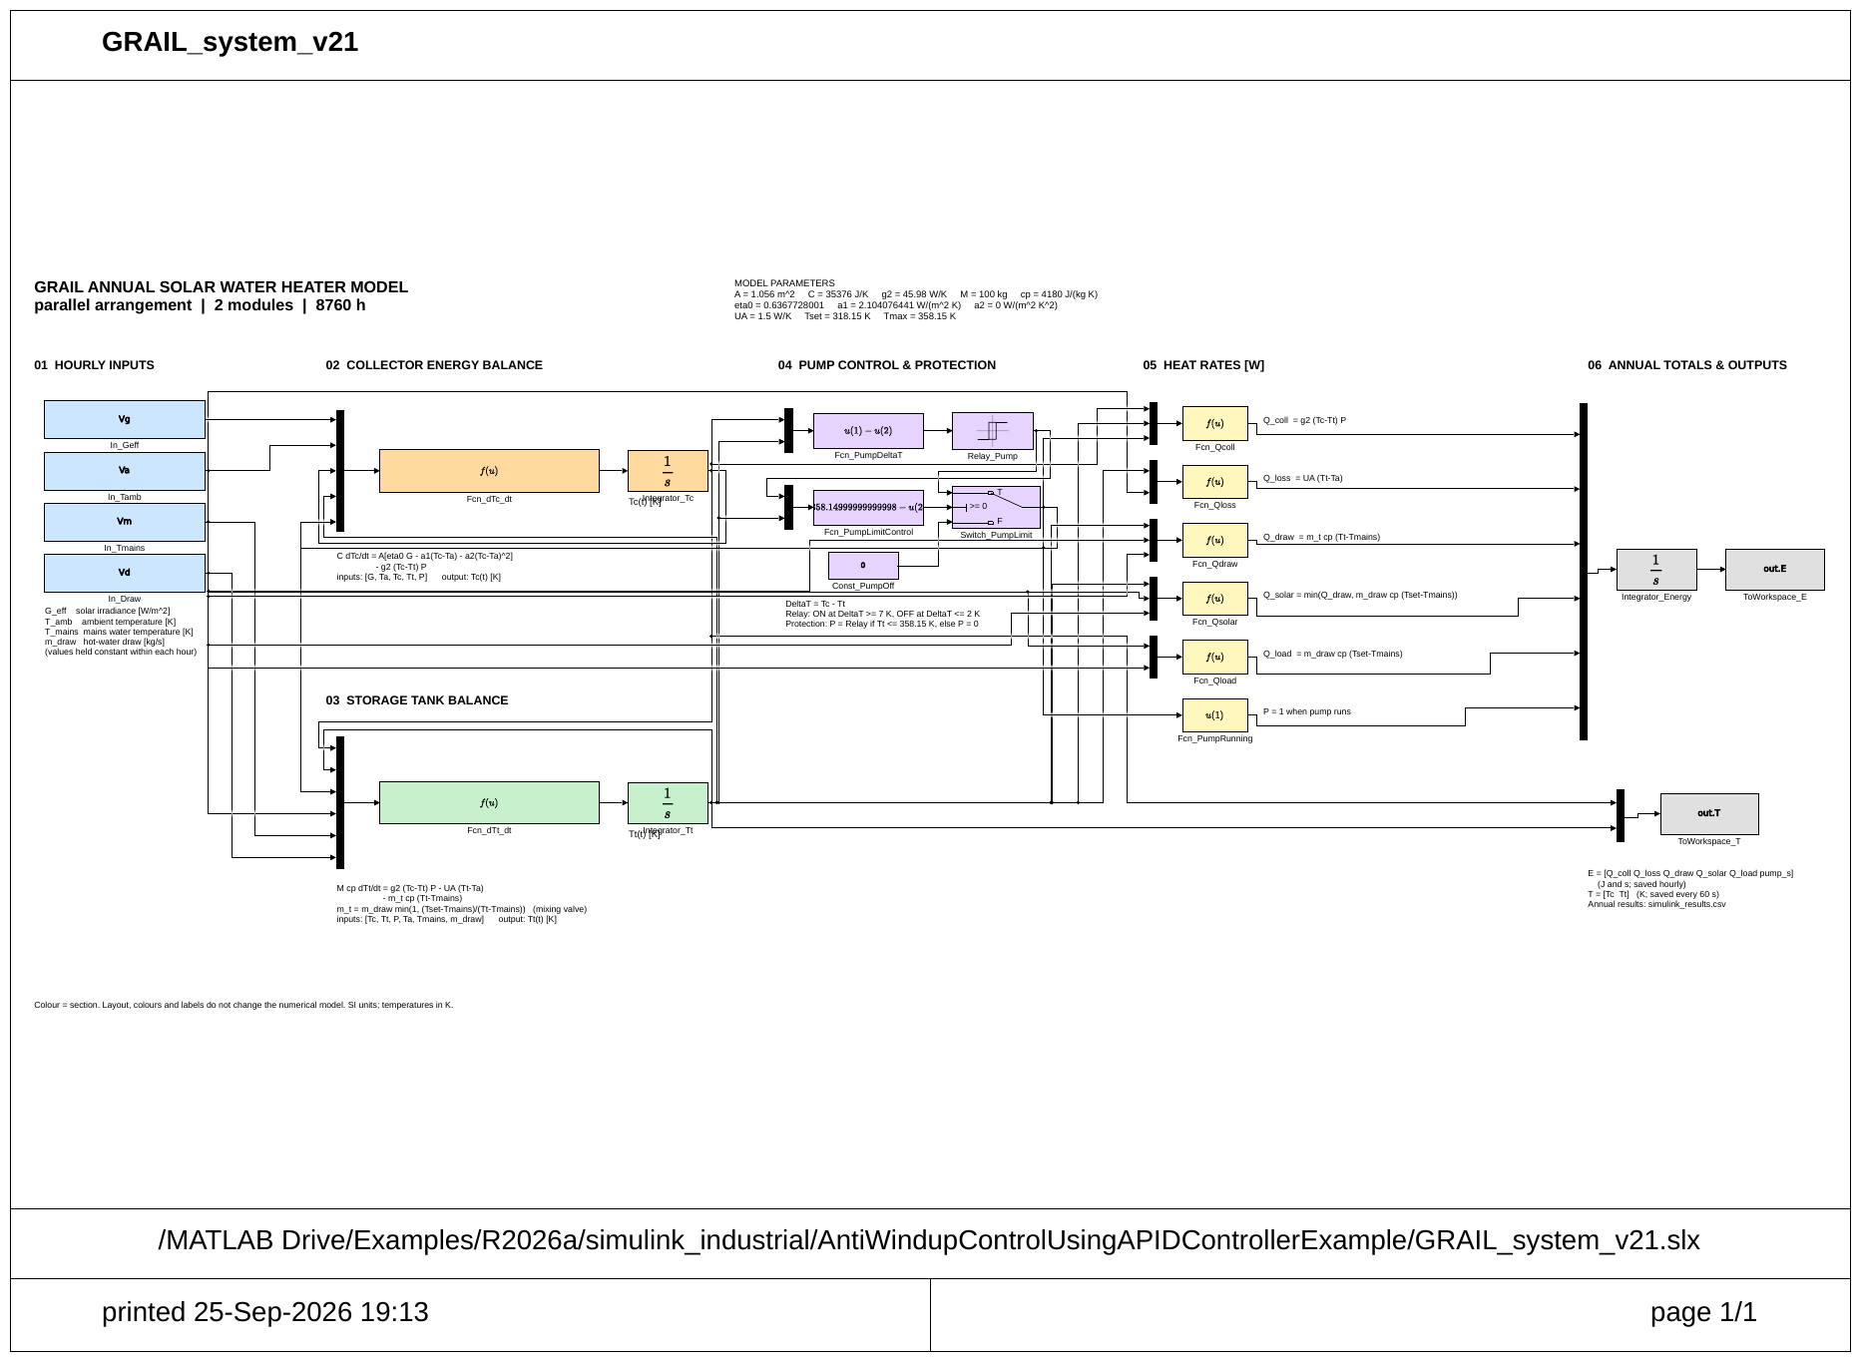
Figure W8.18 (Day 6). Simulink v21 printed from MATLAB Online
Printout of GRAIL_system_v21 (25 Sep 2026) used as the record of the final model.
Day 7 — Sunday, 27 Sep 2026
Today we compared the two flow arrangements at the same average plate temperature and found that their efficiency is then equal; the loss with alternating flow comes from its higher plate temperature. We did a first patent search on Google Patents, Justia and OSTI. Finally we wrote the journal paper draft, the roadmap completion status and the simple engineering report. The validation is at method and component level only; a prototype test is still needed.
Main points of today's work:
- Compared the two arrangements at matched plate temperature.
- First patent search (Google Patents, Justia, OSTI).
- Wrote the journal paper draft, the roadmap completion status and the simple engineering report.
Result / observation: At equal plate temperature efficiency is equal. Validation against published experiments completed at method and component level; no prototype test yet.

Week summary
All stages complete. System model agrees in three tools. Method checked against published roll-bond and TIM/VIP collectors. Reports written.

Plan for next week
Write the professional engineering report.

Guide sign-off
Work shown to guide on (date)
Guide remarks
Student(s) signature
Guide signature

Monthly review — September 2026
Weeks covered | Weeks 5–8
Main work | Meshing, CFD, GRAIL-CHT, campaign, surrogate model, optimisation, yearly performance, system models, validation

Progress against plan
Planned | Achieved | Remarks

Guide's overall comments

Student(s) signature
Guide signature
Date

Week 9 | 28 Sep – 04 Oct 2026 | Planned
Title of the week: Professional engineering report
Dates: 28 Sep – 04 Oct 2026 (Monday to Sunday)
Status: Planned

Aim of this week
Convert the simple report into the formal engineering report in the college format (planned).
Day 1 — Monday, 28 Sep 2026
Planned work for today: Collect the college report format and template. List the required sections: certificate, declaration, acknowledgement, abstract, contents, nomenclature, chapters, references, appendices. Make the chapter outline and agree it within the team.
Steps planned:
- Collect the college report format and template.
- List the required sections: certificate, declaration, acknowledgement, abstract, contents, nomenclature, chapters, references, appendices.
- Make the chapter outline and agree it within the team.
What was actually done:
_____________________________________________________________________________________
_____________________________________________________________________________________
_____________________________________________________________________________________
Day 2 — Tuesday, 29 Sep 2026
Planned work for today: Write the abstract (≤ 250 words): problem, method, key numbers, conclusion. Write the nomenclature table with SI units.
Steps planned:
- Write the abstract (≤ 250 words): problem, method, key numbers, conclusion.
- Write the nomenclature table with SI units.
What was actually done:
_____________________________________________________________________________________
_____________________________________________________________________________________
_____________________________________________________________________________________
Day 3 — Wednesday, 30 Sep 2026
Planned work for today: Redraw key figures at print quality (300 dpi, readable fonts). Check every figure against its data file; check no labels overlap.
Steps planned:
- Redraw key figures at print quality (300 dpi, readable fonts).
- Check every figure against its data file; check no labels overlap.
What was actually done:
_____________________________________________________________________________________
_____________________________________________________________________________________
_____________________________________________________________________________________
Day 4 — Thursday, 01 Oct 2026
Planned work for today: Fix crowded tables; check units and significant figures. Make every caption self-explanatory.
Steps planned:
- Fix crowded tables; check units and significant figures.
- Make every caption self-explanatory.
What was actually done:
_____________________________________________________________________________________
_____________________________________________________________________________________
_____________________________________________________________________________________
Day 5 — Friday, 02 Oct 2026
Planned work for today: Add author names, roll numbers, institution and guide details. Update the reference list to one format.
Steps planned:
- Add author names, roll numbers, institution and guide details.
- Update the reference list to one format.
What was actually done:
_____________________________________________________________________________________
_____________________________________________________________________________________
_____________________________________________________________________________________
Day 6 — Saturday, 03 Oct 2026
Planned work for today: Assemble draft 1 of the engineering report. Spell check and number check.
Steps planned:
- Assemble draft 1 of the engineering report.
- Spell check and number check.
What was actually done:
_____________________________________________________________________________________
_____________________________________________________________________________________
_____________________________________________________________________________________
Day 7 — Sunday, 04 Oct 2026
Planned work for today: Show draft 1 to the guide. Write down every comment in this diary.
Steps planned:
- Show draft 1 to the guide.
- Write down every comment in this diary.
What was actually done:
_____________________________________________________________________________________
_____________________________________________________________________________________
_____________________________________________________________________________________

Week summary
(write at the end of the week)

Plan for next week
Write the thesis chapters.

Guide sign-off
Work shown to guide on (date)
Guide remarks
Student(s) signature
Guide signature

Week 10 | 05 Oct – 11 Oct 2026 | Planned
Title of the week: Thesis / project report chapters
Dates: 05 Oct – 11 Oct 2026 (Monday to Sunday)
Status: Planned

Aim of this week
Write the project report (thesis) chapters (planned).
Day 1 — Monday, 05 Oct 2026
Planned work for today: Chapter 1 Introduction: background, motivation, research question, objectives, scope.
What was actually done:
_____________________________________________________________________________________
_____________________________________________________________________________________
_____________________________________________________________________________________
Day 2 — Tuesday, 06 Oct 2026
Planned work for today: Chapter 2 Literature review: use the literature review section of this diary (31 papers, themes, gap).
What was actually done:
_____________________________________________________________________________________
_____________________________________________________________________________________
_____________________________________________________________________________________
Day 3 — Wednesday, 07 Oct 2026
Planned work for today: Chapter 3 Design: concept, layer stack, grading law, CAD model, parameter register, verification checks.
What was actually done:
_____________________________________________________________________________________
_____________________________________________________________________________________
_____________________________________________________________________________________
Day 4 — Thursday, 08 Oct 2026
Planned work for today: Chapter 4 Methods: meshing, 3-D CFD, GRAIL-CHT, Nu correction, campaign design.
What was actually done:
_____________________________________________________________________________________
_____________________________________________________________________________________
_____________________________________________________________________________________
Day 5 — Friday, 09 Oct 2026
Planned work for today: Chapter 5 Results: campaign, mechanism, uncertainty. Chapter 6 Surrogate model, optimisation, virtual efficiency test and yearly performance.
Steps planned:
- Chapter 5 Results: campaign, mechanism, uncertainty.
- Chapter 6 Surrogate model, optimisation, virtual efficiency test and yearly performance.
What was actually done:
_____________________________________________________________________________________
_____________________________________________________________________________________
_____________________________________________________________________________________
Day 6 — Saturday, 10 Oct 2026
Planned work for today: Chapter 7 Validation against published experiments, matched-temperature comparison, patent search and limitations. Chapter 8 Conclusions and future work.
Steps planned:
- Chapter 7 Validation against published experiments, matched-temperature comparison, patent search and limitations.
- Chapter 8 Conclusions and future work.
What was actually done:
_____________________________________________________________________________________
_____________________________________________________________________________________
_____________________________________________________________________________________
Day 7 — Sunday, 11 Oct 2026
Planned work for today: Guide review of project report draft 1.
What was actually done:
_____________________________________________________________________________________
_____________________________________________________________________________________
_____________________________________________________________________________________

Week summary
(write at the end of the week)

Plan for next week
Presentation and paper.

Guide sign-off
Work shown to guide on (date)
Guide remarks
Student(s) signature
Guide signature

Week 11 | 12 Oct – 18 Oct 2026 | Planned
Title of the week: Presentation and paper finalisation
Dates: 12 Oct – 18 Oct 2026 (Monday to Sunday)
Status: Planned

Aim of this week
Prepare the review presentation and finalise the journal paper (planned).
Day 1 — Monday, 12 Oct 2026
Planned work for today: Slide outline: title, problem, objectives, concept, design (about 5 slides).
What was actually done:
_____________________________________________________________________________________
_____________________________________________________________________________________
_____________________________________________________________________________________
Day 2 — Tuesday, 13 Oct 2026
Planned work for today: Slides: CAD, mesh, 3-D CFD, Nu correction, campaign results (about 8 slides).
What was actually done:
_____________________________________________________________________________________
_____________________________________________________________________________________
_____________________________________________________________________________________
Day 3 — Wednesday, 14 Oct 2026
Planned work for today: Slides: surrogate model, optimisation, yearly performance, validation, economics, conclusions, future work (about 7 slides).
What was actually done:
_____________________________________________________________________________________
_____________________________________________________________________________________
_____________________________________________________________________________________
Day 4 — Thursday, 15 Oct 2026
Planned work for today: Choose the target journal; format the paper to its template (abstract, highlights, figures, references).
What was actually done:
_____________________________________________________________________________________
_____________________________________________________________________________________
_____________________________________________________________________________________
Day 5 — Friday, 16 Oct 2026
Planned work for today: Fill author details and affiliations; check figure permissions.
What was actually done:
_____________________________________________________________________________________
_____________________________________________________________________________________
_____________________________________________________________________________________
Day 6 — Saturday, 17 Oct 2026
Planned work for today: Timed practice of the presentation (15 min + 5 min questions).
What was actually done:
_____________________________________________________________________________________
_____________________________________________________________________________________
_____________________________________________________________________________________
Day 7 — Sunday, 18 Oct 2026
Planned work for today: Show presentation v1 to the guide.
What was actually done:
_____________________________________________________________________________________
_____________________________________________________________________________________
_____________________________________________________________________________________

Week summary
(write at the end of the week)

Plan for next week
Corrections after guide review.

Guide sign-off
Work shown to guide on (date)
Guide remarks
Student(s) signature
Guide signature

Week 12 | 19 Oct – 25 Oct 2026 | Planned
Title of the week: Corrections after guide review
Dates: 19 Oct – 25 Oct 2026 (Monday to Sunday)
Status: Planned

Aim of this week
Correct the report, presentation and paper after the guide's review (planned).
Day 1 — Monday, 19 Oct 2026
Planned work for today: List every guide comment from Weeks 9–11 with page numbers.
What was actually done:
_____________________________________________________________________________________
_____________________________________________________________________________________
_____________________________________________________________________________________
Day 2 — Tuesday, 20 Oct 2026
Planned work for today: Correct report chapters 1–4.
What was actually done:
_____________________________________________________________________________________
_____________________________________________________________________________________
_____________________________________________________________________________________
Day 3 — Wednesday, 21 Oct 2026
Planned work for today: Correct report chapters 5–8 and the appendices.
What was actually done:
_____________________________________________________________________________________
_____________________________________________________________________________________
_____________________________________________________________________________________
Day 4 — Thursday, 22 Oct 2026
Planned work for today: Correct the presentation (slide order, figure size, speaker notes).
What was actually done:
_____________________________________________________________________________________
_____________________________________________________________________________________
_____________________________________________________________________________________
Day 5 — Friday, 23 Oct 2026
Planned work for today: Correct the paper; submit it only with the guide's approval.
What was actually done:
_____________________________________________________________________________________
_____________________________________________________________________________________
_____________________________________________________________________________________
Day 6 — Saturday, 24 Oct 2026
Planned work for today: Re-check all figures and tables after the corrections.
What was actually done:
_____________________________________________________________________________________
_____________________________________________________________________________________
_____________________________________________________________________________________
Day 7 — Sunday, 25 Oct 2026
Planned work for today: Show draft 2 to the guide.
What was actually done:
_____________________________________________________________________________________
_____________________________________________________________________________________
_____________________________________________________________________________________

Week summary
(write at the end of the week)

Plan for next week
Final checks and viva preparation.

Guide sign-off
Work shown to guide on (date)
Guide remarks
Student(s) signature
Guide signature

Week 13 | 26 Oct – 01 Nov 2026 | Planned
Title of the week: Final checks and viva preparation
Dates: 26 Oct – 01 Nov 2026 (Monday to Sunday)
Status: Planned

Aim of this week
Final checks and viva preparation (planned).
Day 1 — Monday, 26 Oct 2026
Planned work for today: Check every number in the report against the source files (dataset, JSON results, run records).
What was actually done:
_____________________________________________________________________________________
_____________________________________________________________________________________
_____________________________________________________________________________________
Day 2 — Tuesday, 27 Oct 2026
Planned work for today: Proof-read the report: spelling, units, equation numbers, reference format.
What was actually done:
_____________________________________________________________________________________
_____________________________________________________________________________________
_____________________________________________________________________________________
Day 3 — Wednesday, 28 Oct 2026
Planned work for today: Mock presentation 1 within the team.
What was actually done:
_____________________________________________________________________________________
_____________________________________________________________________________________
_____________________________________________________________________________________
Day 4 — Thursday, 29 Oct 2026
Planned work for today: Viva practice: prepare answers for about 30 likely questions.
What was actually done:
_____________________________________________________________________________________
_____________________________________________________________________________________
_____________________________________________________________________________________
Day 5 — Friday, 30 Oct 2026
Planned work for today: Mock presentation 2 with the guide.
What was actually done:
_____________________________________________________________________________________
_____________________________________________________________________________________
_____________________________________________________________________________________
Day 6 — Saturday, 31 Oct 2026
Planned work for today: Print and bind the final report (number of copies as required).
What was actually done:
_____________________________________________________________________________________
_____________________________________________________________________________________
_____________________________________________________________________________________
Day 7 — Sunday, 01 Nov 2026
Planned work for today: Pack the project files (CAD, code, data, reports) into the submission folder.
What was actually done:
_____________________________________________________________________________________
_____________________________________________________________________________________
_____________________________________________________________________________________

Week summary
(write at the end of the week)

Plan for next week
Submission.

Guide sign-off
Work shown to guide on (date)
Guide remarks
Student(s) signature
Guide signature

Week 14 | 02 Nov – 03 Nov 2026 | Planned
Title of the week: Final submission
Dates: 02 Nov – 03 Nov 2026 (Monday to Sunday)
Status: Planned

Aim of this week
Final submission (planned).
Day 1 — Monday, 02 Nov 2026
Planned work for today: Final check of the printed copies and the project files.
What was actually done:
_____________________________________________________________________________________
_____________________________________________________________________________________
_____________________________________________________________________________________
Day 2 — Tuesday, 03 Nov 2026
Planned work for today: Submit the final report, presentation and project files (3 November 2026).
What was actually done:
_____________________________________________________________________________________
_____________________________________________________________________________________
_____________________________________________________________________________________

Week summary
(write at the end of the week)

Plan for next week
—

Guide sign-off
Work shown to guide on (date)
Guide remarks
Student(s) signature
Guide signature

Monthly review — October 2026
Weeks covered | Weeks 9–13
Main work | Professional report, thesis chapters, presentation, corrections, final checks

Progress against plan
Planned | Achieved | Remarks

Guide's overall comments

Student(s) signature
Guide signature
Date

Guide meeting log
No. | Date | Week | Points discussed | Guide sign
1 |  | 1 | Topic selection and literature survey
2 |  | 2 | Concept design and design roadmap
3 |  | 3 | Parametric CAD model — absorber and channels
4 |  | 4 | Full CAD assembly, verification and CFD domains
5 |  | 5 | Meshing and 3-D channel hydraulics
6 |  | 6 | Reduced-order model GRAIL-CHT and first campaign
7 |  | 7 | 3-D conjugate CFD, Nu correction and final dataset
8 |  | 8 | ANN, optimisation, system models, validation and reports
9 |  | 9 | Professional engineering report
10 |  | 10 | Thesis / project report chapters
11 |  | 11 | Presentation and paper finalisation
12 |  | 12 | Corrections after guide review
13 |  | 13 | Final checks and viva preparation
14 |  | 14 | Final submission

Final certificate
This is to certify that the project diary records the weekly work done on the minor project “The GRAIL Collector” from 03 August 2026 to 03 November 2026, and that the work was shown to the guide every week.

Student name(s) / Roll no.
Student(s) signature
Guide name
Guide signature
Head of Department
Date

