LAB 1 ASSIGNMENT – ARRAY

**ARGHA MALLICK - 11500122014**

**1. WACP to insert and delete elements from a 1D array**

#include<stdio.h>

void printArray(int arr[], int n){

for(int i=0; i<n; i++) {

printf("%d, ", arr[i]);

}

printf("\n");

}

void deleteElement(int arr[], int n, int d) {

for(int i=0; i<n; i++){

if(arr[i] == d) {

for(int j=i; j<n-1; j++) {

arr[j] = arr[j+1];

}

}

}

}

int main() {

int n, d;

printf("Enter number of elements: ");

scanf("%d", &n);

int arr[n];

printf("Enter %d elements\n", n);

for(int i=0; i<n; i++) {

scanf("%d", &arr[i]);

}

printArray(arr, n);

printf("Enter the element you want to delete: ");

scanf("%d", &d);

deleteElement(arr, n, d);

printArray(arr, n-1);

}

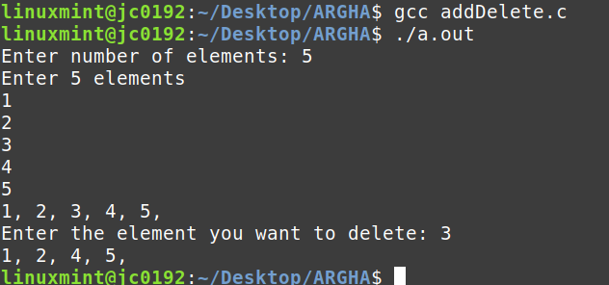

**2. Reverse the elements in an array**

#include<stdio.h>

void printArray(int arr[], int n){

for(int i=0; i<n; i++) {

printf("%d, ", arr[i]);

}

printf("\n");

}

int main(){

int n;

printf("Enter array size: ");

scanf("%d",&n);

int arr[n];

for(int i=0; i<n; i++) {

printf("Enter number: ");

scanf("%d",&arr[i]);

}

printArray(arr, n);

for(int i=0; i<n/2; i++) {

int temp = arr[i];

arr[i] = arr[n-i-1];

arr[n-i-1] = temp;

}

printArray(arr, n);

}

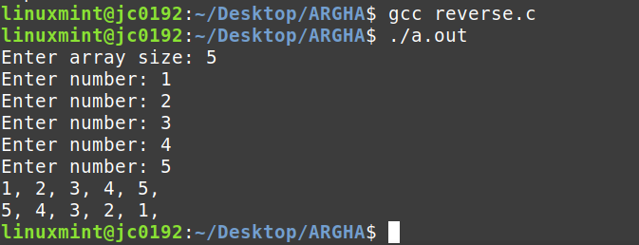

**3. Delete duplicate elements in an array**

#include<stdio.h>

int main() {

int n;

printf("Enter array size: ");

scanf("%d",&n);

int arr[n];

for(int i=0; i<n; i++) {

printf("Enter number: ");

scanf("%d",&arr[i]);

}

for(int i=0; i<n; i++){

for(int j=i+1; j<n; j++) {

if(arr[i] == arr[j]){

printf("Duplicate found! -> %d\n", arr[j]);

}

}

}

}

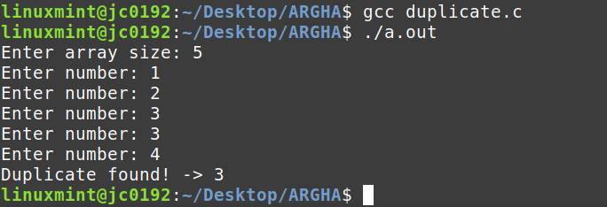

**4. Find the largest and smallest element in an array**

#include<stdio.h>

int main() {

int n;

printf("Enter array size: ");

scanf("%d",&n);

int arr[n];

for(int i=0; i<n; i++) {

printf("Enter number: ");

scanf("%d",&arr[i]);

}

int small = arr[0];

int large = arr[0];

for(int i=0; i<n; i++) {

small = arr[i] < small ? arr[i] : small;

large = arr[i] > large ? arr[i] : large;

}

printf("Largest: %d\n", large);

printf("Smallest: %d\n", small);

}

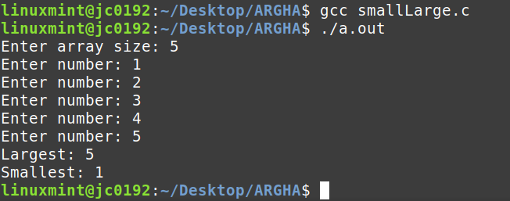

**5. Find the second largest and second smallest element in an array**

#include<stdio.h>

void bubbleSort(int arr[], int n) {

for(int i=0; i<n-1; i++){

for(int j=0; j<n-i-1; j++){

if(arr[j] > arr[j+1]){

int temp = arr[j];

arr[j] = arr[j+1];

arr[j+1] = temp;

}

}

}

}

int main() {

int n;

printf("Enter array size: ");

scanf("%d",&n);

int arr[n];

for(int i=0; i<n; i++) {

printf("Enter number: ");

scanf("%d",&arr[i]);

}

bubbleSort(arr, n);

printf("Second largest: %d\n", arr[n-2]);

printf("Second smallest: %d\n", arr[1]);

}

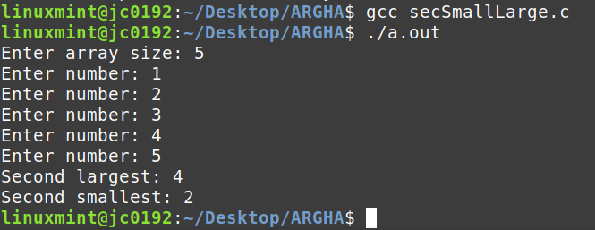

**6. Implement linear and binary search - iterative and recursive**

#include<stdio.h>

void linearSearch(int arr[], int n, int key){

for(int i=0; i<n; i++){

if(arr[i] == key) {

printf("Element is present in the array\n");

return;

}

}

printf("Element is not present in the array!\n");

}

void RLinearSearch(int arr[], int n, int i, int key) {

if(i == n) {

printf("Element is not present in the array!\n");

return;

}

if(arr[i] == key) {

printf("Element is present in the array\n");

return;

} else RLinearSearch(arr, n, i+1, key);

}

void binarySearch(int arr[], int left, int right, int key){

while(left <= right) {

int mid = left + (right-1) / 2;

if(arr[mid] == key) { printf("Element is present in the array\n"); return; }

if(key > arr[mid]) left=mid+1;

else right=mid-1;

}

printf("Element is not present in the array!\n");

return;

}

void RBinarySearch(int arr[], int left, int right, int key){

if(left <= right) {

int mid = left + (right-1) / 2;

if(key == arr[mid]) {

printf("Element is present in the array\n");

return;

}

if(key < arr[mid]) return RBinarySearch(arr, left, mid-1, key);

else return RBinarySearch(arr, mid+1, right, key);

}

printf("Element is not present in the array!\n");

return;

}

int main() {

int n, key;

printf("Enter array size: ");

scanf("%d",&n);

int arr[n];

for(int i=0; i<n; i++) {

printf("Enter number: ");

scanf("%d",&arr[i]);

}

printf("Enter the element to search: ");

scanf("%d", &key);

// linearSearch(arr, n, key);

// binarySearch(arr, 0, n-1, key);

// RLinearSearch(arr, n, 0, key);

RBinarySearch(arr, 0, n-1, key);

}

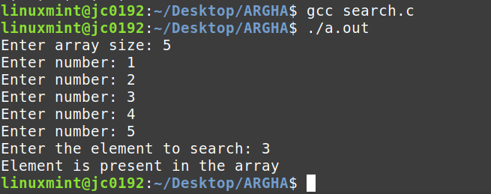

**7. Implement bubble sort on an array**

#include<stdio.h>

void bubbleSort(int arr[], int n) {

for(int i=0; i<n-1; i++){

for(int j=0; j<n-i-1; j++){

if(arr[j] > arr[j+1]){

int temp = arr[j];

arr[j] = arr[j+1];

arr[j+1] = temp;

}

}

}

}

void printArray(int arr[], int n){

for(int i=0; i<n; i++) {

printf("%d, ", arr[i]);

}

printf("\n");

}

int main(){

int n;

printf("Enter array size: ");

scanf("%d",&n);

int arr[n];

for(int i=0; i<n; i++) {

printf("Enter number: ");

scanf("%d",&arr[i]);

}

bubbleSort(arr, n);

printArray(arr, n);

}

