EpiControl AI
A Reproducible Two Cohort SEIR Framework
for Adaptive Intervention Analysis
Prof Bhagyashri Thorat  Department of Electronics and  Telecommunication  International Institute Of Information  Technology  Pune, India  t.bhagyashri@email | Parth Omprakash Bhad  Department of Computer Engineering  International Institute Of Information  Technology  Pune, India  parthbhad2@gmail.com | Aaditya Shrikrishna Hingmire  Department of Information Technology  International Institute Of Information  Technology  Pune, India  aadityahingmire@gmail.com
Yugraj Prabhakar Mangate  Department of Computer Engineering  International Institute Of Information  Technology  Pune, India  yugrajmngate@gmail.com | Manasvi Manoj Yeole  Department of Computer Engineering  International Institute Of Information  Technology  Pune, India  manasviyeole@gmail.com

Abstract – Epidemic intervention models are only useful if their assumptions, the costs of policies and how they are evaluated are clear. This paper introduces EpiControl AI, a decision-support tool that connects a two-cohort susceptible-exposed-infectious-recovered model with weekly tabular reinforcement learning and an interactive web interface. The simulator represents 49,000 people grouped into child and adult compartments. Three controllers trained independently are tested on 40 scenarios over 180 days and compared with four fixed policies and a policy triggered by infection levels. The average peak infectious population across all learned controllers is 968, compared with 11,900 without restrictions. The controllers also reduce the restriction-cost proxy by 47.4% relative to constant strict restrictions. However, strict restrictions achieve lower peaks, and the learned controllers vary substantially across training seeds. A follow-up test that removes restrictions after day 180 leads to outbreaks showing that short-term control does not mean long-term elimination. These results emphasize the need for comparisons under clearly stated assumptions. The contact matrix, hospital demand proxy and policy-cost function must be calibrated with data before this framework can support operational decisions.
Index Terms – Adaptive intervention, epidemic simulation, reinforcement learning, SEIR model.
I. Introduction
Responding to an epidemic involves repeated decisions about reducing contact, when to act, and how much burden to place on groups. A measure that limits transmission may also interrupt work or school. That trade-off shifts as infections rise and compliance changes. Compartmental models offer a way to describe these changes [1] and age-based differences in contact patterns justify dividing the population into subgroups [2].
Reinforcement learning can be used to choose interventions through repeated interactions with an environment. Previous studies have already combined epidemic models with learned policies [3]–[6]. This study asks whether a small, inspectable controller can improve a given synthetic goal and what limitations emerge when the same experiment is repeated with different random seeds or extended beyond the original time frame.
EpiControl AI addresses this question using a shared simulation engine for training, testing, and user interaction. Its contributions include a two-cohort setup, a comparison against fixed and threshold policies and a clear assessment after the control period ends. The model uses eight compartment values rather than tracking individual agents. This study evaluates a prototype under synthetic conditions; it does not claim to reflect real-world policy effectiveness in any specific country.
II. Related Work
The compartmental approach started with Kermack and McKendrick [1] to describe how epidemics spread through population-level transitions. Adding an exposed compartment accounts for a hidden phase before someone becomes contagious. In this model exposed individuals do not transmit. Modeling presymptomatic spread would require another state or a change in the infection rate.
Prem et al. [2] Used. Demographic data to project contact patterns by age. Their work shows how population structure can shape mixing assumptions but highlights uncertainty when direct contact data is missing. EpiControl AI uses a two-cohort contact matrix. Its values are not drawn from estimates and stronger adult mixing is an experimental assumption, not an observed fact.
Kompella et al. [3] Built an agent-based simulator where interactions happen at locations and studied policies balancing economic activity and hospital capacity. Their model captures behavior and local contacts but requires more detail. The current aggregate simulator is simpler and easier to inspect with less behavioral complexity.
Ohi et al. [4] Explored reinforcement learning to balance health and economic outcomes during an epidemic. Rao [5] combined a SEIRD model with a deep double recurrent Q-network and tested reward functions. Jain et al. [6] Worked with a SIR model. Studied choices between restrictions and vaccination focusing on health and economic trade-offs. Together, these works show that combining epidemic simulators with reinforcement learning is an active research area.
This study uses tabular Q-learning [7]. The main contribution is documenting a working comparison showing how results depend on seeds and testing what happens after restrictions end. Results from simulators aren’t used as direct benchmarks because population definitions, rewards, time horizons and calibration differ.
A. Contact Structure and Cohort Heterogeneity
Diary-based studies by Mossong et al. [8] Provide evidence that contact patterns differ by age and setting. Davies et al. [9] Modeled age-based differences in susceptibility and disease severity during COVID-19. Both support the idea of grouping populations. Neither provides the exact two-by-two contact values used here.
Recent analyses have asked which contact entries matter most to model outputs [10] who gets infected from whom in early Belgium outbreaks [11] age-specific contact roles in Germany [12]. How transmission varies by age under controls in Shanghai [13]. All point to the fact that a simple two-cohort matrix's a reasonable starting point, not a transferable estimate of real contact behavior.
B. Intervention Evidence and Behaviour
Studies of pandemic responses estimated effects across European countries [14] ranked combinations of measures by region [15] looked at large-scale anti-contagion actions [16] and inferred impacts of specific government steps [17]. These methods. Their findings cannot be directly applied as the effect sizes for synthetic actions in Table I.
Contact rates change with interventions as seen in a method to update contact matrices [18]. Reviews of policy advice [19] and UK response measures [20] put estimates in a context. An analysis of self-protection in Germany [21] shows why behavior can't be captured by formal policy intensity. A survey of modellers [22] outlines data and decision needs while a multi-country study looks at vaccines and non-pharmaceutical measures together [23]. Post-pandemic surveys in Italy [24] and a stochastic study of U.S. Epidemics [25] highlight differences in settings and scale.
C. Adaptive and Learning Based Control
Extending beyond homogeneous systems some models include spatial variation with different virus strains [26] connected communities and correctional facilities [27] real-time policy adjustments [28] and regional flu interventions [29]. Hierarchical reinforcement learning has been tried for multiple control types [30] and semi-connected SEIQR regions have been used to manage outbreaks [31]. These models include forms of heterogeneity that the present tabular controller ignores.
Deep reinforcement learning in simulations [32] and large-scale agent-based pandemic control [33] explore richer action or population representations.. Their algorithms and evaluation setups differ from this study. The controller here is kept small so that state bins, rewards, training seeds and failures under parameter changes can be checked directly.
D. Hospital Demand and Capacity
Healthcare planning studies have linked epidemic forecasts with allocation [34] optimized bed schedules across hospitals [35] and made local bed-demand projections on request [36]. A practical forecast of bed occupancy was tested with health-system data [37] and near-term case and hospitalization predictions were built for Aotearoa New Zealand [38]. These works model operational measures that can’t be deduced from infection numbers
Forecasting ICU demand using a two-stage method [39] and hospital admissions via time-series models [40] offer options. Vaccination and healthcare demand have been studied together [41] and a capacity-based control approach links projected demand to actions [42]. EpiControl AI labels 0.05 times infectious prevalence as a proxy for hospital demand and does not claim it reflects actual occupancy.
E. Calibration and Uncertainty
Fitting models to data and analyzing uncertainty are crucial when making claims about real-world decisions. Approximate Bayesian computation has been sped up for agent-based calibration [43] multiscale approaches have been proposed for early outbreak assessment [44]. Neural calibration has been paired with uncertainty estimates [45]. A review of molecular surveillance [46] discusses the level of monitoring available.
The US Scenario Modeling Hub has been assessed as a way to guide response under uncertainty [47]. Ensemble sub-epidemic forecasts [48] Bayesian estimation of parameters [49] and multiscale spatial modeling with uncertain data [50] give different ways to handle uncertainty. This literature explains why the parameter grid in Section VI is a stress test rather than a calibrated population confidence interval.
III. Model and Controller
A. Cohort Dynamics
Let g denote the child or adult cohort. Each cohort includes S_g exposed E_g, infectious I_g and recovered R_g people with fixed total N_g. Births, deaths, reinfection, migration and vaccination are left out. Recovered individuals stay immune for the simulation period. The force of infection depends on the fraction of people, in both cohorts.
(1)
(2)
(3)
(4)
(5)
β is the baseline transmission coefficient. Σ is the transition rate. Γ is the recovery rate. All of these values are given per day. C_gh is a dimensionless mixing coefficient. A policy gives each cohort a restriction intensity u_g. The factor f_g equals 1 minus c times u_g where c's compliance. Reducing contact on both sides of an interaction is called a symmetric contact-reduction assumption. This reduction is not an estimated intervention effect. The child fraction is 0.3 and the adult fraction is 0.7. The contact rows are (0.8 0.35) for one group and (0.15, 1.2) for the other. Cross-cohort contacts satisfy reciprocity because the product of N_child and C_child adult equals the product of N_adult and C_adult,child. Exposed and infectious counts are split in proportion to the size of each cohort. The ordinary differential equations are solved with fourth-order Runge–Kutta using two half-day steps each day. Results are recorded once, per day.
B. Weekly Actions and Observation
Decisions are made every seven days. A shorter final interval is used when needed. Table I lists the actions that can be taken. The restriction-cost proxy is given by C(a) = Σ_g (N_g/N)u_g². This formula shows the intensity of the intervention. It does not represent a financial loss, a percentage of economic activity or a validated welfare index.
TABLE I. Synthetic intervention actions
Action | Child u | Adult u | Cost
None | 0.00 | 0.00 | 0.0000
Moderate | 0.35 | 0.35 | 0.1225
Targeted | 0.15 | 0.65 | 0.3025
Strict | 0.85 | 0.85 | 0.7225
The controller observes a state that includes time, susceptible share, exposed share, infectious share, and the previous action.
Time is split into six thirty-day bins.
The susceptible-share thresholds are 0.5 and 0.9.
The exposed-share and infectious-share thresholds are 0.002 and 0.02.
The resulting table has 648 state bins and four actions, giving 2,592 action values.
This compression loses cohort detail and continuous parameter information. Therefore it is an approximate state representation and it does not create a fully observed Markov decision process.
C.. Q Update
The hospital-demand proxy is H_d = 0.05 I_d, where I_d's the total infectious population on day d.
Synthetic capacity K equals 100.
Hospital admissions, delay and length of stay are not simulated separately.
The weekly reward penalises infections, daily excess demand, intervention cost and changes, in restriction intensity:
(6)
(7)
The daily sum in (6) covers the current decision interval, whose length is n_t days; Δ_d is the reduction in susceptible population that day. V_t is the mean absolute change in the two restriction intensities from the preceding action. All terms are dimensionless. Their relative weights encode a chosen synthetic objective rather than a consensus policy preference.
(8)
(9)
The learning rate η equals 0.1 and the discount factor δ equals 0.95 for each decision. Terminal transitions use the reward as the target. Exploration follows an epsilon-greedy rule: epsilon begins at 1.0 is multiplied by 0.997 after each episode and never falls below 0.05. Q values begin at zero. Greedy evaluation locks the table and resolves ties by picking the action index. These implementation choices are recorded because they can affect the learned policy [7].
IV. Software Architecture
The prototype follows a workflow that monitors, models and manages. Monitoring shows simulated compartment paths and derived indicators. Modelling uses a shared SEIR environment for every policy. Managing shows fixed, threshold. Learned policies through a Flask interface. The code comes from the EpiControl AI repository [51]. Includes a repaired model module, explicit validation and repeatable experiment scripts.
The web application gives scenario controls for population, transmission, compliance, initial conditions, capacity, and horizon. A scenario endpoint returns metrics and daily trajectories while a comparison endpoint checks policies under the same inputs. Cohort curves show the mixing assumptions. No external surveillance service is. Geographic infection rates are not derived from population weights. Model output is shown as scenario data, on the whole interface.
Experiment outputs include training returns saved Q-tables, parameter manifests, evaluation records, sensitivity records and daily example trajectories. Three training seeds are kept separately. The published source baseline is repository commit 8d5cf6a964f2c008a163cbbbac40d8fda04cfaad; the experiment uses the revision that comes with it not just that commit. The source code and data package must also come with the manuscript so that others can reproduce the results.
V. Experimental Design
A. Training and Held Out Scenarios
Each controller is trained for 1,200 episodes, using seeds 11, 22, and 33. At the start of each episode, β is sampled uniformly from 0.24 to 0.36 per day and compliance from 0.7 to 1.0. Initial exposed counts are sampled uniformly from the integers 10 through 50, and initial infectious counts from 5 through 20. Population, contact matrix, latent rate, recovery rate, capacity, and reward weights remain fixed. Dynamics within an episode are deterministic; randomness comes from scenario generation and action exploration.
TABLE II. Shared experiment assumptions
Parameter | Value
Population | 49,000
Child and adult shares | 0.30 and 0.70
Training and evaluation horizon | 180 days
Latent transition σ | 0.20 per day
Recovery γ | 0.10 per day
Hospital fraction and capacity | 0.05 and 100
RK4 step and policy interval | 0.5 day and 7 days
Episodes per training seed | 1,200
Held-out scenario seeds | 10,000 through 10,039
Evaluation uses 40 scenarios that are generated independently. These scenarios come from the same parameter ranges with seeds numbered from 10,000 to 10,039. The same scenario is used for each of the three Q-tables and also for each baseline. Fixed policies apply four types of restrictions: none, uniform, adult-targeted or strict uniform. The threshold policy applies targeted actions when the total infectious prevalence goes above 0.002. Otherwise it applies no restrictions. This policy revises its decisions every seven days.
B. Metrics and Additional Checks
The reported metrics include peak population, attack rate, days spent above the hospital-demand proxy capacity mean restriction cost and undiscounted cumulative reward. Attack rate is calculated as (N − S_T)/N which includes people who were initially exposed or infectious. Peak values include data from day zero. Learned-policy summaries gather results from 120 evaluations. These represent three training seeds applied to the set of 40 scenarios. Because the same scenarios are reused across seeds the records are. Not fully independent.
A paired comparison begins by averaging the learned-policy return across the three training seeds for each scenario. Then it subtracts the threshold policy’s return for the scenario. To estimate variability a bootstrap resampling method is used. It resamples the 40 paired differences 10,000 times using seed 20,261,007. This interval captures scenario-level variation given the three trained controllers. It does not account for uncertainty across training runs.
Sensitivity analysis tests the seed-11 controller, at β values of 0.24, 0.30, 0.36 and 0.42. It also considers compliance values of 0.50, 0.70 0.85 and 1.00. Each test starts with 20 exposed individuals and 10 initially infectious ones. The values 0.42 and 0.50 go beyond the training ranges. Integration checks compare step sizes of 0.5, 0.25 and 0.125 days. A separate extension runs each learned policy or strict restrictions until day 180. Then all restrictions are. The simulation continues until day 365 keeping disease parameters unchanged.
VI. Results
A. Policy Comparison
Table III reports mean outcomes. No restrictions produce a mean peak of 11,899.6 infectious people and a 96.91% attack rate. The pooled learned policies reduce the mean peak to 968.0, a 91.9% reduction relative to the no-restriction mean. Their mean attack rate is 12.42%. Strict uniform restrictions yield a much lower peak of 24.5 and an attack rate of 0.147%, with a restriction cost of 0.7225 throughout the horizon.
TABLE III. Mean outcomes over the evaluation scenarios
Policy | Peak | Attack % | Cost | Return
None | 11,899.6 | 96.91 | 0.000 | -1.284
Moderate | 4,165.6 | 63.23 | 0.123 | -0.776
Targeted | 2,134.9 | 36.05 | 0.302 | -0.485
Strict | 24.5 | 0.15 | 0.723 | -0.261
Threshold | 2,188.8 | 40.93 | 0.275 | -0.525
Q pooled | 968.0 | 12.42 | 0.380 | -0.264
The learned policies have a restriction cost of 0.3797, which is 47.4 percent lower than strict uniform restrictions. Their mean return is minus 0.2638 compared with minus 0.2608 for restrictions and minus 0.5253 for the threshold rule. Thus the pooled learned policy does not outperform restrictions on mean combined return. Their paired return improvement over the threshold rule is 0.2614 with a scenario-bootstrap 95 percent interval of [0.2391, 0.2845]. This comparison is specific to the reward weights and selected baseline.
The mean number of days above the demand-proxy capacity is 2.03 for the pooled learned policies, 26.50 for the threshold policy and zero for restrictions. The pooled peak standard deviation is 983.5 people and the attack-rate standard deviation is 10.87 percentage points. These large dispersions show that a mean curve alone would hide variation. Figure 1 shows the held-out scenario as an example rather, than an average or a selected best case.
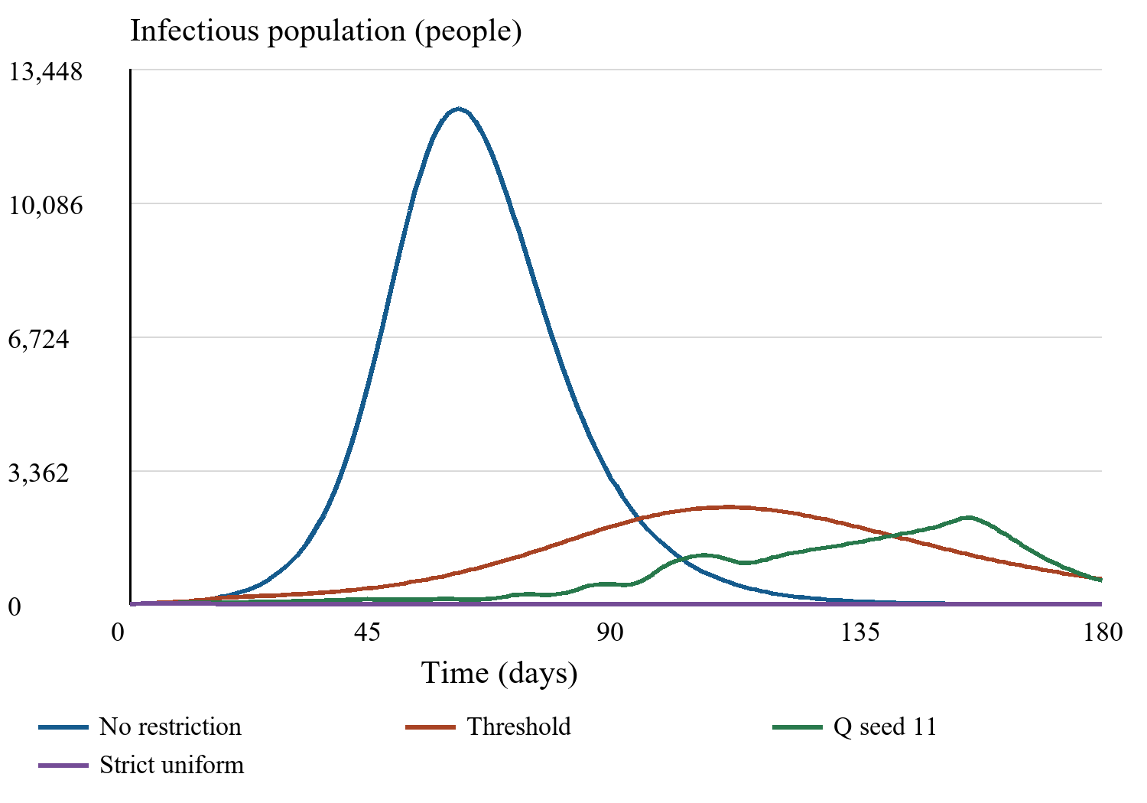
Fig. 1. Daily infectious population for held-out scenario seed 10000. The Q curve uses training seed 11; all curves share the same parameters.
B. Training Variability
Table IV separates the three training seeds. Their mean peak infectious populations range from 465.6 to 1,528.6, and their mean returns range from −0.2065 to −0.3372. The seed-11 controller exceeds demand-proxy capacity for a mean of 4.83 days, whereas the seed-33 controller does not exceed it in these scenarios. Reporting only the strongest seed would overstate reliability.
TABLE IV. Learned-policy variation across training seeds
Seed | Mean peak | Mean attack % | Mean return
11 | 1528.6 | 19.46 | -0.3372
22 | 909.9 | 11.11 | -0.2478
33 | 465.6 | 6.68 | -0.2065
Figure 2 displays trailing 100-episode means of negative training return; lower values represent better outcomes. The curves describe exploratory training on changing scenarios, rather than greedy-policy evaluation on a fixed validation set. They do not establish convergence to an optimal controller.
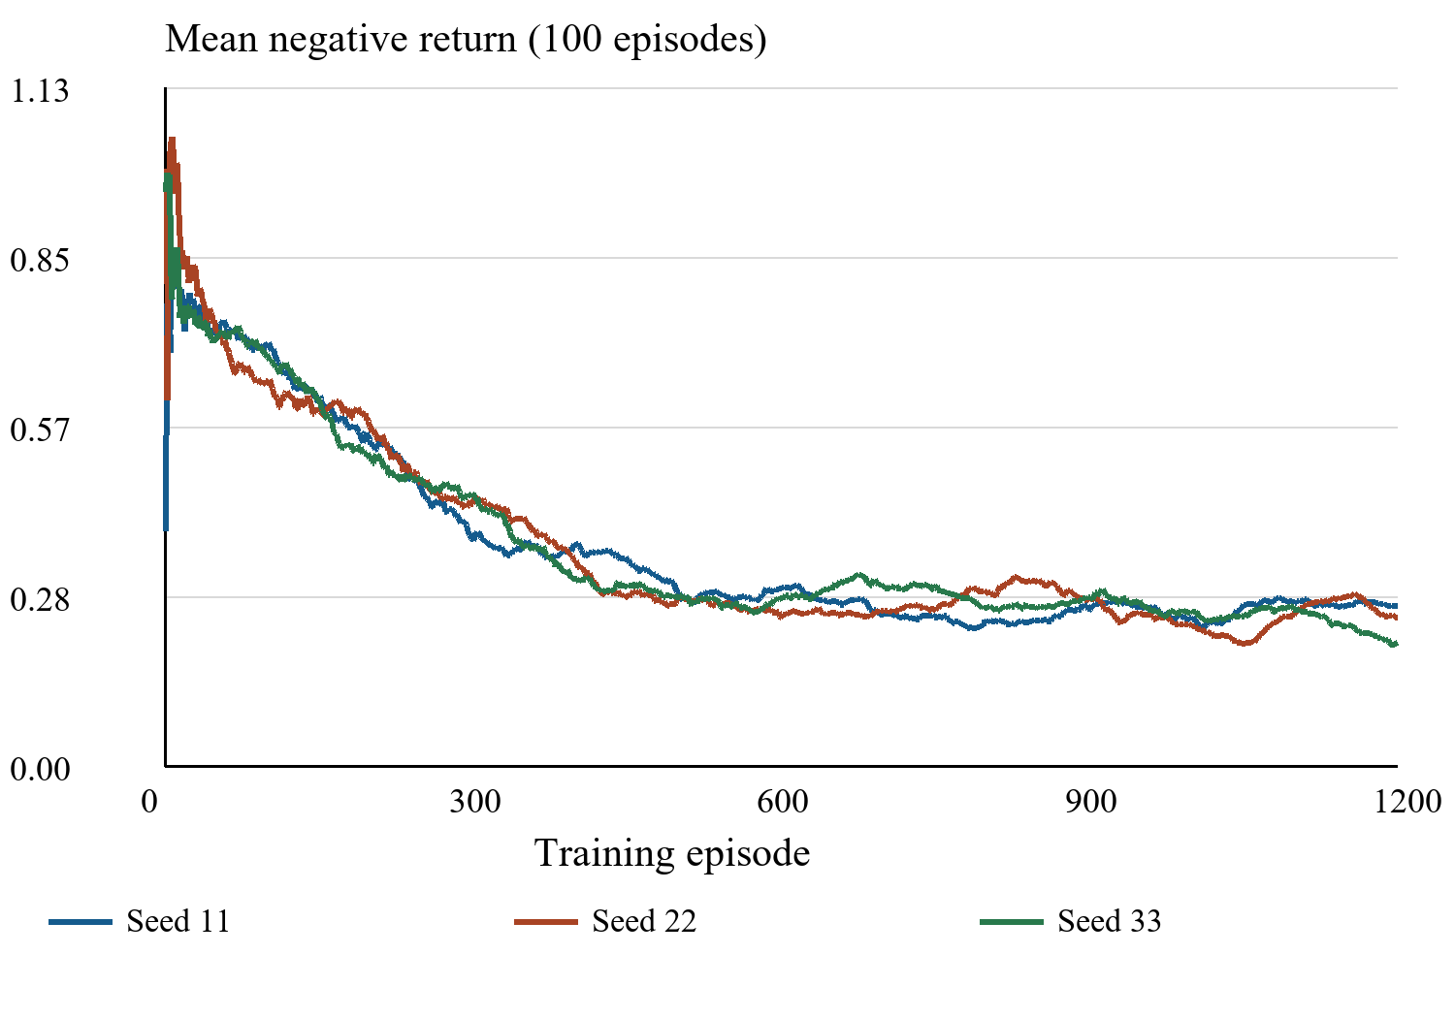
Fig. 2. Trailing mean negative training return for three seeds. Early windows contain all available episodes up to a maximum of 100.
C. Sensitivity and Numerical Checks
The learned controller is sensitive to transmission and compliance (Fig. 3). At β = 0.42 and compliance 0.50, its peak reaches 12,877.1 infectious people and its attack rate reaches 99.06%. At the same transmission coefficient and compliance 1.00, the peak is 2,701.8 and the attack rate is 35.00%. These stress tests use one controller and fixed initial conditions; they indicate limited robustness rather than population-level estimates.
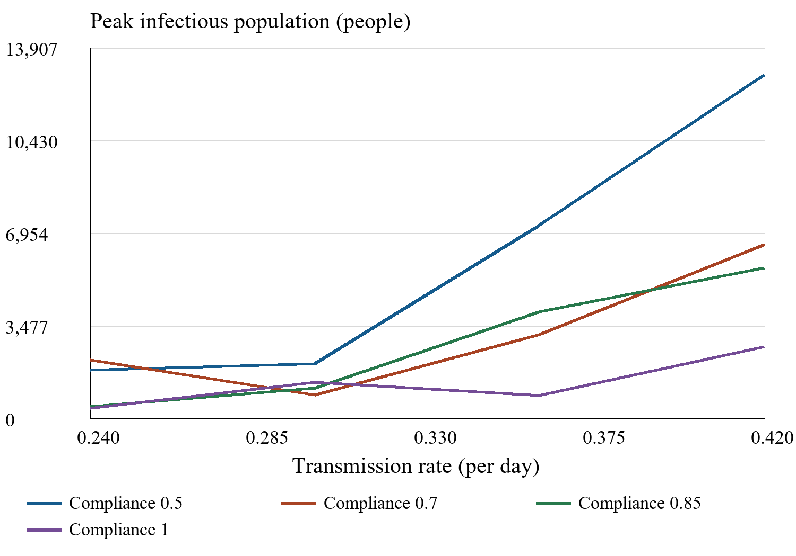
Fig. 3. Seed-11 controller evaluated across transmission coefficients and compliance values. Points are deterministic scenario outputs joined for readability
Across the evaluation records the largest error in keeping the population count correct is about 1.2 × 10⁻¹⁰ people. In the default no-restriction scenario the infectious peak reaches 12,372.0951 when a 0.5-day integration step is used and 12,372.0938 when a 0.125-day step is used. The difference between these peaks is 1.1 × 10⁻⁷ and the peak occurs on day 65 in both cases. These numbers show that the implementation is consistent. They do not prove that the model is accurate in real life.
D. Outcomes After Restriction Removal
Removing restrictions after day 180 produces a wave of infections in every controller group. The average peak after release is 8,303.3 for training seed 11 9,657.4 for training seed 22 and 10,615.6 for training seed 33. The attack rates on day 365 are 95.08 %, 96.01 % and 96.42 %. Even strict restrictions do not eliminate risk permanently; they only delay it. The average post-release peak for restrictions is 11,490.9 and the day-365 attack rate is 89.66 %.
The extension assumes that residual infection behaves deterministically that transmissibility stays the same that immunity lasts forever and that there is no vaccination or extra response. It does not consider extinction, new cases from outside or changes in clinical care. The goal is to demonstrate that a controller that is rewarded for 180 days can push infections past the evaluation limit. The extension does not provide a real-world reopening policy.
VII.. Limitations
The results give two conclusions in this setting. First the learned controllers perform better on the stated goal than a simple policy targeting a specific prevalence and they use less restriction intensity than continuous strict control. Second the performance changes with training seeds gets worse when some parameters shift and it does not mean that the epidemic will be permanently eliminated. These findings show that the evaluation boundary matters much as the drop in peak infections.
Many assumptions limit how we can interpret the results. The contact coefficients and cohort fractions are examples and the intensity of a policy lowers contact on both sides. Therefore the differences seen between cohorts depend on the mixing structure chosen. The hospital proxy does not include admission or discharge dynamics and economic cost is shown by the square of restriction intensity. Things like mortality, vaccination, clinical severity, behavioural change, reporting delay and unequal burdens of intervention are not included in the model.
The controller relies on aggregate data and only three training seeds. The benchmark set contains a threshold rule but it lacks an optimized threshold, a model-predictive controller or a continuous-action reinforcement learning algorithm. The reward weights are. Changing preferences would need new training. A policy can take advantage of the horizon by pushing infections later; the post-release results explain why objectives that focus on longer horizons and terminal risk need separate assessment.
Before the model can be used in practice it must be calibrated against case and admission data, validated independently over time include a hospital compartment grounded in clinical reality account for uncertainty in observation and transmission and explicitly address fairness and feasibility. Testing the interface with the people who will use it is also necessary. At present, the application is best suited to learning scenarios and repeatable computational experiments.
VIII. Conclusion
EpiControl AI offers a working two-cohort SEIR simulator, a tabular Q-learning controller and a shared interface for comparing policies. In scenarios that were not used during training the learned policies lower infection peaks more than a no-restriction policy and lower the cost proxy of restrictions more than strict uniform control. The average combined return is similar to that of restrictions but there is big variation between training seeds. Sensitivity tests and post-release experiments reveal problems that a short demonstration would miss. The framework gives a foundation for more modelling and validation but its claims are limited to the synthetic experiments recorded.
Acknowledgment
OpenAI Codex accessed October 7 2026 helped draft and restructure Sections I-VIII, review records and produce the updated software, experiment scripts and figures. Figures 1-3 were made from recorded simulation outputs, not from example images. This help does not make Codex an author; the human authors keep responsibility, for verification, attribution and approval of the article.
References
[1] W. O. Kermack and A. G. McKendrick, “A contribution to the mathematical theory of epidemics,” Proc. R. Soc. Lond. A, vol. 115, no. 772, pp. 700-721, 1927, doi: 10.1098/rspa.1927.0118.
[2] K. Prem, A. R. Cook, and M. Jit, “Projecting social contact matrices in 152 countries using contact surveys and demographic data,” PLoS Comput. Biol., vol. 13, no. 9, Art. no. e1005697, 2017, doi: 10.1371/journal.pcbi.1005697.
[3] V. Kompella et al., “Reinforcement learning for optimization of COVID-19 mitigation policies,” arXiv:2010.10560, 2020, doi: 10.48550/arXiv.2010.10560.
[4] A. Q. Ohi, M. F. Mridha, M. M. Monowar, and M. A. Hamid, “Exploring optimal control of epidemic spread using reinforcement learning,” Sci. Rep., vol. 10, Art. no. 22106, 2020, doi: 10.1038/s41598-020-79147-8.
[5] I. Rao, “Modeling and optimization of epidemiological control policies through reinforcement learning,” arXiv:2402.06640, 2024, doi: 10.48550/arXiv.2402.06640.
[6] M. Jain, Z. Uddin, and W. Ibrahim, “SIR-RL: Reinforcement learning for optimized policy control during epidemiological outbreaks in emerging market and developing economies,” arXiv:2404.08423, 2024, doi: 10.48550/arXiv.2404.08423.
[7] C. J. C. H. Watkins and P. Dayan, “Q-learning,” Mach. Learn., vol. 8, pp. 279-292, 1992, doi: 10.1007/BF00992698.
[8] J. Mossong et al., “Social contacts and mixing patterns relevant to the spread of infectious diseases,” PLoS Med., vol. 5, no. 3, Art. no. e74, 2008, doi: 10.1371/journal.pmed.0050074.
[9] N. G. Davies et al., “Age-dependent effects in the transmission and control of COVID-19 epidemics,” Nat. Med., vol. 26, 2020, doi: 10.1038/s41591-020-0962-9.
[10] E. K. Korir and Z. Vizi, “Eigenvector-based sensitivity analysis of contact patterns in epidemic modelling,” J R Soc Interface, vol. 22, no. 233, 2025, doi: 10.1098/rsif.2025.0664.
[11] L. Angeli et al., “Who acquires infection from whom? A sensitivity analysis of transmission dynamics during the early phase of the COVID-19 pandemic in Belgium,” J Theor Biol, vol. 581, 2024, doi: 10.1016/j.jtbi.2024.111721.
[12] I. Rodiah et al., “Age-specific contribution of contacts to transmission of SARS-CoV-2 in Germany,” Eur J Epidemiol, vol. 38, no. 1, 2023, doi: 10.1007/s10654-022-00938-6.
[13] W. Zhu et al., “Age-specific transmission dynamics under suppression control measures during SARS-CoV-2 Omicron BA.2 epidemic,” BMC Public Health, vol. 23, no. 1, 2023, doi: 10.1186/s12889-023-15596-w.
[14] S. Flaxman et al., “Estimating the effects of non-pharmaceutical interventions on COVID-19 in Europe,” Nature, vol. 584, 2020, doi: 10.1038/s41586-020-2405-7.
[15] N. Haug et al., “Ranking the effectiveness of worldwide COVID-19 government interventions,” Nat. Hum. Behav., vol. 4, 2020, doi: 10.1038/s41562-020-01009-0.
[16] S. Hsiang et al., “The effect of large-scale anti-contagion policies on the COVID-19 pandemic,” Nature, vol. 584, 2020, doi: 10.1038/s41586-020-2404-8.
[17] J. M. Brauner et al., “Inferring the effectiveness of government interventions against COVID-19,” Science, vol. 371, no. 6531, 2021, doi: 10.1126/science.abd9338.
[18] W. Frederiks et al., “Predicting contact rates in response to non-pharmaceutical interventions: A validated protocol for generating contact matrices relevant to transmission modelling of respiratory diseases,” Epidemics, vol. 56, 2026, doi: 10.1016/j.epidem.2026.100934.
[19] M. Lotfi and L. Kaderali, “Data-driven strategies for model-informed decision-making during the COVID-19 pandemic: a systematic review,” BMJ Open, vol. 16, no. 1, 2026, doi: 10.1136/bmjopen-2025-107660.
[20] T. Ashcroft et al., “Effectiveness of non-pharmaceutical interventions as implemented in the UK during the COVID-19 pandemic: a rapid review,” J Public Health (Oxf), vol. 47, no. 2, 2025, doi: 10.1093/pubmed/fdaf017.
[21] M. Schulte, N. Leithäuser, and J. Mohring, “Estimating the effect of self-protection on transmission dynamics of SARS-CoV-2 in Germany in 2021: a modelling study,” BMC Public Health, vol. 26, no. 1, 2026, doi: 10.1186/s12889-026-27264-w.
[22] E. van Kleef et al., “Modelling practices, data provisioning, sharing and dissemination needs for pandemic decision-making: a European survey-based modellers' perspective, 2020 to 2022,” Euro Surveill, vol. 30, no. 42, 2025, doi: 10.2807/1560-7917.es.2025.30.42.2500216.
[23] M. Fajgenblat et al., “Evaluating the direct effect of vaccination and non-pharmaceutical interventions during the COVID-19 pandemic in Europe,” Commun Med (Lond), vol. 4, no. 1, 2024, doi: 10.1038/s43856-024-00600-0.
[24] L. Lucchini et al., “Implications for distancing measures on in-person school and work attendance from Italian post-pandemic social contact data,” Commun Med (Lond), vol. 6, no. 1, 2026, doi: 10.1038/s43856-026-01543-4.
[25] P. Alahakoon, P. G. Taylor, and J. M. McCaw, “Stochastic modelling of early-stage COVID-19 epidemic dynamics in rural communities in the United States,” J Theor Biol, vol. 615, 2025, doi: 10.1016/j.jtbi.2025.112248.
[26] M. Choi et al., “Adaptive social distancing under variant-specific transmission dynamics in a spatial SEIIR model with reinforcement learning,” J Theor Biol, vol. 632, 2026, doi: 10.1016/j.jtbi.2026.112530.
[27] C. Weyant, S. Lee, and J. D. Goldhaber-Fiebert, “Reinforcement Learning-Based Control of Epidemics on Networks of Communities and Correctional Facilities,” Med Decis Making, vol. 46, no. 2, 2026, doi: 10.1177/0272989x251378472.
[28] G. Gemignani et al., “Real-time responses to epidemics: A Reinforcement-Learning approach,” Math Biosci Eng, vol. 23, no. 3, 2026, doi: 10.3934/mbe.2026029.
[29] Y. Tian et al., “Optimizing spatiotemporal nonpharmaceutical interventions for influenza: An adaptive reinforcement learning approach for regional heterogeneity,” Infect Dis Model, vol. 11, no. 1, 2026, doi: 10.1016/j.idm.2025.10.001.
[30] X. Du et al., “HRL4EC: Hierarchical reinforcement learning for multi-mode epidemic control,” Inf Sci (N Y), vol. 640, 2023, doi: 10.1016/j.ins.2023.119065.
[31] Y. Kao et al., “A dynamic approach to support outbreak management using reinforcement learning and semi-connected SEIQR models,” BMC Public Health, vol. 24, no. 1, 2024, doi: 10.1186/s12889-024-18251-0.
[32] S. Bushaj et al., “A simulation-deep reinforcement learning (SiRL) approach for epidemic control optimization,” Ann Oper Res, 2022, doi: 10.1007/s10479-022-04926-7.
[33] X. Guo et al., “PaCAR: COVID-19 Pandemic Control Decision Making via Large-Scale Agent-Based Modeling and Deep Reinforcement Learning,” Med Decis Making, vol. 42, no. 8, 2022, doi: 10.1177/0272989x221107902.
[34] S. Abazari et al., “Integrating epidemiological modeling and time-series forecasting to optimize pandemic patient allocation,” Int J Health Geogr, vol. 25, no. 1, 2026, doi: 10.1186/s12942-026-00455-9.
[35] M. Shams Eddin and H. El Hajj, “An Optimization-Based Framework to Dynamically Schedule Hospital Beds in a Pandemic,” Healthcare (Basel), vol. 13, no. 18, 2025, doi: 10.3390/healthcare13182338.
[36] R. Kociurzynski et al., “Forecasting local hospital bed demand for COVID-19 using on-request simulations,” Sci Rep, vol. 13, no. 1, 2023, doi: 10.1038/s41598-023-48601-8.
[37] D. Lovett et al., “Evaluation of a pragmatic approach to predicting COVID-19-positive hospital bed occupancy,” BMJ Health Care Inform, vol. 32, no. 1, 2025, doi: 10.1136/bmjhci-2024-101055.
[38] M. J. Plank, L. Watson, and O. J. Maclaren, “Near-term forecasting of Covid-19 cases and hospitalisations in Aotearoa New Zealand,” PLoS Comput Biol, vol. 20, no. 1, 2024, doi: 10.1371/journal.pcbi.1011752.
[39] D. Borges and M. C. V. Nascimento, “COVID-19 ICU demand forecasting: A two-stage Prophet-LSTM approach,” Appl Soft Comput, vol. 125, 2022, doi: 10.1016/j.asoc.2022.109181.
[40] M. J. Panaggio et al., “Gecko: A time-series model for COVID-19 hospital admission forecasting,” Epidemics, vol. 39, 2022, doi: 10.1016/j.epidem.2022.100580.
[41] M. I. Betti et al., “COVID-19 Vaccination and Healthcare Demand,” Bull Math Biol, vol. 85, no. 5, 2023, doi: 10.1007/s11538-023-01130-x.
[42] J. Van Yperen et al., “A hospital demand and capacity intervention approach for COVID-19,” PLoS One, vol. 18, no. 5, 2023, doi: 10.1371/journal.pone.0283350.
[43] T. Bayley et al., “ML-ABC: Machine-learning assisted Approximate Bayesian Computation for efficient calibration of agent-based models for pandemic outbreak analysis,” Epidemics, vol. 54, 2026, doi: 10.1016/j.epidem.2025.100881.
[44] D. M. Manias et al., “Mechanistic Understanding of Pandemic Dynamics: A Multiscale Algorithmic Framework,” Life (Basel), vol. 16, no. 6, 2026, doi: 10.3390/life16060889.
[45] T. Gaskin et al., “Neural parameter calibration and uncertainty quantification for epidemic forecasting,” PLoS One, vol. 19, no. 10, 2024, doi: 10.1371/journal.pone.0306704.
[46] G. Chowell and P. Skums, “Investigating and forecasting infectious disease dynamics using epidemiological and molecular surveillance data,” Phys Life Rev, vol. 51, 2024, doi: 10.1016/j.plrev.2024.10.011.
[47] E. Howerton et al., “Evaluation of the US COVID-19 Scenario Modeling Hub for informing pandemic response under uncertainty,” Nat Commun, vol. 14, no. 1, 2023, doi: 10.1038/s41467-023-42680-x.
[48] G. Chowell et al., “An ensemble n-sub-epidemic modeling framework for short-term forecasting epidemic trajectories: Application to the COVID-19 pandemic in the USA,” PLoS Comput Biol, vol. 18, no. 10, 2022, doi: 10.1371/journal.pcbi.1010602.
[49] C. Bardelli, “Inference on COVID-19 Epidemiological Parameters Using Bayesian Survival Analysis,” Entropy (Basel), vol. 23, no. 10, 2021, doi: 10.3390/e23101262.
[50] G. Bertaglia et al., “Spatial spread of COVID-19 outbreak in Italy using multiscale kinetic transport equations with uncertainty,” Math Biosci Eng, vol. 18, no. 5, 2021, doi: 10.3934/mbe.2021350.
[51] Partha81-star, “Epicontrol_AI,” GitHub repository, baseline commit 8d5cf6a964f2c008a163cbbbac40d8fda04cfaad. Accessed: Oct. 7, 2026. [Online]. Available: https://github.com/Partha81-star/Epicontrol_AI.

