IIS Deployment

1. New Application is created under Default Web Site.
2. Given name for the application as TwitterCloneWebApp

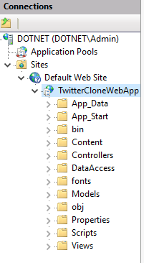

1. New Application Pool is created for TwitterCloneWebApp to run on .NET 4.0 Runtime.

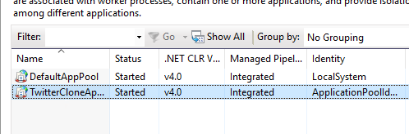

1. Twittter Web App is configured to run on Application Pool “TwitterCloneAppPool”

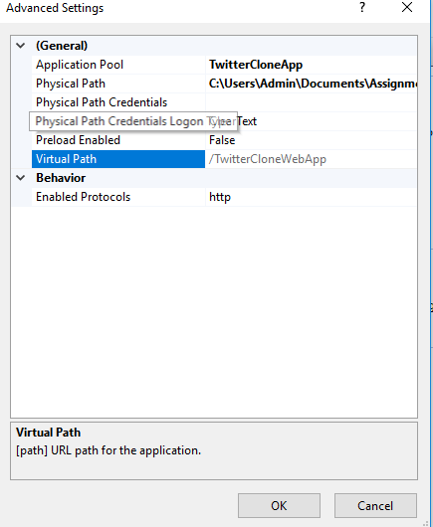

1. Setup to run on ApplicationPoolIdenity

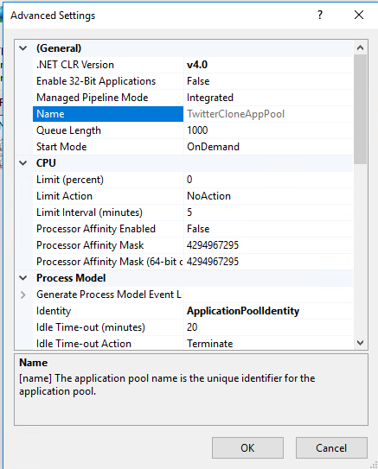

1. Sample Screenshot of the Twitter Clone application running in Local IIS.

