

**American International University- Bangladesh**

**CSC 4181: Advanced Database Management Systems**

**Midterm Report**

**Spring 22-23**

**Project Title:** Hands-for-Hands

**Section:** A

|  |  |
| --- | --- |
| Student Name | Student Id |
| Jim, Jamin Rahman | 20-42732-1 |
| Partha Malakar | 20-42908-1 |
| Sadir Ahmed Zidan | 20-43263-1 |
| Fabiha Tasnim | 20-43426-1 |

Table of Contents

|  |  |  |
| --- | --- | --- |
| System Summary | :................................................................................ | 03 |
| ERD Diagram | :................................................................................ | 04 |
| Class Diagram | :................................................................................ | 05 |
| Use Case Diagram | :................................................................................ | 06 |
| Activity Diagram | :................................................................................ | 07-10 |
| Schema Diagram | :................................................................................ | 11 |
| Creating Tables | :................................................................................ | 12-19 |
| Tables with Data | :................................................................................ | 19-28 |
| Task | :................................................................................ | 29-33 |
| User Interface | :................................................................................ | 34-35 |

**System Summary:**

Throughout daily life, people occasionally desire various things to satisfy their ad hoc needs. These things might be a camera, a bicycle, a book, or anything else. A person decides to purchase the item even though it won't be useful in the long run since the necessity is only temporary. As a result, it qualifies as trash. Consequently, the person has the option of borrowing from others who already own such products rather than making a purchase.

There are four types of user categories –

1. Admin
2. Customer Support
3. Owner
4. Borrower

For this system, the administrative and customer support organizations are crucial. They are in charge of properly maintaining the platform.

Like any contemporary system, anyone may set up an account, log in, and utilize the many features. There is also the opportunity to change your account details and password. Moreover, users might have a distinctive username. Navigating the user interface is simple.

**ERD Diagram:**

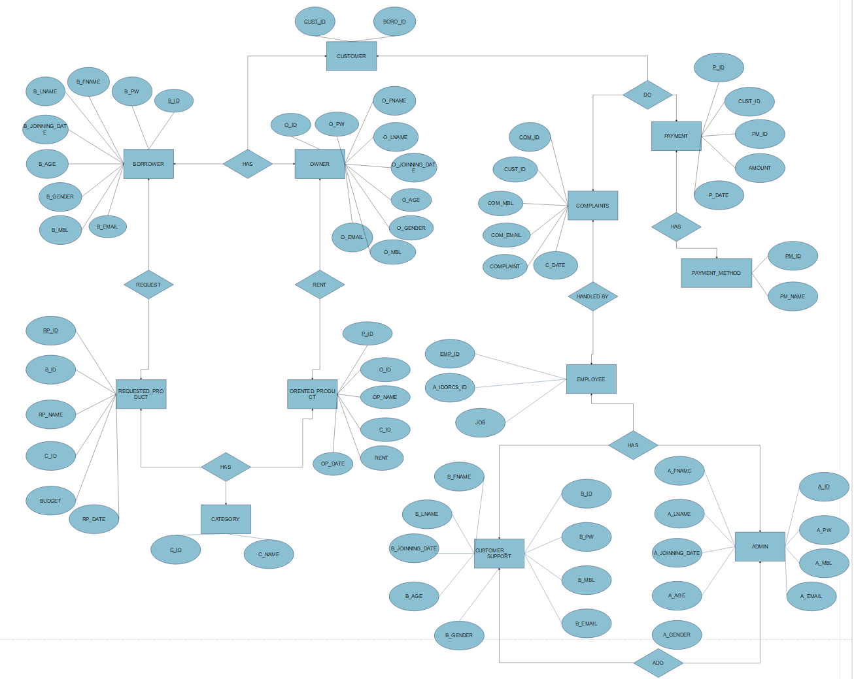

**Class Diagram:**

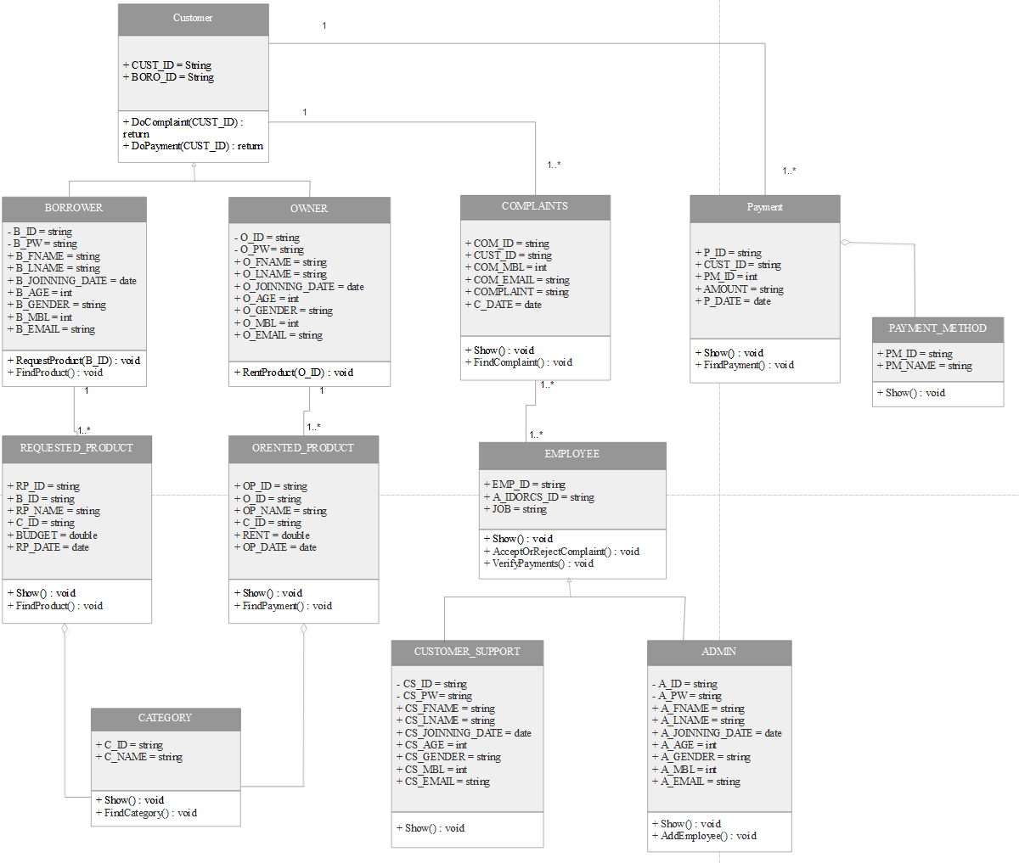

**Use Case Diagram:**

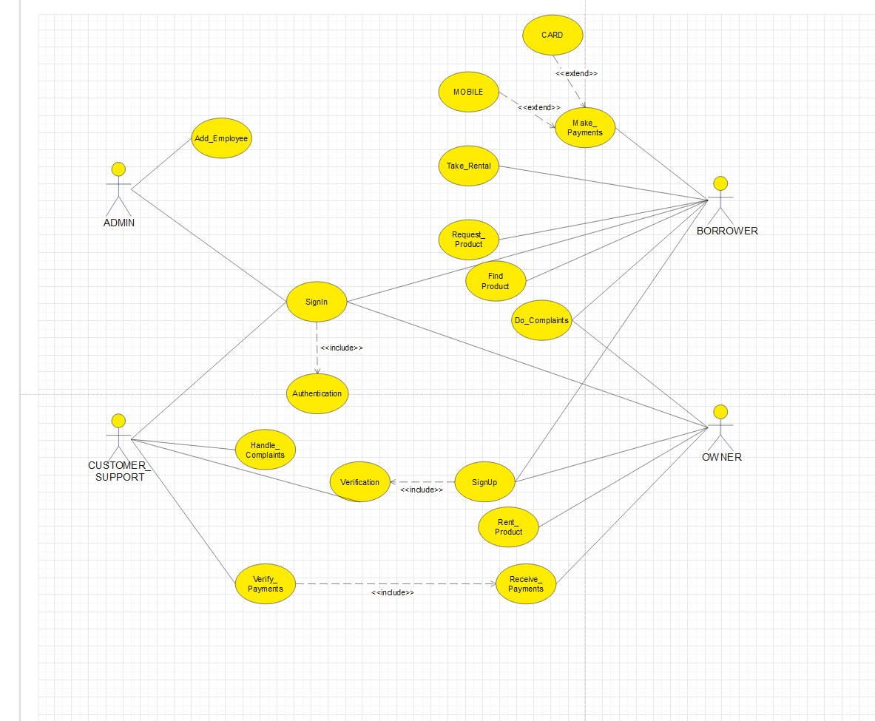

**Activity Diagram: (Admin)**

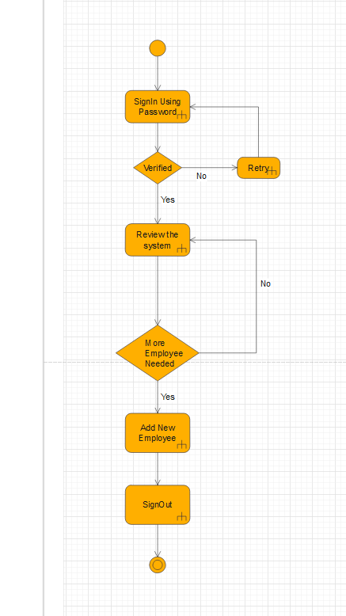

**Activity Diagram: (Customer Support)**

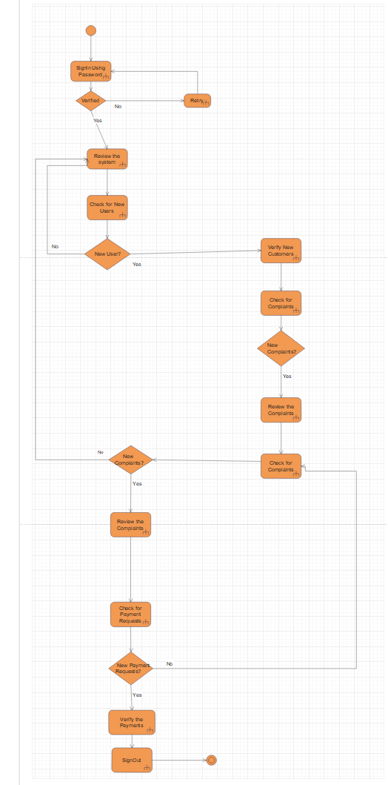

**Activity Diagram: (Borrower)**

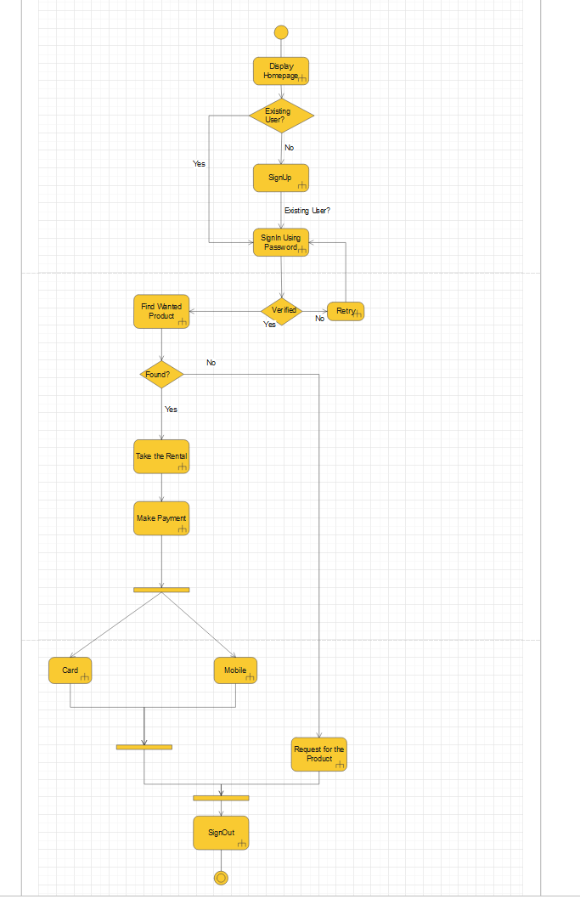

**Activity Diagram: (Owner)**

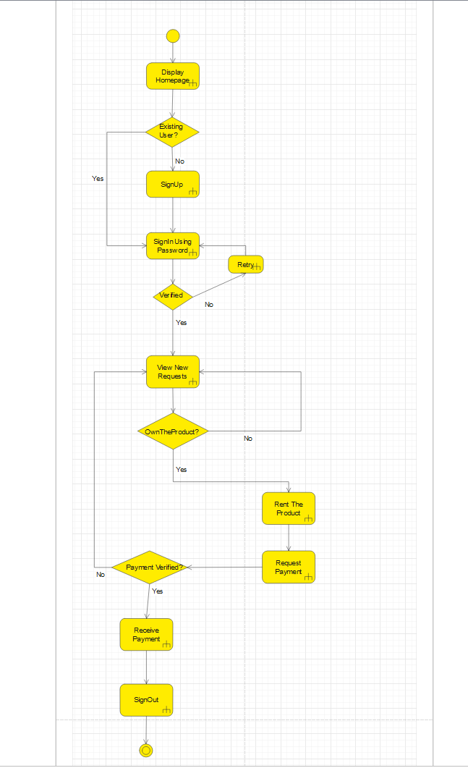

**Schema Diagram:**

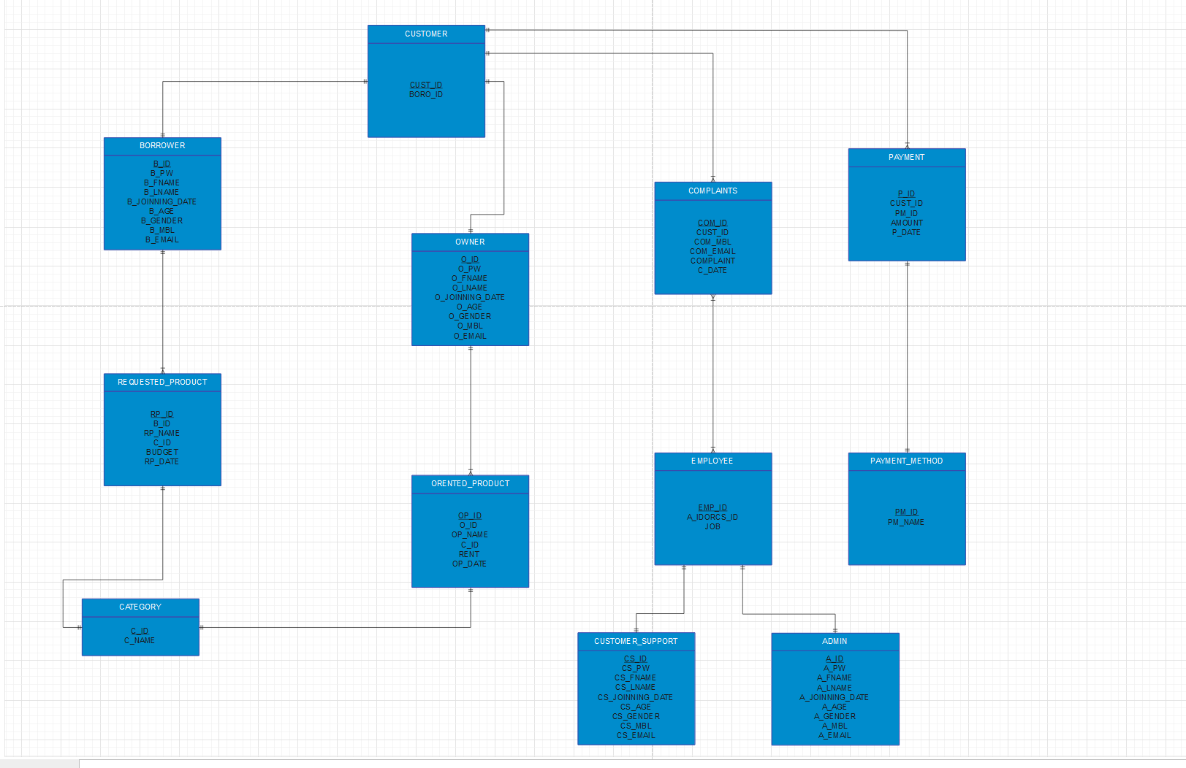

**Create Tables:**

**OWNER**

CREATE TABLE OWNER(

O_ID varchar(30) not null,

O_PW varchar(20) not null,

O_FNAME varchar(40) not null,

O_LNAME varchar(40) not null,

O_JOINNING_DATE date not null,

O_AGE number(3) not null,

O_GENDER varchar(10) not null,

O_MBL varchar(15) not null,

O_EMAIL varchar(30) not null,

PRIMARY KEY (O_ID ) );

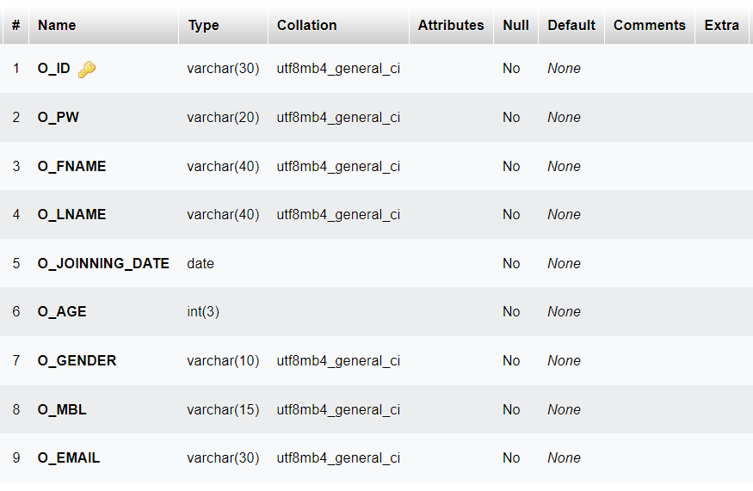

**ADMIN**

CREATE TABLE ADMIN(

A_ID varchar(30) not null,

A_PW varchar(20) not null,

A_FNAME varchar(40) not null,

A_LNAME varchar(40) not null,

A_JOINNING_DATE date not null,

A_AGE number(3) not null,

A_GENDER varchar(10) not null,

A_MBL varchar(15) not null,

A_EMAIL varchar(30) not null, PRIMARY KEY (A_ID ) );

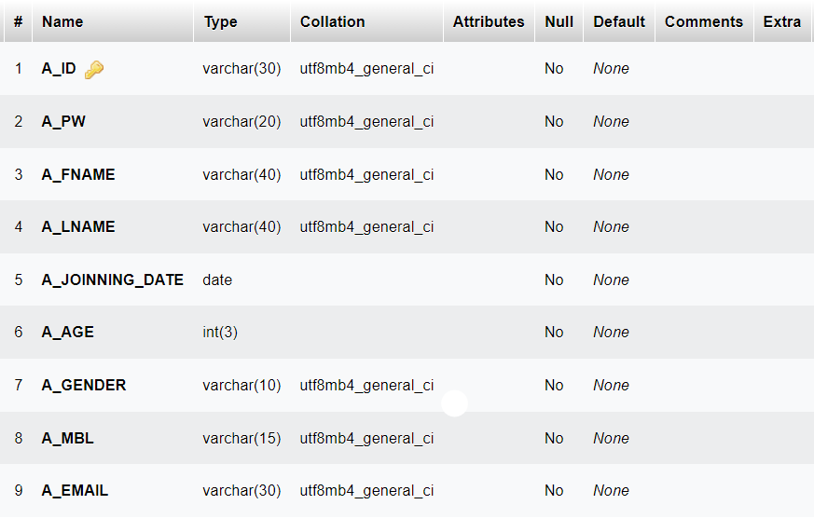

**CUSTOMER_SUPPORT**

CREATE TABLE CUSTOMER_SUPPORT(

CS_ID varchar(30) not null,

CS_PW varchar(20) not null,

CS_FNAME varchar(40) not null,

CS_LNAME varchar(40) not null,

CS_JOINNING_DATE date not null,

CS_AGE number(3) not null,

CS_GENDER varchar(10) not null,

CS_MBL varchar(15) not null,

CS_EMAIL varchar(30) not null,

PRIMARY KEY (CS_ID ) );

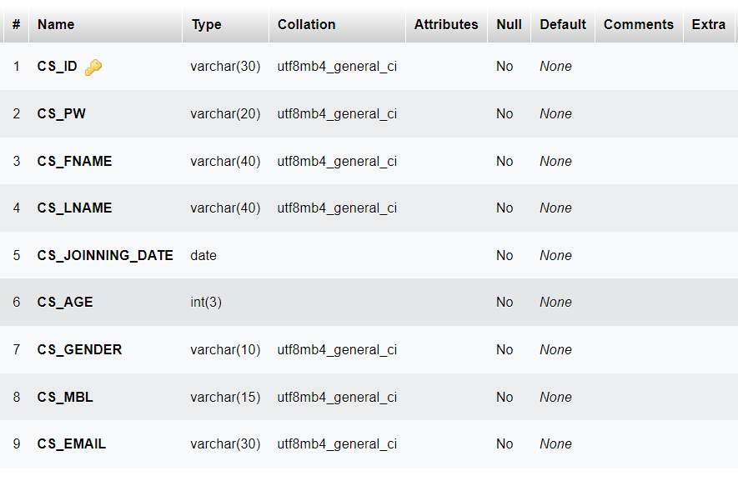

**BORROWER**

CREATE TABLE BORROWER(

B_ID varchar(30) not null,

B_PW varchar(20) not null,

B_FNAME varchar(40) not null,

B_LNAME varchar(40) not null,

B_JOINNING_DATE date not null,

B_AGE number(3) not null,

B_GENDER varchar(10) not null,

B_MBL varchar(15) not null,

B_EMAIL varchar(30) not null,

PRIMARY KEY (B_ID ) );

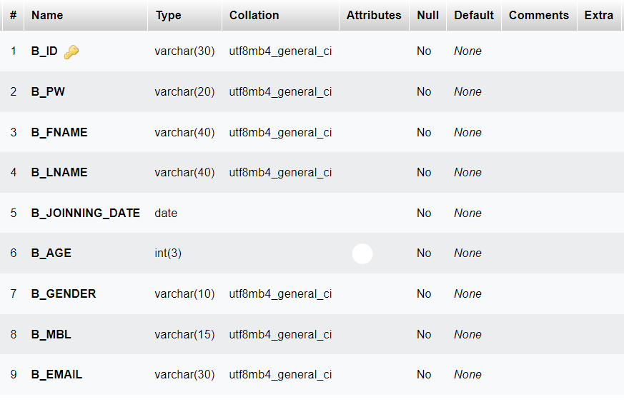

**CUSTOMER**

CREATE TABLE CUSTOMER(

CUST_ID varchar(20) not null,

BORO_ID varchar(30) not null,

PRIMARY KEY (CUST_ID ) );

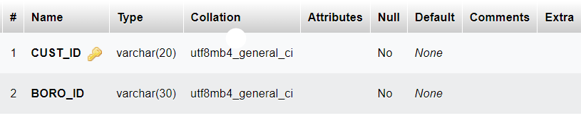

**PAYMENT_METHOD**

CREATE TABLE PAYMENT_METHOD(

PM_ID varchar(20) not null,

PM_NAME varchar(30) not null,

PRIMARY KEY (PM_ID ) );

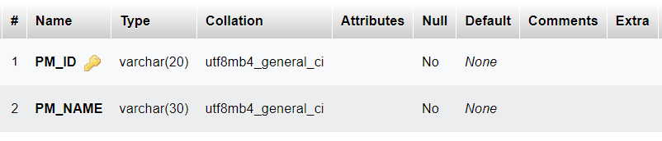

**EMPLOYEE**

CREATE TABLE EMPLOYEE(

EMP_ID varchar(20) not null,

AD_OR_CS_ID varchar(30) not null,

JOB varchar(20) not null,

PRIMARY KEY (EMP_ID ) );

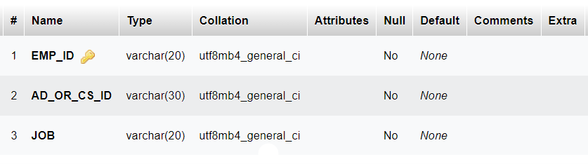

**COMPLAINTS**

CREATE TABLE COMPLAINTS(

COM_ID varchar(20) not null,

CUST_ID varchar(20) not null,

COM_MBL varchar(15) not null,

COM_EMAIL varchar(30) not null,

COMPLAINT long not null,

C_DATE date not null,

PRIMARY KEY (COM_ID ),

FOREIGN KEY(CUST_ID) REFERENCES CUSTOMER(CUST_ID) );

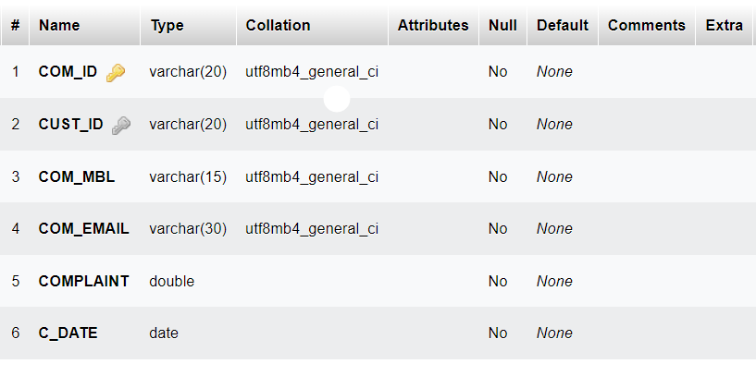

**PAYMENT**

CREATE TABLE PAYMENT(

P_ID varchar(20) not null,

CUST_ID varchar(20) not null,

PM_ID varchar(20) not null,

AMOUNT float(10) not null,

P_DATE date not null,

PRIMARY KEY (P_ID ),

FOREIGN KEY(CUST_ID) REFERENCES CUSTOMER(CUST_ID),

FOREIGN KEY(PM_ID) REFERENCES PAYMENT_METHOD(PM_ID) );

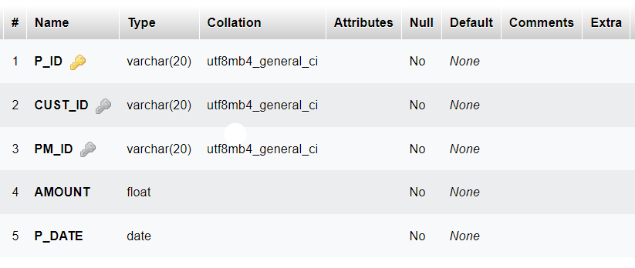

**REQUESTED_PRODUCT**

CREATE TABLE REQUESTED_PRODUCT(

RP_ID varchar(20) not null,

B_ID varchar(30) not null,

RP_NAME varchar(50) not null,

C_ID varchar(20) not null,

BUDGET float(10) not null,

RP_DATE date not null,

PRIMARY KEY (RP_ID),

FOREIGN KEY(B_ID) REFERENCES BORROWER(B_ID),

FOREIGN KEY(C_ID) REFERENCES CATEGORY(C_ID) );

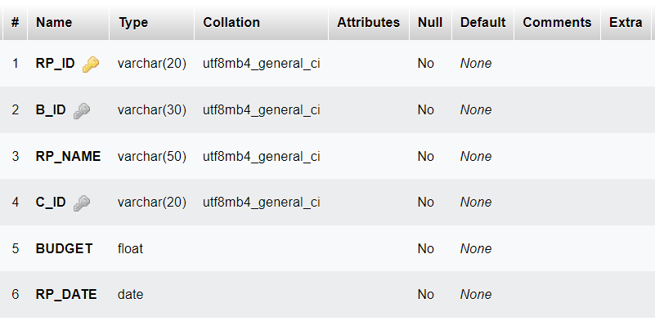

**ORENTED_PRODUCT**

CREATE TABLE ORENTED_PRODUCT(

OP_ID varchar(20) not null,

O_ID varchar(30) not null,

OP_NAME varchar(50) not null,

C_ID varchar(20) not null,

RENT float(10) not null,

OP_DATE date not null,

PRIMARY KEY (OP_ID ),

FOREIGN KEY(O_ID ) REFERENCES OWNER(O_ID ),

FOREIGN KEY(C_ID) REFERENCES CATEGORY(C_ID) );

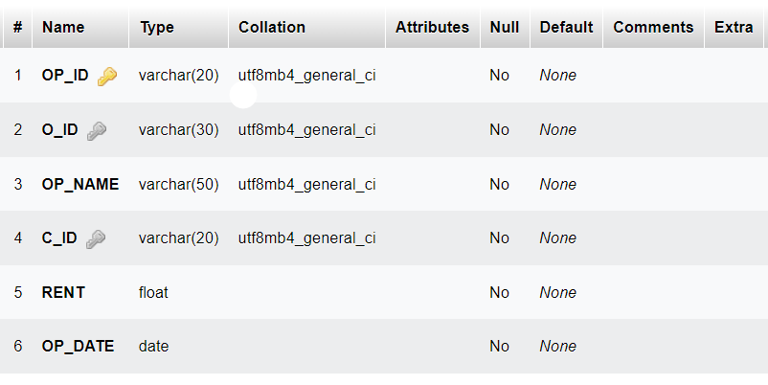

**CATEGORY**

CREATE TABLE CATEGORY(

C_ID varchar(20) not null,

C_NAME varchar(30) not null,

PRIMARY KEY (C_ID ) );

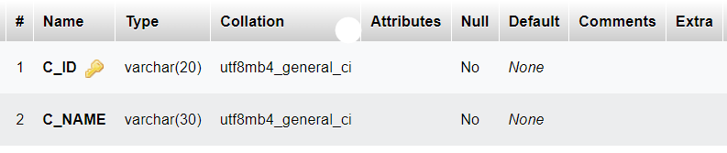

**Insert Into Table:**

**OWNER**

INSERT INTO OWNER(O_ID, O_PW, O_FNAME, O_LNAME, O_JOINNING_DATE, O_AGE, O_GENDER, O_MBL, O_EMAIL) VALUES('OW001','OW001','BRIAN','KRANSTON', '2020/06/01', 48, 'M', '01325463215', 'bkrans236@gmail.com');

INSERT INTO OWNER(O_ID, O_PW, O_FNAME, O_LNAME, O_JOINNING_DATE, O_AGE, O_GENDER, O_MBL, O_EMAIL) VALUES('OW002','OW002','ANNA','GUNN', '2020/06/02', 39, 'F', '01326547896', 'gunnanna47896@gmail.com');

INSERT INTO OWNER(O_ID, O_PW, O_FNAME, O_LNAME, O_JOINNING_DATE, O_AGE, O_GENDER, O_MBL, O_EMAIL) VALUES('OW003','OW003','GUSTAVO','FRING', '2020/07/03', 52, 'M', '01854632102', '[gusfring@gmail.com](mailto:gusfring@gmail.com)');

INSERT INTO OWNER(O_ID, O_PW, O_FNAME, O_LNAME, O_JOINNING_DATE, O_AGE, O_GENDER, O_MBL, O_EMAIL) VALUES('OW004','OW004','JESSE','PINKMAN', '2020/07/03', 27, 'M', '01654123065', 'jessepink00000@gmail.com');

INSERT INTO OWNER(O_ID, O_PW, O_FNAME, O_LNAME, O_JOINNING_DATE, O_AGE, O_GENDER, O_MBL, O_EMAIL) VALUES('OW005','OW005','BOB','ODENKIRK', '2020/06/01', 36, 'M', '01878965425', '[bobbyod879@gmail.com](mailto:bobbyod879@gmail.com)');

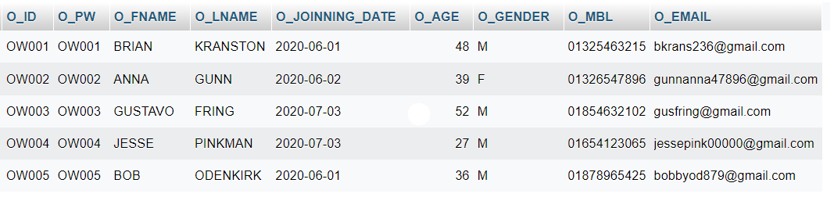

**ADMIN**

INSERT INTO ADMIN (A_ID, A_PW, A_FNAME, A_LNAME, A_JOINNING_DATE, A_AGE, A_GENDER, A_MBL, A_EMAIL) VALUES('AD001','AD001','BRUCE','WAYNE', '2020/01/01', 32, 'M', '01451254120', 'brucewayne@gmail.com');

INSERT INTO ADMIN (A_ID, A_PW, A_FNAME, A_LNAME, A_JOINNING_DATE, A_AGE, A_GENDER, A_MBL, A_EMAIL) VALUES('AD002','AD002','CLARK','KENT', '2020/01/03', 30, 'M', '01230232011', 'clarkkent@gmail.com');

INSERT INTO ADMIN (A_ID, A_PW, A_FNAME, A_LNAME, A_JOINNING_DATE, A_AGE, A_GENDER, A_MBL, A_EMAIL) VALUES('AD003','AD003','ARTHUR','MORGAN', '2020/02/01', 36, 'M', '01230254632', 'arthurm@gmail.com');

INSERT INTO ADMIN (A_ID, A_PW, A_FNAME, A_LNAME, A_JOINNING_DATE, A_AGE, A_GENDER, A_MBL, A_EMAIL) VALUES('AD004','AD004','JAMES','WAYNE', '2020/01/05', 33, 'M', '01236521456', 'jameswayne@gmail.com');

INSERT INTO ADMIN (A_ID, A_PW, A_FNAME, A_LNAME, A_JOINNING_DATE, A_AGE, A_GENDER, A_MBL, A_EMAIL) VALUES('AD005','AD005','GERALT','RIVIA','2020/01/03', 37, 'M', '01232021256', '[geraltrivia@gmail.com](mailto:geraltrivia@gmail.com)');

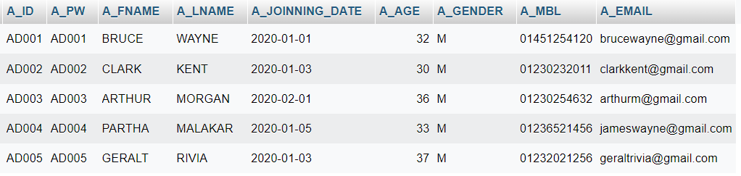

**CUSTOMER_SUPPORT**

INSERT INTO CUSTOMER_SUPPORT(CS_ID, CS_PW, CS_FNAME, CS_LNAME, CS_JOINNING_DATE, CS_AGE, CS_GENDER, CS_MBL, CS_EMAIL) VALUES('CS001','CS001','ALFRED','PENNYWORTH', '2020/04/01', 25, 'M', '01230232549', 'alfredpenny@gmail.com');

INSERT INTO CUSTOMER_SUPPORT(CS_ID, CS_PW, CS_FNAME, CS_LNAME, CS_JOINNING_DATE, CS_AGE, CS_GENDER, CS_MBL, CS_EMAIL) VALUES('CS002','CS002','JACK','SPRING', '2021/01/01', 24, 'M', '01232125478', 'jacks@gmail.com');

INSERT INTO CUSTOMER_SUPPORT(CS_ID, CS_PW, CS_FNAME, CS_LNAME, CS_JOINNING_DATE, CS_AGE, CS_GENDER, CS_MBL, CS_EMAIL) VALUES('CS003','CS003','JOHN','HALO', '2021/03/04', 26, 'M', '01232125469', 'johnhalo002@gmail.com');

INSERT INTO CUSTOMER_SUPPORT(CS_ID, CS_PW, CS_FNAME, CS_LNAME, CS_JOINNING_DATE, CS_AGE, CS_GENDER, CS_MBL, CS_EMAIL) VALUES('CS004','CS004','EDWARD','KENWAY', '2021/03/04', 26, 'M', '02312547896', '[kenwayed23@gmail.com](mailto:kenwayed23@gmail.com)');

INSERT INTO CUSTOMER_SUPPORT(CS_ID, CS_PW, CS_FNAME, CS_LNAME, CS_JOINNING_DATE, CS_AGE, CS_GENDER, CS_MBL, CS_EMAIL) VALUES('CS005','CS005','HOLY LANG','PENNYWORTH', '2022/01/01', 24, 'F', '01546321203', '[langholy456@yahoo.com](mailto:langholy456@yahoo.com)');

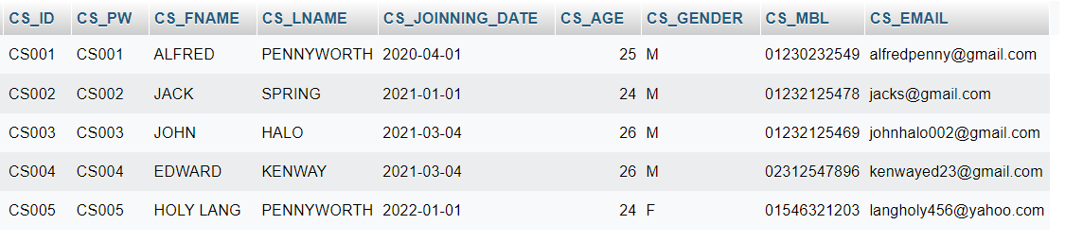

**BORROWER**

INSERT INTO BORROWER(B_ID, B_PW, B_FNAME, B_LNAME, B_JOINNING_DATE, B_AGE, B_GENDER, B_MBL, B_EMAIL) VALUES('BO001','BO001','KEN','KANEKI', '2020/06/03', 19, 'M', '01236545897', 'kaneki887@gmail.com');

INSERT INTO BORROWER(B_ID, B_PW, B_FNAME, B_LNAME, B_JOINNING_DATE, B_AGE, B_GENDER, B_MBL, B_EMAIL) VALUES('BO002','BO002','SAUL','GOODMAN', '2020/06/04', 31, 'M', '01456321564', 'sgoodman002@gmail.com');

INSERT INTO BORROWER(B_ID, B_PW, B_FNAME, B_LNAME, B_JOINNING_DATE, B_AGE, B_GENDER, B_MBL, B_EMAIL) VALUES('BO003','BO003','JIMMY','MCGIL','2020/06/04', 31, 'M', '01325648563', 'jimc002@gmail.com');

INSERT INTO BORROWER(B_ID, B_PW, B_FNAME, B_LNAME, B_JOINNING_DATE, B_AGE, B_GENDER, B_MBL, B_EMAIL) VALUES('BO004','BO004','CHUCK','MCGIL','2020/08/26', 39, 'M', '01230254789', 'chuckmcgil2135@gmail.com');

INSERT INTO BORROWER(B_ID, B_PW, B_FNAME, B_LNAME, B_JOINNING_DATE, B_AGE, B_GENDER, B_MBL, B_EMAIL) VALUES('BO005','BO005','MIKE','ERHMENTRAUT', '2022020/06/03',48, 'M', '01459875462', '[mikey@gmail.com](mailto:mikey@gmail.com)');

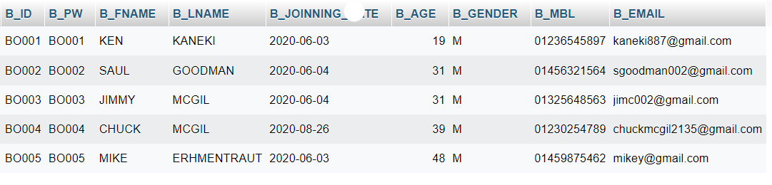

**CUSTOMER**

INSERT INTO CUSTOMER(CUST_ID, BORO_ID) VALUES('CUST001','BO002');

INSERT INTO CUSTOMER(CUST_ID, BORO_ID) VALUES('CUST002','OW001');

INSERT INTO CUSTOMER(CUST_ID, BORO_ID) VALUES('CUST003','BO005');

INSERT INTO CUSTOMER(CUST_ID, BORO_ID) VALUES('CUST004','OW002');

INSERT INTO CUSTOMER(CUST_ID, BORO_ID) VALUES('CUST005','OW004');

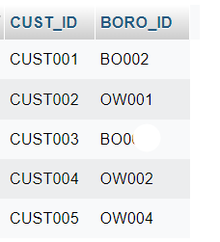

**PAYMENT_METHOD**

INSERT INTO PAYMENT_METHOD(PM_ID, PM_NAME) VALUES('PM001','BKASH');

INSERT INTO PAYMENT_METHOD(PM_ID, PM_NAME) VALUES('PM002','NAGAD');

INSERT INTO PAYMENT_METHOD(PM_ID, PM_NAME) VALUES('PM003','ROCKET');

INSERT INTO PAYMENT_METHOD(PM_ID, PM_NAME) VALUES('PM004','VISA');

INSERT INTO PAYMENT_METHOD(PM_ID, PM_NAME) VALUES('PM005','AMERICAN EXPRESS');

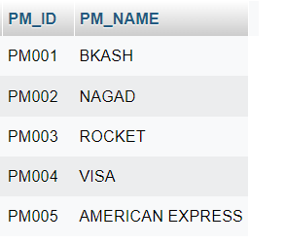

**EMPLOYEE**

INSERT INTO EMPLOYEE(EMP_ID, AD_OR_CS_ID, JOB) VALUES('EMP001','AD001','ADMIN');

INSERT INTO EMPLOYEE(EMP_ID, AD_OR_CS_ID, JOB) VALUES('EMP002','AD003','ADMIN');

INSERT INTO EMPLOYEE(EMP_ID, AD_OR_CS_ID, JOB) VALUES('EMP003','AD004','ADMIN');

INSERT INTO EMPLOYEE(EMP_ID, AD_OR_CS_ID, JOB) VALUES('EMP004','CS002','CUSTOMER SUPPORT');

INSERT INTO EMPLOYEE(EMP_ID, AD_OR_CS_ID, JOB) VALUES('EMP005','CS005','CUSTOMER SUPPORT');

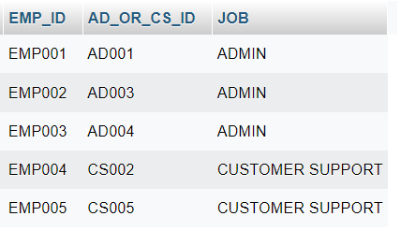

**COMPLAINTS**

INSERT INTO COMPLAINTS(COM_ID, CUST_ID, COM_MBL, COM_EMAIL, COMPLAINT, C_DATE) VALUES('COM001', 'CUST002', '01325463215', 'bkrans236@gmail.com', 'I did not get the requested product.','2020-06-08');

INSERT INTO COMPLAINTS(COM_ID, CUST_ID, COM_MBL, COM_EMAIL, COMPLAINT, C_DATE) VALUES('COM002', 'CUST002', '01325463215', 'bkrans236@gmail.com', 'The customer support was not able to help.', '2020-06-09');

INSERT INTO COMPLAINTS(COM_ID, CUST_ID, COM_MBL, COM_EMAIL, COMPLAINT, C_DATE) VALUES('COM003', 'CUST001', '01456321564', 'sgoodman002@gmail.com', 'I was charged more than the shown amount.','2020-07-10');

INSERT INTO COMPLAINTS(COM_ID, CUST_ID, COM_MBL, COM_EMAIL, COMPLAINT, C_DATE) VALUES('COM004', 'CUST003', '01459875462', 'mikey@gmail.com', 'I received a faulty product.', '2020-07-11');

INSERT INTO COMPLAINTS(COM_ID, CUST_ID, COM_MBL, COM_EMAIL, COMPLAINT, C_DATE) VALUES('COM005', 'CUST005', '01654123065', 'jessepink00000@gmail.com', 'I was charged more than the shown amount.', '2020-07-11');

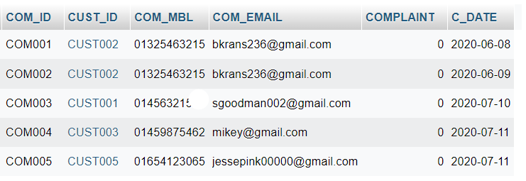

**PAYMENT**

INSERT INTO PAYMENT(P_ID, CUST_ID, PM_ID, AMOUNT, P_DATE) VALUES('PA001', 'CUST005', 'PM001', 2000, '2020-11-06');

INSERT INTO PAYMENT(P_ID, CUST_ID, PM_ID, AMOUNT, P_DATE) VALUES('PA002', 'CUST002', 'PM004', 150, '2020-11-07');

INSERT INTO PAYMENT(P_ID, CUST_ID, PM_ID, AMOUNT, P_DATE) VALUES('PA003', 'CUST005', 'PM005', 800, '2020-11-08');

INSERT INTO PAYMENT(P_ID, CUST_ID, PM_ID, AMOUNT, P_DATE) VALUES('PA004', 'CUST001', 'PM001', 1200, '2020-11-09');

INSERT INTO PAYMENT(P_ID, CUST_ID, PM_ID, AMOUNT, P_DATE) VALUES('PA005', 'CUST003', 'PM002', 200, '2020-11-09');

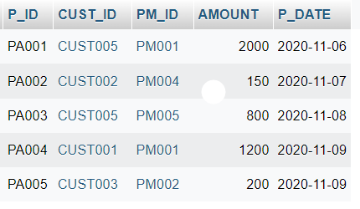

**REQUESTED_PRODUCT**

INSERT INTO REQUESTED_PRODUCT(RP_ID, B_ID, RP_NAME, C_ID, BUDGET, RP_DATE) VALUES('RP001', 'BO002', 'SONY CYBER-SHOT W800 20MP', 'CA004', 2500, '2020-11-06');

INSERT INTO REQUESTED_PRODUCT(RP_ID, B_ID, RP_NAME, C_ID, BUDGET, RP_DATE) VALUES('RP002', 'BO001', 'WOODEN ARM CHAIR', 'CA001', 150, '2020-11-06');

INSERT INTO REQUESTED_PRODUCT(RP_ID, B_ID, RP_NAME, C_ID, BUDGET, RP_DATE) VALUES('RP003', 'BO002', 'Apple MacBook Air 13.3-Inch', 'CA004', 4000, '2020-11-07');

INSERT INTO REQUESTED_PRODUCT(RP_ID, B_ID, RP_NAME, C_ID, BUDGET, RP_DATE) VALUES('RP004', 'BO005', '5 Way Manual Treadmill', 'CA003', 1000, '2020-11-08');

INSERT INTO REQUESTED_PRODUCT(RP_ID, B_ID, RP_NAME, C_ID, BUDGET, RP_DATE) VALUES('RP005', 'BO003', 'Apple Studio Display 27"', 'CA004', 2500, '2020-11-10');

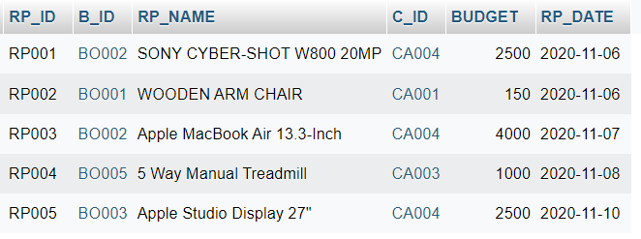

**ORENTED_PRODUCT**

INSERT INTO ORENTED_PRODUCT (OP_ID, O_ID, OP_NAME, C_ID, RENT, OP_DATE) VALUES('OP001', 'OW003', 'SONY CYBER-SHOT W800 20MP', 'CA004', 2500, '2020-11-06');

INSERT INTO ORENTED_PRODUCT (OP_ID, O_ID, OP_NAME, C_ID, RENT, OP_DATE) VALUES('OP002', 'OW005', 'Curren 9065 Quartz Watch ', 'CA002', 500, '2020-11-07');

INSERT INTO ORENTED_PRODUCT (OP_ID, O_ID, OP_NAME, C_ID, RENT, OP_DATE) VALUES('OP003', 'OW001', 'WOODEN ARM CHAIR', 'CA001', 150, '2020-11-08');

INSERT INTO ORENTED_PRODUCT (OP_ID, O_ID, OP_NAME, C_ID, RENT, OP_DATE) VALUES('OP004', 'OW002', 'SONY CYBER-SHOT W800 20MP', 'CA004', 2000,'2020-11-08');

INSERT INTO ORENTED_PRODUCT (OP_ID, O_ID, OP_NAME, C_ID, RENT, OP_DATE) VALUES('OP005', 'OW004', 'NVIDIA Quadro P1000 4GB', 'CA004', 800, '2020-11-09');

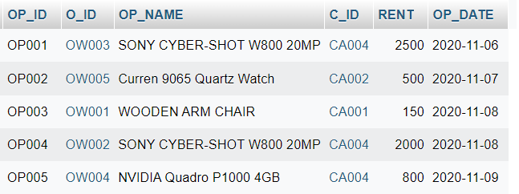

**CATEGORY**

INSERT INTO CATEGORY(C_ID, C_NAME) VALUES('CA001','FURNITURES');

INSERT INTO CATEGORY(C_ID, C_NAME) VALUES('CA002','CLOTHING');

INSERT INTO CATEGORY(C_ID, C_NAME) VALUES('CA003','SPORTS');

INSERT INTO CATEGORY(C_ID, C_NAME) VALUES('CA004','ELECTRONICS');

INSERT INTO CATEGORY(C_ID, C_NAME) VALUES('CA005','KITCHEN');

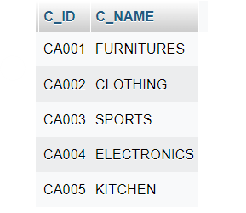

**Tasks:**

1. Find employees who joined after year 2019 and employee type is admin.

=select emp_id, job from employee where AD_OR_CS_ID IN (select A_ID from admin where A_JOINNING_DATE > to_date('31 Dec 2019','DD MON YYYY')) OR AD_OR_CS_ID IN (select CS_ID from CUSTOMER_SUPPORT WHERE CS_JOINNING_DATE > to_date('31 Dec 2019','DD MON YYYY')) and Job ='ADMIN';

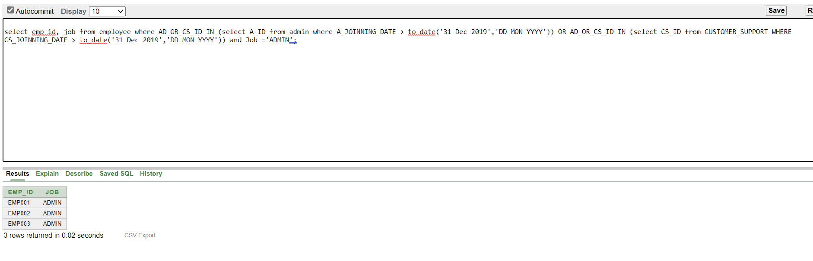

1. Find the requested and rented products which have same budget.

=select requested_product.*, orented_product.* from requested_product, orented_product where BUDGET=RENT and RP_NAME = OP_NAME;

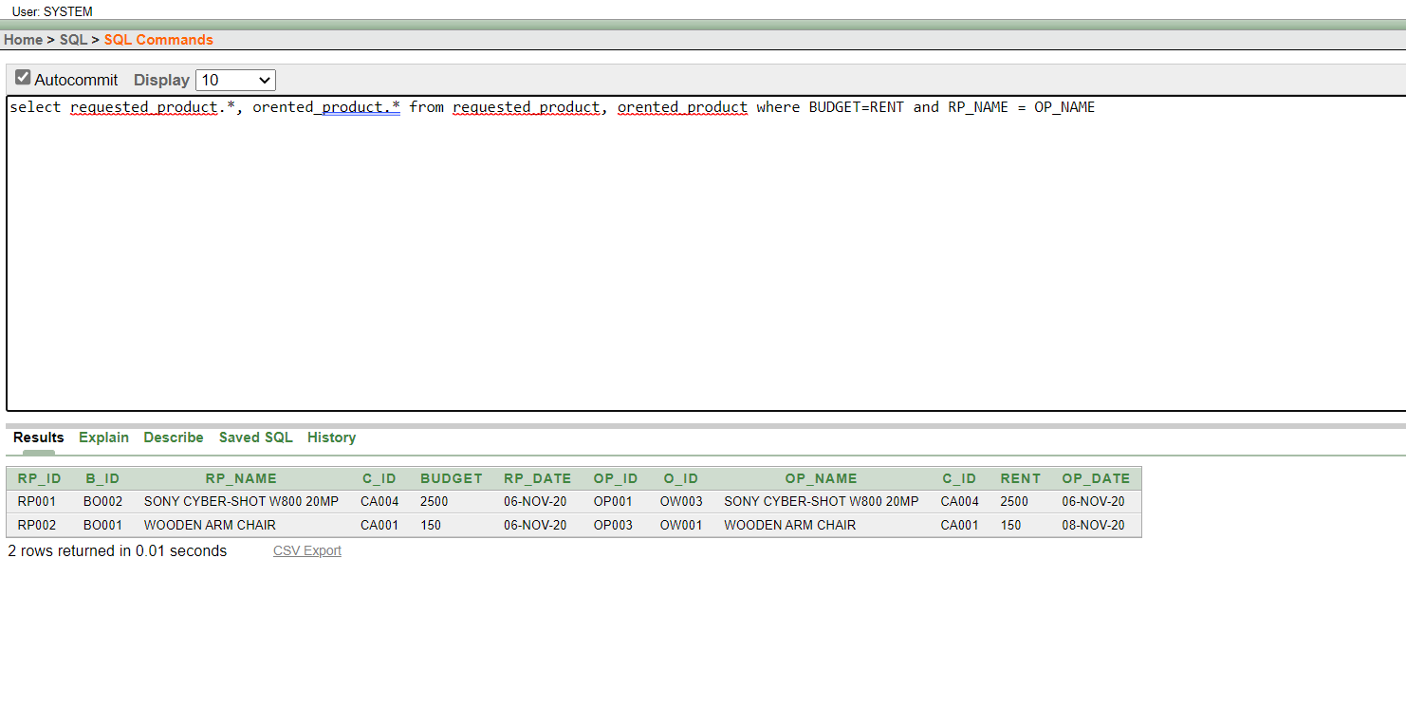

1. Find the borrowers who paid with BKASH.

= select * from BORROWER where B_ID IN (select BORO_ID from CUSTOMER where CUST_ID IN (select CUST_ID from PAYMENT where PM_ID=( select PM_ID from PAYMENT_METHOD where PM_NAME='BKASH')))

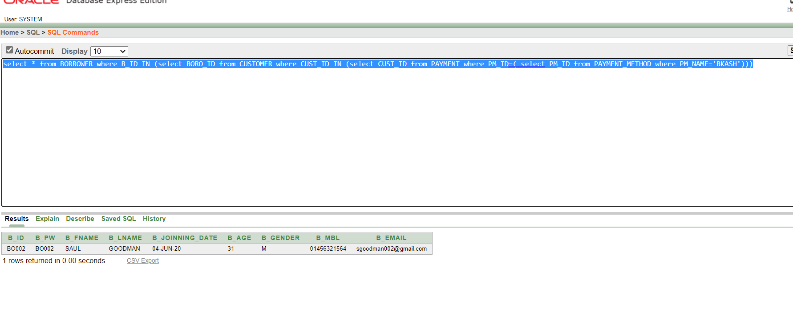

1. Find the product category that are requested most.

=select C_NAME from CATEGORY where C_ID=(select C_ID from requested_product group by C_ID having count(C_ID)=(select MAX(COUNT(C_ID)) from requested_product GROUP BY C_ID))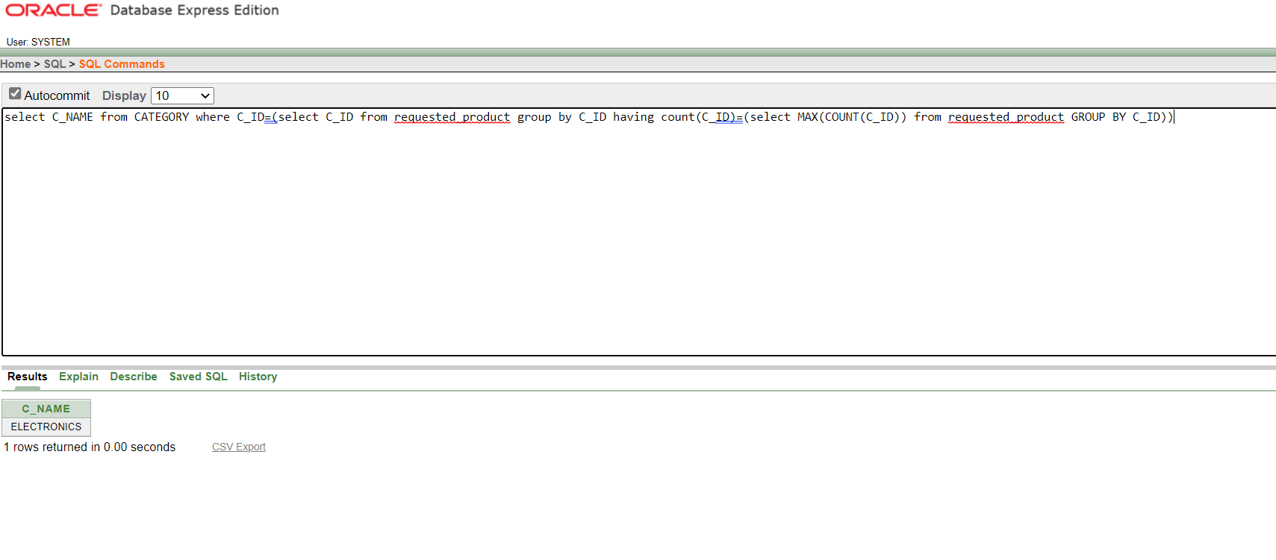

1. Find out the product of second highest price.

=select p.* from requested_product p where p.BUDGET in(select max(BUDGET) from requested_product where BUDGET<(select max(BUDGET) from requested_product ));

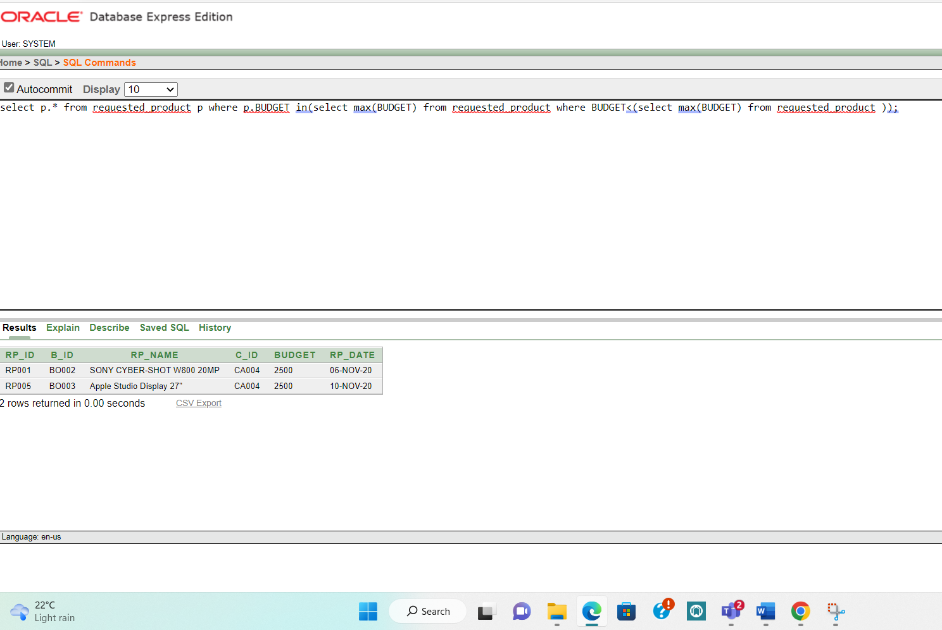

1. Find out the month in which maximum number of admin joined.

= select to_char(A_JOINNING_DATE, 'YYYY-MM') from ADMIN group by to_char(A_JOINNING_DATE, 'YYYY-MM') having count(to_char(A_JOINNING_DATE, 'YYYY-MM')) = (select max(count(to_char(A_JOINNING_DATE, 'YYYY-MM'))) from ADMIN group by to_char(A_JOINNING_DATE, 'YYYY-MM'))

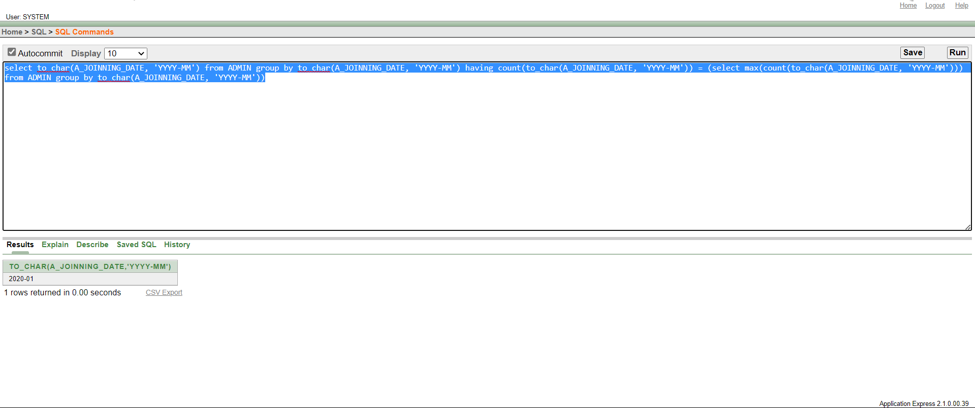

1. Find out the category and the requested date of requested product 4.

= select C_NAME, RP_DATE from requested_product, CATEGORY where requested_product.C_ID=CATEGORY.C_ID AND RP_ID='RP004'

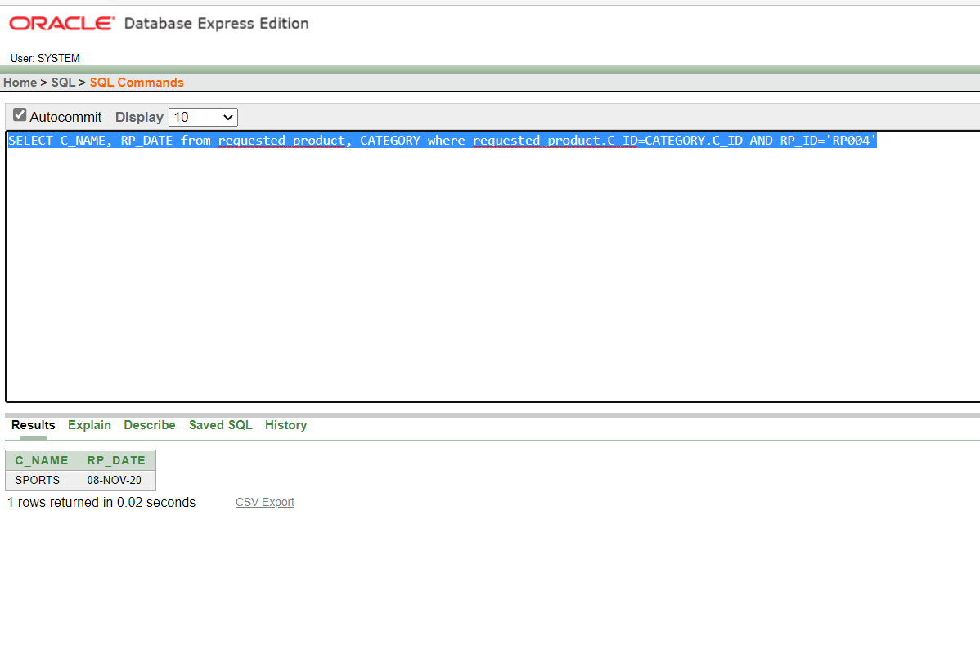

1. Find out the joinning date of most junior customer support executive.

= select * from CUSTOMER_SUPPORT where CS_AGE=(select min(CS_AGE) from CUSTOMER_SUPPORT)

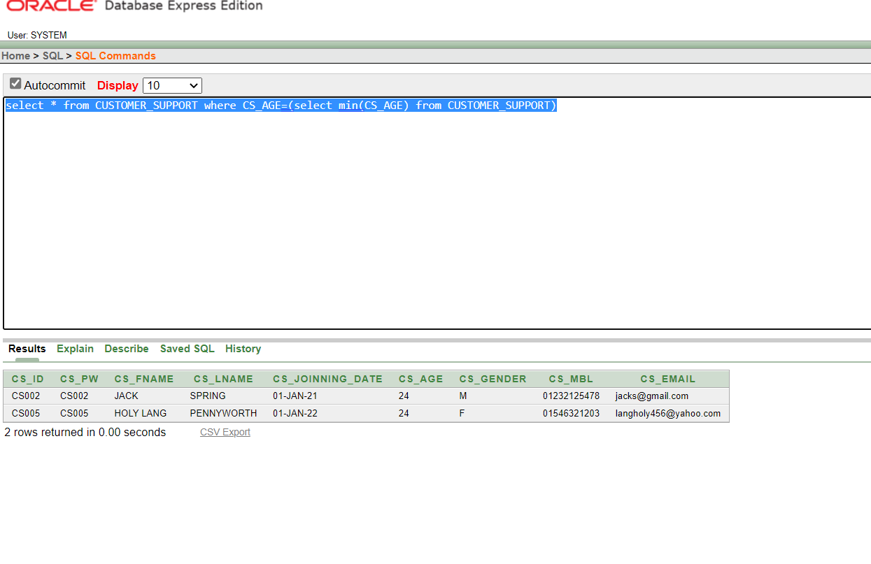

1. Find out the rented product and its category with the highest price.

=select orented_product.*, CATEGORY.C_NAME from orented_product, CATEGORY where orented_product.C_ID=(select C_ID from orented_product where RENT=(select MAX(MAX(RENT)) from orented_product group by C_ID)) AND CATEGORY.C_ID=(select C_ID from orented_product where RENT=(select max(max(RENT)) from orented_product group by C_ID))

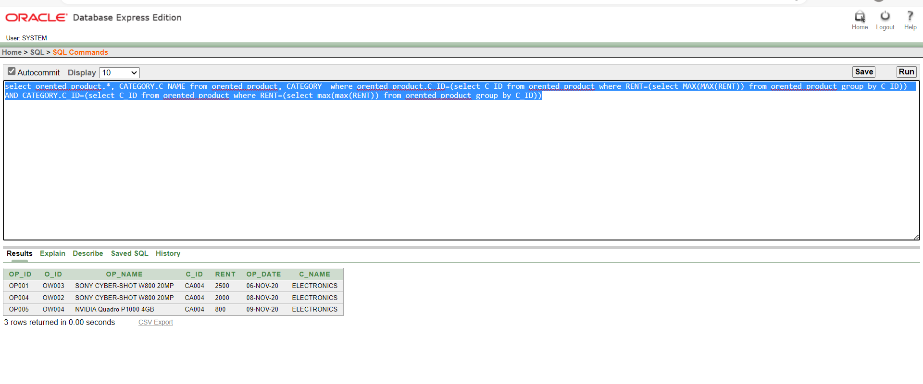

1. Find out the customer with oldest complaint.

= select customer.BORO_ID, complaints.C_DATE from complaints, customer where complaints.CUST_ID=customer.CUST_ID and C_DATE=(select min(C_DATE) from complaints)

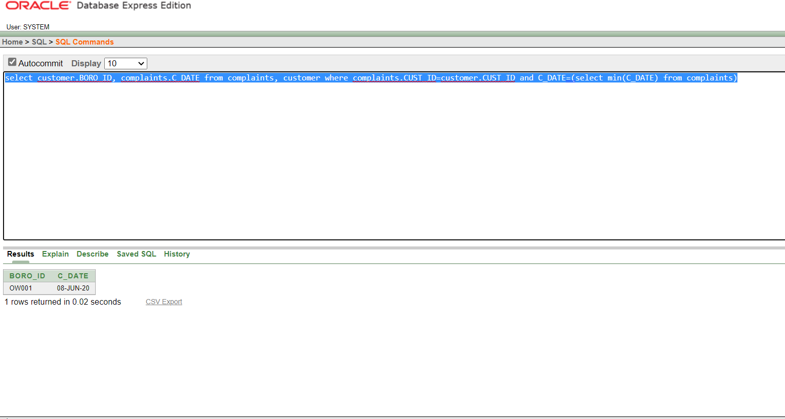

**User Interface**

