# How to use Task List.

* To create a new Task list navigate to site content and click on “add an app”.

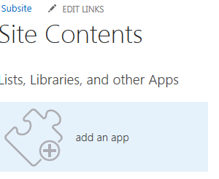

* Next click on “**Tasks**” template and add a name for your task list. If you want to add description click on “**Advanced Options**” on Add Task screen.

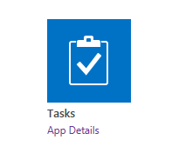

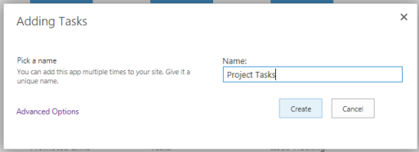

* When a task list gets created click on your Task list to open it.

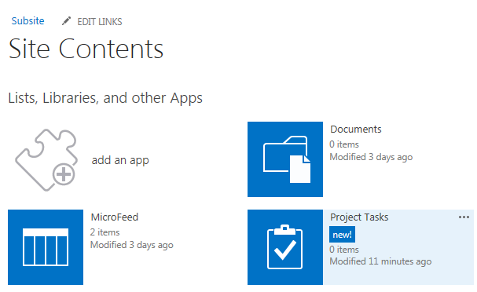

* As you may notice Tasks list now has a new View. Some of the added features are highlighted below –

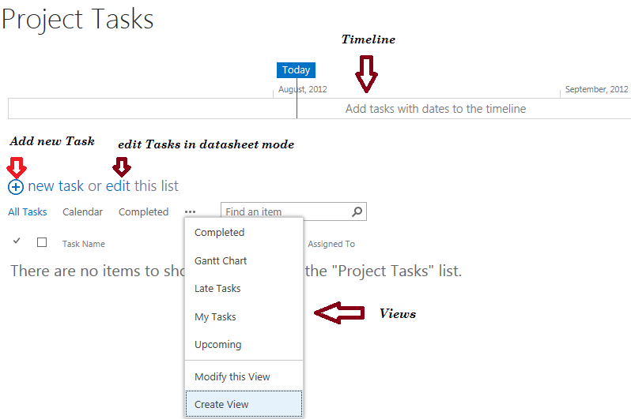

* **Creating new Task**

There are two ways to create a Task. One from “**new task**” and other from **edit task**.

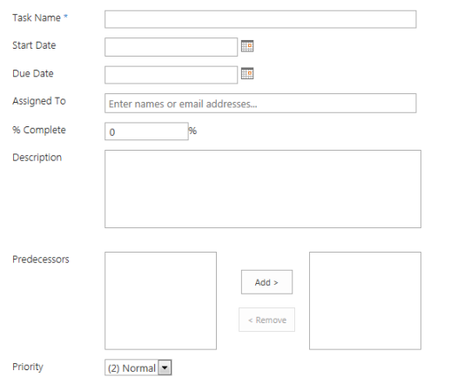

If you want to create several tasks quickly you can create from **edit view**. It is like a datasheet view where you can also add columns to this view dynamically.

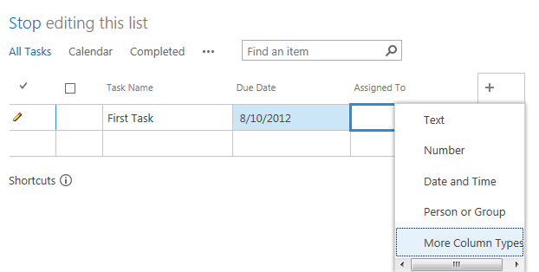

* Task Properties – Click on “**…**” to access Task properties.

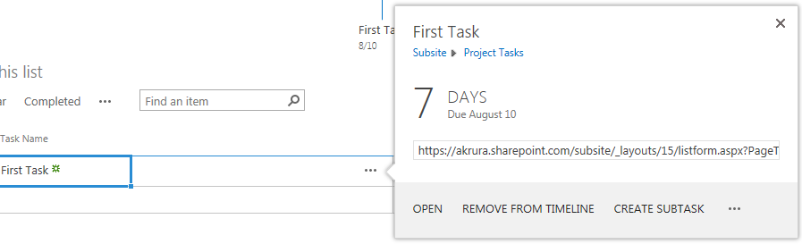

* **Delete Task**

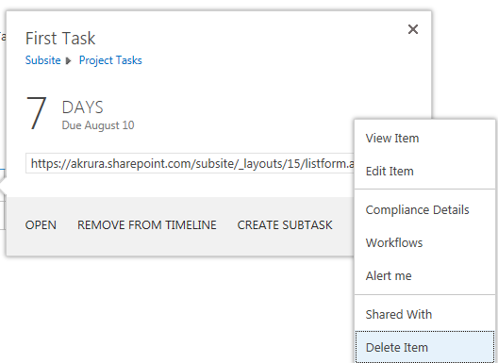

# How to set an announcement.

* To create a new Task list navigate to site content and click on “add an app”.



* Next click on “**Announcement**” template and add a name for your announcement list. If you want to add description click on “**Advanced Options**”.



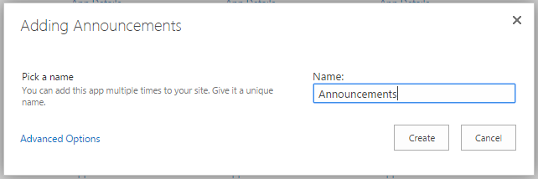

* When an announcement list gets created click on your announcement list to open it.



* **Creating new announcement**

Click on the **new announcement** button.

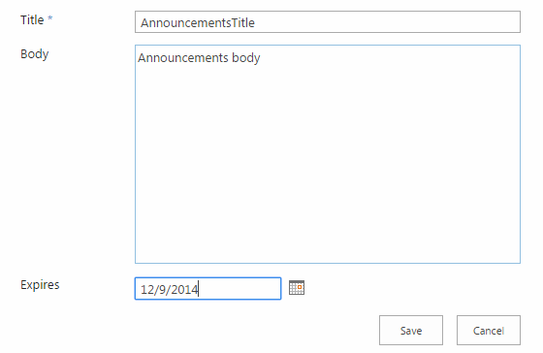

* **Announcement** Properties – Click on **“…”** to access **Announcement** properties.

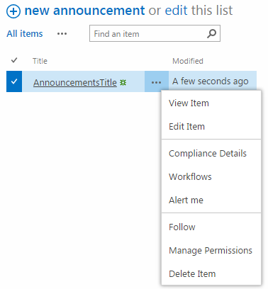

# How to invite external or internal user

* Click the Share link in the top right corner.

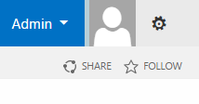

* After clicking the Share link a new popup will appear where you have to add the email addresses of the users you want to invite. You can add a personal message and the email will be sent with a link inviting them to login and access the site. If they are internal users, they login as normal. If they are external users, they will be prompted to login with either a Microsoft Windows Live account or Office 365 account.

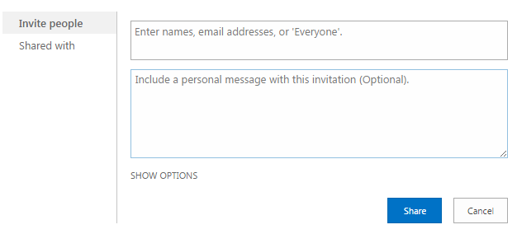

# How to create / remove/replace users

* As the Office 365 admin, you can create user accounts for everyone in your organization that uses Office 365 services. Every user of Office 365 needs a license, and an admin assigns licenses to users when the admin creates users for the service.
* **Add a single user account**

1. Sign in to Office 365 with your work account.
2. Go to the Office 365 admin centre.
3. Go to **Users** > **Active Users** > **Add a user**.
4. On the ‘**create new user account’** page, enter the user's information. Make sure you select password information (you can enter a total of five email addresses) and what license you want to assign to the user. Select **create**.
5. Review the information on the results page, and then click **Close**.

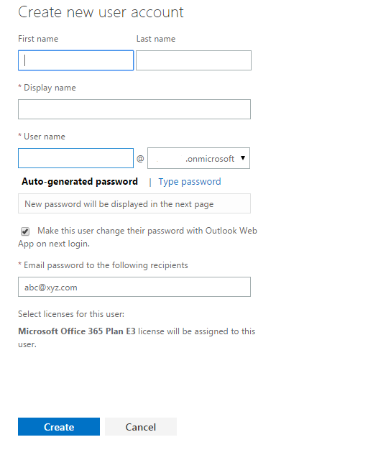

* **Delete User Account**

To delete the account for one or more users

1. Sign in to Office 365 with your work account.
2. Go to the Office 365 admin centre.
3. Go to **Users** > **Active Users**.
4. Choose the names of the users that you want to delete, and then select **DELETE**Delete.
5. In the confirmation box, select ‘**Yes’**.