Submission Date : 27th January, 2017

COMPUTATIONAL METHODS FOR COMPRESSIBLE FLOW

ASSIGNMENT 1

Partha Surve (SC14B036)
3rd Year Aerospace Engineering

(All the Problems in this Assignment are solved using Scilab )

1) Solving 1-D Heat Equation using Explicit and Implicit method for Dirichlet and Neumann Boundary Conditions.

a) The given heat Equation has two Dirichlet type Boundary conditions at starting and end node.

I have solved it numerically using Forward Time Central Space Scheme (FTCS) for 8 nodes and 101 time steps .

This partiular configuration was chosen because FTCS can yield unstable solutions that oscillate and grow if ∆t is too large. Stable solutions with the FTCS scheme are only obtained if
r = α ∆t /(∆x* ∆x) < 0.5

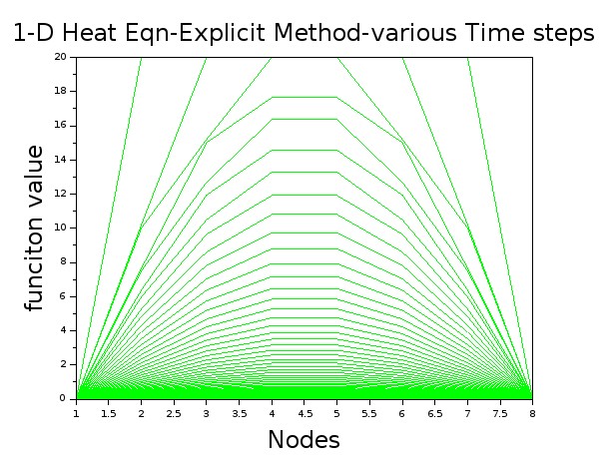

If we increase the Number of nodes such that r > 0.5 then we get an Unstable solution
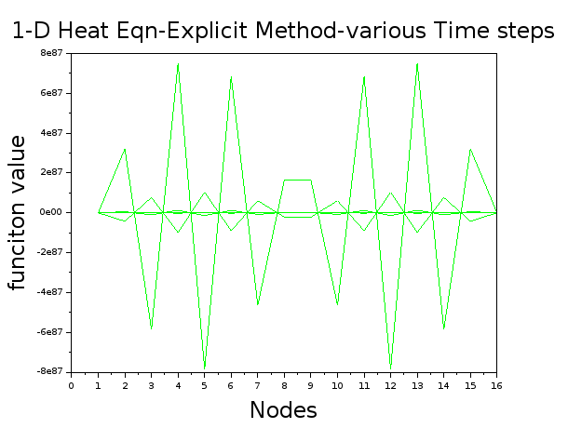
nodes=16

same Problem was solved using Implicit method, Backward Time Central Space Scheme (BTCS) .

The computationla effort of the BTCS is more than FTCS as we have to solve system of linear equations. But BTCS is unconditionally stable for any temporal or spatial step size. It is as accurate as FTCS as both have a spatial second order error and first order temporal error.

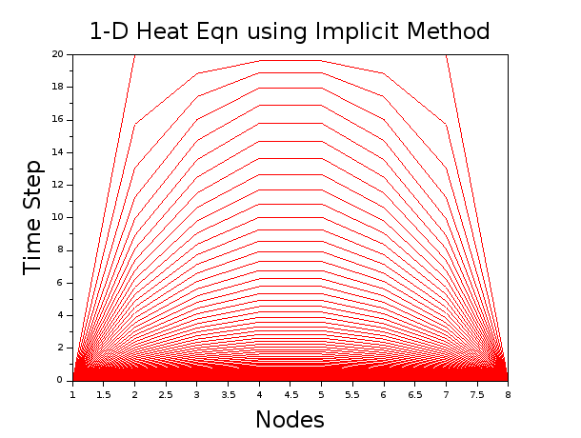
8 nodes and 101 time steps .

Increasing the nodes to 16
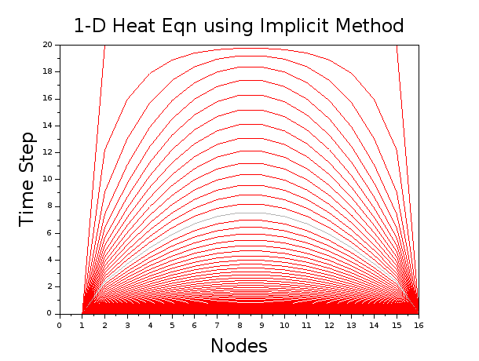

CODE 1

// Assigment 1 Computational Methods for compressible flow
//--------------------------------------------------------//
// Submition date : 27-01-2017
// Explicit Forward Time Central Space scheme (FTSC) for solving PDEs
// Author: Partha Surve (SC14B036, Aerospace Engineering 3rd Year, IIST)

clc;
clear;
clf;
//initializing the parameters
L = 1 //length of the domain
t_max = 1 //end time
n_x = 8 // No of nodes
n_t = 101 // time steps
dx = L/(n_x-1); //spacial step size
dt = t_max/(n_t-1);//temporal step size
alpha = 1; //diffusion term
r=(alpha*dt/(dx*dx));
T=zeros(n_t,n_x);//initializing an array

//Boundary condition
T(:,1) = 0; //dirichlet at the tip and end node
T(:,n_x) = 0;

for k = 2:1:n_x-1
T(:,k)=20;
end

//solving using FTCS
for j = 1:1:n_t-1
for i = 2:1:n_x-1
T(j+1,i) = T(j,i)+r.*(T(j,i-1)-2.*T(j,i)+T(j,i+1));

end
end

//Plotting for each time step
i=[1:1:n_x]
for j = 1:1:n_t
plot(i,T(j,:),"g");
end
title('1-D Heat Eqn-Explicit Method-various Time steps', "fontsize", 5);
xlabel("Nodes", "fontsize", 5);
ylabel("funciton value","fontsize", 5);

CODE 2

// Assigment 1 Computational Methods for compressible flow
//--------------------------------------------------------//
// January 27-01-2017
// Implicit Backward Time Central Space scheme (BTSC) for solving PDEs
// Author: Partha Surve (SC14B036, Aerospace Engineering 3rd year, IIST)

clc;
clear;
clf;

//initializing the parameters
//--------------------------//
L = 1 //length of the domain
t_max = 1 //end time
n_x = 8 // No of nodes
n_t = 101 // time steps
dx = L/(n_x-1); //spacial step size
dt = t_max/(n_t-1);//temporal step size
alpha=1;

//initializing an array
A=zeros(n_x,n_x);
T=zeros(n_t,n_x);
T_old=ones(1,n_x);

//components of the tridiagonal matrix
b= 1+(2*alpha*dt/(dx*dx));
a= -alpha*dt/(dx*dx);
c= -alpha*dt/(dx*dx);

//Boundary condition
//-------------------//

for i = 1:1:n_x
A(i,i)=b;

end
for i = 1:1:n_x-1
A(i,i+1)=a;
A(i+1,i)=c;

end

//temperature at the nodes
T_old(1) = 0;
T_old(n_x) = 0;

for i = 2:1:n_x-1// initial temp of rod
T_old(i)=20;
end

//inverting the matrix to get the temp at the nodes
//TDMA can be used for more effiecient calculation.... need to work on that
for i = 1:1:n_t-1
T(1,:)=T_old // initial rod conditions

T(i,1)=0 //Boundary condition
T(i,n_x)=0

T(i+1,:)=T(i,:)*inv(A);
end

//Plotting the Temp profile
i=[1:1:n_x]
for j = 1:1:n_t
plot(i,T(j,:),"r");
end
title('1-D Heat Eqn using Implicit Method', "fontsize", 5);
xlabel("Nodes", "fontsize", 5);
ylabel("Time Step","fontsize", 5);

b) The given heat Equation has one Dirichlet type and one Neumann type Boundary conditions at starting and end node.

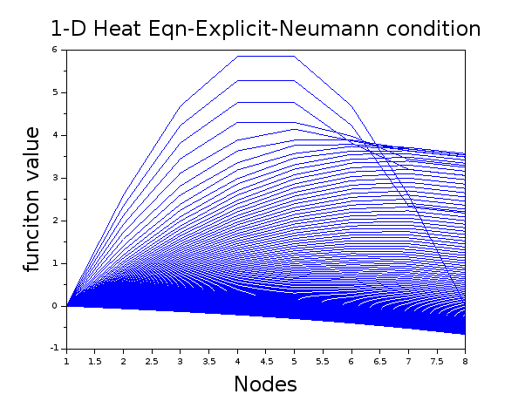

CODE 3

// Assigment 1 Computational Methods for compressible flow
//--------------------------------------------------------//
// January 17-01-2017
// Explicit Forward Time Central Space scheme (FTSC) for solving PDEs with Neumann BC
// Author: Partha Surve (SC14B036, Aerospace Engineering, IIST)

clc;
clear;
clf;
//==========================//
//initializing the parameters
//==========================//

L = 1 //length of the domain
t_max = 1 //end time

n_x = 8 // No of nodes
n_t = 101 // time steps

dx = L/(n_x-1); //spacial step size
dt = t_max/(n_t-1);//temporal step size

alpha = 1; //diffusion term
r=(alpha*dt/(dx*dx));
T=zeros(n_t,n_x);//initializing an array

//Boundary condition
T(:,1) = 0; //dirichlet at the tip and end node

for k = 2:1:n_x
T(1,k)=6*sin(%pi*(k-1)*dx/L);
end

//solving using FTCS
for j = 1:1:n_t-1
for i = 2:1:n_x-1
T(j+1,i) = T(j,i)+r.*(T(j,i-1)-2.*T(j,i)+T(j,i+1));
T(j+1,n_x)= T(j+1,n_x-1)-dx // neuman BC incorporated here

end
end

//Plotting for each time step
i=[1:1:n_x]
for j = 1:1:n_t
plot(i,T(j,:),"b");
end
title('1-D Heat Eqn-Explicit-Neumann condition', "fontsize", 5);
xlabel("Nodes", "fontsize", 5);
ylabel("funciton value","fontsize", 5);

2) Using Thomas Algorithm for for the Implicit Scheme

In the implicit scheme (BTCS) , we have to solve the system of linear equations using Matric Inversion method. This is computational expensive to carry out at each time step .

Thus Thomas Diagonal Matrix algorithm can be used to sove for sparse matrix

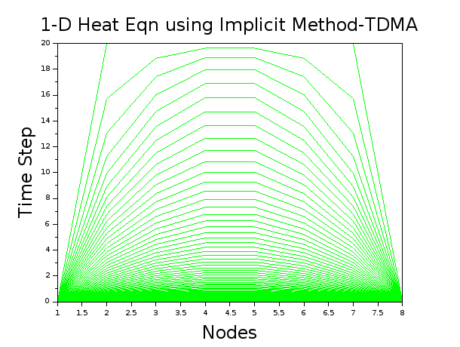
I have evaluated the 1st Heat equation with Dirichlet boundary condition using TDMA

I have written a C++ code for TDMA .
For the implicit code I have made use of the TDMA code avalible on WIKI

CODE 4 TDMA for a simple 3*3 matrix
#include <iostream>
using namespace std;
int main()

{

double a[3] = { 0, 1, 1 };
double b[3] = { -2, -2, -2 };
double c[3] = {1, 1, 0 };
double d[3] = { 5, 5, 10 };
double x[3];
double denom;
int i;

c[0]=c[0]/b[0];
d[0]=d[0]/b[0];

for (i=1; i< 2; i++)
{
denom = b[i] - a[i]*c[i-1];
c[i] = c[i]/denom;
d[i] = (d[i] - d[i-1] * a[i])/denom;

}

d[2] = (d[2] - d[1] * a[2])/(b[2] - a[2]*c[1]);

x[2] = d[2];
for( int j=1; j>-1 ; j--)
{
x[j]=d[j] - c[j]*x[j+1];
}

cout<<"The Tri-Diagonal matrix is as follows : "<<endl;
cout<<b[0]<<" "<<c[0]<<" 0"<<endl;
cout<<a[1]<<" "<<b[1]<<" "<<c[1]<<endl;
cout<<"0 "<<a[2]<<" "<<b[2]<<endl;

for(i=0;i<3;i++)
{
cout<<"x"<<i<<" = "<<x[i]<<endl;
}
return 0;
}

CODE 5

// Reffered from WIKI//
//-----------------------//

function x=TDMAsolver(a, b, c, d)
//a, b, c are the column vectors for the compressed tridiagonal matrix, d is the right vector
n = length(d); //n is the number of rows

//Modify the first-row coefficients
c(1) = c(1) / b(1); // Division by zero risk.
d(1) = d(1) / b(1);

for i = 2:n-1
temp = b(i) - a(i) * c(i-1);
c(i) = c(i) / temp;
d(i) = (d(i) - a(i) * d(i-1))/temp;
end

d(n) = (d(n) - a(n) * d(n-1))/( b(n) - a(n) * c(n-1));

//Now back substitute.
x(n) = d(n);
for i = n-1:-1:1
x(i) = d(i) - c(i) * x(i + 1);
end
CODE 6

// Assigment 1 Computational Methods for compressible flow
//--------------------------------------------------------//
// January 27-01-2017
// Implicit Backward Time Central Space scheme (BTSC) for solving PDEs using TDMA
// Author: Partha Surve (SC14B036, Aerospace Engineering 3rd year, IIST)

clf;

//initializing the parameters
//--------------------------//
L = 1 //length of the domain
t_max = 1 //end time
n_x = 8 // No of nodes
n_t = 101 // time steps
dx = L/(n_x-1); //spacial step size
dt = t_max/(n_t-1);//temporal step size
alpha=1;

//initializing an array

T=zeros(n_t,n_x);

a=zeros(1,n_x)
b=zeros(1,n_x)
c=zeros(1,n_x)
d=ones(1,n_x);

for i = 1:1:n_x
a(i)=-alpha*dt/(dx*dx);
b(i)= 1+(2*alpha*dt/(dx*dx));
c(i)=-alpha*dt/(dx*dx);
end

c(n_x)=0
a(1)=0

//Boundary condition

//temperature at the nodes
d(1) = 0;
d(n_x) = 0;

for i = 2:1:n_x-1// initial temp of rod
d(i)=20;
end

//inverting the matrix to get the temp at the nodes
//TDMA can be used for more effiecient calculation.... need to work on that
for i = 1:1:n_t-1
T(i,:)=d // initial rod conditions

T(i,1)=0 //Boundary condition
T(i,n_x)=0

x()=TDMAsolver(a,b,c,d)
T(i+1,:)=x
end

//Plotting the Temp profile
i=[1:1:n_x]
for j = 1:1:n_t
plot(i,T(j,:),"r");
end
title('1-D Heat Eqn using Implicit Method-TDMA', "fontsize", 5);
xlabel("Nodes", "fontsize", 5);
ylabel("Time Step","fontsize", 5);

3) Compare numerical solution with the analytical solution (Series solution ) at t = 0.01s for problem a

In this problem I have taken a series solution of the 1-D heat equation till n=13
Because after n=13 every new additon to series solution has a value less than 10e-08
I have considered a tolerance value for truncation of the series as 10e-08

BLUE – numerical solution
RED – analytical solution

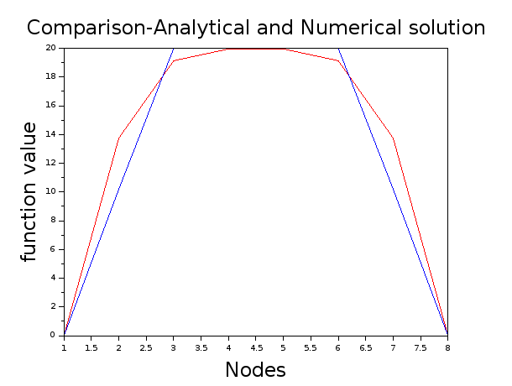
nodes = 8
time steps = 101

CODE 7

// Assigment 1 Computational Methods for compressible flow
//--------------------------------------------------------//
// Submition date : 27-01-2017
// Comparison between Analytical solution using series method and Explicit Forward Time Central Space scheme (FTSC) solutonfor solving PDEs
// Author: Partha Surve (SC14B036, Aerospace Engineering 3rd Year, IIST)

clc;
clear;
clf;
//initializing the parameters
L = 1 //length of the domain
t_max = 1 //end time
n_x = 8 // No of nodes
n_t = 101 // time steps
dx = L/(n_x-1); //spacial step size
dt = t_max/(n_t-1);//temporal step size
alpha = 1; //diffusion term

t=0.01//time at which we are evaluating the analytical funciton

r=(alpha*dt/(dx*dx));
T=zeros(n_t,n_x);//initializing an array

//Analytical Solution//
//=========================================================//
//the 'n' value can be varied to increase the accuracy
for i = 1:n_x
T_ana(i)=0
for n = 1:1:13// tolerance value of 10e-08
U(n)= (40*(1-(-1)^n)/(n*%pi))*sin(n*%pi*(i-1)*dx/L)*%e^(-alpha*t*(n*%pi/L)^2)
T_ana(i)=T_ana(i)+U(n)
end
end
//Plotting the funciton value at a particular time step for all the nodes

j=[1:1:n_x]

plot(j,T_ana(j),"r");

//===========================================================//
//Numerical Solution using Explicit Method
//============================================================//

//Boundary condition
T(:,1) = 0; //dirichlet at the tip and end node
T(:,n_x) = 0;

//initial condition at all the elements
for k = 2:1:n_x-1
T(:,k)=20;
end

//solving using FTCS
for j = 1:1:n_t-1
for i = 2:1:n_x-1
T(j+1,i) = T(j,i)+r.*(T(j,i-1)-2.*T(j,i)+T(j,i+1));

end
end

//Plotting for each time step
i=[1:1:n_x]

plot(i,T(2,:),"b");

title('Comparison-Analytical and Numerical solution ', "fontsize", 5);
xlabel("Nodes", "fontsize", 5);
ylabel("function value","fontsize", 5);

//================================================================//

4) For a given ∆x and ∆t, how much time does explicit method and implicit method take to reach steady state.

RMS error was evaluated between succesive time steps and a consition was placed to evaluate the steady state condition, such that

if (RMS[u(x, t) − u(x, t + ∆t)] ≤ n*∆t*epsilon )
then steady state is reached

epsilon = 10^-3
n- number of nodes

For Explicit method Steady State Time - 0.99
For Implicit method Steady State Time - 1.00

CODE 8

// Assigment 1 Computational Methods for compressible flow
//-----------------------------------------------------
// January 27-01-2017
// To find steady state time for Explicit Forward Time Central Space scheme (FTSC) for solving PDEs
// Author: Partha Surve (SC14B036, Aerospace Engineering, IIST)

clc;
clear;
clf;
L = 1 //length of the domain
t_max = 1 //end time
n_x = 8 // No of nodes
n_t = 101 // time steps
dx = L/(n_x-1); //spacial step size
dt = t_max/(n_t-1);//temporal step size
alpha = 1; //diffusion term
r=(alpha*dt/(dx*dx));
T=zeros(n_t,n_x);//initializing an array

//Boundary condition
T(:,1) = 0; //dirichlet at the tip and end node
T(:,n_x) = 0;

for k = 2:1:n_x-1
T(:,k)=20;
end

//solving using FTCS
for j = 1:1:n_t-1
for i = 2:1:n_x-1
T(j+1,i) = T(j,i)+r.*(T(j,i-1)-2.*T(j,i)+T(j,i+1));

end
end

//initializing the parameters
//Calculating the RMS error
for j = 1:1:n_t-1
err=0
for i = 1:1:n_x
err=(T(j,i)-T(j+1,i))^2 +err
end
RMS_err(j)=sqrt(err/n_x)
TIME=j*dt
if RMS_err(j) < n_x*10^(-3)*dt
break

end

end

CODE 9

// Assigment 1 Computational Methods for compressible flow
//--------------------------------------------------------//
// January 27-01-2017
// Steady state time for Implicit Backward Time Central Space scheme (BTSC) for solving PDEs
// Author: Partha Surve (SC14B036, Aerospace Engineering 3rd year, IIST)

clc;
clear;
clf;
//initializing the parameters
//--------------------------//
L = 1 //length of the domain
t_max = 1 //end time
n_x = 8 // No of nodes
n_t = 101 // time steps
dx = L/(n_x-1); //spacial step size
dt = t_max/(n_t-1);//temporal step size
alpha=1;

//initializing an array
A=zeros(n_x,n_x);
T=zeros(n_t,n_x);
T_old=ones(1,n_x);

//components of the tridiagonal matrix
a= 1+(2*alpha*dt/(dx*dx));
b= -alpha*dt/(dx*dx);
c= -alpha*dt/(dx*dx);

//Boundary condition
//-------------------//

for i = 1:1:n_x
A(i,i)=a;

end
for i = 1:1:n_x-1
A(i,i+1)=b;
A(i+1,i)=c;

end

//Boundary condition
A(1,1) = 1; //dirichlet at the tip and end node
A(2,1) = 0;
A(n_x,n_x) = 1;
A(n_x-1,n_x) = 0;

//temperature at the nodes
T_old(1) = 0;
T_old(n_x) = 0;

for i = 2:1:n_x-1// initial temp of rod
T_old(i)=20;
end

//inverting the matrix to get the temp at the nodes
//TDMA can be used for more effiecient calculation.... need to work on that
for i = 1:1:n_t-1
T(1,:)=T_old
T(i+1,:)=T(i,:)*inv(A);
end

//Calculating the RMS error
for j = 1:1:n_t-1
err=0
for i = 1:1:n_x
err=(T(j,i)-T(j+1,i))^2 +err
end
RMS_err(j)=sqrt(err/n_x)
TIME=j*dt
if RMS_err(j) < n_x*10^(-3)*dt
break

end

end
5) Study the effect of ∆t, ∆x and diffusion number in accuracy of solution at a flow time of your interest

a) Plot error in z-axis, for a given Diffusion number of your choice

X-axis Time step
Y-axis Nodes
Z-axis error
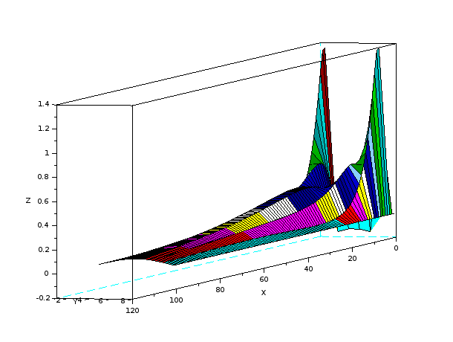

b)Plot error in z-axis, for a given ∆t of your choice.

varying the diffusion term and keeping the time step at 0.5
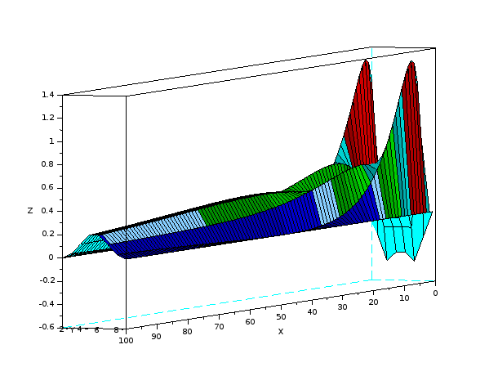

c)Plot error in z-axis, for a given ∆x of your choice.

Keeping node constant at n=4
plotting error for time step and diffusion term
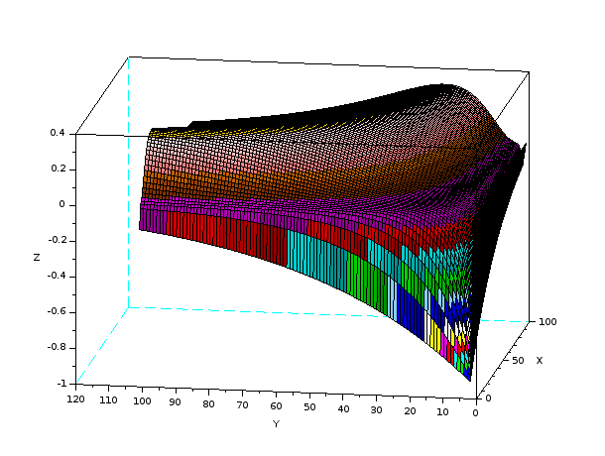

CODE 10

// Assigment 1 Computational Methods for compressible flow
//--------------------------------------------------------//
// Submition date : 27-01-2017
// Contour Plot of the error between Analytical solution using series method and Explicit Forward Time Central Space scheme (FTSC) soluton for solving PDEs. Diffusion Coefficient is kept constant
// Author: Partha Surve (SC14B036, Aerospace Engineering 3rd Year, IIST)

clc;
clear;
clf;
//initializing the parameters

L = 1 //length of the domain
t_max = 1 //end time

n_x = 8 // No of nodes
n_t = 101 // time steps

dx = L/(n_x-1); //spacial step size
dt = t_max/(n_t-1);//temporal step size

alpha = 0.001; //diffusion term

t=0.01

T=zeros(100,n_t,n_x);//initializing an array

//Analytical Solution//
//=========================================================//
//the 'n' value can be varied to increase the accuracy

for k=1:1:100
for j=2:1:n_t
for i = 1:n_x
T_ana(k,j,i)=0
for n = 1:1:13// tolerance value of 10e-08
U(n)= (40*(1-(-1)^n)/(n*%pi))*sin(n*%pi*(i-1)*dx/L)*%e^(-alpha*k*( j-1)*dt*(n*%pi/L)^2)
T_ana(k,j,i)=T_ana(k,j,i)+U(n)
end
end
end
end
//===========================================================//
//Numerical Solution using Explicit Method
//============================================================//

//Boundary condition
T(:,1,:) = 20;
T(:,:,1) = 0; //dirichlet at the tip and end node
T(:,:,n_x) = 0;
T_ana(:,1,:) = 20;
T_ana(:,:,1) = 0;
T_ana(:,:,n_x) = 0;

//initial condition at all the elements

//solving using FTCS

for k = 1:1:100
for j = 1:1:n_t-1
for i = 2:1:n_x-1
T(k,j+1,i) = T(k,j,i)+(alpha*k*dt/(dx*dx)).*(T(k,j,i-1)-2.*T(k,j,i)+T(k,j,i+1));
end
end
end

//================================================================//
// Evaluating and ploting the Error contour
//================================================================//
//constant diffusion coefficient

for k = 1:1:100
for j = 1:1:n_t
for i = 1:1:n_x
err(k,j,i)=T_ana(k,j,i)-T(k,j,i)
end
end
end

//keeping the diffusion term constant and varying the time and spatial step
for j = 1:1:n_t
for i = 1:1:n_x
err1(j,i)=err(100,j,i)
end
end
//varying the diffusion term and keeping the time step at 0.5
for k = 1:1:100
for i = 1:1:n_x
err2(k,i)=err(k,50,i)
end
end
//keeping the spatial step constant
for k = 1:1:100
for j = 1:1:n_t
err3(k,j)=err(k,j,n_x/2)
end
end

j = [1:1:n_t]
i = [1:1:n_x]
k = [1:1:100]

// turn on the required plot by turning off the comment
//plot3d1(j,i,err1(j,i))
//plot3d1(k,i,err2(k,i))
plot3d1(k,j,err3(k,j))

6) comparing it with analytical solution at transient stage at a flow time of your interest by grid convergence study.

I have varied the number of nodes for 3 to 34 and the RMS error value was plotted against the Number of Node.
The error evaluation was done at time step t = 0.1 sec

It was seen that the error becomes constant after 17 nodes.
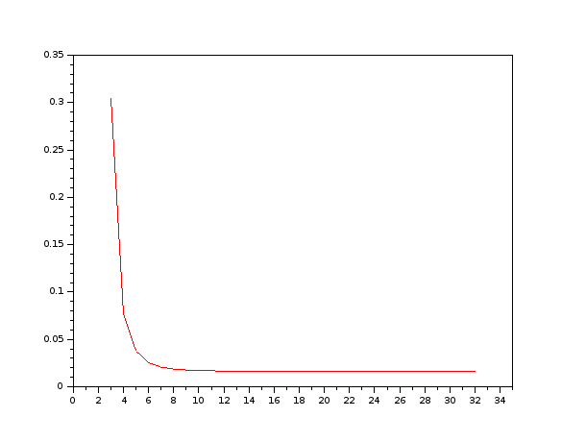
The log plot of this error will have a slope of 2 thus from it we can tell that the scheme is second order .

CODE 11

// Assigment 1 Computational Methods for compressible flow
//--------------------------------------------------------//
// Submition date : 27-01-2017
// Grid convergence study
// Author: Partha Surve (SC14B036, Aerospace Engineering 3rd Year, IIST)

clc;
clear;
clf;
//initializing the parameters
L = 1 //length of the domain
t_max = 1 //end time

n_x1 = 32 // vary the No of nodes from 3 to 34 for grid convergence study

n_t = 2001 // time steps remain the same

dx1 = L/(n_x1-1); //spacial step size

dt = t_max/(n_t-1);//temporal step size
alpha = 1; //diffusion term
t=0.01

r1=(alpha*dt/(dx1*dx1));

T1=zeros(n_t,n_x1);//initializing an array

//Analytical Solution//
//=========================================================//
//the 'n' value can be varied to increase the accuracy
//evaluate the analytical solution for various spatial step size
for j=2:1:n_t
for i = 1:n_x1
T_ana1(j,i)=0
for n = 1:1:13// tolerance value of 10e-08
U1(n)= (40*(1-(-1)^n)/(n*%pi))*sin(n*%pi*(i-1)*dx1/L)*%e^(-alpha*(j-1)*dt*(n*%pi/L)^2)
T_ana1(j,i)=T_ana1(j,i)+U1(n)
end
end
end

//===========================================================//
//Numerical Solution using Explicit Method
//============================================================//

//Boundary condition
T1(1,:) = 20;
T1(:,1) = 0; //dirichlet at the tip and end node
T1(:,n_x1) = 0;
T_ana1(1,:) = 20;
T_ana1(:,1) = 0;
T_ana1(:,n_x1) = 0;

//initial condition at all the elements

//solving using FTCS
for j = 1:1:n_t-1
for i = 2:1:n_x1-1
T1(j+1,i) = T1(j,i)+r1.*(T1(j,i-1)-2.*T1(j,i)+T1(j,i+1));

end

end

//================================================================//
// Evaluating and ploting the Error contour
//================================================================//
//constant diffusion coefficient
for j = 1:1:n_t

for i = 1:1:n_x1
err1(j,i)=T_ana1(j,i)-T1(j,i)
end
end

//Calculating the RMS error
for j = 1:1:n_t
err=0
for i = 1:1:n_x1
err=(T_ana1(j,i)-T1(j,i))^2 +err
end
RMS_err(j)=sqrt(err/n_x1)

end

i = [1:1:n_x1]

plot(i,err1(25,:),"r");

title('The steady state error', "fontsize", 5);
xlabel("Nodes", "fontsize", 5);
ylabel("Error","fontsize", 5);

