

**Narula Institute of Technology**

**Department Of Civil Engineering**

**Cement Manufacturing**

**Relationship between Mining and Cement Manufacturing Submitted to:**

**Dr. Biman Mukherjee**

**By:**

**Partha Dey**

**Civil Engineering (B. Tech Lateral)**

**January/2021**

**Abstract**

This study evaluates cement manufacture, cement any substance which binds together other materials by a combination of chemical processes known collectively as setting. Cements are dry powders and should not be confused with concretes or mortars, but they are an important constituent of both of these materials, in which they act as the 'glue' that gives strength to structures, Cement is an extremely important construction material, Cements used in construction can be characterized as being either hydraulic or non-hydraulic.

The first step in the manufacture of cement is to combine a variety of raw ingredients so that the resulting cement will have the desired chemical composition. These ingredients are ground into small particles to make them more reactive, blended together, and then the resulting raw mix is fed into a cement kiln which heats them to extremely high temperatures.

The basic mixture of cement industry consists of Chalk Lime stone Clay Calcium Carbonate Silicon Oxide Aluminum oxide and iron (II) oxide.

Portland cement is by far the most common type of cement in general use around the world. This cement is made by heating limestone (calcium carbonate) with other materials (such as clay)

Raw Materials processing included: Setting and curing and cement manufacturing process, Process Discretion: Wet process, Semi-dry process, Dry process and Finish process.

The environmental impact of the cement production and its variations between different cement plants, using Life Cycle Impact assessment. For that purpose, details of the cement production processes are investigated in order to show the respective part of raw materials preparation and clinker production using

**TABLE OF CONTENT**

**Abstract**

**Chapter (1): An Introduction**

**Title Page**

1. Background about study…………………………………………………………………………………………………………………………….. 1

1.1.1. Background about Cement ………………………………………………………………………………………………………….………. 1

**Chapter (2): Raw materials for cement manufacture**

Raw materials for cement manufacture……………………………………………………………………………………………………………… 2

1. Description of Raw Materials of Cement…………………………………………………………………………………………………….. 3
2. Chalk……………………………………………………………………………………………………………………………………………… 3
3. Lime stone…………………………………………………………………………………………………………………………………….. 5
4. Clay…………………………………………………………………………………………………………………………………………………. 7

**Chapter (3): Raw Materials processing**

Raw Materials processing…………………………………………………………………………………………………………………………………….. 9

1. Setting and curing…………………………………………………………………………………………………………………………. 9
2. Cement manufacturing process…………………………………………………………………………………………………….. 9

3.2.1. The quarry…………………………………………………………………………………………………………………………………… 9

**Chapter (4): Process Discretion**

1. . Wet process……………………………………………………………………………………………………………………………………………. 12

**3.2.2 Making clinker 10**

1. . Semi-dry process……………………………………………………………………………………………………………………………………… 12
2. . Dry process……………………………………………………………………………………………………………………………………………… 12
3. . Finish process…………………………………………………………………………………………………………………………………………… 13

**Chapter (5): Environmental impact for cement**

1. . Environmental impact caused by emissions into the air…………………………………………………………………………… 15
2. Environmental impact resulting from the liquid waste…………………………………………………………………………….. 15
3. Environmental impact resulting from the disposal of solid waste…………………………………………………………….. 16

Conclusion…………………………………………………………………………………………………………………………………………………………….. 17

Reference……………………………………………………………………………………………………………………………………………………………… 18

**LIST OF FIGURES**

Figure (1): Location map of Chalk deposits in Jordan

Figure (2): Location map of Pure Limestone deposits in Jordan

Figure (3): Location map of Kaoline deposits in Jordan

Figure (4): Cement raw materials processing

Figure (5): The Wet process of cement

Figure (6): Cement Roasting flow sheet.

Figure (7): The Cement Production Flow Sheet By the dry process

**LIST OF TABLES**

Table (1): Raw ingredients used to provide each of the main cement elements.

Table (2): Chemical and physical properties of the studied areas.

**Chapter 1: An introduction**

1. **Background about study**
2. **Background about Cement**

Cement is any substance which binds together other materials by a combination of chemical processes known collectively as setting. Cements are dry powders and should not be confused with concretes or mortars, but they are an important constituent of both of these materials, in which they act as the 'glue' that gives strength to structures. Mortar is a mixture of cement and sand whereas concrete also includes rough aggregates; because it is a major component of both of these building materials, cement is an extremely important construction material. It is used in the production of the many structures that make up the modern world including buildings, bridges, harbors, runways and roads. It is also used for facades and other decorative features on buildings. The constant demand for all of these structures, increasingly from the developing world, means that cement is the second most consumed commodity in the world after water (Francesca, 2010).

Cements used in construction can be characterized as being either hydraulic or non-hydraulic, depending upon the ability of the cement to set in the presence of water (Blezard, 2004).

Non-hydraulic cement will not set in wet conditions or underwater; rather, it sets as it dries and reacts with carbon dioxide in the air. It can be attacked by some aggressive chemicals after setting (Blezard, 2004).

Hydraulic cements (e.g., Portland cement) set and become adhesive due to a chemical reaction between the dry ingredients and water. The chemical reaction results in mineral hydrates that are not very water-soluble and so are quite durable in water and safe from chemical attack. This allows setting in wet condition or underwater and further protects the hardened material from chemical attack. The chemical process for hydraulic cement found by ancient Romans used volcanic ash (Blezard, 2004).

**Chapter 2: Raw materials for cement manufacture**

The first step in the manufacture of cement is to combine a variety of raw ingredients so that the resulting cement will have the desired chemical composition. These ingredients are ground into small particles to make them more reactive, blended together, and then the resulting raw mix is fed into a cement kiln which heats them to extremely high temperatures (Kosmatka et.al, 2002).

Since the final composition and properties of cement are specified within rather strict bounds, it might be supposed that the requirements for the raw mix would be similarly strict. As it turns out, this is not the case. While it is important to have the correct proportions of calcium, silicon, aluminum, and iron, the overall chemical composition and structure of the individual raw ingredients can vary considerably. The reason for this is that at the very high temperatures in the kiln, many chemical components in the raw ingredients are burned off and replaced with oxygen from the air. Table1 lists just some of the many possible raw ingredients that can be used to provide each of the main cement elements (Kosmatka et.al, 2002). The cement industry is considered of strategic industries. It is so simple with the industry compared to major industries, and depend on the availability of the necessary raw materials for it.

**Table (1): Raw ingredients used to provide each of the main cement elements (Kosmatka et.al 2002).**

|  |  |  |  |
| --- | --- | --- | --- |
| Calcium | Silicon | Aluminum | Iron |
| Limestone | Clay | Clay | Clay |
| Marl | Marl | Shale | Iron ore |
| Calcite | Sand | Fly ash | Mill scale |
| Aragonite | Shale | Aluminum | Shale |
| Shale | Fly ash |  | Blast furnace dust |
| Sea Shells | Rice hull ash |  |  |
| Cement kiln dust | Slag |  |  |

**The materials of which is made up of cement**

The basic mixture of cement industry consists of: (Taylor, 1997).

* Chalk
* lime stone
* Clay
* Calcium carbonate
* Silicon oxide
* Aluminum oxide
* Iron(II) oxide

1. **Description of Raw Materials of Cement**
2. **Chalk:** Chalk is a fine-grained white limestone or micrite. On average, it consists of 97.5 – 98.5% calcium carbonate. Clay and quartz are the most common impurities. Most chalk is soft friable rock that does not required explosives in mining (Fadda, 1996).

**Mining:** Underground mining within the Chalk outcrop of southern and eastern England has taken place over a long-time span. Some of the earliest mine workings date from the Neolithic period. The scale of mining may differ according to purpose, comprising for example a single small-scale mine working covering an area of <100m² (Fadda, 1996).

**Uses:** Chalk as a form of carbonate rocks containing high calcium carbonate can be used in many industrial applications such as:

* Chalk can be used as a building stone, and chalk rubble is often used in road construction.
* When heated, chalk becomes lime, which has a great many applications, Lime is used in the production of steel, Aluminum, Glass, Paper, Sugar, Cement, and Fertilizer.

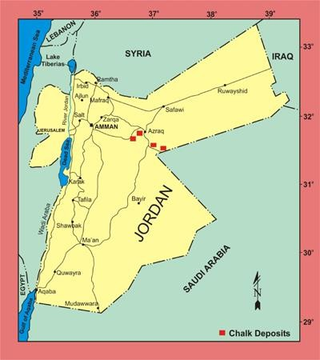**Locations:** Chalk deposits exposed over an area extend from east of Zarqa to the area of Al Azraq are shown in Figure (1) (AbuQudera, 1998).

**Figure (1): Location map of Chalk deposits in Jordan (AbuQudera, 1998)**

**Location:** (AbuQudera,1998)

1. Al – Umary (Abar Al Hazim) / Dahikiya Area.
2. This area is located about 45km south east of Al- Azraq.
3. Wadi Al-Ghadaf Area.
4. This area is located about 35km south of Al-Azraq.
5. Qaser Al-Harrana Area.
6. This area is located about 50km east of Amman.
7. Wadi Al- Dha'abi Area
8. This area is located about 60km east of Amman.

* **Chemical and Physical Properties**

The Chemical and Physical Properties listed in table (1)

**Table (2): Chemical and physical properties of the studied areas. (H.F.W. Taylor 1997)**

|  |  |  |
| --- | --- | --- |
| Area | CaO% | Brightness |
| Al – Umary – Dahikiya | 38.9 – 49.6 | 74.8 – 81.7% |
| Wadi Al-Ghadaf | 43.6 – 52.6 | 79.5 – 81.4% |
| Qaser Al-Harrana | 47.9 – 52.6 | 76.6 – 83.5% |
| Wadi Al- Dha'abi | 51.59 – 53.15 | 76.6 – 85% |

1. **Lime stone:**

Pure limestone is among the most important non-metallic raw material used for industrial and agricultural purposes (Techno stone, 1984).

**Mining:**

Sedimentary limestone deposits can be extensive, covering hundreds of square miles, and can be relatively uniform in thickness and quality. Therefore, limestone quarries can be large and long lived, mining limestone layers that can be hundreds of feet thick over areas of several square miles. Many quarries produce multiple products, and crushed rocks that are not pure enough for certain uses may still be suitable as road aggregate. Marble quarries can also be very large.However, these rocks that were once regularly bedded have been metamorphosed into irregularly shaped bodies that are more difficult and costly to mine (Technostone,1984).

**Pure limestone uses:** (Technostone,1984)

* In the metallurgical industry as a fluxing agent for the smelting and refining of iron, aluminum and copper.
* In the chemical industry in the production of lime, calcium carbonate, alkali compounds, calcium carbide, magnesium oxides.
* In industries of white cement, iron and steel, glass, paper, sugar-refining, water purification, sewage and waste treatment, and gas desulphurization.
* Agricultural uses in soil condition, fertilizers and animal feeds.
* As a filler material in paints, rubber, paper, ceramics, floor tiles, tooth paste, medicine.

Cement industry.

**Location:**

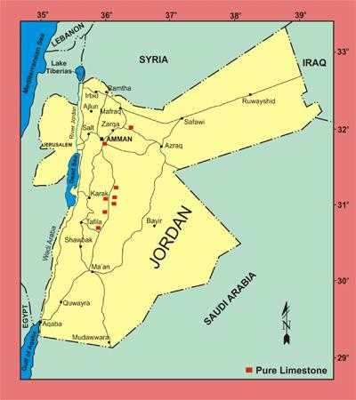Location map of Pure Limestone deposits in Jordan show in figure 2.

**Figure (2): Location map of Pure Limestone deposits in Jordan (Teimeh and Hiyari, 1978).**

**Cement Industry**

In white cement industry pure limestone should have CaO >52%. The insistent need for pure limestone deposit is due to the increasing prices of cement and the development of construction industries, so the investment opportunity will be increased in this industry **(**Teimeh and Hiyari,1978).

1. **Clay**

**Definition and Uses**

Kaolin is white, soft, plastic clay mainly composed of the fine grained platy mineral kaolinite; a white hydrous aluminum silicate, Al2Si2O5(OH)4, containing 23.5% alumina, 46.5% silica It is used in the manufacturing of white-ware ceramics and in filling and coating of paper. It is also used as filler in paints, rubber, plastics and many OTHER productions (Ajlouni and Gharaybeh, 1986).

**Mining**

The mining and processing of kaolin begins with exploration. Geologists study the earth’s surface, research literature and other data to identify land with potential kaolin deposits.

**Location**

Location of Kaoline deposits in Jordan shown in Figure (3)

* Batn el-Ghoul area
* Mudawwara area
* Al-Hiswa area Deposit

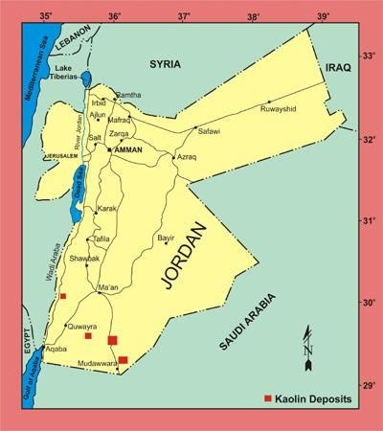

**Figure (3): Location map of Kaoline deposits in Jordan (Abu Lihie, 1988).**

**Chapter 3: Raw Materials Processing**

Portland cement is by far the most common type of cement in general use around the world. This cement is made by heating limestone (calcium carbonate) with other materials (such as clay) to 1450 °C in a kiln, in a process known as calcinations, whereby a molecule of carbon dioxide is liberated from the calcium carbonate to form calcium oxide, or quicklime, which is then blended with the other materials that have been included in the mix to form calcium silicates and other cementitious compounds. The resulting hard substance, called 'clinker', is then ground with a small amount of gypsum into a powder to make 'Ordinary Portland Cement', the most commonly used type of cement (often referred to as OPC). Portland cement is a basic ingredient of concrete, mortar and most non-specialty grout. The most common use for Portland cement is in the production of concrete. Concrete is a composite material consisting of aggregate (gravel and sand), cement, and water. As a construction material, concrete can be cast in almost any shape desired, and once hardened, can become a structural (load bearing) element. Portland cement may be grey or white (Gamble, William, 2005).

1. **Setting and curing**

Cement starts to set when mixed with water which causes a series of hydration chemical reactions. The constituents slowly hydrate and the mineral hydrates solidify; the interlocking of the hydrates gives cement its strength. Contrary to popular perceptions, hydraulic cements do not set by drying out; proper curing requires maintaining the appropriate moisture content during the curing process. If hydraulic cements dry out during curing, the resulting product.

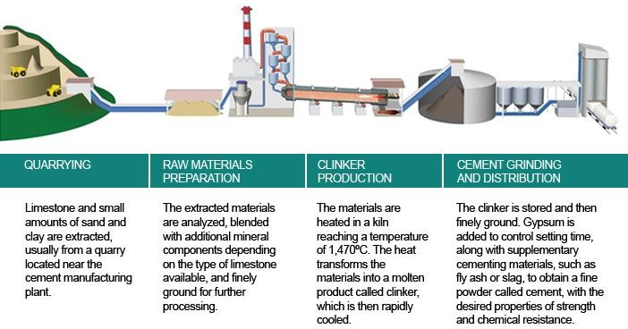

**Figure (4): Cement raw materials processing (Hahn, et.al 1997).**

1. **Cement manufacturing process**
2. **The quarry**

Cement plants are usually located closely either to hot spots in the market or to areas with sufficient quantities of raw materials. The aim is to keep transportation costs low. Basic constituents for cement (limestone and clay) are taken from quarries in these areas (Hahn, et.al 1997).

* A two-step process

Basically, cement is produced in two steps:

First, clinker is produced from raw materials. In the second step cement is produced from cement clinker.

The first step can be a dry, wet, semi-dry or semi-wet process according to the state of the raw material.

1. **Making clinker**

The raw materials are delivered in bulk, crushed and homogenised into a mixture which is fed into a rotary kiln. This is an enormous rotating pipe of 60 to 90 m long and up to 6 m in diameter. This huge kiln is heated by a 2000°C flame inside of it. The kiln is slightly inclined to allow for the materials to slowly reach the other end, where it is quickly cooled to 100-200°C (Hahn, et.al 1997).

Four basic oxides in the correct proportions make cement clinker: calcium oxide (65%), silicon oxide (20%), alumina oxide (10%) and iron oxide (5%). These elements mixed homogeneously (called “raw meal” or slurry) will combine when heated by the flame at a temperature of approximately 1450°C. New compounds are formed: silicates, aluminates and ferrites of calcium. Hydraulic hardening of cement is due to the hydration of these compounds (Hahn, et.al 1997).

The final product of this phase is called “clinker”. These solid grains are then stored in huge silos.

**Chapter 4: Process Description**

So, to make clinker there are three processes:

1. **. Wet process**

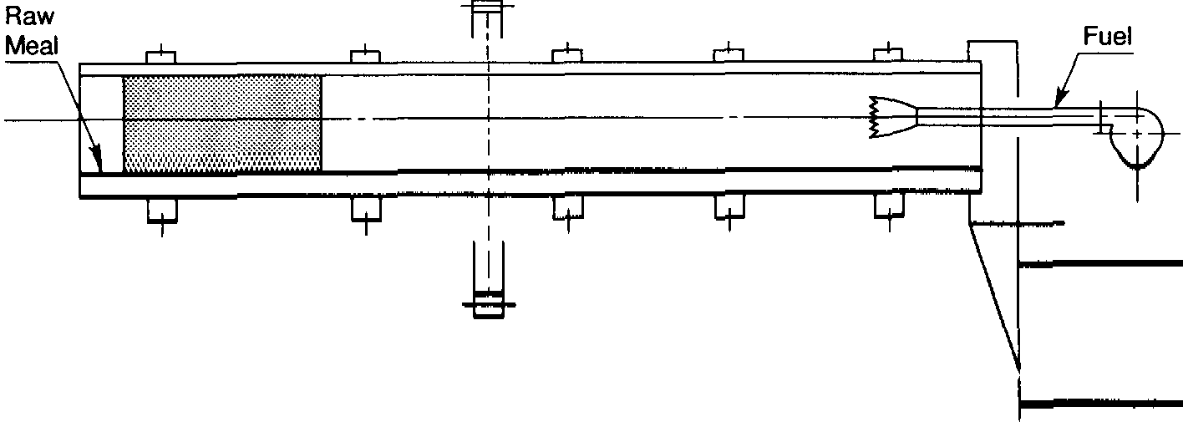This process is made by cylindrical type kiln the length for it = 40times of the shell’s inner diameter it is using to help dry the slurry see figure 4.

**Figure (5): The Wet process of cement (Mahasenan, et.al 2008)**

1. **. Semi-dry process**

It example to dry process and uses a Lepol kiln : in the lepol kiln the pellets are dried and preheated once by the movable grate (Mahasenan, et.al 2008).

1. **. Dry process**

The Cement Roasting Machine is the device to heat and dry materials. The Materials in the coaxial type roasting machine are roasted through retracing and raising between the helical lobe and the intermittent spiral plate. The sleeve structure of the machine can severalfold shorten the length of dryer, hereby the radiating surface and heat consumption are significantly reduced, while the increased heat exchange surface greatly enhances thermal efficiency. As to the materials that could not contact smoke, the multi drum cement roasting machine is equipped with inside smokestacks and ringlike smokestacks, and each smoke tube linked through radial flue, consequently, reaching the effect of high efficiency and energy saving see Figure 5 (Mahasenan, et.al 2008).

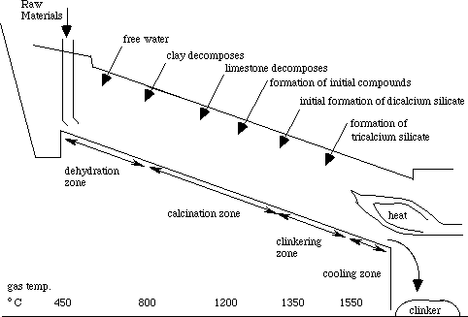

**Figure (6): Cement Roasting flow sheet (Mahasenan, et.al 2008).**

In this case there are three types of kilns to uses:

* long kiln, the short kiln with boiler, the SP kiln and the NSP
* the long kiln is ues in the Near and Middle East (it used because rain falls less

It can be seen that the wet process is rapidly replaced by the dry process the cause it for energy conservation (Mahasenan, et.al 2008).

1. **. Finish process**

The second phase is handled in a cement grinding mill, which may be located in a different place to the clinker plant. Gypsum (calcium sulphates) and possibly additional cementations (such as blast furnace slag, coal fly ash, natural pozzolanas, etc.) or inert materials (limestone) are added to the clinker. All constituents are ground leading to a fine and homogenous powder. End of phase two. The cement is then stored in silos before being dispatched either in bulk or bagged see figure 6 (Mahasenan, et.al 2008).

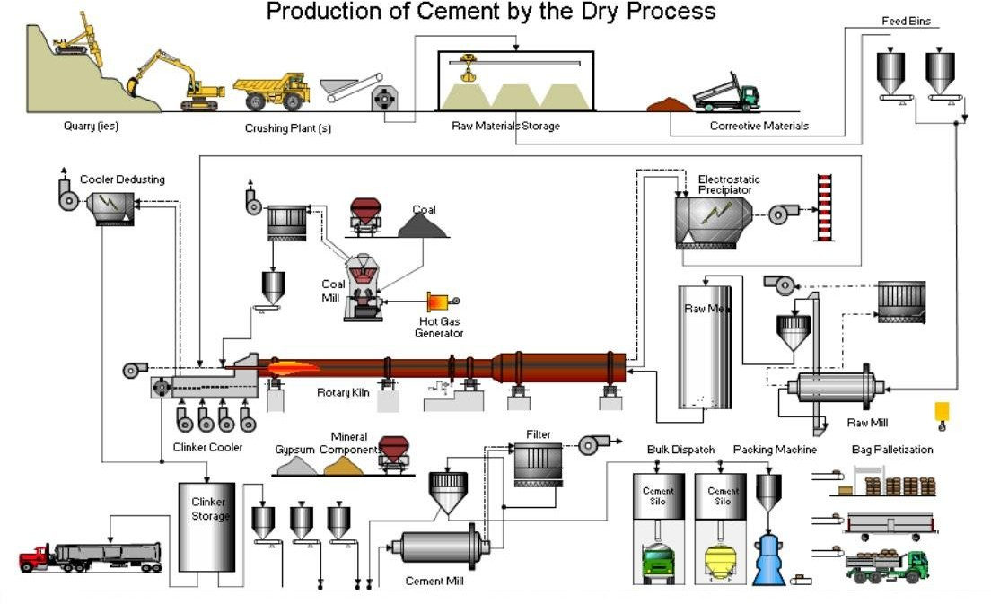

**Figure (7): The Cement Production Flow Sheet By the dry process.**

**Chapter 5: Environmental impact for cement**

Environmental and health effects of pollutants resulting from the cement industry

1. **. Environmental impact caused by emissions into the air**

* Atoms dirt: these atoms to permeate ready lung and caused great damage to the respiratory tract (diseases such as asthma and chronic cough and inflammatory coral aerobic). And these emissions consist of ash and soot and carbon components, which are often resulting from incomplete combustion process (Chandak, Shobhit, 2011).
* Sulfur Oxides: The air pollution caused by the pollutants sulfur and one of the most dangerous air pollutants, which cause sulfur compounds in major problems for the animals and plants, as well as for the building, because the acid rain causing corrosion of metals, limestone, and other materials. For example but not limited to (Chandak, Shobhit, 2011).
* NOx: nitrogen monoxide has the same harmful effect of the environment as the first carbon dioxide, which can combine with hemoglobin cells to limit the ability of blood to carry oxygen, and nitrogen dioxide causes inflammation of coral bronchial pneumonia (Chandak, Shobhit, 2011).
* Carbon dioxide: and it is one of the six greenhouse gases that cause global warming phenomenon where these gases absorb heat radiation and store them, which contributes to increase the surface temperature (Chandak, Shobhit, 2011).

1. **. Environmental impact resulting from the liquid waste**

In the case of access to the dust furnace systems fluid exchange, it may lead to the formation of clay which can lead to clogged sewage pipes (Berkes, Howard, 2011).As well as form oils and lubricants resulting from garages and workshops and a great danger in the case discharged into the sewage system, where Tzb in gluing pipes which lead to many difficulties in maintenance operations. And also, if the discharge of such effluent into water bodies, they can interfere with aquatic life in this body of water or can be a great oily and lead to serious pollution of the environment surrounding spots (Berkes, Howard, 2011).

1. **. Environmental impact resulting from the disposal of solid waste**

Arise atoms dirt minute of crushing and milling operations and confused in addition to the dust sedimentation resulting from the process of electrolysis in the last milling stage before packing. It is worth mentioning that the disposal of such waste by dumping in buried outside the factory area requires the addition of stabilizing agents to reduce the harm and that may lead to serious risks to the population surrounding environment in case of high proportion of these pollutants in the air (Berkes, Howard, 2011).

**Conclusion**

* The mining sector enters significantly in the cement industry, this sector is considered the most important in terms of extraction, mining, and processing of raw materials.
* 99% approximately from the raw materials used are considered mining material.
* Mining methods used in the extraction equipment for a cement raw material considered ways rather easy and inexpensive and most commonly used material extracted from quarries.
* Considered one of Lime stone and clay the most important raw material for the manufacture of cement different kinds.
* Mining and processing of raw materials include Setting curing and clinker.
* Cement process include wet, dry, wet dry process and finish process.
* Roasting cement Considered one of the most important processing steps where they are roasting constituent components through the roasting oven.
* After use cement (concrete) greatly effect on the environment in general, Bust greatly affect the soil and groundwater.
* Environmental and health effects of pollutants resulting from the cement industry include environmental impact caused by emissions into the air liquid waste disposal of solid waste.

**Reference**

1. Abu Lihie, O. (1988) Geological map of Dubaidib area.
2. Ajlouni, and Gharaybeh, M. (1986) Report clay Occurrences of Jable Mulayh Area, Tafila.
3. Berkes, Howard (2011). EPA Regulations Give Kilns Permission to Pollute: NPR.
4. Chandak, Shobhit. (2011) Report on cement industry in India, Scribed pp 17.
5. Fadda, E. (1998) The Geology of Wadi Ed-Dabi Area Map Sheet No. 3353-III.
6. Fadda, E. (1998) The Geology of Wadi Ed-Dabi Area Map Sheet No. 3353-III.
7. Gamble, William. (2005) Cement, Mortar, and Concrete. In Baumeister; Avallone, McGraw Hill. p177.
8. H.F.W. Taylor. (1997) Cement Chemistry, Thomas Telford, London.
9. Hahn, Thomas F, and Emory Leland Kemp (1994) Cement mills along the Potomac River. Morgantown, West Virginia University Press.
10. Hunjul, N. (2001) The Geology of Qaser Al-Harana Map Sheet No. 3253-II.
11. Mahasenan, Natesan, Steve Smith, Kenneth Humphreys and Y. Kaya (2003). The Cement Industry and Global Climate Change: Current and Potential Future Cement Industry.
12. Mohammad, Abu Qudera. (1998) Studied the occurrences of chalk in the Azraq basin areas PP 12-20.
13. Ridi, Francesca. (April 2010) Hydration of Cement: still a lot to be understood La Chemical Industrial Societal, Chimica Italiana.
14. Robert, G, Blezard. (2004) The History of Calcareous Cements in chemistry of cement and concrete, Elsevier Butterworth-Heinemann.
15. S.H. Kosmatka, B. Kerkhoff, and W.C. Panarese. (2002) Design and Control of Concrete Mixtures: Portland cement Association, Skokie.
16. Technostone, S.P.A. (1984) Report on White Limestone, Ajlun Area: Study for the Exploitation of Deposits of Lithic Materials in Jordan P 39.
17. Teimeh, M. and Hiyari, M. (1978) Report on The Lime stone Occurrences in Southern Jordan, p22.