**Bank Customer Churn Analysis – Power BI Report**

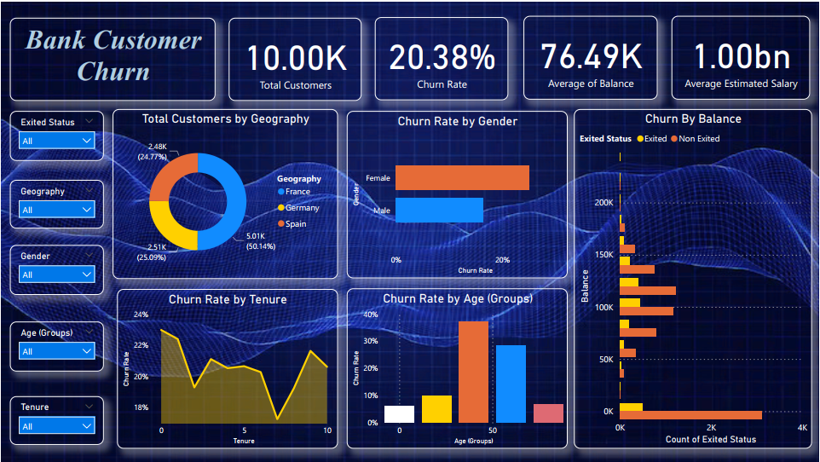

**Overview :**

This Power BI report provides an in-depth analysis of customer churn for a banking institution. It includes key metrics, interactive visuals, and insights into factors affecting customer retention.

**Dataset Details :**

* **Total Records: 10,000 customers**
* **Key Attributes:** 
  + Customer ID, Geography, Gender, Age, Tenure
  + Account Balance, Estimated Salary
  + Number of Products, Credit Score, Active Membership
  + Churn Status (Exited/Not Exited)

**Key Insights :**

1. **Churn Rate: 20.38% of customers have exited.**
2. **Geographical Impact:** 
   * France: 50.14% of total customers
   * Germany: 25.09%
   * Spain: 24.77%
3. **Churn by Tenure:** 
   * Higher churn observed in customers with shorter tenure (0–5 years).
4. **Churn by Gender:** 
   * Females show slightly higher churn **rates than males.**
5. **Churn by Age Groups:** 
   * Customers aged 40–50 have the highest churn rate.
6. **Balance vs. Churn:** 
   * Customers with lower balances are more likely to leave.

**Visuals in the Report :**

1. Total Customers & Churn Rate – KPIs
2. Churn by Geography – Bar Chart
3. Churn by Tenure – Line Chart
4. Churn by Gender – Bar Chart
5. Churn by Age Groups – Column Chart
6. Churn by Balance – Scatter Plot

**Technology Used :**

* Power BI – Data visualization and interactive dashboards
* Excel / CSV – Raw data preprocessing
* DAX (Data Analysis Expressions) – Calculations and measures

**Conclusion :**

This report helps identify churn patterns and key factors influencing customer retention. It can assist banks in making data-driven decisions to improve customer engagement and reduce churn.