**Advanced Computer Architecture**

**Project – Multi Pipeline Processor**

I used Python 3.8 to complete the project. I used Spyder for running Python 3.8. The project is divided into two parts. Part one is a file named MultiPipelineAnalyzer.py and part two is a file named Stimulator.py.

For running the project, I ran Stimulator.py with command line arguments as inst.txt data.txt reg.txt config.txt result.txt.

Please find the attached image below which shows how I ran the project with command line arguments.

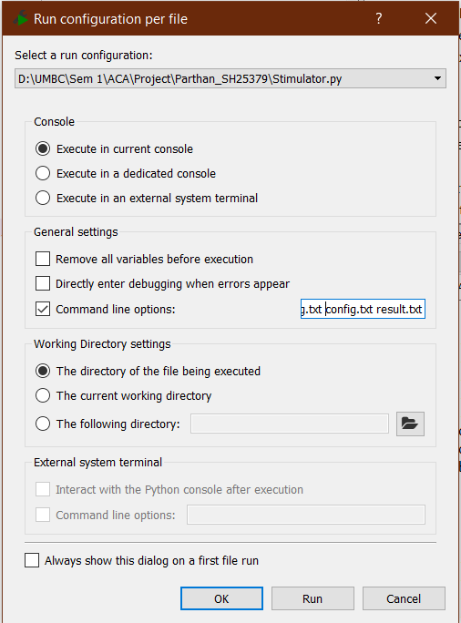

This will release two outputs, one will output the entire table and the other will return this table into a file named result.txt, which will be available in the directory location.