PROJECT REPORT
Workshop & Lab Fume Exposure Logger
An IoT-Based Cumulative Gas Exposure Monitoring System
Recommended Grade (self-assessed): | 10
Domain: | IoT / Embedded Systems / Occupational Safety Tech
Institution: | REVA University, Bengaluru
Programme: | B.Tech Electronics & Communication Engineering (ECE)

1. Project Title & Recommended Grade
Project Title: Workshop & Lab Fume Exposure Logger (WLFEL)
Subtitle: An IoT-based cumulative fume/gas exposure monitor with real-time alerting
Recommended Grade (self-assessed): 10
Justification: the project goes beyond a simple threshold gas alarm by introducing a cumulative, time-weighted exposure model (conceptually similar to an occupational Time-Weighted Average), includes real hardware debugging and iteration (a compiler-level bug fix, sensor-response validation against real smoke, and a full redesign of the alert logic for simplicity), and was verified working end-to-end on physical hardware rather than only in simulation. This recommendation is a self-assessment against the stated evaluation criteria and is intended for the evaluator's consideration, not a substitute for official grading.

2. Career / Industry Relevance & Problem Statement

Industry Relevance
This project sits at the intersection of IoT/Embedded Systems and Occupational Health & Safety (OHS) technology. Low-cost environmental and gas monitoring is increasingly used in industries such as electronics manufacturing/rework, chemistry and materials labs, welding/soldering workshops, 3D-printing spaces, and small-scale industrial units, where affordable, connected sensing is replacing or supplementing expensive certified safety equipment for day-to-day awareness.

Problem Statement
Workshops and labs (soldering stations, chemistry benches, 3D printers, small fabrication setups) expose people to fumes and volatile organic compounds (VOCs) that are often below the threshold of immediate danger but harmful when inhaled continuously over a session. Most low-cost gas sensor projects only implement a simple instantaneous threshold alarm ("gas level above X -> alarm"), which misses the real risk: a moderate gas level sustained over a long period can be just as harmful as a brief spike, but a simple threshold alarm never flags it. There is a need for an affordable, standalone device that tracks exposure over time, not just the current reading.

3. Proposed Solution & Working Principle
The Workshop & Lab Fume Exposure Logger continuously samples an MQ135 gas sensor, converts each reading into a relative Exposure Index based on how far it is above a calibrated clean-air baseline, and accumulates that index over time to produce a Cumulative Exposure value and a Time-Weighted Average (TWA) — giving a running picture of exposure over a session rather than only the instantaneous reading.

Working Principle - Step by Step
- Warm-up: on power-up, the device waits (with an on-screen countdown) for the MQ135 heating element to stabilise before trusting any reading.
- Baseline calibration: the sensor is averaged over in clean air to establish a reference ("baseline") ADC value.
- Continuous sampling: every ~1 second, the sensor is re-read and compared against the baseline as a percentage deviation.
- Exposure Index: the percentage above baseline is mapped onto a 0-90
- Cumulative Exposure & TWA: Exposure Index is multiplied by elapsed time and summed continuously, giving a running total (Cumulative Exposure) and an average rate (TWA) for the whole session.
- State classification: the system classifies the situation into NORMAL, ELEVATED, HIGH, or CRITICAL based on both the instantaneous index and the cumulative total, so a mild-but-sustained exposure escalates the same way a sharp spike would.
- Alerting: the OLED shows live readings and status at all times; the buzzer escalates behaviour as the state worsens
- Reset / recalibration: a physical button triggers a full device restart, re-running the warm-up and calibration sequence from scratch for a new session.

4. Components Used & Approximate Costing
Prices are approximate market estimates for Bengaluru/India as of 2026 and will vary by vendor. Replace with your actual purchase costs for the final submission if exact figures are required.
Component |  | Qty | Approx. Unit Price (INR)
ESP32 NodeMCU-32S Dev Board |  | 1 | 350
MQ135 Gas Sensor Module |  | 1 | 120
0.96" SSD1306 OLED Display (I2C) |  | 1 | 250
Active Buzzer Module |  | 1 | 30
Push Button (Reset) |  | 1 | 10
Breadboard |  | 1 | 120
Jumper Wires (set) |  | 1 | 60
Rs 940

5. Step-by-Step Development
- Requirement analysis: identified the gap between simple threshold gas alarms and real-world cumulative exposure risk.
- Component selection: chose ESP32 (NodeMCU-32S) for its ADC, I2C, and general availability; MQ135 for broad VOC/CO2-family sensitivity; SSD1306 OLED for a compact live readout.
- Circuit design: planned wiring for the sensor, display, buzzer, and reset button, including a voltage divider to protect the ESP32's 3.3V-only ADC input from the sensor's higher-voltage output.
- Base firmware: implemented raw sensor reading, OLED initialisation, and Serial debug output first, to confirm hardware was alive before adding logic.
- Calibration logic: added a warm-up countdown and a multi-sample baseline average, since MQ-series sensors drift significantly right after power-on.
- Exposure model: designed and implemented the percentage-above-baseline -> Exposure Index -> Cumulative Exposure -> TWA pipeline, with an adjustable response curve.
- Buzzer logic - first pass: implemented a non-blocking, millis()-based state machine so beep patterns wouldn't stall sensor reads or button checks.
- Debugging round 1 - compiler error: an enum using HIGH and CRITICAL as member names collided with ESP32 core macros (HIGH is #defined as 0x1), producing a cascade of compile errors; fixed by renaming the enum members (STATE_HIGH, STATE_CRITICAL, etc.).
- Debugging round 2 - sensor behaviour: observed the gas reading dropping when breathing on the sensor, which would have looked like a wiring/inversion fault; isolated the cause by testing with real smoke, which correctly increased the reading and confirmed the sensor and wiring were correct (the breath test was misleading due to an airflow-cooling artifact, not a hardware fault).
- Buzzer logic - simplification pass: reworked the buzzer from a multi-phase non-blocking state machine into a shorter, easier-to-read version (HIGH = one 2-second beep, CRITICAL = continuous beeping) based on a request for simpler code, with the trade-off documented (brief blocking during the HIGH beep).
- Final validation: confirmed end-to-end operation - NORMAL state at rest, correct escalation through ELEVATED/HIGH/CRITICAL under real smoke, buzzer behaviour matching each state, and reset returning the device to a full recalibration cycle.

6. Circuit, Code & Logic

6.1 Wiring / Circuit Connections
Module | Module Pin | ESP32 Pin | Notes
MQ135 Sensor | VCC | 3.3V (VIN) | Heater element needs 3.3V
MQ135 Sensor | GND | GND
MQ135 Sensor | AOUT | GPIO 34
OLED (SSD1306) | VCC | 3.3V
OLED (SSD1306) | GND | GND
OLED (SSD1306) | SDA | GPIO 21 | I2C data
OLED (SSD1306) | SCL | GPIO 22 | I2C clock
Buzzer | + | GPIO 25 | Active buzzer, direct drive
Buzzer | - | GND
Reset Button | Leg 1 | GPIO 27 | INPUT_PULLUP - no external resistor needed
Reset Button | Leg 2 | GND

6.2 Exposure State & Buzzer Logic
Status | Trigger Condition | Buzzer Behaviour
NORMAL | Gas reading at or below calibrated baseline | Silent
ELEVATED | Exposure Index > 0 (reading >= 10% above baseline) | Silent (visual/serial indication only)
HIGH | Exposure Index >= 40, or cumulative exposure >= 5000 index-seconds | Beeps for 2 seconds, then stops
CRITICAL | Exposure Index >= 70, or cumulative exposure >= 10000 index-seconds | Continuous beeping until resolved

6.3 Key Code Logic (excerpts)
The full, fully-commented source code (Workshop_Lab_Fume_Exposure_Logger_fixed.ino) is provided alongside this report. The excerpts below show the core logic referenced above.
Exposure Index calculation:
float percentage = ((reading - baseline) / baseline) * 100.0;
if (percentage < EXPOSURE_START) return 0;
float range = percentage - EXPOSURE_START;
float maxRange = EXPOSURE_RANGE_MAX - EXPOSURE_START;
float normalized = range / maxRange;
float index = pow(normalized, EXPOSURE_CURVE_POWER) * EXPOSURE_INDEX_MAX;
State determination:
if (cumulativeExposure >= CRITICAL_LIMIT ||
exposureIndex >= CRITICAL_EXPOSURE)
currentState = STATE_CRITICAL;
else if (cumulativeExposure >= WARNING_LIMIT ||
exposureIndex >= HIGH_EXPOSURE)
currentState = STATE_HIGH;
else if (exposureIndex > 0)
currentState = STATE_ELEVATED;
else
currentState = STATE_NORMAL;
Buzzer logic (simplified version):
if (currentState == STATE_CRITICAL) {
digitalWrite(BUZZER_PIN, HIGH); // keep beeping, no stop
} else if (currentState == STATE_HIGH) {
digitalWrite(BUZZER_PIN, HIGH);
delay(2000); // beep for 2 seconds
digitalWrite(BUZZER_PIN, LOW); // then stop
} else {
digitalWrite(BUZZER_PIN, LOW); // silent
}
Reset button -> full recalibration:
void restartDevice() {
digitalWrite(BUZZER_PIN, LOW);
Serial.println("RESET BUTTON PRESSED - RESTARTING");
delay(200);
ESP.restart(); // reboots -> setup() re-runs warm-up + calibration
}

7. Photos of Actual Working Prototype

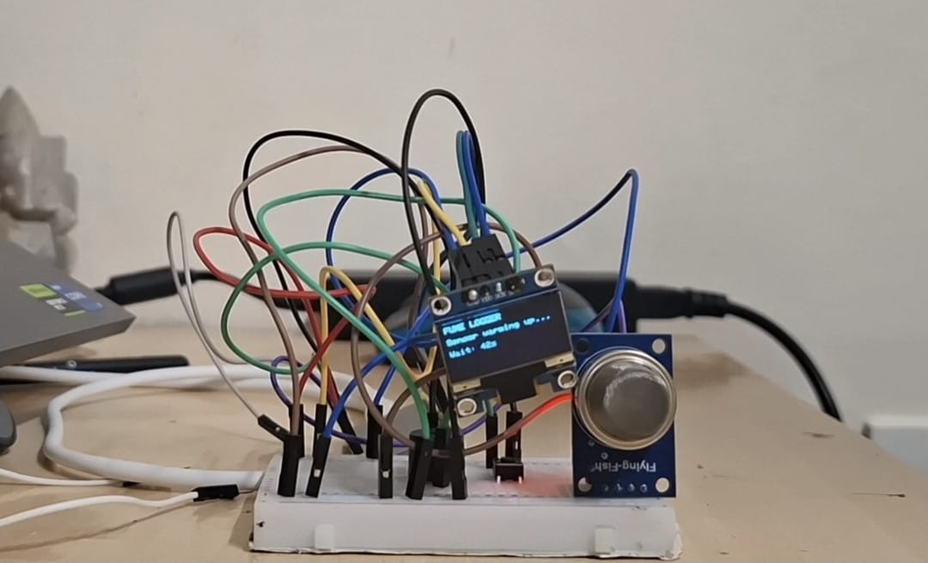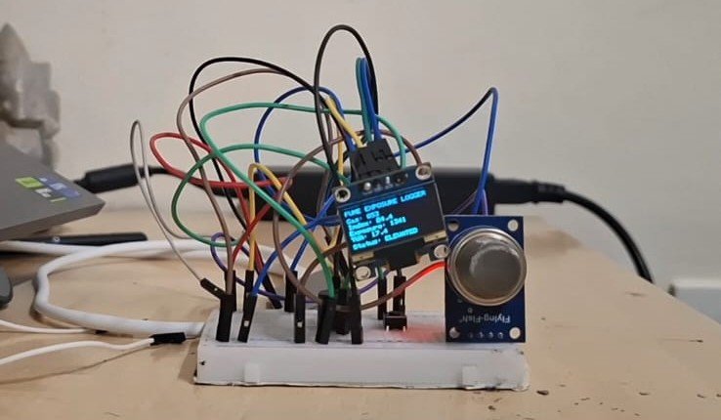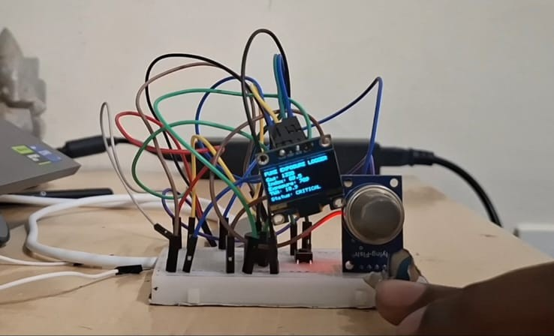

8. Approximate Completion Time
Phase | Approx. Time
Problem research & component selection | 1 - 1.5 hrs
Circuit wiring & hardware assembly | 1 hr
Base firmware (sensor read, OLED, Serial output) | 1.5 hrs
Exposure index / TWA logic & threshold tuning | 1.5 hrs
Buzzer logic (design + simplification pass) | 1 hr
Debugging (compile errors, sensor behaviour, calibration) | 1.5 - 2 hrs
Testing with real smoke source & threshold validation | 1 hr
Documentation & report | 1 hr
Approx. Total Effective Development Time |  | 9.5 - 10.5 hrs

9. Student Learning Outcomes
- Practical understanding of MOS-type gas sensors (MQ135): warm-up drift, baseline calibration, and the difference between a raw signal and a calibrated measurement.
- Embedded C/C++ programming on the ESP32 (Arduino framework), including working with global state, enums, and modular function design.
- State-machine design for classifying continuous sensor data into discrete alert levels.
- Concrete experience with the trade-off between non-blocking (millis()-based) and blocking (delay()-based) code, and when each is appropriate.
- I2C peripheral interfacing (SSD1306 OLED) and basic display driver usage.
- Debounce theory and its implementation for a physical push-button input.
- Real hardware debugging methodology: isolating whether unexpected behaviour is a wiring fault, a sensor characteristic, or a software bug (as in the breath-vs-smoke sensor investigation).
- Reading and resolving a compiler-level error caused by a naming collision with platform-reserved macros (HIGH from the ESP32 core).
- Applying a real-world safety concept (time-weighted exposure, conceptually related to occupational TWA limits) to a low-cost embedded project.
- Technical documentation and reporting skills, including presenting design decisions and their trade-offs clearly for a non-implementer audience.

