Helm-

Connect with the cluster from linux workstation.

>> sudo apt update

>> sudo apt-get update

>> sudo apt upgrade

Install az.

>> curl -sL https://aka.ms/InstallAzureCLIDeb | sudo bash

Configure azure account.

>> az login

Install kubectl.

>> curl -LO [https://dl.k8s.io/release/$(curl -L -s https://dl.k8s.io/release/stable.txt)/bin/linux/amd64/kubectl](https://dl.k8s.io/release/$(curl%20-L%20-s%20https://dl.k8s.io/release/stable.txt)/bin/linux/amd64/kubectl)

>> chmod +x kubectl

>> sudo mv kubectl /usr/local/bin/

Set subscription and get luster credentials (add IP to cluster)

Install helm-

>> curl -fsSL -o get_helm.sh <https://raw.githubusercontent.com/helm/helm/main/scripts/get-helm-3>

>> chmod 700 get_helm.sh

>> ./get_helm.sh

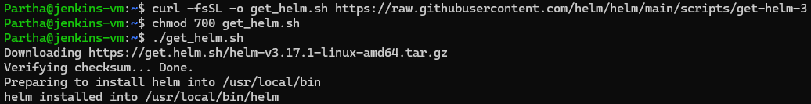

Once Helm is installed, you can add a chart repository. For example, to add the Bitnami repository:

>> helm repo add bitnami <https://charts.bitnami.com/bitnami>

>> helm repo update

To install a chart, you can use the helm install command. For example, to install a MySQL chart:

>> helm install my-mysql bitnami/mysql

Check helm is working fine.

>> helm list



Install helm plugin for getting GUI dashboard for helm.

>> helm plugin install https://github.com/komodorio/helm-dashboard

>> helm dashboard

Browse helm by serverIP:port

Serverip:8080

If not accessible check NSG and if that port is used by any other service use different port.

>> helm dashboard --port 8081

Check if it’s available locally.

Curl localhost:port

Then go for providing access to globally.

>> export HD_BIND=0.0.0.0

>> helm dashboard --bind 0.0.0.0

If still having issue, try to follow below steps.

>> export HD_BIND=0.0.0.0

>> helm dashboard

>> helm dashboard --bind 0.0.0.0 --port 8090

The last cmd is to provide external port to helm.

Now try by “serverip:port”

If any issue on helm. Can use – debug to troubleshoot.

>> helm dashboard --bind 0.0.0.0 --port 8090 –debug

Helm and other azure related learning publ repo lnk-

[Azure Samples](https://github.com/Azure-Samples)

It includes interview questions.