Register and Login
Xampp
Xampp is an application to create a local host server. It supports hosting the PHP websites. It also contains inbuilt installer for mysql database. It also provides the graphical user interface of the database, hence users can easily manage and edit database tables.

Connecting Java application and Database
Importing of the packages:
This step requires the developer to include packages which contains the JDBC classes which are needed for database programming. Most of the times, the use of java.sql.* package will work.

Register the JDBC driver:
In order to open the communication channel with the database, the developer is required to initialize the driver.

Starting a communication:
Creatation of Connection object requires the DriverManager.getConnection() method. It represents the physical connection with the database.
Login and Sign Up
Login:
The login screen is developed using Java applet to make the interface as simple as possible. It is also easy to run a java application, hence reducing the work of the end user. It takes the unique chat id for connection and password from the user. The backend code then sends the data to the server which checks the crediential of the person. If the unique ID matches with the password, the user is directed to the connection page.

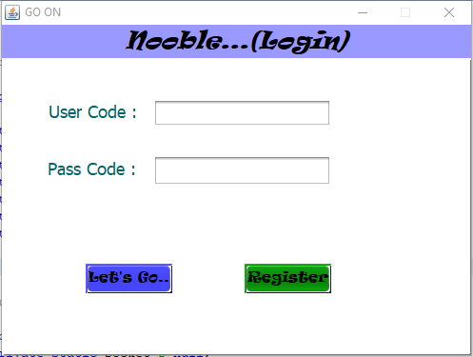

Register Page:
Register page is used for registration of new users. It enables a user to sign up for the chatting facility after which he can use the software. The option for new registration is available in the login page. The registration page is also created using Java Applets. The registration page has the following options:
-First Name
-Last Name
-User Code (Unique)
-Password
-Re-enter password
-Profile picture selection.

The profile picture selection option is used for selecting an image file from the computer which the user wants to upload as profile picture.

All the entered information is then transferred to server. It updates the local host database with the newly enter data. Hence the registration is completed when the data is successfully stored in the database.
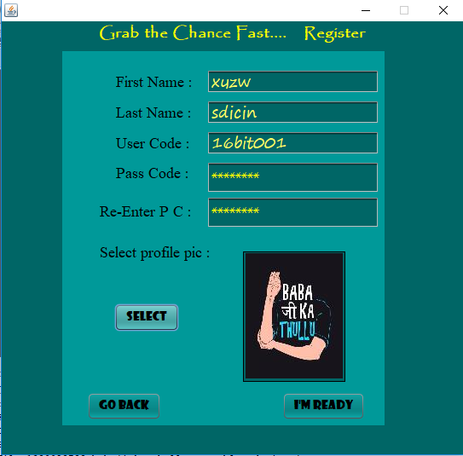
Figure

Application Home

The application home is the main home screen where the actual chatting takes place.
There are the following main graphical components involved:
-Search Bar and search button
-Profile pic-1 (Current user)
-Profile pic-2 (User on the other side)
-Connection information
-Message display terminal
-Message typing field
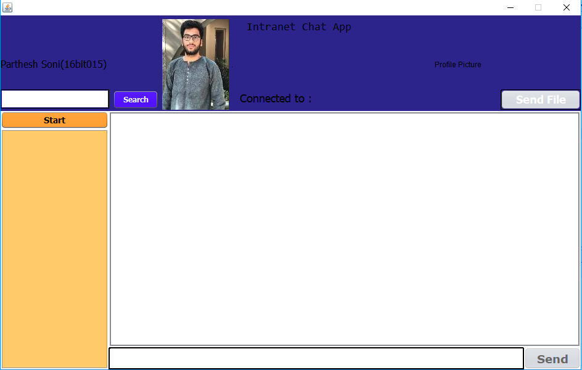

Search Bar and button
The search bar is used for searching the people who are actually online at the moment. The search button is the button which actually initiates the searching.
The user is supposed to type the unique ID of the person with whom he/she wants to communicate. After typing, when search button is pressed, the list of the users online is shown in the list which is below the search button.

Profile pic-1
This portion of the application home is used for display of the profile picture of the user who is currently logged in the application home. This serves the purpose of validating the person who is logged in.

Profile pic-2
The profile picture of the user with whom the logged in user communicates is displayed in this area. This serves the purpose of recognise the person with whom chatting is done. This also enables the user to set his/her own identity in the network.

Connection information
This area displays the person’s name and unique ID, who is connected with the logged in user.

Message display terminal
This is the actual portion where the messages sent and recieved are printed. The message along with the details of the sender is printed. Upon clicking the unique id of the other user, the chat home will be directed to that particular user. The message field is refreshed when the application home is active.

Message typing field
Here, the user can type the message which he/she wants to send to the other side. The field supports input of standard characters. There is a send button which will send the message to the other user. The sent information will also be printed in the message display terminal. Which is shown in the following image.

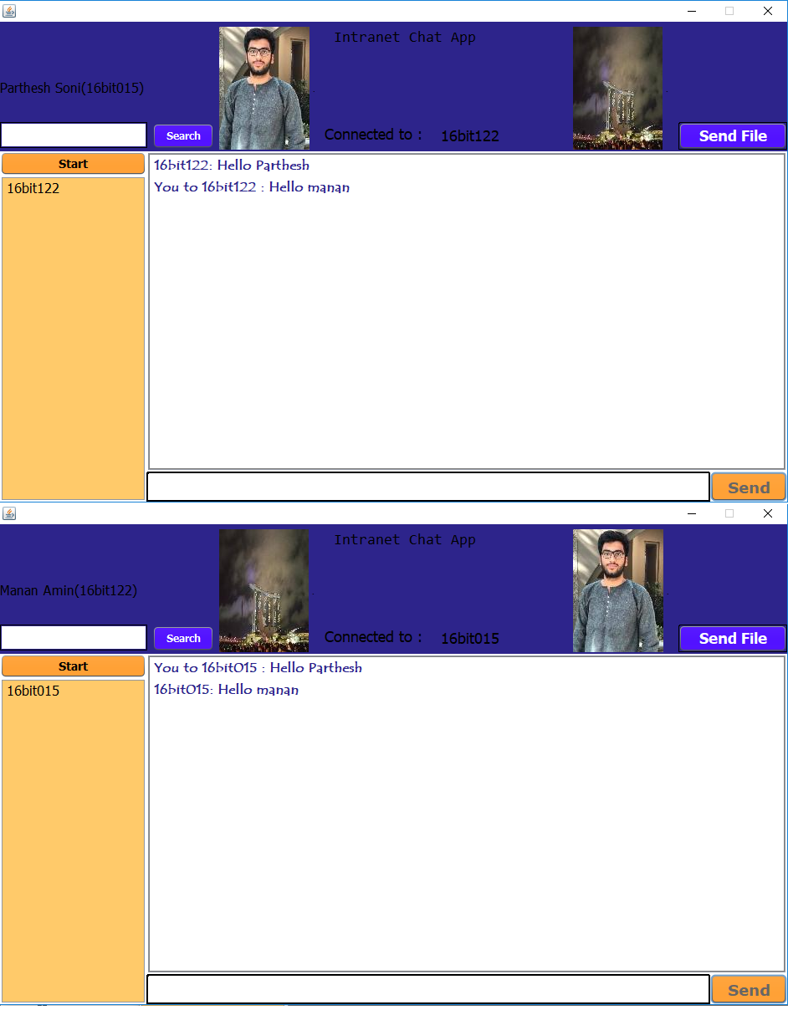

Socket Programming concepts used in the project

Socket
The communication between two distinct processes on same or different computers is done by sockets. It is also said to be the way in which one computer talks to another with the help of Unix file descriptors. Hence it can be called a low-level file descriptor.

Types of Sockets
Stream Sockets:
This type of socket works on TCP protocol. The delivery of the data is guaranteed by the use of stream socket. Also the sequence of delivery is same as the sequence of sending. If delivery cannot take place at any condition, then the sender gets a message that error occured.

Datagram sockets:
The delivery of a message is not guaranteed in the case of networked environment. This is because one doesn’t need open connection for stream socket to run, hence they are connectionless. One has to build a packet with destination information and send it for transmission.

Raw Sockets:
The communication protocols which supports socket abstraction are provided by raw sockets. Hence it can be inferred that they are inclined towards datagram sockets.

Sequenced packet sockets
They are similar to stream socket, but the boundries for the records are preserved in this kind of sockets.

Server Socket
The server socket is created for attaching itself to a port and wait for a client to connect to it. If the client does not connect, the server waits for long just waiting for some client to connect.

Client Socket
The client is creating for connecting to a server which is waiting for connection. As the client connects to the server, the communication link is established and hence now data can be transmitted.

