|  |
| --- |
| **MODULE: 1**  **SE – Overview of IT Industry** |

1. **What is software? What is software engineering?**

**Ans**.

**Software**: Software is a collection of instructions, data, and programs that tell a computer how to perform tasks. It's the opposite of hardware, which refers to the physical parts of a computer.

**Software Engineering:** Software engineering is a branch of computer science that involves the design, development, testing, and maintenance of software applications. Software engineers use engineering principles and programming languages to create software solutions for end users. They develop web applications, mobile apps, robots, operating systems, and network systems.



1. **Explain types of software?**

**Ans.**

* **Application software**

A group of programs or a single program that allows users to create information, such as spreadsheets, documents, presentations, and web browsers

* **System software**

Software that allows a computer to function and control devices connected to it

* **Operating system**

Controls hardware and creates a user interface between the hardware and the user

* **Driver software**

A piece of software that communicates on behalf of the operating system and devices used in the system, and coordinates the data and actions between them

* **Programming software**

A language used by programmers to write programs, scripts, and instructions that can be executed by a computer



1. **What is SDLC? Explain each phase of SDLC**

**Ans.**

SDLC (Software Development Life Cycle)

It is provides a framework for developer to produce high-quality software that meets user expectation and project requirements.

There are seven types of phase SDLC.

1. Planning
2. Design
3. Coding
4. Testing
5. Release & Deployment
6. Operation
7. Monitoring

**1) Planning :-** The team creates an overview of the project, determines requirements, and sets the groundwork for the actual development process.

**2) Design:-** This is where your average web developer or front-end developer comes in, who creates designs that make the software appealing and east to use.

**3) Coding:-** At this stage, the team translates the system design into code written n a specific programming language.

**4) Testing:-** The purpose of this stage is to emphasize the use of automated tests to prevent defects in the software.

**5) Release & Deployment:-** This phase involves packaging, managing and deploying releases across different environments.

**6) Operation:-** By keeping tabs on performance, the team identifies any problems or areas where improvements can be made.

**7) Monitoring:-** Software monitoring stage is important as it involves the imperative of safeguarding data and ensuring optimum performance.



**4. What is DFD? Create a DFD diagram on Flipkart**

**Ans.**

A Data Flow Diagram (DFD) is a graphical representation of the “flow” of data through an Information system modelling its process aspects. It is powerful tool use in system analysis and design and it allows a clear and concise representation of the system components, data, and interactions.

**The main entities in the Flipkart system are:**

* Customers: Customers are the people who use Flipkart to buy products.
* Sellers: Sellers are the people who sell products on Flipkart.

Flipkart: Flipkart is the company that owns and operates the Flipkart website

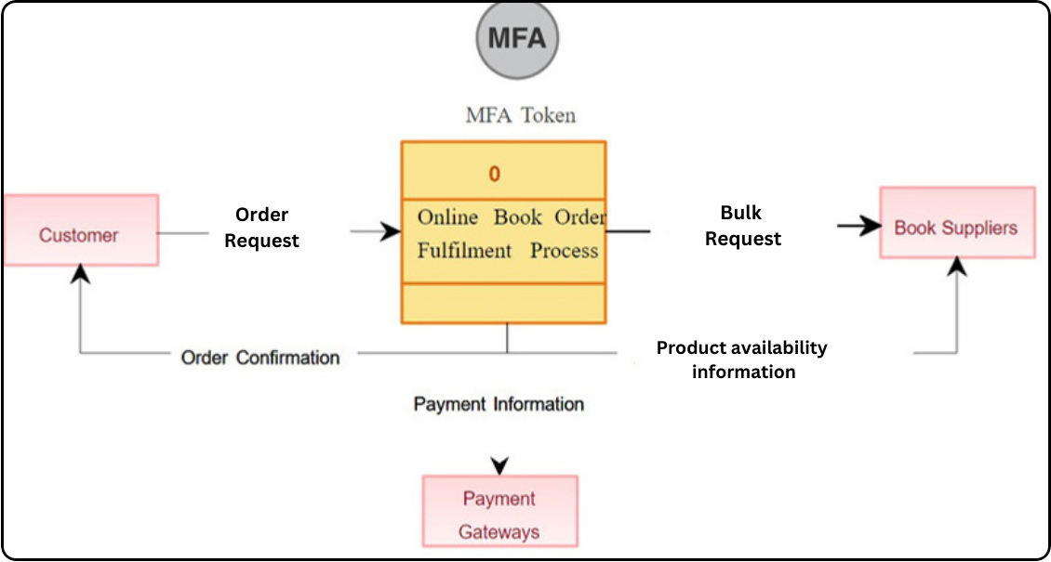

|  |
| --- |
| **DATA FLOW DIAGRAM** |

**The main data flows in the Flipkart system are:**

* Customers place orders: Customers place orders for products on the Flipkart website.
* Flipkart processes orders: Flipkart processes orders and sends them to sellers.
* Sellers ship products: Sellers ship products to customers.
* Customers receive products: Customers receive products and pay for them.

**Here is a theory of how the DFD works:**

1. A customer visits the Flipkart website and browses for products.
2. The customer finds a product that they want to buy and adds it to their cart.
3. The customer proceeds to checkout and enters their shipping and billing information.
4. The customer places the order.



**5. What is Flow chart? Create a flowchart to make addition of two numbers .**

**Ans**.

A flowchart is a graphical representation of a process or algorithm, typically using standardized symbols and connecting lines to illustrate the sequence of steps. It is a visual tool used in various fields such as computer programming, engineering, business, and education to communicate processes and procedures effectively. Flowcharts help in understanding the logic of a process, identifying potential bottlenecks or inefficiencies, and providing a clear structure for problem-solving

|  |
| --- |
|  |
| **FLOW CHART** |

Flowcharts consist of different shapes that represent specific elements of a process, such as:

* 1. Start/End: Indicates the beginning and end of the process.
  2. Process: Represents a task or action to be performed.
  3. Decision: Indicates a branching point in the process based on a condition or decision.
  4. Input/Output: Represents data input or output.
  5. Connector: Connects different parts of the flowchart.



**6. What is Use case Diagram? Create a use-case on bill payment on paytm.**

**Ans.**

Use-case diagrams describe the high-level functions and scope of a system. These diagrams also identify the interactions between the system and its actors. The use cases and actors in use-case diagrams describe what the system does and how the actors use it, but not how the system operates internally.

Paytm, India's leading digital payment platform, offers a seamless solution for bill payment, allowing users to effortlessly settle their various bills with just a few taps on their smartphones. This use-case scenario illustrates how Paytm simplifies the bill payment process for a typical user.



|  |
| --- |
|  |



**Login:** The user logs into the Paytm app to access their account.

**Select Bill Category:** The user selects the category of the bill they want to pay (e.g., electricity, water, mobile postpaid).

**Enter Bill Details:** The user enters the necessary details of the bill (e.g., biller's name, account number, amount).

**Verify Bill Information:** The user verifies the entered bill details for accuracy.

Choose Payment Method: The user selects their preferred payment method (e.g., Paytm Wallet, UPI, debit/credit card).

**Apply Offers/Cashback:** The user checks for and applies any available offers or cashback to the bill payment.

**Authenticate Payment:** The user authenticates the payment using methods such as OTP verification or biometric authentication.

**Process Payment:** The system processes the payment transaction securely.

**Generate Receipt:** The system generates a digital receipt for the completed bill payment transaction.

**View Transaction History:** The user can view their transaction history within the Paytm app.